Maternal obesity and offspring adiposity trajectories during early childhood: a longitudinal study from the PONCH cohort
Åberg, S et al.

Supplementary Material:

Table 1. Estimated marginal means for adiposity and anthropometric outcomes across preschool age according to maternal group
 | NW | OB | GDM | P (between groups)
 | Mean ± SEM | Mean ± SEM | Mean ± SEM | NW vs OB | NW vs GDM | OB vs GDM
Measures
BMI (kg/m²) | 16.15 ± 0.13 | 16.93 ± 0.14 | 16.35 ± 0.16 | <0.001 | 0.438 | 0.003
Body fat (%) | 24.89 ± 0.64 | 28.03 ± 0.74 | 25.96 ± 0.85 | <0.001 | 0.518 | 0.119
Fat mass (kg) | 4.35 ± 0.16 | 5.22 ± 0.18 | 4.43 ± 0.2 | <0.001 | 0.919 | 0.003
Body weight (kg) | 17.51 ± 0.23 | 18.58 ± 0.26 | 18 ± 0.29 | <0.001 | 0.189 | 0.146
Hip circumference (cm) | 56.47 ± 0.36 | 58.75 ± 0.41 | 57.29 ± 0.45 | <0.001 | 0.186 | 0.010
Waist circumference (cm) | 52.84 ± 0.33 | 53.7 ± 0.38 | 52.77 ± 0.43 | 0.083 | 0.989 | 0.165
Table 1. Estimated marginal means for child adiposity and anthropometric outcomes across ages 2–6 years according to maternal group: normal weight (NW), obesity (OB), and gestational diabetes mellitus (GDM). Estimates were derived from linear mixed-effects models including maternal group, child age, and child sex as fixed effects, with child ID included as a random effect. Data are presented as estimated marginal means ± SEM. Pairwise comparisons between maternal groups were performed using Tukey-adjusted contrasts. Letters indicate statistically significant pairwise differences: a, different from NW; b, different from GDM. P-values < 0.05 are presented in bold.

Table 2. Sex-stratified estimated marginal means for adiposity and anthropometric outcomes across preschool age according to maternal group
 | NW | OB | GDM | P (between groups)
 | Mean ± SEM | Mean ± SEM | Mean ± SEM | NW vs OB | NW vs GDM | OB vs GDM
Boys
Measures
BMI (kg/m²) | 15.91 ± 0.16 | 16.93 ± 0.17 | 16.32 ± 0.24 | <0.001 | 0.305 | 0.058
Body fat (%) | 22.31 ± 0.88 | 26.83 ± 0.94 | 24.68 ± 1.26 | <0.001 | 0.269 | 0.332
Fat mass (kg) | 3.81 ± 0.21 | 4.96 ± 0.22 | 4.11 ± 0.3 | <0.001 | 0.681 | 0.042
Body weight (kg) | 17.58 ± 0.29 | 18.61 ± 0.31 | 17.55 ± 0.43 | 0.003 | 0.998 | 0.062
Hip circumference (cm) | 55.87 ± 0.45 | 57.93 ± 0.49 | 55.93 ± 0.68 | <0.001 | 0.997 | 0.025
Waist circumference (cm) | 52.36 ± 0.42 | 53.84 ± 0.47 | 52.7 ± 0.65 | 0.015 | 0.898 | 0.285
Girls
Measures
BMI (kg/m²) | 16.41 ± 0.17 | 16.83 ± 0.22 | 16.46 ± 0.2 | 0.155 | 0.983 | 0.351
Body fat (%) | 27.52 ± 0.91 | 28.91 ± 1.14 | 27.47 ± 1.14 | 0.544 | 0.999 | 0.622
Fat mass (kg) | 4.89 ± 0.22 | 5.41 ± 0.27 | 4.81 ± 0.27 | 0.193 | 0.967 | 0.216
Body weight (kg) | 17.45 ± 0.31 | 18.53 ± 0.39 | 18.35 ± 0.35 | 0.019 | 0.079 | 0.931
Hip circumference (cm) | 57.04 ± 0.5 | 59.62 ± 0.61 | 58.46 ± 0.56 | <0.001 | 0.097 | 0.292
Waist circumference (cm) | 53.4 ± 0.47 | 53.31 ± 0.59 | 53.01 ± 0.54 | 0.990 | 0.828 | 0.917
Sex-stratified estimated marginal means for child adiposity and anthropometric outcomes across ages 2–6 years according to maternal group: normal weight (NW), obesity (OB), and gestational diabetes mellitus (GDM). Estimates were derived from linear mixed-effects models including maternal group, child sex, their interaction, and child age as fixed effects, with child ID included as a random effect. Data are presented as estimated marginal means ± SEM. Pairwise comparisons between maternal groups within each sex were performed using Tukey-adjusted contrasts. P-values < 0.05 are presented in bold.

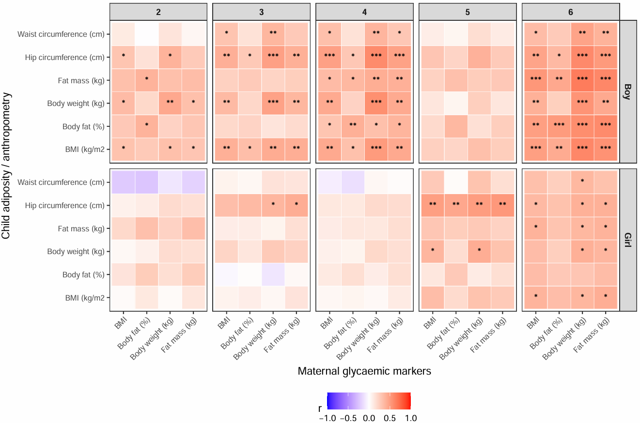
Figure 1. Heatmap showing correlations between maternal adiposity variables (body weight, BMI, body fat percentage, and total fat mass) and child adiposity and anthropometric outcomes (body weight, BMI, body fat percentage, fat mass, hip circumference, and waist circumference) at ages 2–6 years. Panels are stratified by child age (columns) and sex (rows). Color scale represents Pearson correlation coefficients (r), with red indicating positive correlations and blue indicating negative correlations. Asterisks denote statistically significant associations after false discovery rate (FDR) correction (*p < 0.05, **p < 0.01, ***p < 0.001). Only associations surviving FDR correction are marked.

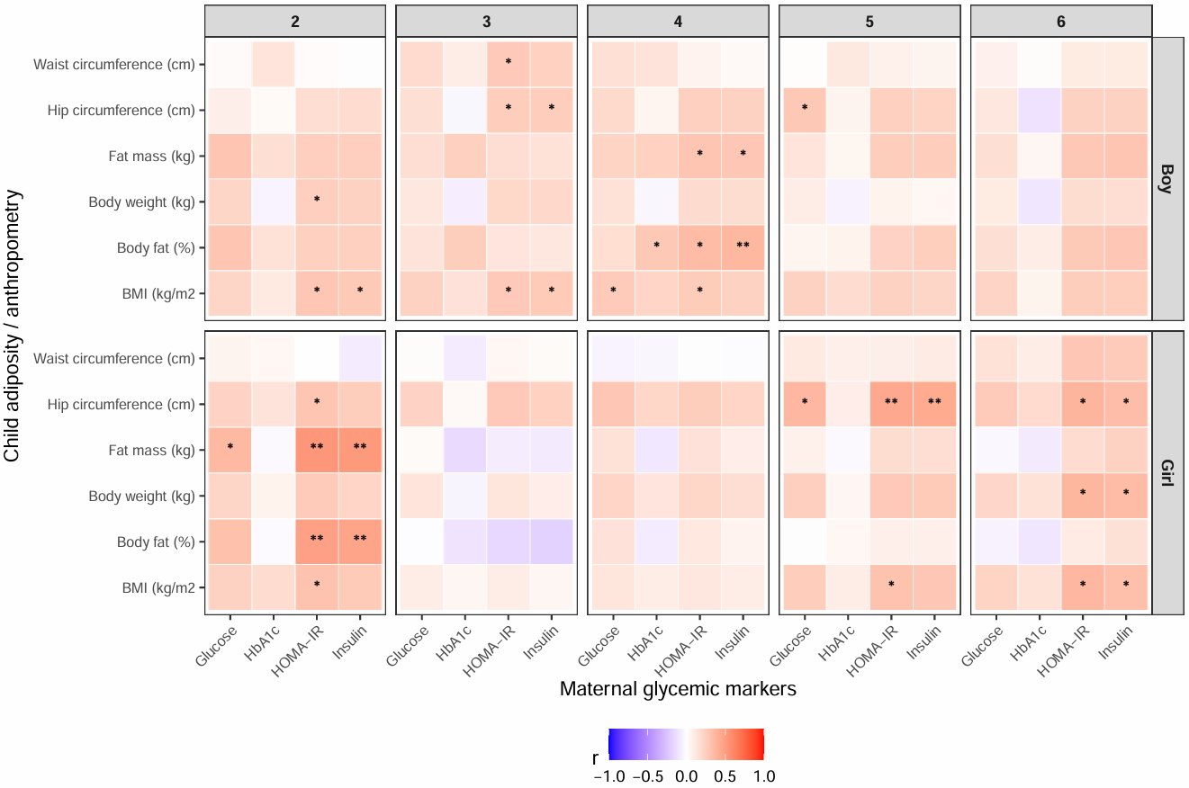
Figure 2. Heatmap showing correlations between maternal glycaemic variables (fasting glucose (mmol/L), HbA1c (mmol/mol), insulin (mE/L), and HOMA-IR) and child adiposity and anthropometric outcomes (body weight, BMI, body fat percentage, fat mass, hip circumference, and waist circumference) at ages 2–6 years. Panels are stratified by child age (columns) and sex (rows). Color scale represents Pearson correlation coefficients (r), with red indicating positive correlations and blue indicating negative correlations. Asterisks denote nominally significant associations based on unadjusted p-values (*p < 0.05, **p < 0.01, ***p < 0.001).

