Filming the Quantum-to-Macroscopic Transition: Capturing Quantum Wavepacket Dynamics in a Laser Plasma

Supplementary Materials

Vassily Kornienko*¹, Yupan Bao², Simon Ek¹, Ali Hosseinia³, Meena Raveesh¹, Christopher Kliewer⁴, Edouard Berrocal¹, Per-Erik Bengtsson¹, Joakim Bood¹, Andreas Ehn¹, Elias Kristensson¹

Affiliations:
¹Department of Physics, Lund University, Professorsgatan 1, 223 64 Lund, Sweden
²Department of Mechanical and Aerospace Engineering, Princeton University, Princeton, NJ 08544, USA
³Luxembourg Institute of Science & Technology, Belvaux L-4362, Luxembourg
³Combustion Research Facility, Sandia National Laboratories, Livermore, California 94551, USA

- The Bloch sphere picture of Coherence Lifetime Imaging
In this chapter the formalities of the Bloch sphere picture will be presented and discussed in the context of coherence lifetime imaging and how it connects to collisional rates. It will start with a section of how a single molecule reacts to the broadband femtosecond pump pulses, followed by multiple molecules and then finally how this connects to the induced macroscopic polarization.

  - Single Molecular response under the influence of the laser field - microscopic coherence
Each rotational eigenstate $|\left.J,M\right\rangle$ is an eigenstate of the rotational Hamiltonian ${\hat{H}}_{rot}=B{\hat{J}}^{2}$ with eigenvalue $E_{J}=BJ(J+1)$ where B is the rotational constant. This is a stationary state that evolves with a global phase of $exp⁡(-iΩ_{t})$, where $Ω$ is the transition frequency between the two states, i.e., $E_{J}/ℏ$. When a broadband fs-laser interacts with this system, it is capable of coupling the rotational states $|\left.J,M\right\rangle$ and $|\left.J+2,M\right\rangle$ through two-photon Raman transitions. While the external electric field is on, i.e., the laser beam is interacting with the molecule, this interaction leads to a superposition state whose angular probability density oscillates in time. It is important to note that this quantum interference of multiple rotational eigenstates occurs on the single molecule level, i.e., the field of the broadband fs-pulse does not couple different molecules to each other but rather couples different rotational states within the same molecule resulting in a coherent superposition given by:
$$\begin{aligned}ϕ_{mol}=\sum_{J}{c_{J}|\left.J,M\right\rangle .} \#\left(1\right)\end{aligned}$$
Here, each amplitude, $c_{J}$, is given by the two-photon Raman couplings between the levels during the pulse. Therefore, the entire "network" of coherences between the rotational states (the off-diagonal element of the density matrix, $ρ_{J,J+2}$) is contained inside a single molecule's density matrix and this is what is meant by microscopic coherence.

Rabi oscillations and population transfer
Given our laser intensity, room temperature N₂ (i.e., the rotational state with maximum population is J = 7) we can calculate that the typical Rabi frequency is on the order of $Ω_{J→J+2}≈3×{10}^{13} s^{-1}=4.8 THz$ for strongly couple states (M = 0). If this Rabi frequency were to perform population transfer, then the J populations would not remain thermal and we would not be measuring the coherences but also the population transfer of the system, resulting in unrepresentative results. We however do not produce a population transfer in our system due to four main reasons:

- The Raman process is non-resonant, therefore the coupling constant is extremely low between the levels.
- The pulse duration of 30 fs is extremely short compared to the rotation of the molecules ($30 fs≪8.4 ps$for the rotational period of N₂ at room temperature).
- The pulse has a high bandwidth, therefore many rotational Raman rotational transitions are included within it.
- Our pulse area is small and since it is not an isolated two-level system, speaking about a $π$-pulse does not present a good picture of the system.

Even when intensities are high enough to produce strong alignment, the probability that a molecule ends up in a different J level is very small. This means that the fs pulse is strong enough to generate a macroscopic polarization, but not strong enough to produce a population change, we are in the perturbative regime.

After the pump laser has passed
Once the laser pulse is gone, the coupling between J-states stops, i.e., the amplitudes $c_{J}$ from Eq. 1 freeze and become constant in magnitude and phase relative to the termination time of the laser pulse, $t_{0}:c_{J}\left(t>t_{0}\right)=c_{J}(t_{0})$. However, the wavefunction remains time-dependent as each eigenstate accumulates its own dynamical phase. Therefore, the density matrix evolves freely as:
$$\begin{aligned}ρ_{mol}= ρ_{mol}\left(0\right)\exp\left(-iΩt\right), \#\left(2\right)\end{aligned}$$
where $ρ_{mol}\left(0\right)$ contains the amplitudes of the state at time $t_{0}$. This is the free evolution of the single molecule.

Upon Collision
If the molecule, which is evolving freely as Eq. 2, undergoes a collisional event at time $t_{c}$, it will experience a phase jump of $Δϕ$. Adding this phase kick results in the post-collisional free evolution of the molecular coherence given by:
$$\begin{aligned}ρ_{mol}= ρ_{mol}\left(0\right)\exp\left(-iΩt\right)\exp\left(-iΔϕ\right). \#\left(3\right)\end{aligned}$$
Before the collision, i.e., at $t<t_{c}$, $Δϕ=0$. After the collision $Δϕ>0$, i.e., a phase kick of magnitude $Δϕ$ will be added to the free evolution of the molecule. Therefore:
$$\begin{aligned}ρ_{mol}= ρ_{mol}\left(0\right)\exp\left(-iΩt\right)\exp\left[-iΔϕΘ\left(t-t_{c}\right)\right], \#\left(4\right)\end{aligned}$$
where $Θ$ is the Heaviside function and a phase jump of magnitude $Δϕ$ will be added at the time of collision $t_{c}$. Once this collision occurs the well-defined phase of the coherence is randomized and the molecule in question has lost synchrony with the phase of the initial coherence inducing laser pulse.

  - Macroscopic Coherence
The laser pulse interacts simultaneously with a huge ensemble of molecules. Since all these molecules experience the same optical phase and polarization, the phase of each molecule’s microscopic coherence is locked to the phase of the driving laser field. Summing over all molecules, the microscopic coherences add constructively, resulting in a macroscopic polarization (a coherent ensemble response). Each molecule j will evolve as Eq. 2:
$$\begin{aligned}ρ_{mol}^{j}\left(t\right)= ρ_{mol}^{j}\left(0\right)\exp\left(-iΩ_{j}t\right), \#\left(5\right)\end{aligned}$$
where we recall that the $ρ^{j}$s are phase aligned as they are all locked to the same fs-laser pulse. Therefore, the ensemble containing N molecules will evolve as:
$$\begin{aligned}ρ_{ens}\left(t\right)= \frac{1}{N}\sum_{j=1}^{N}{ρ^{j}\left(t\right)}= \frac{ρ_{ens}(0)}{N}\sum_{j=1}^{N}{exp⁡(-iΩ_{j}t)}, \#\left(6\right)\end{aligned}$$
which in the continuum limit is given by:
$$\begin{aligned}ρ_{ens}\left(t\right)= ρ_{ens}\left(0\right)\int{g\left(Ω\right)\exp\left(-iΩt\right)dt}, \#\left(7\right)\end{aligned}$$
where $g(Ω)$ is the distribution of transition frequencies across the ensemble, i.e., the weighting function of all the affected $|\left.J,J+2\right\rangle$ transition frequencies. Since our system is in a homogenously broadened regime, then $g(Ω)$ can be defined as a Lorentzian:
$$\begin{aligned}g\left(Ω\right)= \frac{1}{π}\frac{Γ}{{\left(Ω- Ω_{0}\right)}^{2}+ Γ^{2}}, \#\left(8\right)\end{aligned}$$
where $Ω_{0}$ is the frequency at which the average coherence oscillates and $Γ$ is the linewidth of the transition given by $1/T_{2}$ for $T_{2}$ the dephasing time. Performing the integral of Eq. 7 this results in the evolution of the ensemble which rotates at $Ω_{0}$ and dephases with a characteristic time of $T_{2}$:
$$\begin{aligned}ρ_{ens}= ρ_{ens}\left(0\right)\exp\left(-iΩ_{0}t\right)\exp\left(-\frac{t}{T_{2}}\right). \#\left(9\right)\end{aligned}$$
Therefore, when we have an ensemble of molecules, each molecule develops its own internal rotational wavepacket, but because they all see the same laser field phase and polarization, the phase of their internal coherence is synchronized across the ensemble. This ensemble-averaged coherence is what gives rise to the macroscopic polarization. It is important to remember though, that the individual Raman couplings themselves remain strictly intra-molecular.
Macroscopic Polarization
The molecules within the ensemble are in phase with each other such that the individual dipoles add constructively and induce a macroscopic polarization given by:
$$\begin{aligned}\overset{⃑}{P}=N\left\langle μ\left(t\right)\right\rangle ∝ρ_{ens}\left(t\right), \#\left(10\right)\end{aligned}$$
where $〈μ⟩$ is the average dipole moment of the population. For the Raman process described herein $\overset{⃑}{P}$ is a third order polarization that arises from $χ^{3}$. This macroscopic polarization can act as a single density matrix and this is what we create when the pump laser beam interacts with the probe volume.
Probing the macroscopic polarization
This macroscopic polarization can be probed with an optical probe field, $E_{p}$ which oscillates at $ω_{p}$ given by:
$$\begin{aligned}E_{p}∝\exp\left(-iω_{p}t\right). \#\left(11\right)\end{aligned}$$
This optical field heterodynes the oscillation of the macroscopic dipole resulting in a polarization field given by:
$$\begin{aligned}P^{(3)}∝\exp\left(-iω_{p}t\right)\exp\left(-iΩ_{0}t\right)\exp\left(t/{T_{2}}\right)=\exp\left(-iω_{AS}t\right)exp\left(t/{T_{2}}\right), \#\left(12\right)\end{aligned}$$
where the probe has produced an oscillating field at the "anti-stokes" frequency, $ω_{AS}= ω_{p}+ Ω_{0}$. In the case of these experiments, the temporal length of the probe $t_{p}=30 ps$, is longer than rotational time of the molecules ($∼8 ps$), the probe will integrate over the phase evolution of the off-diagonal coherences of the density matrix. Therefore:
$$\begin{aligned}I_{AS}∝\int_{0}^{t_{p}}{{\left|E_{AS}\right|}^{2}dt}∝ \int_{0}^{t_{p}}{exp⁡(-{2t}/{T_{2})}}dt, \#\left(13\right)\end{aligned}$$
i.e., the intensity of the detected anti-stokes signal will give the decay envelope and not the oscillations of the coherences.

  - The Bloch Picture
Since all the above was described in density matrices, it is natural to visualize the above in the Bloch sphere picture.
a) Single Molecule
On the first row of the Fig. S1 is the Bloch sphere picture of single molecule. Initially it lies in the J state, pointing directly towards the north pole. Upon interaction with the fs-pulse it experiences an impulsive rotational kick, that, as we have already discussed, affects the coherences rather than transferring population. The arrow will have shifted away from the pole slightly. Then it is allowed to evolve freely until it collides where it acquires a phase jump, $Δϕ$ and jumps towards a new position (note the top view where the projection onto the xy-plane is depicted). This is an example of an elastic collision where only phase is affected. In the case of an inelastic collision, where energy is transferred, the Bloch vector would fall back towards the pole.
b) Ensemble of molecules
Each molecule begins in the J-state determined by thermal equilibrium. After the impulsive rotational kick, they will first all be tilted towards the same direction. However, since they evolve freely at different frequencies, $Ω_{J}$, they will rotate around the xy-plane at different angular frequencies, resulting in this fanning out of each individual Bloch vector (see top view for the projection on the xy-plane). Since the rotational levels' energies are given by an integer number of the rotational constant, B, when the "slowest" molecule will have completed a single rotation, all the others will also have performed an integer number of rotations, and they will all align in the xy-plane at the initial phase of the laser. This is what is called a revival. When one molecule collides elastically, it will obtain a phase jump of $Δϕ_{j}$, thus shifting its position. It will then not be in phase with the rest of the ensemble and is not a part of the phase locked ensemble anymore. The same argument is made for an inelastic collision, i.e., it drops out of the phase locked ensemble.

c) Macroscopic Coherence and Measurement
The entire ensemble can in principle be described with a single Bloch vector which is the ensemble average of all the molecules that are phase locked with the fs laser. Thus, after the impulsive rotational kick, the ensemble vector will gain a tilt and start rotating freely at frequency an ensemble averaged frequency, $Ω_{0}$. When molecules within this macroscopic ensemble collide and accrue an individual phase of $Δϕ_{j}$ they will interfere destructively with the rest of the ensemble, resulting in a decrease of the ensemble average length of the Bloch vector. Therefore, it will shorten, at a rate given by $exp⁡({-t}/{T_{2})}$. Upon measurement, a probe pulse will heterodyne this macroscopic polarization and perform an integration of the ensemble average over the xy-plane. The electric field strength of this anti-stokes signal will then decrease at the same rate as the vector resulting in a detected intensity proportional to $exp⁡({-2t}/{T_{2})}$.

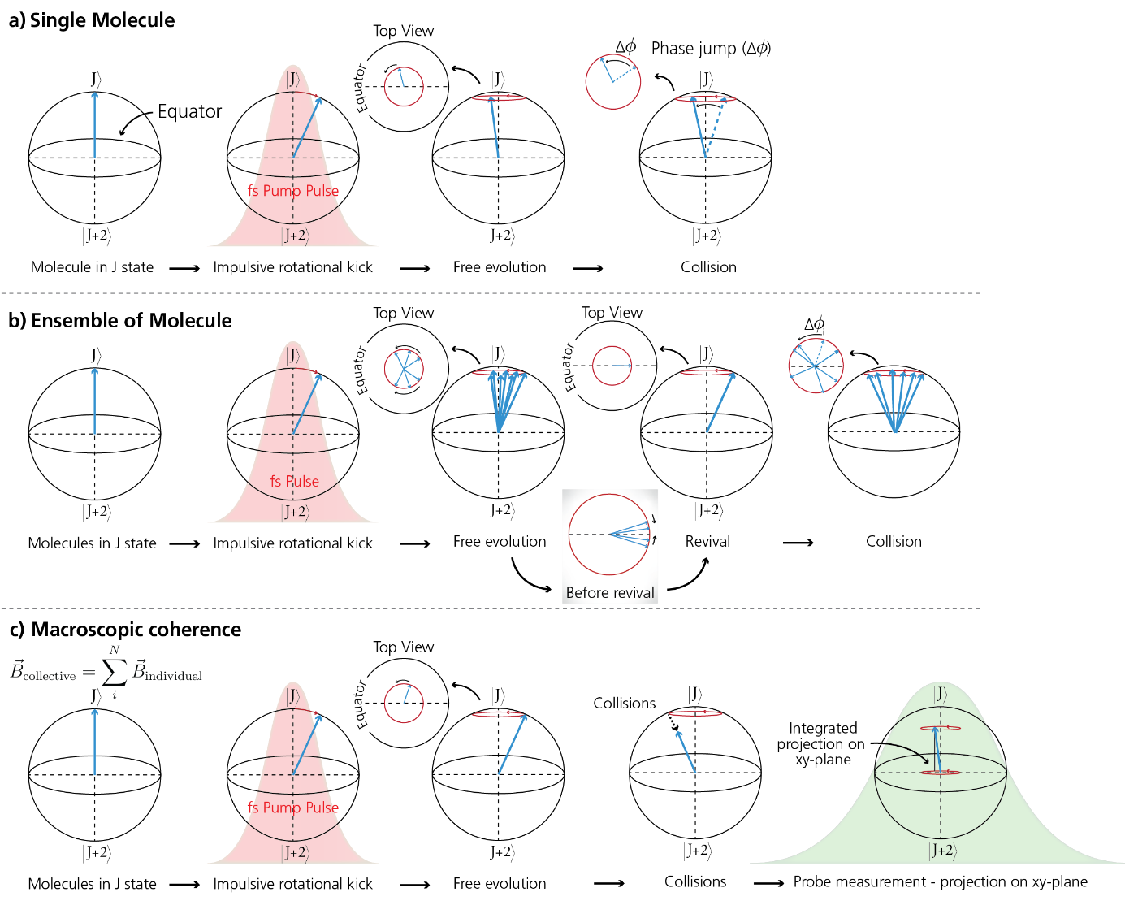
Figure S1: The Bloch sphere picture of coherent anti-stokes Raman Spectroscopy of a a) Single Molecule, b) ensemble of molecules and c) the ensemble average of the phase locked macroscopic polarization state.

- Assumptions related to the extraction of collisional frequencies from CARS lifetimes and T₂
The following is a discussion on the basic assumptions applied when converting a coherence lifetime, extracted via a Coherent Anti-Stokes Raman Spectroscopy (CARS) type measurement, to collisional rates. Its basis is in the book Collisional Effects on Molecular Spectra, by Jean-Michel Hartmann, Christian Boulet and Daniel Robert¹ .

The collisional rate of molecules in a gas, $ν_{c}$, in $s^{-1}$, is given by:
$$\begin{aligned}ν_{c}=\frac{1}{τ_{0}}, \#\left(14\right)\end{aligned}$$
Where $τ_{0}$ is the mean free time of the molecules, i.e., the time between each collision. In this picture, each collision is considered to be efficient in the coherence transfer process, which is effectively true for rotational energy transfers within a molecular system such as N₂ - N₂. This is due to the fact that the involved energy defect is much smaller than the thermal energy, $k_{B}T$ of the system. This is in stark contrast to the case when molecules collide with atomic perturbers whose levels have a much larger spacing in terms of energy. Assuming hard spheres, i.e., the collision cross-section is the projected area of a sphere, and thermodynamic equilibrium at standard pressures and temperatures, the mean free time of flight of molecules is $τ_{0}≈2×{10}^{-10}$ s resulting in a collisional rate of $ν_{c}≈0.5×{10}^{10} s^{-1}$. Assuming that the collisional rate is the dominant broadening mechanism to the transition linewidths of the molecules in question, i.e., $Γ≈Γ_{col}$, this quantity can be extracted from the FWHM of the spectral line, $Γ$:
$$\begin{aligned}ν_{c}=\frac{1}{τ_{0}}=πΓ. \#\left(15\right)\end{aligned}$$
In the work presented herein, we measure a collisional rate of $∼0.8×{10}^{10} s^{-1}$, a slightly larger value than that for the hard-sphere approach. This difference arises from, among other things, the perturbation of molecular potentials as the molecules come closer, manifested as higher collisional cross-sections as compared to the hard-sphere approach. Indeed since we are sensitive to phase perturbations, a “kick” on the wavefunction will cause the ensemble averaged Bloch vector to contract and thus result in faster dephasing.
Coherence Lifetime of Raman Coherences
In a Raman transition, the Raman coherence is the off-diagonal element of the density matrix of the transition. Therefore, the dephasing rate, or loss of coherence, is determined by the sum of relaxation rates of each involved level. Therefore, again assuming that the collisional rate is the dominant mechanism behind the dephasing, the lifetime of the Raman coherence will be the sum of the lifetimes of the involved states.

When impulsively exciting N₂ rotational Raman coherences with a broadband femtosecond pulse at the flux used herein ($2.1×{10}^{14} {Wcm}^{-2}$, the S-band ([J,J+2]) coherences will dominate². In general, the lifetime will increase as a function of J-number (a lower collisional cross-section in a collisionally dominated environment) however the lifetime difference between the levels involved in each individual coherence, [J,J+2], is in fact quite small³. Therefore:
$$\begin{aligned}τ_{0}≈{2τ}_{CARS}, \#\left(16\right)\end{aligned}$$
Where $τ_{CARS}$ is the measured lifetime of the impulsively excited coherent state. Therefore, the collisional frequency of the N₂ gas given a certain measured $τ_{CARS}$ will be given by:
$$\begin{aligned}ν_{c}=\frac{1}{τ_{CARS}}, \#\left(17\right)\end{aligned}$$
an approximation that has been shown to hold for pressures around and greater than 1atm⁴⁵.
The impact approximation
Following is the set of assumptions that must hold if we are to apply Eq. 17 to our measured lifetime maps. In general, around atmospheric pressure, the collisional effect on lifetime and, in continuation, line-broadening is on the order of 10 times larger than the inhomogenous Doppler broadening¹. However, there are the constraints within the impact approximation that must be delved into. The impact approximation, in words, requires that the collisions are strong (they are of high efficiency) and they are well separated in time. Furthermore, it assumes that the molecular rotation is frozen during a collision. For the case of the rotational energy manifold within a single vibrational level of N₂ (what we are targeting with the coherence lifetime imaging technique), this is indeed the case. Following is a description and corroboration of these assumptions within the frame of our Coherence Lifetime Imaging Experiments.
The strength of collisions: As we have already discussed the efficiency of the collisions detected within this work (see above), let us look into the separation in time of the intermolecular collisions and compare to the collision time, $τ_{c}$. For this part of the impact approximation to hold, $τ_{c}≪τ_{0}$, where $τ_{0}$ is the familiar mean free time of flight between molecules. $τ_{c}$ depends on the strength and range of the intermolecular potentials which can itself be, to a first degree approximation, summarized in a characteristic length, $l_{c}$ (where $τ_{c}≈l_{c}/⟨v⟩$, and $⟨v⟩$ is the average relative speed of the molecules). One of the limiting cases of this length is the long range intermolecular and quasi-resonant rotational transfers, where only centred linewidth broadening of low-lying rotational levels are involved. This is indeed the case for the N₂- N₂ system at STP, as has been experimentally measured. Using the same numbers as for the rigid sphere approximation (i.e., relative speed, circular cross-section akin to the size of the molecule and mass), $τ_{c}≈{10}^{-12} s≪ τ_{0}≈{10}^{10} s$.
Freezing of rotation
In order to see if the molecule is ``frozen´´ in its rotation within a collision event, one can look into experimental J-level linewidth data for Q-branch N₂ and find that the collisionally dominated linewidths are on the order of ${10}^{-1} {cm}^{-1}$while the Raman shifts are of the order of $10 {cm}^{-1}$ , corroborating the small detuning that is characteristic of the impact approximation.
Breakdown of the impact approximation
This assumption breaks down at high pressures, due to pressure broadening and the far wings of the rotational manifolds, where anharmonicity of the potential results in more significant long-range perturbations. This is not deemed an issue within our experiments, where we present acoustic pressure waves and hydrodynamic instabilities. Furthermore, high-lying J-levels, where potential anharmonicity can play a role, will be undetectable due to the finite spectral bandwidth of the measurement (both of the fs pulse and the angle between pump/Stokes and probe).

- Detailed Experimental Setup
Figure S2 is a detailed schematic of the experimental setup. In contrast to the larger overview of the main paper, here we include:
- Half wave-plates that spin the polarization for the polarization gating strategy.
- Three 2'' beamsplitters for the ``FRAME optics´´ where the same beamsplitters are used for separation and recombination. These are placed on 3D printed optical stands for easier alignment.
- Global delay stage which gives a $Δt_{GLOBAL}$ to the entire picosecond probe arm. This is used to scan across the coherence in time and place the first probe pulse in time. The placement, 10 ps delay, is chosen as a trade-off between minimal non-resonant signal contribution with a first collision-free measurement of the coherence state.
- The three scanning arms that place the pulses of the pulse train separated by about 50 ps in time. These were optimized so that minimal cross-talk between the pulses (measured by observing interference patterns) is achieved.
- The optical Fourier domain of the probe pulses, i.e., the focal point of L1, where the orders are seen to be separated in space. Here, spatial filtering is performed to get rid of the unnecessary orders for a deeper modulation depth over the entire probe volume.
- The Semrock Edge spectral filters that, since they are interference based, are placed at a given angle such that they cut off the probe wavelength and only the Anti-Stokes signal remains.

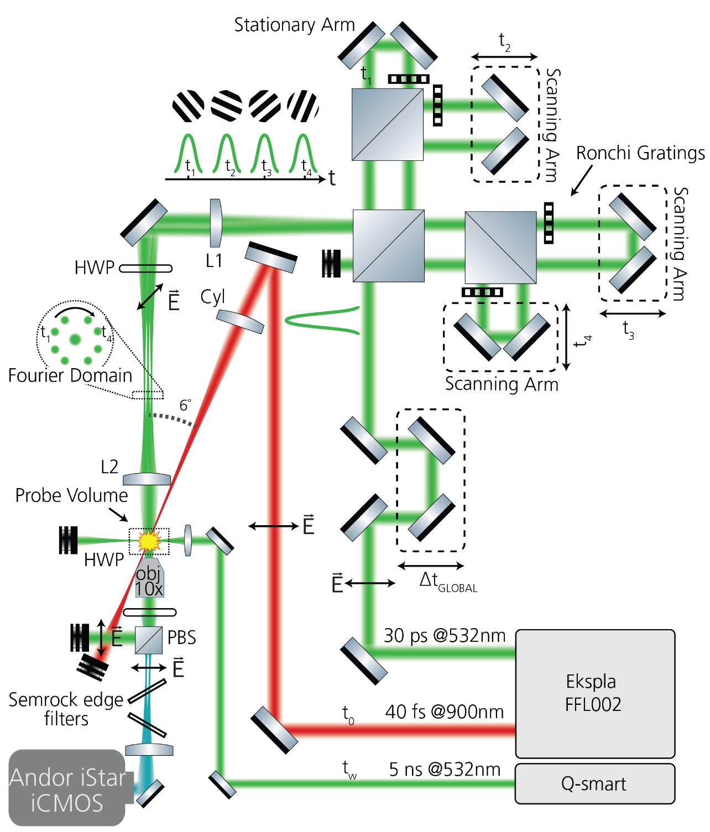
30
Figure S2: Detailed Experimental Setup. A more detailed experimental setup including the pieces that were not included in the main paper

- Lock-in Lifetime Algorithm
Following in a short run-down of the data processing involved behind the CLI images.
The signal that is detected at time $τ$, within this collisional quenching regime is given by⁶:
$$\begin{aligned}I_{CARS}\left(τ\right)= \left|\sum_{j}{f_{j}\exp{{\left(\left(\frac{iΔE_{j}}{ℏ}-Γ_{j}\right)τ\right)}^{2}}}\right|. \#\left(18\right)\end{aligned}$$
In our work, we record four of these in a single shot that are uniquely spatially modulated. Therefore, in image form, the signal that is recorded, $I_{IMAGE}$, is:
$$\begin{aligned}I_{IMAGE}= \sum_{τ_{i}}{M_{τ_{i}}\left(x,y\right)I_{CARS}\left(τ_{i}\right), }\#\left(19\right)\end{aligned}$$
where $M_{τ_{i}}$, is the applied spatial modulation for a given pulse at time $τ_{i}$. Therefore, in order to extract the coherence lifetime map, each individual $I_{CARS}(τ_{i})$ needs to be isolated from $I_{IMAGE}$. Below is a short description of what is being done along the way, following the steps of the existing code. When it is written that the lock-in detection algorithm is utilized we refer to our previous publications such as Kornienko et. al.⁷.
- Firstly, the intensities of each probe pulse are measured by measuring the energy and also by performing a scan over the coherence in time. Both these show identical intensities; hence they are then used to compensate for different probe intensities in the individually extracted images.
- Whitefield CARS imaging is performed on room temperature nitrogen in in order to compensate for beam profile differences:
  - The four Anti-Stokes signals are recorded 100 times.
  - The lock-in algorithm is applied to each with tight low-pass filtering such that the low frequency trends in the spatial profile become evident.
  - The set of 100 extracted images from each pulse is averaged, creating four whitefield images
- A darkfield image is obtained by stopping all the light and performing an identical lock-in analysis as for the whitefield. This has the effect of extracting the spatially dependent dark noise power at the position in Fourier domain where $M_{τ_{i }}$ will be extracted.
- The CARS images with the plasma induced breakdown are recorded (this is $I_{IMAGE}$) and extracted using the lock-in algorithm, resulting in an uncorrected $I_{CARS}(τ_{i})$.
- These are then individually corrected using the whitefield image, the darkfield image and the compensation for probe intensity. They are then placed in datacube where each slice corresponds to a different $τ_{i}$.
- A pixel-wise weighted least squared fit is performed on the natural logarithm of the images along the temporal axis. The weights are extracted from the variance of the noise of a suitable ROI in the whitefield images. This is an important step as the images from larger $τ_{i}$ have a necessarily lower signal to noise ratio.
From these steps a single lifetime map of the molecular nitrogen at the given time after the creation of the plasma is created.

- Extracting lifetimes from the Fourier Components
At around 30 $μs$, the signal from the inflow of cool gas into the plasma kernel results in signals of extremely low SNR, as seen as the green, contrast enhanced signal in the center of the eyes in Fig. 6 of the main text. At the cost of spatial resolution, one can perform the lifetime fit on the Fourier components instead, essentially extracting an average lifetime for the entire region of interest. This has previously been performed by us in order to see atomic oxygen signals in a nanosecond plasma discharge⁸. Here we follow a similar process.
In short, the region of interest is cropped out, the whitefield and probe intensity normalization is performed (see above), and the background noise level of the Fourier domain in an area around the specific position of the Fourier cluster is subtracted. This noise level is extracted from an image where the incoming light is unmodulated. Again, a weighted least squares fit is performed on the natural logarithm of the intensities of the Fourier cluster. Performing on the entire set of the images recorded at the given timestamp results in a histogram that is distributed around a collisional rate of $0.6×{10}^{10}{ s}^{-1}$.

- Suppression of Background Plasma Light via the Lock-In Algorithm
Since broadband emission is mainly centered around the DC component in the spatial Fourier domain, extracting information at the Fourier clusters as is done herein allows for an efficient background suppression⁷ and in continuation high-fidelity extraction of lifetimes as a linear fit to the natural logarithm of the signal. Fig. S3 shows this efficiency:
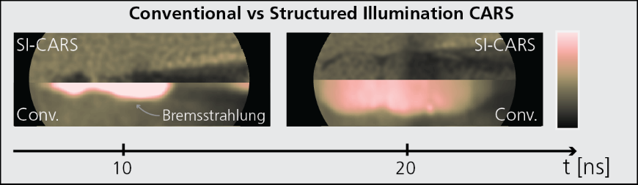

Figure S3: Efficient background suppression of the plasma emission is enabled by the structured illumination approach. This elimination reveals the real structures of the plasma.

References
1. Hartmann, J. M., Boulet, C. & Robert, D. Collisional Effects on Molecular Spectra. (Elsevier Science, London, England, 2008).
2. Xu, S. et al. Multiorder rotational Raman transitions in molecular alignment and orientation. Phys. Rev. A 110, 23116 (2024).
3. Meißner, C., Hölzer, J. I. & Seeger, T. Determination of N2–N2 and N2–O2 S-branch Raman linewidths using time-resolved picosecond pure rotational coherent anti-Stokes Raman scattering. Appl. Opt. 58, C47–C54 (2019).
4. Martinsson, L., Bengtsson, P., Aldén, M., Kröll, S. & Bonamy, J. A test of different rotational Raman linewidth models: Accuracy of rotational coherent anti‐Stokes Raman scattering thermometry in nitrogen from 295 to 1850 K. J. Chem. Phys. 99, 2466–2477 (1993).
5. Kulatilaka, W. D., Hsu, P. S., Stauffer, H. U., Gord, J. R. & Roy, S. Direct measurement of rotationally resolved H 2 Q -branch Raman coherence lifetimes using time-resolved picosecond coherent anti-Stokes Raman scattering. Appl. Phys. Lett. 97, 81112 (2010).
6. Lang, T., Motzkus, M., Frey, H. M. & Beaud, P. High resolution femtosecond coherent anti-Stokes Raman scattering: Determination of rotational constants, molecular anharmonicity, collisional line shifts, and temperature. J. Chem. Phys. 115, 5418–5426 (2001).
7. Kornienko, V., Kristensson, E., Ehn, A., Fourriere, A. & Berrocal, E. Beyond MHz image recordings using LEDs and the FRAME concept. Sci. Rep. 10, 16650 (2020).
8. Ravelid, J. et al. 2D imaging of atomic oxygen reaction dynamics after a nanosecond pulse discharge using Light-field Amplitude Control. Plasma Sources Sci. Technol. 34, 105010 (2025).

