Supporting information
Topology-Controlled Solvent Eviction and Co-Occupation in Liquid-Filled Zeolite Micropores
Table of Contents
Supplementary Figures and Tables
Figure S1. ¹H MAS NMR spectra of FAU with decalin at different temperatures
Figure S2. ²H MAS NMR spectra of pure decalin-d18 at different temperatures
Figure S3. ²H MAS NMR spectra of decalin-d18 adsorbed in MFI and SBA-15
Figure S4. Temperature and time effects on decalin adsorption in MFI and FAU
Figure S5. Symmetry-independent carbon atoms in trans- and cis-decalin
Table S1. PBE+D3 adsorption energies and BAS–adsorbate distances for cyclohexanol, trans-decalin, and cis-decalin
Figure S6. Convergence of ensemble-averaged adsorption energies at 300 K in H-MFI
Figure S7. Definition of the competitive adsorption coordinate used in metadynamics simulations
Figure S8. Cyclohexanol-mediated proton transfer at the Brønsted acid site in H-MFI
Figure S9. kPCA projection along the competitive adsorption coordinate for cyclohexanol–decalin competition in MFI
Figure S10. Correlation between MLP-predicted and DFT reference force components
Figure S11. Evolution of the competitive adsorption coordinate during WMetaD simulations in MFI and FAU
Figure S12. Probability of cyclohexanol and decalin proximity to the BAS in MFI and FAU under decalin-filled conditions

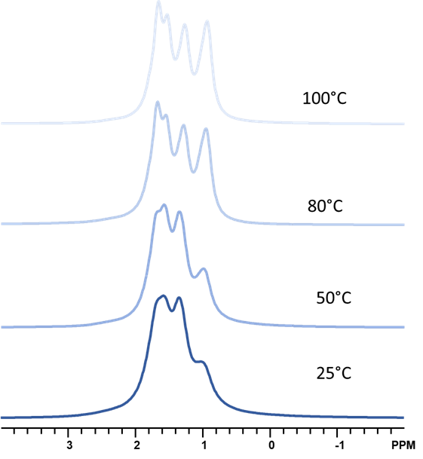
Figure S1. ¹H MAS NMR of 156 mg of FAU and 48 mg of decalin at different temperatures.

NMR spectra of pure decalin-d₁₈ and their temperature dependence
Figure S2a shows the ²H MAS NMR spectra of pure decalin-d₁₈ at different temperatures. In line with previous ²H MAS NMR spectra of decalin ^{1,2}, Seven peaks are apparent, attributed to several deuterium positions of trans- and cis-decalin (numbers 1-10 represent the positions of deuterium, labeled in Figures S2b and c). The assignments are as follows: 1.63 ppm (trans 2,3,6,7e and cis 2,6e, 3,7a, 9,10); 1.50 ppm (trans 1,4,5,8e and cis 1,5e, 4,8a); 1.29 ppm (cis 1,5a); 1.25 ppm (4,8e); 1.18 ppm (cis 3,7e and trans 2,3,6,7a); 0.89 ppm (cis 2,6a and trans 1,4,5,8a); 0.82 ppm (trans 9,10). e and a are equatorial and axial positions, respectively, with respect to the chair conformation of the fused cyclohexyl rings. With increasing temperature, the peaks shift downfield slightly due to the less shielded environment.
(c)
(b)
(a)
Figure S2. ²H MAS NMR of (a) pure decalin at 25–180 °C, (b) trans-decalin, (c) cis-decalin. Spectra were all acquired after temperature equilibration was reached.
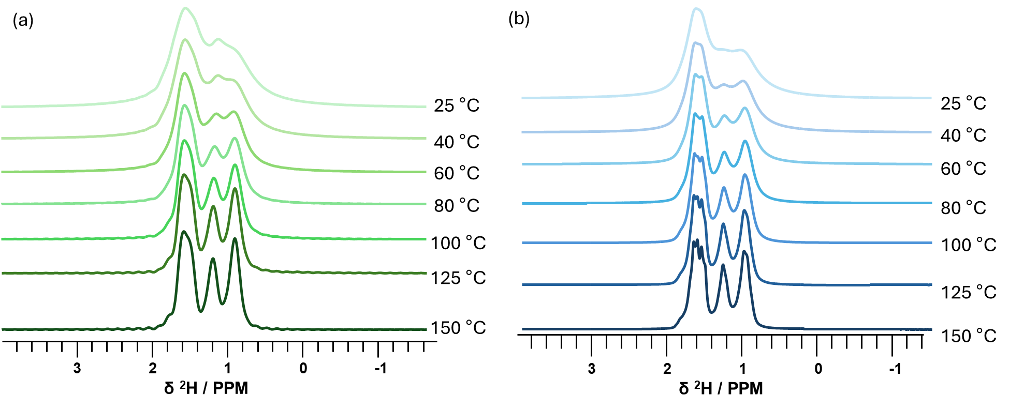
Figure S3. (a) ²H MAS NMR spectra of 188 μL of decalin-d₁₈ with 268 mg MFI (decalin to MFI micropore ratio of 4.8; 10 μmol m⁻²) at different temperatures. (b) ²H MAS NMR spectra of 46.5 μL of D₁₈-decalin with 83 mg SBA-15 (10 μmol m⁻²) at different temperatures.

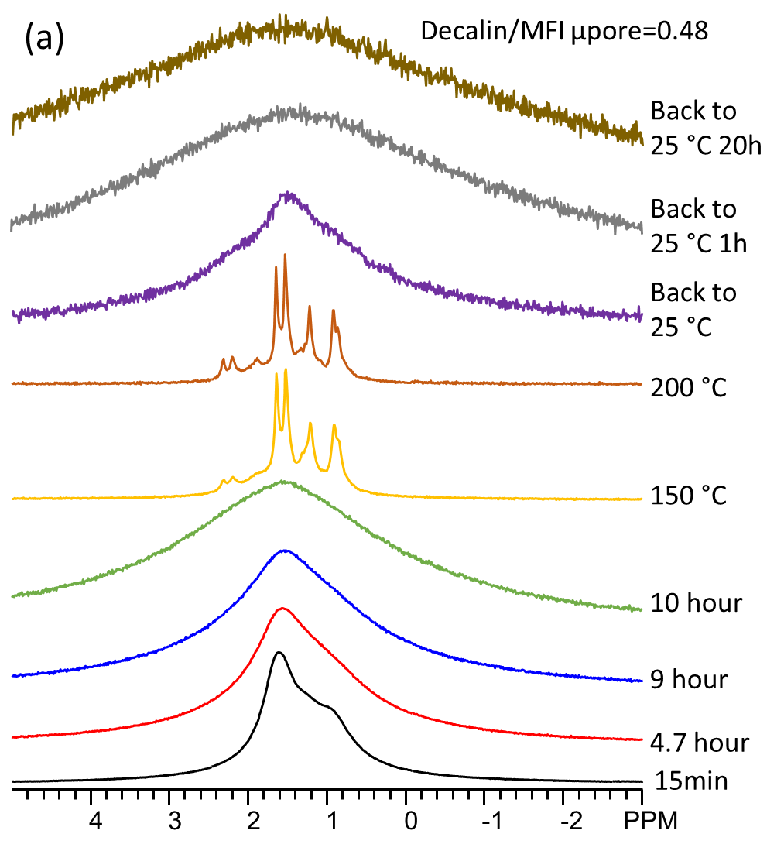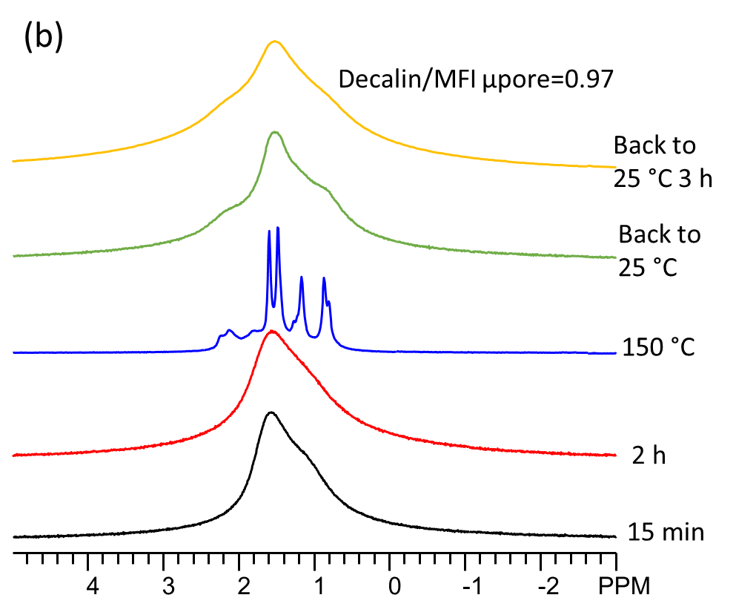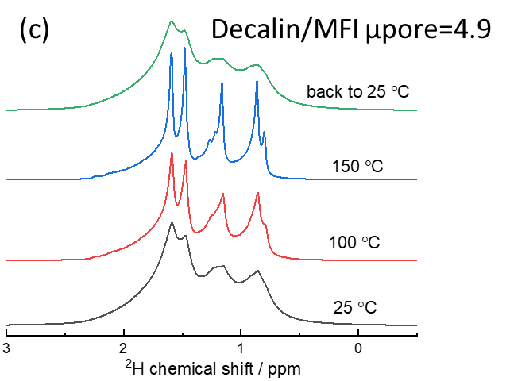
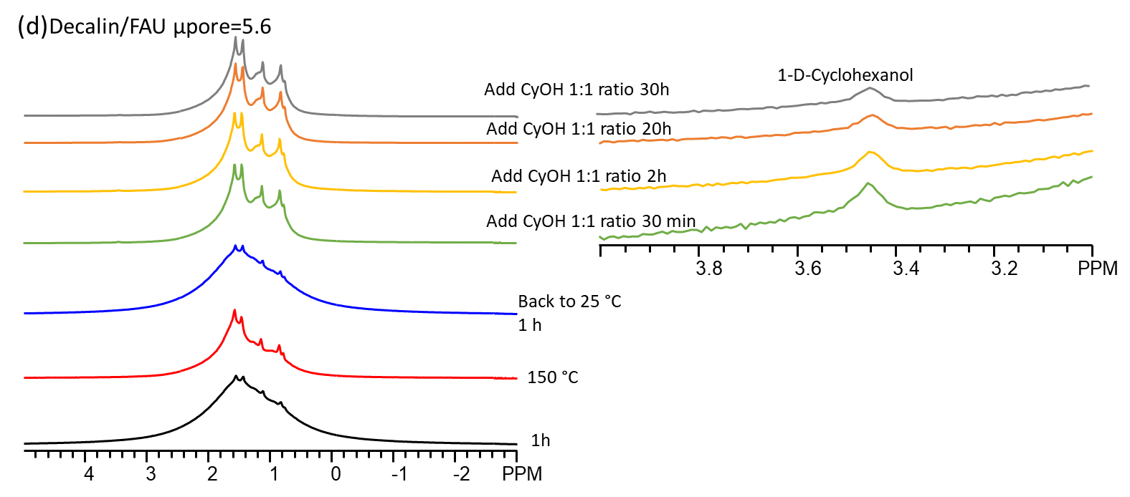
Figure S4. Temperature and Time effect on decalin adsorption on (a), (b), (c) MFI and (d) FAU.
As shown in Figure S4a, b, and c, with volume ratio of decalin to MFI micropore as 0.48 to 4.9, when temperature increases to 100 °C, decalin lineshape become fairly sharp, indicating a portion of decalin is driven out from micropores of MFI. When temperature further increases to 150 °C or 200 °C, the decalin lineshape becomes extremely sharp, suggesting most of decalin is driven out from micropores of MFI due to enhanced movement. In FAU case, it is observed that the peaks become sharper when temperature increases to 150 °C due to a portion of decalin driven out from FAU micropores. However, even when temperature increases to 150 °C, the lineshape is not as sharp as MFI case, attributed to larger-pore size/volume holding much more decalin in the FAU micropore.

Adsorption calculations in MFI
For individual adsorption, we optimized the structures of each adsorbate (cyclohexanol and trans- and cis-decalin) and calculated the adsorption energies with respect to the empty zeolite framework and the molecule in the gas phase. The distances between the acidic hydrogen and adsorption closest substrate atom (hydroxyl oxygen for cyclohexanol and aliphatic carbons for decalin) are of particular interest. As decalin possesses three different symmetrically independent carbon atoms for both trans- and cis-isomers (see Figure S5), we considered their adsorption as three different states for which energy and distance from the BAS were calculated independently.

Figure S5. The green arrows indicate the symmetry independent carbon atoms in trans- and cis-decalin.
Table S1 reports the adsorption energies and distance from the BAS for cyclohexanol, trans-, and cis-decalin. For trans-decalin, the most stable adsorption configuration involves the secondary carbon (C8; see Fig. S5), for which also the OH_{BAS}-C is shortest, indicating a strong interaction with the BAS. For all three adsorption structures, the decalin plane is accommodated along the straight channel of MFI. For cis-decalin, the most stable adsorption configuration is represented by the tertiary carbon in C9 position. However, in this case the distance of this carbon from the BAS is not the shortest. In fact, while trans-decalin resides in the straight MFI channel, the bulkier structure of cis-decalin is fully located at the intersection of the MFI pores. In this configuration, C9 adsorption is not the closest to BAS, but favors attractive dispersion interactions of the cis-isomer with the hydrophobic zeolite. These adsorption configurations for cis- and trans-decalins further support the experimental evidence that decalin can adsorb into MFI micropores. Cyclohexanol interacts more strongly than both cis- and trans-decalin. However, static adsorption energies at the PBE level, even when corrected by D3 corrections, are known to deviate substantially from the experimental heats of adsorption. This effect is more pronounced in the case of alcohols, where PBE + dispersion tends to overestimate the adsorption energies. For instance, Piccini et al.³ demonstrated that for ethanol adsorbed at the BAS in MFI, the bare PBE+D3 energy differs from the experimental heat of adsorption by 44 kJ mol⁻¹. In line with this, our static calculation for a bulkier alcohol, cyclohexanol -whose alkyl carbons interact with the walls of the zeolites - yields an adsorption energy of -178.081 kJ/mol, indicating substantially overbinding. When finite temperature effects are including through MLP-based molecular dynamics at 26 °C, the ensemble-averaged adsorption energy decreases to 144.5 kJ mol⁻¹. This reduction relative to the static minimum highlights the influence of thermal fluctuations, configurational sampling, and dynamic hydrogen-bond rearrangements at operando temperatures, bringing the calculated value into closer agreement with experiment. A similar trend is observed for the decalin isomers. For trans- and cis-decalin, the adsorption energies shift from static values of −121.6 and −99.8 kJ mol⁻¹ to thermally averaged values of −73.9 and −71.7 kJ mol⁻¹, respectively.
Table S1. PBE+D3 adsorption energies and distance from the BAS for cyclohexanol, trans-, and cis-decalin.
Molecule | Position | Adsorption energy (kJ/mol) | Distanceª  (Type, Å)
Cyclohexanol
Cyclohexanol |  | -178.08 | OH--O, 1.10
trans-decalin
trans-decalin | C9 | -103.94 | OH--C, 2.56
trans-decalin | C8 | -121.61 | OH--C, 2.35
trans-decalin | C7 | -61.91 | OH--C, 2.55
cis-decalin
cis-decalin | C9 | -99.75 | OH--C, 2.73
cis-decalin | C8 | -87.15 | OH--C, 2.13
cis-decalin | C7 | -82.39 | OH--C, 3.67
ª Distance from framework oxygen of Brønsted acid site to nearest adsorbate heavy atom.
Convergence of the ensemble-averaged adsorption energies at 300 K was assessed by monitoring the running average of $ΔU_{ads}$ as a function of production time (Figure S6). The initial 75 ps of the cyclohexanol trajectory and 50 ps for the decalin isomers were discarded as equilibration to ensure the system had stabilized at the BAS. For cis- and trans-decalin, three independent trajectories were initiated from distinct orientations relative to the BAS to ensure reproducibility and adequate sampling of the configurational space. The reported adsorption energies correspond to the ensemble-averaged mean values obtained via block averaging with a block size of 5 ps. Statistical uncertainties were estimated as the standard error of the mean (SEM) computed from the block means. For the decalin systems, the final adsorption energy and uncertainty were determined by concatenating the production segments of all three replicas into a single ensemble.
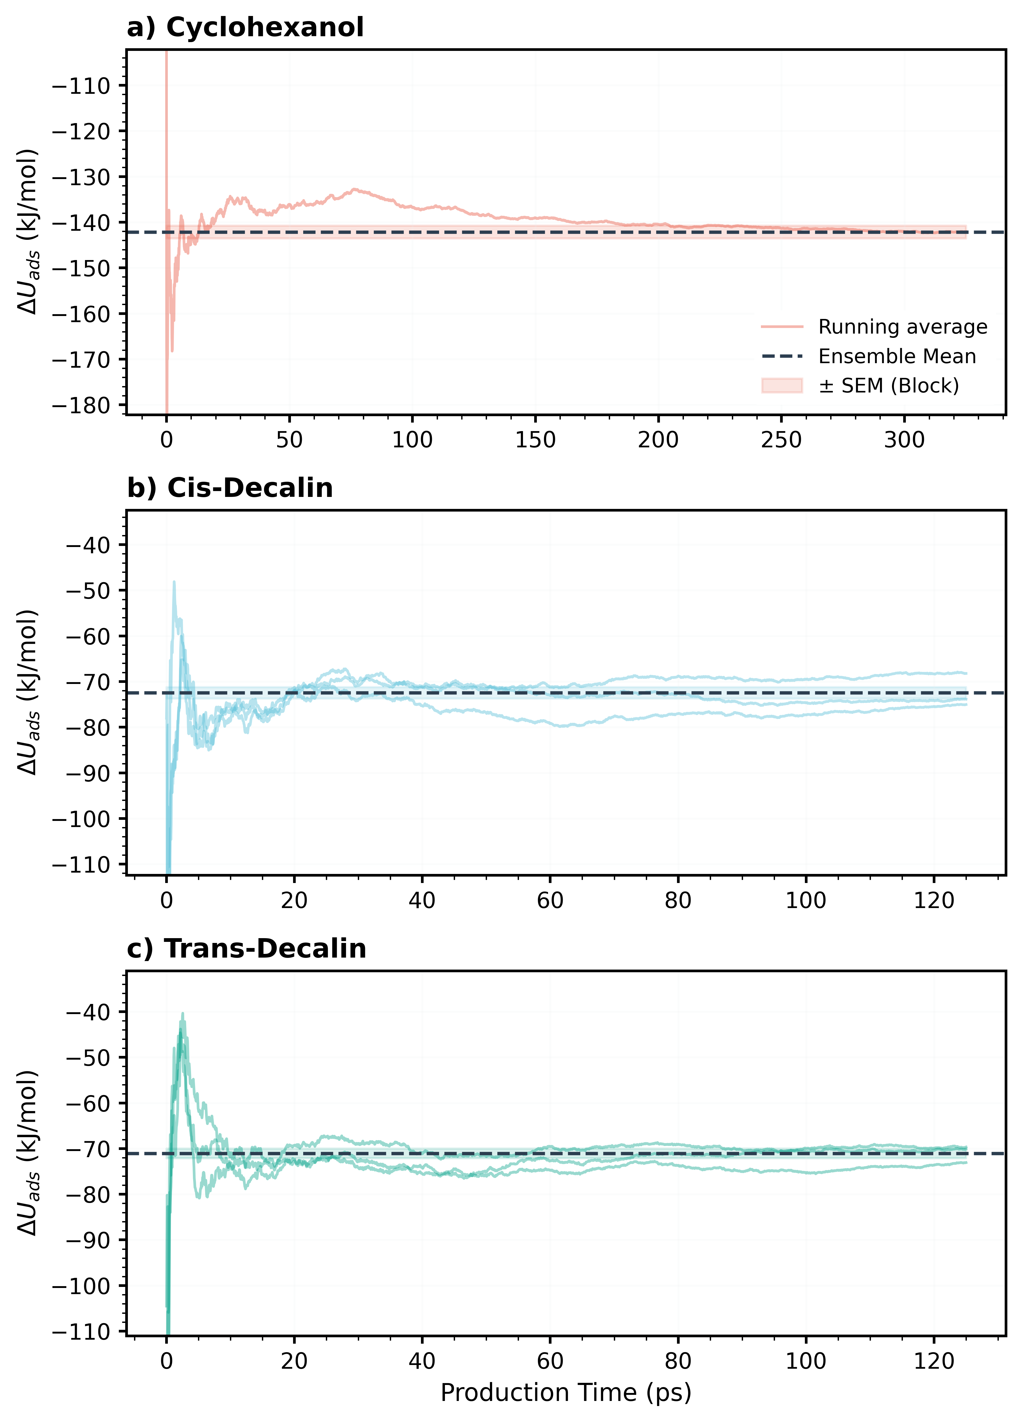
Figure S6. Convergence of ensemble-averaged adsorption energies $ΔU_{ads}$at 300 K for (a) cyclohexanol, (b) cis-decalin, and (c) trans-decalin in H-MFI. Running averages are shown after discarding the initial equilibration period. Dashed horizontal lines denote the block-averaged mean values obtained using a 5 ps block size, and shaded regions indicate the corresponding standard error of the mean (SEM). For the decalin systems, three independent replicas were analyzed.
Collective Variable (CV)
Free energy enhanced sampling methods such as metadynamics enable the observation of rare events that are typically inaccessible within the timescales of first-principles molecular dynamics due to high free energy barriers. To achieve this, the process of interest must be represented in a reduced-dimensional space using appropriately chosen collective variables (CVs). The selected CVs should effectively distinguish between different metastable states and facilitate transitions. In the present calculations, the CV was defined as the difference between two distances: (i) the distance between the oxygen atom of cyclohexanol and the center of the BAS oxygens, and (ii) the distance between the center of three characteristic carbon atoms of decalin and the BAS oxygens. This CV effectively captures the transition between cyclohexanol and decalin adsorption at the BAS.
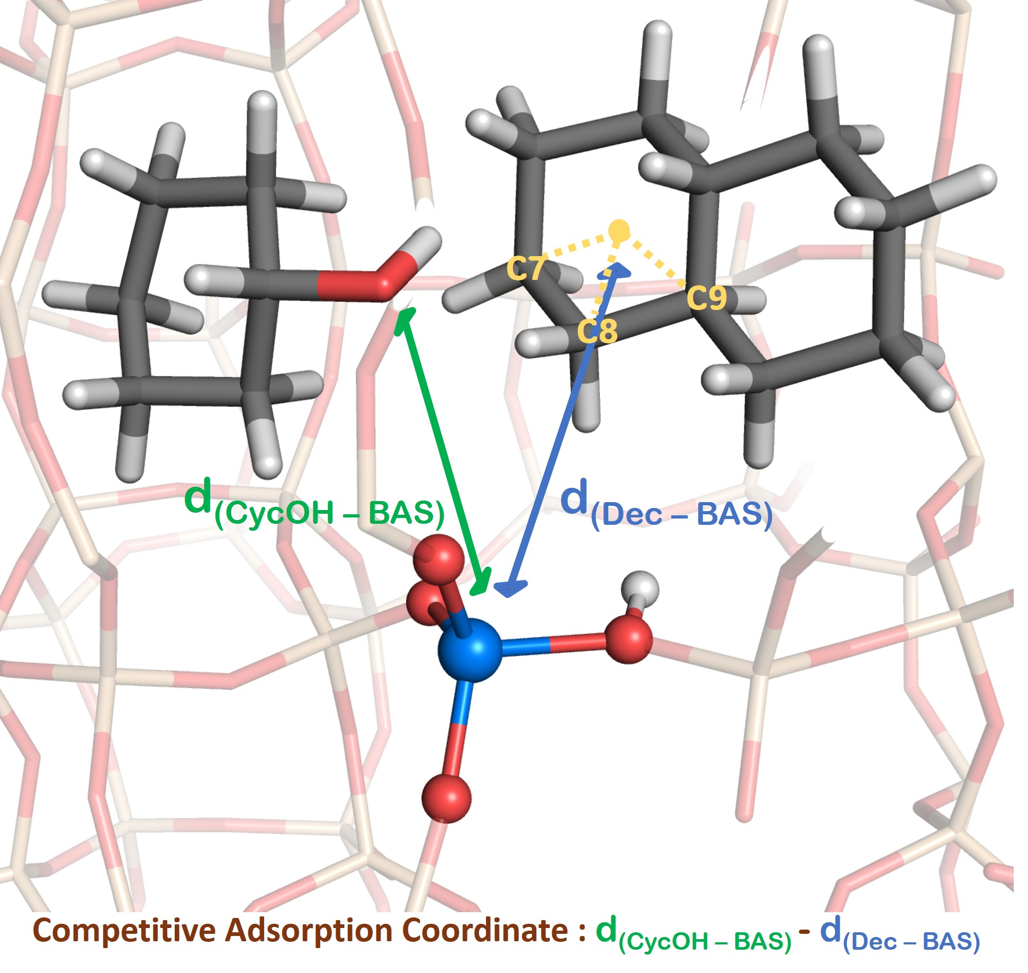
Figure S7. Definition of the competitive adsorption coordinate (CAC) used in the well-tempered metadynamics simulations.
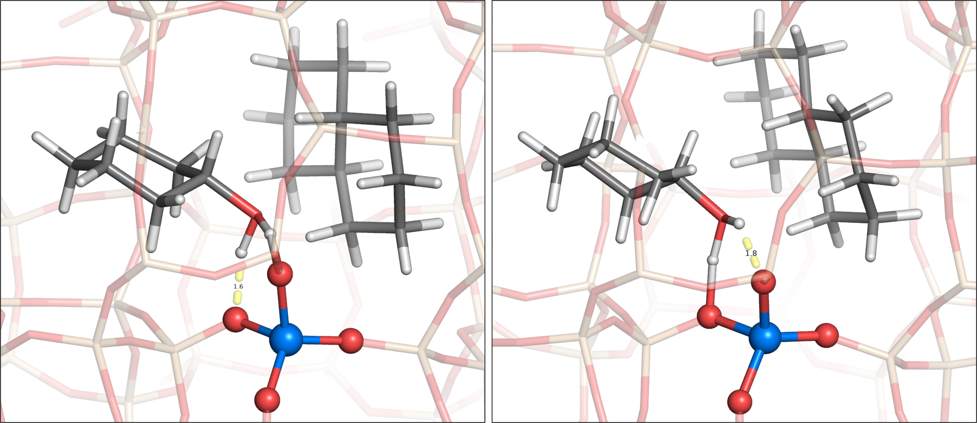
Figure S8. Snapshots from WTMetaD simulations in H-MFI at 300 K illustrating the cyclohexanol-mediated proton transfer at the BAS. Cyclohexanol forms a concerted bridge-like structure, where the hydroxyl group stabilizes the framework proton through a dynamic hydrogen-bonding network. This configuration facilitates the shifting of proton between BAS oxygens without permanent protonation of the cyclohexanol monomer.

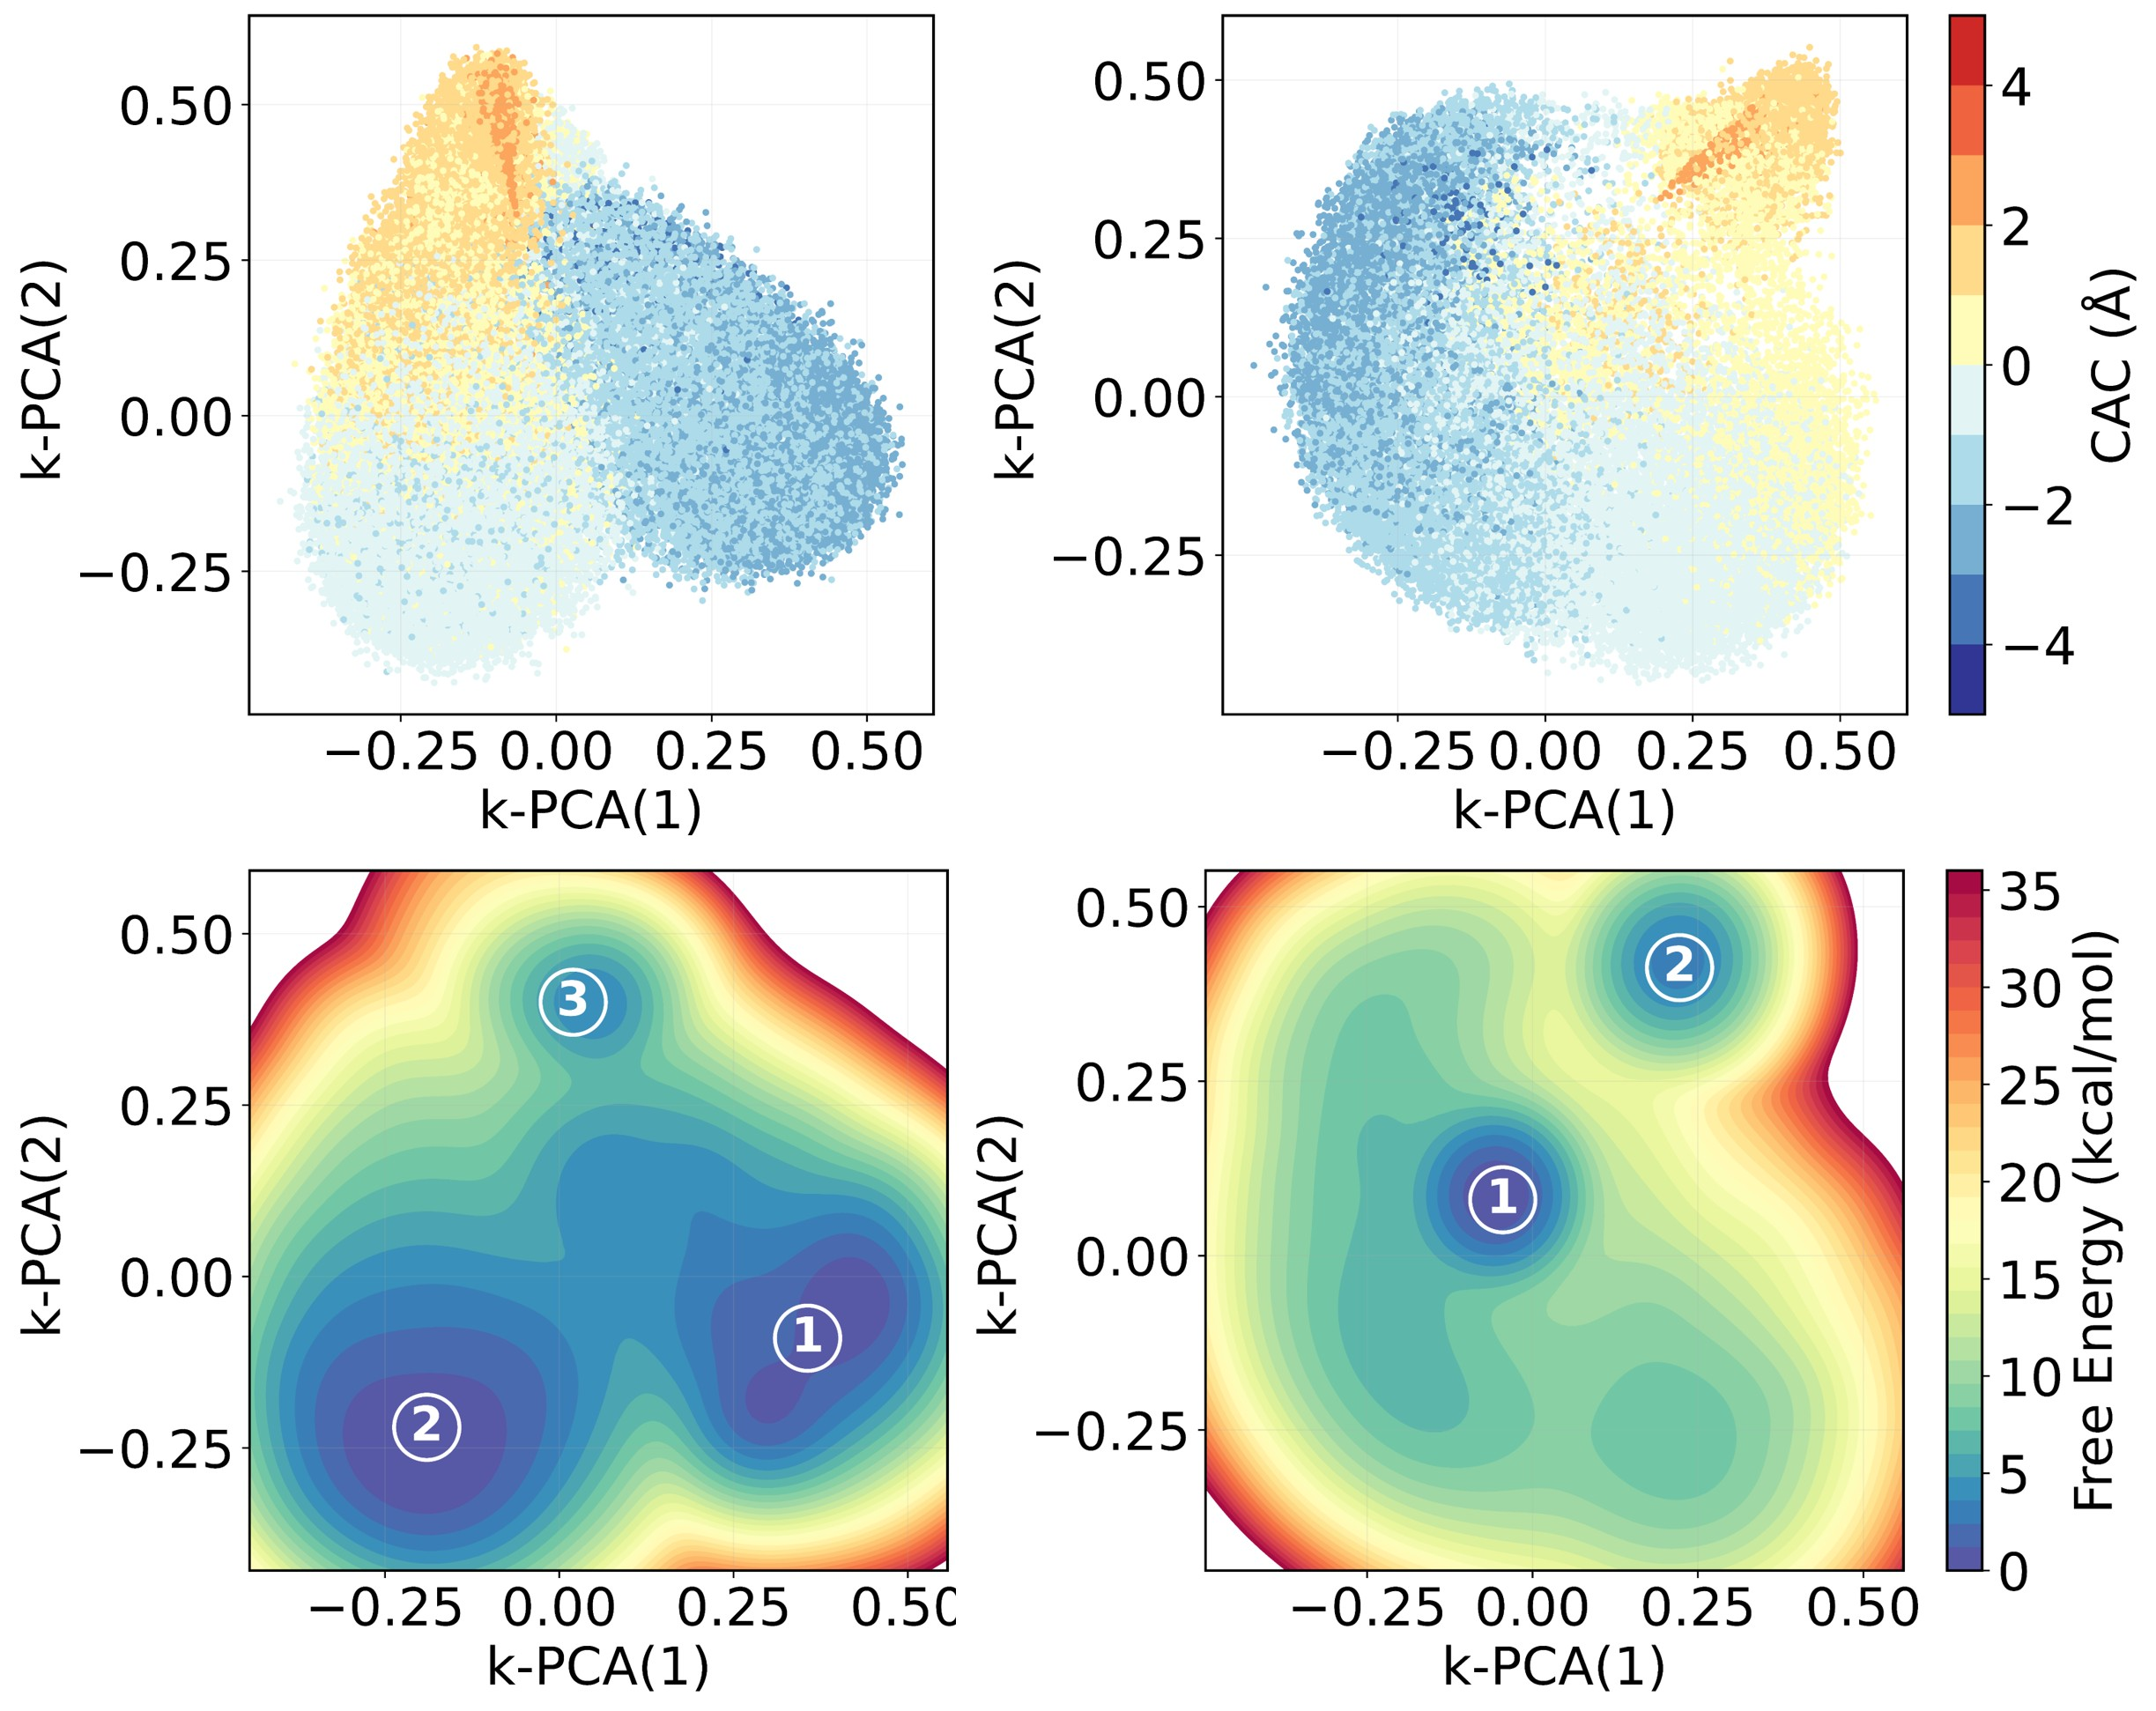
Figure S9. Projection of the two principal components from kPCA analysis along the competitive adsorption coordinate (CAC) for tracking competitive adsorption between cyclohexanol and decalin in MFI.
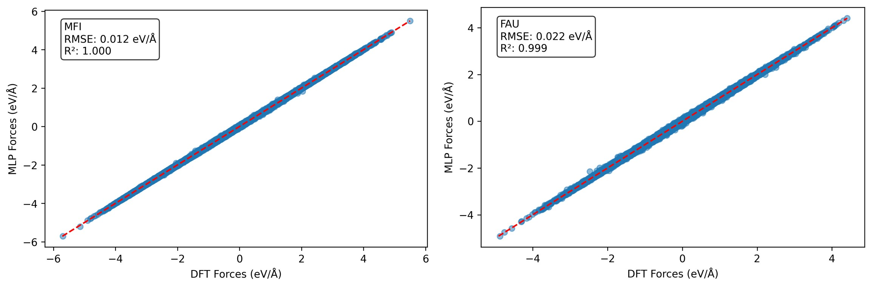
Figure S10. Correlation between forces predicted by MLP and DFT reference force components. Configurations for testing were collected from the MLP-WMetaD trajectories of both cis- and trans-decalin with cyclohexanol in MFI and FAU
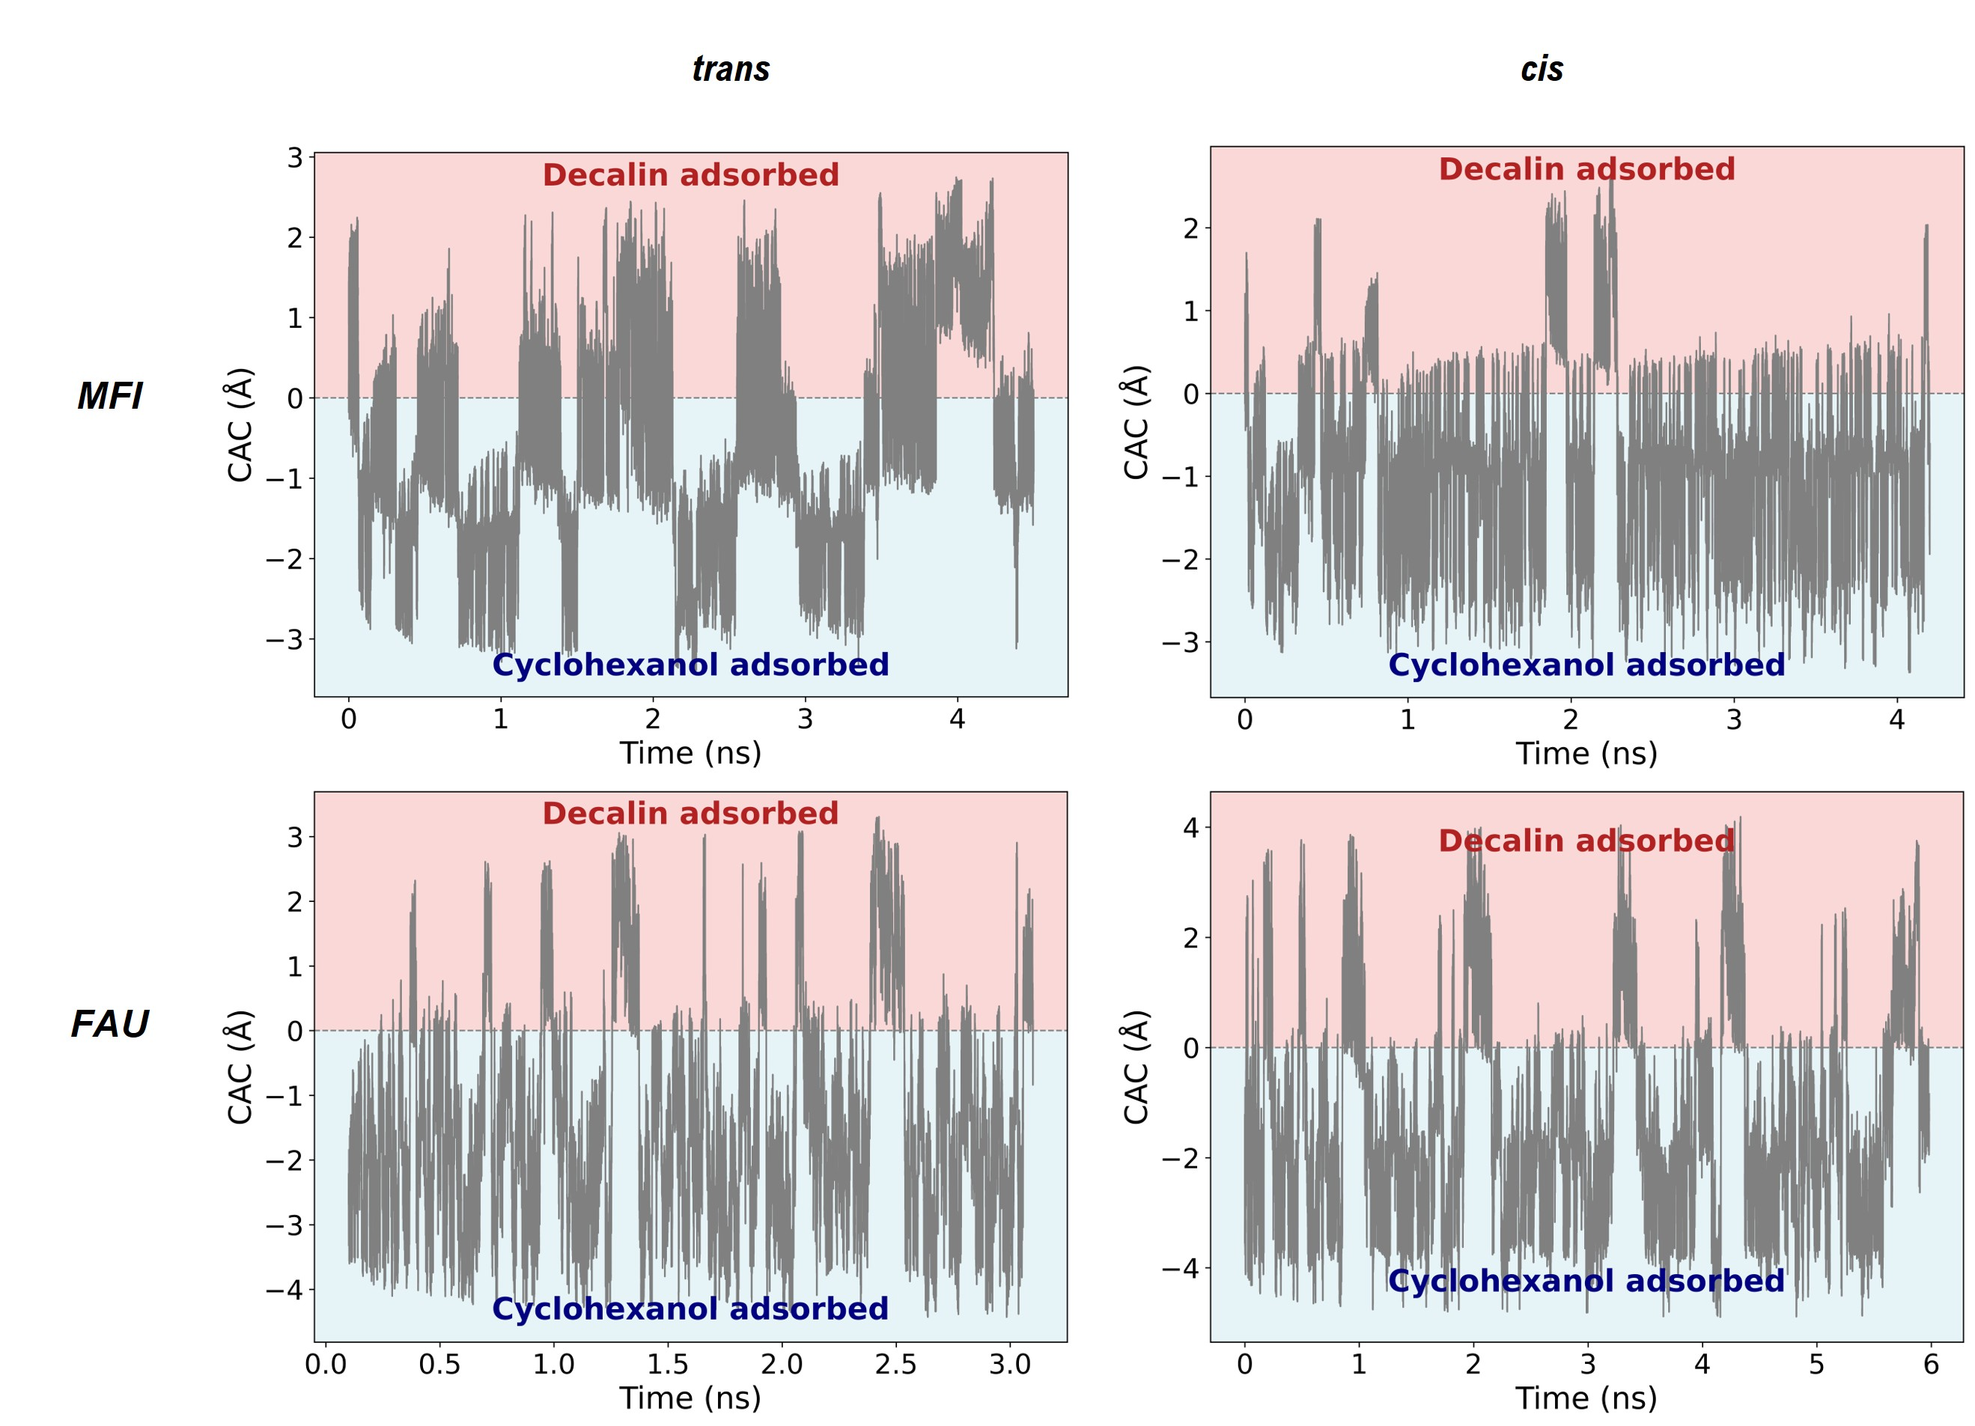
Figure S11. Evolution of the competitive adsorption coordinate (CAC) along time showing exploration of competitive adsorption of cis-(or trans-decalin) and cyclohexanol in MFI and FAU.
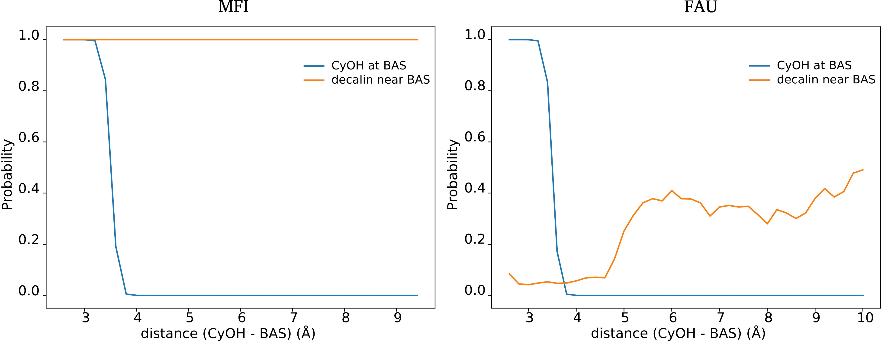
Figure S12. Probability of cyclohexanol and decalin proximity to the BAS as a function of cyclohexanol-BAS distance in MFI and FAU under decalin filled conditions. Cyclohexanol is BAS-bound when its oxygen lies with 3.5 A of BAS center, and decalin proximity is defined by decalin carbon within 4 A of BAS. In MFI, cyclohexanol displacement is strongly coupled to decalin occupation of the BAS vicinity, whereas in FAU cyclohexanol desorption results in configurations without distinct replacement state.

References:
1 J. Abraham, R., A. Warne, M. & Griffiths, L. Proton chemical shifts in NMR spectroscopy. Part 7.1 C–C anisotropy and the methyl effect. J. Chem. Soc., Perkin Trans. 2, 31-40, doi:10.1039/A604567G (1997).
2 Curtis, J., Grant, D. M. & Pugmire, R. J. Distortion in Six-Membered Saturated Rings by Natural Abundance Deuterium NMR. J Am Chem Soc 111, 7711-7716 (1989).
3 Piccini, G., Alessio, M. & Sauer, J. Ab initio study of methanol and ethanol adsorption on Brønsted sites in zeolite H-MFI. Physical Chemistry Chemical Physics 20, 19964-19970, doi:10.1039/C8CP03632B (2018).

