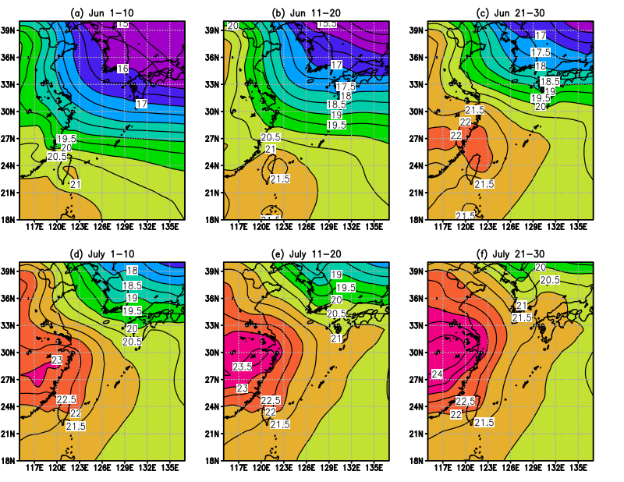
Fig. S1 Climatology (1989-2018) of temperature ($℃$) at 900 hPa during (a) 1-10 June, (b) 11-20 June, (c) 21-30 June, (d) 1-10 July, (e) 11-20 July, and (f) 21-30 July.
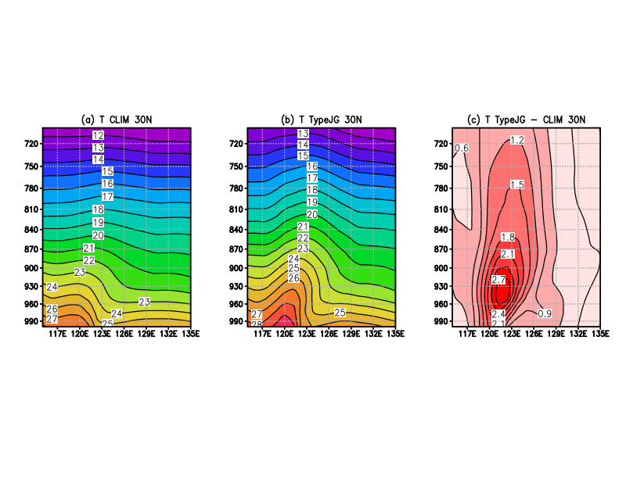

Fig. S2. Longitude-height (hPa) section of temperature $\left(°C\right)$ along $30°N$. (a) Average during 21 June-20 July for 1989-2018 and (b) average of the Type-JG cases during the same period. (c) Difference between the values in (a) and (b). The criterion used to select the cases is described in the text.

