Additional file 2. Supplementary methods, tables, and figures
Does cross-wave validation overestimate screening performance? An ID-isolated evaluation of model complexity for possible sarcopenia in CHARLS
Yu Yue and Chunhua Zhang
Corresponding author: Chunhua Zhang, zch20080808@126.com
Public repository: https://github.com/yuyue611013/charls-possible-sarcopenia-screening
Fixed public release: https://github.com/yuyue611013/charls-possible-sarcopenia-screening/releases/tag/v1.0.0

Contents
Supplementary methods
Tables S1A-S1C. Case-mix and analytic-population comparisons
Tables S2A-S2B. Predictor dictionary and outcome/leakage variables
Table S3. Variable-level missingness
Tables S4-S16. Primary model, threshold, sensitivity, calibration, and robustness analyses
Table S17. Anthropometry quality-control sensitivity analysis
Supportive post hoc participant-overlap analysis: Tables S18-S21 and Figure S7
Figures S1-S7. Supplementary figures
Supplementary methods

Cohort construction and ID isolation
Wave 1 was used for model development and Wave 3 for cross-wave evaluation. The ID-isolated evaluation cohort removed Wave 1 participant IDs from Wave 3. Analyses are unweighted.

Outcome definitions
The primary available-component possible sarcopenia label used sex-specific handgrip thresholds or five-chair-stand time ≥12 seconds. The strict-label sensitivity analysis retained any observed positive component but required both handgrip and chair-stand components to be observed and negative for a negative label.

Predictors and leakage prevention
A-core predictors comprised lower-missingness demographic, socioeconomic, lifestyle, and chronic-disease variables. B predictors comprised height, weight, body mass index, and waist circumference. The parsimonious Logistic A-only model used A-core predictors, whereas the anthropometry-augmented XGBoost A+B model used both domains. C variables were retained for contextual analyses. Outcome components were excluded from all predictor sets.

Model specification and evaluation
The parsimonious Logistic A-only and anthropometry-augmented XGBoost A+B models used the fixed specifications described in the main manuscript. The primary Wave 3 evaluation excluded all Wave 1 participant IDs. Original pooled Wave 3 results and participant-overlap subgroup comparisons are supportive analyses rather than independent external validation.

Anthropometry QC
BMI is presented using median [IQR] where unfiltered extreme values make ordinary mean/SD-based SMDs hard to interpret. The anthropometry QC sensitivity analysis is supplementary and does not alter the primary model results.

Supplementary tables
Table S1A. Wave 1 label-eligible source cohort versus ID-isolated Wave 3 label-eligible source cohort
Characteristic | Category | Development | Evaluation | SMD
Age, years |  | 68.11 (6.68) | 63.92 (5.38) | 0.691
Height, m |  | 1.56 (0.10) | 1.58 (0.10) | -0.129
Weight, kg |  | 56.25 (11.74) | 59.47 (11.40) | -0.279
BMI, kg/m^2 |  | 22.49 [20.18, 25.16] | 23.43 [21.30, 25.96] | Not interpreted due to extreme unfiltered values
Waist circumference, cm |  | 84.40 (12.69) | 85.57 (13.32) | -0.090
Sex | Female | 3009 (49.8%) | 1630 (51.0%) | -0.025
Sex | Male | 3036 (50.2%) | 1563 (49.0%) | 0.025
Residence | Urban | 2196 (36.3%) | 1349 (42.2%) | -0.121
Residence | Rural | 3849 (63.7%) | 1844 (57.8%) | 0.121
Hypertension | Yes | 1997 (33.0%) | 991 (31.0%) | 0.043
Diabetes | Yes | 459 (7.6%) | 303 (9.5%) | -0.068
Heart disease | Yes | 925 (15.3%) | 533 (16.7%) | -0.038
Stroke | Yes | 226 (3.7%) | 105 (3.3%) | 0.024
Arthritis | Yes | 2235 (37.0%) | 1233 (38.6%) | -0.034
Smoking | Current smoker | 1833 (30.3%) | 922 (28.9%) | 0.032
Drinking | Current drinker | 1818 (30.1%) | 1076 (33.7%) | -0.078
Possible sarcopenia | Event | 2878 (47.6%) | 943 (29.5%) | 0.378
Education | Less than primary school | 3600 (59.6%) | 1759 (55.1%) | 0.090
Education | Primary school | 1448 (24.0%) | 659 (20.6%) | 0.080
Education | Middle school | 656 (10.9%) | 492 (15.4%) | -0.135
Education | High school or above | 341 (5.6%) | 283 (8.9%) | -0.124
Marital status | Married | 4581 (75.8%) | 2642 (82.7%) | -0.172
Marital status | Married but living apart | 145 (2.4%) | 110 (3.4%) | -0.062
Marital status | Separated | 0 (0.0%) | 6 (0.2%) | -0.061
Marital status | Divorced | 43 (0.7%) | 10 (0.3%) | 0.056
Marital status | Widowed | 38 (0.6%) | 23 (0.7%) | -0.011
Marital status | Never married | 1184 (19.6%) | 373 (11.7%) | 0.219
Marital status | Other/unknown marital status | 54 (0.9%) | 29 (0.9%) | -0.002
Note. Unweighted. BMI is shown as median [IQR]; BMI SMD is not interpreted because unfiltered BMI contains extreme values. Numeric categories without verified reader-facing labels are omitted from this compact table and retained only in the full CSV.
Table S1B. Logistic A-only complete-case development and evaluation cohorts
Characteristic | Category | Development | Evaluation | SMD
Age, years |  | 68.06 (6.63) | 63.43 (5.03) | 0.787
Sex | Female | 2942 (49.9%) | 1254 (51.1%) | -0.025
Sex | Male | 2958 (50.1%) | 1199 (48.9%) | 0.025
Residence | Urban | 2156 (36.5%) | 977 (39.8%) | -0.068
Residence | Rural | 3744 (63.5%) | 1476 (60.2%) | 0.068
Hypertension | Yes | 1953 (33.1%) | 858 (35.0%) | -0.04
Diabetes | Yes | 454 (7.7%) | 268 (10.9%) | -0.111
Heart disease | Yes | 910 (15.4%) | 462 (18.8%) | -0.091
Stroke | Yes | 215 (3.6%) | 91 (3.7%) | -0.003
Arthritis | Yes | 2175 (36.9%) | 1087 (44.3%) | -0.152
Smoking | Current smoker | 1810 (30.7%) | 727 (29.6%) | 0.023
Drinking | Current drinker | 1777 (30.1%) | 841 (34.3%) | -0.089
Possible sarcopenia | Event | 2787 (47.2%) | 694 (28.3%) | 0.398
Education | Less than primary school | 3489 (59.1%) | 1358 (55.4%) | 0.076
Education | Primary school | 1425 (24.2%) | 502 (20.5%) | 0.089
Education | Middle school | 649 (11.0%) | 394 (16.1%) | -0.148
Education | High school or above | 337 (5.7%) | 199 (8.1%) | -0.095
Marital status | Married | 4484 (76.0%) | 2041 (83.2%) | -0.18
Marital status | Married but living apart | 142 (2.4%) | 92 (3.8%) | -0.078
Marital status | Separated | 0 (0.0%) | 4 (0.2%) | -0.057
Marital status | Divorced | 42 (0.7%) | 4 (0.2%) | 0.083
Marital status | Widowed | 37 (0.6%) | 21 (0.9%) | -0.027
Marital status | Never married | 1145 (19.4%) | 266 (10.8%) | 0.241
Marital status | Other/unknown marital status | 50 (0.8%) | 25 (1.0%) | -0.018
Note. Unweighted. Category labels use verified project labels.
Table S1C. XGBoost A+B complete-case development and evaluation cohorts
Characteristic | Category | Development | Evaluation | SMD
Age, years |  | 67.97 (6.57) | 63.40 (5.00) | 0.782
Height, m |  | 1.56 (0.10) | 1.58 (0.10) | -0.138
Weight, kg |  | 56.32 (11.73) | 59.63 (11.58) | -0.284
BMI, kg/m^2 |  | 22.51 [20.20, 25.19] | 23.41 [21.27, 25.99] | Not interpreted due to extreme unfiltered values
Waist circumference, cm |  | 84.41 (12.68) | 85.53 (13.22) | -0.086
Sex | Female | 2883 (49.9%) | 1246 (51.3%) | -0.028
Sex | Male | 2898 (50.1%) | 1184 (48.7%) | 0.028
Residence | Urban | 2117 (36.6%) | 969 (39.9%) | -0.067
Residence | Rural | 3664 (63.4%) | 1461 (60.1%) | 0.067
Hypertension | Yes | 1900 (32.9%) | 848 (34.9%) | -0.043
Diabetes | Yes | 438 (7.6%) | 263 (10.8%) | -0.113
Heart disease | Yes | 889 (15.4%) | 455 (18.7%) | -0.089
Stroke | Yes | 201 (3.5%) | 86 (3.5%) | -0.003
Arthritis | Yes | 2120 (36.7%) | 1078 (44.4%) | -0.157
Smoking | Current smoker | 1781 (30.8%) | 721 (29.7%) | 0.025
Drinking | Current drinker | 1757 (30.4%) | 835 (34.4%) | -0.085
Possible sarcopenia | Event | 2704 (46.8%) | 683 (28.1%) | 0.393
Education | Less than primary school | 3413 (59.0%) | 1348 (55.5%) | 0.072
Education | Primary school | 1396 (24.1%) | 497 (20.5%) | 0.089
Education | Middle school | 642 (11.1%) | 387 (15.9%) | -0.141
Education | High school or above | 330 (5.7%) | 198 (8.1%) | -0.096
Marital status | Married | 4398 (76.1%) | 2022 (83.2%) | -0.178
Marital status | Married but living apart | 139 (2.4%) | 92 (3.8%) | -0.080
Marital status | Separated | 0 (0.0%) | 4 (0.2%) | -0.057
Marital status | Divorced | 42 (0.7%) | 4 (0.2%) | 0.084
Marital status | Widowed | 36 (0.6%) | 21 (0.9%) | -0.028
Marital status | Never married | 1118 (19.3%) | 263 (10.8%) | 0.240
Marital status | Other/unknown marital status | 48 (0.8%) | 24 (1.0%) | -0.017
Note. Unweighted. BMI is shown as median [IQR]; BMI SMD is not interpreted because unfiltered BMI contains extreme values.
Table S2A. Predictor dictionary for actual model variables
Display name | Source variable | Domain | Variable type | Unit | Model inclusion | Coding
Age | age (年龄) | A-core | continuous | years | Logistic A-only; XGBoost A+B | Continuous; median-imputed and standardised in model pipeline.
Sex | ragender (性别) | A-core | categorical/binary | Not applicable | Logistic A-only; XGBoost A+B | Categorical; 0=Female and 1=Male; one-hot encoded with unknown categories ignored.
Residence | hrural (居住在农村或城市) | A-core | categorical/binary | Not applicable | Logistic A-only; XGBoost A+B | Categorical; 0=Urban and 1=Rural; one-hot encoded with unknown categories ignored.
Marital status | marry (婚姻) | A-core | categorical | Not applicable | Logistic A-only; XGBoost A+B | Categorical; observed codes: 1, 2, 3, 4, 5, 7, 8; one-hot encoded with unknown categories ignored.
Education | raeduc_c (教育) | A-core | categorical | Not applicable | Logistic A-only; XGBoost A+B | Categorical; observed codes: 1, 2, 3, 4; one-hot encoded with unknown categories ignored.
Hukou | hukou (户口4分类) | A-core | categorical | Not applicable | Logistic A-only; XGBoost A+B | Categorical; observed codes: 1, 2, 3, 4; one-hot encoded with unknown categories ignored.
Hypertension | hibpe (高血压) | A-core | categorical/binary | Not applicable | Logistic A-only; XGBoost A+B | Categorical; 0=No and 1=Yes; one-hot encoded with unknown categories ignored.
Diabetes | diabe (糖尿病) | A-core | categorical/binary | Not applicable | Logistic A-only; XGBoost A+B | Categorical; 0=No and 1=Yes; one-hot encoded with unknown categories ignored.
Heart disease | hearte (心脏病) | A-core | categorical/binary | Not applicable | Logistic A-only; XGBoost A+B | Categorical; 0=No and 1=Yes; one-hot encoded with unknown categories ignored.
Stroke | stroke (中风) | A-core | categorical/binary | Not applicable | Logistic A-only; XGBoost A+B | Categorical; 0=No and 1=Yes; one-hot encoded with unknown categories ignored.
Arthritis | arthre (关节炎) | A-core | categorical/binary | Not applicable | Logistic A-only; XGBoost A+B | Categorical; 0=No and 1=Yes; one-hot encoded with unknown categories ignored.
Current drinking | drinkl (现在是否饮酒) | A-core | categorical/binary | Not applicable | Logistic A-only; XGBoost A+B | Categorical; 0=No and 1=Yes; one-hot encoded with unknown categories ignored.
Current smoking | smoken (现在是否吸烟) | A-core | categorical/binary | Not applicable | Logistic A-only; XGBoost A+B | Categorical; 0=No and 1=Yes; one-hot encoded with unknown categories ignored.
Height | mheight (身高/m) | B anthropometric/body-size | continuous | m | XGBoost A+B | Continuous; median-imputed and standardised in model pipeline.
Weight | mweight (体重/kg) | B anthropometric/body-size | continuous | kg | XGBoost A+B | Continuous; median-imputed and standardised in model pipeline.
Body mass index | bmi (BMI) | B anthropometric/body-size | continuous | kg/m^2 | XGBoost A+B | Continuous; median-imputed and standardised in model pipeline.
Waist circumference | mwaist (腰围/cm) | B anthropometric/body-size | continuous | cm | XGBoost A+B | Continuous; median-imputed and standardised in model pipeline.
Vigorous physical activity | vgact_c (重度身体活动) | C physical-activity/biomarker | categorical/binary | Not applicable | Contextual matrix only, not in main models | Categorical; observed codes: 0, 1; one-hot encoded with unknown categories ignored.
Moderate physical activity | mdact_c (中度身体活动) | C physical-activity/biomarker | categorical/binary | Not applicable | Contextual matrix only, not in main models | Categorical; observed codes: 0, 1; one-hot encoded with unknown categories ignored.
Light physical activity | ltact_c (轻度身体活动) | C physical-activity/biomarker | categorical/binary | Not applicable | Contextual matrix only, not in main models | Categorical; observed codes: 0, 1; one-hot encoded with unknown categories ignored.
Glucose | bl_glu (Glucose (mg/dl)血糖) | C physical-activity/biomarker | continuous | mg/dL | Contextual matrix only, not in main models | Continuous; median-imputed and standardised in model pipeline.
HbA1c | bl_hbalc (Glycated Hemoglobin糖化血红蛋白 (%)) | C physical-activity/biomarker | continuous | % | Contextual matrix only, not in main models | Continuous; median-imputed and standardised in model pipeline.
C-reactive protein | bl_crp (C-Reactive Protein (CRP) C反应蛋白(mg/l)) | C physical-activity/biomarker | continuous | mg/L | Contextual matrix only, not in main models | Continuous; median-imputed and standardised in model pipeline.
Creatinine | bl_crea (Creatinine (mg/dl)肌酐) | C physical-activity/biomarker | continuous | mg/dL | Contextual matrix only, not in main models | Continuous; median-imputed and standardised in model pipeline.
Blood urea nitrogen | bl_bun (Blood Urea Nitrogen (BUN) (mg/dl)尿素氮) | C physical-activity/biomarker | continuous | mg/dL | Contextual matrix only, not in main models | Continuous; median-imputed and standardised in model pipeline.
Uric acid | bl_ua (Uric Acid尿酸(mg/dl)) | C physical-activity/biomarker | continuous | mg/dL | Contextual matrix only, not in main models | Continuous; median-imputed and standardised in model pipeline.
Hemoglobin | bl_hgb (Hemoglobin血红蛋白 (g/dl)) | C physical-activity/biomarker | continuous | g/dL | Contextual matrix only, not in main models | Continuous; median-imputed and standardised in model pipeline.
Cystatin C | bl_cysc (Cystatin C胱抑素C(mg/l)) | C physical-activity/biomarker | continuous | mg/L | Contextual matrix only, not in main models | Continuous; median-imputed and standardised in model pipeline.
Total cholesterol | bl_cho (Total Cholesterol (mg/dl)总胆固醇) | C physical-activity/biomarker | continuous | mg/dL | Contextual matrix only, not in main models | Continuous; median-imputed and standardised in model pipeline.
Triglycerides | bl_tg (Triglycerides甘油三酯 (mg/dl)) | C physical-activity/biomarker | continuous | mg/dL | Contextual matrix only, not in main models | Continuous; median-imputed and standardised in model pipeline.
HDL cholesterol | bl_hdl (Hdl Cholesterol高密度脂蛋白胆固醇 (mg/dl)) | C physical-activity/biomarker | continuous | mg/dL | Contextual matrix only, not in main models | Continuous; median-imputed and standardised in model pipeline.
LDL cholesterol | bl_ldl (Ldl Cholesterol低密度脂蛋白胆固醇 (mg/dl)) | C physical-activity/biomarker | continuous | mg/dL | Contextual matrix only, not in main models | Continuous; median-imputed and standardised in model pipeline.
Note. Binary labels for sex, residence, chronic diseases, current smoking, and current drinking were verified from project value labels. For variables without verified reader-facing category meanings, observed codes are shown without assigning unverified labels.
Table S2B. Outcome components, leakage-excluded variables and deferred candidates
Display name | Source variable | Domain | Variable type | Unit | Model inclusion | Outcome/leakage status | Notes
Dominant-hand grip strength | gripsum (优势手的最大测量值) | Outcome component/leakage-excluded | continuous | kg | Outcome construction only; excluded from predictors | Excluded from predictors | No category meaning inferred beyond authoritative project sources.
Left-hand grip strength | lgrip (左手的最大握力测试) | Outcome component/leakage-excluded | continuous | kg | Outcome construction only; excluded from predictors | Excluded from predictors | No category meaning inferred beyond authoritative project sources.
Right-hand grip strength | rgrip (右手的最大握力测试) | Outcome component/leakage-excluded | continuous | kg | Outcome construction only; excluded from predictors | Excluded from predictors | No category meaning inferred beyond authoritative project sources.
Five-chair-stand time | chr5sec (5次站立的时间) | Outcome component/leakage-excluded | continuous | s | Outcome construction only; excluded from predictors | Excluded from predictors | No category meaning inferred beyond authoritative project sources.
Five-chair-stand completion | chr5comp (是否完成5次站立) | Outcome component/leakage-excluded | categorical/binary | Not applicable | Outcome construction only; excluded from predictors | Excluded from predictors | No category meaning inferred beyond authoritative project sources.
Number of chair stands completed | chr5num (完成站立的次数) | Outcome component/leakage-excluded | categorical/binary | Not applicable | Outcome construction only; excluded from predictors | Excluded from predictors | No category meaning inferred beyond authoritative project sources.
Walking speed | wspeed (步行速度测试-均值) | Outcome component/leakage-excluded | continuous | Not reported in the verified project dictionary | Not used in the primary outcome or highlighted models; retained as a deferred candidate | Excluded from predictors | No category meaning inferred beyond authoritative project sources.
Note. Outcome components were not used as model predictors.
Table S3. Variable-level missingness among label-eligible cohorts
Predictor | Domain | Wave 1 missing n | Wave 1 missing % | Original Wave 3 missing n | Original Wave 3 missing % | ID-isolated Wave 3 missing n | ID-isolated Wave 3 missing % | Main-model inclusion
age (年龄) | A-core predictor | 0 | 0.0 | 0 | 0.0 | 0 | 0.0 | Logistic A-only; XGBoost A+B
ragender (性别) | A-core predictor | 0 | 0.0 | 0 | 0.0 | 0 | 0.0 | Logistic A-only; XGBoost A+B
hrural (居住在农村或城市) | A-core predictor | 0 | 0.0 | 0 | 0.0 | 0 | 0.0 | Logistic A-only; XGBoost A+B
marry (婚姻) | A-core predictor | 0 | 0.0 | 2 | 0.024 | 0 | 0.0 | Logistic A-only; XGBoost A+B
raeduc_c (教育) | A-core predictor | 0 | 0.0 | 0 | 0.0 | 0 | 0.0 | Logistic A-only; XGBoost A+B
hukou (户口4分类) | A-core predictor | 0 | 0.0 | 631 | 7.699 | 329 | 10.304 | Logistic A-only; XGBoost A+B
hibpe (高血压) | A-core predictor | 27 | 0.447 | 562 | 6.857 | 447 | 13.999 | Logistic A-only; XGBoost A+B
diabe (糖尿病) | A-core predictor | 53 | 0.877 | 614 | 7.491 | 488 | 15.283 | Logistic A-only; XGBoost A+B
hearte (心脏病) | A-core predictor | 44 | 0.728 | 565 | 6.894 | 457 | 14.313 | Logistic A-only; XGBoost A+B
stroke (中风) | A-core predictor | 19 | 0.314 | 530 | 6.467 | 460 | 14.407 | Logistic A-only; XGBoost A+B
arthre (关节炎) | A-core predictor | 19 | 0.314 | 537 | 6.552 | 459 | 14.375 | Logistic A-only; XGBoost A+B
drinkl (现在是否饮酒) | A-core predictor | 7 | 0.116 | 14 | 0.171 | 7 | 0.219 | Logistic A-only; XGBoost A+B
smoken (现在是否吸烟) | A-core predictor | 48 | 0.794 | 13 | 0.159 | 6 | 0.188 | Logistic A-only; XGBoost A+B
mheight (身高/m) | B anthropometric/body-size predictor | 79 | 1.307 | 87 | 1.061 | 26 | 0.814 | XGBoost A+B
mweight (体重/kg) | B anthropometric/body-size predictor | 70 | 1.158 | 72 | 0.878 | 22 | 0.689 | XGBoost A+B
bmi (BMI) | B anthropometric/body-size predictor | 110 | 1.82 | 100 | 1.22 | 30 | 0.94 | XGBoost A+B
mwaist (腰围/cm) | B anthropometric/body-size predictor | 48 | 0.794 | 64 | 0.781 | 20 | 0.626 | XGBoost A+B
vgact_c (重度身体活动) | C physical-activity/biomarker predictor | 3530 | 58.395 | 4285 | 52.282 | 1667 | 52.208 | Not in main models; included in contextual matrix
mdact_c (中度身体活动) | C physical-activity/biomarker predictor | 3530 | 58.395 | 4287 | 52.306 | 1667 | 52.208 | Not in main models; included in contextual matrix
ltact_c (轻度身体活动) | C physical-activity/biomarker predictor | 3539 | 58.544 | 4285 | 52.282 | 1665 | 52.145 | Not in main models; included in contextual matrix
bl_glu (Glucose (mg/dl)血糖) | C physical-activity/biomarker predictor | 1624 | 26.865 | 1463 | 17.85 | 599 | 18.76 | Not in main models; included in contextual matrix
bl_hbalc (Glycated Hemoglobin糖化血红蛋白 (%)) | C physical-activity/biomarker predictor | 1594 | 26.369 | 1455 | 17.753 | 595 | 18.635 | Not in main models; included in contextual matrix
bl_crp (C-Reactive Protein (CRP) C反应蛋白(mg/l)) | C physical-activity/biomarker predictor | 1615 | 26.716 | 1478 | 18.033 | 606 | 18.979 | Not in main models; included in contextual matrix
bl_crea (Creatinine (mg/dl)肌酐) | C physical-activity/biomarker predictor | 1625 | 26.882 | 1478 | 18.033 | 607 | 19.01 | Not in main models; included in contextual matrix
bl_bun (Blood Urea Nitrogen (BUN) (mg/dl)尿素氮) | C physical-activity/biomarker predictor | 1616 | 26.733 | 1477 | 18.021 | 606 | 18.979 | Not in main models; included in contextual matrix
bl_ua (Uric Acid尿酸(mg/dl)) | C physical-activity/biomarker predictor | 1615 | 26.716 | 1463 | 17.85 | 599 | 18.76 | Not in main models; included in contextual matrix
bl_hgb (Hemoglobin血红蛋白 (g/dl)) | C physical-activity/biomarker predictor | 1645 | 27.213 | 1534 | 18.716 | 623 | 19.511 | Not in main models; included in contextual matrix
bl_cysc (Cystatin C胱抑素C(mg/l)) | C physical-activity/biomarker predictor | 2363 | 39.09 | 1481 | 18.07 | 607 | 19.01 | Not in main models; included in contextual matrix
bl_cho (Total Cholesterol (mg/dl)总胆固醇) | C physical-activity/biomarker predictor | 1619 | 26.782 | 1477 | 18.021 | 606 | 18.979 | Not in main models; included in contextual matrix
bl_tg (Triglycerides甘油三酯 (mg/dl)) | C physical-activity/biomarker predictor | 1619 | 26.782 | 1477 | 18.021 | 606 | 18.979 | Not in main models; included in contextual matrix
bl_hdl (Hdl Cholesterol高密度脂蛋白胆固醇 (mg/dl)) | C physical-activity/biomarker predictor | 1616 | 26.733 | 1477 | 18.021 | 606 | 18.979 | Not in main models; included in contextual matrix
bl_ldl (Ldl Cholesterol低密度脂蛋白胆固醇 (mg/dl)) | C physical-activity/biomarker predictor | 1622 | 26.832 | 1478 | 18.033 | 606 | 18.979 | Not in main models; included in contextual matrix
gripsum (优势手的最大测量值) | Outcome component (not predictor) | 86 | 1.423 | 99 | 1.208 | 33 | 1.034 | Outcome component / leakage-excluded
lgrip (左手的最大握力测试) | Outcome component (not predictor) | 88 | 1.456 | 110 | 1.342 | 39 | 1.221 | Outcome component / leakage-excluded
rgrip (右手的最大握力测试) | Outcome component (not predictor) | 94 | 1.555 | 112 | 1.367 | 41 | 1.284 | Outcome component / leakage-excluded
chr5sec (5次站立的时间) | Outcome component (not predictor) | 571 | 9.446 | 516 | 6.296 | 127 | 3.977 | Outcome component / leakage-excluded
chr5comp (是否完成5次站立) | Outcome component (not predictor) | 12 | 0.199 | 17 | 0.207 | 9 | 0.282 | Outcome component / leakage-excluded
chr5num (完成站立的次数) | Outcome component (not predictor) | 536 | 8.867 | 506 | 6.174 | 125 | 3.915 | Outcome component / leakage-excluded
Note. Aggregate counts and percentages only; outcome components are labelled separately from predictors.
Table S4. Original non-isolated eight-model matrix comparison
Model | Predictor set | Wave 1 development N | Wave 1 AUROC | Wave 1 AUPRC | Original non-isolated Wave 3 N | Wave 3 AUROC | Wave 3 AUPRC | Sensitivity | Specificity | F1
Logistic | A-only | 5900 | 0.6812 | 0.6436 | 6839 | 0.7052 | 0.6063 | 0.6075 | 0.6869 | 0.5802
Logistic | B-only | 5918 | 0.6017 | 0.5712 | 8080 | 0.6166 | 0.5189 | 0.4319 | 0.7228 | 0.4644
Logistic | C-only | 1487 | 0.6138 | 0.6264 | 3187 | 0.5995 | 0.4840 | 0.4134 | 0.7322 | 0.4469
Logistic | A+B+C | 1438 | 0.6753 | 0.6679 | 2658 | 0.6824 | 0.5675 | 0.5698 | 0.6735 | 0.5387
XGBoost | A-only | 5900 | 0.6768 | 0.6332 | 6839 | 0.6986 | 0.6013 | 0.6210 | 0.6619 | 0.5786
XGBoost | B-only | 5918 | 0.6117 | 0.5663 | 8080 | 0.6242 | 0.5199 | 0.4518 | 0.7222 | 0.4803
XGBoost | C-only | 1487 | 0.6206 | 0.6161 | 3187 | 0.5614 | 0.4366 | 0.4101 | 0.6825 | 0.4255
XGBoost | A+B+C | 1438 | 0.6569 | 0.6406 | 2658 | 0.6522 | 0.5368 | 0.4945 | 0.6963 | 0.4940
Note. Contextual analysis only: original Wave 3 evaluation retained participant overlap and is not the primary ID-isolated evaluation. Development sample sizes are aligned to the compact source and do not report a separate XGBoost-only N for the contextual matrix. Wave 1 discrimination values in this contextual matrix are the original cross-validation summary estimates; Table S10 reports pooled out-of-fold estimates for the two highlighted models.
Table S5. Regularised Logistic A-only transformed-feature coefficients
Transformed feature | Coefficient | Absolute coefficient | Odds ratio | Domain | Original variable
categorical__hukou (户口4分类)_4.0 | 0.7874 | 0.7874 | 2.1976 | A-core | hukou (户口4分类)
categorical__raeduc_c (教育)_4.0 | -0.6861 | 0.6861 | 0.5035 | A-core | raeduc_c (教育)
categorical__hukou (户口4分类)_3.0 | -0.5343 | 0.5343 | 0.5861 | A-core | hukou (户口4分类)
continuous__age (年龄) | 0.5091 | 0.5091 | 1.6638 | A-core | age (年龄)
categorical__raeduc_c (教育)_1.0 | 0.4983 | 0.4983 | 1.6460 | A-core | raeduc_c (教育)
categorical__marry (婚姻)_8.0 | 0.3819 | 0.3819 | 1.4651 | A-core | marry (婚姻)
categorical__stroke (中风)_1.0 | 0.2299 | 0.2299 | 1.2584 | A-core | stroke (中风)
categorical__stroke (中风)_0.0 | -0.2175 | 0.2175 | 0.8046 | A-core | stroke (中风)
categorical__raeduc_c (教育)_2.0 | 0.2104 | 0.2104 | 1.2341 | A-core | raeduc_c (教育)
categorical__hukou (户口4分类)_2.0 | -0.1886 | 0.1886 | 0.8282 | A-core | hukou (户口4分类)
categorical__marry (婚姻)_2.0 | -0.1552 | 0.1552 | 0.8563 | A-core | marry (婚姻)
categorical__marry (婚姻)_1.0 | -0.1418 | 0.1418 | 0.8678 | A-core | marry (婚姻)
Note. Top coefficients shown for readability; full aggregate coefficient CSV remains available. Predictive associations are not causal effects.
Table S6. XGBoost A+B gain-based transformed-feature importance
Rank | Transformed feature | Normalized importance | Domain | Original variable
1 | categorical__raeduc_c (教育)_1.0 | 0.0922 | A-core | raeduc_c (教育)
2 | continuous__age (年龄) | 0.0799 | A-core | age (年龄)
3 | categorical__ragender (性别)_0.0 | 0.0668 | A-core | ragender (性别)
4 | categorical__raeduc_c (教育)_4.0 | 0.0607 | A-core | raeduc_c (教育)
5 | categorical__drinkl (现在是否饮酒)_1.0 | 0.0533 | A-core | drinkl (现在是否饮酒)
6 | categorical__drinkl (现在是否饮酒)_0.0 | 0.0342 | A-core | drinkl (现在是否饮酒)
7 | categorical__stroke (中风)_0.0 | 0.0331 | A-core | stroke (中风)
8 | categorical__hearte (心脏病)_0.0 | 0.0293 | A-core | hearte (心脏病)
9 | categorical__marry (婚姻)_7.0 | 0.0282 | A-core | marry (婚姻)
10 | categorical__hukou (户口4分类)_2.0 | 0.0276 | A-core | hukou (户口4分类)
11 | categorical__hukou (户口4分类)_1.0 | 0.0273 | A-core | hukou (户口4分类)
12 | categorical__ragender (性别)_1.0 | 0.0261 | A-core | ragender (性别)
13 | continuous__mweight (体重/kg) | 0.0252 | B-anthropometric/body-size | mweight (体重/kg)
14 | categorical__raeduc_c (教育)_2.0 | 0.0252 | A-core | raeduc_c (教育)
15 | categorical__hibpe (高血压)_0.0 | 0.0244 | A-core | hibpe (高血压)
Note. Top features shown for readability; full aggregate importance CSV remains available. Importance is predictive, not causal.
Table S7. XGBoost A+B domain-level gain importance summary
Domain | No. transformed features | Total importance | Percentage of total | Interpretation
A-core | 33 | 0.9078 | 90.8 | grouped transformed-feature importance from saved XGBoost A+B model; predictive contribution only
B-anthropometric/body-size | 4 | 0.0922 | 9.2 | grouped transformed-feature importance from saved XGBoost A+B model; predictive contribution only
Note. A-core versus B anthropometric/body-size grouping.
Table S8. Decision-curve net benefit at representative thresholds
Model | Threshold | N | Prevalence | Net benefit | True positives | False positives | Treat-all net benefit | Treat-none net benefit
Logistic A-only | 0.0500 | 2430 | 0.2810 | 0.2432 | 683 | 1747 | 0.2432 | 0.0000
XGBoost A+B | 0.0500 | 2430 | 0.2810 | 0.2432 | 683 | 1747 | 0.2432 | 0.0000
Logistic A-only | 0.1000 | 2430 | 0.2810 | 0.2017 | 683 | 1736 | 0.2012 | 0.0000
XGBoost A+B | 0.1000 | 2430 | 0.2810 | 0.2007 | 680 | 1730 | 0.2012 | 0.0000
Logistic A-only | 0.1500 | 2430 | 0.2810 | 0.1578 | 676 | 1658 | 0.1542 | 0.0000
XGBoost A+B | 0.1500 | 2430 | 0.2810 | 0.1573 | 677 | 1670 | 0.1542 | 0.0000
Logistic A-only | 0.2000 | 2430 | 0.2810 | 0.1127 | 664 | 1561 | 0.1013 | 0.0000
XGBoost A+B | 0.2000 | 2430 | 0.2810 | 0.1090 | 652 | 1549 | 0.1013 | 0.0000
Logistic A-only | 0.2500 | 2430 | 0.2810 | 0.0735 | 645 | 1399 | 0.0414 | 0.0000
XGBoost A+B | 0.2500 | 2430 | 0.2810 | 0.0701 | 635 | 1394 | 0.0414 | 0.0000
Logistic A-only | 0.3000 | 2430 | 0.2810 | 0.0342 | 591 | 1185 | -0.0270 | 0.0000
XGBoost A+B | 0.3000 | 2430 | 0.2810 | 0.0313 | 569 | 1150 | -0.0270 | 0.0000
Logistic A-only | 0.3500 | 2430 | 0.2810 | 0.0073 | 518 | 929 | -0.1060 | 0.0000
XGBoost A+B | 0.3500 | 2430 | 0.2810 | 0.0113 | 497 | 872 | -0.1060 | 0.0000
Logistic A-only | 0.4000 | 2430 | 0.2810 | -0.0030 | 416 | 635 | -0.1982 | 0.0000
XGBoost A+B | 0.4000 | 2430 | 0.2810 | -0.0052 | 382 | 592 | -0.1982 | 0.0000
Logistic A-only | 0.4500 | 2430 | 0.2810 | -0.0017 | 283 | 351 | -0.3071 | 0.0000
XGBoost A+B | 0.4500 | 2430 | 0.2810 | -0.0079 | 286 | 373 | -0.3071 | 0.0000
Logistic A-only | 0.5000 | 2430 | 0.2810 | 0.0115 | 196 | 168 | -0.4379 | 0.0000
XGBoost A+B | 0.5000 | 2430 | 0.2810 | -0.0041 | 225 | 235 | -0.4379 | 0.0000
Note. Main Figure 4 displays thresholds 0.05–0.50; complete 0.05–0.80 values are in the aggregate CSV. Values are calculated on the common ID-isolated evaluation subset.
Table S9. Threshold sensitivity and screening-oriented cut-off analysis
Model | Threshold type | Threshold | Sensitivity | Specificity | Accuracy | False positives | False negatives | PPV | NPV | N | Events
Logistic A-only | Default threshold | 0.5000 | 0.2911 | 0.9039 | 0.7305 | 169 | 492 | 0.5445 | 0.7637 | 2453 | 694
Logistic A-only | Sensitivity target ≥0.70 | 0.3800 | 0.7003 | 0.5623 | 0.6013 | 770 | 208 | 0.3869 | 0.8262 | 2453 | 694
Logistic A-only | Sensitivity target ≥0.75 | 0.3500 | 0.7608 | 0.4690 | 0.5516 | 934 | 166 | 0.3611 | 0.8325 | 2453 | 694
Logistic A-only | Sensitivity target ≥0.80 | 0.3200 | 0.8098 | 0.3798 | 0.5014 | 1091 | 132 | 0.3400 | 0.8350 | 2453 | 694
XGBoost A+B | Default threshold | 0.5000 | 0.3294 | 0.8655 | 0.7148 | 235 | 458 | 0.4891 | 0.7675 | 2430 | 683
XGBoost A+B | Sensitivity target ≥0.70 | 0.3500 | 0.7277 | 0.5009 | 0.5646 | 872 | 186 | 0.3630 | 0.8247 | 2430 | 683
XGBoost A+B | Sensitivity target ≥0.75 | 0.3400 | 0.7540 | 0.4659 | 0.5469 | 933 | 168 | 0.3557 | 0.8289 | 2430 | 683
XGBoost A+B | Sensitivity target ≥0.80 | 0.3200 | 0.8082 | 0.4064 | 0.5193 | 1037 | 131 | 0.3474 | 0.8442 | 2430 | 683
Logistic A-only | Recommended screening threshold | 0.3500 | 0.7608 | 0.4690 | 0.5516 | 934 | 166 | 0.3611 | 0.8325 | 2453 | 694
XGBoost A+B | Recommended screening threshold | 0.3400 | 0.7540 | 0.4659 | 0.5469 | 933 | 168 | 0.3557 | 0.8289 | 2430 | 683
Note. Default threshold 0.50 and sensitivity-oriented thresholds 0.35/0.34 are exploratory; target thresholds use sensitivity ≥0.75 with highest specificity.
Table S10. Wave 1 pooled out-of-fold model performance
Model | N | AUROC (95% CI) | AUPRC (95% CI) | Accuracy (95% CI) | Sensitivity (95% CI) | Specificity (95% CI) | F1 score (95% CI)
Logistic A-only | 5900 | 0.6809 (0.6669–0.6953) | 0.6418 (0.6215–0.6628) | 0.6371 (0.6244–0.6497) | 0.5422 (0.5228–0.5605) | 0.7221 (0.7063–0.7378) | 0.5853 (0.5689–0.6015)
XGBoost A+B | 5781 | 0.6750 (0.6610–0.6891) | 0.6276 (0.6072–0.6484) | 0.6267 (0.6144–0.6393) | 0.5385 (0.5197–0.5575) | 0.7043 (0.6876–0.7206) | 0.5744 (0.5583–0.5898)
Note. Internal development estimates from pooled out-of-fold predictions where available.
Table S11. Strict-label flow and eligibility
Wave | Age eligible | Primary-label eligible | Strict-label eligible | Strict positives | Confirmed negatives | Uncertain partial negatives | Both components missing | Strict prevalence
Wave 1 | 7560 | 6045 | 5732 | 2878 | 2854 | 313 | 1515 | 0.5021
Wave 3 | 10131 | 8196 | 7918 | 3242 | 4676 | 278 | 1935 | 0.4094
Note. Strict-label analysis excluded uncertain partial negatives.

Table S12. Strict-label model performance
Dataset | Model | N | Events | Prevalence | AUROC (95% CI) | AUPRC (95% CI) | Brier score (95% CI) | Accuracy (95% CI) | Sensitivity (95% CI) | Specificity (95% CI) | F1 (95% CI) | Calibration intercept (95% CI) | Calibration slope (95% CI)
Wave 1 development OOF | Logistic A-only | 5597 | 2787 | 0.498 | 0.7007 (0.6872–0.7145) | 0.6985 (0.6790–0.7181) | 0.2191 (0.2149–0.2231) | 0.6475 (0.6346–0.6600) | 0.6093 (0.5909–0.6269) | 0.6854 (0.6677–0.7028) | 0.6325 (0.6172–0.6469) | -0.0004 (−0.0579 to 0.0572) | 0.9753 (0.9012–1.0570)
Wave 1 development OOF | XGBoost A+B | 5498 | 2704 | 0.492 | 0.6944 (0.6808–0.7074) | 0.6870 (0.6675–0.7050) | 0.2213 (0.2172–0.2258) | 0.6419 (0.6293–0.6539) | 0.5921 (0.5746–0.6115) | 0.6901 (0.6731–0.7066) | 0.6192 (0.6037–0.6345) | -0.0086 (−0.0666 to 0.0462) | 0.8514 (0.7818–0.9211)
ID-isolated Wave 3 evaluation | Logistic A-only | 2391 | 694 | 0.29 | 0.6822 (0.6595–0.7054) | 0.4901 (0.4523–0.5278) | 0.1985 (0.1925–0.2044) | 0.7093 (0.6913–0.7273) | 0.3732 (0.3359–0.4100) | 0.8468 (0.8311–0.8644) | 0.4270 (0.3916–0.4604) | -0.5377 (−0.6402 to −0.4324) | 1.0148 (0.8859–1.1649)
ID-isolated Wave 3 evaluation | XGBoost A+B | 2373 | 683 | 0.288 | 0.6704 (0.6467–0.6943) | 0.4751 (0.4381–0.5148) | 0.2014 (0.1955–0.2073) | 0.6957 (0.6780–0.7139) | 0.3660 (0.3308–0.4022) | 0.8290 (0.8107–0.8473) | 0.4092 (0.3749–0.4425) | -0.5956 (−0.7004 to −0.4943) | 0.9060 (0.7724–1.0526)
Note. Bootstrap confidence intervals used 2,000 requested participant-level replicates, seed 20260613, with fixed predictions and no bootstrap model refitting.
Table S13. Primary versus strict-label comparison
Dataset | Model | Metric | Primary value | Strict-label value | Strict minus primary
Wave 1 development OOF | Logistic A-only | N | 5900 | 5597 | -303
Wave 1 development OOF | Logistic A-only | Events | 2787 | 2787 | 0
Wave 1 development OOF | Logistic A-only | Prevalence | 0.4724 | 0.4979 | 0.0256
Wave 1 development OOF | Logistic A-only | AUROC | 0.6809 | 0.7007 | 0.0197
Wave 1 development OOF | Logistic A-only | AUPRC | 0.6418 | 0.6985 | 0.0567
Wave 1 development OOF | Logistic A-only | Brier score | 0.2248 | 0.2191 | -0.0057
Wave 1 development OOF | Logistic A-only | Accuracy | 0.6371 | 0.6475 | 0.0104
Wave 1 development OOF | Logistic A-only | Sensitivity | 0.5422 | 0.6093 | 0.0671
Wave 1 development OOF | Logistic A-only | Specificity | 0.7221 | 0.6854 | -0.0367
Wave 1 development OOF | Logistic A-only | F1 | 0.5853 | 0.6325 | 0.0472
Wave 1 development OOF | Logistic A-only | Calibration intercept | -0.0040 | -0.0004 | 0.0037
Wave 1 development OOF | Logistic A-only | Calibration slope | 0.9644 | 0.9753 | 0.0110
Wave 1 development OOF | XGBoost A+B | N | 5781 | 5498 | -283
Wave 1 development OOF | XGBoost A+B | Events | 2704 | 2704 | 0
Wave 1 development OOF | XGBoost A+B | Prevalence | 0.4677 | 0.4918 | 0.0241
Wave 1 development OOF | XGBoost A+B | AUROC | 0.6750 | 0.6944 | 0.0194
Wave 1 development OOF | XGBoost A+B | AUPRC | 0.6276 | 0.6870 | 0.0594
Wave 1 development OOF | XGBoost A+B | Brier score | 0.2268 | 0.2213 | -0.0055
Wave 1 development OOF | XGBoost A+B | Accuracy | 0.6267 | 0.6419 | 0.0152
Wave 1 development OOF | XGBoost A+B | Sensitivity | 0.5385 | 0.5921 | 0.0536
Wave 1 development OOF | XGBoost A+B | Specificity | 0.7043 | 0.6901 | -0.0142
Wave 1 development OOF | XGBoost A+B | F1 | 0.5744 | 0.6192 | 0.0449
Wave 1 development OOF | XGBoost A+B | Calibration intercept | -0.0227 | -0.0086 | 0.0141
Wave 1 development OOF | XGBoost A+B | Calibration slope | 0.8161 | 0.8514 | 0.0352
ID-isolated Wave 3 evaluation | Logistic A-only | N | 2453 | 2391 | -62
ID-isolated Wave 3 evaluation | Logistic A-only | Events | 694 | 694 | 0
ID-isolated Wave 3 evaluation | Logistic A-only | Prevalence | 0.2829 | 0.2903 | 0.0073
ID-isolated Wave 3 evaluation | Logistic A-only | AUROC | 0.6798 | 0.6822 | 0.0024
ID-isolated Wave 3 evaluation | Logistic A-only | AUPRC | 0.4759 | 0.4901 | 0.0142
ID-isolated Wave 3 evaluation | Logistic A-only | Brier score | 0.1943 | 0.1985 | 0.0042
ID-isolated Wave 3 evaluation | Logistic A-only | Accuracy | 0.7305 | 0.7093 | -0.0212
ID-isolated Wave 3 evaluation | Logistic A-only | Sensitivity | 0.2911 | 0.3732 | 0.0821
ID-isolated Wave 3 evaluation | Logistic A-only | Specificity | 0.9039 | 0.8468 | -0.0571
ID-isolated Wave 3 evaluation | Logistic A-only | F1 | 0.3793 | 0.4270 | 0.0477
ID-isolated Wave 3 evaluation | Logistic A-only | Calibration intercept | -0.4338 | -0.5377 | -0.1039
ID-isolated Wave 3 evaluation | Logistic A-only | Calibration slope | 1.1500 | 1.0148 | -0.1352
ID-isolated Wave 3 evaluation | XGBoost A+B | N | 2430 | 2373 | -57
ID-isolated Wave 3 evaluation | XGBoost A+B | Events | 683 | 683 | 0
ID-isolated Wave 3 evaluation | XGBoost A+B | Prevalence | 0.2811 | 0.2878 | 0.0068
ID-isolated Wave 3 evaluation | XGBoost A+B | AUROC | 0.6656 | 0.6704 | 0.0049
ID-isolated Wave 3 evaluation | XGBoost A+B | AUPRC | 0.4604 | 0.4751 | 0.0147
ID-isolated Wave 3 evaluation | XGBoost A+B | Brier score | 0.1971 | 0.2014 | 0.0042
ID-isolated Wave 3 evaluation | XGBoost A+B | Accuracy | 0.7148 | 0.6957 | -0.0191
ID-isolated Wave 3 evaluation | XGBoost A+B | Sensitivity | 0.3294 | 0.3660 | 0.0366
ID-isolated Wave 3 evaluation | XGBoost A+B | Specificity | 0.8655 | 0.8290 | -0.0365
ID-isolated Wave 3 evaluation | XGBoost A+B | F1 | 0.3937 | 0.4092 | 0.0155
ID-isolated Wave 3 evaluation | XGBoost A+B | Calibration intercept | -0.5251 | -0.5956 | -0.0705
ID-isolated Wave 3 evaluation | XGBoost A+B | Calibration slope | 0.9563 | 0.9060 | -0.0503
Note. Counts are rounded to integers; estimates are rounded to 4 decimal places. Strict minus primary compares the strict-label sensitivity analysis with the primary available-component label.

Table S14. Paired model differences on the primary common subset
Dataset | Common N | Metric | Estimate (95% CI)
Primary ID-isolated Wave 3 common subset | 2430 | AUROC advantage | 0.0116 (−0.0028 to 0.0263)
Primary ID-isolated Wave 3 common subset | 2430 | AUPRC advantage | 0.0087 (−0.0105 to 0.0282)
Primary ID-isolated Wave 3 common subset | 2430 | Brier-score advantage | 0.0027 (−0.0001 to 0.0053)
Primary ID-isolated Wave 3 common subset | 2430 | Sensitivity difference | -0.0425 (−0.0671 to −0.0189)
Primary ID-isolated Wave 3 common subset | 2430 | Specificity difference | 0.0384 (0.0240–0.0519)
Primary ID-isolated Wave 3 common subset | 2430 | F1 difference | -0.0193 (−0.0457 to 0.0062)
Note. Positive values favour Logistic A-only. Brier-score advantage is defined as XGBoost Brier score minus Logistic Brier score. Bootstrap confidence intervals used 2,000 requested paired participant-level replicates, seed 20260613.
Table S15. Calibration uncertainty
Label definition | Dataset | Model | N | Prevalence | Brier score (95% CI) | Calibration intercept (95% CI) | Calibration slope (95% CI) | Calibration-in-the-large | ECE
Primary available-component label | Wave 1 development OOF | Logistic A-only | 5900 | 0.472 | 0.2248 (0.2209–0.2287) | -0.0040 (−0.0574 to 0.0519) | 0.9644 (0.8768–1.0569) | 0.0001 | 0.0136
Primary available-component label | Wave 1 development OOF | XGBoost A+B | 5781 | 0.468 | 0.2268 (0.2225–0.2311) | -0.0227 (−0.0768 to 0.0333) | 0.8161 (0.7439–0.8931) | 0.0001 | 0.0259
Primary available-component label | ID-isolated Wave 3 evaluation | Logistic A-only | 2453 | 0.283 | 0.1943 (0.1884–0.2000) | -0.4338 (−0.5363 to −0.3280) | 1.1500 (0.9889–1.3216) | -0.1001 | 0.1001
Primary available-component label | ID-isolated Wave 3 evaluation | XGBoost A+B | 2430 | 0.281 | 0.1971 (0.1913–0.2031) | -0.5251 (−0.6277 to −0.4179) | 0.9563 (0.8126–1.1131) | -0.1024 | 0.1024
Strict-label sensitivity | Wave 1 development OOF | Logistic A-only | 5597 | 0.498 | 0.2191 (0.2149–0.2231) | -0.0004 (−0.0579 to 0.0572) | 0.9753 (0.9012–1.0570) | 0.0 | 0.013
Strict-label sensitivity | Wave 1 development OOF | XGBoost A+B | 5498 | 0.492 | 0.2213 (0.2172–0.2258) | -0.0086 (−0.0666 to 0.0462) | 0.8514 (0.7818–0.9211) | -0.0001 | 0.0291
Strict-label sensitivity | ID-isolated Wave 3 evaluation | Logistic A-only | 2391 | 0.29 | 0.1985 (0.1925–0.2044) | -0.5377 (−0.6402 to −0.4324) | 1.0148 (0.8859–1.1649) | -0.1098 | 0.1098
Strict-label sensitivity | ID-isolated Wave 3 evaluation | XGBoost A+B | 2373 | 0.288 | 0.2014 (0.1955–0.2073) | -0.5956 (−0.7004 to −0.4943) | 0.9060 (0.7724–1.0526) | -0.1147 | 0.1147
Note. Calibration-in-the-large is observed prevalence minus mean predicted probability. ECE uses 10 equal-frequency bins. Bootstrap confidence intervals used fixed predictions.

Table S16. Subgroup robustness
Subgroup domain | Category | Model | N | Events | AUROC (95% CI) | AUPRC (95% CI) | Brier score
Sex | Men | Logistic A-only | 1184 | 290 | 0.6836 (0.6478–0.7190) | 0.4448 (0.3925–0.5065) | 0.1744
Sex | Men | XGBoost A+B | 1184 | 290 | 0.6652 (0.6270–0.7019) | 0.4289 (0.3761–0.4858) | 0.1778
Sex | Women | Logistic A-only | 1246 | 393 | 0.6586 (0.6251–0.6913) | 0.4853 (0.4361–0.5384) | 0.2136
Sex | Women | XGBoost A+B | 1246 | 393 | 0.6484 (0.6151–0.6807) | 0.4815 (0.4321–0.5347) | 0.2155
Age | 60-69 years | Logistic A-only | 2176 | 545 | 0.6388 (0.6133–0.6642) | 0.3526 (0.3190–0.3920) | 0.1908
Age | 60-69 years | XGBoost A+B | 2176 | 545 | 0.6287 (0.6033–0.6545) | 0.3593 (0.3247–0.4005) | 0.1932
Age | 70-79 years | Logistic A-only | 201 | 101 | 0.6457 (0.5712–0.7205) | 0.6205 (0.5241–0.7298) | 0.2364
Age | 70-79 years | XGBoost A+B | 201 | 101 | 0.6189 (0.5394–0.6964) | 0.5855 (0.4966–0.6975) | 0.2422
Age | ≥80 years | Logistic A-only | 53 | 37 | 0.7027 (0.5386–0.8531) | 0.8416 (0.7158–0.9451) | 0.1848
Age | ≥80 years | XGBoost A+B | 53 | 37 | 0.7348 (0.5825–0.8731) | 0.8755 (0.7698–0.9542) | 0.186
Residence | Rural | Logistic A-only | 1461 | 449 | 0.6482 (0.6165–0.6790) | 0.4715 (0.4262–0.5178) | 0.2074
Residence | Rural | XGBoost A+B | 1461 | 449 | 0.6400 (0.6088–0.6702) | 0.4630 (0.4185–0.5096) | 0.2088
Residence | Urban | Logistic A-only | 969 | 234 | 0.7083 (0.6691–0.7459) | 0.4655 (0.4050–0.5342) | 0.175
Residence | Urban | XGBoost A+B | 969 | 234 | 0.6906 (0.6491–0.7293) | 0.4529 (0.3890–0.5208) | 0.1796
Education | High school or above | Logistic A-only | 198 | 24 | 0.6705 (0.5406–0.7931) | 0.3281 (0.1681–0.5281) | 0.1016
Education | High school or above | XGBoost A+B | 198 | 24 | 0.6334 (0.5098–0.7444) | 0.1848 (0.1130–0.3278) | 0.11
Education | Less than primary school | Logistic A-only | 1348 | 455 | 0.6493 (0.6178–0.6810) | 0.5106 (0.4633–0.5595) | 0.2202
Education | Less than primary school | XGBoost A+B | 1348 | 455 | 0.6306 (0.5971–0.6631) | 0.5064 (0.4575–0.5546) | 0.2221
Education | Middle school | Logistic A-only | 387 | 68 | 0.6498 (0.5769–0.7200) | 0.3444 (0.2487–0.4458) | 0.1461
Education | Middle school | XGBoost A+B | 387 | 68 | 0.6372 (0.5622–0.7157) | 0.3379 (0.2423–0.4538) | 0.1503
Education | Primary school | Logistic A-only | 497 | 136 | 0.6056 (0.5473–0.6603) | 0.3813 (0.3108–0.4638) | 0.1995
Education | Primary school | XGBoost A+B | 497 | 136 | 0.6146 (0.5576–0.6706) | 0.3804 (0.3121–0.4674) | 0.2006
Note. Fixed primary predictions were used; no subgroup-specific refitting was performed. Results are descriptive only and are not formal interaction or fairness tests.
Table S17. Anthropometry quality-control sensitivity analysis
Dataset | Analysis | N | Events | AUROC | AUPRC | Brier | Accuracy | Sensitivity | Specificity | Calibration intercept | Calibration slope |  | ΔN | ΔAUROC | ΔAUPRC
Wave 1 OOF development | Sensitivity A | 5680 | 2651 | 0.6774 | 0.6239 | 0.2262 | 0.6317 | 0.5375 | 0.7141 | -0.0190 | 0.8252 | -101 |  | 0.0020 | -0.0075
ID-isolated Wave 3 evaluation | Sensitivity A | 2378 | 667 | 0.6675 | 0.4598 | 0.1968 | 0.7157 | 0.3253 | 0.8679 | -0.5292 | 0.9611 | -52 |  | 0.0019 | -0.0006
Note. Sensitivity A excludes rows with flagged anthropometry. Delta columns compare against the corresponding primary XGBoost A+B analysis.

Supportive post hoc participant-overlap analysis

Rationale and fixed-model methods
This supportive post hoc analysis was conducted to clarify whether the descriptive difference between original pooled and participant-isolated evaluation could be interpreted as overlap-specific. Wave 3 model-specific complete-case samples were divided into mutually exclusive overlap-only and unseen-only groups according to whether an ID appeared in Wave 1. The saved Logistic A-only and XGBoost A+B models were applied without retraining, refitting, or retuning. Delta was defined as overlap-only minus unseen-only. Delta AUROC was the primary supportive comparison; AUPRC, Brier score, calibration, and threshold metrics were secondary. Confidence intervals used 5,000 independent participant-level bootstrap replicates within groups with random seed 20260615. Because overlap status was not randomized and the groups differed in age, prevalence, and clinical composition, the analysis is associational and does not estimate the isolated causal effect of participant overlap.

Table S18. Supportive participant-overlap subgroup performance
Model | Group | N | Events | Prev. | AUROC  (95% CI) | AUPRC  (95% CI) | Brier  (95% CI) | Cal.  intercept | Cal.  slope | Acc. | Sens. | Spec. | F1
Logistic A-only | Overlap-only | 4386 | 1984 | 0.452 | 0.686 (0.670–0.702) | 0.638 (0.616–0.663) | 0.229 (0.225–0.233) | -0.394 | 1.062 | 0.614 | 0.718 | 0.528 | 0.627
Logistic A-only | Unseen-only | 2453 | 694 | 0.283 | 0.680 (0.657–0.703) | 0.476 (0.440–0.515) | 0.194 (0.189–0.200) | -0.434 | 1.150 | 0.731 | 0.291 | 0.904 | 0.379
XGBoost A+B | Overlap-only | 4316 | 1937 | 0.449 | 0.692 (0.676–0.708) | 0.642 (0.618–0.666) | 0.226 (0.221–0.230) | -0.330 | 0.934 | 0.637 | 0.703 | 0.583 | 0.635
XGBoost A+B | Unseen-only | 2430 | 683 | 0.281 | 0.666 (0.641–0.689) | 0.460 (0.422–0.499) | 0.197 (0.191–0.203) | -0.525 | 0.956 | 0.715 | 0.329 | 0.865 | 0.394
Note. Models were fixed and not retrained. Confidence intervals for AUROC, AUPRC, and Brier score used 5,000 participant-level bootstrap replicates within each subgroup. AUPRC is prevalence-dependent; Brier score is lower-is-better. Prev., prevalence; Cal., calibration; Acc., accuracy; Sens., sensitivity; Spec., specificity.

Table S19. Supportive overlap-minus-unseen performance differences
Model | Metric | Overlap estimate | Unseen estimate | Delta | 95% CI | Valid replicates
Logistic A-only | AUROC | 0.686 | 0.680 | 0.006 | -0.023 to 0.035 | 5000
Logistic A-only | AUPRC | 0.638 | 0.476 | 0.162 | 0.117 to 0.207 | 5000
Logistic A-only | Brier score | 0.229 | 0.194 | 0.035 | 0.028 to 0.042 | 5000
Logistic A-only | Calibration intercept | -0.394 | -0.434 | 0.040 | -0.094 to 0.175 | 5000
Logistic A-only | Calibration slope | 1.062 | 1.150 | -0.088 | -0.293 to 0.106 | 5000
Logistic A-only | Accuracy at 0.50 | 0.614 | 0.731 | -0.117 | -0.139 to -0.094 | 5000
Logistic A-only | Sensitivity at 0.50 | 0.718 | 0.291 | 0.427 | 0.387 to 0.466 | 5000
Logistic A-only | Specificity at 0.50 | 0.528 | 0.904 | -0.376 | -0.400 to -0.352 | 5000
Logistic A-only | F1 at 0.50 | 0.627 | 0.379 | 0.248 | 0.208 to 0.288 | 5000
XGBoost A+B | AUROC | 0.692 | 0.666 | 0.027 | -0.002 to 0.056 | 5000
XGBoost A+B | AUPRC | 0.642 | 0.460 | 0.182 | 0.136 to 0.226 | 5000
XGBoost A+B | Brier score | 0.226 | 0.197 | 0.029 | 0.021 to 0.036 | 5000
XGBoost A+B | Calibration intercept | -0.330 | -0.525 | 0.195 | 0.071 to 0.319 | 5000
XGBoost A+B | Calibration slope | 0.934 | 0.956 | -0.023 | -0.197 to 0.144 | 5000
XGBoost A+B | Accuracy at 0.50 | 0.637 | 0.715 | -0.078 | -0.100 to -0.054 | 5000
XGBoost A+B | Sensitivity at 0.50 | 0.703 | 0.329 | 0.374 | 0.333 to 0.414 | 5000
XGBoost A+B | Specificity at 0.50 | 0.583 | 0.865 | -0.282 | -0.308 to -0.256 | 5000
XGBoost A+B | F1 at 0.50 | 0.635 | 0.394 | 0.241 | 0.201 to 0.281 | 5000
Note. Delta equals overlap-only minus unseen-only. The AUROC-difference confidence intervals included zero for both models. Positive Brier-score deltas indicate worse Brier performance in overlap-only participants because lower Brier score is better.

Table S20. Case-mix comparison for participant-overlap groups
Model | Variable | Summary type/category | Overlap-only | Unseen-only | SMD / robust difference | Note
Logistic A-only | Age | mean (SD) | 71.20 (6.02) | 63.43 (5.03) | 1.402 | Primary descriptive row.
Logistic A-only | Sex: Male | Male | 2209 (50.4%) | 1199 (48.9%) | 0.030 | Category label used only because coding was confirmed.
Logistic A-only | Residence: Rural | Rural | 2880 (65.7%) | 1476 (60.2%) | 0.114 | Category label used only because coding was confirmed.
Logistic A-only | Hypertension: Yes | Yes | 1859 (42.4%) | 858 (35.0%) | 0.153 | Category label used only because coding was confirmed.
Logistic A-only | Diabetes: Yes | Yes | 489 (11.1%) | 268 (10.9%) | 0.007 | Category label used only because coding was confirmed.
Logistic A-only | Heart disease: Yes | Yes | 989 (22.5%) | 462 (18.8%) | 0.092 | Category label used only because coding was confirmed.
Logistic A-only | Stroke: Yes | Yes | 233 (5.3%) | 91 (3.7%) | 0.077 | Category label used only because coding was confirmed.
Logistic A-only | Arthritis: Yes | Yes | 2163 (49.3%) | 1087 (44.3%) | 0.100 | Category label used only because coding was confirmed.
Logistic A-only | Current smoking: Yes | Yes | 1197 (27.3%) | 727 (29.6%) | -0.052 | Category label used only because coding was confirmed.
Logistic A-only | Current drinking: Yes | Yes | 1386 (31.6%) | 841 (34.3%) | -0.057 | Category label used only because coding was confirmed.
Logistic A-only | Outcome prevalence: possible sarcopenia | event=value 1 | 1984 (45.2%) | 694 (28.3%) | 0.357 | Outcome prevalence; not a covariate adjustment.
XGBoost A+B | Age | mean (SD) | 71.13 (5.98) | 63.40 (5.00) | 1.403 | Primary descriptive row.
XGBoost A+B | Sex: Male | Male | 2178 (50.5%) | 1184 (48.7%) | 0.035 | Category label used only because coding was confirmed.
XGBoost A+B | Residence: Rural | Rural | 2831 (65.6%) | 1461 (60.1%) | 0.113 | Category label used only because coding was confirmed.
XGBoost A+B | Hypertension: Yes | Yes | 1815 (42.1%) | 848 (34.9%) | 0.147 | Category label used only because coding was confirmed.
XGBoost A+B | Diabetes: Yes | Yes | 482 (11.2%) | 263 (10.8%) | 0.011 | Category label used only because coding was confirmed.
XGBoost A+B | Heart disease: Yes | Yes | 978 (22.7%) | 455 (18.7%) | 0.097 | Category label used only because coding was confirmed.
XGBoost A+B | Stroke: Yes | Yes | 218 (5.1%) | 86 (3.5%) | 0.075 | Category label used only because coding was confirmed.
XGBoost A+B | Arthritis: Yes | Yes | 2130 (49.4%) | 1078 (44.4%) | 0.100 | Category label used only because coding was confirmed.
XGBoost A+B | Current smoking: Yes | Yes | 1187 (27.5%) | 721 (29.7%) | -0.048 | Category label used only because coding was confirmed.
XGBoost A+B | Current drinking: Yes | Yes | 1366 (31.6%) | 835 (34.4%) | -0.058 | Category label used only because coding was confirmed.
XGBoost A+B | Outcome prevalence: possible sarcopenia | event=value 1 | 1937 (44.9%) | 683 (28.1%) | 0.354 | Outcome prevalence; not a covariate adjustment.
XGBoost A+B | BMI, kg/m2 | median [IQR], unfiltered model sample | 22.82 [20.32, 25.43] | 23.41 [21.27, 25.99] | -0.164 | Primary BMI row for manuscript-facing case-mix reporting; model performance unchanged.
XGBoost A+B | BMI, kg/m2 | median [IQR], QC-restricted 10-80 descriptive sensitivity only | 22.81 [20.31, 25.41] | 23.40 [21.25, 25.97] | -0.163 | Descriptive sensitivity row only; not used to recompute model performance.
Note. Binary-variable labels use confirmed project value labels: value 1 represents Male, Rural, or Yes for the listed condition/behaviour variables. BMI is summarized principally as unfiltered median [IQR] because extreme upper outliers inflated the raw SD. The BMI 10-80 range was an existing QC prompt and not an automatic exclusion rule; QC-restricted BMI rows are descriptive sensitivity summaries only and were not used to recompute model performance.

Table S21. Bootstrap diagnostics for the supportive overlap-minus-unseen analysis
Model | Metric | Attempted | Valid | Skipped/failed | Valid fraction | Seed
Logistic A-only | AUROC | 5000 | 5000 | 0 | 1.000 | 20260615
Logistic A-only | AUPRC | 5000 | 5000 | 0 | 1.000 | 20260615
Logistic A-only | Brier score | 5000 | 5000 | 0 | 1.000 | 20260615
Logistic A-only | Calibration intercept | 5000 | 5000 | 0 | 1.000 | 20260615
Logistic A-only | Calibration slope | 5000 | 5000 | 0 | 1.000 | 20260615
Logistic A-only | Accuracy at 0.50 | 5000 | 5000 | 0 | 1.000 | 20260615
Logistic A-only | Sensitivity at 0.50 | 5000 | 5000 | 0 | 1.000 | 20260615
Logistic A-only | Specificity at 0.50 | 5000 | 5000 | 0 | 1.000 | 20260615
Logistic A-only | F1 at 0.50 | 5000 | 5000 | 0 | 1.000 | 20260615
XGBoost A+B | AUROC | 5000 | 5000 | 0 | 1.000 | 20260615
XGBoost A+B | AUPRC | 5000 | 5000 | 0 | 1.000 | 20260615
XGBoost A+B | Brier score | 5000 | 5000 | 0 | 1.000 | 20260615
XGBoost A+B | Calibration intercept | 5000 | 5000 | 0 | 1.000 | 20260615
XGBoost A+B | Calibration slope | 5000 | 5000 | 0 | 1.000 | 20260615
XGBoost A+B | Accuracy at 0.50 | 5000 | 5000 | 0 | 1.000 | 20260615
XGBoost A+B | Sensitivity at 0.50 | 5000 | 5000 | 0 | 1.000 | 20260615
XGBoost A+B | Specificity at 0.50 | 5000 | 5000 | 0 | 1.000 | 20260615
XGBoost A+B | F1 at 0.50 | 5000 | 5000 | 0 | 1.000 | 20260615
Note. All requested bootstrap replicates were valid for all reported metrics, including calibration-difference metrics.

Supplementary figures

Figure S1. XGBoost gain-based feature importance
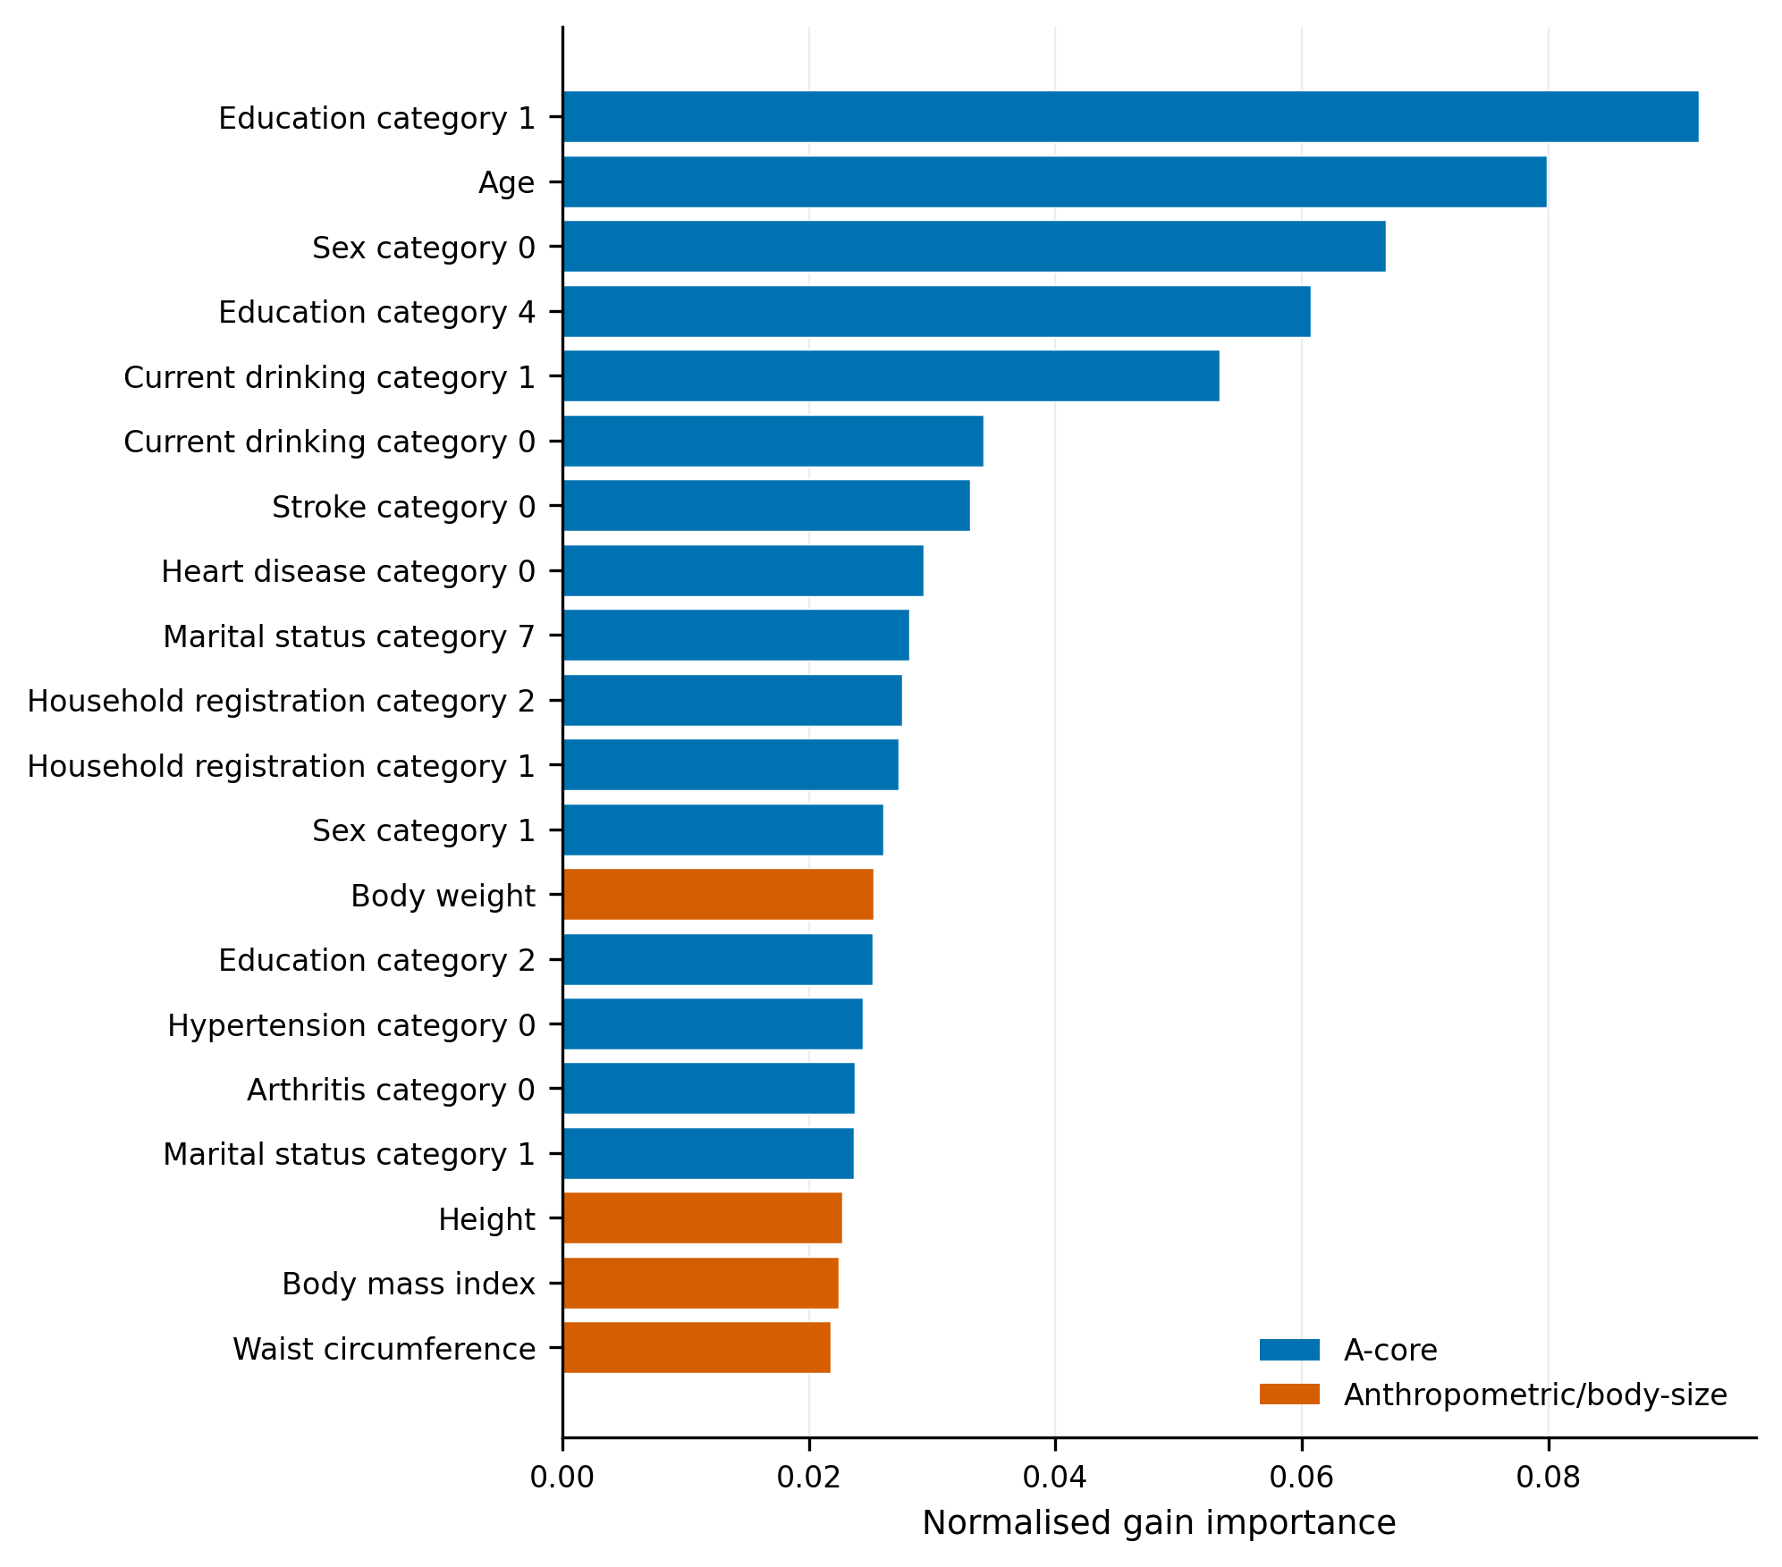
XGBoost A+B normalised gain-based feature importance. Features reflect predictive contribution and are not causal effects.

Figure S2. Screening-threshold trade-offs
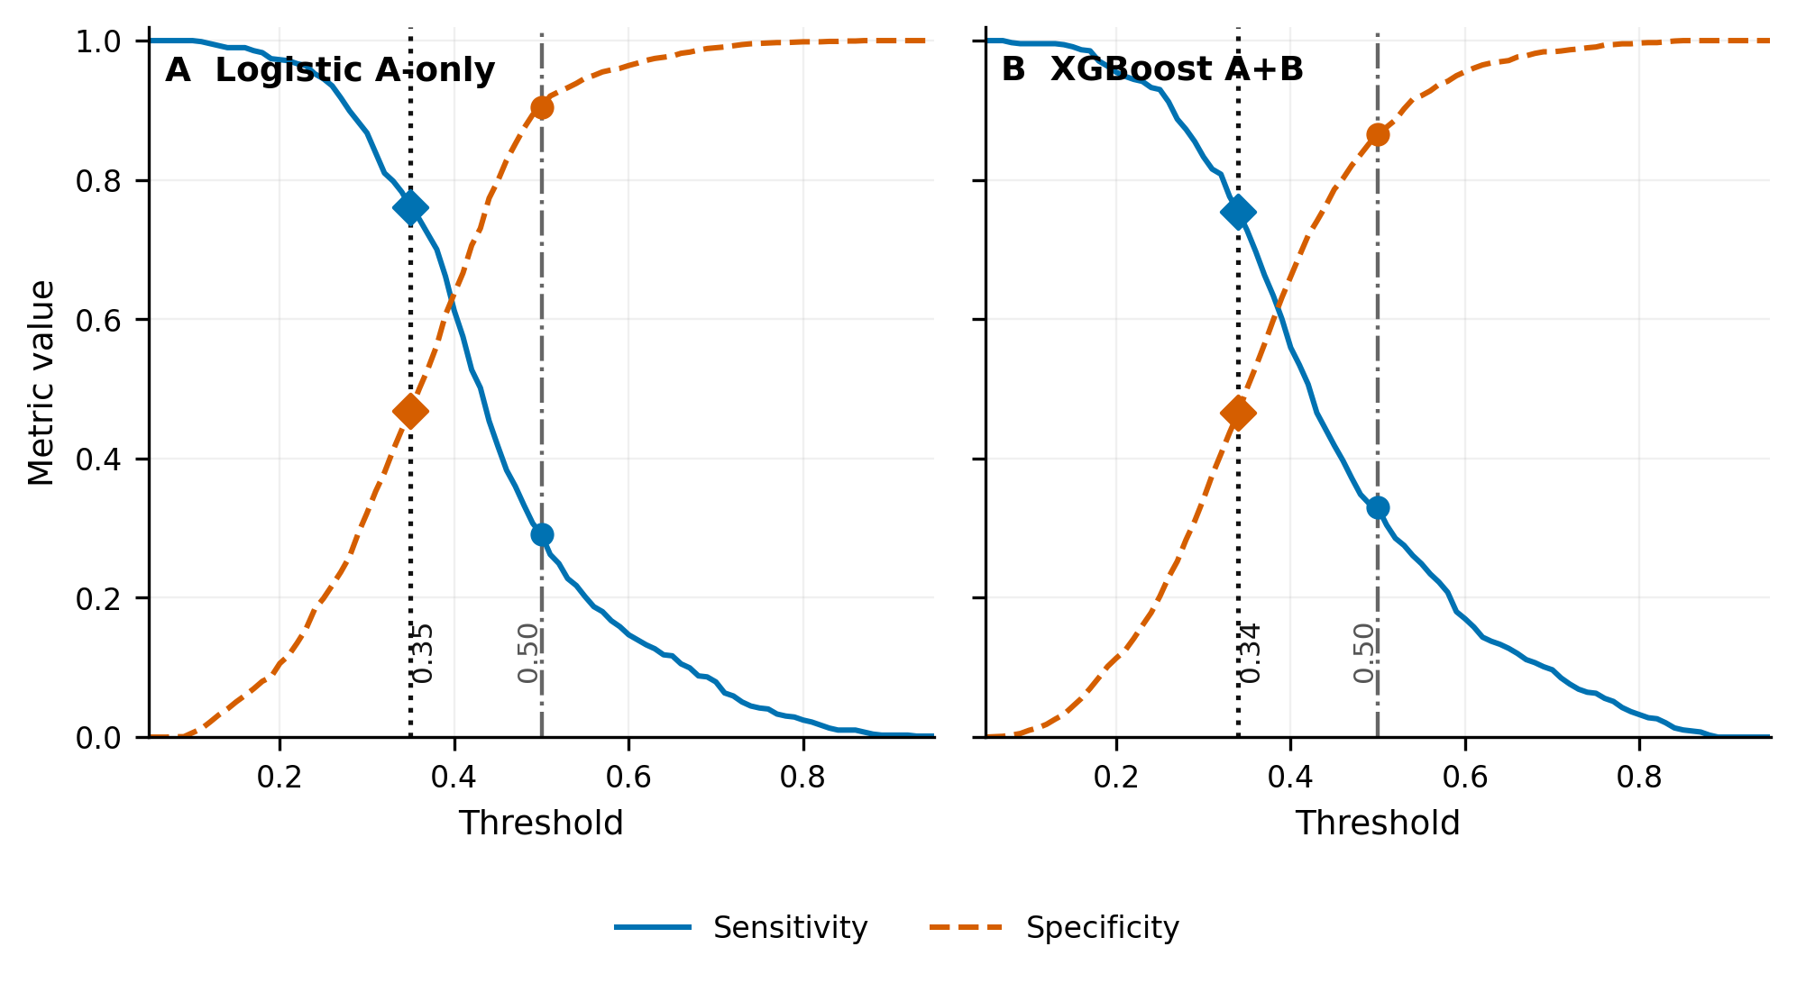
Screening-threshold sensitivity and specificity trade-offs for Logistic A-only and XGBoost A+B.
Figure S3. Wave 1 pooled out-of-fold discrimination and calibration
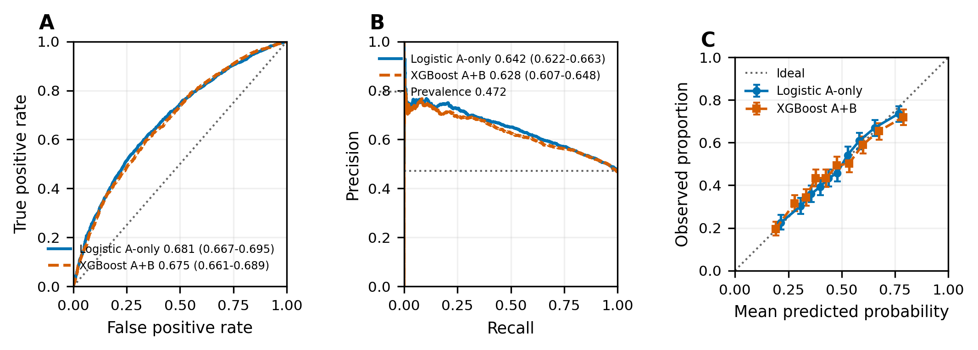
Wave 1 pooled out-of-fold ROC, precision-recall and calibration summaries.

Figure S4. Original non-isolated versus ID-isolated performance
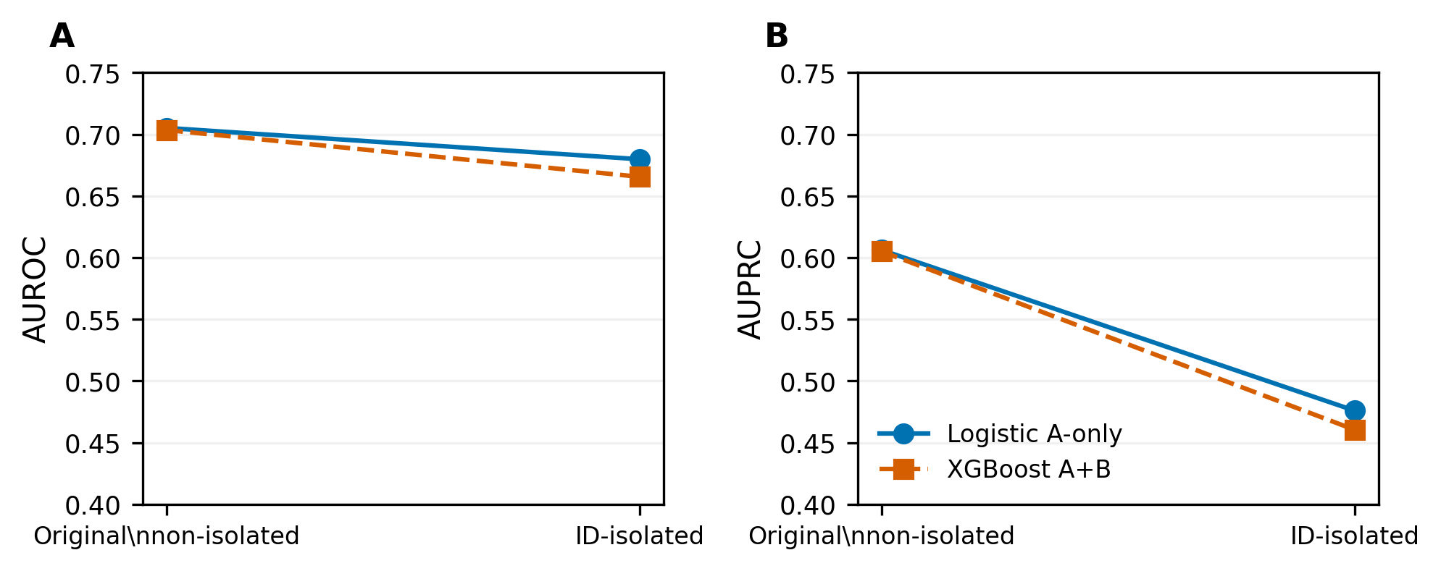
Original non-isolated versus ID-isolated Wave 3 performance. Original non-isolated results are contextual because participant overlap remained.
Figure S5. Subgroup robustness
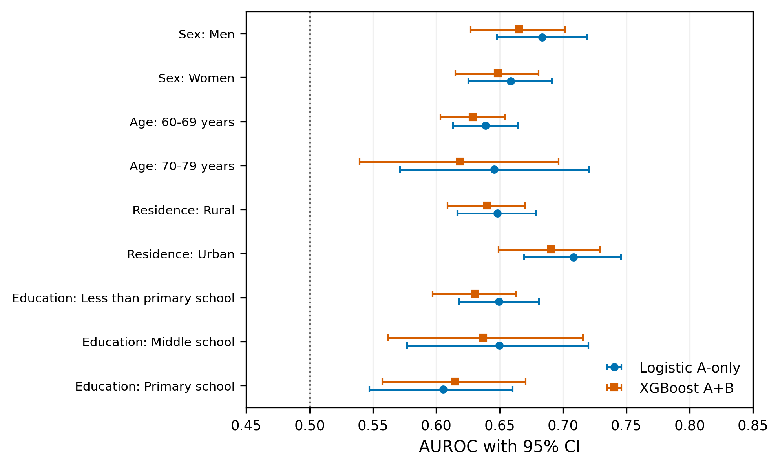
Subgroup robustness using fixed predictions. Subgroup differences are descriptive only.

Figure S6. Learning curves
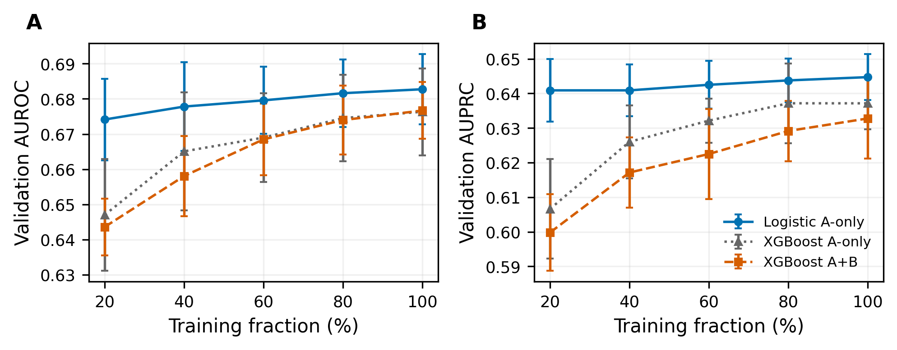
Learning-curve summaries from the verified existing analysis. The figure is exploratory.

Figure S7. Supportive participant-overlap forest plot
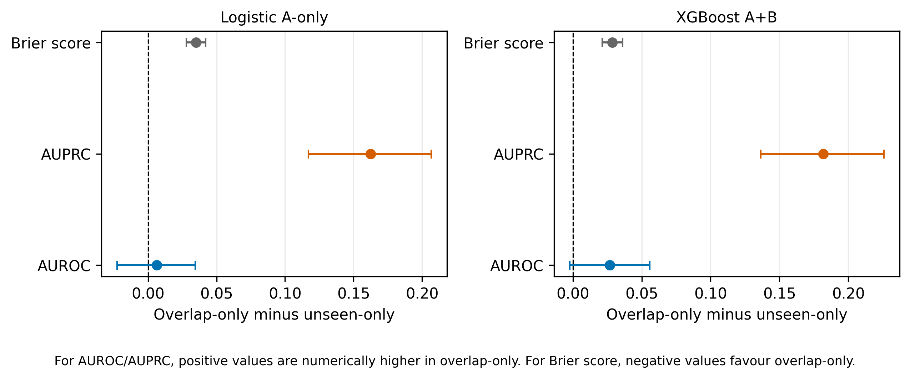
Delta equals overlap-only minus unseen-only. Positive AUROC and AUPRC differences indicate numerically higher values in overlap-only participants; positive Brier-score differences indicate worse performance because lower Brier score is better. Confidence intervals reflect 5,000 independent participant-level bootstrap replicates. This is a supportive associational analysis and should not be interpreted as estimating an overlap-specific causal effect.

Interpretation
The overlap-minus-unseen AUROC confidence intervals included zero for both models. AUPRC was higher in overlap-only participants, but outcome prevalence was approximately 45% in the overlap groups and 28% in the unseen groups. Brier scores were worse in overlap-only participants. Together with the marked age and clinical differences, these findings show that the descriptive pooled-versus-isolated change cannot be attributed to participant overlap alone. The analysis supports participant-level separation for independent evaluation while also demonstrating the need to report case mix, prevalence, calibration, and threshold performance.

