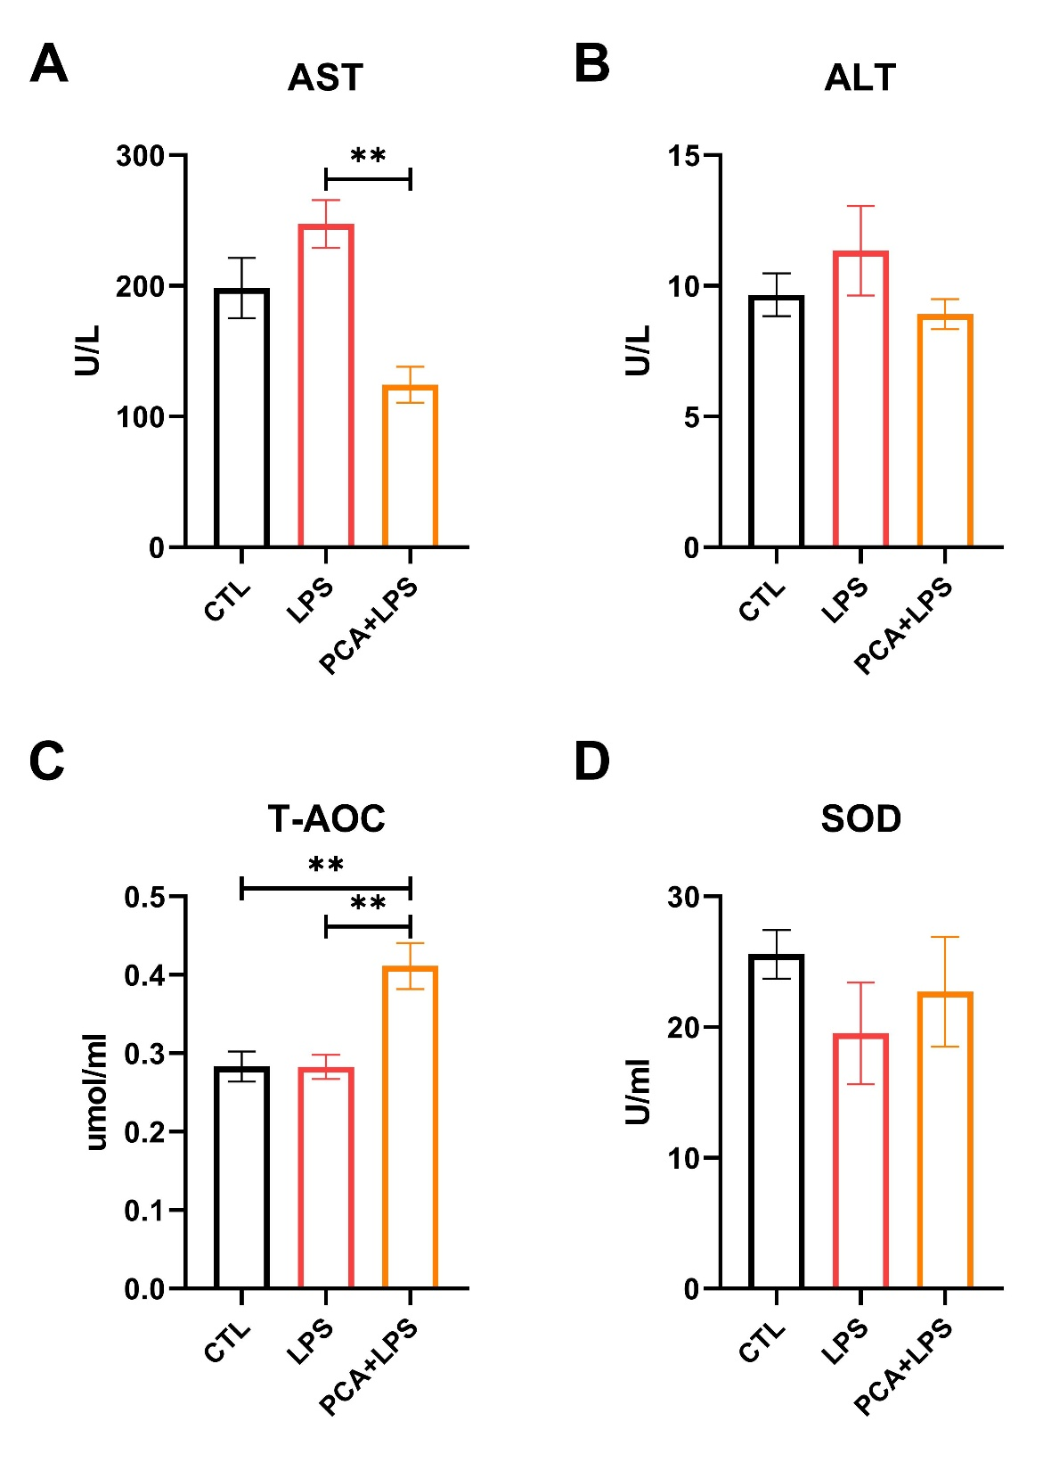
Fig. S1. PCA mitigated the inflammation and oxidative stress induced by LPS in piglets. The levels of AST and ALT in serum (A&B); Changes in T-AOC and SOD in serum (C&D). Data are shown as the means ± SEMs (n=6), *p < 0.05, **p < 0.01.

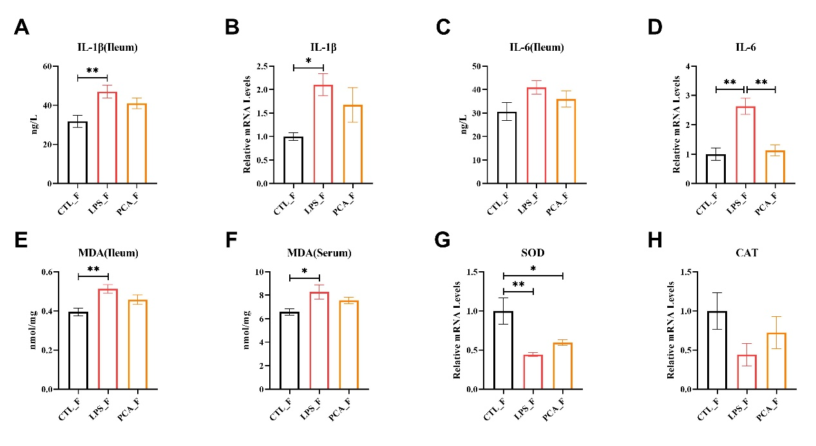
Fig. S2. FMT affected the anti-inflammatory and antioxidant capacity of mice. The effect of FMT on intestinal inflammation related indicators (A-D); The content of MDA in mouse serum and intestinal tissue after FMT (E&F); the relative mRNA expression levels of SOD and Catalase (CAT) in intestinal tissue (G&H). Data are shown as the means ± SEMs (n=10), *p < 0.05, **p < 0.01.

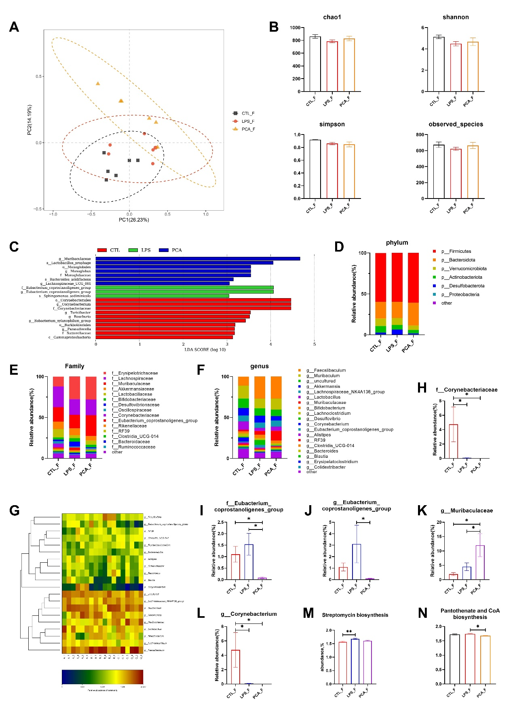
Fig. S3. FMT modified the composition of the gut microbiota in murine models. Principal Component Analysis (PCA) was employed for cluster analysis (A); α diversity of gut microbiota in mice (B); The main microbial differential groups of the three processed mice at all taxonomic levels, p<0.05 and LDA score>3.00 are considered statistically significant (C); The composition of gut microbiota at the phylum, family, and genus levels (D-F); Relative abundance of differential microorganisms in various samples (G); Proportions of differential abundant microbes among treatments (H); KEGG enrichment analysis results (M&N). Data are shown as the means ± SEMs (n=6), *p < 0.05, **p < 0.01.

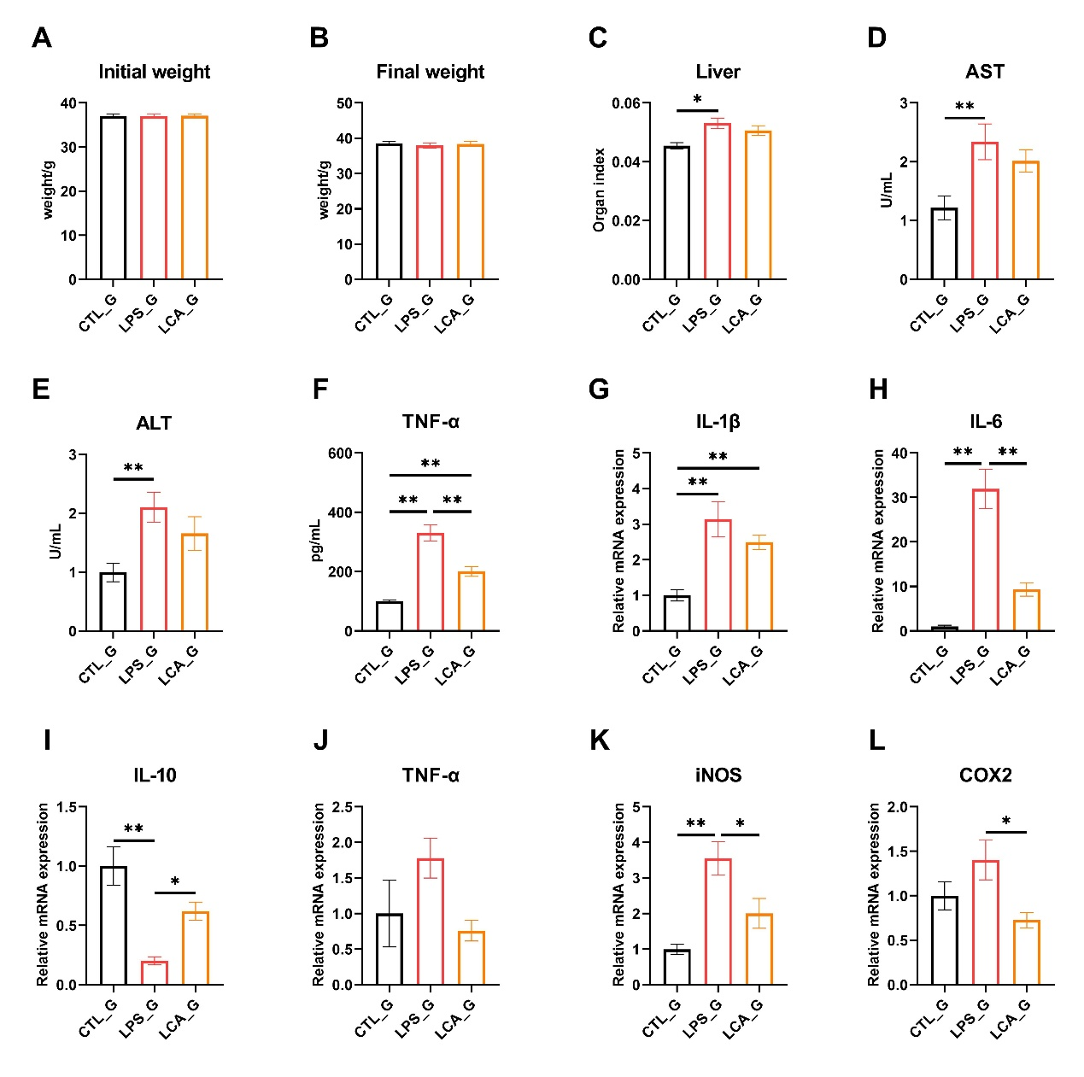
Fig. S4. The impact of LCA administration on murine models. The baseline body weight of the mice (A) and the subsequent alterations in their weight following pharmacological intervention (B); Organ index of liver (C); The levels of AST (D), ALT (E), and TNF-α in serum (F) (n=10); The relative mRNA expression levels of IL-1β, IL-6, IL-10, TNF-α, iNOS and COX2 in intestinal tissue (G-L) (n=8), Data are shown as the means ± SEMs , *p < 0.05, **p < 0.01.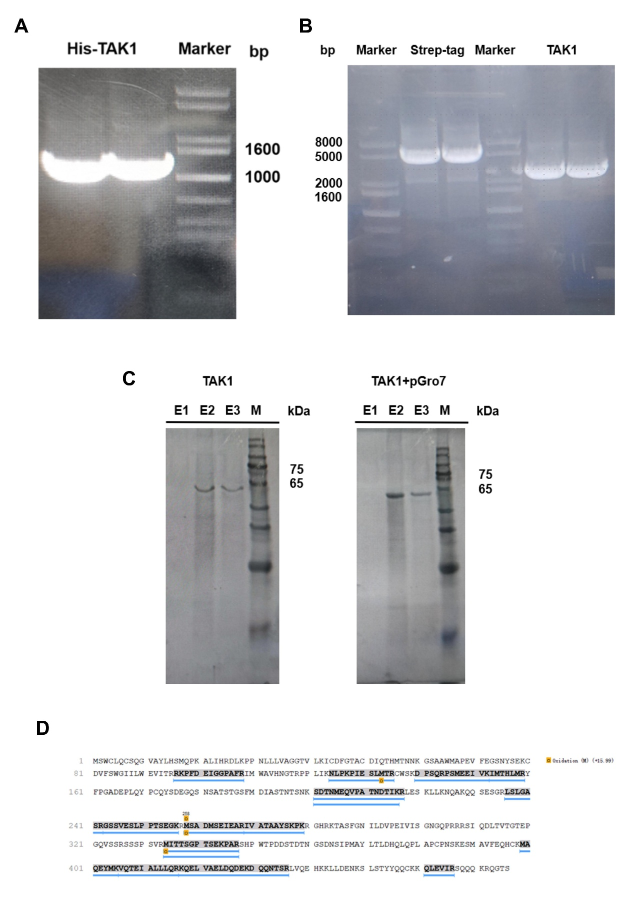
Fig. S5. Heterologous expression of TAK1 protein. Validation of the TAK1 gene (A); Construction of Strep-TAK1 plasmid (B); SDS-PAGE analysis of the purified Strep-TAK1 protein (C); Mass spectrometry analysis of the purified Strep-TAK1 protein (D).
Table S1. Antibody information and incubation conditions
 | Antibodies | Cat. No. | Diluted ratio | Loading quantity of protein sample | Incubation conditions | Exposure time
1 | Phospho-TAK1(Thr184/187) | #4508, CST/  AF14603, AiFang biological | 1:1000  1:1000  1:500  1:500  1:1000 | 30μg  50μg  20μg  20μg  30μg | 4 °C overnight | 8-15s  5-10s  3-5s  5-10  60-120
2 | TAK1 | #5206, CST | 1:1000  1:1000  1:1000  1:1000  1:1000 | 20μg  30μg  10μg  20μg  40μg | 4 °C overnight | 4-6s  50-80s  5-10s  3-5s  8-15s
3 | p-IKBα(S32/S36) | HA722770, HUABIO | 1:500 | 40μg | 4 °C overnight | 10-20s
4 | IKBα | #9242, CST | 1:1000 | 20μg | 4 °C overnight | 8-15s
5 | Phospho-NF-κB p65 (Ser536) | #3033, CST | 1:1000  1:500 | 30μg  20μg | 4 °C overnight | 30-50s  40-60s
6 | P65 | #6956, CST | 1:1000  1:1000 | 15μg  15μg | 4 °C overnight | 4-10s  20-30s
7 | Phospho-p44/42 MAPK (Erk1/2) (Thr202/Tyr204) | #4370, CST | 1:1000 | 20μg | 4 °C overnight | 4-6s
8 | p44/42 MAPK (Erk1/2) | #4695, CST | 1:1000 | 20μg | 4 °C overnight | 1-4s
9 | Phospho-p38 MAPK (Thr180/Tyr182 ) | #9211, CST | 1:1000  1:1000 | 20μg  20μg | 4 °C overnight | 3-5s  3-5s
10 | p38 MAPK | #8690, CST | 1:1000  1:1000 | 15μg  15μg | 4 °C overnight | 3-5s  1-5s
11 | Phospho-c-Jun (Ser73) | #3270, CST | 1:500 | 32μg | 4 °C overnight | 8-15s
12 | c-Jun | ET1608-3, HUABIO | 1:500 | 20μg | 4 °C overnight | 6-10s
13 | Occludin | EPR20992, Abcam | 1:1000 | 15μg | 4 °C overnight | 5-10s
14 | ZO-1 | HL1185, Abcam | 1:1000 | 20μg | 4 °C overnight | 40-60s
15 | β-actin | #4970, CST | 1:1000  1:1000  1:1000  1:1000 | 10μg  5μg  5μg  5μg | 4 °C overnight | 2-5s
16 | HRP-linked Antibody | #7074, CST | 1: 5,000 | - | Room temperature for 1 h
The same antibody has multiple parameters, which are organized according to the sequence of protein bands as presented in the text.

Table S2. The primers used in Experiment
Name | Sequence (5’-3’) | Size, bp | Species
β-actin | F: CTATTGGCAACGAGCGGTTCC | 106 | pig
 | R: GCACTGTGTTGGCATAGAGGTC | 106
IL-6 | F: GAGAGGAGACTTCACAGAGGATACC | 97 | pig
 | R: TCATTTCCACGATTTCCCAGAGAAC | 97
TNF-α | F: CACGCTCTTCTGTCTACTGAACTTC | 116 | pig
 | R: CTTGGTGGTTTGTGAGTGTGAGG | 116
Occludin | F: GTGGTAACTTGGAGGCGTCTTC | 101 | pig
 | R: CGTCGTGTAGTCTGTCTCGTAATG | 101
ZO-1 | F: TGATGATCGTCTGTCCTACCTGTC | 105 | pig
 | R: CCGCCTTCTGTATCTGTGTCTTC | 105
β-actin | F: CTATTGGCAACGAGCGGTTCC | 150 | mice
 | R: GCACTGTGTTGGCATAGAGGTC | 150
IL-1β | F: TCGCAGCAGCACATCAACAAG | 94 | mice
 | R: TCCACGGGAAAGACACAGGTAG | 94
IL-6 | F: GAGAGGAGACTTCACAGAGGATACC | 128 | mice
 | R: TCATTTCCACGATTTCCCAGAGAAC | 128
IL-10 | F: GGACAACATACTGCTAACCGACTC | 75 | mice
 | R: ATTTCCGATAAGGCTTGGCAACC | 75
CAT | F: CGGCACATGAATGGCTATGGATC | 93 | mice
 | R: CTGGTCGGTCTTGTAATGGAACTTG | 93
SOD | F: AAGCGGTGAACCAGTTGTGTTG | 140 | mice
 | R: GTTTCTTAGAGTGAGGATTAAAATGAGGTC | 140
Claudin-1 | F: TGTCCTACTTTCCTGCTCCTGTC | 78 | mice
 | R: GAAGGTGTTGGCTTGGGATAAGG | 78
Occludin | F: TGGCTATGGCGGATATACAGACC | 86 | mice
 | R: TTACTAAGGAAGCGATGAAGCAGAAG | 86
ZO-1 | F: GCGGATGGTGCTACAAGTGATG | 138 | mice
 | R: GCCTTCTGTATCTGTGTCTTCATAGTC | 138
TNF-α | F: CACGCTCTTCTGTCTACTGAACTTC | 119 | mice
 | R: CTTGGTGGTTTGTGAGTGTGAGG | 119
COX2 | F: GTGCCTGGTCTGATGATGTATGC | 80 | mice
 | R: GGATGCTCCTGCTTGAGTATGTC | 80
iNOS | F: TCACTCAGCCAAGCCCTCAC | 113 | mice
 | R: TCCAATCTCTGCCTATCCGTCTC | 113

