Supplementary materials
Table of Contents
Supplementary Methods
S1 Detailed Definition of VDII
S2 LASSO and Boruta Variable Selection
S3 Bootstrap Internal Validation Procedure
S4 Complete-Case Sensitivity Analysis
S5 Subgroup Analysis Definition
S6 Restricted Cubic Spline (RCS) Configuration
Supplementary Tables
Table S1 Baseline Characteristics of Training and Testing Sets
Table S2 Full LASSO Coefficients for All Candidate Variables
Table S3 Correlation Matrix of All Candidate Predictors
Table S4 Variance Inflation Factor (VIF) for Model 1, Model 2, and Model 3
Table S5 Bootstrap Internal Validation Results (300 Resamples)
Table S6 Complete-Case Sensitivity Analysis (Testing Set)
Table S7 Integrated Discrimination Improvement (IDI) and Net Reclassification Improvement (NRI)
Table S8 Detailed Subgroup Analysis Results
Table S9 External Calibration Metrics for All Models
Table S10 Hosmer-Lemeshow Test for All Models in Testing and External Sets
Table S11 Discriminative Performance of Single Imaging Markers (Full Detail)
Supplementary Figures
Figure S1 Distribution of VDII by Hematoma Progression Status
Figure S2 Calibration Curves for Model 1, Model 3, and VDII-only

Supplementary Methods
S1 Detailed Definition of VDII
The Volume-Density Integration Index (VDII) was constructed using the harmonic mean of baseline contusion volume (V, in mL) and the density coefficient of variation (DCV) of the hematoma:
• Volume (V): Extracted via 3D Slicer (version 5.8.1) using manual correction after initial HU thresholding (50–100 HU).
• Density Coefficient of Variation (DCV): Defined as $DCV =\frac{ Standard Deviation }{Mean}$, where SD is the standard deviation of Hounsfield Units within the hematoma region, and Mean is the mean HU.
• VDII: $VDII=\frac{2 }{\frac{1}{baseline contusion volume}+\frac{1}{hematoma DCV}}$.
Raw VDII was Z‑standardized using the mean and standard deviation from the training set to obtain standardized VDII used in all regression models.

S2 LASSO and Boruta Variable Selection
LASSO regression with 10‑fold cross‑validation was used to select the optimal lambda (lambda.min). Variables with non‑zero coefficients at lambda.min were retained. The Boruta algorithm (maxRuns = 100, importance source = 'Xgboost') was then applied to confirm variable importance. Only variables confirmed as ‘Confirmed’ by Boruta were retained for final model building.

S3 Bootstrap Internal Validation Procedure
Internal validation was performed using 300 bootstrap resamples of the training set. For each bootstrap sample, the model was refitted, and the AUC was computed on both the bootstrap sample (apparent performance) and the original training set (test performance). The optimism was calculated as the mean difference between bootstrap apparent AUC and test AUC across all resamples. The optimism‑corrected AUC was derived by subtracting the mean optimism from the apparent AUC of the original model.

S4 Complete-Case Sensitivity Analysis
A complete‑case analysis was conducted on the testing set (n=85) without any imputation for missing data. All 341 patients in the development cohort had complete data for the variables included in Model 1, Model 2, and Model 3.

S5 Subgroup Analysis Definition
Subgroup analyses were predefined based on:
• Age group: Low age (≤ median, 52 years) vs. High age (> median).
• Volume group: Low volume (≤ median, 8.18 mL) vs. High volume (> median).
• GCS group: GCS < 13 vs. GCS ≥ 13.
• Hypertension: Yes vs. No.
• Diabetes: Yes vs. No.
• Gender: Male (1) vs. Female (0).
• SAH/SDH: Presence (1) vs. Absence (0).

S6 Restricted Cubic Spline (RCS) Configuration
RCS with 4 knots placed at the 5th, 35th, 65th, and 95th percentiles of VDII was used to model the association between VDII and HPC risk, adjusting for age, GCS score, hematoma density SD, SIRI, LMR, and eosinophil count.

Supplementary Tables
Table S1 Baseline Characteristics of Training and Testing Sets
Characteristic | Training (n=256) | Testing (n=85) | P-value
Age, mean (SD) | 50.9 (15.8) | 50.3 (16.0) | 0.768
GCS score, mean (SD) | 13.8 (1.8) | 13.7 (2.0) | 0.665
Baseline contusion volume, mL, mean (SD) | 11.9 (12.7) | 11.5 (11.6) | 0.793
Hematoma DCV, mean (SD) | 0.19 (0.02) | 0.19 (0.02) | 0.943
Hematoma density SD, mean (SD) | 12.9 (1.7) | 12.8 (1.8) | 0.647
Raw VDII, mean (SD) | 0.37 (0.04) | 0.37 (0.04) | 0.951
Blood glucose, mean (SD) | 8.0 (2.8) | 8.1 (2.7) | 0.774
Albumin, mean (SD) | 41.0 (5.0) | 41.1 (4.7) | 0.874
SIRI, mean (SD) | 66.7 (44.9) | 68.3 (43.5) | 0.770
LMR, mean (SD) | 2.0 (1.9) | 1.9 (1.8) | 0.664
Eosinophil count, mean (SD) | 0.26 (0.64) | 0.25 (0.60) | 0.899
HPC events, n (%) | 74 (29.0%) | 24 (28.3%) | 0.899
Abbreviations: SD, standard deviation; DCV, density coefficient of variation; VDII, volume-density integration index; SIRI, systemic inflammation response index; LMR, lymphocyte-to-monocyte ratio; HPC, hematoma progression.

Table S2. Full LASSO Coefficients for All Candidate Variables
Variable | Coefficient
baseline_contusion_volume | 0
age | 0
gender1 | 0
sah1 | 0
sdh1 | 0
edh1 | -0.159656634045046
skull_fracture1 | 0
time_to_baseline_ct | -0.00677391984773881
midline_shift | 0
intraventricular_compression | 0.162715086446819
widening_and_deepening_of_cerebral_sulcus | 0
shallow_fissure_fission_in_the_cerebral_sulcus | 0.475114098419099
black_hole_sign1 | 0
island_sign1 | 0
blend_sign1 | 0
satellite_sign1 | 0
baseline_crebral_edema_volume | 0
hematoma_mean_density | 0
hematoma_density_sd | 0
baseline_contusion_surface_area | 0
hematoma_sr | 0
hematoma_dcv | -7.92411855107556
hypertension1 | 0
coronary_heart_disease1 | 0
diabetes1 | 0
gcs_score | -0.0812886547744209
temperature | 0
heart_rate | 0
systolic_blood_pressure | 0
diastolic_blood_pressure | 0
white_blood_cell | 0.00104792856939711
neutrophil | 0
lymphocyte | 0
monocyte | 0
eosinophil | 0.0398649473804027
basophil | 0
red_blood_cell | 0
hemoglobin | 0
rdw_sd | 0
platelet | 0
blood_potassium | 0
blood_sodium | 0
urea | 0
creatinine | 0.000679509837844846
blood_glucose | 0
uric_acid | 0.000756181658196346
total_bilirubin | 0
total_protein | 0
albumin | 0
ast | 0
alt | 0
pt | 0
inr | 0
aptt | 0
fib | 0
tt | 0
d_dimer | 0
sii | 0
nlr | 0
siri | -0.00104760556477971
plr | 0
dfr | 0
lmr | 0
rpr | 0
pni | 0.00068530631128948
apri | 0
gpr | 0
anterior_horns_of_the_bilateral_lateral_ventricles | 0
mean_arterial_pressure | 0
ultra_early_edema_expansion_rate | 0

Table S3 Correlation Matrix of All Candidate Predictors
 | vdii_raw | hematoma_dcv | baseline_contusion_volume | hematoma_density_sd | siri | lmr | gcs_score | eosinophil | age | blood_glucose | albumin
vdii_raw | 1.000 | 0.845 | -0.231 | 0.686 | -0.041 | 0.046 | 0.148 | 0.101 | -0.036 | -0.129 | -0.062
hematoma_dcv | 0.845 | 1.000 | -0.617 | 0.922 | -0.058 | 0.064 | 0.202 | 0.086 | -0.079 | -0.207 | -0.097
baseline_contusion_volume | -0.231 | -0.617 | 1.000 | -0.728 | 0.049 | -0.056 | -0.130 | -0.060 | 0.140 | 0.226 | 0.059
hematoma_density_sd | 0.686 | 0.922 | -0.728 | 1.000 | -0.016 | 0.025 | 0.212 | 0.026 | -0.075 | -0.230 | -0.130
siri | -0.041 | -0.058 | 0.049 | -0.016 | 1.000 | -0.985 | -0.096 | -0.581 | 0.031 | 0.039 | -0.055
lmr | 0.046 | 0.064 | -0.056 | 0.025 | -0.985 | 1.000 | 0.095 | 0.557 | -0.027 | -0.013 | 0.066
gcs_score | 0.148 | 0.202 | -0.130 | 0.212 | -0.096 | 0.095 | 1.000 | 0.043 | -0.100 | -0.229 | 0.041
eosinophil | 0.101 | 0.086 | -0.060 | 0.026 | -0.581 | 0.557 | 0.043 | 1.000 | -0.021 | -0.015 | 0.072
age | -0.036 | -0.079 | 0.140 | -0.075 | 0.031 | -0.027 | -0.100 | -0.021 | 1.000 | 0.251 | -0.243
blood_glucose | -0.129 | -0.207 | 0.226 | -0.230 | 0.039 | -0.013 | -0.229 | -0.015 | 0.251 | 1.000 | 0.104
albumin | -0.062 | -0.097 | 0.059 | -0.130 | -0.055 | 0.066 | 0.041 | 0.072 | -0.243 | 0.104 | 1.000
Table S4 Variance Inflation Factor (VIF) for Model 1, Model 2, and Model 3
Model 1 | VIF | Model 2 | VIF | Model 3 | VIF
hematoma_density_sd | 12.65 | hematoma_density_sd | 2.96 | hematoma_density_sd | 3.09
hematoma_dcv | 12.32 | siri | 1.72 | siri | 1.74
baseline_contusion_volume | 1.72 | lmr | 1.69 | lmr | 1.71
siri | 1.73 | gcs_score | 1.08 | gcs_score | 1.13
lmr | 1.68 | eosinophil | 1.18 | eosinophil | 1.18
gcs_score | 1.08 | age | 1.05 | age | 1.16
eosinophil | 1.17 | standardized VDII | 2.92 | standardized VDII | 3.01
age | 1.06 |  |  | blood_glucose | 1.11
 |  |  |  | albumin | 1.11

Table S5 Bootstrap Internal Validation Results (300 Resamples)
Model | Apparent AUC | Mean Optimism | Optimism-Corrected AUC
VDII-only | 0.70644 | -0.00068 | 0.70712
Model 1 | 0.70995 | 0.03128 | 0.67867
Model 2 | 0.74259 | 0.02702 | 0.71557
Model 3 | 0.75006 | 0.03446 | 0.71560

Table S6 Complete-Case Sensitivity Analysis (Testing Set)
Model | AUC
VDII-only | 0.745
Model 1 | 0.711
Model 2 | 0.754
Model 3 | 0.767

Table S7 Integrated Discrimination Improvement (IDI) and Net Reclassification Improvement (NRI)
Dataset | Comparison | IDI | NRI (Events) | NRI (Non-events)
Internal test | Model 2 vs Model 1 | 0.03664 | 0.1875 | 0.1481
Internal test | Model 3 vs Model 2 | 0.02975 | 0.1875 | 0.0741
External validation | Model 2 vs Model 1 | 0.04092 | 0.2192 | 0.1721
External validation | Model 3 vs Model 2 | 0.00278 | 0.0690 | 0.0744
Note: NRI was calculated using categorical risk thresholds (≤0.2, 0.2–0.4, >0.4). Positive values indicate improvement in reclassification.

Table S8 Detailed Subgroup Analysis Results
Subgroup | Level | N | Events | OR | Lower95 | Upper95 | P_Value | Interaction_P
age_group | High age | 243 | 67 | 0.392 | 0.279 | 0.549 | <0.001 | 0.022
age_group | Low age | 211 | 64 | 0.658 | 0.490 | 0.883 | 0.005 | 0.022
gender | 1 | 353 | 106 | 0.523 | 0.409 | 0.671 | <0.001 | 0.639
gender | 0 | 101 | 25 | 0.460 | 0.282 | 0.749 | 0.002 | 0.639
hypertension | 1 | 102 | 27 | 0.584 | 0.344 | 0.990 | 0.046 | 0.590
hypertension | 0 | 352 | 104 | 0.497 | 0.389 | 0.636 | <0.001 | 0.590
diabetes | 0 | 412 | 118 | 0.541 | 0.433 | 0.676 | <0.001 | 0.039
diabetes | 1 | 42 | 13 | 0.178 | 0.054 | 0.589 | 0.005 | 0.039
gcs_group | GCS <13 | 103 | 43 | 0.558 | 0.359 | 0.866 | 0.009 | 0.735
gcs_group | GCS >=13 | 351 | 88 | 0.511 | 0.395 | 0.659 | <0.001 | 0.735
volume_group | High volume | 227 | 65 | 0.580 | 0.442 | 0.762 | <0.001 | 0.005
volume_group | Low volume | 227 | 66 | 0.263 | 0.157 | 0.440 | <0.001 | 0.005
sah | 1 | 334 | 101 | 0.512 | 0.394 | 0.666 | <0.001 | 0.906
sah | 0 | 120 | 30 | 0.497 | 0.330 | 0.750 | <0.001 | 0.906
sdh | 1 | 261 | 76 | 0.471 | 0.344 | 0.645 | <0.001 | 0.460
sdh | 0 | 193 | 55 | 0.556 | 0.409 | 0.755 | <0.001 | 0.460

Table S9 External Calibration Metrics for All Models
Model | Calibration Intercept | Calibration Slope | Recalibration Intercept
VDII-only | 0.00119 | 2.4604 | 1.7717
Model 1 | -0.54898 | 0.9147 | -0.6043
Model 2 | -0.42065 | 1.2331 | -0.2506
Model 3 | -0.46546 | 1.1249 | -0.3804

Table S10 Hosmer-Lemeshow Test for All Models in Testing and External Sets
Dataset | Model | Chi-Square | DF | P-value
Testing | VDII-only | 6.376 | 8 | 0.605
Testing | Model 1 | 4.708 | 8 | 0.788
Testing | Model 2 | 9.897 | 8 | 0.272
Testing | Model 3 | 4.450 | 8 | 0.814
External | VDII-only | 39.572 | 8 | <0.001
External | Model 1 | 19.211 | 8 | 0.014
External | Model 2 | 13.974 | 8 | 0.082
External | Model 3 | 18.053 | 8 | 0.021
Note: Hosmer-Lemeshow test P > 0.05 indicates adequate calibration. In the external set, only Model 2 achieved non-significant P-value (0.082), indicating acceptable calibration.

Table S11 Discriminative Performance of Single Imaging Markers (Full Detail)
Model | AUC | CI_Lower | CI_Upper | 95% CI
Volume-only | 0.514 | 0.382 | 0.642 | [0.382, 0.642]
DCV-only | 0.659 | 0.537 | 0.766 | [0.537, 0.766]
VDII-only | 0.745 | 0.643 | 0.836 | [0.643, 0.836]

Supplementary Figures

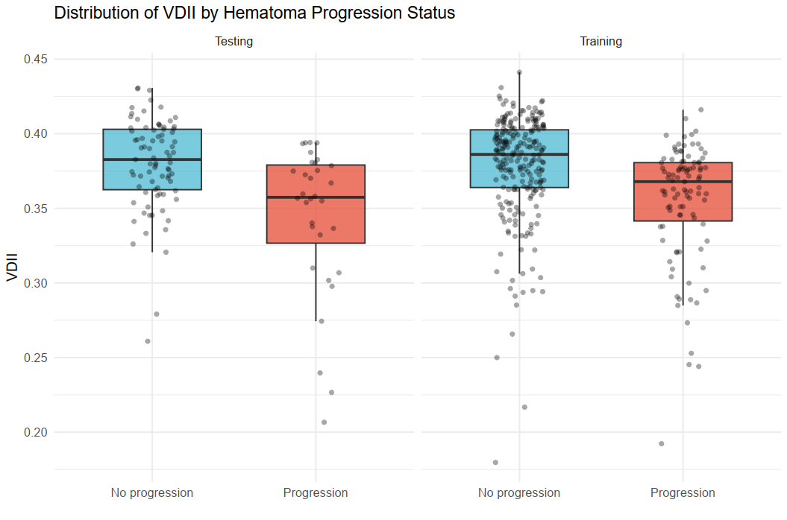
Figure S1 Distribution of VDII by Hematoma Progression Status
Boxplot showing the distribution of raw VDII values in patients with (Progression) and without (No progression) hematoma progression in the training set. The median VDII is significantly lower in the progression group (Mann‑Whitney U test, p < 0.001).

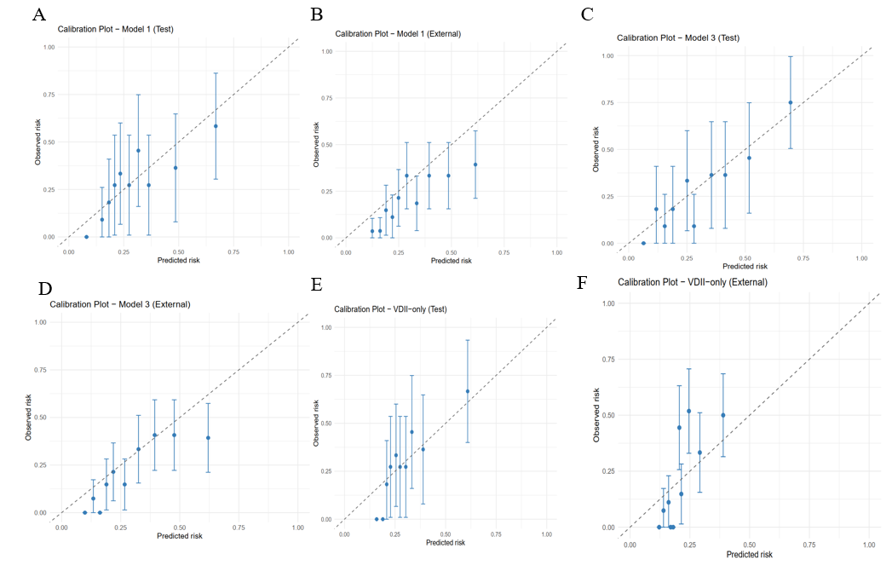
Figure S2 Calibration Curves for Model 1, Model 3, and VDII-only
Calibration plots for Model 1, Model 3, and VDII-only in the (A) testing set and (B) external validation set. The dashed diagonal line represents perfect calibration. Points above the line indicate underestimation of risk; points below indicate overestimation. Model 2 is shown in the main text (Figure 7).

