Extended Data

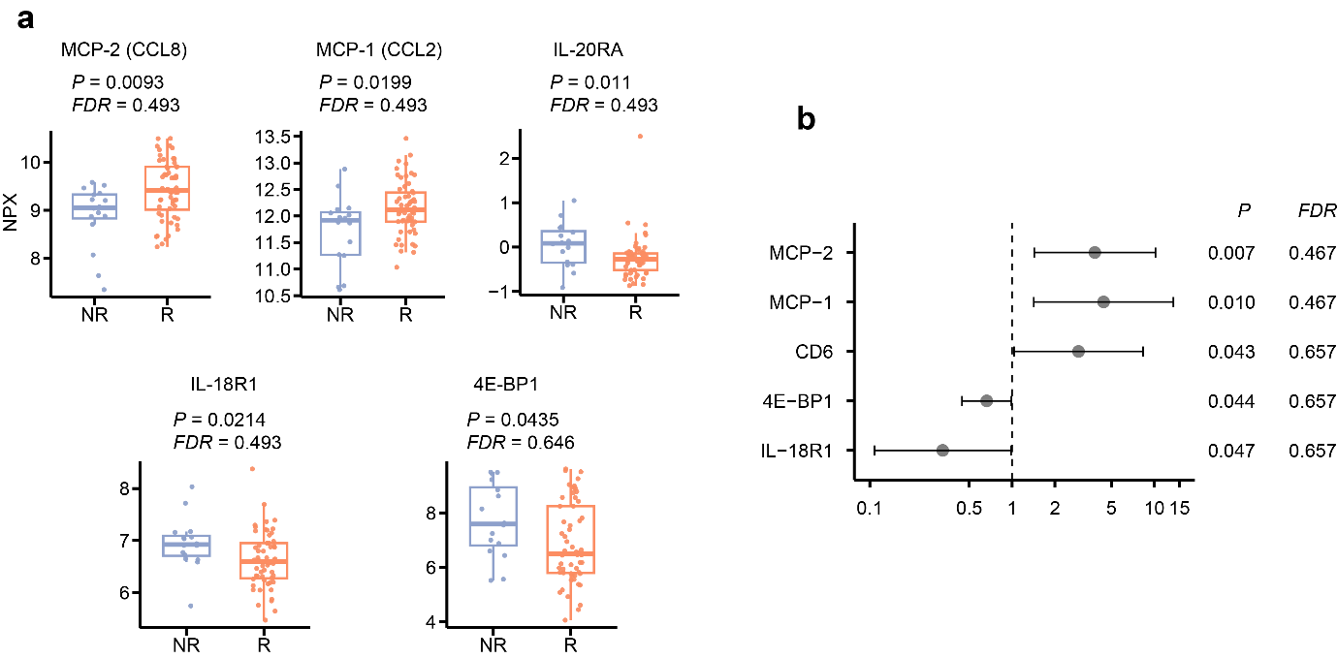

Extended Data Fig. 1 | Baseline serum protein profiles in relation to early immunotherapy response.
a, Boxplots of baseline normalized protein expression (NPX) levels of specific baseline serum proteins that demonstrated unadjusted statistical significance (P < 0.05) between 3-month non-responders (NR, n = 16) and responders (R, n = 56). Boxes show 25th, 50th and 75th centiles; whiskers indicate 1.5 × inter-quartile range; points represent individual samples. P values were calculated by two-sided Wilcoxon rank-sum test. b, Forest plot of odds ratios of baseline serum proteins that demonstrated unadjusted statistical significance (P < 0.05) for predicting 3-month response. Circles represent odds ratios derived from univariate logistic regression, and whiskers indicate 95% confidence intervals. All FDR P values were adjusted using the Benjamini-Hochberg method globally across all 92 evaluated serum proteins; no proteins retained statistical significance (FDR < 0.1) following global adjustment.

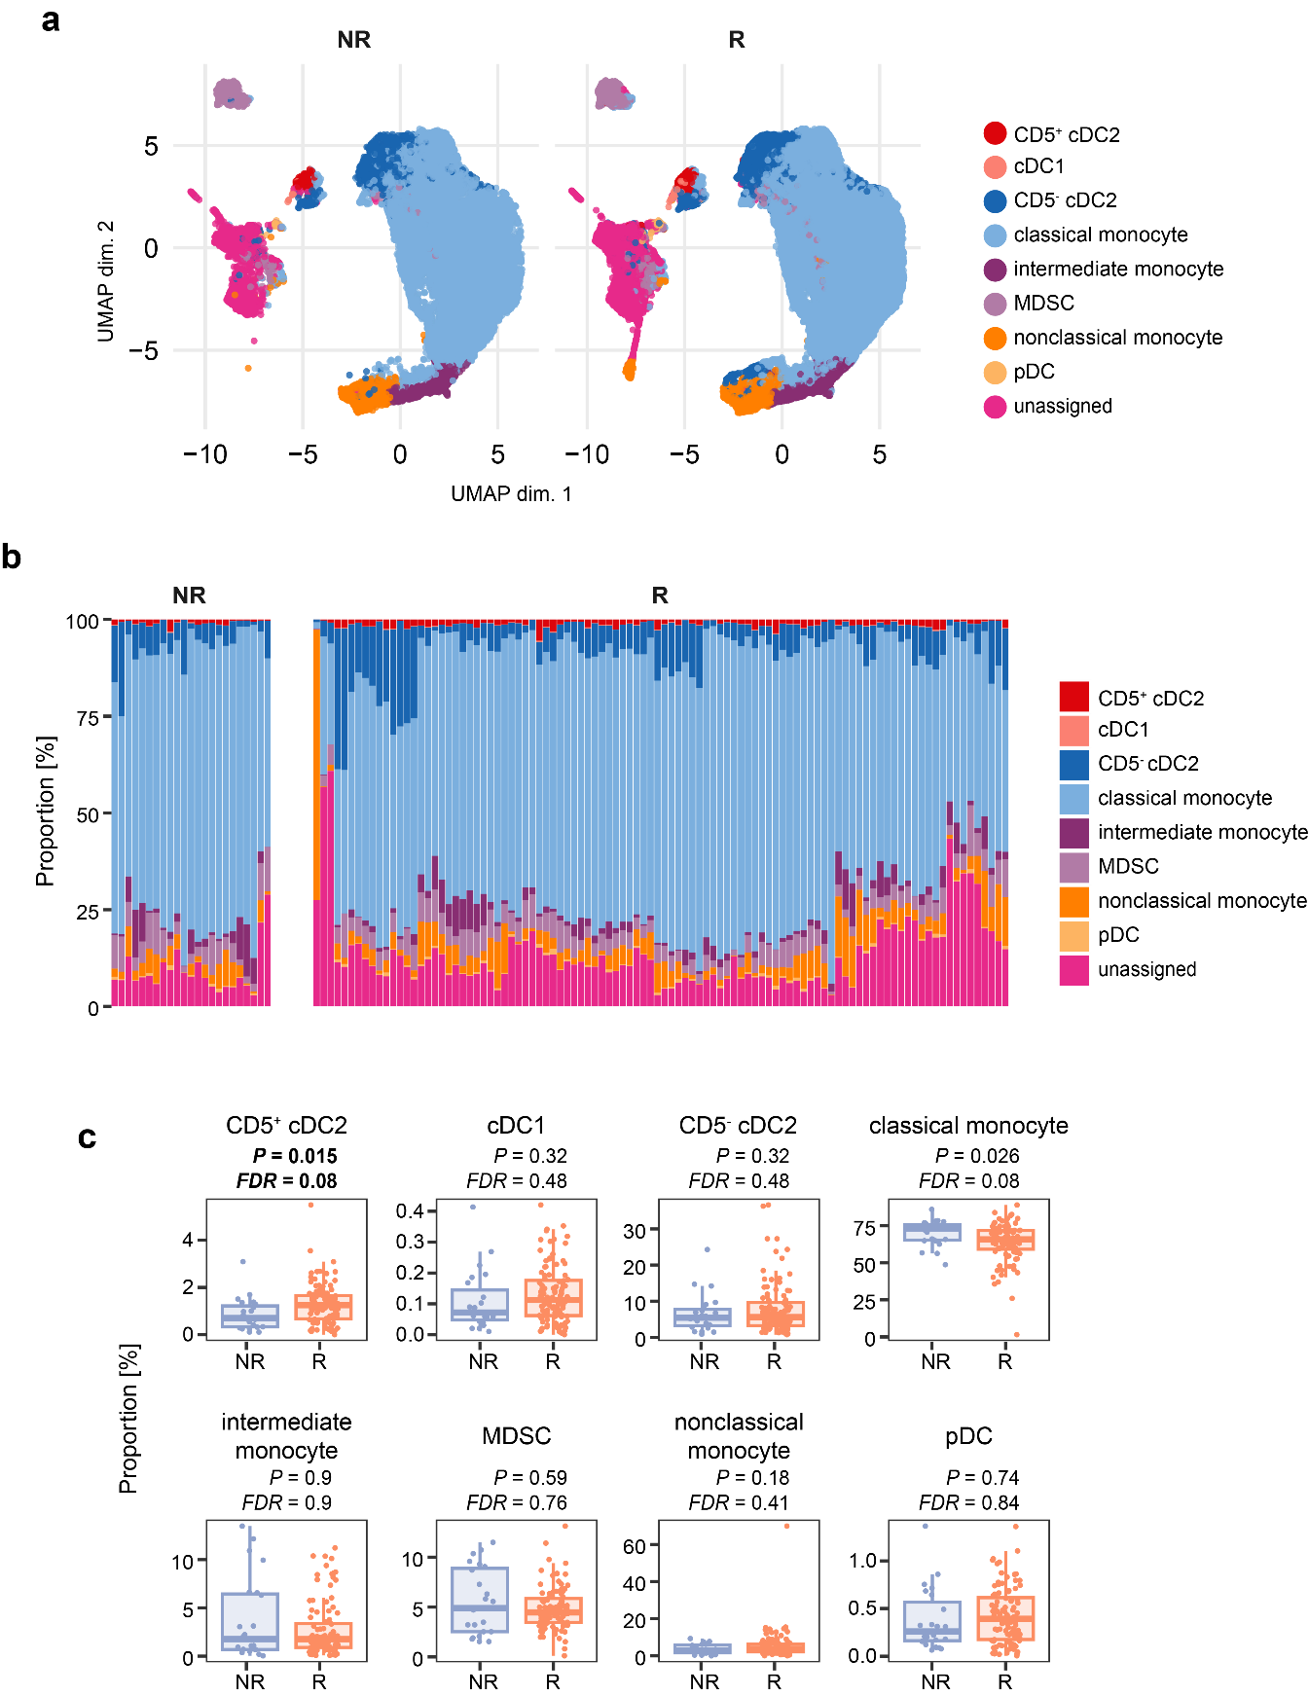

Extended Data Fig. 2 | Automated clustering and differential abundance analysis of myeloid cell subsets in peripheral blood.
a, Uniform Manifold Approximation and Projection (UMAP) of the targeted myeloid compartment (CD3⁻CD19⁻CD56⁻CD15⁻ cells) following FlowSOM and consensus clustering, with manual annotation of cell subsets for 3-month responder (R) and non-responder (NR) groups. Clustering was performed on all available baseline and 3-month samples (n = 123 total samples; R, n = 100, NR, n = 23). b, Stacked bar plot illustrating the proportional composition of annotated myeloid subsets within each individual sample, grouped by response status (R, n = 100, NR, n = 23). c, Boxplots comparing the frequency of each myeloid subset between R (n = 100) and NR (n = 23) groups in the combined baseline and 3-month dataset. Statistical significance was assessed using generalized linear mixed models (GLMMs), FDR P values were adjusted using the Benjamini-Hochberg method. CD5⁺ cDC2 was the only subset significantly elevated in responders. Although classical monocytes also exhibit statistical significance, their lower frequency in responders reflects a general post-treatment reduction experienced by all patients captured in this. Boxes show 25th, 50th and 75th centiles; whiskers indicate 1.5 × inter-quartile range; points represent individual samples.
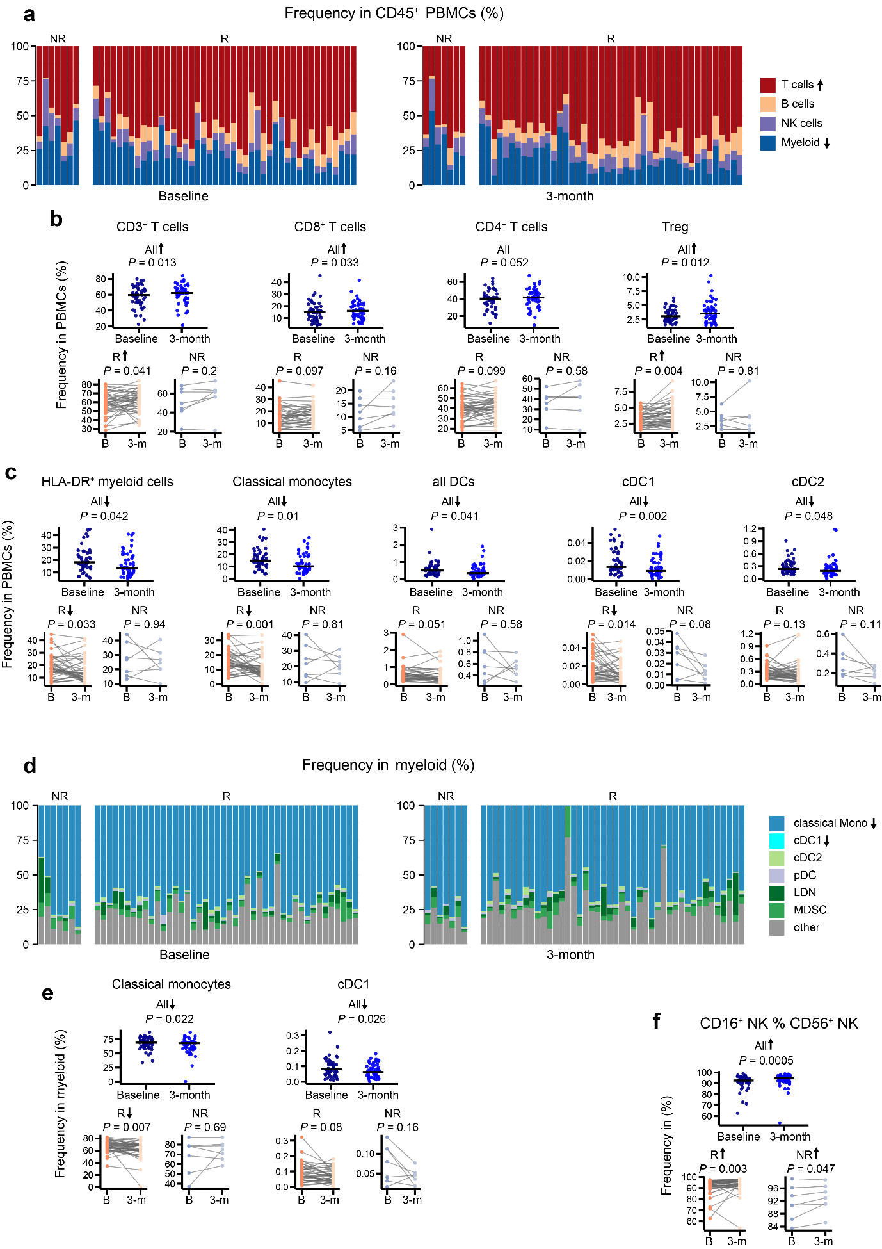

Extended Data Fig. 3 | Broad shifts in peripheral lymphoid and myeloid frequencies following early ICI therapy.
a, Stacked bar plots illustrating the relative frequencies of major immune lineages (T cells, B cells, NK cells, and myeloid cells) within the overall CD45⁺ PBMC compartment at baseline and 3 months post-treatment, stratified by early response status (R, n = 44 pairs; NR, n = 7 pairs).
b, c, Longitudinal changes in the frequencies of specific T cell subsets (b) and myeloid cell subsets (c) as a percentage of total PBMCs. Data for the entire cohort (All) are presented as scatter plots, while data stratified by response (R, NR) are shown as paired line plots.
d, Stacked bar plots detailing the subset composition within the myeloid compartment (defined as CD3⁻CD19⁻CD56⁻ cells) at baseline and 3 months, stratified by response. e, Longitudinal changes in the frequencies of classical monocytes and cDC1 subsets as a proportion of the myeloid layer. f, Longitudinal changes in the percentage of mature CD16⁺ cells within the total CD56⁺ NK cell compartment, demonstrating a significant maturation shift across all patient groups. For panels a and d, arrows inside the colour legends indicate subsets with significant overall increases (upward) or decreases (downward). For panels b, c, e, and f, arrows next to the cohort labels denote a significant longitudinal change for that specific group. Unless otherwise noted, paired data are shown for all longitudinal analyses (All cohort, n = 51 pairs; R cohort, n = 44 pairs; NR cohort, n = 7 pairs). All P values were calculated using paired Wilcoxon signed-rank tests comparing baseline and 3-month time points.
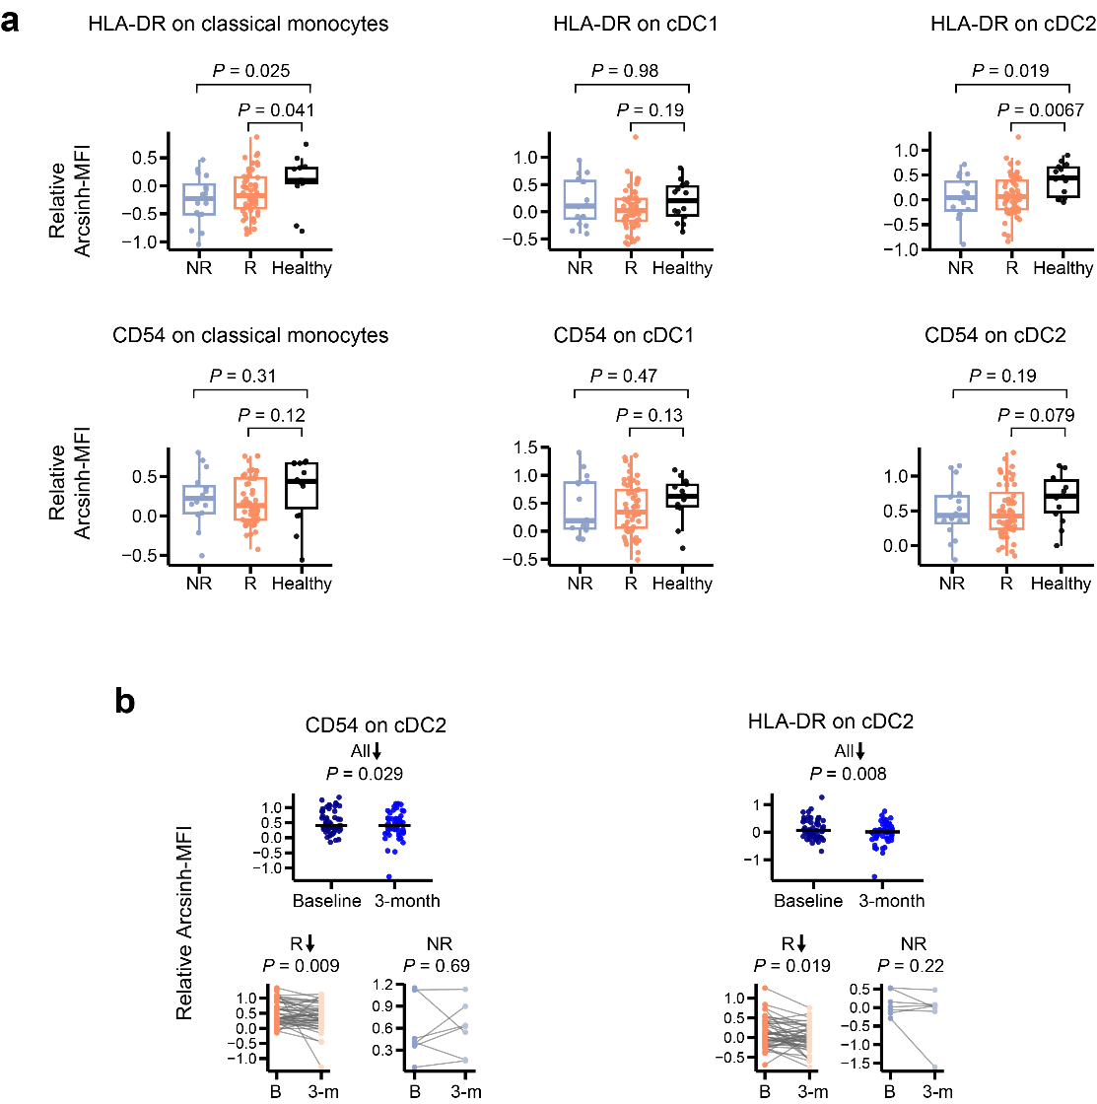

Extended Data Fig. 4 | Baseline and longitudinal expression of maturation markers on myeloid subsets.
a, Baseline relative expression (arcsinh-transformed median fluorescence intensity [MFI]) of HLA-DR (top row) and CD54 (bottom row) on classical monocytes, cDC1, and cDC2 subsets in non-responders (NR, n = 16), responders (R, n = 56), and healthy controls (n = 14). These data complement Fig. 4h by detailing maturation marker expression on the broader myeloid populations beyond the representative CD5⁺ cDC2 subset. Boxes show 25th, 50th and 75th centiles; whiskers indicate 1.5 × inter-quartile range; points represent individual samples. P values comparing patient cohorts to healthy controls were calculated using the two-sided Wilcoxon rank-sum test. b, Longitudinal changes in CD54 and HLA-DR expression on cDC2 cells from baseline to 3 months post-treatment, shown for the entire cohort (All, n = 51 pairs) and stratified by response (R, n = 44 pairs; NR, n = 7 pairs). These data complement Fig. 4i by illustrating the dynamic longitudinal changes within the total cDC2 compartment. Arrows next to the cohort labels denote a significant longitudinal decrease for that specific group. P values were calculated using paired Wilcoxon signed-rank tests.

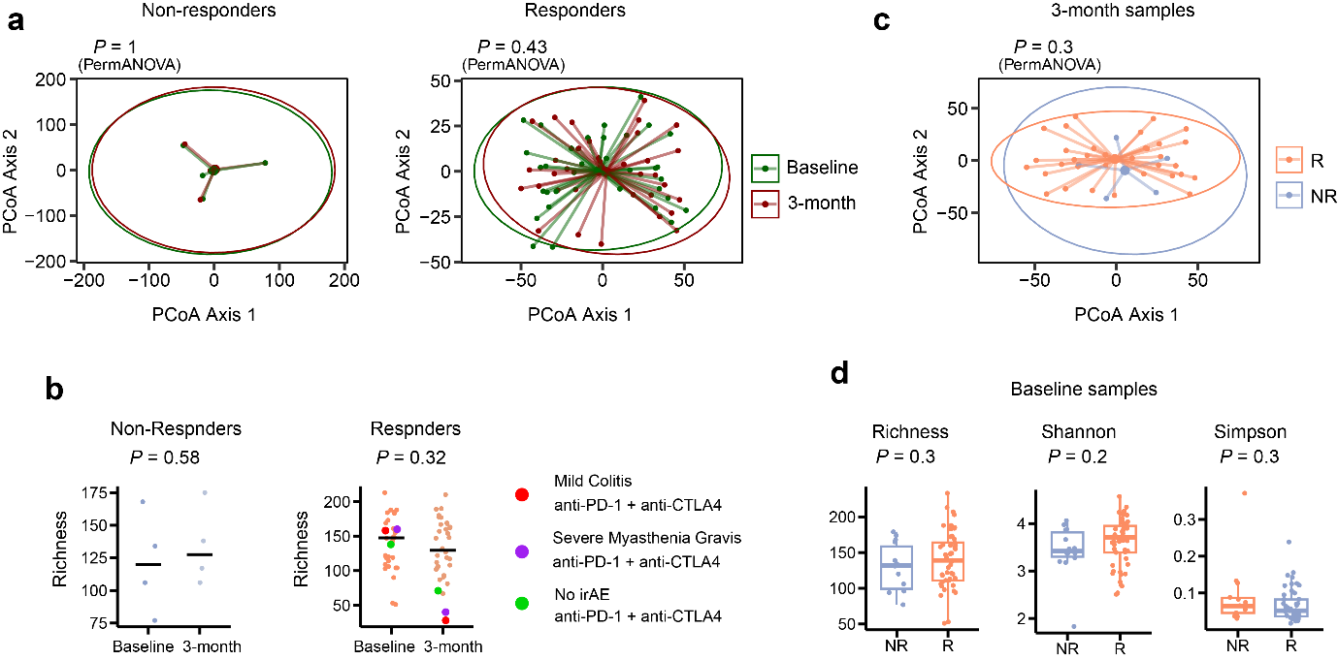

Extended Data Fig. 5 | Longitudinal and cross-sectional analysis of gut microbiome diversity in relation to clinical response.
a, Principal coordinate analysis (PCoA) of beta diversity comparing baseline and 3-month gut microbiome samples within the paired non-responder (left, n = 4 pairs) and responder (right, n = 34 pairs) cohorts. P values were calculated using PERMANOVA (permutational multivariate analysis of variance). b, Longitudinal changes in gut microbial richness from baseline to 3 months for non-responders (NR, n = 4 pairs) and responders (R, n = 34 pairs). Coloured data points highlight three specific patients receiving dual-checkpoint blockade (anti-PD-1 + anti-CTLA4) who exhibited severe richness reduction, annotated by their corresponding immune-related adverse events (irAEs). The patient highlighted in purple indicates the overlapping individual who also experienced profound oral richness depletion (detailed in Extended Data Fig. 8g). Horizontal lines represent the median. P values were derived from paired Wilcoxon signed-rank test. c, PCoA of beta diversity comparing responders (R, n = 34) and non-responders (NR, n = 5) at the 3-month post-treatment time point. Statistical significance was determined by PermANOVA. d, Boxplots of baseline gut alpha diversity (Richness, Shannon, and Unbiased Simpson indices) between non-responders (NR, n = 14) and responders (R, n = 49). Boxes show 25th, 50th and 75th centiles; whiskers indicate 1.5 × inter-quartile range; points represent individual samples. Statistical significance was determined by a two-sided Wilcoxon rank-sum test.

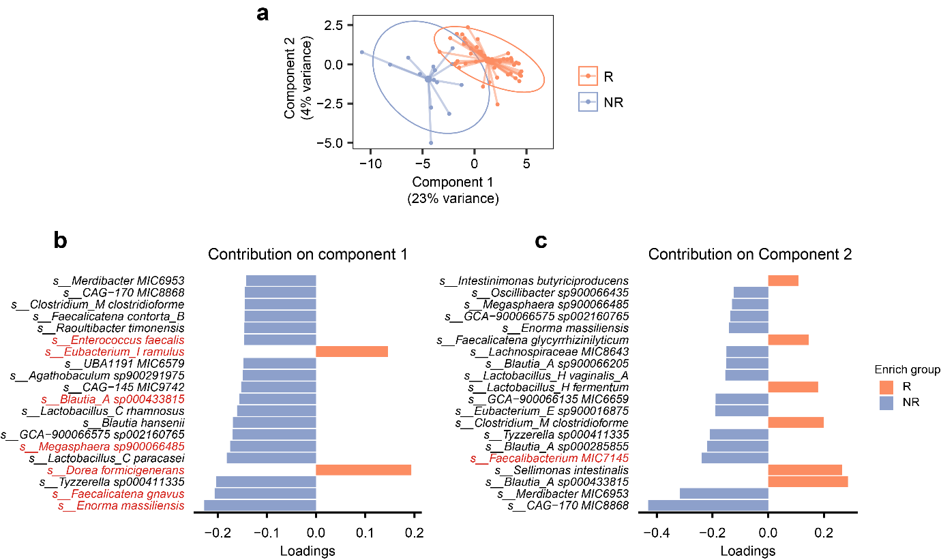

Extended Data Fig. 6 | Sparse partial least squares discriminant analysis (sPLS-DA) of baseline gut microbiota.
a, sPLS-DA score plot illustrating the multivariate separation between subsequent responders (R, n = 49) and non-responders (NR, n = 14). The model was constructed using the 50 species initially identified as differentially abundant by the Wilcoxon rank-sum test (detailed in Fig. 5b). The axes denote the first two latent components, accounting for 23% (Component 1) and 4% (Component 2) of the explained variance. b, c, Loading plots displaying the top 20 species contributing to the group separation along Component 1 (b) and Component 2 (c). Horizontal bars indicate the loading weights for each feature, with colours denoting the clinical group (R or NR) in which the species is enriched. Taxonomic labels highlighted in red indicate species that are also part of the final robust 11-species signature (identified in Fig. 5f).

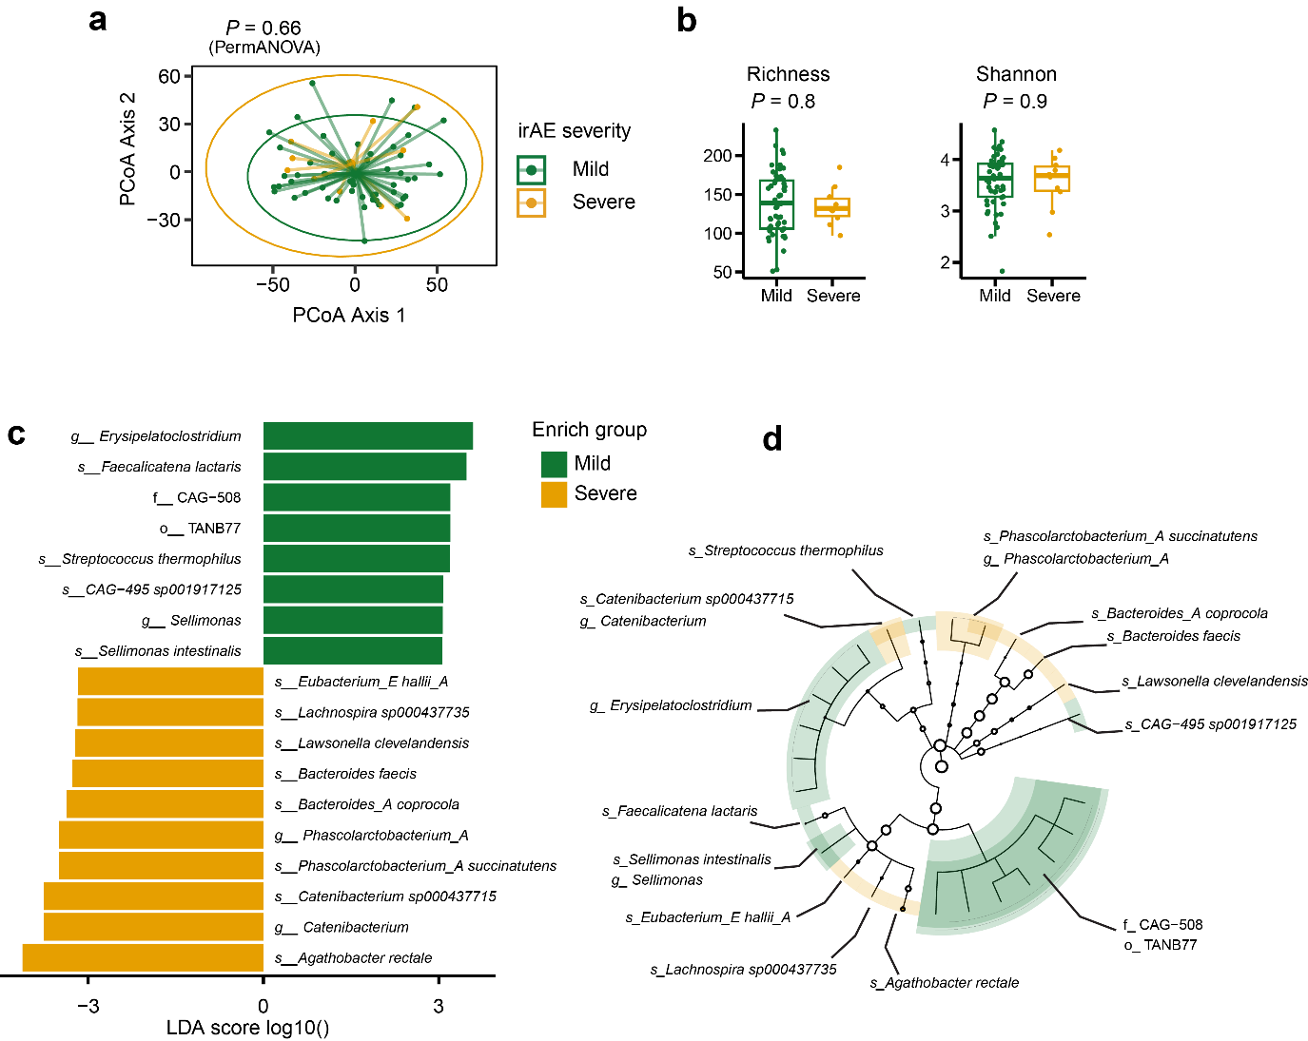

Extended Data Fig. 7 | Baseline gut microbiome composition in relation to immune-related adverse event (irAE) severity.
a, Principal coordinates analysis (PCoA) based on Aitchison distance demonstrating significant baseline microbial beta diversity separation between subsequent mild irAE (n = 53) and severe irAE (n = 10) group. P value was calculated using PERMANOVA (permutational multivariate analysis of variance). b, Boxplots of baseline gut alpha diversity (Richness and Shannon index) between the mild irAE (n = 53) and severe irAE (n = 10) group. Boxes show 25th, 50th and 75th centiles; whiskers indicate 1.5 × inter-quartile range; points represent individual samples. Statistical significance was determined by a two-sided Wilcoxon rank-sum test. c, Linear discriminant analysis effect size (LEfSe) plot highlighting differentially abundant taxa distinguishing patients with mild versus severe irAEs (P < 0.05, LDA score > 3). d, Cladogram illustrating the phylogenetic relationships and hierarchical structure (from phylum to species) of the differentially abundant taxa identified in c.

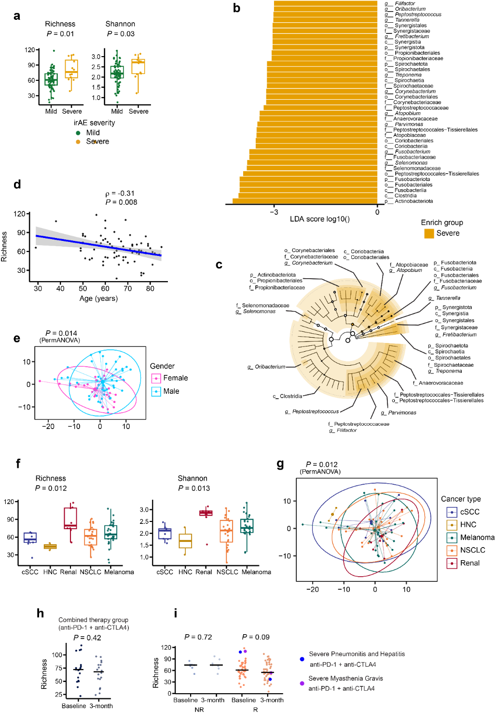

Extended Data Fig. 8 | Baseline oral microbiome correlates with systemic immunotherapy toxicity, demographic variables, and clinical covariates. a, Boxplots of baseline oral alpha diversity (Richness and Shannon index) between the mild irAE (n = 61) and severe irAE (n = 12) group. Statistical significance was determined by a two-sided Wilcoxon rank-sum test. b, Linear discriminant analysis effect size (LEfSe) identifying 37 baseline oral taxa significantly enriched in patients who subsequently developed severe immune-related adverse events (irAEs, n = 12) compared to those with mild irAEs (n = 61). Data are presented as a bar plot (P < 0.05, LDA score > 3). No taxa were significantly enriched in the mild irAE group. c, Cladogram illustrating the phylogenetic relationships and hierarchical structure (from phylum to species) of the differentially abundant taxa identified in (b). d, Scatterplot demonstrating an inverse correlation between baseline oral richness and patient age. Spearman’s ρ and P value were calculated by Spearman’s rank correlation. The blue line depicts a linear regression fit, and grey shaded area indicates 95% confidence interval. e, Principal coordinates analysis (PCoA) based on Aitchison distance showing differences in baseline oral beta diversity between female (n = 25) and male (n = 48) patients. P value was calculated using PermANOVA (permutational multivariate analysis of variance). f, Baseline oral alpha diversity (Richness and Shannon indices) stratified by cancer type (cSCC, n = 9; HNC, n = 2; Renal, n = 8; NSCLC, n = 24; Melanoma, n = 30). Statistical significance was assessed using a Kruskal–Wallis test. g, PCoA demonstrating variations in baseline oral beta diversity across cancer types. P value was calculated using PermANOVA. h, Longitudinal comparison of oral microbial richness from baseline to 3 months specifically within the combination therapy subgroup (n = 18 pairs). i, Longitudinal changes in oral microbial richness from baseline to 3 months for non-responders (NR, n = 7 pairs) and responders (R, n = 45 pairs). Two specific patients receiving dual-checkpoint blockade who exhibited severe richness reduction (>50%) are highlighted with coloured data points and annotated by their specific irAEs. The patient highlighted in purple indicates the same individual who exhibited concurrent severe gut richness depletion (detailed in Extended Data Fig. 5b). In f and g, horizontal lines denote the median, and P values were calculated using Wilcoxon signed-rank test. For all boxplots (a, d), boxes show 25th, 50th and 75th centiles; whiskers indicate 1.5 × inter-quartile range; points represent individual samples. cSCC, cutaneous squamous cell carcinoma; HNC, head and neck cancer; NSCLC, non-small cell lung cancer.

Extended Data Table 1. Presence and absence of eight key responder-enriched functional features across 11 signature species.
Identified differentially abundant functional features
(all enriched in R)
 | Identified significant species | EC 2.7.7.7 | EC 2.7.7.6 | THIORED  OX -PWY | SAM-PWY | PWY-5686 | PWY-5344 | PEPTIDO  GLYCANSYN-PWY | Aromatic Compound Biosynthesis
Enriched in  NR | Faecalicatena gnavus | ✓ | ✓ | ✓ | ✓ | ✓ | ✓ | ✓ | ✓
Enriched in  NR | Enorma massiliensis | ✓ | ✓ | ✓ | ✓ | ✓ | — | ✓ | ✓
Enriched in  NR | Blautia_A sp000433815 | ✓ | ✓ | ✓ | ✓ | ✓ | — | ✓ | ✓
Enriched in  NR | Megasphaera sp900066485 | ✓ | ✓ | ✓ | ✓ | ✓ | ✓ | ✓ | ✓
Enriched in  NR | Enterococcus faecalis | ✓ | ✓ | ✓ | ✓ | ✓ | — | ✓ | ✓
Enriched in  NR | Dorea sp000509125 | — | — | — | — | — | — | — | —
Enriched in  R | Dorea formicigenerans | ✓ | ✓ | ✓ | ✓ | ✓ | ✓ | ✓ | ✓
Enriched in  R | Eubacterium_I ramulus | ✓ | ✓ | ✓ | ✓ | ✓ | — | ✓ | ✓
Enriched in  R | Eisenbergiella sp900066775 | ✓ | ✓ | ✓ | ✓ | ✓ | ✓ | ✓ | ✓
Enriched in  R | Faecalibacterium MIC7145 | ✓ | ✓ | ✓ | ✓ | ✓ | ✓ | ✓ | ✓
Enriched in  R | Coprococcus_A catus | ✓ | ✓ | ✓ | ✓ | ✓ | ✓ | ✓ | ✓
Note: Check marks (✓) indicate the presence of a functional feature within the species' genomic profile, and dashes (—) indicate its absence. All eight functional features were identified as significantly enriched in responders at the community level. EC 2.7.7.7, DNA-directed DNA polymerase; EC 2.7.7.6, DNA-directed RNA polymerase; THIOREDOX-PWY, thioredoxin pathway; SAM-PWY, S-adenosyl-L-methionine biosynthesis; PWY-5686, UMP (uridine monophosphate) biosynthesis I; PWY-5344, L-homocysteine biosynthesis; PEPTIDOGLYCANSYN-PWY, peptidoglycan biosynthesis I (meso-diaminopimelate containing); R, responders; NR, non-responders.

