SUPPLEMENTARY MATERIAL

Supplementary note 1. Spectral flow cytometry for deep immunophenotyping

1.1 Panel summary
To comprehensively phenotype the peripheral immune landscape and identify circulating biomarkers of ICI response, a custom 30-parameter surface marker panel was designed for human PBMCs. The panel was specifically configured to achieve three technical objectives: (1) high-resolution identification of lymphoid and myeloid lineages; (2) functional characterization of cellular activation and exhaustion states; and (3) prioritized detection of rare myeloid-derived suppressor cells (MDSCs) and antigen-presenting cells (APCs). Because PBMCs from cancer patients exhibit distinct biological and morphological alterations compared to healthy donors, the panel and its subsequent gating strategy were heavily optimized to address the unique technical challenges posed by these clinical samples.

1.2 Panel design
The panel was designed following established principles for high-parameter flow cytometry, as outlined in best-practice guidelines for conventional cytometric approaches¹. Antigens were categorized as primary, secondary, or tertiary based on expression levels, with co-expression patterns evaluated through schematic gating trees and literature reviews of marker distribution across target subsets. Leveraging commercially available fluorochrome-conjugated antibodies, an initial 26-colour panel was optimized for the BD FACSymphony A5 cytometer. This configuration successfully resolved key populations including T, B, NK cells, monocytes, and dendritic cell subset (Supplementary Fig. 1a).
Shortly after establishing the BD panel, the Cytek Aurora full-spectrum cytometer was acquired at the institute. The panel was migrated to this 5-laser platform to capitalize on the Aurora’s capabilities. To leverage the platform’s enhanced spectral resolution, the panel was expanded to a 30-parameter configuration with the addition of markers critical for resolving immunosuppressive myeloid subsets (CD15, CD33, CD11b, CD5), accompanied by the necessary repositioning of some antibodies.
A critical observation during panel validation involved significant signal spread from APC-Fire 810 (R8 channel, emission peak 807 nm) into the APC channel (R1 channel, emission peak 660 nm) after unmixing (Supplementary Fig. 1b), a phenomenon worthy of emphasis given its occurrence despite the Aurora’s advanced spectral resolution. Initial suspicions of tandem dye degradation were ruled out after testing fresh reagents, confirming inherent spectral proximity as the cause. Consequently, APC-Fire 810 was omitted, and antibody positions were further adjusted. Notably, fluorochromes with closer spectral proximity to APC—such as APC-H7 (R7 channel) and Alexa Fluor 647 (R2 channel)—did not exhibit comparable spread, underscoring the fluorochrome-specific nature of this interference. This finding highlights critical lessons: spectral overlap persists even in high-resolution full-spectrum systems post-unmixing, and interference patterns are fluorochrome-dependent rather than strictly proximity-driven. Such errors are easily overlooked without rigorous pairwise examination of all fluorochrome combinations, particularly when relying on automated spectral unmixing algorithms.
The finalized panel demonstrates an optical layout across the Aurora’s 5-laser spectral map, achieving a similarity index of 11.42, indicative of robust performance for a 30-colour configuration (Supplementary Table 1, Supplementary Fig. 2). Antibody clones were selected based on either their prevalence in published studies or manufacturer recommendations for clone-specific performance (Supplementary Table 2).

1.3 Panel optimization

Reference control validation
Unmixing accuracy in full-spectrum cytometry critically depends on the spectral fidelity of reference controls. To address well-documented spectral shifts induced by cellular microenvironments^{2,3}, parallel reference controls were initially generated using both UltraComp™ beads (Thermo Fisher Scientific) and human PBMCs stained individually with each antibody. A systematic comparison of unmixing results revealed that bead-based controls introduced significant unmixing errors for tandem dyes (BUV563, BV480, BV570, BV605, BV711, BV786, PE-Cy5, PE-Cy7) and proteinaceous fluorochromes (PE, PE-CF594, APC-R700). These spectral discrepancies manifested as false-positive populations in off-target channels (Supplementary Fig. 3). Consequently, cell-based reference controls utilizing healthy donor PBMCs were strictly adopted for all markers to ensure absolute spectral congruence between reference controls and experimental samples.

Antibody Titration and Panel Validation
To ensure statistically robust gating of rare immune subsets (<0.1% frequency, including conventional dendritic cells and MDSCs), the assay was scaled to require a minimum of 5 × 10⁶ PBMCs per sample. Initial antibody titrations were performed on 1 × 10⁶ cells due to healthy donor PBMC limitations, with full-panel validation (on both healthy and patient PBMCs) subsequently confirmed across escalating cell counts (1–5 × 10⁶) to verify performance at scale. All titrations were performed in a 200 µL staining volume to mirror final panel conditions.
Each of the 30 reagents was titrated across eight two-fold dilutions. Starting concentrations were guided by manufacturer recommendations: standard reagents (e.g., BD Horizon™ antibodies) began at 1:20 dilution (10 µL in 200 µL), while high-volume reagents (e.g., PE-Cy5 anti-CD54, Alexa Fluor 647 anti-CD127) started at 1:5 (40 µL in 200 µL). For viability dye (Live Dead Blue™), a 1:250 dilution (exceeding the recommended 1:1000) was used as starting point to accommodate high cell counts, with accuracy validated using live/heat-killed cell mixtures. CD45 titration employed partial staining of PBMCs (50% stained, 50% unstained) given that nearly all PBMCs are CD45⁺. Optimal titers (red boxes in Supplementary Fig. 4) were selected by identifying the lowest antibody concentration maintaining clear positive/negative population separation, with stain index values serving as a quantitative reference.
Provisional titers for Live Dead Blue™ and CD45 (dashed boxes in Supplementary Fig. 4a and c), initially optimized for 1 × 10⁶ cells, required revision during clinical sample validation. Full-panel validation on healthy and cancer patient PBMCs (1–5 × 10⁶ cells) revealed patient-specific challenges, including elevated debris and CD45⁻ populations not observed in healthy PBMCs. To resolve this, CD45 and Live Dead Blue™ were re-titrated using 5 × 10⁶ cells under experimental conditions (no dead/live cell mixing, two additional washes), mirroring final assay workflows (Supplementary Fig. 5a-b). Additionally, cFluorB548_CD15, critical for PMN-MDSC identification (CD3⁻CD19⁻CD56⁻CD14⁻CD15⁺), required stringent optimization due to cFluorB548 (CD15⁺) spillover into BUV805 (CD14⁺) channel. Full-panel titration coupled with fluorescence-minus-one (FMO) controls determined that a 1:320 dilution optimally resolved CD15⁺ PMN-MDSCs while suppressing CD14⁺-associated background (Supplementary Fig. 5c).
Final validation of the fully stained samples—unmixed using single-stained reference controls prepared at their optimally titrated concentrations—confirmed the reliable resolution of all target subsets, including rare populations, in both healthy and patient PBMCs. Panel robustness was further demonstrated via an N×N matrix of 19 selected lineage markers in fully stained healthy donor PBMCs, confirming the clean resolution of lineage-defining and low-abundance populations (Supplementary Fig. 6). Ultimately, final titer selections (Supplementary Table 3) were established by balancing biological and technical considerations: (1) population-specific intensity requirements (e.g., monocyte versus lymphocyte markers), (2) spillover minimization in a high-dimensional context, and (3) clinical sample limitations regarding inherent viability and debris profiles.

1.4 Technical optimizations

High-density sample acquisition
Data collection was standardized using a preconfigured Cytek Cloud template, with validation-optimized instrument settings applied uniformly across the cohort without modification. Due to the high cellular density required for rare population detection (5 × 10⁶ cells per tube), continuous acquisition initially resulted in exceptionally large FCS files and prolonged acquisition times (>10 minutes per sample), which occasionally triggered instrument software pauses. To ensure continuous and stable cytometer performance and prevent data loss during the acquisition of high event counts, each stained sample was acquired sequentially across two separate data files within the acquisition software, processing approximately half of the sample volume per file.

Spectral unmixing and autofluorescence extraction
To maximize spectral unmixing accuracy and mitigate inaccuracies associated with longitudinal cytometer drift, all single-color cell-based reference controls were freshly generated alongside the experimental cohort. Crucially, these refreshed controls utilized PBMCs from the identical healthy donor employed for longitudinal batch normalization, stained at validated optimal titers (1 × 10⁶ cells in a 200 µL volume). To minimize technical variance, the entire clinical cohort staining and reference acquisitions were completed within a strict three-week window under identical cytometer settings.
Furthermore, to address the pronounced inter-individual autofluorescence variability inherent to cancer patient PBMCs, a matched unstained control was acquired for every sample to enable precise, per-sample autofluorescence extraction. While this profound biological variance still yielded minor unmixing artifacts across the 154-sample cohort, all target immune subsets—including low-abundance dendritic cells and MDSCs—remained unequivocally resolvable. Consequently, the algorithmically unmixed data were retained intact, avoiding subjective, per-sample manual compensation adjustments.

1.5 Gating strategy

Initial data cleanup and leukocyte identification
Initial assessment of forward scatter (FSC) and side scatter (SSC) revealed significant morphological discrepancies between healthy donor and patient PBMCs (Supplementary Fig. 7a). Patient samples were frequently characterized by the pronounced expansion of a low-SSC, predominantly CD45⁻ population (Subset A). While this debris population cleanly separates from leukocytes in healthy PBMCs, it exhibited continuous morphological overlap with the viable PBMC population in patient samples (Supplementary Fig. 7b). This lack of discrete boundaries precluded the reliable use of standard scatter-based debris exclusion without risking the inadvertent loss of viable leukocytes.
Furthermore, patient samples uniquely contained a high-SSC, CD45^{low/high}, CD15+ population (Subset B; Supplementary Fig. 7a). This phenotype is consistent with low-density neutrophils, which are known to co-purify with the mononuclear fraction during density gradient centrifugation⁴ and represented a deliberate biological target within the panel design.
Consequently, conventional FSC/SSC-based initial gating (Supplementary Fig. 7c)—which would inherently exclude the high-SSC low-density neutrophils (Subset B) and risk misclassifying overlapping cells near the debris field (Subset A)—was circumvented. Instead, a marker-driven hierarchical gating strategy was implemented. Single cells were first isolated using forward scatter height versus area (FSC-H vs. FSC-A), followed immediately by dead cell exclusion (Live Dead Blue⁻). Finally, a comprehensive CD45⁺ gate was applied to accurately capture all viable leukocytes (Supplementary Fig. 7d). This sequence effectively retained the high-SSC neutrophil populations of interest while definitively excluding the overlapping CD45⁻ debris.

T cells
Within the viable CD45+ population, target subsets were identified using sequential gating (Supplementary Fig. 8). Major lymphoid lineages were first delineated into CD3⁺ T cells and CD19⁺ B cells. The T cell compartment was subsequently segregated into γδ and αβ T cells, with the αβ subset further partitioned into major CD4⁺ and CD8+ lineages (Supplementary Fig. 8a). Given the surface-only assay design, regulatory T cells (Tregs) were defined as CD4⁺CD25^{hi}CD127^{lo/-}, serving as an established extracellular proxy for intracellular FoxP3 expression⁵.
While CD127 was initially included to further delineate naïve/memory (CD127⁺) from effector (CD127⁻) T cells, its surface expression profile proved technically unstable across longitudinal batch controls (identical healthy donor PBMCs), precluding the reliable binary separation of these populations (Supplementary Fig. 9a). Consequently, to maintain rigorous gating standardization across the cohort, CD127 was utilized exclusively for Treg identification and omitted from broader downstream T cell subsetting.

NK cells
NK cells were identified within the CD3⁻CD19⁻ lymphoid fraction based on broad CD56 expression (Supplementary Fig. 8b). Subsequent evaluation of CD16 (FcγIII) stratified the NK cell compartment into functionally distinct CD16^{bright} (predominantly cytotoxic) and CD16^{low/−} (predominantly cytokine-producing) subsets, consistent with established classifications⁶. To account for pronounced inter-individual biological variability in CD16 expression intensities across the clinical cohort, a standardized, fixed gating threshold was established and applied uniformly to ensure the objective and reproducible segregation of these subsets (Supplementary Fig. 10a).

Low-density neutrophils (LDNs)
Following the exclusion of CD3⁺ T, CD19⁺ B, and CD56⁺ NK cells, the residual CD3⁻CD19⁻CD56⁻ fraction (NonTBNK) is conventionally partitioned by HLA-DR to delineate monocytes and dendritic cells (DCs). However, prominent high-SSC events in patient samples systematically obscured the true HLA-DR⁺/⁻ boundary (Supplementary Fig. 10b left). These events correspond to low-density neutrophils (LDNs), which aberrantly co-purify with the mononuclear fraction in pathological states ⁴.
To prevent these cells from distorting the identification of classical antigen-presenting cells (APCs), CD15^{high} LDNs were systematically identified and separated from CD14⁺ cells utilizing CD14 vs. CD15 biaxial gating prior to HLA-DR assessment (Supplementary Fig. 8c, Supplementary Fig. 10b middle). The LDN phenotype was further confirmed by their high SSC profile, uniform CD11b positivity, and CD33dim expression (Supplementary Fig. 10b right).
While a subset of these LDNs exhibited non-canonical HLA-DR expression—suggestive of documented APC-like plasticity ⁷—their upstream exclusion was methodologically imperative to isolate canonical mononuclear APCs. This targeted removal of CD15+ LDNs yielded a clean, residual fraction (designated NonTBNKneu) that permitted the unambiguous downstream resolution of HLA-DR+ and HLA-DR− mononuclear subsets without interference (Supplementary Fig. 10b).

Dendritic cells
While conventional dendritic cell (DC) gating strategies typically exclude CD14⁺ events, recent single-cell evidence demonstrates CD14 expression within specific DC subsets^{8,9}. To capture these populations, CD14⁺ events were retained, and DCs were identified directly within the HLA-DR⁺ lineage-negative (CD3⁻CD19⁻CD56⁻CD15⁻) compartment (Supplementary Fig. 8d). Plasmacytoid DCs (pDCs) were first identified as CD123⁺CD11c⁻. The remaining CD11c⁺ antigen-presenting cells (APCs)—encompassing both conventional DCs (cDCs) and monocytes—were subsequently isolated. Due to continuous and highly variable CD11c expression profiles across patient samples, a standardized, uniform CD11c gating threshold was applied across the cohort to ensure reproducible subsetting (Supplementary Fig. 10c).
Within the CD11c⁺ APC fraction, biaxial gating of CD141 and CD1c delineated cDC1 (CD141⁺) and cDC2 (CD1c⁺) subsets (Supplementary Fig. 8d). While recent literature characterizes a CD14⁺CD5⁻ "DC3" population within the broader cDC2 compartment^{9,10}, this specific subset was omitted from downstream analysis. This decision was driven by the observed longitudinal instability of CD14 expression within cDC2s across healthy batch controls (Supplementary Fig. 9b, upper panels), coupled with highly dysregulated and heterogeneous CD14/CD5 co-expression profiles uniquely present in the patient cohort (Supplementary Fig. 9b, lower panels), which collectively precluded reliable DC3 boundary definition.
Within the cDC2 compartment, CD5⁺ cDC2s were evaluated due to their emerging role in anti-tumour immunity^{11,12}. While these cells are classically characterized as CD14⁻ (distinct from the DC3 population), the inability to definitively exclude DC3s necessitated gating the CD5⁺ subset directly from the total cDC2 pool. To account for continuous CD5 expression, matched intra-sample B cells—which naturally comprise distinct CD5⁻ and CD5⁺ populations¹³⁻¹⁵—were leveraged as internal calibrators to establish objective CD5 gating thresholds (Supplementary Fig. 10d). Notably, despite being quantified from the unpartitioned cDC2 pool, the resulting CD5⁺ cDC2s were predominantly CD14⁻, remaining biologically consistent with classical DC2 phenotypes.

Monocytes
Monocytes were identified within the HLA-DR+ NonTBNKneu compartment. Because overlapping marker expression precluded the reliable exclusion of dendritic cells via standard sequential gating, a Boolean subtraction strategy (FCS Express) was utilized. By logically subtracting the previously defined pDC, cDC1, and cDC2 populations from the parental gate, strict mutual exclusivity between the DC and monocyte lineages was guaranteed. The resulting purified monocyte pool was subsequently resolved into classical (CD14⁺⁺CD16⁻), intermediate (CD14⁺CD16⁺), and nonclassical (CD14⁻CD16⁺) subsets using standard CD14 vs. CD16 biaxial gating (Supplementary Fig. 8e).

Myeloid-derived suppressive cells (MDSCs)
Consensus guidelines broadly categorize MDSCs into polymorphonuclear (PMN-MDSC; CD11b⁺CD14⁻CD15⁺) and monocytic (M-MDSC; HLA-DR^{low/−}CD11b⁺CD14⁺CD15⁻) subsets^{16,17}. In our analysis, the canonical PMN-MDSC phenotype perfectly aligns with the low-density neutrophil (LDN) population systematically isolated upstream in our gating strategy (Supplementary Fig. 8c). Because surface immunophenotyping of the PBMC layer confirms low-density granulocytic identity but cannot definitively prove immunosuppressive function ⁴, we conservatively retained the nomenclature "LDNs" for this CD15⁺ population to avoid overinterpretation, deliberately separating them from HLA-DR-dependent gating.
To identify M-MDSCs, we evaluated the HLA-DR^{low/−} compartment within the CD15-excluded NonTBNKneu fraction (Supplementary Fig. 8f). However, analysis of standardized batch controls revealed substantial pre-analytical variability in CD14 expression specifically within this HLA-DR^{low/−} compartment. Unlike classical HLA-DR⁺ monocytes, which maintained robust and stable CD14 expression, the HLA-DR^{low/−} fraction frequently exhibited an unresolvable continuum of CD14 expression ranging from low to high intensity (Supplementary Fig. 10e). To ensure analytical reproducibility and avoid arbitrary CD14 boundary placement, all CD11b⁺⁺ events within the HLA-DR^{low/−} compartment were analysed collectively. The CD11b threshold was objectively calibrated at the transition zone between CD11b⁺⁺ cells (which captured the full continuum of CD14⁺ events) and CD11b^{inter} cells (which were exclusively CD14⁻). Because this inclusive approach inherently captures both CD14⁺ and CD14⁻ subsets, this population was conservatively designated under the broader term "MDSCs" rather than strictly "M-MDSCs".

Functional and activation markers
Following the identification of all cellular subsets, functional and activation markers (PD-1, PD-L1, CTLA-4, LAG-3, CD69, CD64, CD54, CCR4) were assessed within defined populations. Due to continuous expression patterns without clear, objective positive/negative thresholds (Supplementary Fig. 11), discrete gating (e.g., PD-1⁺ CD8⁺ T cells) was infeasible. Instead, functional marker expression was quantified using arcsinh-transformed median fluorescence intensity (arcsinh-MFI).

Summary of analytical strategy
Collectively, this manual gating framework was explicitly tailored to address the profound phenotypic dysregulation inherent to cancer patient PBMCs, prioritizing biological fidelity over rigid theoretical definitions. Notably, while automated high-dimensional clustering was initially evaluated for global population discovery, the extreme heterogeneity of patient PBMCs resulted in biologically discordant resolution across the full parameter space. Consequently, this expert-guided manual framework was utilized to ensure robust population tracking across the multi-batch cohort. Automated clustering was strictly reserved for targeted downstream analyses within manually pre-gated, biologically coherent compartments (e.g., isolated T cell or NonTBNK lineages) to prevent algorithm-induced artifacts.

Supplementary figures and tables
Supplementary Fig. 1 | Initial 26-colour panel and identified issues during panel development

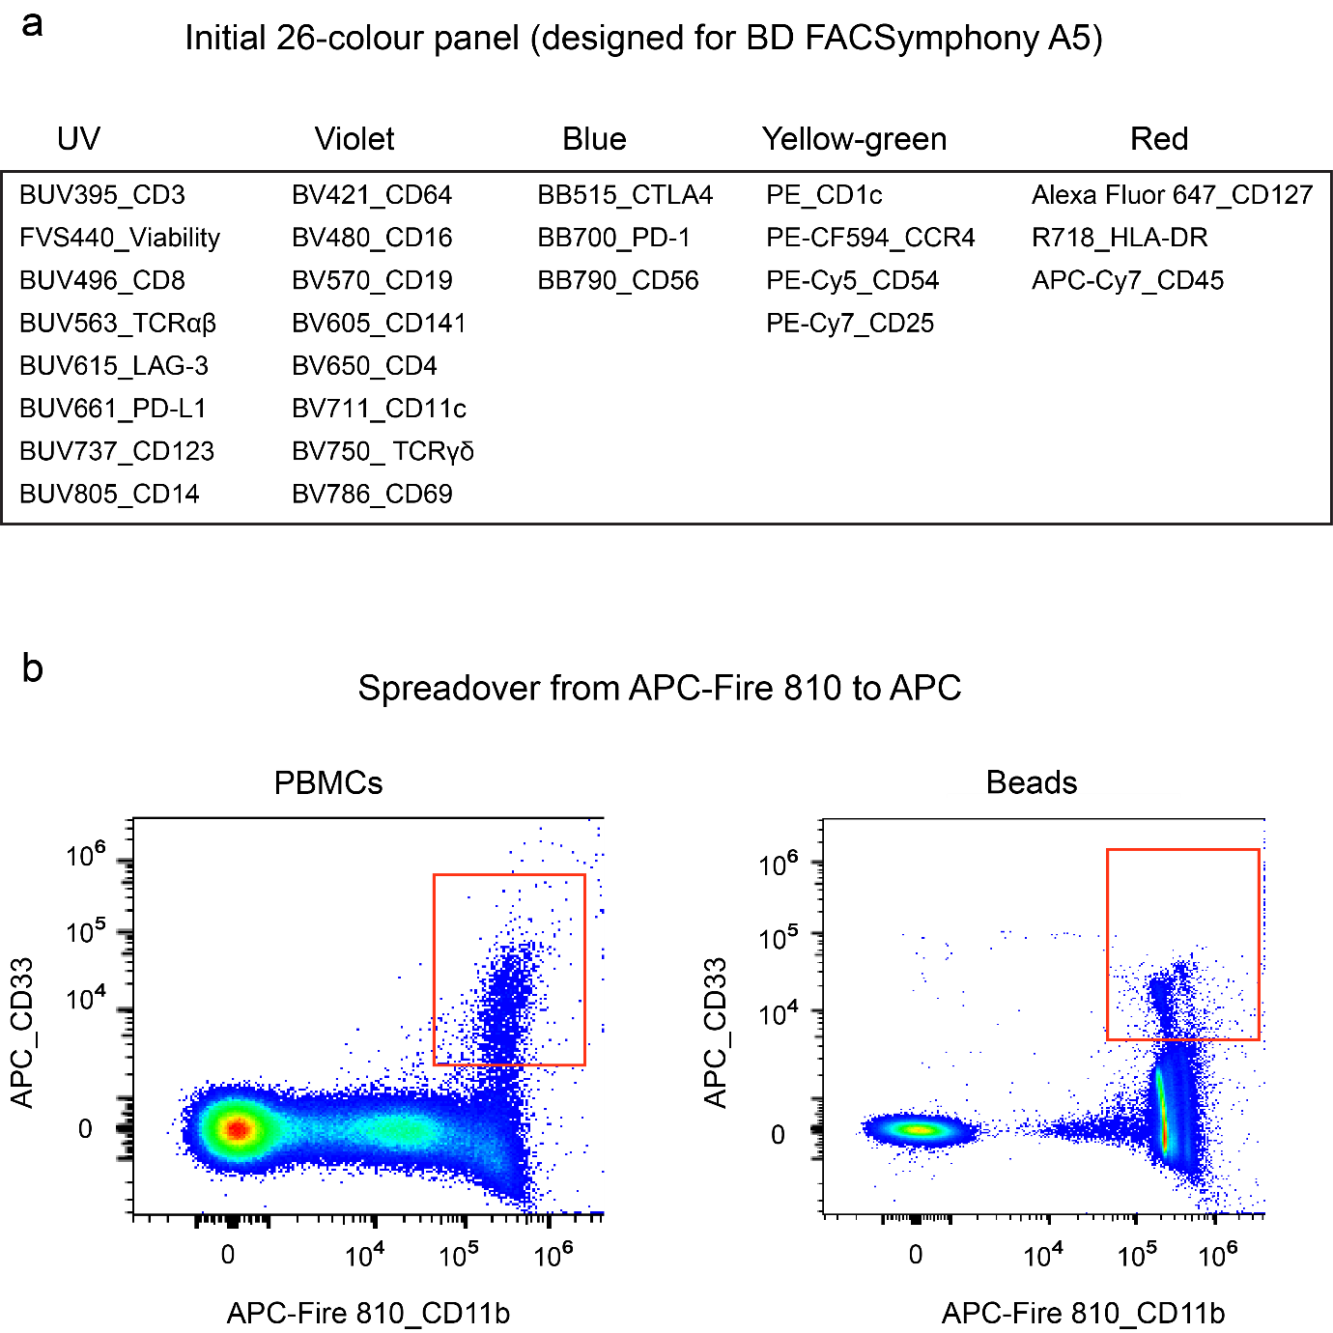
Supplementary Fig. 1 | Initial 26-colour panel and identified issues during panel Development.
a, The initial 26-colour panel used on the BD FACSymphony A5. b, On the Spectral cytometer Aurora, persistent signal spread from APC-Fire 810 (R8, emission peak 807 nm) into the APC (R1, emission peak 660 nm) channel observed after unmixing. This effect was detected in both PBMCs (left) and beads (right).

Supplementary Fig. 2 | Panel similarity index generated by Cytek Full Spectrum Viewer

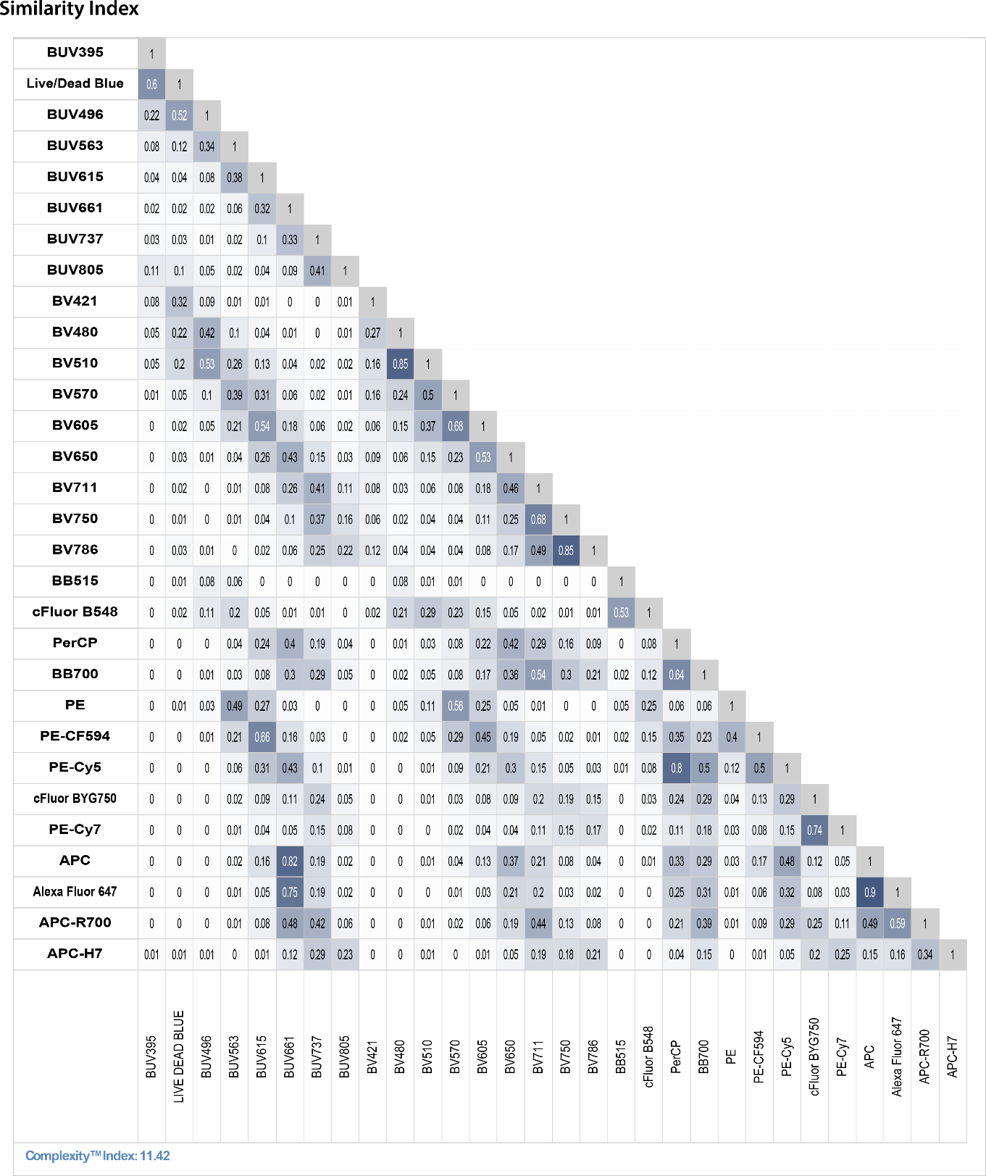
Supplementary Fig. 2 | Panel similarity index generated by Cytek Full Spectrum Viewer.
The matrix presents the Similarity Index values, which quantify the spectral similarity between pairs of fluorochromes used in the study panel. A value of 1 denotes near-identical spectral profiles, indicating high overlap, while a value of 0 reflects completely distinct spectra. Numerical values are shown for each fluorochrome pair included in the panel. The complexity index, shown at the bottom of the matrix, represents a metric to evaluate the overall spectral complexity of the panel, with higher values indicating greater potential for spectral overlap.

Supplementary Fig. 3 | Example of unmixing error when using beads as reference controls

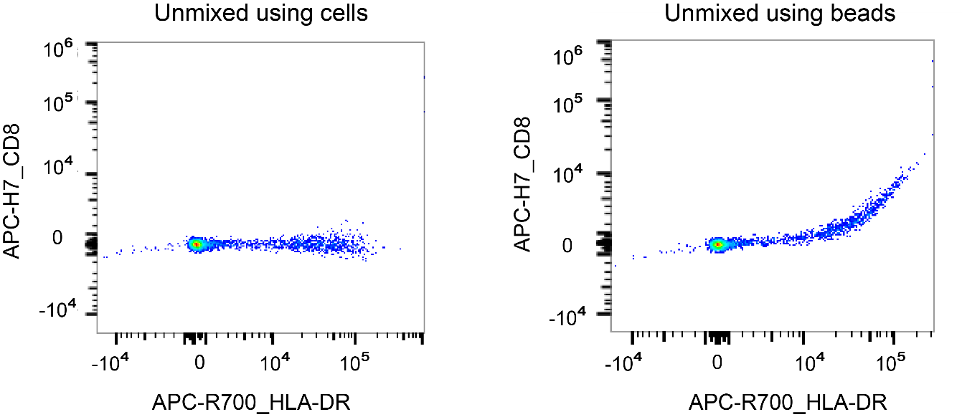
Supplementary Fig. 3 | Example of unmixing error when using beads as reference controls.
Comparison of unmixing accuracy using different reference controls for APC-R700_HLA-DR. (Left) Unmixing performed using cell-based controls shows no inaccuracies in the APC-H7 channel. (Right) Unmixing using bead-based reference controls results in signal spillover into the APC-H7 channel, demonstrating an unmixing error.

Supplementary Fig. 4 | Antibody reagent titration
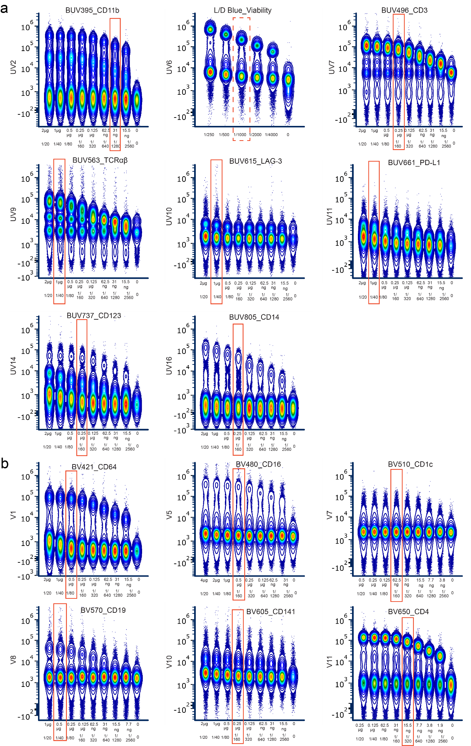
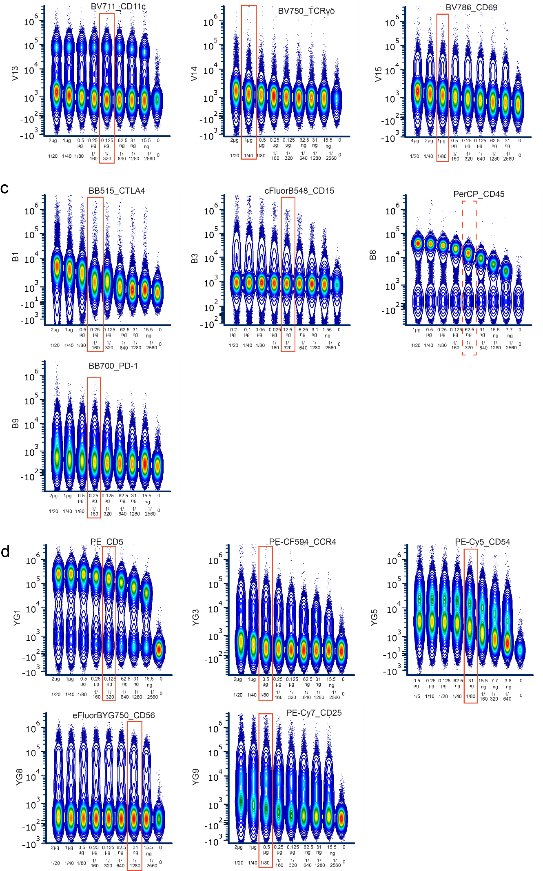
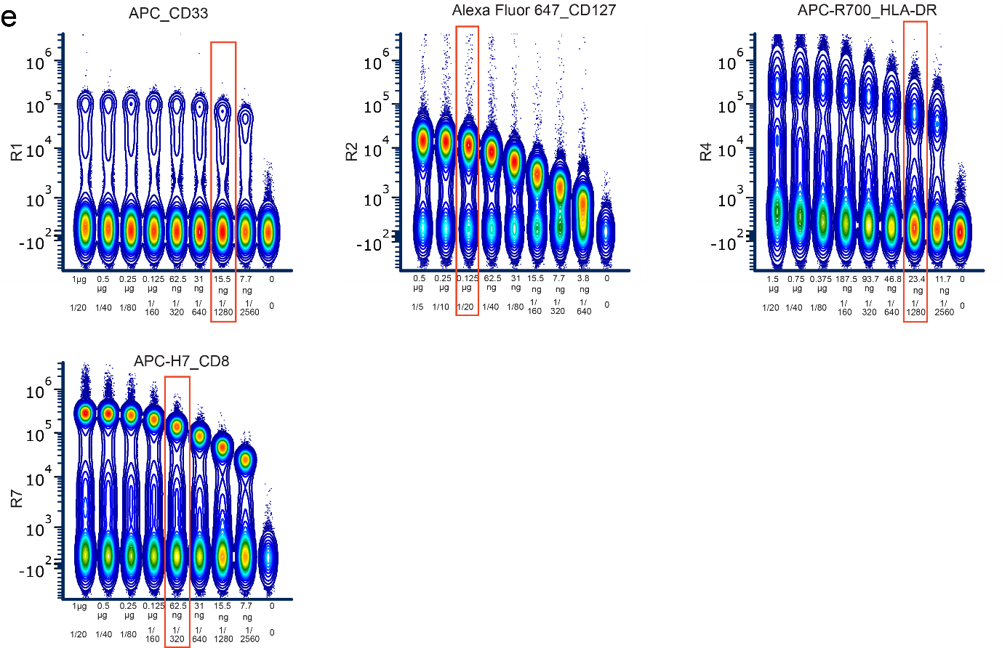
Supplementary Fig. 4 | Antibody reagent titration
All reagents were titrated using 1 × 10⁶ cells in a 200µL staining volume, with two-fold dilutions tested. The dilution range is described in the text. Antibody mass and dilution factors are shown on the x axis. Titrations for reagents primarily excited by the UV laser (355 nm) are shown in (a), violet laser (405 nm) in (b), blue laser (488 nm) in (c), yellow laser (561 nm) in (d), and red laser (640 nm) in (e). The optimal concentration of each reagent is indicated by the red box. Note that the concentrations for Live Dead Blue and PerCP_CD45 were not the final ones used, as indicated by dashed red boxes.

Supplementary Fig. 5 | Re-titration of three markers in the full panel after panel testing
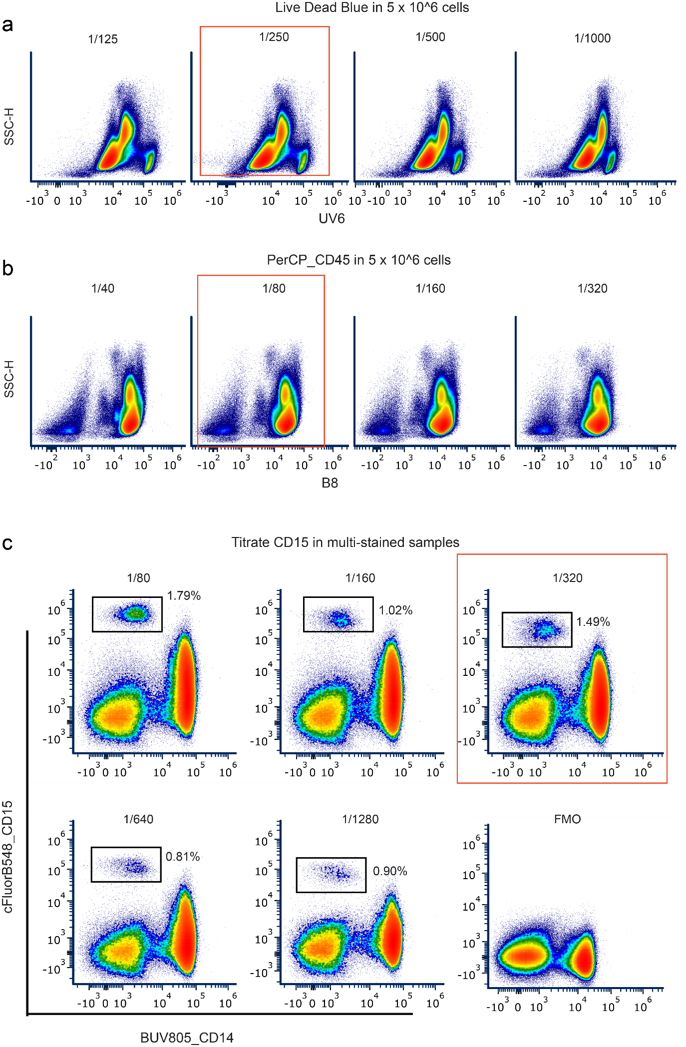
Supplementary Fig. 5 | Re-titration of three markers in the full panel after panel testing
a-b, Re-titration of Live Dead Blue (a) and PerCP_CD45 (b) at 5 × 10⁶ cells without mixing dead or unstained cells, simulating conditions of the final experiments. The concentrations chosen for the final experiments are indicated in the red box. c, Titration of CD15 in a scaled-down panel. The populations shown are unmixed, with each plot displaying CD45⁺CD3⁻CD19⁻CD56⁻ cells. The dilution of 1:320 was selected for final experiment (indicated by the red box).
Supplementary Fig. 6 | Panel robustness assessed by an N×N matrix of 19 lineage markers in one healthy donor PBMCs

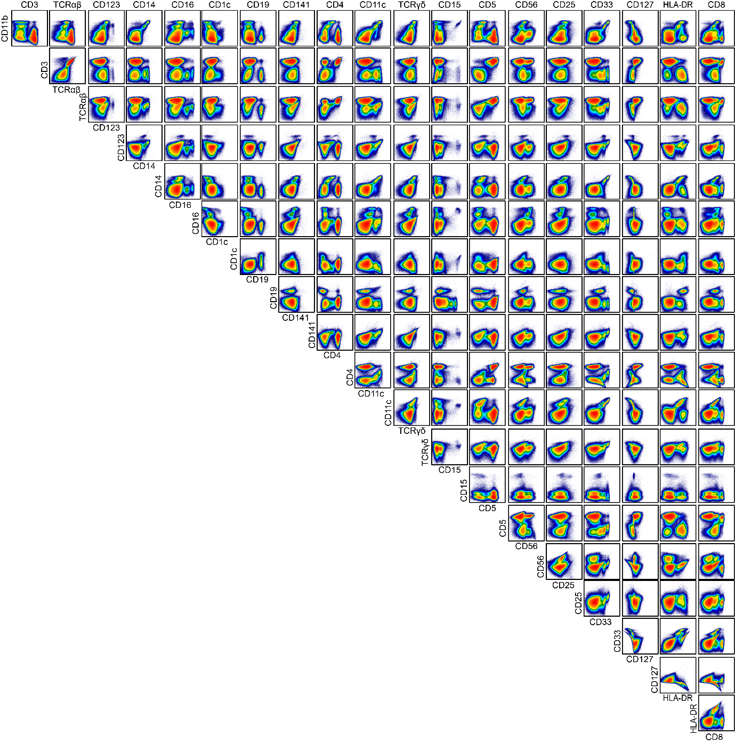
Supplementary Fig. 6 | Panel robustness assessed by an N×N matrix of 19 lineage markers in one healthy donor PBMCs.
A comprehensive pairwise matrix displaying the expression patterns of 19 lineage markers in healthy donor PBMCs, stained with the concluded panel concentration. Population was pre-gated on live CD45⁺ cells.

Supplementary Fig. 7 | Initial cleanup of manual gating

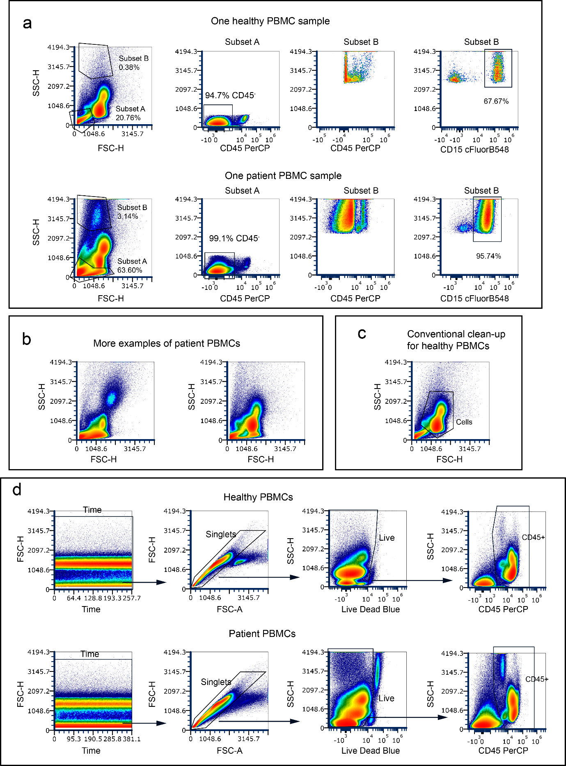
Supplementary Fig. 7 | Initial cleanup of manual gating.
a, Example comparison of healthy PBMCs and patient PBMCs, showing distinct cell distributions along SSC. The very low SSC population is referred to as Subset A, while the very high SSC population is referred to as Subset B. Notably, Subsets A and B appear at higher percentages in this patient PBMC sample, with the majority of Subset B identified as CD45⁺ and CD15⁺. b, Additional patient PBMC samples are shown, each displaying unique distributions on SSC versus FSC. c, Standard gating applied to healthy PBMCs on SSC versus FSC to obtain a cleaned-up cell population. d, Cleanup step of gating adopted in this study: Time – Single Cells – Viability – CD45, without reliance on any specific position along FSC versus SSC. All samples shown in this figure were obtained in the same batch. The healthy sample is a control from a healthy subject (HS14), which was included in every batch. All percentages shown in the plots represent the proportion of the gated population relative to the parent population displayed in the given plot.
Supplementary Fig. 8 | Gating strategy within CD45⁺ population
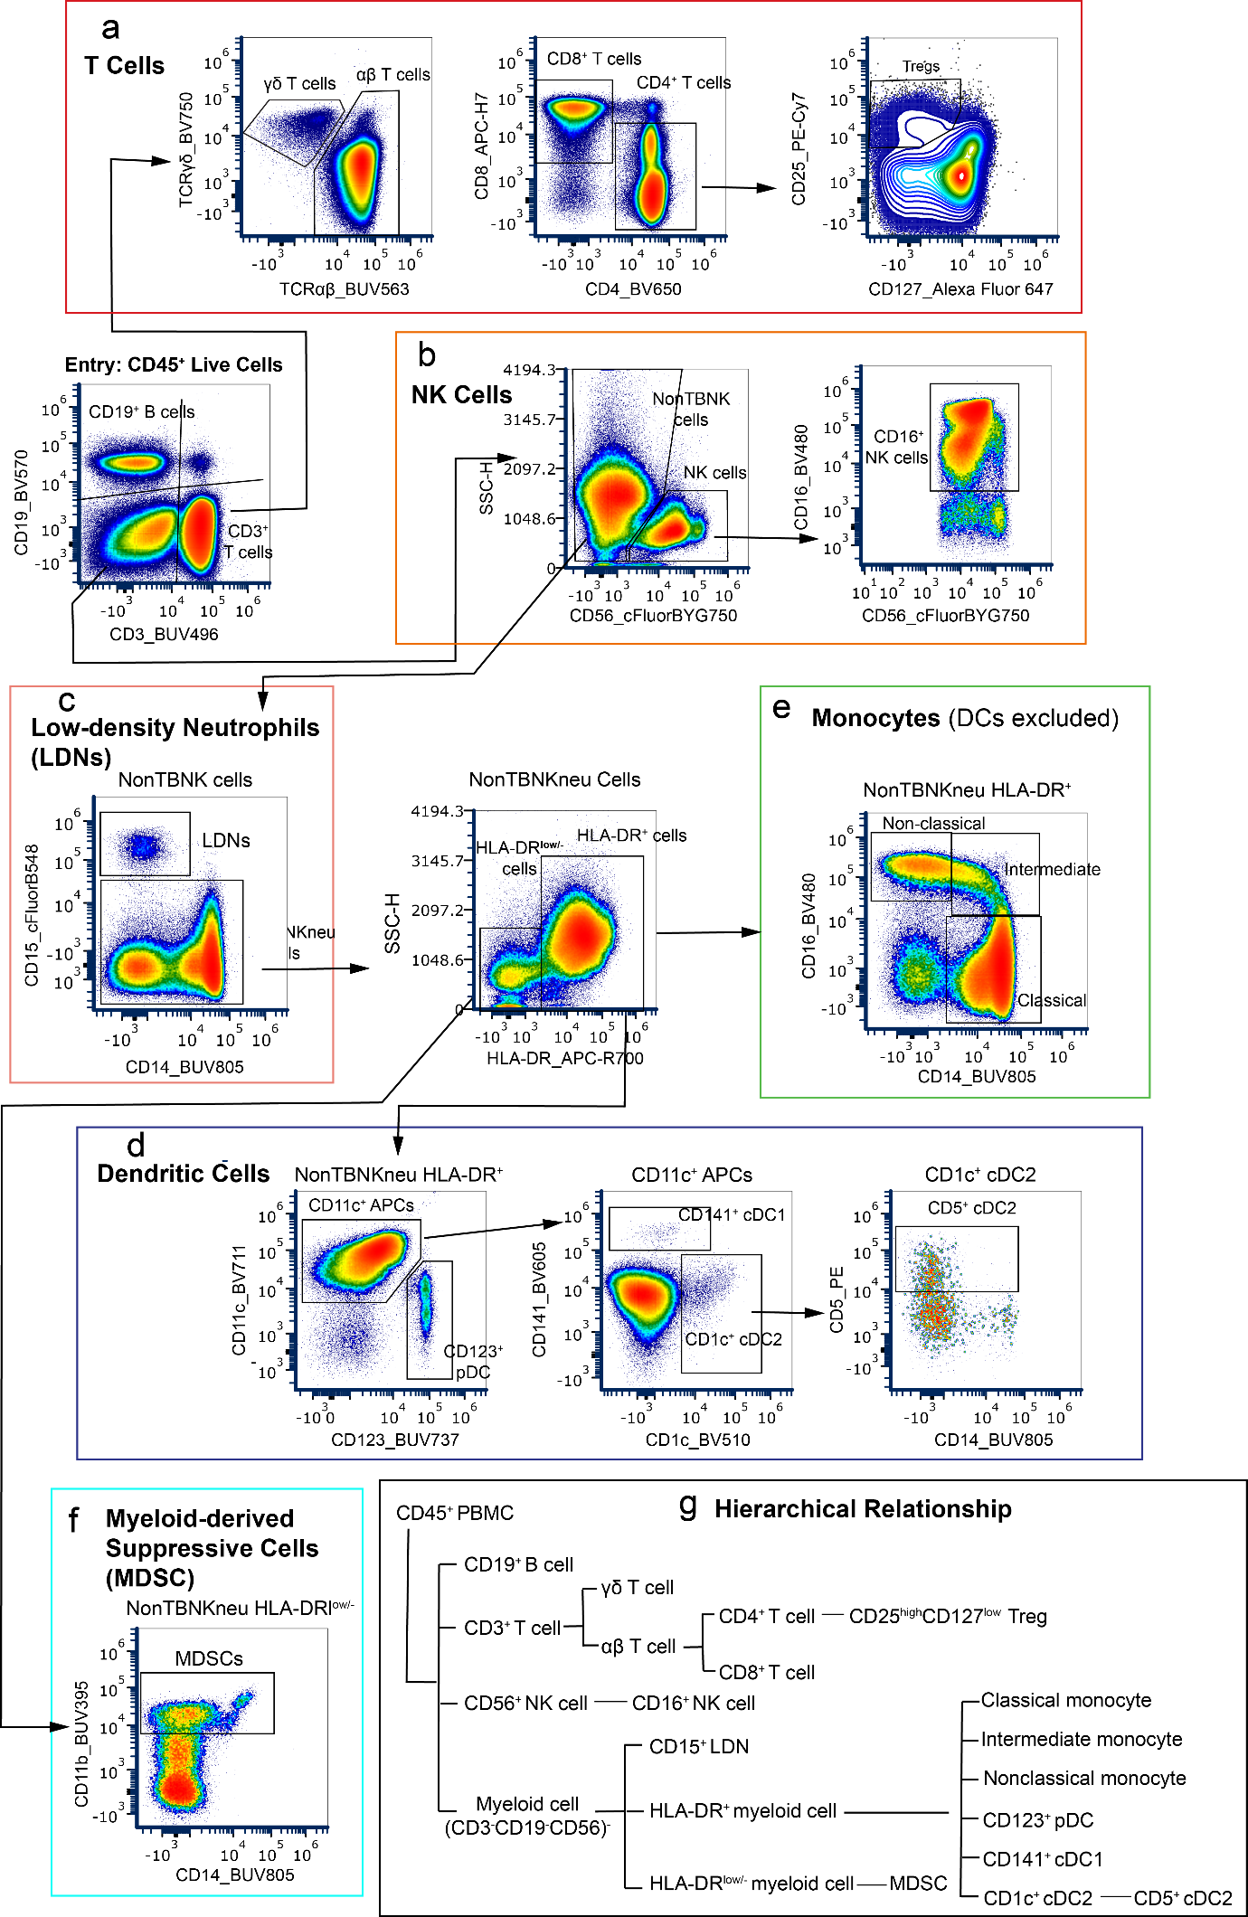
Supplementary Fig. 8 | Gating strategy within CD45⁺ population.
Representative gating strategies for identifying specific immune subsets within the CD45+ population: (a) T cells, (b) NK cells, (c) low-density neutrophils (LDNs), (d) dendritic cells, (e) monocytes, and (f) myeloid-derived suppressor cells (MDSCs). (g) A schematic diagram summarizing the hierarchical gating relationships and lineage branches of all identified immune subsets. Data shown in flow plots (a–f) are from a Batch-1 control sample (healthy subject).
Supplementary Fig. 9 | Technical instability and phenotypic distortion preclude the discrete resolution of specific immune subsets

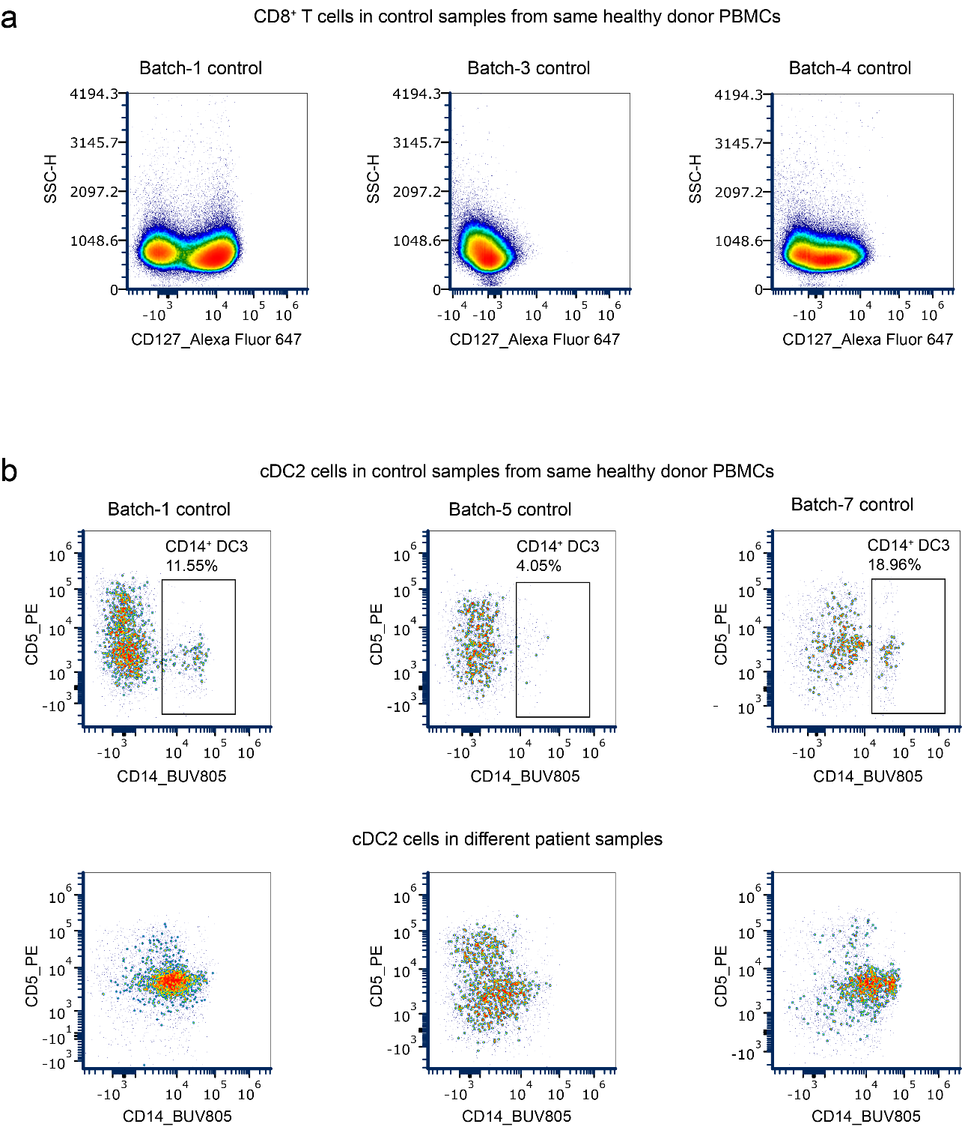
Supplementary Fig. 9 | Technical instability and phenotypic distortion preclude the discrete resolution of specific immune subsets.
a, Representative biaxial plots displaying CD127 expression on CD8+ T cells from a single healthy donor control PBMC sample acquired across three independent experimental batches. The severe batch-dependent fluctuation of the CD127 signal intensity and population distribution precluded the reliable, cohort-wide stratification of memory and effector T cell subsets. b, Evaluation of putative CD14+ DC3 populations pre-gated on cDC2s. Top: Plots from the same healthy donor control sample analyzed across three different batches, demonstrating profound technical instability in the frequency of the CD14+ fraction (percentages indicated). Bottom: Representative plots of cDC2s from three distinct cancer patient samples. The disease-associated phenotypic distortion creates a continuous spectrum of CD14 expression, rendering the discrete DC3 subset biologically unresolvable in the clinical cohort. Consequently, to ensure analytical rigor, subsets shown in (a) and (b) were not discretely partitioned and were instead evaluated collectively in downstream analyses.

Supplementary Fig. 10 | Manual gating strategies to resolve phenotypic distortion and batch variability in cancer patient PBMCs
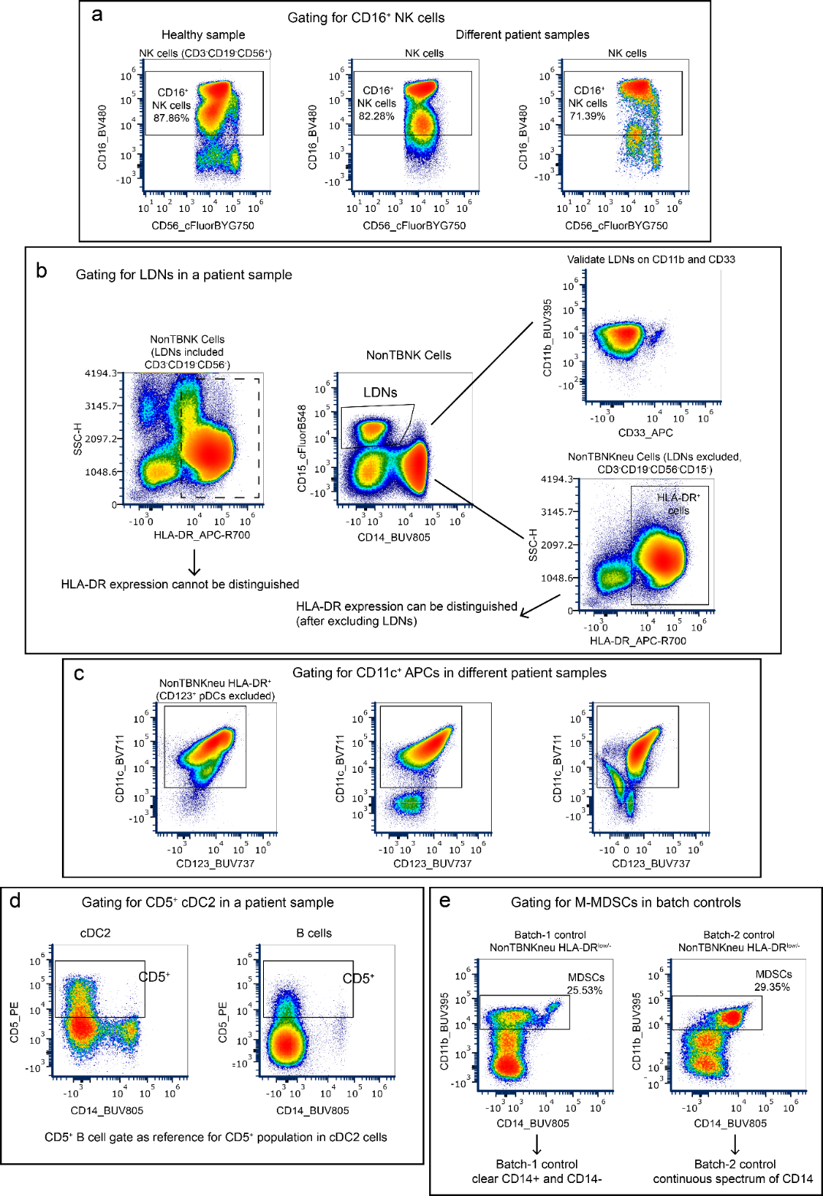
Supplementary Fig. 10 | Manual gating strategies to resolve phenotypic distortion and batch variability in cancer patient PBMCs.
a, Uniform gating of CD16⁺ NK cells within CD56⁺ NK cells. Compared to the discrete populations seen in healthy donors (left), patient samples frequently exhibit distorted, continuous CD16 expression. Standardized gating accommodates this disease-associated continuum (all three samples are from the same batch). b, Early gating of disease-expanded low-density neutrophils (LDNs; CD15⁺CD14⁻) to prevent downstream interference. LDNs are confirmed as CD11b⁺CD33^{dim} (top right). Separating them from the remaining NonTBNK compartment (yielding NonTBNKneu cells) restores the resolution of the HLA-DR⁺ and HLA-DR^{low/}⁻ compartments (bottom right), which are otherwise entirely masked by the LDN continuum (left). c, Uniform gating of CD11c⁺ antigen-presenting cells (APCs) across different patient samples, demonstrating how standardized gating is maintained despite severe, patient-specific phenotypic heterogeneity in CD11c and CD123 expression shapes. d, Identification of CD5⁺ cDC2 subsets using an intra-sample internal calibration strategy. The boundary for CD5 positivity on cDC2s (left) is objectively established using the CD5 expression profile on B cells (right) from the exact same patient sample. e, Batch-resilient gating of myeloid-derived suppressor cells (MDSCs). Comparison of the identical control sample acquired in two different batches reveals technical instability in CD14 expression (discrete in Batch-1 vs. a continuous spectrum in Batch-2). To prevent arbitrary thresholding errors, MDSCs are gated collectively using stable CD11b⁺⁺ expression within the HLA-DR^{low/}⁻ compartment.
Supplementary Fig. 11 | Expression of functional and activation markers

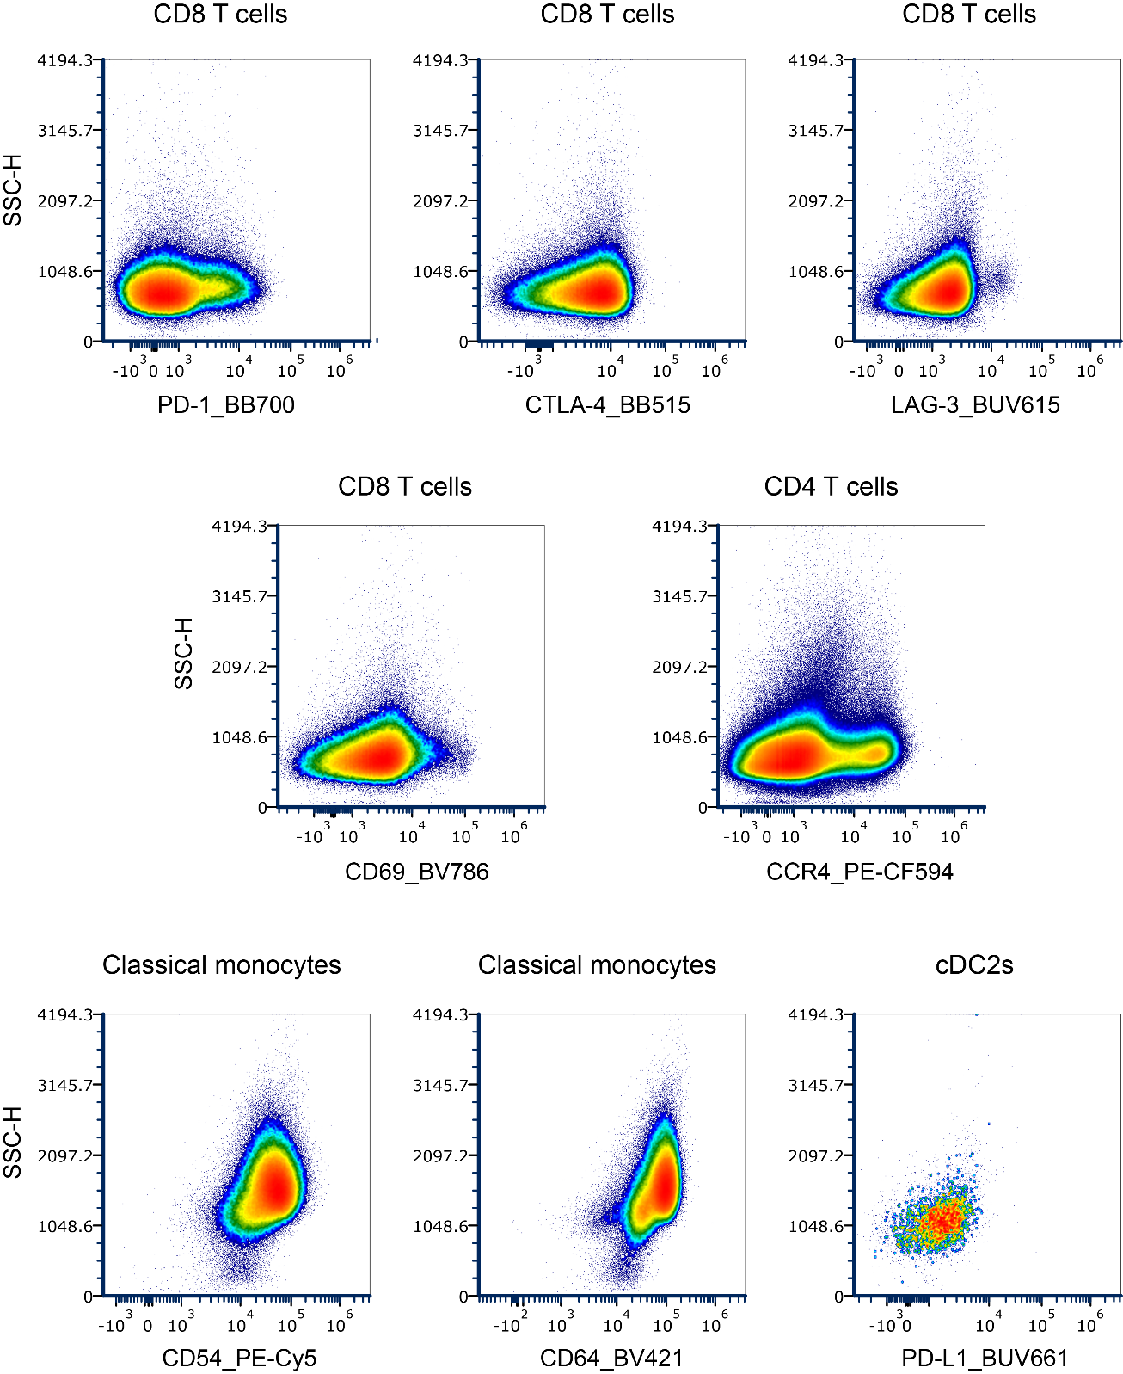
Supplementary Fig. 11| Expression of functional and activation markers.
Representative plots illustrating continuous expression patterns of functional markers in selected cell subsets. Arcsinh-transformed Median fluorescence intensity (arcsinh-MFI) values were used for quantitative analysis, as definitive positive or negative gating was not feasible.

Supplementary Fig. 12 | Assessment of technical variability and subset consistency across batch controls

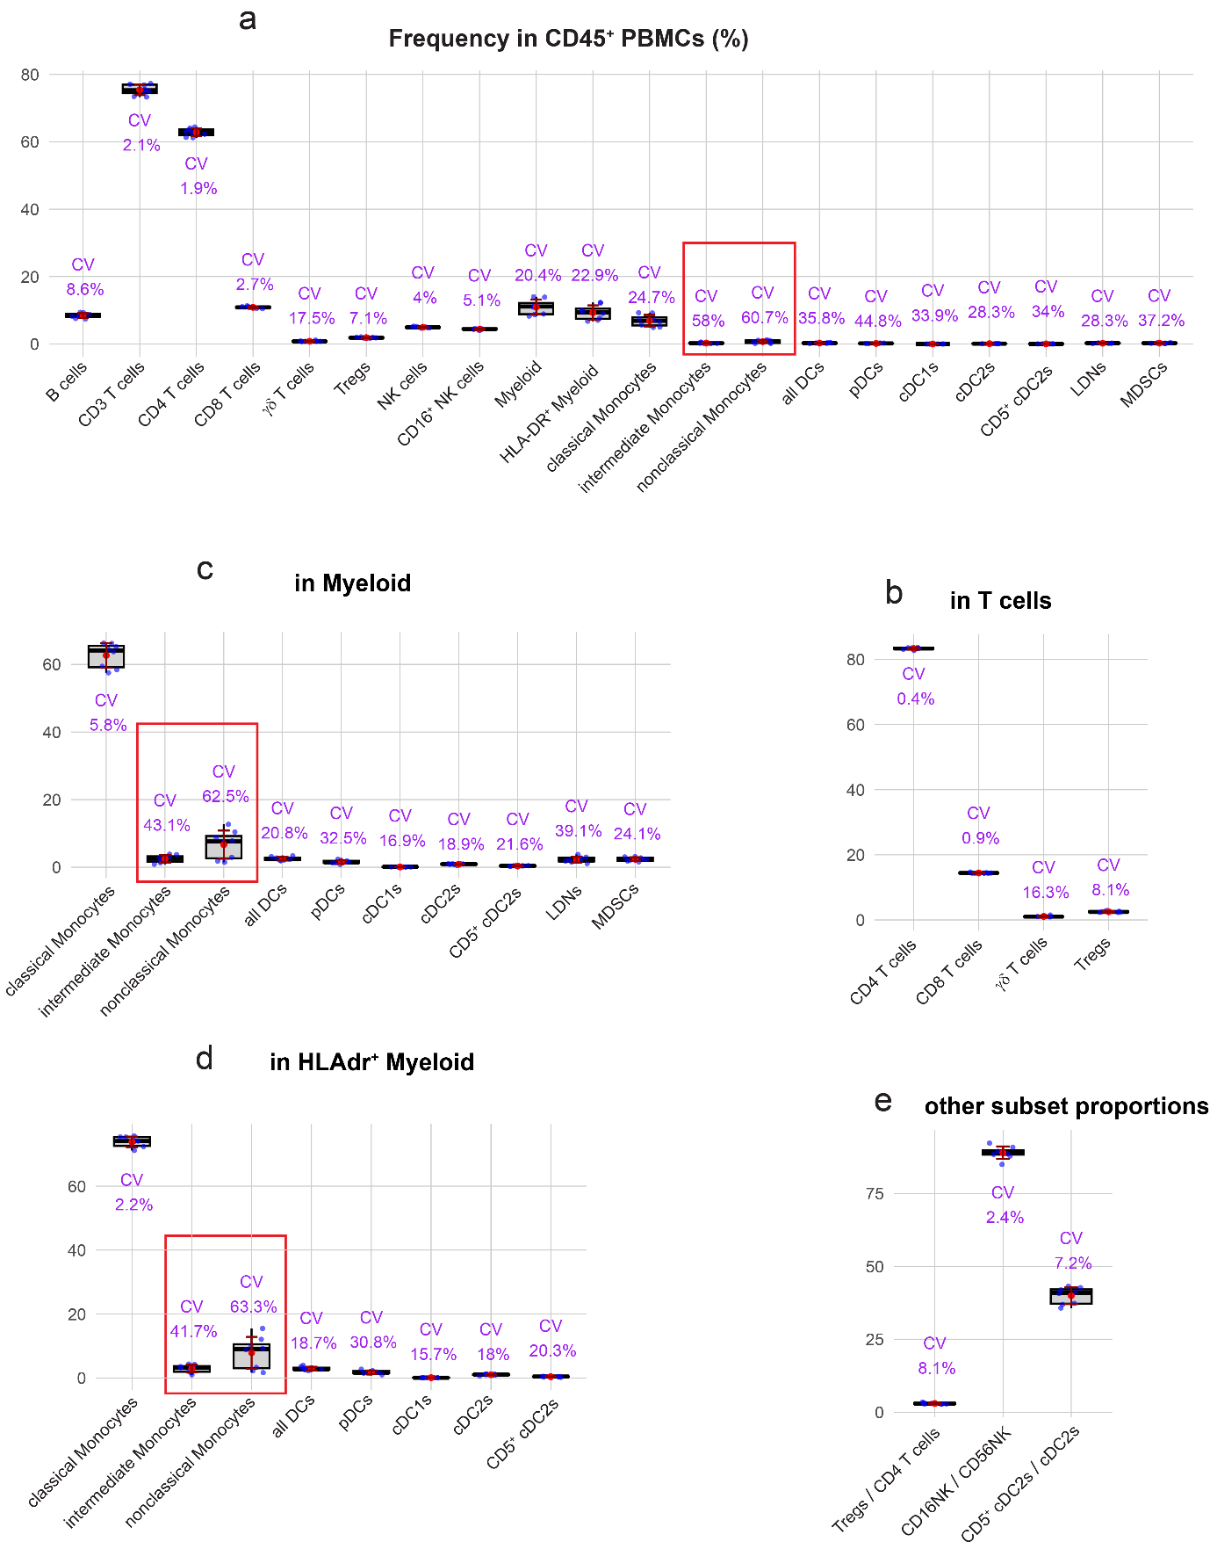
Supplementary Fig. 12 | Assessment of technical variability and subset consistency across batch controls.
Box plots illustrating immune cell subset frequencies calculated relative to different parent populations (denominators) using identical healthy control samples included in each experimental batch (8 independent batches). Frequencies are shown as: a, percentage of total CD45⁺ PBMCs, b, percentage of CD3⁺ T cells, c, percentage of total myeloid cells, d, percentage of HLA-DR⁺ myeloid cells, and e, selected proportions relative to other specific subsets. For each cell population, blue dots represent individual control values from each batch. The red dot and corresponding red error bars denote the mean $±$ standard deviation (SD). Boxes show 25th, 50th and 75th centiles; whiskers indicate 1.5 × inter-quartile range; points represent individual samples. Although the absolute SD values across all subsets remained relatively low (range: 0.003 to 3.615), SD does not account for differences in mean population sizes. Therefore, the coefficient of variation (CV) was calculated (displayed in purple) to properly assess relative variability. This CV assessment revealed that intermediate and nonclassical monocytes lacked technical consistency; these subsets are highlighted with red bounding boxes and were subsequently excluded from downstream analyses.
Supplementary Fig. 13 | Phenotypic characterization and validation of automated myeloid cell clustering.
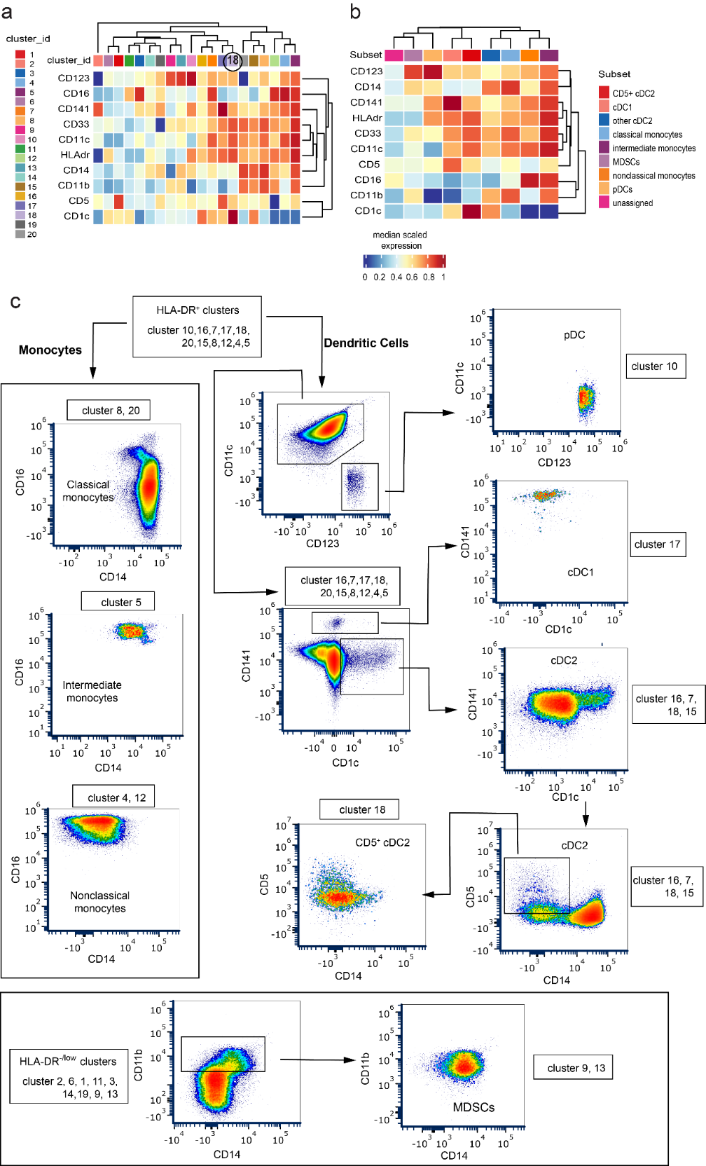
Supplementary Fig. 13 | Phenotypic characterization and validation of automated myeloid cell clustering.
a, Heatmap displaying the median scaled expression of ten phenotypic lineage markers across the 20 metaclusters generated by unsupervised clustering (FlowSOM and ConsensusClusterPlus) of pre-gated myeloid cells (CD3⁻CD19⁻CD56⁻CD15⁻). Metacluster 18, which corresponds to the CD5⁺ cDC2 population, is highlighted by a black circle. b, Heatmap illustrating the aggregated marker expression profiles after manually annotating and merging the 20 initial metaclusters into distinct biological subsets. c, Representative bi-axial flow cytometry plots displaying the computationally derived metaclusters. The flow of the arrows demonstrates that the phenotypic hierarchy and distribution of the automated clusters align with the established manual gating strategy (detailed in Supplementary Fig. 8). This back-gating validation confirms the phenotypic consistency and biological relevance of the unsupervised clustering approach. However, a technical artifact emerged in cluster 17 (annotated as cDC1): automated clustering assigned high CD5 expression to this subset in the heatmaps (a, b), whereas manual gating reveals cDC1s exhibit only moderate or low CD5 compared to CD5⁺ cDC2. This discrepancy likely reflects redistributed CD5 expression intensities during computational batch alignment, underscoring a limitation of automated workflows in resolving overlapping continuous marker distributions.
Supplementary Fig. 14 | Baseline PD-1 expression on dendritic cells versus T cell subsets.

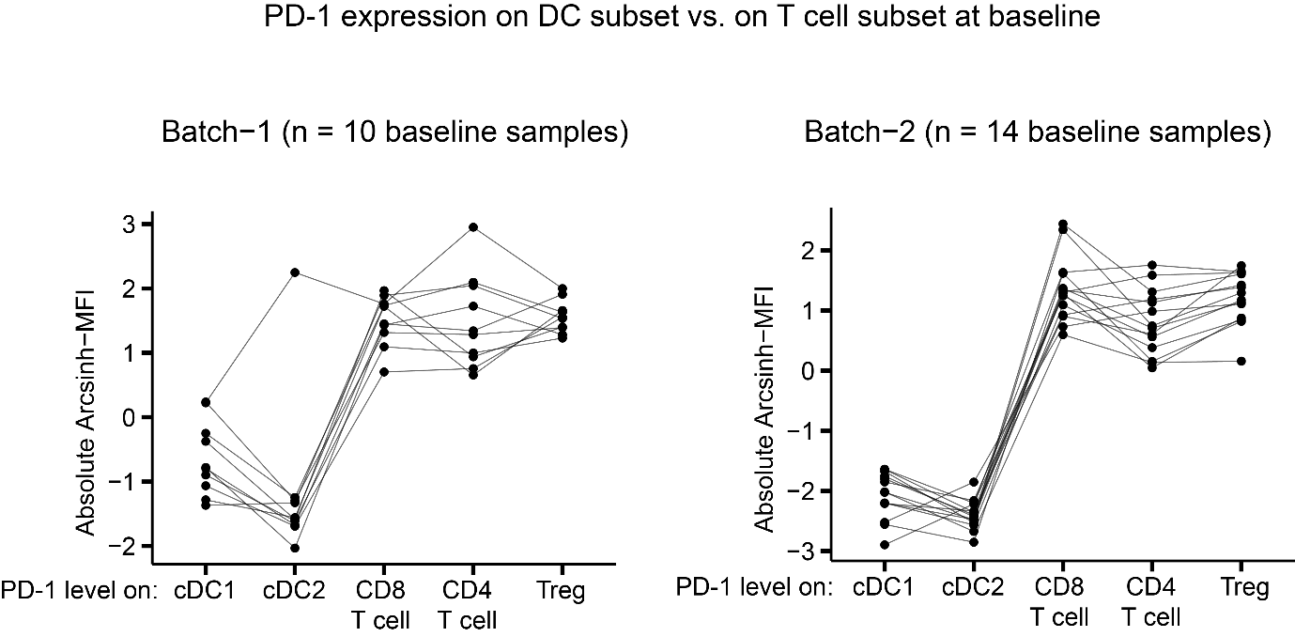
Supplementary Fig. 14 | Baseline PD-1 expression on dendritic cells versus T cell subsets.
Line plots displaying the absolute arcsinh-transformed median fluorescence intensity (MFI) of PD-1 across five immune cell subsets (cDC1, cDC2, CD8⁺ T cells, CD4⁺ T cells, and Tregs) at baseline. Data are presented for two independent experimental batches (Batch-1, n = 10 baseline samples; Batch-2, n = 14 baseline samples). Lines connect data points from the same individual patient to illustrate intra-sample expression hierarchies. To enable valid cross-subset comparisons within individual samples, absolute arcsinh-MFI values are utilized here. This approach fundamentally differs from the subset-specific normalized MFI used in the main figures, which correct for batch-to-batch variability across different samples but preclude direct comparisons between distinct cell lineages. These unnormalized data consistently demonstrate that baseline PD-1 expression on cDC1 and cDC2 subsets is minimal compared to the high levels observed on T cells. This minimal baseline expression supports the biological premise that post-treatment PD-1 upregulation on myeloid cells likely reflects activation-induced signalling rather than the direct therapeutic blockade of pre-existing receptors. No statistical testing was applied to these illustrative intra-sample comparisons.

Supplementary Fig. 15 | Schematic representation of the species-resolved functional data structure used for differential per-cell output modelling.

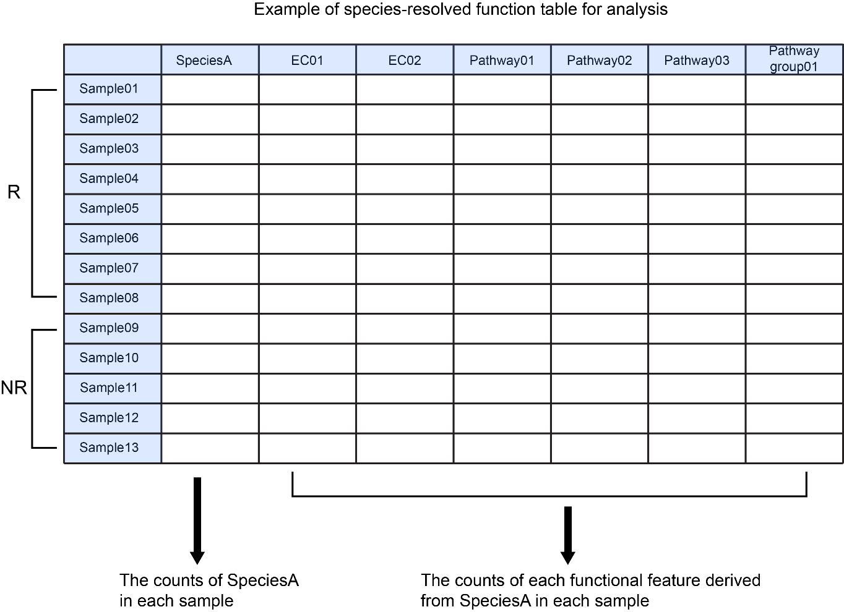
Supplementary Fig. 15 | Schematic representation of the species-resolved functional data structure used for differential per-cell output modelling.
This table illustrates the input data matrix generated for each signature species to evaluate function-per-cell output via DESeq2. Rows represent individual patient samples, stratified by clinical response (R, responders; NR, non-responders). Columns denote the absolute counts of a representative species (e.g., "SpeciesA") alongside the absolute counts of specific functional features (such as Enzyme Commission [EC] genes, MetaCyc pathways, and pathway groups) that are genetically derived from that exact species within each sample. In the subsequent differential analysis, the species counts (left arrow) were incorporated as the library size factor to normalize the corresponding functional feature counts (right arrow), allowing for the isolation of metabolic shifts independent of changes in taxonomic biomass.

Supplementary Table 1. Optical layout of fluorochromes and reagents
Approx. Emission  Wavelength (nm) | UV | Violet | Blue | Yellow Green | Red
395 | BUV395  (CD11b)
420 |  | BV421  (CD64)
450 | L/D Blue  (Viability)
480 |  | BV480  (CD16)
500 | BUV496  (CD3) |  | BB515  (CTLA-4)
520 |  | BV510  (CD1c)
550 |  |  | cFluorB548  (CD15)
570 | BUV563  (TCRαβ) | BV570  (CD19)
580 |  |  |  | PE  (CD5)
600 | BUV615  (LAG-3) | BV605  (CD141) |  | PE-CF594  (CCR4)
660 | BUV661  (PD-L1) | BV650  (CD4) |  |  | APC  (CD33)
680 |  |  | PerCP  (CD45) | PE-Cy5  (CD54) | Alexa Fluor 647  (CD127)
700 |  | BV711  (CD11c) | BB700  (PD-1) |  | APC-R700  (HLA-DR)
730 | BUV737  (CD123)
750 |  | BV750  (TCRγδ) |  | cFluor BYG750  (CD56)
780 |  | BV786  (CD69) |  | PE-Cy7  (CD25) | APC-H7  (CD8)
800 | BUV805  (CD14)

Supplementary Table 2. Antibody panel with fluorochromes, clones, and functional purpose
Specificity | Fluorochrome | Clone | Purpose
Viability | Live Dead UV Blue |  | Viability
CD45 | PerCP | 2D1 | Leukocytes
CD3 | BUV496 | UCHT1 | Pan T cells
TCRγδ | BV750 | 11F2 | γδ T cells
TCRαβ | BUV563 | IP26 | αβ T cells
CD4 | BV650 | SK3 | Helper T cell subsets
CD8 | APC-H7 | HIT8a | Cytotoxic T cells
CD25 | PE-Cy7 | M-A251 | Regulatory T cells
CD127 | Alexa Fluor 647 | HIL-7R-M21 | T cell differentiation and memory
CD19 | BV570 | HIB19 | B cells
CD56 | cFluor-BYG750 | TULY56 | NK cells
HLA-DR | APC-R700 | G46-6 | Antigen-presenting cells
CD14 | BUV805 | M5E2 | Monocyte subsets
CD16 | BV480 | 3G8 | Monocyte, dendritic cell, NK cell activation
CD11c | BV711 | S-HCL-3 | Dendritic cell differentiation
CD123 | BUV737 | 9F5 | Plasmacytoid dendritic cells
CD141 | BV605 | 1A4 | Conventional dendritic cell differentiation
CD1c | BV510 | L161 | Conventional dendritic cell differentiation
CD11b | BUV395 | D12 | Innate immune cells
CD33 | APC | P67.6 | Myeloid cells
CD15 | cFluorB548 | HI98 | Neutrophil-like cells
CD5 | PE | UCHT2 | Dendritic cell activation
CD69 | BV786 | FN50 | Early T cell activation
CD64 | BV421 | MD22 | Monocyte, dendritic cell activation
CD54 | PE-Cy5 | HA58 | Activation of T, B, NK, dendritic cells and monocytes
PD-1 | BB700 | EH12.1 | Inhibitory receptor, T cell exhaustion
PD-L1 | BUV661 | MIH1 | Immune checkpoint ligand, expressed on APCs
CTLA-4 | BB515 | BNI3 | Inhibitory receptor on regulatory and activated T cells
LAG-3 | BUV615 | T47-530 | Inhibitory receptors; T cell regulation and exhaustion
CCR4 | PE-CF594 | 1G1 | Chemokine receptor; Treg and Th2 cell trafficking

Supplementary Table 3. Antibody sources, vendors, and titration details
Antibody | Catalog | Vendor | Titer (ng/test) | Working Dilution  (per 200µl test)
BUV395_ CD11b | 742634 | BD Biosciences | 31 | 1/1280
Live Dead UV Blue | L34962 | Thermo Fisher | – | 1/250
BUV496_CD3 | 612940 | BD Biosciences | 250 | 1/160
BUV563_ TCRαβ | 749197 | BD Biosciences | 1000 | 1/40
BUV615_ LAG-3 | 752362 | BD Biosciences | 1000 | 1/40
BUV661_ PD-L1 | 741666 | BD Biosciences | 1000 | 1/40
BUV737_ CD123 | 741851 | BD Biosciences | 250 | 1/160
BUV805_ CD14 | 612902 | BD Biosciences | 250 | 1/160
BV421_ CD64 | 744827 | BD Biosciences | 500 | 1/80
BV480_ CD16 | 566108 | BD Biosciences | 500 | 1/160
BV510_ CD1c | 331534 | BioLegend | 62.5 | 1/160
BV570_ CD19 | 302236 | BioLegend | 500 | 1/40
BV605_ CD141 | 740421 | BD Biosciences | 250 | 1/160
BV650_ CD4 | 563875 | BD Biosciences | 15.5 | 1/320
BV711_ CD11c | 744438 | BD Biosciences | 125 | 1/320
BV750_ TCRγδ | 747127 | BD Biosciences | 1000 | 1/40
BV786_ CD69 | 563834 | BD Biosciences | 1000 | 1/80
BB515_ CTLA-4 | 566917 | BD Biosciences | 250 | 1/160
cFluorB548_ CD15 | R7-11025 | CYTEK | 125 | 1/320
PerCP_CD45 | 679459 | CYTEK | 250 | 1/80
BB700_ PD-1 | 566460 | BD Biosciences | 250 | 1/160
PE_ CD5 | 500059 | CYTEK | 125 | 1/320
PE-CF594_ CCR4 | 565391 | BD Biosciences | 500 | 1/80
PE-Cy5_ CD54 | 555512 | BD Biosciences | 31 | 1/80
cFluor-BYG750_ CD56 | R7-20283 | CYTEK | 31 | 1/1280
PE-Cy7_ CD25 | 557741 | BD Biosciences | 500 | 1/80
APC_ CD33 | 366606 | BioLegend | 15.5 | 1/1280
Alexa Fluor 647_ CD127 | 558598 | BD Biosciences | 125 | 1/20
APC-R700_ HLA-DR | 565127 | BD Biosciences | 23.4 | 1/1280
APC-H7_ CD8 | 566855 | BD Biosciences | 62.5 | 1/320

Supplementary Table 4. Associations of patient demographics and clinical variables with response status
Characteristics | Responders  ( n = 56) | Non-responders  (n = 17) | P-value
Gender  • Male  • Female | 36 (64.29%, 75%)  20 (35.71%, 80%) | 12 (70.59%, 25%)  5 (29.41%, 20%) | 0.851  (Chi-squared)
Age | mean (66.02) | mean (62.24) | 0.092  (Wilcoxon)
BMI | mean (29.19) | mean (28.72) | 1  (Wilcoxon)
Cancer Type  1. Melanoma  2. NSCLC  3. Renal  4. cSCC  5. HNC | 1. 24 (42.85%, 80%)  2. 19 (33.93%, 79.16%)  3. 5 (8.93%, 62.5%)  4. 8 (14.29%, 88.89%)  5. 0 | 1. 6 (35.29%, 20%)  2. 5 (29.41%, 20.83%)  3. 3 (17.65%, 37.5%)  4. 1 (5.88%, 11.11%)  5. 2 (11.76%, 100%) | 0.1227  (Fisher's exact)
Pre-treatment antibiotic use (past 3 months)  • Yes  • No | • 21 (37%, 87.5%)  • 35 (62%, 71.43%) | • 3 (17%, 12.5%)  • 14 (82%, 28.57%) | 0.218  (Chi-squared)
Alcohol  1. Current  2. Former  3. Never | 1. 24 (42.86%, 82.76%)  2. 9 (16.07%, 75%)  3. 23 (41.07%, 71.88%) | 1. 5 (29.41%, 17.24%)  2. 3 (17.65%, 25%)  3. 9 (52.94%, 28.12%) | 0.6143  (Fisher's exact)
Smoking  1. Current  2. Former  3. Never | 1. 14 (25%, 73.69%)  2. 24 (42.86%, 77.42%)  3. 18 (32.14%, 78.26%) | 1. 5 (29.41%, 26.31%)  2. 7 (41.18%, 22.58%)  3. 5 (29.41%, 21.74%) | 1  (Fisher's exact)
Therapy Type  • Monotherapy  (Cemiplimab or Pembrolizumab  or Nivolumab)  • Combined therapy  (Ipilimumab / Nivolumab) | • 37 (66.07%, 78.72%)  • 19 (33.93%, 73.08%) | • 10 (58.82%, 21.28%)  • 7 (41.18%, 26.92%) | 0.797  (Chi-squared)
irAE severity  • Mild (Grade 0 -2)  • Severe (Gade >= 3) | • 46 (82.14%, 75.41%)  • 10 (17.86%, 83.33%) | • 15 (88.24%, 24.59%)  • 2 (11.75%, 16.67%) | 0.72  (Fisher's exact)
Note: For categorical variables, data are presented as patient counts with column and row percentages: n (column %, row %). Continuous variables (age and body mass index [BMI]) are presented as mean values. Statistical significance between responders (n = 56) and non-responders (n = 17) was assessed using two-sided Wilcoxon rank-sum tests for continuous variables. For categorical variables, Pearson's chi-squared tests were utilized when all expected cell frequencies were $≥$5; otherwise, Fisher’s exact tests were applied. The specific statistical test used for each variable is indicated in the rightmost column.

Supplementary Table 5. Association between therapy type and longitudinal changes in surface CTLA-4 expression across immune cell subsets.
 | Combined Therapy  (anti-PD-1/CTLA-4)  （n = 18) | Mono Therapy  (anti-PD-1)  (n = 33) | P value  (chi-squared)
CTLA-4 on B cells  • Decrease  • Increase | • 6 (33.33%, 33.33%)  • 12 (66.67%, 36.36%) | • 12 (36.36%, 66.67%)  • 21 (63.64%, 63.64%) | 0.829
CTLA-4 on CD4 cells  • Decrease  • Increase | • 6 (33.33%, 31.58%)  • 12 (66.67%, 37.5%) | • 13 (39.39%, 68.42%)  • 20 (60.61%, 62.5%) | 0.669
CTLA-4 on CD8 cells  • Decrease  • Increase | • 5 (27.78%, 29.41%)  • 13(72.22%, 38.24%) | • 12 (36.36%, 70.59%)  • 21 (63.63%, 61.76%) | 0.534
CTLA-4 on Tregs  • Decrease  • Increase | • 5 (27.78%, 27.78%)  • 13(72.22%, 39.39%) | • 13 (39.39%, 72.22%)  • 20 (60.61%, 60.6%) | 0.407
CTLA-4 on NK cells  • Decrease  • Increase | • 3 (16.67%, 20%)  • 15(83.33%, 41.67%) | • 12 (36.36%, 80%)  • 21 (63.63%, 58.33%) | 0.14
CTLA-4 on CD16⁺ NK cells  • Decrease  • Increase | • 3 (16.67%, 20%)  • 15(83.33%, 41.67%) | • 12 (36.36%, 80%)  • 21 (63.63%,58.33%) | 0.14
CTLA-4 on HLA-DR myeloid cells  • Decrease  • Increase | • 4 (22.22%, 22.22%)  • 14(77.78%, 42.42%) | • 14 (42.42%, 77.78%)  • 19 (57.58%, 57.58%) | 0.149
CTLA-4 on Classical monocytes  • Decrease  • Increase | • 4 (22.22%, 22.22%)  • 14(77.78%, 42.42%) | • 14 (42.42%, 77.78%)  • 19 (57.58%, 57.58%) | 0.149
CTLA-4 on pDC  • Decrease  • Increase | • 3 (16.67%, 15%)  • 15(83.33%, 48.39%) | • 17 (51.51%, 85%)  • 16 (48.49%, 51.61%) | 0.0148
CTLA-4 on cDC1  • Decrease  • Increase | • 4 (22.22%, 23.52%)  • 14(77.78%, 41.17%) | • 13 (39.39%, 76.47%)  • 20 (60.61%, 58.82%) | 0.214
CTLA-4 on cDC2  • Decrease  • Increase | • 2 (11.11%, 13.33%)  • 16(88.89%, 44.44%) | • 13 (39.39%, 86.67%)  • 20 (60.61%, 55.56%) | 0.0341
CTLA-4 on CD5⁺ cDC2  • Decrease  • Increase | • 2 (11.11%, 10.52%)  • 16(88.89%, 50%) | • 17 (51.51%, 89.47%)  • 16 (48.49%, 50%) | 0.004
CTLA-4 on LDNs  • Decrease  • Increase | • 7 (38.89%, 29.17%)  • 11(61.11%, 40.74%) | • 17 (51.51%, 70.83%)  • 16 (48.49%, 59.26%) | 0.388
CTLA-4 on MDSCs  • Decrease  • Increase | • 5 (27.78%, 27.78%)  • 13(72.22%, 39.39%) | • 13 (39.39%, 72.22%)  • 20 (60.61%, 60.60%) | 0.407
Note: Data are presented as patient counts with column and row percentages: n (column %, row %). The direction of CTLA-4 expression change (increase or decrease from baseline to post-treatment) was compared between patients receiving anti-PD-1 monotherapy (n = 33) and anti-PD-1/CTLA-4 combination therapy (n = 18). P values were calculated using Pearson’s chi-squared test (all expected group counts $≥$ 5); bold text indicates nominal significance (P < 0.05). While pDC, cDC2, and CD5⁺ cDC2 subsets exhibited nominal statistical significance, combination therapy was paradoxically associated with a higher frequency of CTLA-4 increase rather than the expected decrease associated with CTLA-4 blockade. Consequently, these variations were not considered indicative of a systematic, therapy-driven reduction in CTLA-4 expression, justifying the pooling of these cohorts for downstream analysis.

Supplementary Table 6. Association between longitudinal changes in surface CTLA-4 expression and clinical response within the combination therapy cohort.
 | Responders  (n = 15) | Non-responders  (n = 3) | P-value  (Fisher's exact)
CTLA-4 on B cells  • Decrease  • Increase | • 5 (33.33%, 83.33%)  • 10 (66.67%, 83.33%) | • 1 (33.33%, 16.67%)  • 2 (66.67%, 16.67%) | 1
CTLA-4 on CD4 cells  • Decrease  • Increase | • 5 (33.33%, 83.33%)  • 10 (66.67%, 83.33%) | • 1 (33.33%, 16.67%)  • 2 (66.67%, 16.67%) | 1
CTLA-4 on CD8 cells  • Decrease  • Increase | • 5 (33.33%, 100%)  • 10 (66.67%, 76.92%) | • 0  • 3 (100%, 23.08%) | 0.522
CTLA-4 on Tregs  • Decrease  • Increase | • 5 (33.33%, 100%)  • 10 (66.67%, 79.92%) | • 0  • 3 (100%, 23.08%) | 0.522
CTLA-4 on NK cells  • Decrease  • Increase | • 3 (20%, 100%)  • 12 (80%, 80%) | • 0  • 3 (100%, 20%) | 1
CTLA-4 on CD16⁺ NK cells  • Decrease  • Increase | • 3 (20%, 100%)  • 12 (80%, 80%) | • 0  • 3 (100%, 20%) | 1
CTLA-4 on HLA-DR Myeloid cells  • Decrease  • Increase | • 4 (26.67%, 100%)  • 11 (73.33%, 78.57%) | • 0  • 3 (100%, 21.42%) | 1
CTLA-4 on classical Monocytes  • Decrease  • Increase | • 4 (26.67%, 100%)  • 11 (73.33%, 78.57%) | • 0  • 3 (100%, 21.42) | 1
CTLA-4 on pDC  • Decrease  • Increase | • 3 (20%, 100%)  • 12 (80%, 80%) | • 0  • 3 (100%, 20%) | 1
CTLA-4 on cDC1  • Decrease  • Increase | • 4 (26.67%, 100%)  • 11 (73.33%, 78.57%) | • 0  • 3 (100%, 21.42%) | 1
CTLA-4 on cDC2  • Decrease  • Increase | • 2 (13.33%, 100%)  • 13 (86.67%, 81.25%) | • 0  • 3 (100%, 18.75%) | 1
CTLA-4 on CD5⁺ cDC2  • Decrease  • Increase | • 2 (13.33%, 100%)  • 13 (86.67%, 81.25%) | • 0  • 3 (100%, 18.75%) | 1
CTLA-4 on LDNs  • Decrease  • Increase | • 7 (46.67%, 100%)  • 8 (53.33%, 72.73%) | • 0  • 3 (100%, 27.27%) | 0.245
CTLA-4 on MDSCs  • Decrease  • Increase | • 5 (33.33%, 100%)  • 10 (66.67%, 79.92%) | • 0  • 3 (100%, 23.08%) | 0.522
Note: Data are presented as patient counts with column and row percentages: n (column %, row %). The table evaluates the association between the direction of change in surface CTLA-4 expression (increase vs. decrease over time) and clinical response among patients receiving combination therapy (responders, n = 15; non-responders, n = 3). P values were calculated using two-sided Fisher’s exact tests because expected cell counts were less than 5. No statistically significant associations were detected across any subset (all P > 0.2), indicating that changes in CTLA-4 expression were not related to clinical outcome in this cohort. Together with previous analyses, this lack of significant modulation by either therapy regimen or response status supports the pooling of CTLA-4 data for downstream analyses.

Supplementary Table 7. Hierarchical definitions of analytical layers for immune cell subset frequencies.
Layer | Denominator | Analytic Subsets (Numerator)
Leukocyte | CD45⁺ PBMCs | B cells;
Leukocyte | CD45⁺ PBMCs | CD3⁺ T cells; γδ T cells; CD4⁺ T cells; CD8⁺ T cells; Tregs
Leukocyte | CD45⁺ PBMCs | CD56⁺ NK cells; CD16⁺ NK cells;
Leukocyte | CD45⁺ PBMCs | myeloid cells; HLA-DR⁺ myeloid cells;
Leukocyte | CD45⁺ PBMCs | classical monocytes; Intermediate monocytes; Nonclassical monocytes;
Leukocyte | CD45⁺ PBMCs | pDCs; cDC1; cDC2; CD5⁺ cDC2; all DCs
Leukocyte | CD45⁺ PBMCs | LDNs; MDSCs;
T cell | CD3⁺ T cells | γδ Tcells; CD4⁺ T cells; CD8⁺ T cells; Tregs
Myeloid | Myeloid cells | classical monocytes; intermediate monocytes; nonclassical monocytes;
Myeloid | Myeloid cells | pDCs; cDC1; cDC2; CD5⁺ cDC2, all DCs
Myeloid | Myeloid cells | LDNs; MDSCs;
HLA-DR⁺ myeloid | HLA-DR⁺ myeloid cells | classical monocytes; intermediate monocytes; nonclassical monocytes;
HLA-DR⁺ myeloid | HLA-DR⁺ myeloid cells | pDCs; cDC1; cDC2; CD5⁺ cDC2; all DCs
NK cell | CD56⁺ NK cells | CD16⁺ NK cells
CD4 T cell | CD4⁺ T cells | Tregs
cDC2 | CD1c⁺ cDC2 | CD5⁺ cDC2
Note: The table outlines the gating hierarchy used to calculate the relative frequencies of the targeted immune cell populations. For each defined layer, subset frequencies were computed as the proportion of the analytic subset (numerator) within its respective parent population (denominator). Note that intermediate and non-classical monocytes were excluded from subsequent downstream analyses due to high technical variability across batches.

Supplementary Table 8. Functional and activation markers evaluated across gated immune cell subsets.
Subset | PD-1 | PD-L1 | LAG3 | CTLA-4 | CD69 | CD64 | CD54 | CCR4 | HLA-DR
B cell | ✓ | ✓ | ✓ | ✓ | ✓ | — | ✓ | — | ✓
CD4 T | ✓ | ✓ | ✓ | ✓ | ✓ | — | — | ✓ | ✓
CD8 T | ✓ | ✓ | ✓ | ✓ | ✓ | — | — | ✓ | ✓
Treg | ✓ | ✓ | ✓ | ✓ | ✓ | — | — | ✓ | ✓
NK cell | ✓ | ✓ | ✓ | ✓ | ✓ | — | — | — | ✓
CD16⁺ NK cell | ✓ | ✓ | ✓ | ✓ | ✓ | — | — | — | ✓
HLA-DR⁺ myeloid | ✓ | ✓ | ✓ | ✓ | — | ✓ | ✓ | — | ✓
classical monocyte | ✓ | ✓ | ✓ | ✓ | — | ✓ | ✓ | — | ✓
pDC | ✓ | ✓ | ✓ | ✓ | — | ✓ | ✓ | — | ✓
cDC1 | ✓ | ✓ | ✓ | ✓ | — | ✓ | ✓ | — | ✓
cDC2 | ✓ | ✓ | ✓ | ✓ | — | ✓ | ✓ | — | ✓
CD5⁺ cDC2 | ✓ | ✓ | ✓ | ✓ | — | ✓ | ✓ | — | ✓
LDN (PMN-MDSC) | ✓ | ✓ | ✓ | ✓ | — | ✓ | ✓ | — | ✓
MDSC | ✓ | ✓ | ✓ | ✓ | — | ✓ | ✓ | — | ✓
Note: Check marks (✓) indicate the specific functional or activation markers quantified for the corresponding immune cell subset. Dashes (—) indicate markers that were not evaluated for that subset.

Supplementary Table 9. List of the 92 serum soluble proteins quantified by "Olink Target 96 Inflammation" panel.
ADA | CXCL6 | IFN-γ | IL-17C | MCP-3 | CD8A
ARTN | CXCL9 | IL-1α | IL-18 | MCP-4 | TSLP
AXIN1 | CXCL10 | IL-2 | IL-18R1 | CD244 | TNFB
β-NGF | CXCL11 | IL-2RB | IL-20 | NT-3 | TRANCE
CASP-8 | CST5 | IL-4 | IL-20RA | NRTN | TRAIL
CCL3 | DNER | IL-5 | IL-22 RA1 | OSM | TGF-α
CCL4 | CCL11 | IL-6 | IL-24 | OPG | TWEAK
CCL19 | 4E-BP1 | IL-7 | IL-33 | PD-L1 | TNF
CCL20 | FGF-21 | IL-8 | LAP TGF-β-1 | EN-RAGE | TNFSF14
CCL23 | FGF-23 | IL-10 | LIF | SLAMF1 | TNFRSF9
CCL25 | FGF-5 | IL-10RA | LIF-R | SIRT2 | uPA
CCL28 | FGF-19 | IL-10RB | CSF-1 | STAMBP | VEGF-A
CD40 | Flt3L | IL-12B | MMP-1 | SCF
CDCP1 | CX3CL1 | IL-13 | MMP-10 | ST1A1
CXCL1 | GDNF | IL-15RA | MCP-1 | CD6
CXCL5 | HGF | IL-17A | MCP-2 | CD5

Supplementary Table 10. Statistical analysis of baseline immune cell frequencies stratified by clinical response.
 |  | Wilcoxon rank-sum test  (3 month R n = 56 vs. NR n = 16) |  |  | Wilcoxon rank-sum test  (6 month R n = 47 vs. NR n = 8) |  |  | Logistic regression  (3 month R n = 56 vs. NR n = 16)
Layer | Subset | Z Statistic | P Value | FDR P | Z Statistic | P Value | FDR P | Odds ratio | P Value | FDR P
Leukocyte layer | B cell | -1.233 | 0.223 | 0.699 | 0.095 | 0.935 | 0.935 | 1.181 | 0.704 | 0.912
Leukocyte layer | CD3 T cell | -1.057 | 0.297 | 0.764 | 1.218 | 0.233 | 0.419 | 1.251 | 0.315 | 0.898
Leukocyte layer | CD4 T cell | -0.474 | 0.643 | 0.891 | 1.456 | 0.151 | 0.407 | 1.157 | 0.580 | 0.912
Leukocyte layer | CD8 T cell | -0.163 | 0.877 | 0.963 | 0.573 | 0.582 | 0.805 | 1.172 | 0.676 | 0.912
Leukocyte layer | Treg | -0.122 | 0.909 | 0.963 | -0.764 | 0.459 | 0.689 | 1.325 | 0.912 | 0.912
Leukocyte layer | γδ T cell | -0.528 | 0.605 | 0.891 | -0.263 | 0.806 | 0.906 | 3.747 | 0.449 | 0.898
Leukocyte layer | NK cell | -0.555 | 0.587 | 0.891 | 0.095 | 0.935 | 0.935 | 0.904 | 0.826 | 0.912
Leukocyte layer | CD16+ NK cell | -0.704 | 0.489 | 0.891 | 0.286 | 0.788 | 0.906 | 0.907 | 0.838 | 0.912
Leukocyte layer | HLA-DR myeloid | 1.219 | 0.228 | 0.699 | -1.528 | 0.131 | 0.407 | 0.711 | 0.208 | 0.898
Leukocyte layer | myeloid | 1.205 | 0.233 | 0.699 | -1.313 | 0.197 | 0.419 | 0.738 | 0.219 | 0.898
Leukocyte layer | classical monocytes | 1.368 | 0.175 | 0.699 | -1.241 | 0.224 | 0.419 | 0.659 | 0.174 | 0.898
Leukocyte layer | all DCs | -0.176 | 0.867 | 0.963 | -2.626 | 0.007 | 0.043 | 4.800 | 0.831 | 0.912
Leukocyte layer | pDC | 0.190 | 0.856 | 0.963 | -1.432 | 0.158 | 0.407 | 11.168 | 0.809 | 0.912
Leukocyte layer | cDC1 | -0.027 | 0.984 | 0.984 | -2.435 | 0.013 | 0.060 | 0.000 | 0.367 | 0.898
Leukocyte layer | cDC2 | -0.501 | 0.624 | 0.891 | -3.080 | 0.001 | 0.022 | 8.784 | 0.898 | 0.912
Leukocyte layer | CD5+ cDC2 | -1.463 | 0.147 | 0.699 | -2.745 | 0.005 | 0.042 | 5.94E+16 | 0.405 | 0.898
Leukocyte layer | MDSC | 1.314 | 0.193 | 0.699 | -0.501 | 0.631 | 0.811 | 0.005 | 0.087 | 0.898
Leukocyte layer | LDN | 0.488 | 0.634 | 0.891 | 0.955 | 0.352 | 0.577 | 0.153 | 0.256 | 0.898
T cell layer | CD4 T cell | 0.163 | 0.877 | 0.909 | 0.310 | 0.770 | 0.953 | 0.927 | 0.741 | 0.945
T cell layer | CD8 T cell | 0.190 | 0.856 | 0.909 | 0.072 | 0.953 | 0.953 | 0.983 | 0.945 | 0.945
T cell layer | γδ T cell | -0.122 | 0.909 | 0.909 | -0.621 | 0.550 | 0.953 | 1.758 | 0.549 | 0.945
T cell layer | Treg | 0.406 | 0.692 | 0.909 | -1.456 | 0.151 | 0.605 | 0.361 | 0.405 | 0.945
Myeloid layer | MDSC | 0.379 | 0.712 | 0.814 | 0.143 | 0.898 | 0.898 | 0.490 | 0.431 | 0.517
Myeloid layer | LDN | 0.163 | 0.877 | 0.877 | 1.385 | 0.173 | 0.263 | 0.520 | 0.200 | 0.444
Myeloid layer | classical monocytes | 1.707 | 0.089 | 0.325 | 1.313 | 0.197 | 0.263 | 0.701 | 0.243 | 0.444
Myeloid layer | pDC | -0.677 | 0.506 | 0.675 | -1.122 | 0.273 | 0.312 | 34.041 | 0.452 | 0.517
Myeloid layer | cDC1 | -1.070 | 0.291 | 0.465 | -1.838 | 0.067 | 0.195 | 2.63E+06 | 0.756 | 0.756
Myeloid layer | cDC2 | -1.463 | 0.147 | 0.325 | -1.790 | 0.075 | 0.195 | 189.331 | 0.278 | 0.444
Myeloid layer | CD5+ cDC2 | -2.736 | 0.006 | 0.044 | -1.790 | 0.075 | 0.195 | 3.06E+11 | 0.056 | 0.444
Myeloid layer | all DCs | -1.409 | 0.162 | 0.325 | -1.671 | 0.098 | 0.195 | 27.600 | 0.246 | 0.444
HLA-DR myeloid Layer | classical monocytes | 1.205 | 0.233 | 0.280 | 1.814 | 0.071 | 0.090 | 0.543 | 0.191 | 0.298
HLA-DR myeloid Layer | pDC | -0.921 | 0.364 | 0.364 | -1.194 | 0.242 | 0.242 | 54.393 | 0.374 | 0.449
HLA-DR myeloid Layer | cDC1 | -1.205 | 0.233 | 0.280 | -1.886 | 0.060 | 0.090 | 2.05E+08 | 0.643 | 0.643
HLA-DR myeloid Layer | cDC2 | -1.571 | 0.118 | 0.237 | -1.790 | 0.075 | 0.090 | 230.442 | 0.199 | 0.298
HLA-DR myeloid Layer | CD5+ cDC2 | -2.817 | 0.004 | 0.025 | -1.910 | 0.057 | 0.090 | 1.02E+11 | 0.038 | 0.231
HLA-DR myeloid Layer | all DCs | -1.815 | 0.070 | 0.211 | -1.934 | 0.053 | 0.090 | 41.910 | 0.164 | 0.298
cDC2 layer | CD5+ cDC2 | -2.276 | 0.022 | 0.022 | -0.119 | 0.916 | 0.916 | 2.231 | 0.013 | 0.013
NK layer | CD16+ NK cell | -1.720 | 0.087 | 0.087 | 0.836 | 0.417 | 0.417 | 1.555 | 0.242 | 0.242
CD4 T cell layer | Treg | 0.433 | 0.673 | 0.673 | -2.005 | 0.045 | 0.045 | 0.648 | 0.593 | 0.593
Note: Statistical comparisons of baseline immune cell proportions within layers between responders (R) and non-responders (NR). Three analyses were performed: a Wilcoxon rank-sum test for 3-month response (R, n = 56; NR, n = 16), a Wilcoxon rank-sum test for 6-month response (R, n = 47; NR, n = 8), and a logistic regression model for 3-month response. The Z-statistic indicates directional abundance differences: a positive Z-statistic (Z > 0) denotes higher frequency in NR, while a negative Z-statistic (Z < 0) denotes higher frequency in R. Logistic regression odds ratio greater than 1 indicates that a higher frequency is associated with a greater probability of clinical response; odds ratio less than 1 indicates a higher frequency is associated with a greater probability of clinical nonresponse. P values were adjusted for multiple comparisons within each distinct cell layer using the Benjamini-Hochberg method. Yellow highlighting denotes subsets with an unadjusted P < 0.05 and a false discovery rate (FDR) < 0.1.

Supplementary Table 11. Statistical analysis of baseline functional marker expression stratified by clinical response.
 |  | Wilcoxon rank-sum test  (3 month R n = 56 vs. NR n = 16) |  |  | Wilcoxon rank-sum test  (6 month R n = 47 vs. NR n = 8) |  |  | Logistic regression  (3 month R n = 56 vs. NR n = 16)
Cell type | Marker | Z Statistic | P Value | FDR P | Z Statistic | P Value | FDR P | Odds ratio | P Value | FDR P
B cell | PD1 | -1.734 | 0.084 | 0.295 | -0.119 | 0.916 | 0.916 | 2.698 | 0.240 | 0.748
B cell | PDL1 | 0.799 | 0.432 | 0.561 | 1.122 | 0.273 | 0.916 | 0.738 | 0.327 | 0.748
B cell | LAG3 | 1.029 | 0.310 | 0.561 | 0.430 | 0.682 | 0.916 | 0.482 | 0.472 | 0.748
B cell | CD69 | 0.799 | 0.432 | 0.561 | 0.812 | 0.431 | 0.916 | 0.807 | 0.744 | 0.748
B cell | CTLA4 | 0.271 | 0.794 | 0.794 | 0.668 | 0.519 | 0.916 | 0.743 | 0.748 | 0.748
B cell | CD54 | 3.102 | 0.002 | 0.011 | 0.454 | 0.665 | 0.916 | 0.112 | 0.013 | 0.094
B cell | HLA-DR | 0.718 | 0.481 | 0.561 | 0.215 | 0.842 | 0.916 | 0.591 | 0.571 | 0.748
CD4 T cell | PD1 | -0.677 | 0.506 | 1.000 | 0.310 | 0.770 | 0.898 | 1.403 | 0.568 | 0.916
CD4 T cell | PDL1 | 1.111 | 0.273 | 1.000 | 0.931 | 0.365 | 0.898 | 0.395 | 0.391 | 0.916
CD4 T cell | LAG3 | 0.488 | 0.634 | 1.000 | 0.716 | 0.489 | 0.898 | 0.494 | 0.607 | 0.916
CD4 T cell | CD69 | 0.014 | 0.995 | 1.000 | 0.454 | 0.665 | 0.898 | 1.109 | 0.916 | 0.916
CD4 T cell | CTLA4 | 0.163 | 0.877 | 1.000 | 0.501 | 0.631 | 0.898 | 0.826 | 0.841 | 0.916
CD4 T cell | CCR4 | 0.000 | 1.000 | 1.000 | -0.095 | 0.935 | 0.935 | 1.095 | 0.897 | 0.916
CD4 T cell | HLA-DR | 0.582 | 0.568 | 1.000 | -0.454 | 0.665 | 0.898 | 0.822 | 0.859 | 0.916
CD4 T cell | PD1 | -1.585 | 0.115 | 0.806 | -0.072 | 0.953 | 0.953 | 1.786 | 0.331 | 0.901
CD4 T cell | PDL1 | 0.542 | 0.596 | 0.877 | 1.504 | 0.138 | 0.707 | 0.630 | 0.650 | 0.901
CD4 T cell | LAG3 | 0.163 | 0.877 | 0.877 | 0.907 | 0.378 | 0.707 | 0.870 | 0.901 | 0.901
CD4 T cell | CD69 | -0.271 | 0.794 | 0.877 | 0.859 | 0.404 | 0.707 | 1.565 | 0.591 | 0.901
CD4 T cell | CTLA4 | 0.271 | 0.794 | 0.877 | 0.859 | 0.404 | 0.707 | 0.818 | 0.824 | 0.901
CD4 T cell | CCR4 | -0.488 | 0.634 | 0.877 | 0.334 | 0.752 | 0.877 | 1.821 | 0.504 | 0.901
CD4 T cell | HLA-DR | 0.203 | 0.846 | 0.877 | -0.501 | 0.631 | 0.877 | 1.276 | 0.732 | 0.901
Treg | PD1 | -0.650 | 0.524 | 0.899 | 1.027 | 0.317 | 0.726 | 1.443 | 0.516 | 0.978
Treg | PDL1 | 0.826 | 0.416 | 0.899 | 1.003 | 0.328 | 0.726 | 0.778 | 0.668 | 0.978
Treg | LAG3 | 0.257 | 0.804 | 0.899 | 0.692 | 0.503 | 0.726 | 1.020 | 0.978 | 0.978
Treg | CD69 | -0.135 | 0.899 | 0.899 | 0.430 | 0.682 | 0.770 | 1.172 | 0.772 | 0.978
Treg | CTLA4 | 0.325 | 0.753 | 0.899 | 0.668 | 0.519 | 0.726 | 0.943 | 0.937 | 0.978
Treg | CCR4 | -0.230 | 0.825 | 0.899 | -0.310 | 0.770 | 0.770 | 1.087 | 0.907 | 0.978
Treg | HLA-DR | -0.298 | 0.773 | 0.899 | -1.218 | 0.233 | 0.726 | 1.422 | 0.597 | 0.978
NK cell | PD1 | -2.099 | 0.035 | 0.213 | -0.597 | 0.565 | 0.565 | 2.884 | 0.072 | 0.431
NK cell | PDL1 | 0.637 | 0.532 | 0.704 | 1.218 | 0.233 | 0.504 | 0.575 | 0.544 | 0.686
NK cell | LAG3 | 0.894 | 0.379 | 0.704 | 0.955 | 0.352 | 0.529 | 0.504 | 0.407 | 0.686
NK cell | CD69 | 0.555 | 0.587 | 0.704 | 1.170 | 0.252 | 0.504 | 0.625 | 0.572 | 0.686
NK cell | CTLA4 | 0.325 | 0.753 | 0.753 | 0.740 | 0.474 | 0.565 | 0.738 | 0.727 | 0.727
NK cell | HLA-DR | -1.314 | 0.193 | 0.579 | -1.599 | 0.114 | 0.504 | 1.446 | 0.512 | 0.686
CD16+ NK cell | PD1 | -2.018 | 0.044 | 0.238 | -0.788 | 0.445 | 0.459 | 2.381 | 0.145 | 0.509
CD16+ NK cell | PDL1 | 0.650 | 0.524 | 0.761 | 1.146 | 0.262 | 0.459 | 0.631 | 0.604 | 0.759
CD16+ NK cell | LAG3 | 0.759 | 0.456 | 0.761 | 0.883 | 0.391 | 0.459 | 0.585 | 0.498 | 0.759
CD16+ NK cell | CD69 | 0.488 | 0.634 | 0.761 | 1.074 | 0.294 | 0.459 | 0.722 | 0.692 | 0.759
CD16+ NK cell | CTLA4 | 0.230 | 0.825 | 0.825 | 0.764 | 0.459 | 0.459 | 0.771 | 0.759 | 0.759
CD16+ NK cell | HLA-DR | -1.761 | 0.079 | 0.238 | -1.456 | 0.151 | 0.459 | 2.588 | 0.170 | 0.509
classic monocyte | PD1 | 0.542 | 0.596 | 0.762 | 1.122 | 0.273 | 0.382 | 0.862 | 0.731 | 0.731
classic monocyte | PDL1 | 1.327 | 0.189 | 0.660 | 2.435 | 0.013 | 0.093 | 0.433 | 0.138 | 0.496
classic monocyte | LAG3 | 0.461 | 0.653 | 0.762 | 1.886 | 0.060 | 0.210 | 0.676 | 0.626 | 0.731
classic monocyte | CTLA4 | 0.095 | 0.931 | 0.931 | 1.456 | 0.151 | 0.265 | 0.771 | 0.726 | 0.731
classic monocyte | CD64 | 1.463 | 0.147 | 0.660 | 1.671 | 0.098 | 0.228 | 0.409 | 0.142 | 0.496
classic monocyte | CD54 | 0.691 | 0.498 | 0.762 | 0.668 | 0.519 | 0.605 | 0.676 | 0.677 | 0.731
classic monocyte | HLA-DR | -0.880 | 0.386 | 0.762 | 0.525 | 0.614 | 0.614 | 2.194 | 0.286 | 0.667
pDC | PD1 | -0.433 | 0.673 | 0.952 | 1.743 | 0.084 | 0.240 | 1.217 | 0.556 | 0.917
pDC | PDL1 | 0.176 | 0.867 | 0.952 | 1.289 | 0.206 | 0.240 | 0.902 | 0.729 | 0.917
pDC | LAG3 | -0.163 | 0.877 | 0.952 | 1.361 | 0.181 | 0.240 | 1.057 | 0.917 | 0.917
pDC | CTLA4 | 0.312 | 0.763 | 0.952 | 1.528 | 0.131 | 0.240 | 0.923 | 0.891 | 0.917
pDC | CD64 | 0.068 | 0.952 | 0.952 | 1.337 | 0.189 | 0.240 | 0.933 | 0.863 | 0.917
pDC | CD54 | 0.515 | 0.615 | 0.952 | -1.313 | 0.197 | 0.240 | 0.823 | 0.694 | 0.917
pDC | HLA-DR | -0.542 | 0.596 | 0.952 | -1.027 | 0.317 | 0.317 | 1.262 | 0.399 | 0.917
cDC1 | PD1 | -1.368 | 0.175 | 0.973 | -0.048 | 0.972 | 0.972 | 1.486 | 0.227 | 0.794
cDC1 | PDL1 | 0.406 | 0.692 | 0.973 | 2.101 | 0.035 | 0.122 | 0.847 | 0.605 | 0.935
cDC1 | LAG3 | 0.379 | 0.712 | 0.973 | 2.340 | 0.018 | 0.122 | 0.857 | 0.775 | 0.935
cDC1 | CTLA4 | 0.081 | 0.941 | 0.973 | 1.504 | 0.138 | 0.241 | 1.049 | 0.935 | 0.935
cDC1 | CD64 | 0.122 | 0.909 | 0.973 | 1.767 | 0.079 | 0.185 | 0.954 | 0.886 | 0.935
cDC1 | CD54 | 0.041 | 0.973 | 0.973 | 0.645 | 0.534 | 0.623 | 0.883 | 0.838 | 0.935
cDC1 | HLA-DR | 0.867 | 0.393 | 0.973 | 1.122 | 0.273 | 0.382 | 0.389 | 0.201 | 0.794
cDC2 | PD1 | -0.190 | 0.856 | 0.909 | 0.836 | 0.417 | 0.584 | 0.985 | 0.962 | 0.968
cDC2 | PDL1 | 0.826 | 0.416 | 0.909 | 1.313 | 0.197 | 0.441 | 0.770 | 0.323 | 0.968
cDC2 | LAG3 | -0.515 | 0.615 | 0.909 | 1.170 | 0.252 | 0.441 | 1.462 | 0.579 | 0.968
cDC2 | CTLA4 | -0.122 | 0.909 | 0.909 | 1.647 | 0.103 | 0.360 | 1.185 | 0.824 | 0.968
cDC2 | CD64 | 1.097 | 0.279 | 0.909 | 1.958 | 0.050 | 0.353 | 0.602 | 0.186 | 0.968
cDC2 | CD54 | 0.325 | 0.753 | 0.909 | 0.501 | 0.631 | 0.736 | 1.031 | 0.968 | 0.968
cDC2 | HLA-DR | -0.298 | 0.773 | 0.909 | 0.215 | 0.842 | 0.842 | 1.328 | 0.692 | 0.968
CD5+ cDC2 | PD1 | -0.420 | 0.682 | 0.931 | 0.477 | 0.648 | 0.648 | 1.044 | 0.871 | 0.945
CD5+ cDC2 | PDL1 | 0.975 | 0.336 | 0.931 | 1.504 | 0.138 | 0.337 | 0.764 | 0.239 | 0.945
CD5+ cDC2 | LAG3 | -0.108 | 0.920 | 0.931 | 1.218 | 0.233 | 0.407 | 1.088 | 0.877 | 0.945
CD5+ cDC2 | CTLA4 | 0.095 | 0.931 | 0.931 | 1.480 | 0.144 | 0.337 | 1.045 | 0.945 | 0.945
CD5+ cDC2 | CD64 | 1.016 | 0.316 | 0.931 | 1.767 | 0.079 | 0.337 | 0.682 | 0.314 | 0.945
CD5+ cDC2 | CD54 | 0.244 | 0.814 | 0.931 | 0.597 | 0.565 | 0.648 | 1.050 | 0.944 | 0.945
CD5+ cDC2 | HLA-DR | 0.366 | 0.722 | 0.931 | 1.003 | 0.328 | 0.460 | 0.853 | 0.813 | 0.945
LDN | PD1 | -1.531 | 0.128 | 0.660 | 0.095 | 0.935 | 0.935 | 1.326 | 0.368 | 0.582
LDN | PDL1 | -0.772 | 0.448 | 0.784 | -0.477 | 0.648 | 0.935 | 1.894 | 0.353 | 0.582
LDN | LAG3 | -0.420 | 0.682 | 0.843 | -0.239 | 0.824 | 0.935 | 1.719 | 0.499 | 0.582
LDN | CTLA4 | -0.122 | 0.909 | 0.909 | -0.239 | 0.824 | 0.935 | 1.194 | 0.833 | 0.833
LDN | CD64 | 0.366 | 0.722 | 0.843 | 0.740 | 0.474 | 0.935 | 0.725 | 0.427 | 0.582
LDN | CD54 | -1.327 | 0.189 | 0.660 | -0.286 | 0.788 | 0.935 | 1.793 | 0.065 | 0.453
LDN | HLA-DR | -0.853 | 0.401 | 0.784 | 0.358 | 0.734 | 0.935 | 1.381 | 0.367 | 0.582
MDSC | PD1 | -0.217 | 0.835 | 0.984 | 1.814 | 0.071 | 0.404 | 1.126 | 0.840 | 0.982
MDSC | PDL1 | 0.027 | 0.984 | 0.984 | 1.408 | 0.166 | 0.404 | 0.890 | 0.834 | 0.982
MDSC | LAG3 | -0.041 | 0.973 | 0.984 | 0.668 | 0.519 | 0.726 | 1.094 | 0.878 | 0.982
MDSC | CTLA4 | 0.027 | 0.984 | 0.984 | 1.385 | 0.173 | 0.404 | 0.902 | 0.885 | 0.982
MDSC | CD64 | -0.041 | 0.973 | 0.984 | 0.740 | 0.474 | 0.726 | 0.993 | 0.982 | 0.982
MDSC | CD54 | 0.461 | 0.653 | 0.984 | 0.358 | 0.734 | 0.752 | 0.784 | 0.798 | 0.982
MDSC | HLA-DR | -2.086 | 0.037 | 0.257 | 0.334 | 0.752 | 0.752 | 1.974 | 0.034 | 0.240
Note: Statistical comparisons of baseline activation and functional marker expression within each immune cell type between responders (R) and non-responders (NR). Three analyses were performed: a Wilcoxon rank-sum test for 3-month response (R, n = 56; NR, n = 16), a Wilcoxon rank-sum test for 6-month response (R, n = 47; NR, n = 8), and a logistic regression model for 3-month response. The Z-statistic indicates directional abundance differences: a positive Z-statistic (Z > 0) denotes higher expression in NR, while a negative Z-statistic (Z < 0) denotes higher expression in R. Logistic regression odds ratio greater than 1 indicates that a higher expression is associated with a greater probability of clinical response; odds ratio less than 1 indicates a higher expression is associated with a greater probability of clinical nonresponse. P values were adjusted within each cell type using the Benjamini-Hochberg method. Yellow highlighting denotes subsets with an unadjusted P < 0.05 and a false discovery rate (FDR) < 0.1.

Supplementary Table 12. Statistical analysis of baseline serum protein level stratified by clinical response.
 | Wilcoxon rank-sum test  (3 month R n = 56 vs. NR n = 16) |  |  | Wilcoxon rank-sum test  (6 month R n = 47 vs. NR n = 8) |  |  | Logistic regression  (3 month R n = 56 vs. NR n = 16)
Protein | Z Statistic | P Value | FDR P | Z Statistic | P Value | FDR P | Odds ratio | P Value | FDR P
IL-8 | -0.461 | 0.653 | 0.858 | -0.931 | 0.365 | 0.994 | 0.965 | 0.860 | 0.963
VEGFA | 1.531 | 0.128 | 0.733 | 0.621 | 0.550 | 0.994 | 0.499 | 0.150 | 0.657
CD8A | 1.084 | 0.285 | 0.763 | 1.981 | 0.048 | 0.728 | 0.536 | 0.186 | 0.660
MCP-3 | -1.341 | 0.184 | 0.734 | -0.167 | 0.879 | 0.994 | 1.691 | 0.169 | 0.657
GDNF | 1.734 | 0.084 | 0.645 | 0.525 | 0.614 | 0.994 | 0.474 | 0.113 | 0.657
CDCP1 | 0.081 | 0.941 | 0.995 | -0.072 | 0.953 | 0.994 | 0.934 | 0.836 | 0.963
CD244 | 0.027 | 0.984 | 0.995 | 0.621 | 0.550 | 0.994 | 1.270 | 0.688 | 0.894
IL-7 | 0.041 | 0.973 | 0.995 | -0.310 | 0.770 | 0.994 | 0.934 | 0.863 | 0.963
OPG | 0.176 | 0.867 | 0.961 | 1.074 | 0.294 | 0.994 | 0.849 | 0.778 | 0.942
LAP TGF-β-1 | -0.786 | 0.440 | 0.763 | 0.597 | 0.565 | 0.994 | 2.353 | 0.325 | 0.722
uPA | -0.772 | 0.448 | 0.763 | -0.263 | 0.806 | 0.994 | 2.099 | 0.257 | 0.722
IL-6 | 1.246 | 0.218 | 0.741 | 0.836 | 0.417 | 0.994 | 0.735 | 0.107 | 0.657
IL-17C | 0.813 | 0.424 | 0.763 | 0.979 | 0.340 | 0.994 | 0.736 | 0.315 | 0.722
MCP-1 | -2.316 | 0.020 | 0.493 | -1.719 | 0.088 | 0.994 | 4.400 | 0.010 | 0.467
IL-17A | 0.542 | 0.596 | 0.831 | 0.645 | 0.534 | 0.994 | 0.718 | 0.312 | 0.722
CXCL11 | -0.989 | 0.329 | 0.763 | -1.098 | 0.283 | 0.994 | 1.316 | 0.365 | 0.722
AXIN1 | 1.625 | 0.106 | 0.716 | 0.454 | 0.665 | 0.994 | 0.497 | 0.058 | 0.657
TRAIL | -0.772 | 0.448 | 0.763 | -0.716 | 0.489 | 0.994 | 3.815 | 0.086 | 0.657
IL-20RA | 2.519 | 0.011 | 0.493 | -0.477 | 0.648 | 0.994 | 0.337 | 0.070 | 0.657
CXCL9 | -0.799 | 0.432 | 0.763 | -0.191 | 0.861 | 0.994 | 1.203 | 0.472 | 0.775
CST5 | -0.393 | 0.702 | 0.897 | -0.597 | 0.565 | 0.994 | 0.943 | 0.885 | 0.963
IL-2RB | 0.867 | 0.392 | 0.763 | -0.406 | 0.697 | 0.994 | 0.414 | 0.264 | 0.722
IL-1α | 0.312 | 0.763 | 0.911 | -0.836 | 0.417 | 0.994 | 1.046 | 0.951 | 0.975
OSM | 1.761 | 0.079 | 0.645 | 1.337 | 0.189 | 0.994 | 0.634 | 0.129 | 0.657
IL-2 | 0.203 | 0.846 | 0.961 | 0.836 | 0.417 | 0.994 | 0.856 | 0.888 | 0.963
CXCL1 | 0.799 | 0.432 | 0.763 | 0.454 | 0.665 | 0.994 | 0.660 | 0.377 | 0.722
TSLP | 1.097 | 0.279 | 0.763 | 0.239 | 0.824 | 0.994 | 0.522 | 0.133 | 0.657
CCL4 | -0.569 | 0.577 | 0.831 | -0.883 | 0.391 | 0.994 | 1.036 | 0.900 | 0.963
CD6 | -1.734 | 0.084 | 0.645 | 1.098 | 0.283 | 0.994 | 2.931 | 0.043 | 0.657
SCF | -0.014 | 0.995 | 0.995 | -0.573 | 0.582 | 0.994 | 1.431 | 0.380 | 0.722
IL-18 | 0.813 | 0.424 | 0.763 | 0.573 | 0.582 | 0.994 | 0.703 | 0.369 | 0.722
SLAMF1 | 1.354 | 0.180 | 0.734 | 0.048 | 0.972 | 0.994 | 0.635 | 0.200 | 0.662
TGF-α | 0.989 | 0.329 | 0.763 | 0.836 | 0.417 | 0.994 | 0.860 | 0.632 | 0.881
MCP-4 | -1.829 | 0.068 | 0.645 | -1.480 | 0.144 | 0.994 | 2.361 | 0.084 | 0.657
CCL11 | -0.400 | 0.694 | 0.897 | -2.005 | 0.045 | 0.728 | 1.255 | 0.760 | 0.932
TNFSF14 | 0.962 | 0.343 | 0.763 | 0.692 | 0.503 | 0.994 | 0.811 | 0.597 | 0.858
FGF-23 | 1.503 | 0.135 | 0.733 | -0.406 | 0.699 | 0.994 | 0.680 | 0.128 | 0.657
IL-10RA | 0.488 | 0.634 | 0.858 | 0.143 | 0.898 | 0.994 | 1.233 | 0.523 | 0.816
FGF-5 | -1.165 | 0.250 | 0.763 | -0.024 | 0.991 | 1.000 | 2.076 | 0.381 | 0.722
MMP-1 | 0.041 | 0.973 | 0.995 | 0.191 | 0.861 | 0.994 | 1.032 | 0.953 | 0.975
LIF-R | -0.135 | 0.897 | 0.971 | 1.289 | 0.205 | 0.994 | 1.388 | 0.618 | 0.874
FGF-21 | 0.867 | 0.393 | 0.763 | 0.072 | 0.953 | 0.994 | 0.893 | 0.427 | 0.727
CCL19 | 0.880 | 0.386 | 0.763 | 0.000 | 1.000 | 1.000 | 0.840 | 0.538 | 0.826
IL-15RA | -0.203 | 0.846 | 0.961 | -0.167 | 0.879 | 0.994 | 0.906 | 0.894 | 0.963
IL-10RB | 1.057 | 0.297 | 0.763 | 1.432 | 0.158 | 0.994 | 0.425 | 0.304 | 0.722
IL-22 RA1 | -1.815 | 0.070 | 0.645 | -0.883 | 0.391 | 0.994 | 2.993 | 0.069 | 0.657
IL-18R1 | 2.289 | 0.021 | 0.493 | 2.363 | 0.017 | 0.728 | 0.326 | 0.047 | 0.657
PD-L1 | 1.016 | 0.316 | 0.763 | 1.194 | 0.242 | 0.994 | 0.683 | 0.422 | 0.727
β-NGF | -0.352 | 0.732 | 0.898 | -0.430 | 0.682 | 0.994 | 4.391 | 0.419 | 0.727
CXCL5 | -0.691 | 0.498 | 0.803 | -0.836 | 0.417 | 0.994 | 1.334 | 0.464 | 0.775
TRANCE | -0.664 | 0.515 | 0.816 | -0.430 | 0.682 | 0.994 | 1.268 | 0.420 | 0.727
HGF | 1.436 | 0.154 | 0.734 | 0.812 | 0.431 | 0.994 | 0.560 | 0.186 | 0.660
IL-12B | 0.014 | 0.995 | 0.995 | 0.048 | 0.972 | 0.994 | 1.119 | 0.681 | 0.894
IL-24 | 0.163 | 0.877 | 0.961 | -0.358 | 0.734 | 0.994 | 1.330 | 0.518 | 0.816
IL-13 | -0.650 | 0.524 | 0.816 | -0.883 | 0.391 | 0.994 | 1.441 | 0.339 | 0.722
ARTN | 0.759 | 0.456 | 0.763 | -1.671 | 0.098 | 0.994 | 1.034 | 0.933 | 0.975
MMP-10 | 0.352 | 0.732 | 0.898 | -1.241 | 0.224 | 0.994 | 0.625 | 0.214 | 0.665
IL-10 | 1.327 | 0.189 | 0.734 | 1.241 | 0.224 | 0.994 | 0.839 | 0.569 | 0.858
TNF | -0.853 | 0.401 | 0.763 | 0.286 | 0.788 | 0.994 | 1.178 | 0.690 | 0.894
CCL23 | 0.230 | 0.825 | 0.961 | 0.597 | 0.565 | 0.994 | 0.727 | 0.588 | 0.858
CD5 | -0.555 | 0.587 | 0.831 | 0.454 | 0.665 | 0.994 | 0.980 | 0.971 | 0.975
CCL3 | -0.582 | 0.568 | 0.831 | -0.095 | 0.935 | 0.994 | 1.021 | 0.922 | 0.975
Flt3L | -0.582 | 0.568 | 0.831 | -0.095 | 0.935 | 0.994 | 1.413 | 0.327 | 0.722
CXCL6 | 0.352 | 0.732 | 0.898 | 0.167 | 0.879 | 0.994 | 0.818 | 0.667 | 0.894
CXCL10 | -0.935 | 0.357 | 0.763 | -0.692 | 0.503 | 0.994 | 1.373 | 0.282 | 0.722
4E-BP1 | 2.018 | 0.044 | 0.645 | 1.170 | 0.252 | 0.994 | 0.663 | 0.044 | 0.657
IL-20 | 0.528 | 0.605 | 0.831 | -0.095 | 0.935 | 0.994 | 0.320 | 0.171 | 0.657
SIRT2 | 1.531 | 0.128 | 0.733 | 0.215 | 0.842 | 0.994 | 0.753 | 0.100 | 0.657
CCL28 | -0.528 | 0.605 | 0.831 | -0.072 | 0.953 | 0.994 | 0.924 | 0.886 | 0.963
DNER | 1.057 | 0.297 | 0.763 | 1.576 | 0.119 | 0.994 | 0.710 | 0.654 | 0.894
EN-RAGE | 1.747 | 0.082 | 0.645 | 0.621 | 0.550 | 0.994 | 0.674 | 0.305 | 0.722
CD40 | 0.014 | 0.995 | 0.995 | 0.597 | 0.565 | 0.994 | 0.869 | 0.817 | 0.963
IL-33 | -0.813 | 0.424 | 0.763 | -2.101 | 0.035 | 0.728 | 0.784 | 0.517 | 0.816
IFN-γ | -1.436 | 0.154 | 0.734 | 0.406 | 0.699 | 0.994 | 1.308 | 0.217 | 0.665
FGF-19 | 0.230 | 0.825 | 0.961 | 0.764 | 0.459 | 0.994 | 0.906 | 0.722 | 0.911
IL-4 | 1.273 | 0.208 | 0.734 | 0.358 | 0.734 | 0.994 | 0.614 | 0.268 | 0.722
LIF | 1.314 | 0.193 | 0.734 | 0.716 | 0.489 | 0.994 | 0.926 | 0.886 | 0.963
NRTN | -0.176 | 0.867 | 0.961 | -2.077 | 0.037 | 0.728 | 1.009 | 0.975 | 0.975
MCP-2 | -2.574 | 0.009 | 0.493 | -1.122 | 0.273 | 0.994 | 3.818 | 0.007 | 0.467
CASP-8 | 1.815 | 0.070 | 0.645 | 0.143 | 0.898 | 0.994 | 0.572 | 0.156 | 0.657
CCL25 | 0.596 | 0.559 | 0.831 | 1.981 | 0.048 | 0.728 | 0.837 | 0.737 | 0.917
CX3CL1 | 0.312 | 0.763 | 0.911 | -0.310 | 0.770 | 0.994 | 0.834 | 0.723 | 0.911
TNFRSF9 | 1.043 | 0.303 | 0.763 | 0.645 | 0.534 | 0.994 | 0.681 | 0.384 | 0.722
NT-3 | -0.880 | 0.386 | 0.763 | -0.549 | 0.598 | 0.994 | 2.319 | 0.202 | 0.662
TWEAK | 0.461 | 0.653 | 0.858 | -0.573 | 0.582 | 0.994 | 0.704 | 0.584 | 0.858
CCL20 | 1.612 | 0.109 | 0.716 | 0.692 | 0.503 | 0.994 | 0.707 | 0.107 | 0.657
ST1A1 | -1.395 | 0.167 | 0.734 | -0.143 | 0.898 | 0.994 | 1.459 | 0.113 | 0.657
STAMBP | 1.287 | 0.203 | 0.734 | 0.191 | 0.861 | 0.994 | 0.728 | 0.164 | 0.657
IL-5 | -1.151 | 0.255 | 0.763 | -0.621 | 0.550 | 0.994 | 1.529 | 0.167 | 0.657
ADA | 1.070 | 0.291 | 0.763 | -0.048 | 0.972 | 0.994 | 0.677 | 0.308 | 0.722
TNFB | -0.731 | 0.472 | 0.776 | 0.143 | 0.898 | 0.994 | 1.527 | 0.335 | 0.722
CSF-1 | 1.002 | 0.323 | 0.763 | 0.907 | 0.378 | 0.994 | 0.380 | 0.397 | 0.727
Note: Statistical comparisons of baseline serum protein level between responders (R) and non-responders (NR). Three analyses were performed: a Wilcoxon rank-sum test for 3-month response (R, n = 56; NR, n = 16), a Wilcoxon rank-sum test for 6-month response (R, n = 47; NR, n = 8), and a logistic regression model for 3-month response. The Z-statistic indicates directional abundance differences: a positive Z-statistic (Z > 0) denotes higher level in NR, while a negative Z-statistic (Z < 0) denotes higher level in R. Logistic regression odds ratio greater than 1 indicates that a higher level is associated with a greater probability of clinical response; odds ratio less than 1 indicates a higher level is associated with a greater probability of clinical nonresponse. P values were adjusted globally across all 92 proteins using the Benjamini-Hochberg method. No proteins retained statistical significance (FDR < 0.1) following global adjustment.

Supplementary Table 13. Statistical analysis of longitudinal changes in immune cell frequencies
 |  | whole cohort  n = 51 pairs |  |  | R: n = 44 pairs |  |  | NR: n = 7 pairs
 | Subset | RBC | P Value |  | RBC | P Value |  | RBC | P Value
Leukocyte layer | B cell | -0.0196 | 0.6723 |  | 0.0455 | 0.4985 |  | -0.4286 | 0.4688
Leukocyte layer | CD3 T cell | 0.1765 | 0.0130 |  | 0.1818 | 0.0409 |  | 0.1429 | 0.2188
Leukocyte layer | CD4 T cell | 0.2549 | 0.0524 |  | 0.2727 | 0.0990 |  | 0.1429 | 0.5781
Leukocyte layer | CD8 T cell | 0.2549 | 0.0329 |  | 0.2273 | 0.0966 |  | 0.4286 | 0.1563
Leukocyte layer | Treg | 0.1765 | 0.0120 |  | 0.2273 | 0.0046 |  | -0.1429 | 0.8125
Leukocyte layer | γδ Tcells | 0.1765 | 0.2269 |  | 0.1818 | 0.1833 |  | 0.1429 | 0.9375
Leukocyte layer | NK cell | 0.1373 | 0.8344 |  | 0.1818 | 0.7507 |  | -0.1429 | 0.8125
Leukocyte layer | CD16+ NK | 0.1765 | 0.5800 |  | 0.2273 | 0.5437 |  | -0.1429 | 0.8125
Leukocyte layer | HLA-DR Myeloid | -0.2157 | 0.0417 |  | -0.2273 | 0.0332 |  | -0.1429 | 0.9375
Leukocyte layer | Myeloid | -0.2157 | 0.0245 |  | -0.2273 | 0.0353 |  | -0.1429 | 0.4688
Leukocyte layer | classical Monocyte | -0.1373 | 0.0095 |  | -0.1364 | 0.0095 |  | -0.1429 | 0.8125
Leukocyte layer | DCs | -0.2549 | 0.0408 |  | -0.2273 | 0.0514 |  | -0.4286 | 0.5781
Leukocyte layer | pDC | -0.0588 | 0.2858 |  | -0.0909 | 0.1833 |  | 0.1429 | 0.8125
Leukocyte layer | cDC1 | -0.2941 | 0.0018 |  | -0.2273 | 0.0139 |  | -0.7143 | 0.0781
Leukocyte layer | cDC2 | -0.3333 | 0.0479 |  | -0.2727 | 0.1257 |  | -0.7143 | 0.1094
Leukocyte layer | CD5+ cDC2 | -0.2549 | 0.0624 |  | -0.2273 | 0.0966 |  | -0.4286 | 0.3750
Leukocyte layer | MDSC | -0.0588 | 0.3302 |  | 0.0909 | 0.9493 |  | -1.0000 | 0.0156
Leukocyte layer | LDN | -0.0980 | 0.7274 |  | -0.0909 | 0.8852 |  | -0.1429 | 0.6875
T cell layer | CD4 T cell | -0.1765 | 0.2858 |  | -0.1818 | 0.4839 |  | -0.1429 | 0.4688
T cell layer | CD8 T cell | 0.2157 | 0.3256 |  | 0.1818 | 0.6480 |  | 0.4286 | 0.2969
T cell layer | γδ Tcells | 0.0588 | 0.9075 |  | 0.0455 | 0.9401 |  | 0.1429 | 0.9375
T cell layer | Treg | 0.1765 | 0.1126 |  | 0.2273 | 0.0486 |  | -0.1429 | 0.5781
Myeloid layer | MDSC | 0.0196 | 0.8344 |  | 0.1818 | 0.2034 |  | -1.0000 | 0.0156
Myeloid layer | LDN | 0.1373 | 0.2901 |  | 0.1364 | 0.1833 |  | 0.1429 | 0.9375
Myeloid layer | classical monocyte | -0.2157 | 0.0216 |  | -0.2727 | 0.0073 |  | 0.1429 | 0.6875
Myeloid layer | pDC | 0.0980 | 0.9963 |  | 0.0455 | 0.6986 |  | 0.4286 | 0.3750
Myeloid layer | cDC1 | -0.2157 | 0.0264 |  | -0.1818 | 0.0810 |  | -0.4286 | 0.1563
Myeloid layer | cDC2 | -0.2157 | 0.4882 |  | -0.1364 | 0.8038 |  | -0.7143 | 0.0469
Myeloid layer | CD5+ cDC2 | -0.2549 | 0.3688 |  | -0.2727 | 0.5134 |  | -0.1429 | 0.3750
Myeloid layer | DCs | -0.0980 | 0.5301 |  | -0.1364 | 0.5437 |  | 0.1429 | 0.9375
HLA-DR myeloid layer | classical monocyte | -0.2941 | 0.0134 |  | -0.3182 | 0.0113 |  | -0.1429 | 0.5781
HLA-DR myeloid layer | pDC | 0.1373 | 0.6058 |  | 0.0909 | 0.9218 |  | 0.4286 | 0.3750
HLA-DR myeloid layer | cDC1 | -0.1373 | 0.0598 |  | -0.0909 | 0.2206 |  | -0.4286 | 0.1094
HLA-DR myeloid layer | cDC2 | -0.1765 | 0.6058 |  | -0.0909 | 0.9401 |  | -0.7143 | 0.0313
HLA-DR myeloid layer | CD5+ cDC2 | -0.1765 | 0.4708 |  | -0.1364 | 0.6480 |  | -0.4286 | 0.1563
HLA-DR myeloid layer | DCs | -0.0980 | 0.7066 |  | -0.1364 | 0.7860 |  | 0.1429 | 0.8125
cDC2 layer | CD5+ cDC2 | -0.2157 | 0.2162 |  | -0.3182 | 0.0640 |  | 0.4286 | 0.0781
NK layer | CD16+ NK | 0.4118 | 0.0005 |  | 0.3636 | 0.0030 |  | 0.7143 | 0.0469
CD4 Tcell layer | Treg | 0.1765 | 0.0788 |  | 0.2273 | 0.0543 |  | -0.1429 | 0.8125
Note: Statistical comparisons of immune cell subset proportions between paired baseline and three-month post-treatment samples. P values were calculated using the Wilcoxon signed-rank test for the whole cohort (n = 51 pairs), responders (R, n = 44 pairs), and non-responders (NR, n = 7 pairs). Background highlighting denotes P < 0.05 within specific comparison groups: yellow for the whole cohort, brown for responders, and purple for non-responders. The rank biserial correlation (RBC) quantifies the effect size and directionality of longitudinal changes. Positive RBC values indicate increased abundance at 3 months compared to baseline, and negative RBC values indicate decreased abundance at 3 months. The magnitude of the RBC ranges from -1 to 1 and reflects the strength of the monotonic trend, with absolute values ≥ 0.3 suggesting moderate effects.

Supplementary Table 14. Statistical analysis of longitudinal changes in marker expression
 |  | whole cohort  n = 51 pairs |  |  | R: n = 44 pairs |  |  | NR: n = 7 pairs
Cell type | Marker | RBC | P Value |  | RBC | P Value |  | RBC | P Value
B cell | PD1 | -0.0196 | 0.5301 |  | 0.0455 | 0.4078 |  | -0.4286 | 0.9375
B cell | PDL1 | 0.2549 | 0.1022 |  | 0.1818 | 0.2251 |  | 0.7143 | 0.1563
B cell | LAG3 | 0.2157 | 0.0560 |  | 0.1364 | 0.1993 |  | 0.7143 | 0.0781
B cell | CD69 | 0.4118 | 0.0056 |  | 0.3182 | 0.0499 |  | 1.0000 | 0.0156
B cell | CTLA4 | 0.2941 | 0.0080 |  | 0.2727 | 0.0332 |  | 0.4286 | 0.1094
B cell | CD54 | 0.3725 | 0.0116 |  | 0.2727 | 0.0711 |  | 1.0000 | 0.0156
B cell | HLA-DR | 0.2941 | 0.0638 |  | 0.2727 | 0.1347 |  | 0.4286 | 0.2969
CD4 T cell | PD1 | -0.6863 | 0.0000 |  | -0.6364 | 0.0000 |  | -1.0000 | 0.0156
CD4 T cell | PDL1 | 0.5294 | 0.0004 |  | 0.4545 | 0.0054 |  | 1.0000 | 0.0156
CD4 T cell | LAG3 | 0.0980 | 0.2128 |  | -0.0455 | 0.5437 |  | 1.0000 | 0.0156
CD4 T cell | CD69 | 0.2941 | 0.0120 |  | 0.1818 | 0.0942 |  | 1.0000 | 0.0156
CD4 T cell | CTLA4 | 0.2549 | 0.0130 |  | 0.2273 | 0.0574 |  | 0.4286 | 0.0781
CD4 T cell | CCR4 | 0.6078 | 0.0000 |  | 0.5455 | 0.0001 |  | 1.0000 | 0.0156
CD4 T cell | HLA-DR | -0.2941 | 0.0110 |  | -0.3182 | 0.0079 |  | -0.1429 | 0.8125
CD4 T cell | PD1 | -0.6471 | 0.0000 |  | -0.6364 | 0.0000 |  | -0.7143 | 0.0469
CD4 T cell | PDL1 | 0.5294 | 0.0001 |  | 0.4545 | 0.0024 |  | 1.0000 | 0.0156
CD4 T cell | LAG3 | 0.1765 | 0.0239 |  | 0.0455 | 0.1410 |  | 1.0000 | 0.0156
CD4 T cell | CD69 | 0.4118 | 0.0022 |  | 0.3182 | 0.0353 |  | 1.0000 | 0.0156
CD4 T cell | CTLA4 | 0.3333 | 0.0021 |  | 0.2727 | 0.0195 |  | 0.7143 | 0.0313
CD4 T cell | CCR4 | 0.3333 | 0.0065 |  | 0.2273 | 0.0657 |  | 1.0000 | 0.0156
CD4 T cell | HLA-DR | -0.0196 | 0.9297 |  | -0.0909 | 0.5908 |  | 0.4286 | 0.2969
Treg | PD1 | -0.6863 | 0.0000 |  | -0.6818 | 0.0000 |  | -0.7143 | 0.0313
Treg | PDL1 | 0.4118 | 0.0003 |  | 0.3182 | 0.0050 |  | 1.0000 | 0.0156
Treg | LAG3 | 0.1373 | 0.0337 |  | 0.0000 | 0.1872 |  | 1.0000 | 0.0156
Treg | CD69 | 0.2941 | 0.0080 |  | 0.1818 | 0.0750 |  | 1.0000 | 0.0156
Treg | CTLA4 | 0.2941 | 0.0041 |  | 0.2273 | 0.0342 |  | 0.7143 | 0.0313
Treg | CCR4 | 0.3333 | 0.0025 |  | 0.2727 | 0.0294 |  | 0.7143 | 0.0313
Treg | HLA-DR | 0.2157 | 0.1285 |  | 0.1364 | 0.4484 |  | 0.7143 | 0.0469
NK cell | PD1 | 0.1373 | 0.1408 |  | 0.0909 | 0.3332 |  | 0.4286 | 0.1563
NK cell | PDL1 | 0.3725 | 0.0021 |  | 0.2727 | 0.0252 |  | 1.0000 | 0.0156
NK cell | LAG3 | 0.2549 | 0.0071 |  | 0.1364 | 0.0657 |  | 1.0000 | 0.0156
NK cell | CD69 | 0.4902 | 0.0001 |  | 0.4091 | 0.0027 |  | 1.0000 | 0.0156
NK cell | CTLA4 | 0.4118 | 0.0011 |  | 0.3636 | 0.0079 |  | 0.7143 | 0.0469
NK cell | HLA-DR | 0.3333 | 0.0046 |  | 0.3182 | 0.0117 |  | 0.4286 | 0.2969
CD16+ NK cell | PD1 | 0.0196 | 0.2233 |  | -0.0455 | 0.4912 |  | 0.4286 | 0.2188
CD16+ NK cell | PDL1 | 0.3333 | 0.0078 |  | 0.2273 | 0.0675 |  | 1.0000 | 0.0156
CD16+ NK cell | LAG3 | 0.2941 | 0.0153 |  | 0.1818 | 0.1172 |  | 1.0000 | 0.0156
CD16+ NK cell | CD69 | 0.4902 | 0.0004 |  | 0.4091 | 0.0091 |  | 1.0000 | 0.0156
CD16+ NK cell | CTLA4 | 0.4118 | 0.0013 |  | 0.3636 | 0.0088 |  | 0.7143 | 0.0469
CD16+ NK cell | HLA-DR | 0.4118 | 0.0025 |  | 0.4091 | 0.0091 |  | 0.4286 | 0.1563
classic monocyte | PD1 | 0.5294 | 0.0000 |  | 0.5455 | 0.0000 |  | 0.4286 | 0.0781
classic monocyte | PDL1 | 0.3333 | 0.0010 |  | 0.2273 | 0.0126 |  | 1.0000 | 0.0156
classic monocyte | LAG3 | 0.1765 | 0.0153 |  | 0.0455 | 0.1040 |  | 1.0000 | 0.0156
classic monocyte | CTLA4 | 0.2941 | 0.0004 |  | 0.1818 | 0.0095 |  | 1.0000 | 0.0156
classic monocyte | CD64 | -0.0196 | 0.5240 |  | -0.0909 | 0.2994 |  | 0.4286 | 0.3750
classic monocyte | CD54 | -0.1765 | 0.6454 |  | -0.2273 | 0.4415 |  | 0.1429 | 0.5781
classic monocyte | HLA-DR | -0.0980 | 0.9592 |  | -0.1818 | 0.5592 |  | 0.4286 | 0.2188
pDC | PD1 | 0.2941 | 0.0003 |  | 0.1818 | 0.0076 |  | 1.0000 | 0.0156
pDC | PDL1 | 0.2549 | 0.0017 |  | 0.1364 | 0.0397 |  | 1.0000 | 0.0156
pDC | LAG3 | 0.1765 | 0.0184 |  | 0.0455 | 0.2296 |  | 1.0000 | 0.0156
pDC | CTLA4 | 0.2157 | 0.0014 |  | 0.0909 | 0.0353 |  | 1.0000 | 0.0156
pDC | CD64 | 0.2941 | 0.0014 |  | 0.1818 | 0.0386 |  | 1.0000 | 0.0156
pDC | CD54 | -0.3333 | 0.0027 |  | -0.2727 | 0.0285 |  | -0.7143 | 0.0313
pDC | HLA-DR | -0.3333 | 0.0059 |  | -0.2273 | 0.0769 |  | -1.0000 | 0.0156
cDC1 | PD1 | 0.2549 | 0.0321 |  | 0.2273 | 0.1172 |  | 0.4286 | 0.0781
cDC1 | PDL1 | 0.3725 | 0.0007 |  | 0.2727 | 0.0117 |  | 1.0000 | 0.0156
cDC1 | LAG3 | 0.2157 | 0.0061 |  | 0.1364 | 0.0409 |  | 0.7143 | 0.0313
cDC1 | CTLA4 | 0.3333 | 0.0028 |  | 0.2273 | 0.0332 |  | 1.0000 | 0.0156
cDC1 | CD64 | 0.4510 | 0.0003 |  | 0.3636 | 0.0068 |  | 1.0000 | 0.0156
cDC1 | CD54 | -0.2157 | 0.2651 |  | -0.2273 | 0.3332 |  | -0.1429 | 0.5781
cDC1 | HLA-DR | -0.0588 | 0.6997 |  | -0.0909 | 0.9862 |  | 0.1429 | 0.3750
cDC2 | PD1 | 0.5686 | 0.0000 |  | 0.5909 | 0.0000 |  | 0.4286 | 0.1094
cDC2 | PDL1 | 0.3725 | 0.0004 |  | 0.2727 | 0.0088 |  | 1.0000 | 0.0156
cDC2 | LAG3 | 0.1765 | 0.1460 |  | 0.0909 | 0.5059 |  | 0.7143 | 0.0469
cDC2 | CTLA4 | 0.4118 | 0.0010 |  | 0.3182 | 0.0171 |  | 1.0000 | 0.0156
cDC2 | CD64 | 0.0196 | 0.6723 |  | -0.0909 | 0.9585 |  | 0.7143 | 0.0313
cDC2 | CD54 | -0.2157 | 0.0292 |  | -0.3182 | 0.0095 |  | 0.4286 | 0.6875
cDC2 | HLA-DR | -0.3333 | 0.0082 |  | -0.3182 | 0.0188 |  | -0.4286 | 0.2188
CD5+ cDC2 | PD1 | 0.4902 | 0.0000 |  | 0.5000 | 0.0003 |  | 0.4286 | 0.1094
CD5+ cDC2 | PDL1 | 0.3725 | 0.0006 |  | 0.2727 | 0.0160 |  | 1.0000 | 0.0156
CD5+ cDC2 | LAG3 | 0.1765 | 0.1309 |  | 0.0909 | 0.4985 |  | 0.7143 | 0.0469
CD5+ cDC2 | CTLA4 | 0.2549 | 0.0025 |  | 0.1818 | 0.0294 |  | 0.7143 | 0.0313
CD5+ cDC2 | CD64 | 0.2157 | 0.1434 |  | 0.0909 | 0.5670 |  | 1.0000 | 0.0156
CD5+ cDC2 | CD54 | -0.2941 | 0.0264 |  | -0.4091 | 0.0065 |  | 0.4286 | 0.8125
CD5+ cDC2 | HLA-DR | -0.4510 | 0.0030 |  | -0.4091 | 0.0091 |  | -0.7143 | 0.1563
LDN | PD1 | -0.1373 | 0.0890 |  | -0.1364 | 0.0942 |  | -0.1429 | 0.6875
LDN | PDL1 | 0.0196 | 0.6723 |  | 0.0000 | 0.9954 |  | 0.1429 | 0.2969
LDN | LAG3 | 0.2549 | 0.0306 |  | 0.2727 | 0.1172 |  | 0.1429 | 0.2188
LDN | CTLA4 | 0.0588 | 0.3349 |  | 0.0455 | 0.4912 |  | 0.1429 | 0.3750
LDN | CD64 | 0.2157 | 0.0251 |  | 0.1818 | 0.0675 |  | 0.4286 | 0.2188
LDN | CD54 | 0.1373 | 0.2651 |  | 0.0909 | 0.4346 |  | 0.4286 | 0.2969
LDN | HLA-DR | 0.5294 | 0.0001 |  | 0.5000 | 0.0007 |  | 0.7143 | 0.0469
MDSC | PD1 | 0.3725 | 0.0010 |  | 0.3182 | 0.0117 |  | 0.7143 | 0.0313
MDSC | PDL1 | 0.3333 | 0.0036 |  | 0.2273 | 0.0543 |  | 1.0000 | 0.0156
MDSC | LAG3 | 0.2941 | 0.0090 |  | 0.1818 | 0.0966 |  | 1.0000 | 0.0156
MDSC | CTLA4 | 0.2941 | 0.0034 |  | 0.1818 | 0.0421 |  | 1.0000 | 0.0156
MDSC | CD64 | 0.0588 | 0.2494 |  | -0.0909 | 0.9862 |  | 1.0000 | 0.0156
MDSC | CD54 | 0.0980 | 0.2455 |  | -0.0455 | 0.8761 |  | 1.0000 | 0.0156
MDSC | HLA-DR | 0.0196 | 0.1309 |  | -0.1364 | 0.7949 |  | 1.0000 | 0.0156
Note: Statistical comparisons of functional and activation marker expression on each cell type between paired baseline and three-month post-treatment samples. P values were calculated using the Wilcoxon signed-rank test for the whole cohort (n = 51 pairs), responders (R, n = 44 pairs), and non-responders (NR, n = 7 pairs). Background highlighting denotes P < 0.05 within specific comparison groups: yellow for the whole cohort, brown for responders, and purple for non-responders. The rank biserial correlation (RBC) quantifies the effect size and directionality of longitudinal changes. Positive RBC values indicate increased abundance at 3 months compared to baseline, and negative RBC values indicate decreased abundance at 3 months. The magnitude of the RBC ranges from -1 to 1 and reflects the strength of the monotonic trend, with absolute values ≥ 0.3 suggesting moderate effects.

Supplementary Table 15. Statistical associations of baseline and longitudinal gut microbial diversity with clinical response and patient metadata.
Baseline
 | Richness (S)  P value | Shannon Index (H)  P value | Unbiased_Simpson Index (Unbiased_D)  P value | Beta diversity  (PermANOVA)
Response  R (n = 49)  NR (n = 14) | 0.34 | 0.2 | 0.27 | 0.014
irAE severity  Mild (n = 53)  Severe (n = 10) | 0.79 | 0.93 | 0.74 | 0.66
Gender  Male (n = 40)  Female (n = 23) | 0.14 | 0.25 | 0.39 | 0.35
Pre-treatment antibiotic use  (past 3 months)  Yes (n = 23)  No (n = 40) | 0.53 | 0.99 | 0.49 | 0.99
Age (38 - 85)  (n = 63) | rho =0.06  P = 0.63 | rho = 0.014  P = 0.91 | rho = 0.008  P =0.94 | 0.29
Cancer Type  Melanoma (n = 25)  NSCLC (n = 21)  Renal (n = 8)  cSCC (n = 7)  HNC (n = 2) | 0.86 | 0.93 | 0.65 | 0.16
Longitudinal change (baseline vs. 3-month samples)
 | Richness (S)  P value | Shannon Index (H)  P value | Unbiased_Simpson Index (Unbiased_D)  P value | Beta diversity  (PermANOVA)
All patients  (n = 38 pairs) | 0.43 | 0.9 | 0.59 | 0.42
Responders  (n = 34 pairs) | 0.32 | 0.8 | 0.8 | 0.43
Non-responders  (n = 4 pairs) | 0.58 | 0.27 | 0.47 | 1
irAE_present  (n = 22 pairs) | 0.59 | 0.86 | 0.86 | 0.46
irAE_severe  (n = 4 pairs) | 0.14 | 0.14 | 0.27 | 0.82
Combined therapy (anti-PD-1 + anti-CTLA4)  (n = 11 pairs) | 0.2 | 0.29 | 0.48 | 0.97
Note: P values for baseline alpha diversity (Richness, Shannon Index, and Unbiased Simpson Index) were calculated using a two-sided Wilcoxon rank-sum test for two-group categorical variables (Response, irAE severity, Gender, Pre-treatment antibiotic use) and a Kruskal–Wallis test for multi-group categorical variables (Cancer Type). For the continuous variable (Age), statistical associations were determined using Spearman’s rank correlation, with Spearman’s rho ($ρ$) provided. P values for longitudinal alpha diversity changes (baseline vs. 3-month paired samples) were calculated using a two-sided Wilcoxon signed-rank test. P values for all beta diversity comparisons were calculated using Permutational Multivariate Analysis of Variance (PermANOVA) based on Aitchison distance. Statistically significant values (P < 0.05) are highlighted in yellow. R, responders; NR, non-responders; irAE, immune-related adverse event; NSCLC, non-small cell lung cancer; cSCC, cutaneous squamous cell carcinoma; HNC, head and neck cancer.

Supplementary Table 16. Results of Wilcoxon rank-sum test on baseline gut microbial species abundance between responders and non-Responders
Taxon | Z Statistic | Log2FC | P Value | Enrich group
s__Enorma massiliensis | 4.212 | -7.180 | 0.000 | NR
s__Tyzzerella sp000411335 | 3.858 | -6.804 | 0.000 | NR
s__Faecalicatena gnavus | 3.676 | -11.779 | 0.000 | NR
s__Blautia hansenii | 3.288 | -5.529 | 0.001 | NR
s__Lactobacillus_C paracasei | 3.280 | -4.197 | 0.001 | NR
s__Megasphaera sp900066485 | 3.139 | -5.105 | 0.002 | NR
s__GCA-900066575 sp002160765 | 3.115 | -4.730 | 0.002 | NR
s__Blautia_A sp000433815 | 2.832 | -8.605 | 0.005 | NR
s__Lactobacillus_C rhamnosus | 2.759 | -4.408 | 0.006 | NR
s__Clostridium_M clostridioforme | 2.745 | -6.598 | 0.006 | NR
s__Agathobaculum sp900291975 | 2.703 | -5.344 | 0.007 | NR
s__Enterococcus faecalis | 2.694 | -4.311 | 0.007 | NR
s__CAG-145 MIC9742 | 2.662 | -3.535 | 0.008 | NR
s__Coprococcus_A catus | -2.651 | 6.605 | 0.008 | R
s__UBA1191 MIC6579 | 2.623 | -4.985 | 0.009 | NR
s__Faecalicatena contorta_B | 2.621 | -3.193 | 0.009 | NR
s__CAG-1427 sp000435475 | 2.594 | -4.668 | 0.009 | NR
s__Lactobacillus_H fermentum | 2.581 | -3.209 | 0.010 | NR
s__Parabacteroides gordonii | 2.581 | -3.421 | 0.010 | NR
s__Raoultibacter timonensis | 2.581 | -2.873 | 0.010 | NR
s__Lachnospirales MIC6978 | 2.542 | -2.741 | 0.011 | NR
s__Merdibacter MIC6953 | 2.513 | -4.251 | 0.012 | NR
s__Eubacterium_E sp900016875 | 2.486 | -4.827 | 0.013 | NR
s__Faecalibacterium MIC7145 | -2.481 | 6.692 | 0.013 | R
s__Acutalibacteraceae MIC6990 | 2.454 | -3.826 | 0.014 | NR
s__Dorea sp000509125 | 2.443 | -5.360 | 0.015 | NR
s__CAG-170 MIC8868 | 2.424 | -3.712 | 0.015 | NR
s__Blautia_A sp900066355 | -2.421 | 5.377 | 0.015 | R
s__Intestinimonas butyriciproducens | 2.361 | -4.313 | 0.018 | NR
s__Oscillibacter sp900066435 | 2.351 | -3.873 | 0.019 | NR
s__Sellimonas intestinalis | 2.343 | -5.299 | 0.019 | NR
s__Blautia_A sp000285855 | -2.339 | 5.356 | 0.019 | R
s__Holdemanella sp002299315 | -2.324 | 6.012 | 0.020 | R
s__Eubacterium_I ramulus | -2.305 | 7.931 | 0.021 | R
s__Anaerotignum sp000436415 | -2.226 | 4.780 | 0.026 | R
s__Hungatella_A MIC8772 | -2.226 | 4.659 | 0.026 | R
s__Dorea formicigenerans | -2.225 | 8.777 | 0.026 | R
s__GCA-900066135 MIC6659 | -2.182 | 5.475 | 0.029 | R
s__Eisenbergiella sp900066775 | -2.178 | 6.078 | 0.029 | R
s__Lactobacillus_H vaginalis_A | 2.134 | -2.549 | 0.033 | NR
s__Blautia_A sp900066205 | -2.127 | 4.630 | 0.033 | R
s__CAG-196 sp002102975 | -2.127 | 4.884 | 0.033 | R
s__UBA4285 MIC9245 | -2.127 | 4.103 | 0.033 | R
s__Faecalicatena glycyrrhizinilyticum | 2.125 | -5.690 | 0.034 | NR
s__Dorea longicatena_B | -2.102 | 5.603 | 0.036 | R
s__Eubacterium limosum_A | 2.098 | -2.726 | 0.036 | NR
s__Acutalibacter MIC8741 | 2.063 | -2.917 | 0.039 | NR
s__Lachnospiraceae MIC8643 | 1.993 | -2.591 | 0.046 | NR
s__Lawsonibacter sp900066825 | 1.991 | -4.812 | 0.047 | NR
s__Fusicatenibacter saccharivorans | -1.961 | 4.164 | 0.050 | R
Note: This table details the 50 species identified as significantly differentially abundant in the baseline gut microbiome between subsequent responders (R, n = 49) and non-responders (NR, n = 14) based on a two-sided Wilcoxon rank-sum test (P < 0.05). The Z Statistic indicates directional abundance differences: a positive Z-statistic (Z > 0) denotes higher frequency in NR, while a negative Z-statistic (Z < 0) denotes higher frequency in R. Log2FC (Log2 fold change) was calculated using the geometric mean of relative abundances per group; a Log2FC > 0 indicates higher abundance in R, whereas a Log2FC < 0 indicates higher abundance in NR. The Enrich group column denotes the clinical cohort in which the taxon is more abundant.

Supplementary Table 17. Results of LEfSe analysis on baseline gut microbial taxa abundance between responders and non-responders.
Taxon | Enrich group | LDA
s__Fusicatenibacter saccharivorans | R | 4.050
g__ Holdemanella | R | 3.545
s__Holdemanella sp002299315 | R | 3.503
s__Faecalibacterium MIC7145 | R | 3.468
f__ Lactobacillaceae | R | 3.394
g__ Coprococcus_A | R | 3.258
g__ Eubacterium_I | R | 3.257
s__Eisenbergiella sp900066775 | R | 3.219
f__ Butyricicoccaceae | R | 3.215
s__Eubacterium_I ramulus | R | 3.194
s__Coprococcus_A catus | R | 3.147
o__ Gastranaerophilales | R | 3.145
p__ Cyanobacteria | R | 3.142
f__ Gastranaerophilaceae | R | 3.140
c__ Vampirovibrionia | R | 3.135
s__Dorea longicatena_B | R | 3.112
s__Blautia_A sp900066205 | R | 3.062
s__Dorea formicigenerans | R | 3.056
g__ CAG-196 | R | 3.043
s__CAG-196 sp002102975 | R | 3.041
g__ GCA-900066135 | R | 3.014
s__Dorea sp000509125 | NR | -3.063
s__Oscillibacter sp900066435 | NR | -3.208
f__ Enterococcaceae | NR | -3.215
s__Enterococcus faecalis | NR | -3.217
g__ Enterococcus | NR | -3.222
f__ Megasphaeraceae | NR | -3.268
g__ Megasphaera | NR | -3.270
s__Megasphaera sp900066485 | NR | -3.270
s__Blautia_A sp000433815 | NR | -3.405
g__ Enorma | NR | -3.415
s__Enorma massiliensis | NR | -3.418
g__ Sellimonas | NR | -3.445
s__Sellimonas intestinalis | NR | -3.445
s__Faecalicatena gnavus | NR | -4.198
Note: This table lists the 35 hierarchical taxa identified as discriminative between responders (R, n = 49) and non-responders (NR, n = 14) at baseline. Linear discriminant analysis effect size (LEfSe) was performed based on the 50 significant species previously screened by the Wilcoxon rank-sum test (detailed in Supplementary Table 16), utilizing a logarithmic linear discriminant analysis (LDA) score threshold of > 3.0. The Taxon column incorporates standard prefixes to denote taxonomic rank (e.g., p__, phylum; c__, class; o__, order; f__, family; g__, genus; s__, species) for the significant species and their parent clades. The Enrich group column indicates the clinical cohort in which the taxon has a higher relative abundance. The LDA column displays the signed log10-transformed effect size score: positive values designate enrichment in responders, whereas negative values designate enrichment in non-responders.

Supplementary Table 18. Results of univariate logistic regression and Fisher's exact test evaluating the association of LEfSe-derived baseline gut microbial species with clinical response.
Univariate logistic regression
Taxon | Odds ratio | CI Lower | CI Upper | P Value | FDR
s__Dorea formicigenerans | 1.266 | 1.103 | 1.453 | 0.001 | 0.014
s__Enorma massiliensis | 0.692 | 0.548 | 0.873 | 0.002 | 0.017
s__Faecalicatena gnavus | 0.743 | 0.612 | 0.903 | 0.003 | 0.017
s__Blautia_A sp000433815 | 0.848 | 0.755 | 0.953 | 0.006 | 0.026
s__Megasphaera sp900066485 | 0.763 | 0.619 | 0.939 | 0.011 | 0.034
s__Eubacterium_I ramulus | 1.217 | 1.046 | 1.417 | 0.011 | 0.034
s__Enterococcus faecalis | 0.803 | 0.670 | 0.961 | 0.017 | 0.042
s__Dorea sp000509125 | 0.856 | 0.751 | 0.975 | 0.020 | 0.042
s__Coprococcus_A catus | 1.187 | 1.026 | 1.373 | 0.021 | 0.042
s__Faecalibacterium MIC7145 | 1.210 | 1.023 | 1.432 | 0.026 | 0.047
s__Sellimonas intestinalis | 0.874 | 0.775 | 0.986 | 0.029 | 0.048
s__Eisenbergiella sp900066775 | 1.218 | 1.004 | 1.476 | 0.045 | 0.068
s__Oscillibacter sp900066435 | 0.578 | 0.333 | 1.003 | 0.051 | 0.071
s__Dorea longicatena_B | 1.205 | 0.993 | 1.462 | 0.058 | 0.075
s__Holdemanella sp002299315 | 1.382 | 0.909 | 2.102 | 0.130 | 0.156
s__Blautia_A sp900066205 | 1.444 | 0.883 | 2.360 | 0.143 | 0.161
s__Fusicatenibacter saccharivorans | 1.080 | 0.972 | 1.201 | 0.153 | 0.162
s__CAG-196 sp002102975 | 1.497 | 0.828 | 2.706 | 0.182 | 0.182
Fisher's exact test
Taxon | Odds ratio | P Value | FDR
s__Faecalicatena gnavus | 0.000 | 0.000 | 0.000
s__Enorma massiliensis | 0.030 | 0.000 | 0.002
s__Dorea formicigenerans | 10.231 | 0.001 | 0.002
s__Blautia_A sp000433815 | 0.125 | 0.002 | 0.006
s__Eubacterium_I ramulus | 8.419 | 0.005 | 0.012
s__Megasphaera sp900066485 | 0.056 | 0.007 | 0.015
s__Enterococcus faecalis | 0.112 | 0.019 | 0.032
s__Eisenbergiella sp900066775 | 8.734 | 0.024 | 0.035
s__Faecalibacterium MIC7145 | 5.620 | 0.030 | 0.038
s__Coprococcus_A catus | 4.769 | 0.032 | 0.038
s__Dorea sp000509125 | 0.263 | 0.041 | 0.045
s__Sellimonas intestinalis | 0.296 | 0.090 | 0.090
Note: This table presents a two-step statistical evaluation of 18 species, originally identified via LEfSe analysis, to assess their association with clinical response. The top section displays the results of univariate logistic regression performed on all 18 species, providing odds ratios, 95% confidence intervals (CI Lower, CI Upper), and unadjusted P values. The bottom section details the results of Fisher's exact test, which was subsequently performed on the 12 species that demonstrated significance (P < 0.05) in the initial logistic regression. For both statistical tests, false discovery rate (FDR) values were adjusted using the Benjamini–Hochberg method.

Supplementary Table 19. Results of LEfSe analysis on baseline gut microbial taxa abundance between mild and severe immune-related adverse (irAE) group.
Taxon | Enrich group | LDA | P value
g__ Erysipelatoclostridium | mild | 3.586 | 0.012
s__Faecalicatena lactaris | mild | 3.475 | 0.028
f__ CAG-508 | mild | 3.197 | 0.044
o__ TANB77 | mild | 3.197 | 0.044
s__Streptococcus thermophilus | mild | 3.194 | 0.049
s__CAG-495 sp001917125 | mild | 3.079 | 0.049
g__ Sellimonas | mild | 3.067 | 0.034
s__Sellimonas intestinalis | mild | 3.063 | 0.034
s__Eubacterium_E hallii_A | severe | -3.178 | 0.037
s__Lachnospira sp000437735 | severe | -3.182 | 0.041
s__Lawsonella clevelandensis | severe | -3.222 | 0.015
s__Bacteroides faecis | severe | -3.269 | 0.044
s__Bacteroides_A coprocola | severe | -3.370 | 0.001
g__ Phascolarctobacterium_A | severe | -3.493 | 0.011
s__Phascolarctobacterium_A succinatutens | severe | -3.499 | 0.007
s__Catenibacterium sp000437715 | severe | -3.759 | 0.007
g__ Catenibacterium | severe | -3.760 | 0.007
s__Agathobacter rectale | severe | -4.123 | 0.024
Note: This table lists the 18 gut hierarchical taxa identified as discriminative between mild irAE (n = 53) and severe irAE (n = 10) group at baseline. Linear discriminant analysis effect size (LEfSe) was performed utilizing a Wilcoxon rank-sum test to identify significant differential abundance (P < 0.05), followed by linear discriminant analysis (LDA) to estimate the effect size of each differentially abundant taxon. Taxa listed met the significance threshold of an LDA score > 3.0. The Taxon column incorporates standard prefixes to denote taxonomic rank (e.g., p__, phylum; c__, class; o__, order; f__, family; g__, genus; s__, species) for the significant species and their parent clades. The Enrich group column indicates the clinical cohort in which the taxon has a higher relative abundance. The LDA column displays the signed log10-transformed effect size score: positive values designate enrichment in mild irAE group, whereas negative values designate enrichment in severe irAE group.

Supplementary Table 20. Baseline oral microbial taxa abundant in severe immune-related adverse (irAE) group by LEfSe analysis
Taxon | Enrich group | LDA | P value
g__ Filifactor | severe | -3.001 | 0.002
g__ Oribacterium | severe | -3.003 | 0.024
g__ Peptostreptococcus | severe | -3.017 | 0.026
g__ Tannerella | severe | -3.019 | 0.003
o__ Synergistales | severe | -3.041 | 0.000
f__ Synergistaceae | severe | -3.042 | 0.000
g__ Fretibacterium | severe | -3.042 | 0.000
c__ Synergistia | severe | -3.042 | 0.000
p__ Synergistota | severe | -3.043 | 0.000
o__ Propionibacteriales | severe | -3.069 | 0.001
f__ Propionibacteriaceae | severe | -3.069 | 0.001
p__ Spirochaetota | severe | -3.204 | 0.001
o__ Spirochaetales | severe | -3.204 | 0.001
g__ Treponema | severe | -3.204 | 0.001
c__ Spirochaetia | severe | -3.205 | 0.001
f__ Spirochaetaceae | severe | -3.205 | 0.001
g__ Corynebacterium | severe | -3.229 | 0.011
o__ Corynebacteriales | severe | -3.230 | 0.010
f__ Corynebacteriaceae | severe | -3.230 | 0.010
f__ Peptostreptococcaceae | severe | -3.302 | 0.006
g__ Atopobium | severe | -3.415 | 0.023
f__ Anaerovoracaceae | severe | -3.423 | 0.015
g__ Parvimonas | severe | -3.484 | 0.005
f__ Peptostreptococcales-Tissierellales | severe | -3.504 | 0.002
f__ Atopobiaceae | severe | -3.513 | 0.038
c__ Coriobacteriia | severe | -3.529 | 0.037
o__ Coriobacteriales | severe | -3.529 | 0.037
f__ Fusobacteriaceae | severe | -3.721 | 0.022
g__ Fusobacterium | severe | -3.721 | 0.022
g__ Selenomonas | severe | -3.778 | 0.042
f__ Selenomonadaceae | severe | -3.791 | 0.036
o__ Peptostreptococcales-Tissierellales | severe | -3.894 | 0.005
p__ Fusobacteriota | severe | -4.000 | 0.023
c__ Fusobacteriia | severe | -4.000 | 0.023
o__ Fusobacteriales | severe | -4.000 | 0.023
c__ Clostridia | severe | -4.033 | 0.023
p__ Actinobacteriota | severe | -4.203 | 0.049
Note: This table lists the 37 oral hierarchical taxa identified as discriminative between mild irAE (n = 61) and severe irAE (n = 12) group at baseline. Linear discriminant analysis effect size (LEfSe) was performed utilizing a Wilcoxon rank-sum test to identify significant differential abundance (P < 0.05), followed by linear discriminant analysis (LDA) to estimate the effect size of each differentially abundant taxon. Taxa listed met the significance threshold of an LDA score > 3.0. The Taxon column incorporates standard prefixes to denote taxonomic rank (e.g., p__, phylum; c__, class; o__, order; f__, family; g__, genus) for the significant species and their parent clades. The Enrich group column indicates the clinical cohort in which the taxon has a higher relative abundance. The LDA column displays the signed log10-transformed effect size score: the negative values designate all taxa are enriched in severe irAE group.

Supplementary Table 21. Statistical associations of baseline and longitudinal oral microbial diversity with clinical response and patient metadata.
Baseline
 | Richness (S)  p-value | Shannon Index (H)  p-value | Unbiased_Simpson Index (Unbiased_D)  p-value | PermANOVA
Response  R (n = 56)  NR (n = 17) | 0.14 | 0.41 | 0.58 | 0.73
irAE severity  Mild (n = 61)  Severe (n = 12) | 0.01 | 0.03 | 0.12 | 0.12
Gender  Male (n = 48)  Female (n = 25) | 0.28 | 0.54 | 0.96 | 0.014
Pre-treatment antibiotic use  (past 3 months)  Yes (n = 24)  No (n = 49) | 0.93 | 0.67 | 0.37 | 0.41
Age (29 - 85)  (n = 73) | rho = -0.31  p = 0.008 | rho = -0.22  p = 0.065 | rho = 0.06  p = 0.58 | 0.11
Cancer Type  Melanoma (n = 30)  NSCLC (n = 24)  Renal (n = 8)  cSCC (n = 9)  HNC (n = 2) | 0.012 | 0.013 | 0.08 | 0.012
Longitudinal change (baseline vs. 3-month samples)
 | Richness (S)  p-value | Shannon Index (H)  p-value | Unbiased_Simpson Index (Unbiased_D)  p-value | PermANOVA
All patients  (n = 52 pairs) | 0.15 | 0.13 | 0.27 | 0.35
Responders  (n = 45 pairs) | 0.09 | 0.19 | 0.35 | 0.49
Non-responders  (n = 7 pairs) | 0.72 | 0.31 | 0.61 | 0.98
irAE_present  (n = 28 pairs) | 0.45 | 0.32 | 0.5 | 0.88
irAE_severe  (n = 7 pairs) | 0.06 | 0.31 | 0.74 | 0.6
Combined therapy (anti-PD-1 + anti-CTLA4)  (n = 18 pairs) | 0.42 | 0.053 | 0.21 | 0.74
Note: P values for baseline alpha diversity (Richness, Shannon Index, and Unbiased Simpson Index) were calculated using a two-sided Wilcoxon rank-sum test for two-group categorical variables (Response, irAE severity, Gender, Pre-treatment antibiotic use) and a Kruskal–Wallis test for multi-group categorical variables (Cancer Type). For the continuous variable (Age), statistical associations were determined using Spearman’s rank correlation, with Spearman’s rho ($ρ$) provided. P values for longitudinal alpha diversity changes (baseline vs. 3-month paired samples) were calculated using a two-sided Wilcoxon signed-rank test. P values for all beta diversity comparisons were calculated using Permutational Multivariate Analysis of Variance (PermANOVA) based on Aitchison distance. Statistically significant values (P < 0.05) are highlighted in yellow. R, responders; NR, non-responders; irAE, immune-related adverse event; NSCLC, non-small cell lung cancer; cSCC, cutaneous squamous cell carcinoma; HNC, head and neck cancer.

Supplementary Table 22. Differentially contributed per-cell functional features of the seven signature species.
Coprococcus_A catus (enriched in R; detected in 28 R, 3 NR)
 | Feature ID | log2FC | P value | Enriched group
Enzyme | 2.2.1.2 | 3.001 | 0.032 | R
Enzyme | 2.5.1.17 | 2.862 | 0.039 | R
Enzyme | 1.11.1.15 | 2.958 | 0.042 | R
Enzyme | 4.2.1.46 | 2.926 | 0.049 | R
Enzyme | 2.3.1.1 | -1.727 | 0.006 | NR
Enzyme | 2.4.1.1 | -1.246 | 0.007 | NR
Enzyme | 1.2.1.41 | -2.012 | 0.009 | NR
Enzyme | 2.3.1.35 | -1.726 | 0.011 | NR
Enzyme | 3.6.3.3 | -1.696 | 0.014 | NR
Enzyme | 1.5.3.1 | -1.179 | 0.026 | NR
Enzyme | 4.1.1.20 | -1.324 | 0.032 | NR
Enzyme | 2.7.14.1 | -1.385 | 0.034 | NR
Enzyme | 2.7.1.107 | -1.710 | 0.038 | NR
Enzyme | 2.7.1.66 | -1.710 | 0.038 | NR
Enzyme | 2.6.1.76 | -1.278 | 0.040 | NR
Enzyme | 3.1.26.11 | -1.285 | 0.048 | NR
Pathway | PWY-5723~Rubisco shunt | 2.992 | 0.031 | R
Pathway | PWY-5154~L-arginine biosynthesis III (via N-acetyl-L-citrulline) | 3.649 | 0.039 | R
Pathway | GLYSYN-THR-PWY~glycine biosynthesis IV | 2.055 | 0.048 | R
Dorea formicigenerans (enriched in R; detected in 42 R, 5 NR)
 | Feature ID | log2FC | P value | Enriched group
Enzyme | 2.5.1.72 | 1.556 | 0.012 | R
Enzyme | 6.2.1.3 | 2.650 | 0.021 | R
Enzyme | 2.4.2.21 | 1.390 | 0.033 | R
Enzyme | 1.5.3.1 | 1.695 | 0.042 | R
Enzyme | 6.3.1.20 | 0.994 | 0.048 | R
Enzyme | 3.5.4.5 | -1.076 | 0.031 | NR
Enzyme | 2.5.1.19 | -1.169 | 0.038 | NR
Enzyme | 7.3.2.1 | -1.062 | 0.046 | NR
Pathway | PWY-5143~long-chain fatty acid activation | 2.638 | 0.026 | R
Pathway | Carbohydrate Degradation | -1.627 | 0.004 | NR
Eubacterium_I ramulus (enriched in R; detected in 29 R, 2 NR)
 | Feature ID | log2FC | P value | Enriched group
Enzyme | 2.1.1.72 | 4.982 | 0.026 | R
Enzyme | 3.1.21.3 | 4.130 | 0.032 | R
Enzyme | 2.4.1.25 | -2.532 | 0.021 | NR
Enzyme | 2.7.11.1 | -1.808 | 0.034 | NR
Enzyme | 2.4.1.1 | -1.821 | 0.035 | NR
Enzyme | 3.2.1.22 | -1.827 | 0.040 | NR
Enzyme | 3.4.21.53 | -2.030 | 0.047 | NR
Pathway | PWY0-1301~melibiose degradation | -1.827 | 0.042 | NR
Pathway | Carbohydrate Degradation | -1.979 | 0.050 | NR
Faecalibacterium MIC7145 (enriched in R; detected in 24 R, 2 NR)
 | Feature ID | log2FC | P value | Enriched group
Enzyme | 3.2.1.86 | 3.309 | 0.002 | R
Enzyme | 2.4.2.22 | 4.304 | 0.004 | R
Enzyme | 3.2.1.122 | 3.040 | 0.004 | R
Enzyme | 4.2.1.6 | 2.729 | 0.008 | R
Enzyme | 5.3.1.17 | 2.708 | 0.009 | R
Enzyme | 6.3.5.4 | 1.536 | 0.010 | R
Enzyme | 2.1.1.133 | 3.210 | 0.011 | R
Enzyme | 5.4.99.25 | 2.098 | 0.014 | R
Enzyme | 5.4.2.2 | 2.151 | 0.015 | R
Enzyme | 5.4.2.8 | 2.151 | 0.015 | R
Enzyme | 3.2.1.22 | 4.785 | 0.022 | R
Enzyme | 3.2.2.9 | 1.750 | 0.024 | R
Enzyme | 5.4.2.10 | 1.673 | 0.028 | R
Enzyme | 1.1.1.42 | 1.611 | 0.029 | R
Enzyme | 4.1.1.36 | 1.331 | 0.030 | R
Enzyme | 6.3.2.5 | 1.331 | 0.030 | R
Enzyme | 5.1.99.6 | 3.491 | 0.031 | R
Enzyme | 3.2.1.135 | 1.484 | 0.033 | R
Enzyme | 5.1.3.13 | 2.148 | 0.040 | R
Enzyme | 6.3.4.4 | 1.233 | 0.046 | R
Enzyme | 2.7.7.85 | 1.568 | 0.050 | R
Enzyme | 2.7.7.49 | -5.505 | 0.001 | NR
Enzyme | 3.6.1.23 | -2.432 | 0.002 | NR
Enzyme | 3.5.4.33 | -1.465 | 0.002 | NR
Enzyme | 1.3.98.3 | -1.028 | 0.002 | NR
Enzyme | 1.3.99.22 | -1.028 | 0.002 | NR
Enzyme | 3.6.3.40 | -1.313 | 0.005 | NR
Enzyme | 2.7.1.6 | -0.975 | 0.016 | NR
Enzyme | 4.3.1.19 | -0.850 | 0.030 | NR
Enzyme | 7.6.2.11 | -0.850 | 0.037 | NR
Enzyme | 2.5.1.49 | -0.653 | 0.043 | NR
Enzyme | 4.4.1.11 | -0.653 | 0.043 | NR
Enzyme | 2.4.2.2 | -0.947 | 0.046 | NR
Enzyme | 2.4.2.4 | -0.947 | 0.046 | NR
Pathway | SALVPURINE2-PWY~xanthine and xanthosine salvage | 4.515 | 0.002 | R
Pathway | ASPARAGINE-BIOSYNTHESIS~L-asparagine biosynthesis I | 1.543 | 0.007 | R
Pathway | GLYCOGENSYNTH-PWY~glycogen biosynthesis I (from ADP-D-Glucose) | 1.098 | 0.019 | R
Pathway | PWY0-1301~melibiose degradation | 4.785 | 0.022 | R
Pathway | PWY-7400~L-arginine biosynthesis IV (archaebacteria) | 4.920 | 0.022 | R
Pathway | PWY-5344~L-homocysteine biosynthesis | -0.623 | 0.038 | NR
Pathway group | Glycan Biosynthesis | 1.106 | 0.022 | R
Blautia_A sp000433815 (enriched in NR; detected in 15 R, 11 NR)
 | Feature ID | log2FC | P value | Enriched group
Enzyme | 2.6.1.9 | 1.255 | 0.004 | R
Enzyme | 2.1.1.37 | 2.732 | 0.033 | R
Enzyme | 6.1.1.14 | -0.728 | 0.015 | NR
Enzyme | 2.7.8.26 | -0.687 | 0.023 | NR
Enzyme | 2.6.1.16 | -3.459 | 0.035 | NR
Enzyme | 5.4.3.8 | -0.627 | 0.046 | NR
Enzyme | 1.17.4.1 | -2.811 | 0.048 | NR
Enterococcus faecalis (enriched in NR; detected in 2 R, 4 NR)
 | Feature ID | log2FC | P value | Enriched group
Pathway group | Glycolysis | 6.483 | 0.002 | R
Faecalicatena gnavus (enriched in NR; detected in 19 R, 14 NR)
 | Feature ID | log2FC | P value | Enriched group
Enzyme | 2.1.1.148 | 2.756 | 0.002 | R
Enzyme | 5.1.3.1 | 0.606 | 0.004 | R
Enzyme | 5.1.3.2 | 0.792 | 0.004 | R
Enzyme | 2.7.1.15 | 0.667 | 0.009 | R
Enzyme | 3.1.21.3 | 2.290 | 0.020 | R
Enzyme | 3.2.1.169 | 1.872 | 0.025 | R
Enzyme | 2.7.1.60 | 2.873 | 0.041 | R
Enzyme | 3.6.3.40 | 1.418 | 0.049 | R
Enzyme | 2.7.11.1 | -0.611 | 0.007 | NR
Enzyme | 2.7.8.5 | -1.030 | 0.016 | NR
Enzyme | 6.3.4.5 | -0.533 | 0.030 | NR
Enzyme | 2.7.6.5 | -0.583 | 0.040 | NR
Enzyme | 2.1.3.15 | -0.540 | 0.040 | NR
Enzyme | 3.6.3.30 | -0.852 | 0.040 | NR
Pathway | PWY-7344~UDP-α-D-galactose biosynthesis | 0.795 | 0.004 | R
Note: This table lists all functional features (enzymes, metabolic pathways, and pathway groups) that demonstrated significantly different per-cell output (P < 0.05) between response groups across the seven evaluable signature species (four taxonomically enriched in responders, three taxonomically enriched in non-responders). The block header for each species indicates its overarching taxonomic enrichment and its cohort prevalence (the absolute number of responder [R] and non-responder [NR] samples in which the species was detected). Absolute functional counts were modelled using DESeq2, incorporating species abundance as the library size factor to isolate functional shifts independent of total biomass. Positive log2 fold-change (log2FC) values denote functional features with upregulated per-cell output in responders, whereas negative log2FC values denote features with upregulated per-cell output in non-responders. Statistical significance (P value) was determined by DESeq2. R, responders; NR, non-responders. Of the originally identified 11 signature species, four were excluded from this per-cell analysis: Dorea sp000509125 lacked functional annotations, and Enorma massiliensis, Megasphaera sp900066485, and Eisenbergiella sp900066775 were excluded due to insufficient representation for meaningful differential inference (each was detected in only a single sample within either the R or NR group).

References

1. Mahnke, Y.D. & Roederer, M. Optimizing a multicolor immunophenotyping assay. Clinics in laboratory medicine 27, 469-485 (2007).
2. Berlier, J.E., et al. Quantitative comparison of long-wavelength Alexa Fluor dyes to Cy dyes: fluorescence of the dyes and their bioconjugates. Journal of Histochemistry & Cytochemistry 51, 1699-1712 (2003).
3. Hulspas, R., O'Gorman, M.R., Wood, B.L., Gratama, J.W. & Sutherland, D.R. Considerations for the control of background fluorescence in clinical flow cytometry. Cytometry part b: Clinical cytometry: The journal of the international society for analytical cytology 76, 355-364 (2009).
4. Sagiv, J.Y., et al. Phenotypic diversity and plasticity in circulating neutrophil subpopulations in cancer. Cell reports 10, 562-573 (2015).
5. Mahnke, Y.D., Beddall, M.H. & Roederer, M. OMIP-015: human regulatory and activated T-cells without intracellular staining. Cytometry a 83, 179-181 (2013).
6. Vivier, E., Tomasello, E., Baratin, M., Walzer, T. & Ugolini, S. Functions of natural killer cells. Nature immunology 9, 503-510 (2008).
7. Polak, D. & Bohle, B. Neutrophils-typical atypical antigen presenting cells? Immunology Letters 247, 52-58 (2022).
8. Villani, A.-C., et al. Single-cell RNA-seq reveals new types of human blood dendritic cells, monocytes, and progenitors. Science 356, eaah4573 (2017).
9. Dutertre, C.-A., et al. Single-cell analysis of human mononuclear phagocytes reveals subset-defining markers and identifies circulating inflammatory dendritic cells. Immunity 51, 573-589. e578 (2019).
10. Bourdely, P., et al. Transcriptional and functional analysis of CD1c+ human dendritic cells identifies a CD163+ subset priming CD8+ CD103+ T cells. Immunity 53, 335-352. e338 (2020).
11. Yin, X., et al. Human blood CD1c+ dendritic cells encompass CD5high and CD5low subsets that differ significantly in phenotype, gene expression, and functions. The Journal of Immunology 198, 1553-1564 (2017).
12. He, M., et al. CD5 expression by dendritic cells directs T cell immunity and sustains immunotherapy responses. Science 379, eabg2752 (2023).
13. Lee, J., Kuchen, S., Fischer, R., Chang, S. & Lipsky, P.E. Identification and characterization of a human CD5+ pre-naive B cell population. The Journal of Immunology 182, 4116-4126 (2009).
14. Gary-Gouy, H., et al. Human CD5 promotes B-cell survival through stimulation of autocrine IL-10 production. Blood, The Journal of the American Society of Hematology 100, 4537-4543 (2002).
15. Sarvaria, A., Madrigal, J.A. & Saudemont, A. B cell regulation in cancer and anti-tumor immunity. Cellular & molecular immunology 14, 662-674 (2017).
16. Bronte, V., et al. Recommendations for myeloid-derived suppressor cell nomenclature and characterization standards. Nature communications 7, 12150 (2016).
17. Veglia, F., Sanseviero, E. & Gabrilovich, D.I. Myeloid-derived suppressor cells in the era of increasing myeloid cell diversity. Nature Reviews Immunology 21, 485-498 (2021).

