Supporting Information

Performance Differences of Copper Paste in Different types of Composite Resin Systems During IPL sintering
Ruihan Lu^{1,2}, Zhenguo Liu^{1,2,*}, Fawang He³, Mengjing Yang³, Jiali Wang³, Haiyan Yan4, Yuanzheng Shen², Baozhi He³
School of Chemistry and Chemical Engineering, Northwestern Polytechnical University, 1 Dongxiang Road, Xi'an, 710129, China

E-mail: iamzgliu@ nwpu.edu.cn

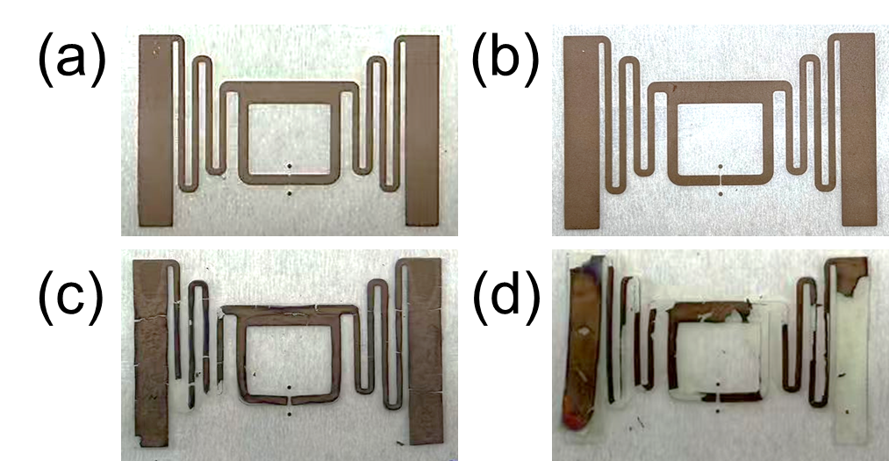
S- 1

Fig S1. Images of (a-b) un-sintered copper pattern and (c-d) broken copper pattern.

