Supplemental Figures

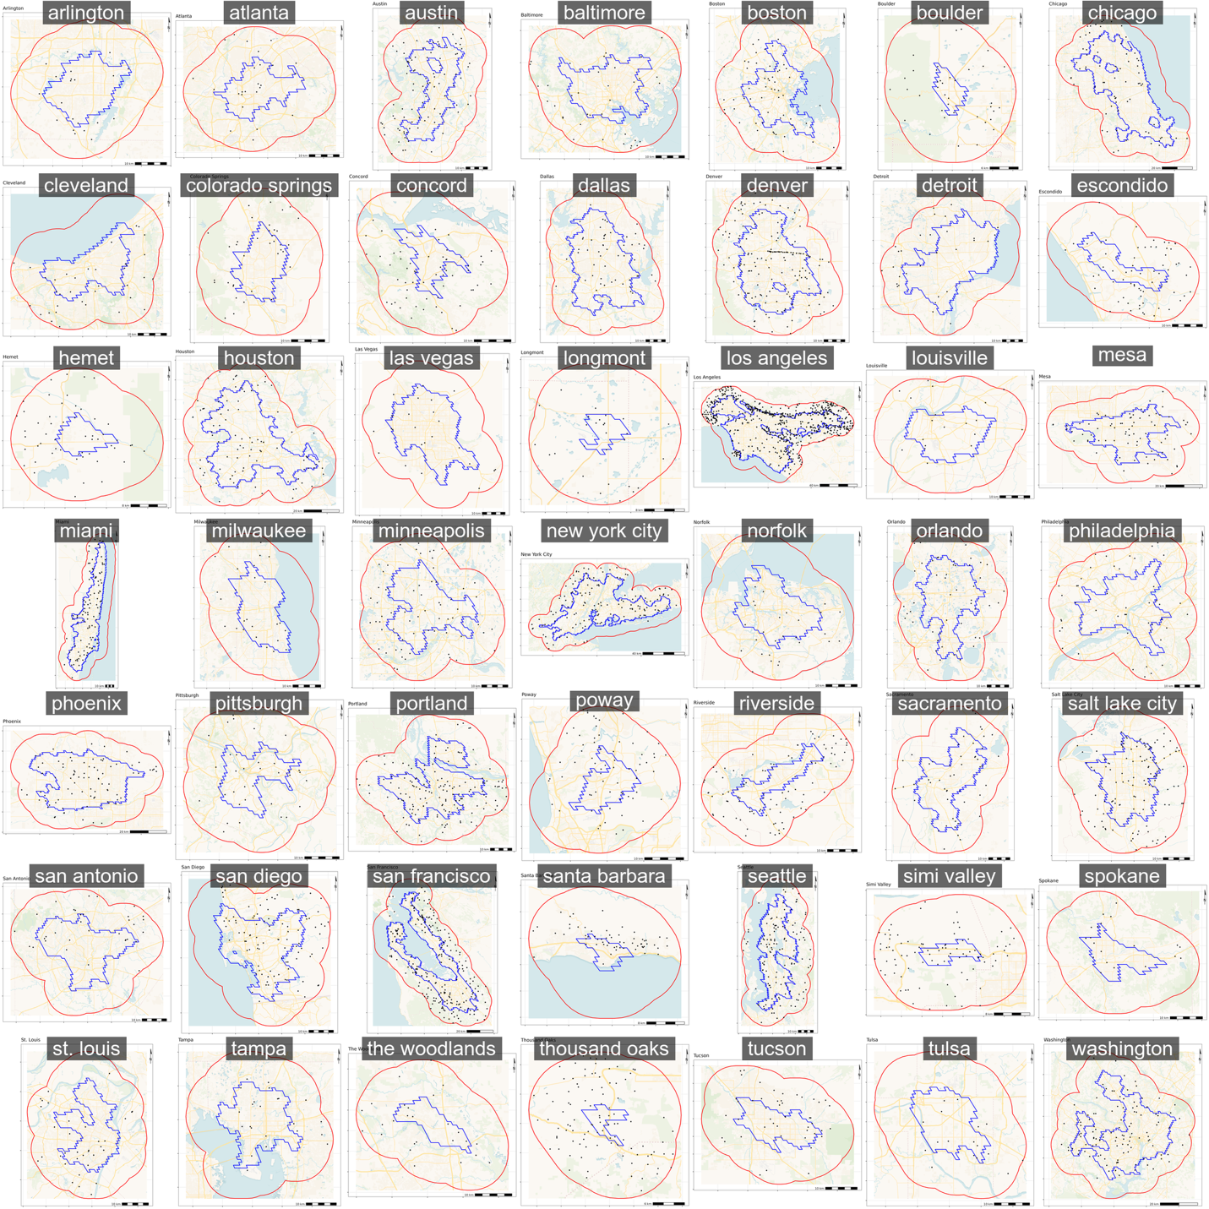
Fig S1. City boundary images with points for stations. The Blue is GHSL urban area, the red indicates the 10km buffer around the urban area.

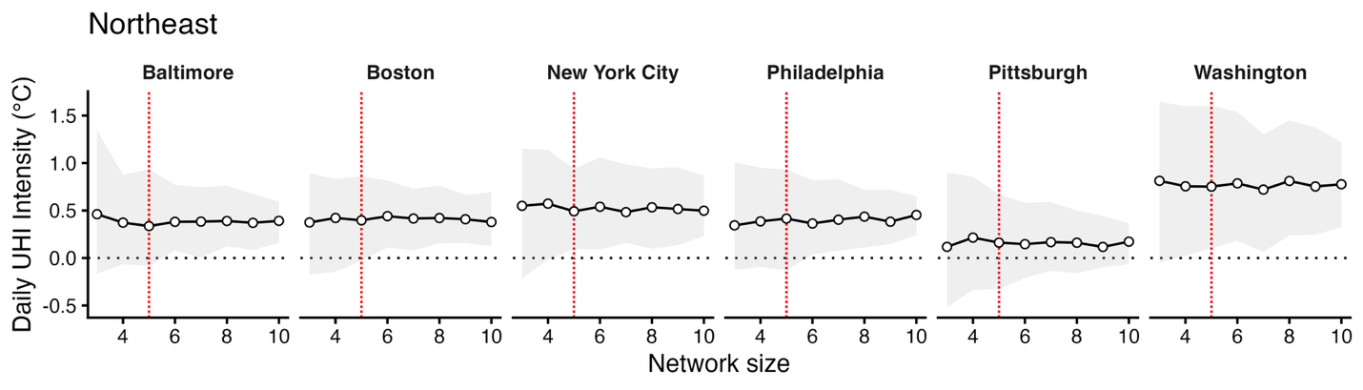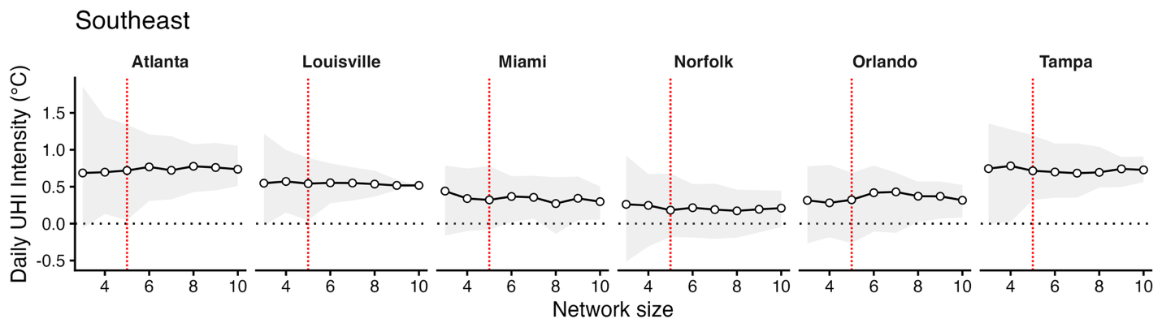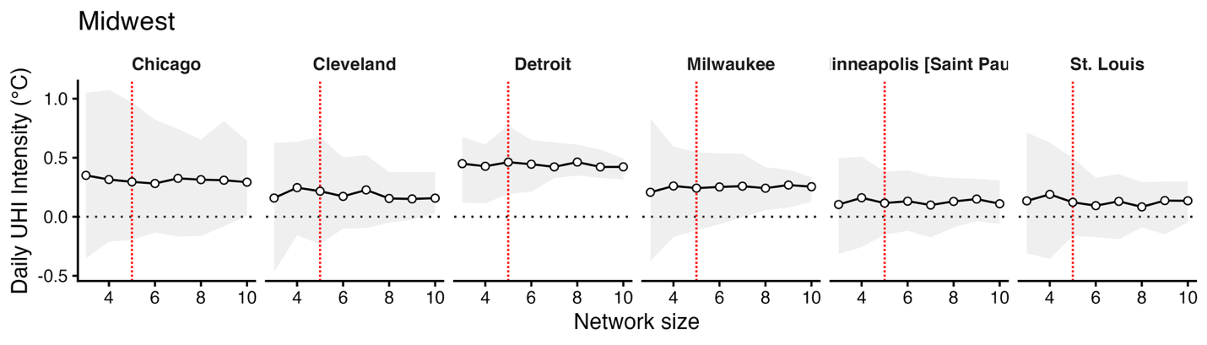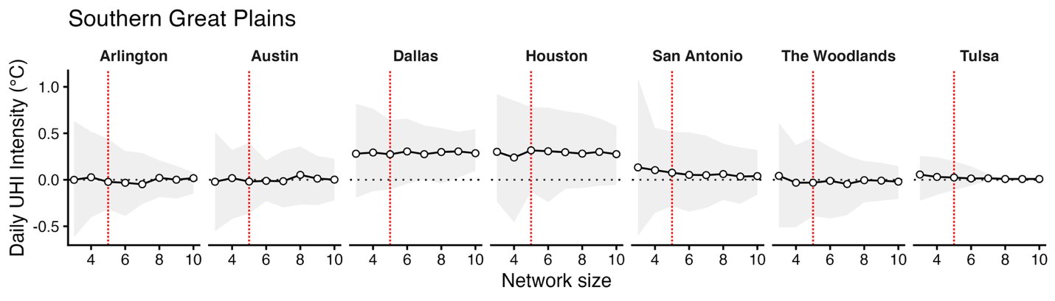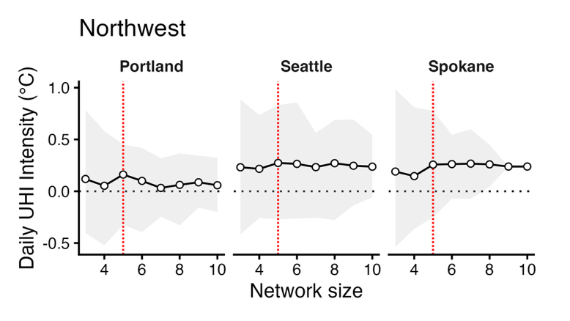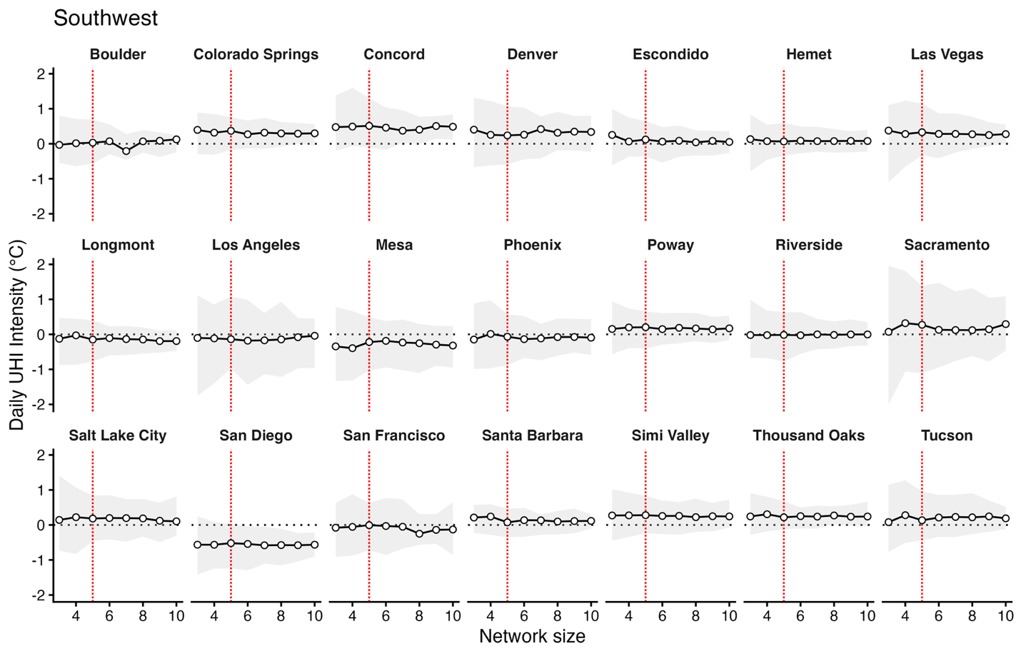
Fig S2. Bootstrapped 95% confidence intervals and median estimates for Daily UHI Intensity as a function of network size per city, organized by US NCA4 region. The 5-station cutoff was chosen as the network size where confidence intervals and median estimates began to stabilize.

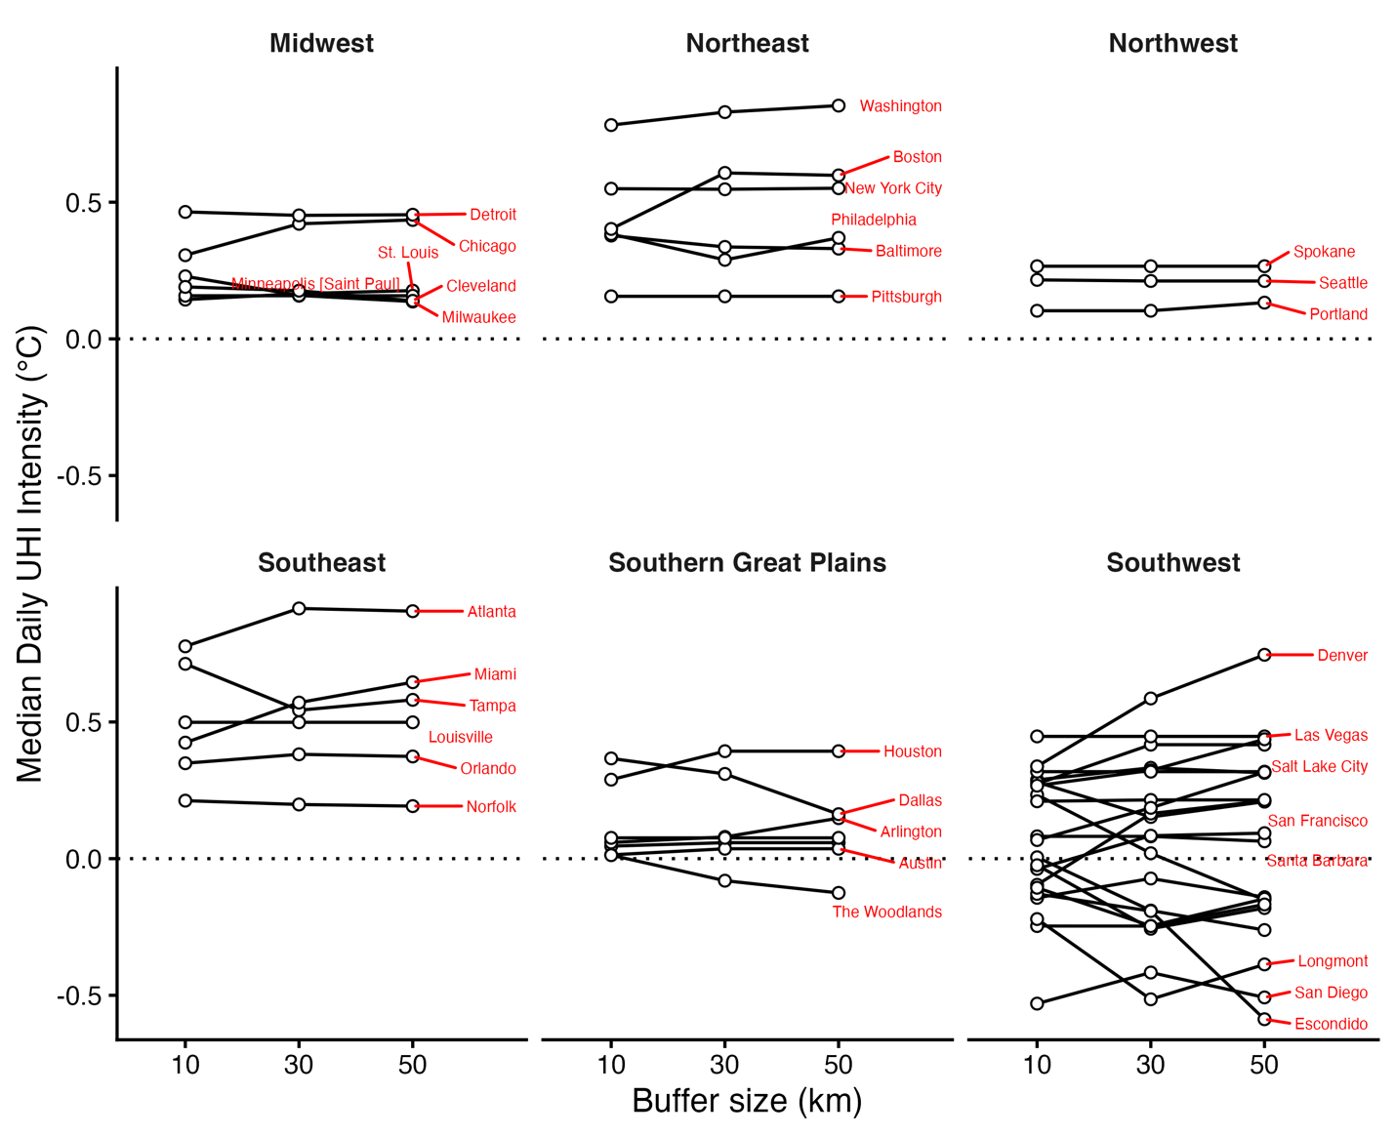
Fig S3. Investigation of the impact of urban area buffer size on median daily urban heat island intensity in different US cities.

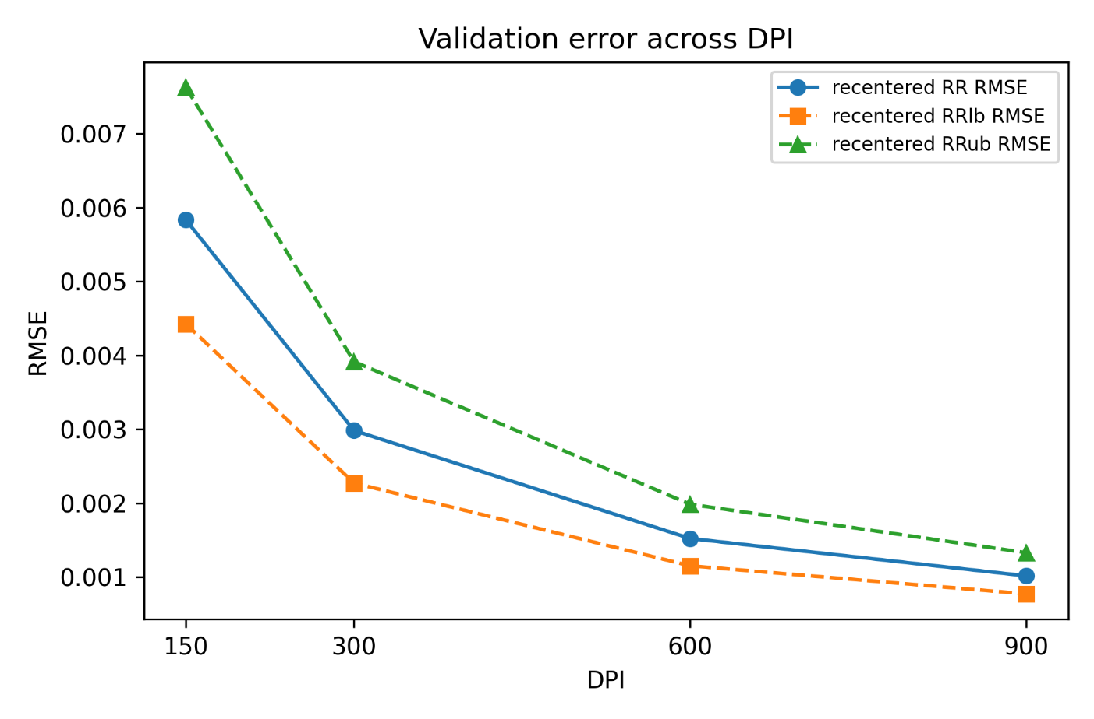
Fig S4. Root mean square errors (RMSE) for re-created relative risks (RR) and confidence intervals (RR lower bound, RRlb, and upper bound, RRub) across different image resolutions (measured by dots per inch, DPI).

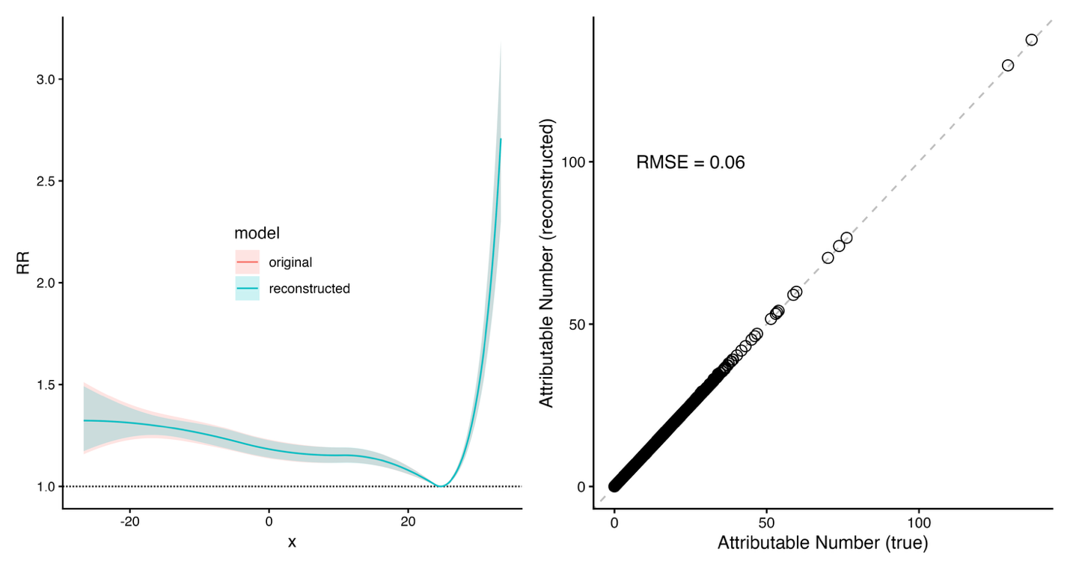
Temperature (degree C)
A.
B.

Fig S5. Using simulated data, reconstruction of (a) the relative risk (RR) curve following Bayesian inference, and (b) the Root Mean Squared Error (RMSE) of the attributable number estimates that result (the dashed 1-1 line is shown).

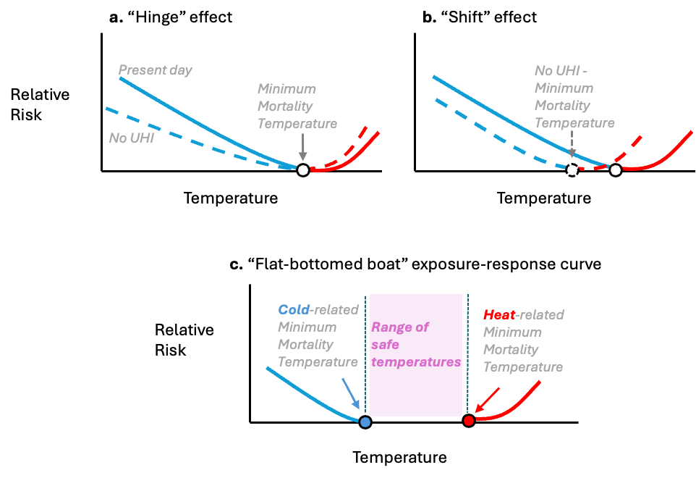
Fig S6. Schematic diagrams showing how the temperature-mortality exposure response curve might (a) “hinge” or (b) “shift” in response to changes in the temperature distribution.

Fig S7. An alternative formulation of the temperature response relationship as a “flat-bottomed” as opposed to a “U-shaped” curve.

