Supplementary Table 1: Comparison of Demographic and Clinical Characteristics Between Groups
 |  | ADHD Without Nail-Biting  (N = 150) | ADHD With Nail-Biting  (N = 100) | Statistics*
 |  | ADHD Without Nail-Biting  (N = 150) | ADHD With Nail-Biting  (N = 100) | U/z or χ² | p
Age (years) | Mean (SD) | 10.0 (1.59) | 11.1 (1.4) | 4408 / -5.524 | < .001
Age (years) | Mdn (IQR) | 9.7 (3.1) | 11.5 (2.3) | 4408 / -5.524 | < .001
Gender, n (%) |  |  |  | .174 | .677
Girl |  | 67 (44.7%) | 42 (42.0%) | .174 | .677
Boy |  | 83 (55.3%) | 58 (58.0%) | .174 | .677
Grade | Mean (SD) | 4.1 (1.9) | 5.7 (1.8) | 4052.5 / -6.261 | < .001
Grade | Mdn (IQR) | 4 (3) | 6 (1) | 4052.5 / -6.261 | < .001
Mother’s Age (years) | Mean (SD) | 37.7 (5.4) | 40.4 (5.3) | 5405.5 / -3.748 | < .001
Mother’s Age (years) | Mdn (IQR) | 38 (8) | 41 (7) | 5405.5 / -3.748 | < .001
Mother’s Education (years) | Mean (SD) | 10.0 (4.5) | 10.3 (4.7) | 7223.0 / -.509 | .611
Mother’s Education (years) | Mdn (IQR) | 10 (8) | 12 (11) | 7223.0 / -.509 | .611
Mother with Psychiatric Illness, n (%) |  | 19 (12.7%) | 11 (11.0%) | .158 | .691
Father’s Age (years) | Mean (SD) | 41.1 (5.7) | 43.4 (6.2) | 5903.0 / -2.857 | .004
Father’s Age (years) | Mdn (IQR) | 41 (8) | 44 (8) | 5903.0 / -2.857 | .004
Father’s Education (years) | Mean (SD) | 10.8 (4.0) | 10.3 (4.1) | 6988.5 / -.948 | .343
Father’s Education (years) | Mdn (IQR) | 12 (8) | 12 (6) | 6988.5 / -.948 | .343
Father with Psychiatric Illness, n (%) |  | 9 (6.0%) | 4 (4.0%) | .487 | .485
Socioeconomic Status | Mean (SD) | 2.7 (.8) | 2.7 (.7) | 6972.0 / -1.026 | .305
Socioeconomic Status | Mdn (IQR) | 2 (1) | 3 (1) | 6972.0 / -1.026 | .305
Note. ADHD = Attention Deficit Hyperactivity Disorder, SD = standard deviation, Mdn = median, IQR = Interquartile range. *Continuous variables were analyzed using the Mann-Whitney U test, and categorical variables were analyzed using Pearson's Chi-Square test.

Supplementary Table 2: Comparison of Body-Focused Repetitive Behaviors Between Groups
 |  | ADHD Without Nail-Biting  (N = 150) | ADHD With Nail-Biting  (N = 100) | Statistics*
 |  | ADHD Without Nail-Biting  (N = 150) | ADHD With Nail-Biting  (N = 100) | U/z or χ² | p
Duration of Nail-Biting, (months) | Mean (SD) | - | 15.0 (10.9) | - | -
Duration of Nail-Biting, (months) | Mdn (IQR) | - | 12 (18) | - | -
Thumb Sucking |  | 24 (16.0%) | 27 (27.0%) | 4.471 | .034
Duration of Thumb Sucking, (months) | Mean (SD) | 15.6 (9.9) | 18.4 (9.1) | 317.0 / -.135 | .892
Duration of Thumb Sucking, (months) | Mdn (IQR) | 18 (14) | 18 (14) | 317.0 / -.135 | .892
Lip or Cheek Biting |  | 17 (12.4%) | 32 (32.0%) | 13.528 | < .001
Duration of Lip or Cheek Biting, (months) | Mean (SD) | 6.6 (2.4) | 4.7 (2.8) | 163.5 | .022
Duration of Lip or Cheek Biting, (months) | Mdn (IQR) | 7 (4.5) | 4 (5) | 163.5 | .022
Teeth Grinding / Bruxism |  | 15 (10.0%) | 35 (35.0%) | 23.438 | < .001
Duration of Teeth Grinding / Bruxism, (months) | Mean (SD) | 8.0 (3.4) | 15.6 (9.9) | 160.5 | .030
Duration of Teeth Grinding / Bruxism, (months) | Mdn (IQR) | 8 (4) | 18 (17) | 160.5 | .030
Note. ADHD = Attention Deficit Hyperactivity Disorder, SD = standard deviation, Mdn = median, IQR = Interquartile range. *Continuous variables were analyzed using the Mann-Whitney U test, and categorical variables were analyzed using Pearson's Chi-Square test.

Supplementary Table 3: Comparison of Psychiatric Comorbidities Between Groups
 | ADHD Without Nail-Biting (N = 150) | ADHD With Nail-Biting (N = 100) | Statistics* |  | Odds Ratio¹
 | ADHD Without Nail-Biting (N = 150) | ADHD With Nail-Biting (N = 100) | χ² | p | Odds Ratio¹
Oppositional Defiant Disorder | 45 (30.0%) | 25 (25.0%) | .744 | .388 | -
Conduct Disorder | 4 (2.7%) | 6 (6.0%) | - | .205 | -
Specific Learning Disorders | 22 (14.7%) | 14 (14.0%) | .022 | .883 | -
Tic Disorders | 3 (2.0%) | 4 (4.0%) | - | .442 | -
Nocturnal Enuresis | 9 (6.0%) | 5 (5.0%) | .113 | .736 | -
Speech Disorders | 6 (4.0%) | 16 (16.0%) | 10.766 | .001 | 4.566
Speech Sound Disorder | 4 (2.7%) | 12 (12.0%) | 8.725 | .003 | 4.975
Speech Fluency Disorder | 2 (1.3%) | 4 (4.0%) | - | .221 | -
Depressive Disorders | 21 (14.0%) | 19 (19.0%) | 1.116 | .291 | -
Anxiety Disorders | 32 (21.3%) | 39 (39.0%) | 9.209 | .002 | 2.358
Separation Anxiety Disorder | 7 (4.7%) | 15 (15.0%) | 7.983 | .005 | 3.610
Social Phobia Disorder | 7 (4.7%) | 16 (16.0%) | 9.226 | .002 | 3.891
Performance Anxiety | 13 (8.7%) | 23 (23.0%) | 10.000 | .002 | 3.145
Generalized Anxiety Disorder | 4 (2.7%) | 5 (5.0%) | - | .490 | -
Panic Disorder | 2 (1.3%) | 2 (2.0%) | - | 1.000 | -
Specific Phobia | 8 (5.3%) | 7 (7.0%) | .296 | .587 | -
Obsessive Compulsive Disorder | 9 (6.0%) | 17 (17.0%) | 7.791 | .005 | 3.205
Sleep Disorders | 8 (5.3%) | 7 (7.0%) | .296 | .587 | -
Note. ADHD = Attention Deficit Hyperactivity Disorder. * Pearson's chi-square test or Fisher's Exact test was used for statistical analyses. (1) Odds ratios represent the likelihood of having psychiatric comorbidity in the ADHD group with nail-biting compared to the ADHD group without nail-biting.
.

Supplementary Figure 1: Behavioral Patterns of Body-Focused Repetitive Behaviors
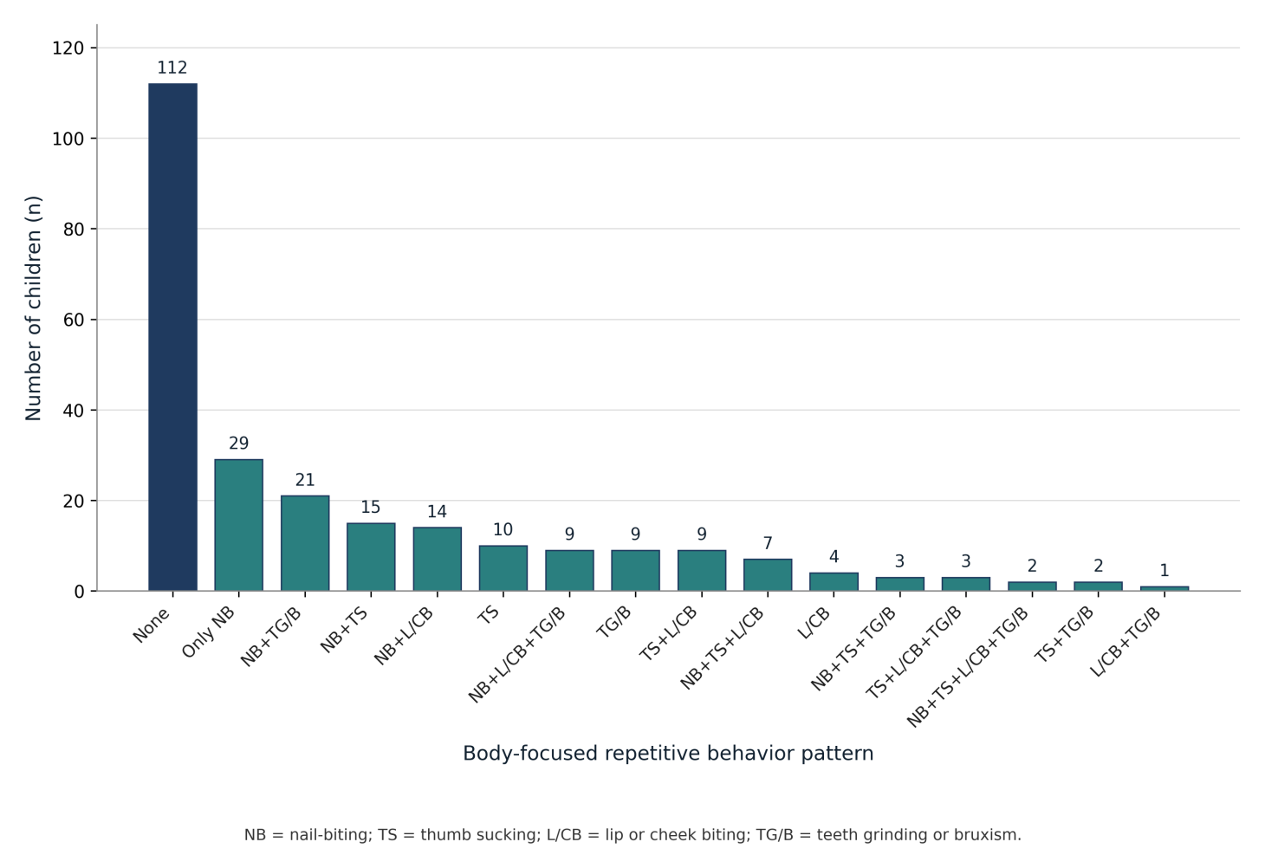

Supplementary Figure 2: Distribution of psychiatric comorbidities (%) in children with ADHD with and without NB. Values represent the percentage of children within each group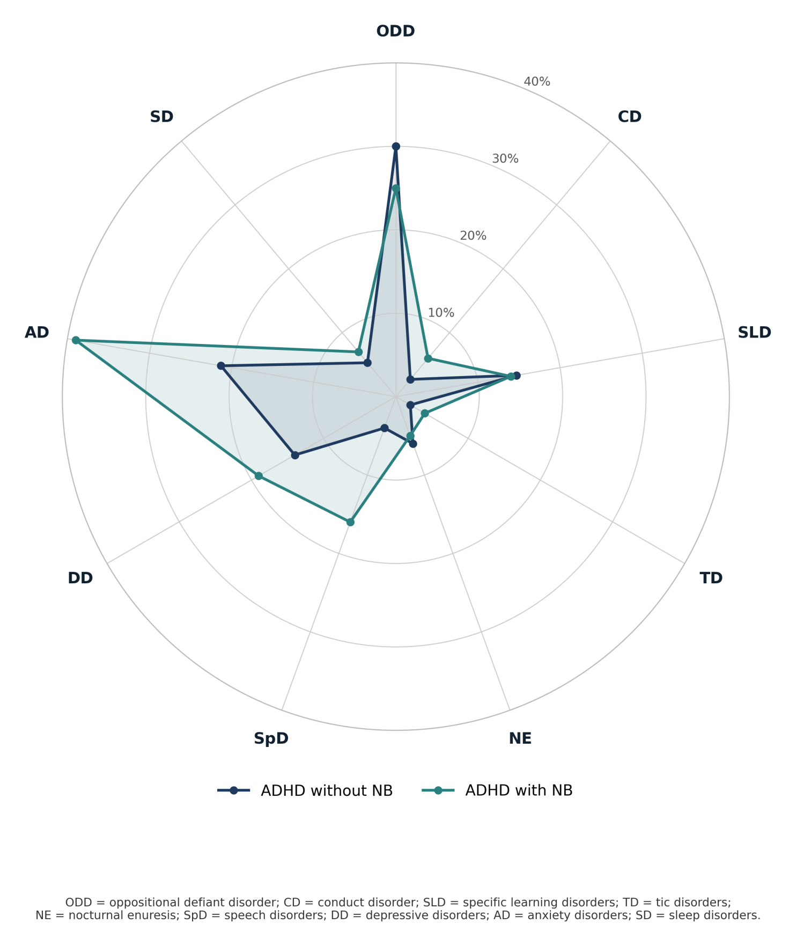

Supplementary Figure 3:
Anxiety disorder profiles (%) in children with ADHD with and without NB. Values represent the percentage of children within each group.
