ADDITIONAL DOCUMENT 2

Formative Evaluation Results

Barriers and facilitators of RT implementation - CFIR Interviews
The barriers and facilitators of RT implementation, as identified through a thematic analysis of semi-structured interviews organized by CFIR domains, for small, medium, and large groups, are summarized in Table 2. The strengths and valence shown in green represent factors that facilitate implementation, such as adaptability, learning climate, and strategic policy alignment, which had positive valence, averaging more than 1.5 across the small, medium, and large groups. The ones shown in red represent the factors that hinder implementation, such as workload capacity, cost, and available resources, with average strength and valence of -1.5 or -2 for the small, medium, and large groups.
The additional CFIR constructs for LMICs are shown in blue font in Table 2. Among the original selected CFIR domains and constructs, the following were well-grounded in the data from all three districts: intervention knowledge/beliefs, compatibility, implementation climate, and culture. The LMIC-optimized constructs “characteristics of the community” and “collective efficacy” were among the most frequently identified constructs in all three districts. The “team characteristics” construct was among those frequently identified in the large and medium districts (but not the small district).
Table 1. Strength and valence of the CFIR constructs (green constructs represent the extension of LMIC-adapted CFIR)
 |  | STRENGTH AND VALENCE
DOMAIN | CONSTRUCT | SMALL GROUP | MEDIUM GROUP | LARGE GROUP
I. INTERVENTION CHARACTERISTICS | Intervention Source | 0 | 0 | 2
I. INTERVENTION CHARACTERISTICS | Evidence Strength & Quality | 2 | 2 | 1
I. INTERVENTION CHARACTERISTICS | Relative Advantage | 1 | 1 | 2
I. INTERVENTION CHARACTERISTICS | Adaptability | 2 | 2 | 2
I. INTERVENTION CHARACTERISTICS | Complexity | 0 | 0 | -1
I. INTERVENTION CHARACTERISTICS | Design Quality & Packaging | 1 | 1 | 1
I. INTERVENTION CHARACTERISTICS | Cost | -2 |  | -2
I. INTERVENTION CHARACTERISTICS | Feasibility | 1.5 | 2 | 2
I. INTERVENTION CHARACTERISTICS | Workload Capacity | -1 | -1.5 | -2
I. INTERVENTION CHARACTERISTICS | Perceived Scalability | 0 | 2 | 1
I. INTERVENTION CHARACTERISTICS | Perceived Sustainability | 0 |  | -1
II. OUTER SETTING | Patient Needs & Resources | 2 | 2 | 1
II. OUTER SETTING | Cosmopolitanism | 0 |  | 1
II. OUTER SETTING | External Policy & Incentives |  | 2
II. OUTER SETTING | Community characteristics | 2 | 1 | 0
III. INNER SETTING | Structural Characteristics | 0 |  | 1
III. INNER SETTING | Networks & Communications | 2 | 1 | 2
III. INNER SETTING | Culture | 2 | 1 | 2
III. INNER SETTING | Implementation Climate | 1 |  | 1
III. INNER SETTING | Tension for Change | 2 | 2 | 1
III. INNER SETTING | Compatibility | 1 | 2 | 2
III. INNER SETTING | Relative Priority | 1.5 | 1 | 1
III. INNER SETTING | Incentives & Rewards | 1.5 | 2 | 2
III. INNER SETTING | Learning Climate | 2 | 2 | 2
III. INNER SETTING | Goals & Feedback |  | 2 | 0
III. INNER SETTING | Readiness for Implementation | 0 | 1
III. INNER SETTING | Leadership Engagement | 1 | 0 | 2
III. INNER SETTING | Available Resources | 0 | -1 | -2
III. INNER SETTING | Access to Knowledge & Inf | 1.5 | 2 | 2
III. INNER SETTING | Team Dynamics | 1.5 | 2 | 1
III. INNER SETTING | Collective Efficacy | 1.5 | 2 | 1
IV. CHARACTERISTICS OF INDIVIDUALS | Knowledge & Beliefs | 1.5 |  | 1
IV. CHARACTERISTICS OF INDIVIDUALS | Self-efficacy | 2 | 2 | 1
IV. CHARACTERISTICS OF INDIVIDUALS | Individual Stage of Change | 1.5 | 2 | 1
IV. CHARACTERISTICS OF INDIVIDUALS | Other Individual Attributes | 2 |  | 1
V. PROCESS OF IMPLEMENTATION | Planning | 1.5 | 1 | 2
V. PROCESS OF IMPLEMENTATION | Formal Implementation Leaders | 1.5 | 2 | 1
V. PROCESS OF IMPLEMENTATION | Champions | 1.5 | 2
V. PROCESS OF IMPLEMENTATION | External Change Agents | 1.5 | 2 | 2
V. PROCESS OF IMPLEMENTATION | Decision making | 0 | 1
VI. CHARACTERISTICS OF SYSTEMS | Authority norms | 1.5 | -2 | 0
VI. CHARACTERISTICS OF SYSTEMS | Implementation level |  | 1 | 1
VI. CHARACTERISTICS OF SYSTEMS | Systems architecture | 2 | 1 | 0
VI. CHARACTERISTICS OF SYSTEMS | Strategic policy alignment | 1.5 | 2 | 2
VI. CHARACTERISTICS OF SYSTEMS | Resource Continuity | 0 | 0 | 0
 | Resource Source |  | -1 | 0

Networks
Table 2 includes a description of the network for each district at each step of the RT process: receiving report, investigating report, notifying report, planning activity, and executing a plan. Overall, there was agreement on the roles that should oversee each activity of the RT across small, medium, and large communities, with the percentage of nominations received divided by total nominations exceeding 20%. For instance, in the first step of who should receive the report of the infected meat or pig, respondents from the small group and the various posts of health centers of the large group nominated the community health agent as the person who should oversee that role. The person responsible for the epidemiology unit was the most nominated role for investigating the suspected case and notifying the confirmed case. Lastly, the chief of the health care center was the most nominated role for planning the RT activities, and the nurse or nurse technician should execute the plan and oversee the activities to provide treatment during the RT.

Table 2. Nominations of roles for each step of the Ring Treatment process.
 |  | Receive report |  |  |  | Investigate report |  |  |  | Notify report |  |  |  | Plan activity |  |  |  |  |  | Execute plan
 | n | # roles  ^{(a)} | Most nominated role | In-deg | % ^{(b)} | # roles | Most nominated role | In-deg | % | # roles | Most nominated role | In-deg | % |  | # roles | Most nominated role | In-deg |  | % | # roles |  | Most nominated role | In-deg |  | %
Small group | 38 | 6 | CHA | 14 | 52% | 13 | Epidemiology | 14 | 25% | 7 | Epidemiology | 10 | 30% |  | 4 | Chief of HC | 24 |  | 51% | 13 |  | Nurse Technician | 12 |  | 26%
Medium group | 76
San Jacinto | 42 | 6 | Resp. of EH | 8 | 32% | 8 | Resp. of EH | 15 | 42% | 4 | Epidemiology | 13 | 42% |  | 8 | Chief of HC | 23 |  | 55% | 9 |  | Resp. of zoonosis | 5 |  | 39%
Casa Blanqueada | 11 | 6 | Lieutenant Governor | 3 | 33% | 5 | Lieutenant Governor | 4 | 33% | 2 | Lieutenant Governor | 1 | 50% |  | 4 | Resp. of zoonosis | 1 |  | 25% | 8 |  | Chief of HC | 6 |  | 24%
Oidor | 5 | 4 | Resp. of zoonosis | 3 | 60% | 3 | Resp. of zoonosis | 2 | 50% | 2 | Resp. of zoonosis | 3 | 75% |  | 2 | Chief of HC | 2 |  | 66% | 5 |  | Resp. of zoonosis | 2 |  | 25%
Rica Playa | 10 | 2 | Resp. of zoonosis | 3 | 75% | 7 | Lieutenant Governor | 2 | 20% | 5 | Chief of HC | 1 | 20% |  | 2 | Chief of HC | 6 |  | 86% | 5 |  | Resp. of zoonosis | 5 |  | 33%
Vaqueria | 8 | 5 | Lieutenant Governor | 3 | 40% | 5 | Epidemiology | 4 | 33% | 3 | Epidemiology | 4 | 50% |  | 5 | Chief of HC | 5 |  | 50% | 6 |  | Resp. of zoonosis | 5 |  | 33%
Large group | 227
Pampa Grande | 81 | 10 | Epidemiology | 6 | 21% | 12 | Epidemiology | 15 | 34% | 5 | Chief of HC | 42 | 58% |  | 11 | Chief of HC | 53 |  | 51% | 14 |  | Resp. of HP | 5 |  | 22%
Pampa del Hospital | 37 | 9 | Chief of HC | 4 | 15% | 12 | Epidemiology | 9 | 31% | 7 | Epidemiology | 9 | 24% |  | 6 | Chief of HC | 23 |  | 70% | 6 |  | CHA | 8 |  | 32%
San Juan de la Virgen | 23 | 7 | Epidemiology | 8 | 42% | 7 | Epidemiology | 13 | 41% | 3 | Epidemiology | 12 | 57% |  | 10 | Chief of HC | 9 |  | 33% | 7 |  | Resp. of HP | 5 |  | 28%
Cabuyal | 24 | 5 | Nurse | 8 | 31% | 7 | Nurse | 15 | 38% | 5 | Nurse | 12 | 43% |  | 3 | Chief of HC | 15 |  | 52% | 7 |  | Nurse | 14 |  | 48%
Cerro Blanco | 11 | 6 | CHA | 3 | 23% | 8 | Physician | 6 | 33% | 5 | Physician | 5 | 38% |  | 5 | Phycisian | 5 |  | 17% | 5 |  | Chief of HC | 8 |  | 35%
Cruz Blanca | 16 | 3 | CHA | 5 | 63% | 5 | CHA | 9 | 32% | 5 | Chief of HC | 9 | 45% |  | 5 | Phycisian | 13 |  | 62% | 4 |  | Phycisian | 9 |  | 43%
El Limon | 14 | 7 | CHA | 7 | 35% | 6 | Epidemiology | 8 | 32% | 5 | Epidemiology | 8 | 53% |  | 4 | Phycisian | 6 |  | 35% | 5 |  | Nurse | 6 |  | 26%
Garbanzal | 21 | 8 | CHA | 7 | 29% | 9 | Nurse | 9 | 35% | 7 | Chief of HC | 8 | 29% |  | 7 | Chief of HC | 12 |  | 52% | 7 |  | Nurse | 12 |  | 30%
CHA: Community Health Agent; HC: Health Center; Resp. of HP: Responsible of Health Promotion; Resp. of EH: Responsible of Environmental Health.
(a) Sum of different roles nominated for each step of the process; (b) percentage of nomination received divided by total nominations

Figure 1 displays participants’ nominations for the reception of the suspected case report in the small group where the pilot study was developed. The graphical representation of the nodes helped identify people in the community who held influence or were considered to have participated in the implementation of the Ring Treatment, such as the Lieutenant Governor, who, in some villages, nominated themselves to receive reported infections. Community health agents are also shown as the bridge or link that connects the sub-networks of the health system to the community.
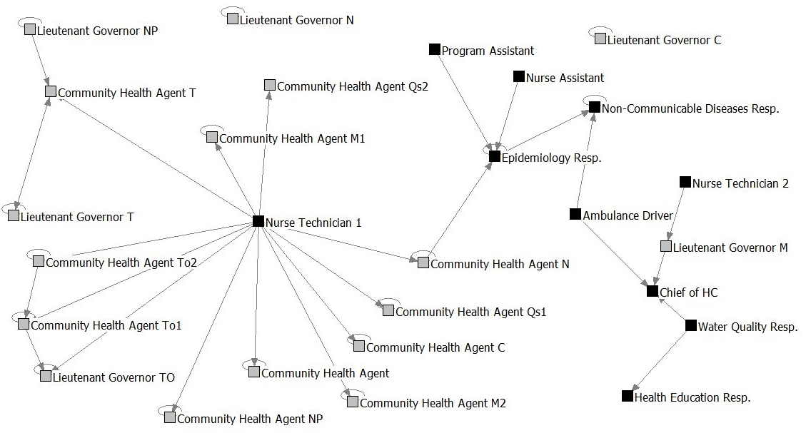
Figure 1. Network representing nominations for the reception of the suspected case report in the small group.
Each square represents the respondent or a network member. The arrows signal the nomination's direction. The color of the nodes represents whether the network member belongs to a community setting (gray) or a health system setting (black).

