Supplementary information
Supplementary File 1 - Machine-learning model development and evaluation.
See attached file
Supplementary Fig. 1. Achieved versus target AUC under standard dosing in the validation cohort. Relationship between the AUC achieved with standard weight-based dosing and the target AUC; dashed lines mark the ±20% window (R²adj = 0.2), which illustrates the limited target attainment of fixed mg/kg dosing.
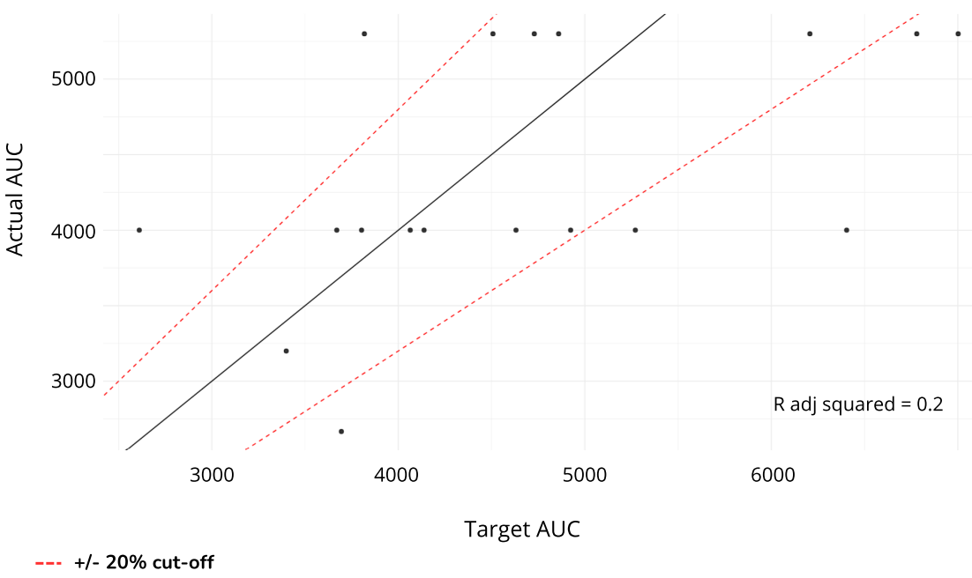

Supplementary Fig. 2. Effect of model-guided dosing on dose, by exposure category. The difference in percentage terms between the model-recommended and standard doses for over-exposed patients (n = 8), under-exposed patients (n = 2) and normo-exposed patients (n = 10). The model would have reduced the dose for over-exposed patients by a median of 15.2%, increased it for under-exposed patients by a median of 10.2%, and made minimal changes for normo-exposed patients (p < 0.02).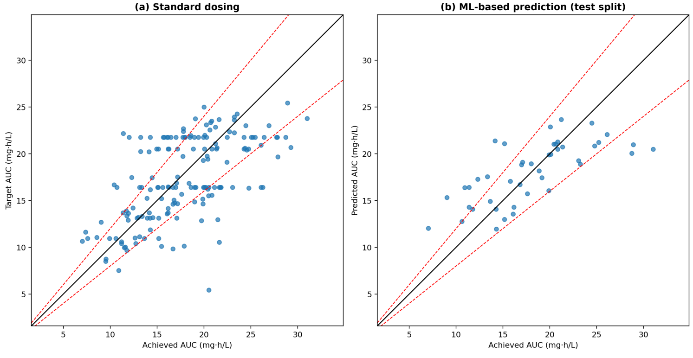
Supplementary Fig.3 . SHAP summary of the dose-prediction model. Each dot represents a patient, with colour encoding the value of each feature (blue = low, red = high). The horizontal position shows the effect of each feature on the predicted dose. In line with both clearance and exposure models, target AUC, weight, body surface area, previous AUC, ferritin and age proved to be the leading predictors. The variables are sorted by average impact (the most influential are at the top).
