Appendices

Appendix I Table II: Data Abstraction Form

Laboratory Number | Hospital Number | Age | Type of hysterectomy | Referring hospital | Possible Determinant
1/2019
2/2019
3
4
5
6
7
8
9
10

Appendix II: Application for Permission Letter
Africa University
P.O.BOX 1320
Mutare

3 September 2020

The Chief Scientist
Parirenyatwa Group of Hospitals Laboratories
P.O. Box CY198
Causeway

Dear Sir,
REF: Request for permission to carry out a cross sectional research study on the epidemiology profile of hysterectomy in Northern Zimbabwean woman at Parirenyatwa Group of Hospitals Laboratory
I am writing this letter kindly requesting permission for the above. My name is Andile Sicoliwe Thaka. I am a fourth year undergraduate registered student in the faculty of Health Sciences doing Medical Laboratory Sciences at Africa University.
I would like to carry out a cross sectional research study on the epidemiology profile of hysterectomy in Northern Zimbabwean women at Parirenyatwa Group of Hospitals laboratory. I chose this laboratory because there is histology department that receives hysterectomy specimens from other hospitals as a referral laboratory. May you please grant me permission carry out the research in the histology department from September 2020 to November 2020.
I am looking forward to a favorable reply.

Yours faithfully,

Andile Sicoliwe Thaka

Appendix III: Parirenyatwa Group of Hospitals Approval Letter
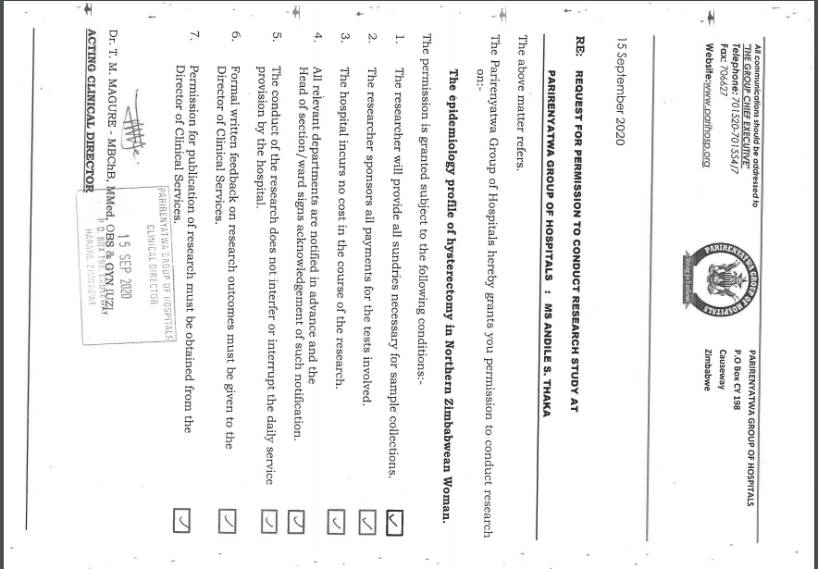

Appendix IV: AUREC Approval Letter
