Supplementary Materials

Preliminary Acceptability and Efficacy of an Expected Value Decision-Making Training Intervention among Older and Younger Adults: A Pilot Study

Results
Training Intervention Efficacy
Model for older adults. The two-way interaction between time and trial type framing on decision performance was significant among older adults and simple effect analysis was conducted to further unpack this interaction effect. Specifically, the results showed that when the trials were framed as gains, older adults were more likely to choose the correct door option immediately after the intervention (β = 0.917, p < 0.001) and at the two-week follow-up (β = 0.645, p < 0.001) compared to baseline. This improvement was sustained over time, as there was no significant difference observed between immediate and two-week post intervention performance (β = -0.272, p < 0.217). When trials were framed as losses, decision-making performance also improved significantly from baseline to immediately after the intervention (β = 1.403, p < 0.001). While performance declined from immediate to two-week post-intervention (β = −0.849, p < 0.001), it remained significantly higher than baseline (β = 0.554, p < 0.001).
Model for younger adults. For younger adults, the two-way interaction between time and trial type framing was also significant. When trials were framed as gains, there was no significant difference in performance between baseline and immediately after the intervention (β = −0.155, p = 0.410). Surprisingly, performance declined significantly at the two-week follow-up compared to both baseline (β = −0.658, p < 0.001) and immediate post-intervention (β = −0.580, p < 0.001). When trials were framed as losses, younger adults’ decision-making performance improved significantly from baseline to immediately after the intervention (β = 0.479, p < 0.001). However, this improvement was not sustained, as there was a significant decrease in performance from immediate to two-week post-intervention (β = −0.670, p < 0.001).

Exploratory Results
Proportion of Younger vs. Older Adults Endorsing Training Acceptability Items. At least 75% of participants, regardless of age, strongly or somewhat agreed that the training was interesting, challenging, and useful. Similarly, over 80% of participants reported being satisfied with the training and felt they learned new information from it (Supplementary Table 7). Results from a two-sample z-test for proportions indicated that a greater proportion of older adults strongly or somewhat agreed that they were satisfied with the training and that the training was interesting, enjoyable, and challenging compared to younger adults.
Correlations Between Training Acceptability Items and Performance Change. Bivariate correlations indicated that greater training interest and enjoyment was associated with greater improvements in decision performance at immediate and two-week follow-up, regardless of age (Supplementary Table 8). Greater perceived challenge of the training was associated with significantly better performance at two-week follow-up (r=0.28, p=0.02) but not immediate follow-up (r=0.22, p=0.09). No other significant correlations between the training acceptability items and decision performance were observed. Similarly, there was no significant difference in correlations between older and younger adults (ps>0.10).
Qualitative Results
Eight categories emerged from the open coding analysis of participants’ responses regarding the most valued aspects of the training: (1) learning new skills (n=26), (2) training content (n=23), (3) cognitive challenge (n=21), (4) practicality and/or usefulness (n=16), (5) training features (n=14), (6) quantifying decisions mathematically (n=7), (7) interactivity (n=5), and (8) simplicity of usability (n=4). These categories were then used to identify four overarching themes: (1) skill acquisition and knowledge gain, (2) cognitive challenge, (3) practical relevance, and (4) training design and delivery. Description, examples, and frequency analysis of these themes are shown in Supplementary Table 9.
For suggestions to improve the training, open coding resulted in seven categories: (1) changes to the training length and/or structure (n=22), (2) strategies to enhance variety and engagement (n=12), (3) provision of tools or aids (n=8), (4) improvements to the interface and/or usability (n=7), (5) better clarity and more detailed feedback explanations (n=7), (6) provision of a performance comparison group (n=3), and (7) provision of real-world examples in the training (n=3). Additionally, 17% of participants (n=11) were satisfied with the training as-is and did not provide suggestions. These categories were then grouped into five themes: (1) changes to the training length and/or structure, (2) user experience and usability improvements, (3), strategies to enhance engagement, (4) provision of decision tools and aids, and (5) improved clarity and feedback explanations. Qualitative results are shown in Supplementary Table 12.

Supplementary Table 1
Order of Baseline Assessment Task Activities
Baseline Assessment Task Order | Approximate Time
1. Demographics Survey | 2 minutes
2. Baseline Decision-Making Task Instructions | 2 minutes
3. Baseline Decision-Making Task without Feedback | 10 minutes
4. Video Tutorial | 6 minutes
5. Intervention Instructions | 3 minutes
6. Decision-Making Training Intervention Task with Feedback | 45 – 55 minutes
7. Immediate Decision-Making Follow-Up Task without Feedback | 10 minutes
8. Acceptability and qualitative feedback survey | 5 minutes
Total Time | 83 – 93 minutes

Supplementary Table 2
Full Regression Model Results
Variable | β Estimate | SE | Z-value | P-value
Intercept | 0.784 | 0.122 | 6.426 | <0.001
Follow-Up: Immediate vs. Baseline | 0.915 | 0.163 | 5.617 | <0.001
Follow-Up: Two-Week vs. Baseline | 0.642 | 0.135 | 4.745 | <0.001
Age Category | 0.112 | 0.165 | 0.678 | 0.498
Trial Type | -0.438 | 0.132 | -3.314 | <0.001
Age Category X Follow-Up: Immediate vs. Baseline | -1.070 | 0.203 | -5.259 | <0.001
Age Category X Follow-Up: Two-Week vs. Baseline | -1.301 | 0.175 | -7.442 | <0.001
Follow-Up: Immediate vs. Baseline X Trial Type | 0.485 | 0.224 | 2.163 | 0.031
Follow-Up: Two-Week vs. Baseline X Trial Type | -0.091 | 0.188 | -0.485 | 0.628
Age Category X Trial Type | -0.082 | 0.177 | -0.463 | 0.643
Immediate Follow-Up X Age Category X Trial Type | 0.150 | 0.280 | 0.537 | 0.591
Two-Week Follow-up X Age Category X Trial Type | 0.559 | 0.245 | 2.284 | 0.022

Supplementary Table 3
Full Model and Simple Effect Analysis Output for Older Adults
Variable | β Estimate | SE | Z-value | P-value
Intercept | 0.786 | 0.127 | 6.176 | <0.001
Follow-Up: Immediate vs. Baseline | 0.917 | 0.163 | 5.626 | <0.001
Follow-Up: Two-Week vs. Baseline | 0.645 | 0.135 | 4.766 | <0.001
Trial Type | -0.439 | 0.132 | -3.319 | <0.001
Follow-Up: Immediate vs. Baseline X Trial Type-Loss | 0.486 | 0.224 | 2.165 | 0.031
Follow-Up: Two-Week vs. Baseline X Trial Type-Loss | -0.091 | 0.188 | -0.485 | 0.627
Simple Effect: Time X Trial Type
Trial Type = Gain:
Immediate vs. Baseline | 0.917 | 0.163 | 5.626 | <0.001
Two-Week vs. Baseline | 0.645 | 0.135 | 4.766 | <0.001
Two-Week vs. Immediate | -0.272 | 0.163 | -1.670 | 0.217
Trial Type = Loss:
Immediate vs. Baseline | 1.403 | 0.157 | 8.931 | <0.001
Two-Week vs. Baseline | 0.554 | 0.132 | 4.719 | <0.001
Two-Week vs. Immediate | -0.849 | 0.1158 | -5.357 | <0.001

Supplementary Table 4
Full Model and Simple Effect Analysis Output for Younger Adults
Variable | β Estimate | SE | Z-value | P-value
Intercept | 0.894 | 0.107 | 8.349 | <0.001
Follow-Up: Immediate vs. Baseline | -0.155 | 0.122 | -1.273 | 0.203
Follow-Up: Two-Week vs. Baseline | -0.658 | 0.110 | -5.955 | <0.001
Trial Type | -0.519 | 0.118 | -4.413 | <0.001
Follow-Up: Immediate vs. Baseline X Trial Type-Loss | 0.634 | 0.168 | 3.781 | <0.001
Follow-Up: Two-Week vs. Baseline X Trial Type-Loss | 0.467 | 0.157 | 2.983 | 0.003
Simple Effect: Time X Trial Type
Trial Type = Gain:
Immediate vs. Baseline | -0.155 | 0.122 | -1.273 | 0.410
Two-Week vs. Baseline | -0.658 | 0.110 | -5.955 | <0.001
Two-Week vs. Immediate | -0.503 | 0.110 | -4.554 | <0.001
Trial Type = Loss:
Immediate vs. Baseline | 0.479 | 0.116 | 4.149 | <0.001
Two-Week vs. Baseline | -0.190 | 0.111 | -1.712 | 0.201
Two-Week vs. Immediate | -0.670 | 0.114 | -5.897 | <0.001

Supplementary Table 5
Full Model Analysis Output for the Exploratory Analysis with Probability as a Moderator
Variable | β Estimate | SE | Z-value | P-value
(Intercept) | 1.051 | 0.141 | 7.466 | <0.001
Immediate | 0.650 | 0.177 | 3.679 | <0.001
Two-Week | 0.441 | 0.155 | 2.850 | 0.004
Age | 0.008 | 0.186 | 0.044 | 0.965
Trial Type | -0.717 | 0.149 | -4.798 | <0.001
Probability | -2.184 | 0.318 | -6.860 | <0.001
Immediate X Age | -0.964 | 0.220 | -4.389 | <0.001
Two-Week X Age | -1.247 | 0.196 | -6.365 | <0.001
Immediate X TrialType | 0.768 | 0.235 | 3.266 | 0.001
Two-Week X TrialType | 0.145 | 0.208 | 0.696 | 0.486
Age X TrialType | 0.036 | 0.196 | 0.182 | 0.856
Immediate X Probability | 2.192 | 0.435 | 5.038 | <0.001
Two-Week X Probability | 1.528 | 0.389 | 3.929 | <0.001
Age X Probability | 0.696 | 0.408 | 1.706 | 0.088
TrialType X Probability | 1.972 | 0.404 | 4.882 | <0.001
Immediate X Age X TrialType | 0.027 | 0.293 | 0.091 | 0.927
Two-Week X Age X TrialType | 0.388 | 0.268 | 1.450 | 0.147
Immediate X Age X Probability | -0.602 | 0.541 | -1.111 | 0.266
Two-Week X Age X Probability | -0.284 | 0.492 | -0.578 | 0.563
Immediate X TrialType X Probability | -2.342 | 0.606 | -3.863 | <0.001
Two-Week X TrialType X Probability | -1.202 | 0.534 | -2.251 | 0.024
Age X TrialType X Probability | -0.473 | 0.525 | -0.900 | 0.368
Immediate X Age X TrialType X Probability | 0.953 | 0.756 | 1.262 | 0.207
Two-Week X Age X TrialType X Probability | -0.531 | 0.687 | -0.773 | 0.440
Note. Immediate and Two-Week refer to comparisons with Baseline performance. TrialType refers to gain vs. loss trials.

Supplementary Table 6
Full Model Analysis Output for the Exploratory Analysis with Outcome Magnitude as a Moderator
Variable | β Estimate | SE | Z-value | P-value
(Intercept) | 1.037 | 0.136 | 7.631 | <0.001
Immediate | 0.674 | 0.175 | 3.855 | <0.001
Two-Week | 0.466 | 0.151 | 3.092 | <0.001
Age | 0.041 | 0.182 | 0.224 | 0.823
TrialType | -0.747 | 0.148 | -5.037 | <0.001
Reward | 0.126 | 0.020 | 6.392 | <0.001
Immediate X Age | -1.000 | 0.218 | -4.578 | <0.001
Two-Week X Age | -1.288 | 0.193 | -6.684 | <0.001
Immediate X TrialType | 0.815 | 0.238 | 3.430 | 0.001
Two-Week X TrialType | 0.143 | 0.203 | 0.704 | 0.482
Age X TrialType | 0.007 | 0.197 | 0.033 | 0.973
Immediate X Reward | -0.132 | 0.024 | -5.576 | <0.001
Two-Week X Reward | -0.078 | 0.024 | -3.254 | 0.001
Age X Reward | -0.037 | 0.026 | -1.407 | 0.159
TrialType X Reward | -0.148 | 0.024 | -6.122 | <0.001
Immediate X Age X TrialType | 0.021 | 0.297 | 0.072 | 0.943
Two-Week X Age X TrialType | 0.503 | 0.262 | 1.918 | 0.055
Immediate X Age X Reward | 0.037 | 0.030 | 1.213 | 0.225
Two-Week X Age X Reward | 0.008 | 0.031 | 0.270 | 0.787
Immediate X TrialType X Reward | 0.131 | 0.032 | 4.045 | <0.001
Two-Week X TrialType X Reward | 0.098 | 0.031 | 3.156 | 0.002
Age X TrialType X Reward | 0.042 | 0.032 | 1.326 | 0.185
Immediate X Age X TrialType X Reward | -0.007 | 0.041 | -0.173 | 0.862
Two-Week X Age X TrialType X Reward | -0.037 | 0.040 | -0.909 | 0.363
Note. Immediate and Two-Week refer to comparisons with Baseline performance. TrialType refers to gain vs. loss trials.

Supplementary Table 7
Item (Mean ± SD) | Overall Sample (N=65) | Older Adults (n=30) | Younger Adults (n=35) | P-Value
I am satisfied with the decision training I completed as part of this study. | 4.09 ± 1.04 | 4.37 ± 0.81 | 3.86 ± 1.17 | 0.048
The training was interesting. | 4.14 ± 1.14 | 4.60 ± 0.81 | 3.74 ± 1.24 | 0.002
I enjoyed the training. | 3.63 ± 0.99 | 4.13 ± 0.63 | 3.20 ± 1.05 | <0.001
The training was challenging. | 4.02 ± 1.05 | 4.53 ± 0.57 | 3.57 ± 1.17 | <0.001
The training was useful. | 3.98 ± 1.12 | 4.20 ± 0.89 | 3.80 ± 1.28 | 0.154
The training was confusing. | 2.69 ± 1.26 | 2.60 ± 1.22 | 2.77 ± 1.31 | 0.589
I feel like I learned new information from this training. | 4.18 ± 1.07 | 4.27 ± 0.94 | 4.11 ± 1.18 | 0.572

Supplementary Table 8
Correlations between Training Acceptability Items and Change in Performance from Baseline to Immediate and Two-Week Follow-Up
 | Performance Change at Immediate Follow-Up | Performance Change at Two-Week Follow-Up
I am satisfied with the decision training I completed as part of this study. | 0.03 | 0.17
The training was interesting. | 0.28* | 0.31*
I enjoyed the training. | 0.36* | 0.41*
The training was challenging. | 0.22 | 0.28*
The training was useful. | 0.07 | 0.13
The training was confusing. | -0.13 | -0.19
I feel like I learned new information from this training. | 0.01 | -0.02
Note. Values represent Pearson correlations.
* indicates significance at the p<0.05 level

Supplementary Table 9
Thematic Analysis for Suggested Training Improvements
Theme | Description | Examples | Age Group Frequencies | P-Value
Changes to the Training Length and/or Structure (n=22) | Changing the number and length of the training session | "Make it shorter or split into two sessions" | OA: 6/30 YA: 16/35 | 0.03
Changes to the Training Length and/or Structure (n=22) | Changing the number and length of the training session | "Make less questions per four sections of the longest part of the training" | OA: 6/30 YA: 16/35 | 0.03
Changes to the Training Length and/or Structure (n=22) | Changing the number and length of the training session | "Change the style of questions and have tips or something during the breaks to break it up more" | OA: 6/30 YA: 16/35 | 0.03
Strategies to Enhance  Engagement (n=15) | Enhancing the stimuli variety and participant interest and motivation | "Instead of choosing doors switch it up to something else" | OA: 6/30 YA: 9/35 | 0.58
Strategies to Enhance  Engagement (n=15) |  | "Need a more engaging video lecture at the beginning" | OA: 6/30 YA: 9/35 | 0.58
Strategies to Enhance  Engagement (n=15) |  | "Provide some information on performance to the mean" | OA: 6/30 YA: 9/35 | 0.58
Improved Clarity and  Feedback Explanations (n=15) | Making the training easier to follow and more meaningful | "Provide practical application: i.e. is paying money for airline ticket or dissatisfaction rate a minus/negative" | OA: 9/30 YA: 6/35 | 0.22
Improved Clarity and  Feedback Explanations (n=15) | Making the training easier to follow and more meaningful | "Make the steps in the calculations clearer, especially doing gains and losses" | OA: 9/30 YA: 6/35 | 0.22
Improved Clarity and  Feedback Explanations (n=15) | Making the training easier to follow and more meaningful | "Help give better explanation to the theory for one who might not fully comprehend" | OA: 9/30 YA: 6/35 | 0.22
Provision of Decision Tools or Aids (n=8) | Reducing effort barriers and supporting training completion | "Provide a calculator or scratch pad" | OA: 5/30 YA: 3/35 | 0.32
Provision of Decision Tools or Aids (n=8) | Reducing effort barriers and supporting training completion | "Providing a calculator or just something to help with the math aspect" | OA: 5/30 YA: 3/35 | 0.32
Provision of Decision Tools or Aids (n=8) | Reducing effort barriers and supporting training completion | "Provide tools to help with  calculations" | OA: 5/30 YA: 3/35 | 0.32
User Experience and  Usability Improvements (n=7) | Making the training more user friendly | "Have the option to read the video script yourself instead of watching it" | OA: 0/30 YA: 7/35 | 0.01
User Experience and  Usability Improvements (n=7) | Making the training more user friendly | "Bold the negatives in loss questions" | OA: 0/30 YA: 7/35 | 0.01
User Experience and  Usability Improvements (n=7) | Making the training more user friendly | "Being able to unselect options if you change your mind" | OA: 0/30 YA: 7/35 | 0.01
User Experience and  Usability Improvements (n=7) | Making the training more user friendly | "Adding something that tells the person being tested their % of completion" | OA: 0/30 YA: 7/35 | 0.01

Appendix 1

Decision-Making Task Instructions
In this task, you will be shown two doors. Each door has a certain chance of having some amount of money behind it. Let’s say one door had a 50% chance of having $5 behind it. If someone were to flip coin and it showed heads, then you would win $5. If you someone were to flip a coin and it showed tails, you would get nothing. Each door has different possible monetary values and chances (or likelihoods) that the money will be behind the door. You will have to make decisions between different doors several times. We are interested to see how people of different backgrounds make different decisions in scenarios like this.
The outcome of one door does NOT depend on the other door; in other words, choosing one door does NOT change the likelihood of monetary value of the other door.
All decisions and outcomes in this task are hypothetical, but please respond as you would if the decisions involved real monetary values.
Initially, you will not be given any feedback because we do not want to bias your responses. In later phases of the study, you will be shown the outcome of your decision.
Use any strategies you like to make these decisions, including (but not limited to) your past experiences, arithmetic, your feelings toward the different options, mental shortcuts, etc.

Appendix 2
Video Link: https://youtu.be/3-EFeGz3OvA
Video Script:
Welcome to this tutorial on decision-making. Today, we’re going to be discussing expected value theory and how this theory can be applied to make good decisions.
What is Expected Value Theory?
Expected value theory is often used to compare different options and determine which one has the highest expected return. An expected value is simply the average expected outcome of a decision.
This can be especially useful when making decisions that involve risk because it allows decision makers to weigh the potential rewards against the potential risks. Using expected value can help decision makers identify which outcomes are most likely and make informed decisions based on probabilities. It can also help them understand how much risk they are taking and what kind of return they should expect from their investments or decisions.
Why make decisions according to this theory?
Expected values allow us to make better predictions about future events in situations in which the outcome is unknown. For example, if you are deciding between two different investment opportunities, you can use expected value theory to determine which one is the better option.
Secondly, people often have an inherent bias in their decision-making strategies. Some people are biased to avoid risk, others are biased to take risks, and some are biased to chase after the biggest payout. Making decisions using expected value theory as a decision strategy can help us to overcome those biases and make objectively good decisions.
Now, the theory isn’t perfect because there are a lot different factors that can influence decision-making that this theory doesn’t take into account like time and effort costs, fluctuations over time, or emotional and moral impacts. So, this theory can’t apply to every decision-making situation or include every variable, but it is a quick and effective way to make objectively good decisions in many situations that involve some degree of uncertainty.
How does it work?
Calculating expected values is quite simple: you take the likelihood of each possible decision outcome, multiply it by the potential payout, and add them up. This tells us how much value each decision provides.
So, let's say that we're deciding whether or not to invest in this potential opportunity, and this opportunity has two potential outcomes. The first potential outcome is a 20% chance of $600 and the second is an 80% chance of $200. If we multiply those two together and add them up, we will get our expected value. If we calculate that out, we have a 20% chance of getting $600 which equals 120, and we add that to the 80% chance of getting $200 which equals 160. We then add those together and we get $280 as our expected value, or our expected return on investment.
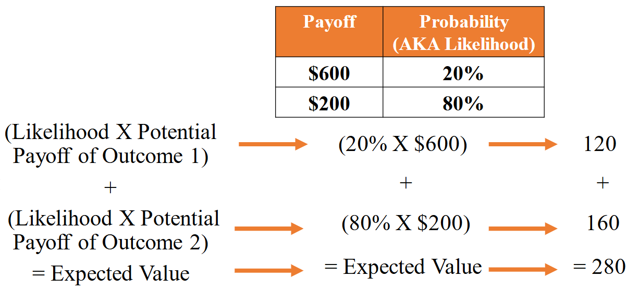
What is an example relevant to investments?
Let's look at a second example of whether or not we should buy a raffle ticket. Imagine you’re at an event and your friend tells you that if you don't buy a raffle ticket, then she'll give you a dollar guaranteed. The second option is to buy the raffle ticket. Now, there's about a hundred people at this event and there are five potential gift card prizes each worth $50. So, this means that there's about a 5% chance of getting $50 if you buy the raffle ticket but that also means there's a 95% chance of not winning. If you don't win, then you'll lose the cost of the raffle ticket, which is a dollar. Let's apply expected value theory and see which option we should choose. For option one, not buying the raffle ticket, we have a 100% chance of a dollar if we don't buy the raffle ticket, so our expected value is one. For option two, buying the raffle ticket, we need to calculate the first potential outcome of winning so that means we have a 5% chance of $50; that’s $2.50. We need to add that to the second potential outcome, which is the 95% chance of losing a dollar—the cost of the raffle ticket. That's negative 95 cents if we add those two together. Then, the expected value for buying the raffle ticket is $1.55. Because $1.55 is greater than $1, we should choose the option of buying the raffle ticket because it has the higher expected value.
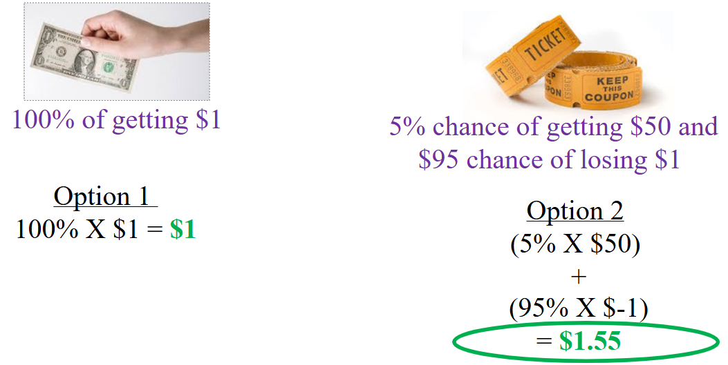
Expected values can apply to a variety of other situations such as playing board games, investment, or trying to decide if we should try something new or stay with the status quo. For example, going back to school or not, changing careers or not, buying an investment property or not. All of these situations can benefit from applying expected value theory. It is a tool for comparing decisions where at least one option has higher expected outcomes.

You are now about to start the training. The training is designed to build habits of using expected values. Habits require repetition, so you are going to make many decisions with the goal of making decisions using expected value theory nearly automatic.

