Supporting Information
Interfacial Engineering and Charge-Transfer Mechanisms of Inorganic CdS/TiO₂ Semiconductor Nanocomposites: Kinetic Modeling and Photocorrosion Inhibition

Nur Mutheerah Antal,¹ Chi Huey Ng,^{1,2*} Siow Hwa Teo,^{3#} Boon Junn Ng,⁴ Zhenhua Xu,⁵ Putao Zhang,⁶ Nur Syamimi Zainudin,^{7,8} Hong Ngee Lim,⁷ Jidon Janaun,¹ Rosalam Hj Sarbatly^{1,2}
¹Faculty of Engineering, Universiti Malaysia Sabah, Jalan UMS, Kota Kinabalu, 88400, Sabah, Malaysia.
²Membrane and Nanomaterials Technology Research Laboratory, Faculty of Engineering, Universiti Malaysia Sabah, Jalan UMS, Kota Kinabalu, 88400, Sabah, Malaysia.
³Faculty of Science and Technology, Universiti Malaysia Sabah, Kota Kinabalu, 88400, Sabah, Malaysia.
⁴School of Energy and Chemical Engineering, Xiamen University Malaysia, Jalan Sunsuria, Bandar Sunsuria, 43900, Sepang, Selangor Darul Ehsan, Malaysia.
⁵School of Materials Science and Engineering, Ningbo Tech University, Ningbo 315100, China.
⁶Henan Key Laboratory of Quantum Materials and Quantum Energy, Henan University, Kaifeng, 475004, Henan, China.
⁷Department of Chemistry, Faculty of Science, Universiti Putra Malaysia, UPM Serdang, 43400, Selangor, Malaysia.
⁸Faculty of Applied Sciences, Universiti Teknologi MARA Cawangan Pahang, Kampus Jengka, 26400 Bandar Tun Abdul Razak Jengka, Pahang, Malaysia.

Corresponding authors:
*CH Ng: chihueyng@ums.edu.my
#SH Teo: tony@ums.edu.my

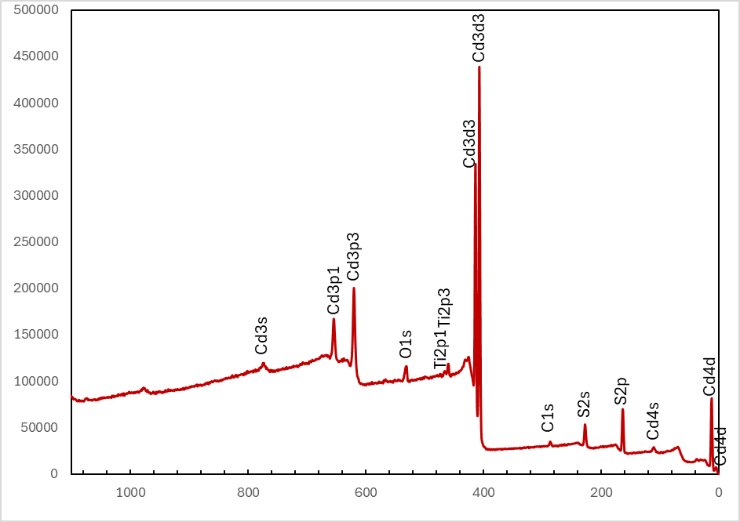
Figure S1. XPS wide scan of C₃T₁.

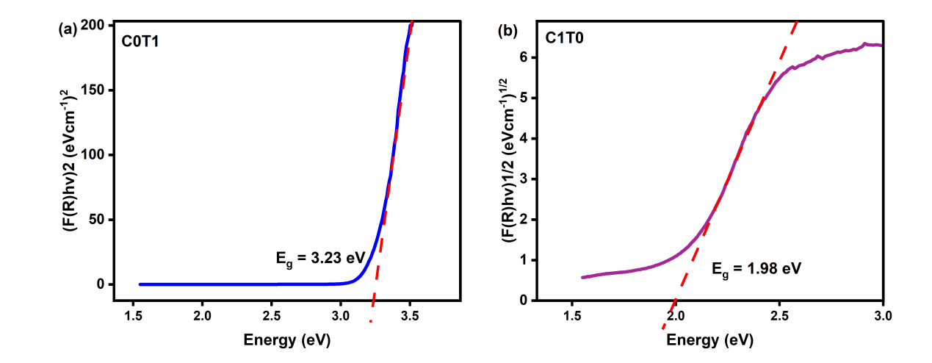
Figure S2. Tauc plot of (a) C₀T₁ and (b) C₁T₀

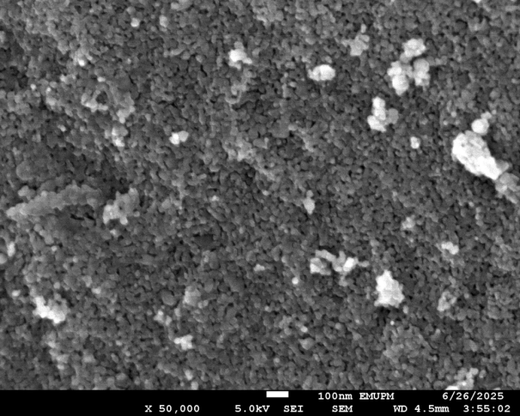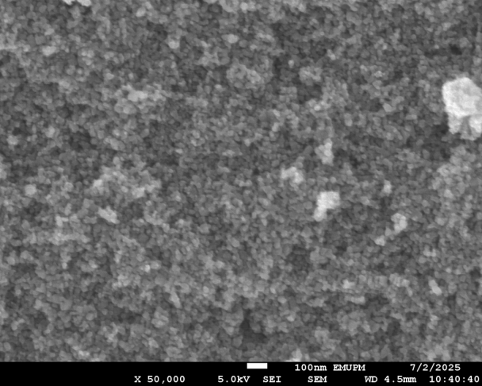
(b)
(a)
C₃T₁
C₀T₁
Figure S3. FESEM images of (a) C₀T₁ and (b) C₃T₁.

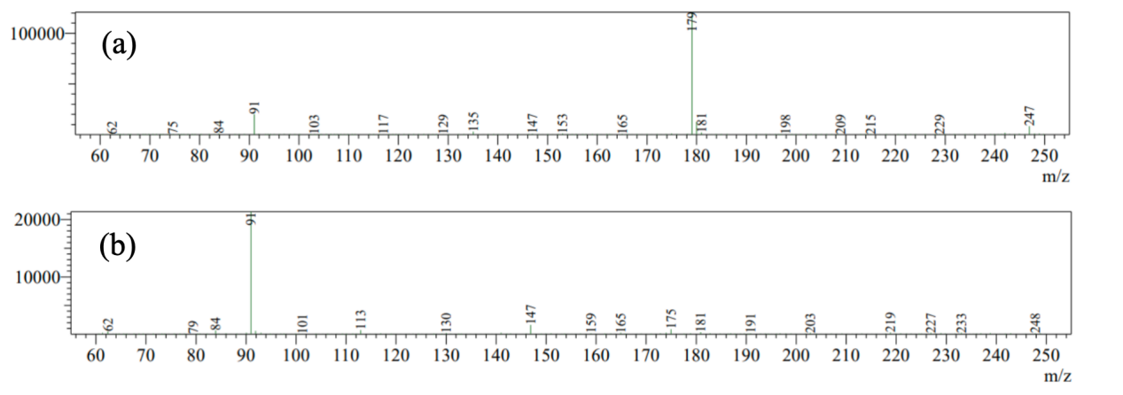

Figure S4. LC–MS total ion chromatograms (TIC) of caffeic acid before and after 300 min photocatalytic degradation using C₃T₁ photocatalyst. Initially, a major caffeic acid peak was observed at 179 m/z, which completely disappeared after treatment. The presence of new peaks at 91 m/z to polar degradation intermediates such as phenolic derivatives and low–molecular weight organic acids, confirming effective photocatalytic breakdown and progression toward mineralization.

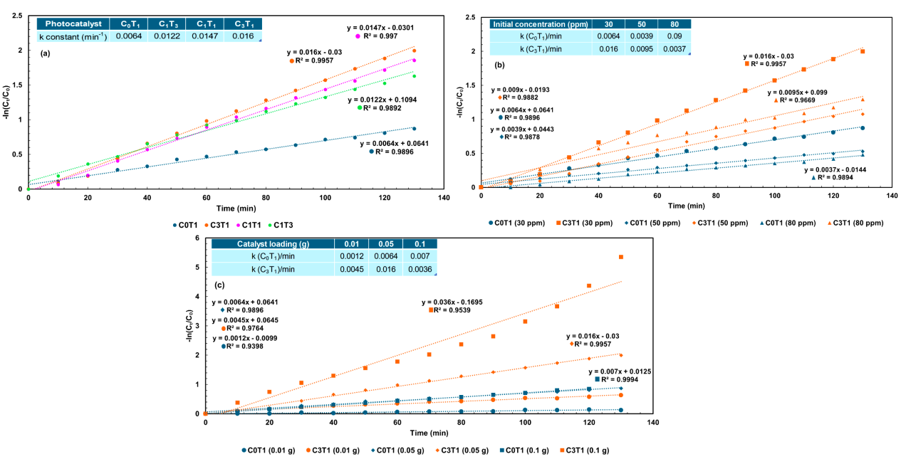
Figure S5. Pseudo-first-order kinetics model for (a) molar ratio of CdS:TiO₂, (b) initial concentration of caffeic acid, and (c) catalyst loading of C₀T₁ and C₃T₁.

