Supplementary Information for:

Extreme heat increases the risk of intrapartum-related asphyxia: evidence from maternal-neonatal cohorts in West Africa

Table S1: Frequency of heat exposure on case and referent days across heat definitions.
 |  | - Daily maximum temperature |  |  | - Daily minimum temperature
Percentile | Heat duration (days) | Threshold temperature¹ (℃) | Case days² (N=491)  n (%) | Referent days³ (N=1,674)  n (%) | Threshold temperature¹ (℃) | Case days² (N=491)  n (%) | Referent days² (N=1,674)  n (%)
≥80th | 1 | 35.4℃ | 113 (23.0) | 368 (22.0) | 25.2℃ | 89 (18.1) | 311 (18.6)
≥80th | 2 | 35.4℃ | 87 (17.7) | 266 (15.9) | 25.2℃ | 63 (12.8) | 222 (13.3)
≥80th | 3 | 35.4℃ | 66 (13.4) | 224 (13.4) | 25.2℃ | 55 (11.2) | 171 (10.2)
≥85th | 1 | 35.9℃ | 83 (16.9) | 280 (16.7) | 25.6℃ | 65 (13.2) | 229 (13.7)
≥85th | 2 | 35.9℃ | 60 (12.2) | 175 (10.5) | 25.6℃ | 47 (9.6) | 156 (9.3)
≥85th | 3 | 35.9℃ | 50 (10.2) | 134 (8.0) | 25.6℃ | 35 (7.1) | 125 (7.5)
≥90th | 1 | 36.5℃ | 62 (12.6) | 177 (10.6) | 26℃ | 51 (10.4) | 159 (9.5)
≥90th | 2 | 36.5℃ | 41 (8.4) | 110 (6.6) | 26℃ | 37 (7.5) | 109 (6.5)
≥90th | 3 | 36.5℃ | 32 (6.5) | 73 (4.4) | 26℃ | 24 (4.9) | 82 (4.9)
≥95th | 1 | 37.3℃ | 38 (7.7) | 106 (6.3) | 26.6℃ | 27 (5.5) | 91 (5.4)
≥95th | 2 | 37.3℃ | 26 (5.3) | 64 (3.8) | 26.6℃ | 15 (3.1) | 54 (3.2)
≥95th | 3 | 37.3℃ | 21 (4.3) | 47 (2.8) | 26.6℃ | 11 (2.2) | 30 (1.8)
Notes: ¹ The threshold temperature is the average of the corresponding threshold temperatures across locations. ² Case days correspond to IRA events; ³ Referent days were selected using a time-stratified case-crossover design matched on weekday, month, and year.

Table S2: Frequency of heat exposure on case and referent days across heat definitions and by country.
 |  |  | Daily maximum temperature |  | Daily minimum temperature
Country | Percentile threshold | Duration in days | Case days  n (%) | Referent days  n (%) | Case days  n (%) | Referent days  n (%)
Burkina Faso | ≥80th | 1 | 30 (23.3) | 98 (22.7) | 30 (23.3) | 106 (24.5)
Burkina Faso |  | 2 | 25 (19.4) | 74 (17.1) | 27 (20.9) | 88 (20.4)
Burkina Faso |  | 3 | 21 (16.3) | 63 (14.6) | 23 (17.8) | 71 (16.4)
Burkina Faso | ≥85th | 1 | 24 (18.6) | 78 (18.1) | 27 (20.9) | 85 (19.7)
Burkina Faso |  | 2 | 16 (12.4) | 51 (11.8) | 22 (17.1) | 70 (16.2)
Burkina Faso |  | 3 | 13 (10.1) | 44 (10.2) | 15 (11.6) | 55 (12.7)
Burkina Faso | ≥90th | 1 | 20 (15.5) | 55 (12.7) | 21 (16.3) | 71 (16.4)
Burkina Faso |  | 2 | 14 (10.9) | 36 (8.3) | 14 (10.9) | 49 (11.3)
Burkina Faso |  | 3 | 10 (7.8) | 29 (6.7) | 10 (7.8) | 37 (8.6)
Burkina Faso | ≥95th | 1 | 16 (12.4) | 32 (7.4) | 12 (9.3) | 48 (11.1)
Burkina Faso |  | 2 | 10 (7.8) | 20 (4.6) | 7 (5.4) | 29 (6.7)
Burkina Faso |  | 3 | 7 (5.4) | 20 (4.6) | 7 (5.4) | 15 (3.5)
The Gambia | ≥80th | 1 | 62 (22.2) | 207 (21.6) | 43 (15.4) | 157 (16.4)
The Gambia |  | 2 | 46 (16.5) | 144 (15.0) | 28 (10.0) | 102 (10.6)
The Gambia |  | 3 | 36 (12.9) | 120 (12.5) | 24 (8.6) | 75 (7.8)
The Gambia | ≥85th | 1 | 47 (16.8) | 151 (15.7) | 28 (10.0) | 112 (11.7)
The Gambia |  | 2 | 35 (12.5) | 89 (9.3) | 18 (6.5) | 66 (6.9)
The Gambia |  | 3 | 30 (10.8) | 65 (6.8) | 15 (5.4) | 53 (5.5)
The Gambia | ≥90th | 1 | 33 (11.8) | 84 (8.8) | 23 (8.2) | 64 (6.7)
The Gambia |  | 2 | 22 (7.9) | 52 (5.4) | 17 (6.1) | 47 (4.9)
The Gambia |  | 3 | 18 (6.5) | 34 (3.5) | 10 (3.6) | 35 (3.6)
The Gambia | ≥95th | 1 | 18 (6.5) | 49 (5.1) | 10 (3.6) | 34 (3.5)
The Gambia |  | 2 | 13 (4.7) | 32 (3.3) | 6 (2.2) | 22 (2.3)
The Gambia |  | 3 | 11 (3.9) | 19 (2.0) | 4 (1.4) | 14 (1.5)
Note: Case days correspond to intrapartum-related asphyxia events; referent days were selected using a time-stratified case-crossover design matched on weekday, month, and year.

Table S3: Frequency of heat exposure on case and referent days across heat definitions and by type of residence.
 |  |  | Daily maximum temperature |  | Daily minimum temperature
Type of residence | Percentile threshold | Duration in days | Case days  n (%) | Referent days  n (%) | Case days  n (%) | Referent days  n (%)
Rural area | ≥80th | 1 | 37 (25.5) | 120 (24.6) | 30 (20.7) | 111 (22.8)
Rural area |  | 2 | 31 (21.4) | 92 (18.9) | 27 (18.6) | 90 (18.5)
Rural area |  | 3 | 26 (17.9) | 79 (16.2) | 23 (15.9) | 71 (14.6)
Rural area | ≥85th | 1 | 30 (20.7) | 94 (19.3) | 27 (18.6) | 88 (18.1)
Rural area |  | 2 | 20 (13.8) | 66 (13.6) | 22 (15.2) | 71 (14.6)
Rural area |  | 3 | 17 (11.7) | 57 (11.7) | 15 (10.3) | 55 (11.3)
Rural area | ≥90th | 1 | 24 (16.6) | 66 (13.6) | 21 (14.5) | 71 (14.6)
Rural area |  | 2 | 18 (12.4) | 47 (9.7) | 14 (9.7) | 49 (10.1)
Rural area |  | 3 | 14 (9.7) | 38 (7.8) | 10 (6.9) | 37 (7.6)
Rural area | ≥95th | 1 | 18 (12.4) | 40 (8.2) | 12 (8.3) | 48 (9.9)
Rural area |  | 2 | 12 (8.3) | 27 (5.5) | 7 (4.8) | 29 (6.0)
Rural area |  | 3 | 9 (6.2) | 25 (5.1) | 7 (4.8) | 15 (3.1)
Urban area | ≥80th | 1 | 55 (20.9) | 185 (20.5) | 43 (16.3) | 152 (16.8)
Urban area |  | 2 | 40 (15.2) | 126 (13.9) | 28 (10.6) | 100 (11.1)
Urban area |  | 3 | 31 (11.8) | 104 (11.5) | 24 (9.1) | 75 (8.3)
Urban area | ≥85th | 1 | 41 (15.6) | 135 (14.9) | 28 (10.6) | 109 (12.1)
Urban area |  | 2 | 31 (11.8) | 74 (8.2) | 18 (6.8) | 65 (7.2)
Urban area |  | 3 | 26 (9.9) | 52 (5.8) | 15 (5.7) | 53 (5.9)
Urban area | ≥90th | 1 | 29 (11.0) | 73 (8.1) | 23 (8.7) | 64 (7.1)
Urban area |  | 2 | 18 (6.8) | 41 (4.5) | 17 (6.5) | 47 (5.2)
Urban area |  | 3 | 14 (5.3) | 25 (2.8) | 10 (3.8) | 35 (3.9)
Urban area | ≥95th | 1 | 16 (6.1) | 41 (4.5) | 10 (3.8) | 34 (3.8)
Urban area |  | 2 | 11 (4.2) | 25 (2.8) | 6 (2.3) | 22 (2.4)
Urban area |  | 3 | 9 (3.4) | 14 (1.5) | 4 (1.5) | 14 (1.5)
Note: Case days correspond to intrapartum-related asphyxia events; referent days were selected using a time-stratified case-crossover design matched on weekday, month, and year.
Table S4: Frequency of heat exposure on case and referent days across heat definitions and by birth season.
 |  |  | Daily maximum temperature |  | Daily minimum temperature
Season | Percentile threshold | Duration in days | Case days  n (%) | Referent days  n (%) | Case days  n (%) | Referent days  n (%)
Dry season | ≥80th | 1 | 62 (24.1) | 207 (24.0) | 35 (13.6) | 114 (13.2)
Dry season |  | 2 | 53 (20.6) | 163 (18.9) | 32 (12.5) | 99 (11.5)
Dry season |  | 3 | 45 (17.5) | 137 (15.9) | 29 (11.3) | 81 (9.4)
Dry season | ≥85th | 1 | 53 (20.6) | 163 (18.9) | 28 (10.9) | 98 (11.4)
Dry season |  | 2 | 40 (15.6) | 113 (13.1) | 23 (8.9) | 84 (9.7)
Dry season |  | 3 | 34 (13.2) | 93 (10.8) | 19 (7.4) | 67 (7.8)
Dry season | ≥90th | 1 | 45 (17.5) | 114 (13.2) | 23 (8.9) | 82 (9.5)
Dry season |  | 2 | 33 (12.8) | 78 (9.0) | 16 (6.2) | 63 (7.3)
Dry season |  | 3 | 26 (10.1) | 59 (6.8) | 14 (5.4) | 48 (5.6)
Dry season | ≥95th | 1 | 32 (12.5) | 72 (8.3) | 12 (4.7) | 60 (7.0)
Dry season |  | 2 | 21 (8.2) | 46 (5.3) | 8 (3.1) | 39 (4.5)
Dry season |  | 3 | 16 (6.2) | 38 (4.4) | 8 (3.1) | 21 (2.4)
Wet season | ≥80th | 1 | 30 (19.9) | 98 (18.6) | 38 (25.2) | 149 (28.2)
Wet season |  | 2 | 18 (11.9) | 55 (10.4) | 23 (15.2) | 91 (17.2)
Wet season |  | 3 | 12 (7.9) | 46 (8.7) | 18 (11.9) | 65 (12.3)
Wet season | ≥85th | 1 | 18 (11.9) | 66 (12.5) | 27 (17.9) | 99 (18.8)
Wet season |  | 2 | 11 (7.3) | 27 (5.1) | 17 (11.3) | 52 (9.8)
Wet season |  | 3 | 9 (6.0) | 16 (3.0) | 11 (7.3) | 41 (7.8)
Wet season | ≥90th | 1 | 8 (5.3) | 25 (4.7) | 21 (13.9) | 53 (10.0)
Wet season |  | 2 | 3 (2.0) | 10 (1.9) | 15 (9.9) | 33 (6.2)
Wet season |  | 3 | 2 (1.3) | 4 (0.8) | 6 (4.0) | 24 (4.5)
Wet season | ≥95th | 1 | 2 (1.3) | 9 (1.7) | 10 (6.6) | 22 (4.2)
Wet season |  | 2 | 2 (1.3) | 6 (1.1) | 5 (3.3) | 12 (2.3)
Wet season |  | 3 | 2 (1.3) | 1 (0.2) | 3 (2.0) | 8 (1.5)
Note: Case days correspond to intrapartum-related asphyxia events; referent days were selected using a time-stratified case-crossover design matched on weekday, month, and year.

Table S5: Frequency of heat exposure on case and referent days across heat definitions and by time of birth.
 |  |  | Daily maximum temperature |  | Daily minimum temperature
Delivery time | Percentile threshold | Duration in days | Case days  n (%) | Referent days  n (%) | Case days  n (%) | Referent days  n (%)
Daytime delivery | ≥80th | 1 | 48 (20.1) | 191 (23.5) | 40 (16.7) | 149 (18.3)
Daytime delivery |  | 2 | 35 (14.6) | 134 (16.5) | 29 (12.1) | 112 (13.8)
Daytime delivery |  | 3 | 29 (12.1) | 110 (13.5) | 21 (8.8) | 85 (10.5)
Daytime delivery | ≥85th | 1 | 39 (16.3) | 140 (17.2) | 30 (12.6) | 109 (13.4)
Daytime delivery |  | 2 | 27 (11.3) | 83 (10.2) | 21 (8.8) | 80 (9.9)
Daytime delivery |  | 3 | 24 (10.0) | 59 (7.3) | 15 (6.3) | 62 (7.6)
Daytime delivery | ≥90th | 1 | 28 (11.7) | 76 (9.4) | 24 (10.0) | 79 (9.7)
Daytime delivery |  | 2 | 17 (7.1) | 49 (6.0) | 17 (7.1) | 56 (6.9)
Daytime delivery |  | 3 | 14 (5.9) | 32 (3.9) | 12 (5.0) | 43 (5.3)
Daytime delivery | ≥95th | 1 | 19 (7.9) | 46 (5.7) | 10 (4.2) | 45 (5.5)
Daytime delivery |  | 2 | 13 (5.4) | 28 (3.4) | 6 (2.5) | 26 (3.2)
Daytime delivery |  | 3 | 11 (4.6) | 20 (2.5) | 5 (2.1) | 18 (2.2)
Nighttime delivery | ≥80th | 1 | 39 (24.2) | 105 (19.1) | 33 (20.5) | 109 (19.8)
Nighttime delivery |  | 2 | 32 (19.9) | 76 (13.8) | 26 (16.1) | 76 (13.8)
Nighttime delivery |  | 3 | 25 (15.5) | 65 (11.8) | 26 (16.1) | 61 (11.1)
Nighttime delivery | ≥85th | 1 | 28 (17.4) | 81 (14.7) | 25 (15.5) | 85 (15.4)
Nighttime delivery |  | 2 | 22 (13.7) | 49 (8.9) | 19 (11.8) | 55 (10.0)
Nighttime delivery |  | 3 | 17 (10.6) | 42 (7.6) | 15 (9.3) | 46 (8.3)
Nighttime delivery | ≥90th | 1 | 23 (14.3) | 57 (10.3) | 20 (12.4) | 56 (10.2)
Nighttime delivery |  | 2 | 17 (10.6) | 33 (6.0) | 14 (8.7) | 40 (7.3)
Nighttime delivery |  | 3 | 12 (7.5) | 25 (4.5) | 8 (5.0) | 29 (5.3)
Nighttime delivery | ≥95th | 1 | 14 (8.7) | 29 (5.3) | 12 (7.5) | 37 (6.7)
Nighttime delivery |  | 2 | 9 (5.6) | 19 (3.4) | 7 (4.3) | 25 (4.5)
Nighttime delivery |  | 3 | 6 (3.7) | 15 (2.7) | 6 (3.7) | 11 (2.0)
Note: Case days correspond to intrapartum-related asphyxia events; referent days were selected using a time-stratified case-crossover design matched on weekday, month, and year.

Table S6: Frequency of heat exposure on case and referent days across heat definitions and by birthweight category.
 |  |  | Daily maximum temperature |  | Daily minimum temperature
Birthweight | Percentile threshold | Duration in days | Case days  n (%) | Referent days  n (%) | Case days  n (%) | Referent days  n (%)
Low birthweight | ≥80th | 1 | 75 (21.6) | 252 (21.3) | 65 (18.7) | 219 (18.5)
Low birthweight |  | 2 | 59 (17.0) | 180 (15.2) | 49 (14.1) | 156 (13.2)
Low birthweight |  | 3 | 46 (13.3) | 152 (12.9) | 42 (12.1) | 124 (10.5)
Low birthweight | ≥85th | 1 | 57 (16.4) | 190 (16.1) | 50 (14.4) | 166 (14.0)
Low birthweight |  | 2 | 43 (12.4) | 113 (9.6) | 37 (10.7) | 113 (9.6)
Low birthweight |  | 3 | 36 (10.4) | 89 (7.5) | 27 (7.8) | 90 (7.6)
Low birthweight | ≥90th | 1 | 43 (12.4) | 111 (9.4) | 40 (11.5) | 111 (9.4)
Low birthweight |  | 2 | 29 (8.4) | 69 (5.8) | 28 (8.1) | 80 (6.8)
Low birthweight |  | 3 | 22 (6.3) | 50 (4.2) | 18 (5.2) | 59 (5.0)
Low birthweight | ≥95th | 1 | 25 (7.2) | 63 (5.3) | 20 (5.8) | 66 (5.6)
Low birthweight |  | 2 | 17 (4.9) | 40 (3.4) | 12 (3.5) | 41 (3.5)
Low birthweight |  | 3 | 12 (3.5) | 29 (2.5) | 10 (2.9) | 25 (2.1)
Normal birthweight | ≥80th | 1 | 15 (25.4) | 50 (24.9) | 8 (13.6) | 44 (21.9)
Normal birthweight |  | 2 | 10 (16.9) | 36 (17.9) | 6 (10.2) | 34 (16.9)
Normal birthweight |  | 3 | 9 (15.3) | 29 (14.4) | 5 (8.5) | 22 (10.9)
Normal birthweight | ≥85th | 1 | 13 (22.0) | 37 (18.4) | 5 (8.5) | 31 (15.4)
Normal birthweight |  | 2 | 7 (11.9) | 25 (12.4) | 3 (5.1) | 23 (11.4)
Normal birthweight |  | 3 | 6 (10.2) | 18 (9.0) | 3 (5.1) | 18 (9.0)
Normal birthweight | ≥90th | 1 | 9 (15.3) | 26 (12.9) | 4 (6.8) | 24 (11.9)
Normal birthweight |  | 2 | 6 (10.2) | 17 (8.5) | 3 (5.1) | 16 (8.0)
Normal birthweight |  | 3 | 5 (8.5) | 11 (5.5) | 2 (3.4) | 13 (6.5)
Normal birthweight | ≥95th | 1 | 8 (13.6) | 16 (8.0) | 2 (3.4) | 16 (8.0)
Normal birthweight |  | 2 | 5 (8.5) | 10 (5.0) | 1 (1.7) | 10 (5.0)
Normal birthweight |  | 3 | 5 (8.5) | 9 (4.5) | 1 (1.7) | 4 (2.0)
Note: Case days correspond to intrapartum-related asphyxia events; referent days were selected using a time-stratified case-crossover design matched on weekday, month, and year.

Table S7: Frequency of heat exposure on case and referent days across heat definitions and by delivery mode.
 |  |  | Daily maximum temperature |  | Daily minimum temperature
Delivery mode | Percentile threshold | Duration in days | Case days  n (%) | Referent days  n (%) | Case days  n (%) | Referent days  n (%)
Cesarian section | ≥80th | 1 | 8 (22.2) | 14 (12.1) | 3 (8.3) | 11 (9.5)
Cesarian section |  | 2 | 5 (13.9) | 9 (7.8) | 2 (5.6) | 8 (6.9)
Cesarian section |  | 3 | 2 (5.6) | 7 (6.0) | 2 (5.6) | 5 (4.3)
Cesarian section | ≥85th | 1 | 7 (19.4) | 8 (6.9) | 2 (5.6) | 5 (4.3)
Cesarian section |  | 2 | 4 (11.1) | 4 (3.4) | 1 (2.8) | 4 (3.4)
Cesarian section |  | 3 | 2 (5.6) | 3 (2.6) | 1 (2.8) | 4 (3.4)
Cesarian section | ≥90th | 1 | 4 (11.1) | 5 (4.3) | 2 (5.6) | 4 (3.4)
Cesarian section |  | 2 | 2 (5.6) | 2 (1.7) | 1 (2.8) | 4 (3.4)
Cesarian section |  | 3 | 2 (5.6) | 1 (0.9) | 1 (2.8) | 3 (2.6)
Cesarian section | ≥95th | 1 | 1 (2.8) | 2 (1.7) | 1 (2.8) | 2 (1.7)
Cesarian section |  | 2 | 1 (2.8) | 1 (0.9) | 1 (2.8) | 2 (1.7)
Cesarian section |  | 3 | 1 (2.8) | 1 (0.9) | 1 (2.8) | 1 (0.9)
Vaginal birth | ≥80th | 1 | 83 (22.4) | 289 (22.7) | 70 (18.9) | 252 (19.8)
Vaginal birth |  | 2 | 65 (17.5) | 207 (16.3) | 53 (14.3) | 182 (14.3)
Vaginal birth |  | 3 | 54 (14.6) | 174 (13.7) | 45 (12.1) | 141 (11.1)
Vaginal birth | ≥85th | 1 | 63 (17.0) | 219 (17.2) | 53 (14.3) | 192 (15.1)
Vaginal birth |  | 2 | 46 (12.4) | 134 (10.5) | 39 (10.5) | 132 (10.4)
Vaginal birth |  | 3 | 40 (10.8) | 104 (8.2) | 29 (7.8) | 104 (8.2)
Vaginal birth | ≥90th | 1 | 48 (12.9) | 132 (10.4) | 42 (11.3) | 131 (10.3)
Vaginal birth |  | 2 | 33 (8.9) | 84 (6.6) | 30 (8.1) | 92 (7.2)
Vaginal birth |  | 3 | 25 (6.7) | 60 (4.7) | 19 (5.1) | 69 (5.4)
Vaginal birth | ≥95th | 1 | 32 (8.6) | 77 (6.1) | 21 (5.7) | 80 (6.3)
Vaginal birth |  | 2 | 21 (5.7) | 49 (3.9) | 12 (3.2) | 49 (3.9)
Vaginal birth |  | 3 | 16 (4.3) | 37 (2.9) | 10 (2.7) | 28 (2.2)
Note: Case days correspond to intrapartum-related asphyxia events; referent days were selected using a time-stratified case-crossover design matched on weekday, month, and year.

Table S8: Associations between maximum daily temperature and IRA across heat thresholds and exposure durations among all births (live births and stillbirths).
Percentile threshold | Duration in days | Odds ratio | Lower 95% CI | Upper 95% CI
≥80th | 1 | 1.127 | 0.802 | 1.584
 | 2 | 1.219 | 0.865 | 1.718
 | 3 | 1.002 | 0.683 | 1.470
≥85th | 1 | 1.025 | 0.719 | 1.462
 | 2 | 1.286 | 0.876 | 1.889
 | 3 | 1.507 | 0.976 | 2.328
≥90th | 1 | 1.358 | 0.922 | 1.999
 | 2 | 1.395 | 0.913 | 2.131
 | 3 | 1.796 | 1.082 | 2.980
≥95th | 1 | 1.354 | 0.863 | 2.123
 | 2 | 1.577 | 0.923 | 2.693
 | 3 | 1.836 | 0.996 | 3.384

Table S9: Associations between minimum daily temperature and IRA across heat thresholds and exposure durations among all births (live births and stillbirths).
Percentile threshold | Duration in days | Odds ratio | Lower 95% CI | Upper 95% CI
≥80th | 1 | 1.00 | 0.71 | 1.41
 | 2 | 0.97 | 0.66 | 1.42
 | 3 | 1.18 | 0.79 | 1.76
≥85th | 1 | 0.97 | 0.66 | 1.43
 | 2 | 1.06 | 0.68 | 1.63
 | 3 | 0.92 | 0.58 | 1.47
≥90th | 1 | 1.19 | 0.77 | 1.82
 | 2 | 1.21 | 0.78 | 1.90
 | 3 | 0.98 | 0.58 | 1.64
≥95th | 1 | 1.03 | 0.63 | 1.69
 | 2 | 0.92 | 0.49 | 1.75
 | 3 | 1.33 | 0.60 | 2.98

Table S10: Associations between maximum daily temperature and IRA across heat thresholds and exposure durations among live births.
Percentile threshold | Duration in days | Odds ratio | Lower 95% CI | Upper 95% CI
≥80th | 1 | 1.08 | 0.73 | 1.58
 | 2 | 1.21 | 0.82 | 1.77
 | 3 | 1.11 | 0.73 | 1.70
≥85th | 1 | 1.13 | 0.76 | 1.68
 | 2 | 1.42 | 0.93 | 2.16
 | 3 | 1.68 | 1.03 | 2.72
≥90th | 1 | 1.58 | 1.03 | 2.43
 | 2 | 1.58 | 0.99 | 2.51
 | 3 | 1.85 | 1.07 | 3.23
≥95th | 1 | 1.72 | 1.05 | 2.83
 | 2 | 1.80 | 1.00 | 3.24
 | 3 | 1.97 | 0.99 | 3.90

Table S11: Associations between minimum daily temperature and IRA across heat thresholds and exposure durations among live births.
Percentile threshold | Duration in days | Odds ratio | Lower 95% CI | Upper 95% CI
≥80th | 1 | 0.94 | 0.64 | 1.37
 | 2 | 1.01 | 0.67 | 1.54
 | 3 | 1.20 | 0.78 | 1.85
≥85th | 1 | 0.95 | 0.62 | 1.45
 | 2 | 1.03 | 0.64 | 1.65
 | 3 | 0.93 | 0.56 | 1.54
≥90th | 1 | 1.25 | 0.78 | 1.99
 | 2 | 1.14 | 0.70 | 1.86
 | 3 | 0.93 | 0.53 | 1.64
≥95th | 1 | 0.90 | 0.52 | 1.56
 | 2 | 0.83 | 0.42 | 1.65
 | 3 | 1.41 | 0.62 | 3.18

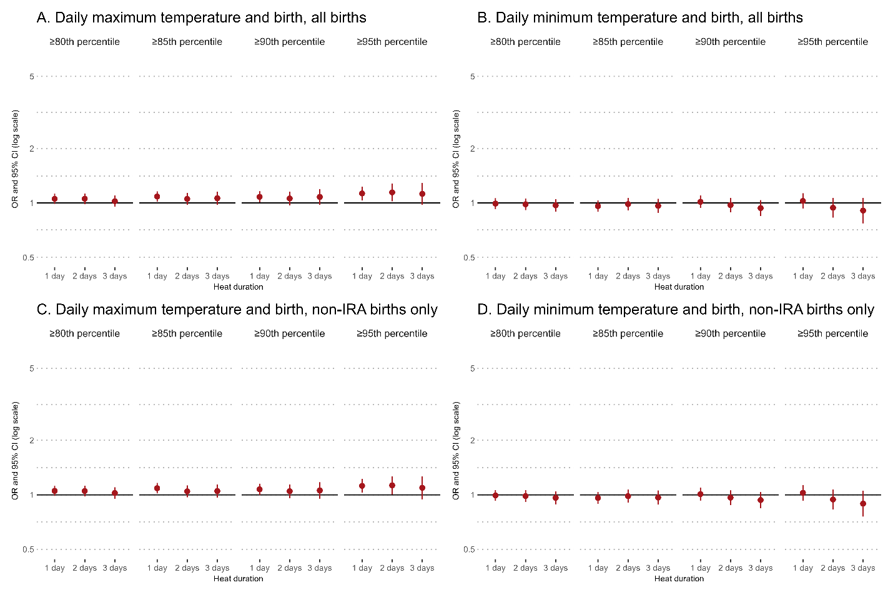
Figure S1. Associations between heat exposure and birth across temperature thresholds and exposure durations. Panels show daily maximum (A, C) and minimum (B, D) temperatures for all births (A–B) and non-IRA births only (C–D).

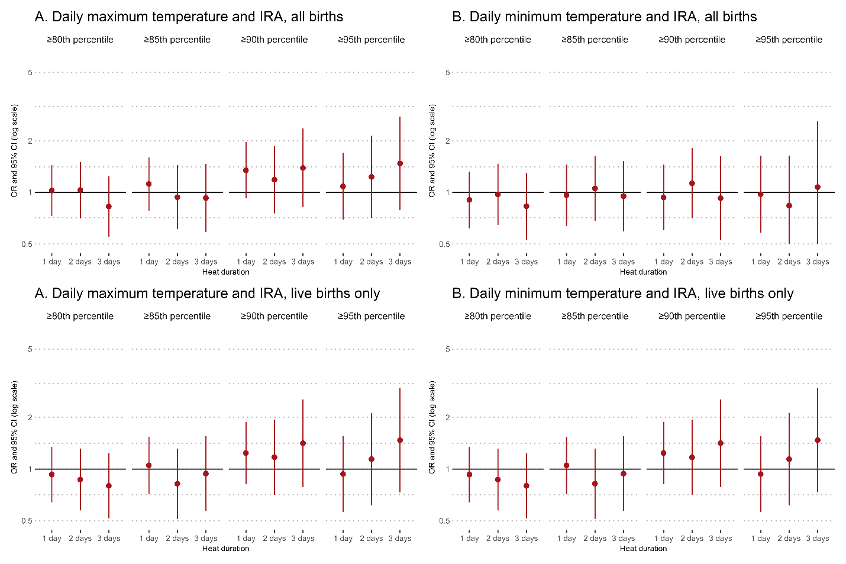
Figure S2: Negative control analysis examining associations between post-delivery temperature exposure (+4, +5, and +6 days after delivery) and intrapartum-related asphyxia (IRA).

