Supplementary Material
Figure S1. Increased senescence in DSCs from patients with RSA. (A, B) Immunohistochemistry detected the expression levels of senescence-associated molecules (CDKN2A, CDKN1A, and TP53) in the decidual tissue of normal early pregnant women (NP; n = 6) and recurrent spontaneous abortion patients (RSA; n = 6). Scale bar, 100 μm and 50 μm. Data were presented as mean ± SEM and analyzed by unpaired t-test or Mann-Whitney U test. **P < 0.01.
Figure S2. Cellular senescence and autophagy inhibition lead to the downregulation of FOXO1. (A) Relative mRNA levels of FOXO1 in H₂O₂ (200 μM)-induced senescent DSCs detected by RT-qPCR (n = 9). (B) Relative mRNA levels of FOXO1 in D-galactose (30 mM)-induced senescent DSCs detected by RT-qPCR (n = 6). (C) FOXO1 mRNA levels in DSCs after autophagy inhibition with 3-MA (10 mM) (n = 6). (D) Foxo1 mRNA levels in uterine tissues from control (n = 7) and 6% Leu (n = 7) groups. (E) The expression of FOXO1 in DSCs under high BCAA treatment. (F) The expression of FOXO1 in senescent DSCs induced by H₂O₂. (G) The expression of FOXO1 in senescent DSCs induced by D-galactose. (H) The expression of FOXO1 in DSCs after treatment with 3-MA. The relative expression levels of proteins were normalized using the internal reference protein GAPDH. Data were presented as mean ± SEM and analyzed by unpaired t-test or Mann-Whitney U test. *P < 0.05, ***P < 0.001, ****P < 0.0001.
Figure S3. Rapamycin alleviates excessive leucine-induced uterine senescence. (A) Immunofluorescence analysis of CDKN1A/p21 and TP53/p53 protein expression in DSCs from the control (Ctrl; n = 6) and 6% Leucine (6% Leu; n = 6) groups. (B) Immunofluorescence analysis of the distribution and intensity of CDKN1A and TP53 in uterine tissues from the 6% Leu (n = 6) and 6% Leu + Rapa ( n = 6) groups. (C) RT-qPCR was used to analyze the relative mRNA levels of autophagy-related genes Becn1, Sqstm1 and Map1lc3b in uterine tissues. Data were presented as mean ± SEM and analyzed by Mann-Whitney U test. *P < 0.05, **P < 0.01, ****P < 0.0001.

Figure S1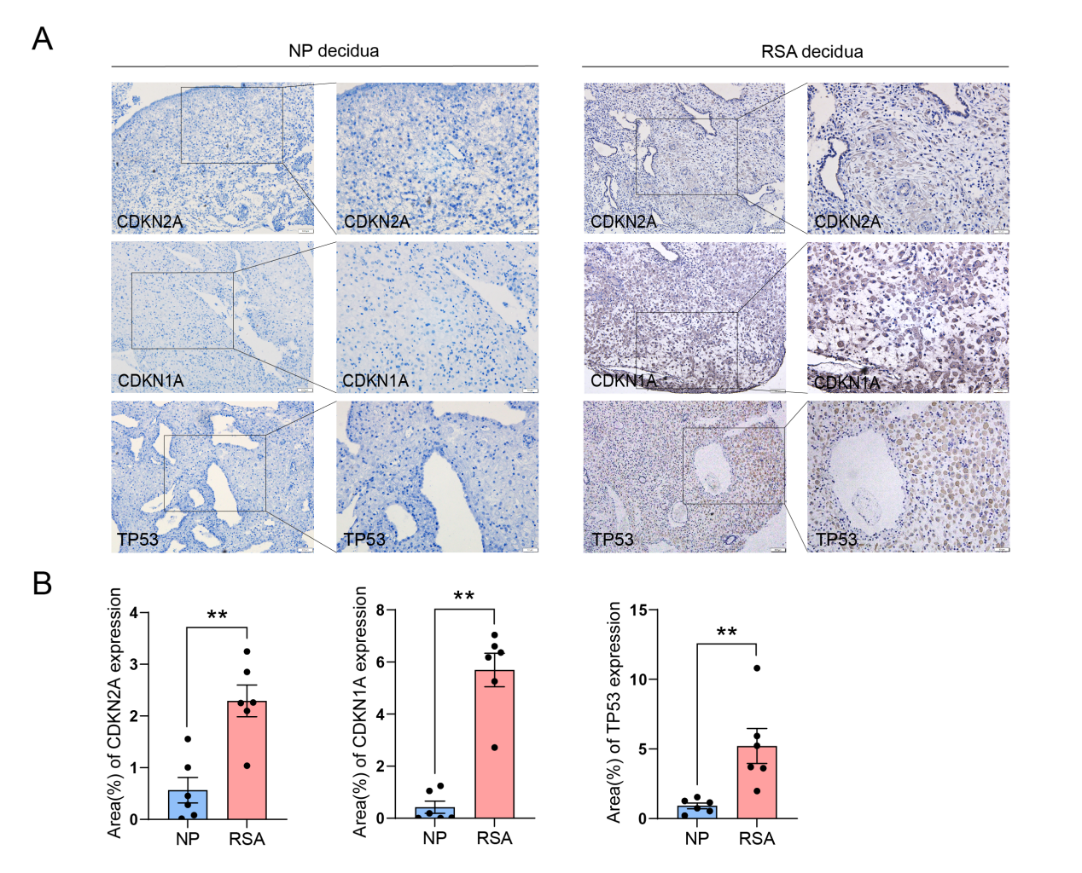

Figure S2
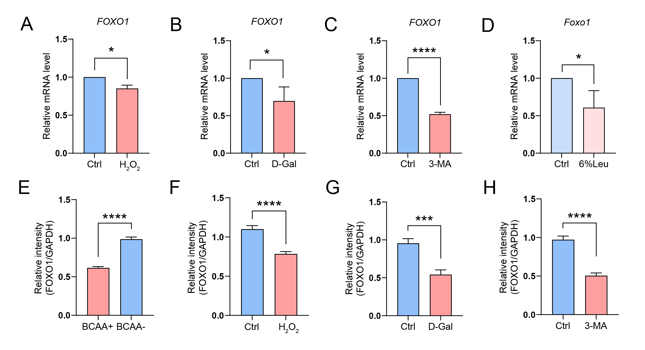

Figure S3
