Supplementary Material
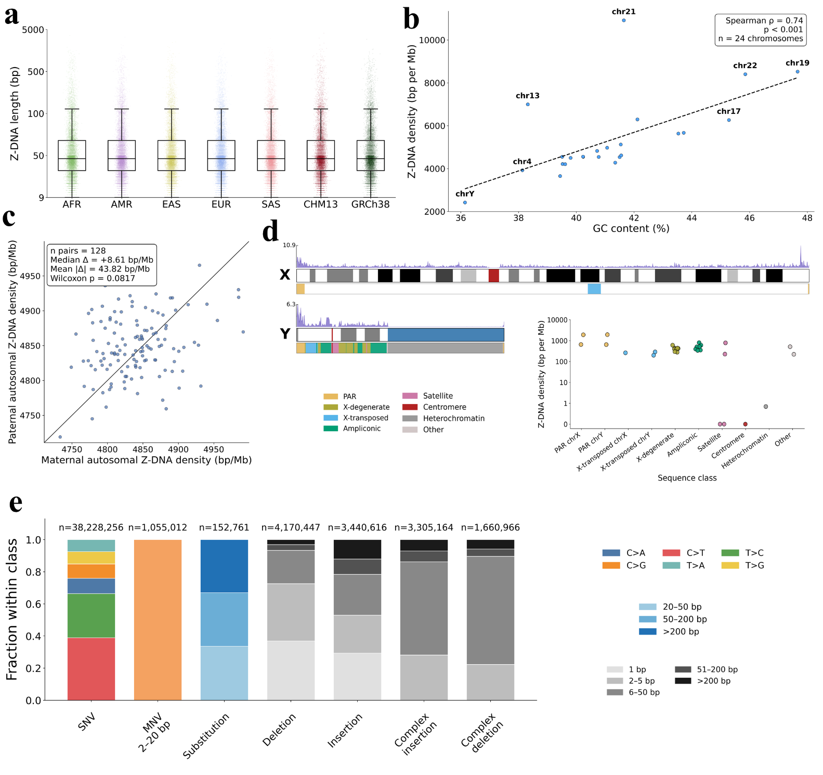
Supplementary Figure 1: Z-DNA sequence properties, chromosome-level density, and HPRC variant composition. a. Box plots of predicted Z-DNA sequence lengths sampled distributions across the 2 human reference genomes and the HPRC superpopulations. b. Correlation between GC content and Z-DNA density across CHM13 chromosomes. c. Paternal versus maternal autosomal Z-DNA density across paired HPRC samples. d. Sex chromosome ideogram with cytoband staining, Z-DNA density (150 kb bins; purple track), and X/Y-specific region annotations. Z-DNA density per annotated segment is displayed in bp per Mb with jitter points. e. Composition of HPRC v2 variants stratified by mutation class and size.

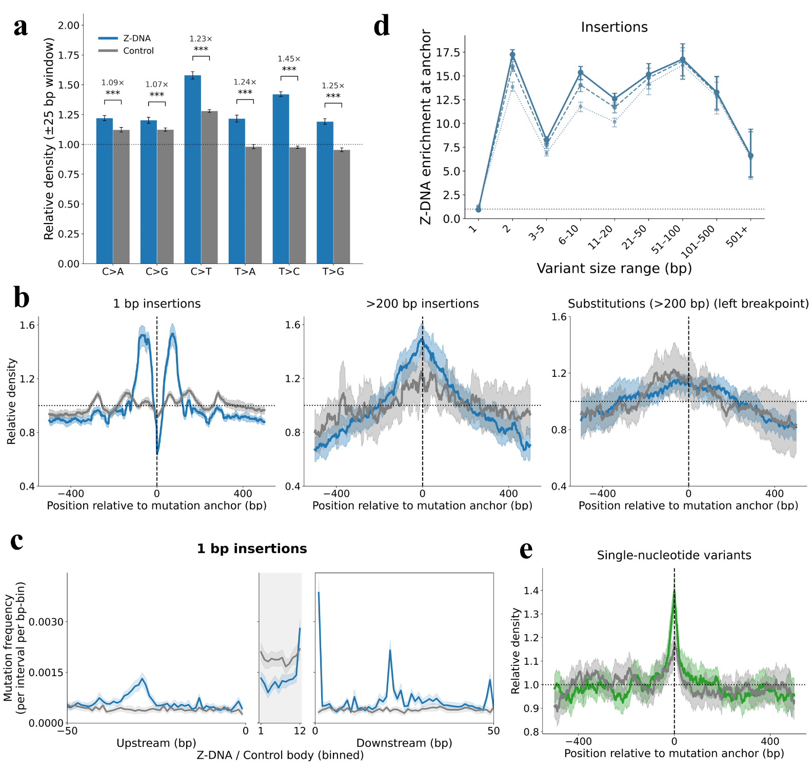
Supplementary Figure 2: Z-DNA enrichment patterns across mutation categories. a. Bar chart of relative densities of Z-DNA (blue) predictions versus Controls (gray) around a 50 bp window of the 6 unique SNV subcategories from the HPRC-CHM13 variant dataset. Stars denote Wilcoxon signed rank test significance after BH-FDR correction, and error bars show 95% chromosome-block bootstrap CIs. b. Z-DNA metaprofiles for 3 non-Z-DNA-enriched mutation classes from the HPRC-CHM13 variant dataset. For each type, Z-DNA overlap (blue) and matched control overlap (gray) were calculated in a ±500 bp window around the mutation point and normalized over the window to give relative density. Shaded bands show 95% chromosome-block bootstrap confidence intervals (CIs). The dashed vertical line marks the mutation position (offset = 0) and the horizontal one indicates the normalized baseline. c. Z-DNA-centered metaprofile for 1 bp insertions. Mutation frequencies were calculated across 50 bp upstream and downstream regions and across the Z-DNA/control interval body (rescaled into equal bins due to varying Z-DNA lengths). Shaded bands show 95% chromosome-block bootstrap CIs. The gray central region represents the Z-DNA/control body. d. Z-DNA enrichment as a function of variant size for insertions. Enrichment is the ratio of local Z-DNA base fraction (within ±10, ±25, or ±50 bp of the mutation anchor) to the genome-wide Z-DNA fraction (0.48%). Insertions were binned into size classes; points show chromosome-block bootstrap means and error bars show 95% CIs. e. Z-DNA (green) metaprofile as in b. but for de novo SNV mutations on the GRCh37 human reference genome.
Supplementary Table 1: Table containing explanations of abbreviations used in this manuscript.
Abbreviation | Full name
CenSat | Centromeric and Pericentromeric Satellite Annotation
HSAT1A | Classical Human Satellite 1A
HSAT1B | Classical Human Satellite 1B
HSAT2 | Classical Human Satellite 2
HSAT3 | Classical Human Satellite 3
HOR | Inactive alpha satellite Higher Order Repeats
DHOR | Divergent alpha satellite Higher Order Repeats
AHOR | Active alpha-satellite Higher-Order Repeats
MON | Monomeric alpha satellites
BSAT | Beta Satellites
GSAT | Gamma Satellites
CT | Centric Transition regions
SNV | Single Nucleotide Variation
MNV | Multiple Nucleotide Variation
MMR | Mismatch repair
NER | Nucleotide Excision Repair
AC | Allele Count
AN | Allele Number
AF | Allele Frequency
CDS | Coding Sequence

