Table 1: Guiding principles underpinning development of the toolkit
Guiding principle | Rationale | Implications for intervention design
Integrate lived experience throughout | Co-design enhances relevance, acceptability, and ethical sensitivity and supports epistemic justice. | Iterative feedback from people with lived experience informed content, tone, pacing, safeguards, and framing; reflexive input from researchers with lived experience.
Emotional validation and non-blaming framing | People with BEDs commonly experience high levels of shame and self-criticism; framing binge eating as a personal failing or deficit may increase distress and disengagement | Content frames binge eating as an understandable, but unhelpful, response to emotional distress; language avoids blame, judgement or deficit-based framing.
Target emotional processes central to binge eating | Emotional awareness, emotion regulation, beliefs about emotions, and secondary emotions are empirically implicated in binge eating and may precede symptom onset. | Content primarily focused on emotional awareness, acceptance, distress tolerance, and adaptive regulation rather than weight, shape, or eating rules.
Provide practice exercise to practice newly acquired learning | Whilst psychoeducation about the emotional drivers of eating-disordered behaviours is expected to support change, engagement in skills practice is likely to be important for changes in behaviour to occur. | Each video is accompanied by a set of practice exercises to reinforce learning. There is also a workbook with additional practice sheets and further information
Prioritise emotional safety in a self-guided format | Self-guided interventions may pose risks if content evokes distress without adequate support, particularly during waiting periods. | Gradual introduction of emotionally evocative content; explicit permission to pause or disengage; clear signposting to additional support and crisis resources. Clarity from the outset that emotions are the central tenant of this intervention.
Support autonomy, choice and flexibility | Individuals on waiting lists may feel powerless, or subject to, services; rigid interventions may increase disengagement. | Modular, self-paced design allowing selective engagement; encouragement of user choice rather than completion requirements and supporting flexible, self-paced engagement with the option to revisit material as needed
Avoid blame for systemic gaps in care | Waiting list interventions risk inadvertently shifting responsibility for managing distress onto individuals in the absence of timely treatment. | Explicit framing of the toolkit as supportive and adjunctive, not a replacement for specialist care; acknowledgement of systemic barriers within content.
Inclusive content reflecting diverse experiences | People with binge eating difficulties have diverse identities and experiences and may feel alienated by content that assumes a narrow or stereotypical presentation of eating disorders. | Content and animations were designed to be inclusive and accessible, avoiding body-focused or stigmatising imagery, and highlighting the variety of experiences due to cultural background, neurodiversity or personal experiences such as trauma.
Ensure feasibility and scalability within routine care | Overstretched services require low-intensity, scalable interventions. | Brief, digital, self-guided format requiring minimal clinician input and no specialist training

Figure 1. Preliminary logic model for FEEL-ED. 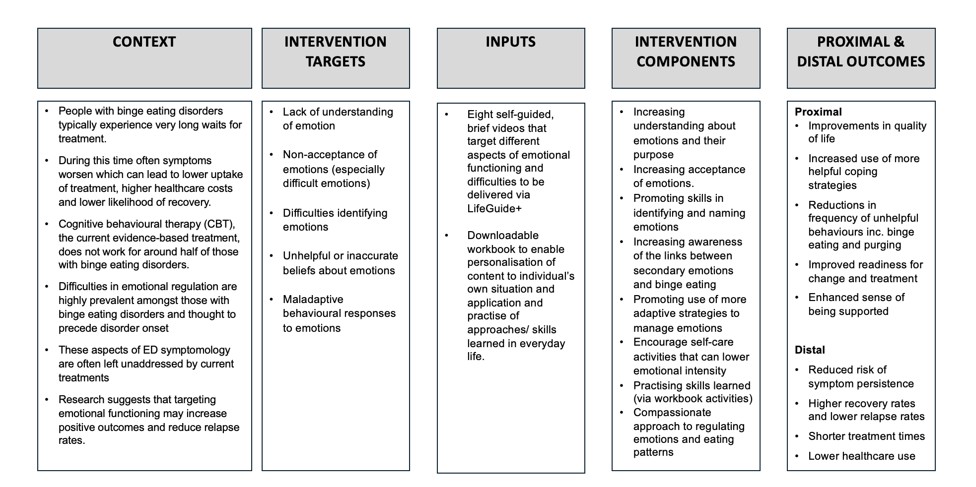
NB. Outcomes are included for conceptual completeness, but were not evaluated in the current study

Survey sent to lived experience contributors:

1: Is there a need for a toolkit like FEEL-ED?
Do you think there is a need for an emotion-based toolkit like FEEL-ED for people who binge-eat or experience similar eating difficulties?

You might want to consider:
- Whether emotional struggles were part of your experience
- Whether they were addressed in any support you had (or didn’t have)
- What felt missing, or what you wished you'd had access to
- Other people who may have different experiences to your own

2: Offering support during waiting times
What are your thoughts on offering something like FEEL-ED while people are waiting for treatment?

You might want to consider:
- Whether you had support while waiting (if you waited for treatment)
- What you think could help someone during that time
- If a toolkit like this would be useful (or not) for that phase
- Thinking about the timing: is the right time for FEEL-ED during awaiting treatment, or once treatment has started, or at the end, or unsure?
3: Benefits of FEEL-ED
What do you see as the possible benefits of the FEEL-ED toolkit?

You might want to consider:
- Emotional literacy or coping skills
- Feeling seen or understood
- Having something rather than nothing while waiting
- Being able to revisit or replay the material
4: Risks or concerns
Do any risks, concerns or possible downsides come to mind when thinking about this toolkit?
You might want to consider:
- Whether the content might feel triggering or overwhelming
- If someone might use it instead of getting treatment
- If it feels like a “tick box” instead of real support
- Whether people might feel unsupported if it doesn’t help them
5: Anything else to share?
Is there anything else you'd like to add?
This could be something about your experience, your ideas, or anything you haven’t had a chance to say yet.

