Appendix A

Derivation of Effective Permeability of Throat-ij

To derive the effective permeability ($K_{ij}$) of a clogged throat, we begin with the cross-sectional area of that throat denoted by $A_{ij}$. This throat consists of both open and clogged regions, with $K_{op}$​ and $K_{cl}$​ representing the permeabilities of the open and clogged sections, respectively, as shown in Figure A.1. The total length of the throat is $L_{tot}^{ij}$, with $L_{op}^{ij}$and $L_{cl}^{ij}$​ being the lengths of the open and clogged regions, respectively. The overall pressure drop across the throat is given by $ΔP_{tot}^{ij}=ΔP_{op}^{ij}+ΔP_{cl}^{ij}$​.

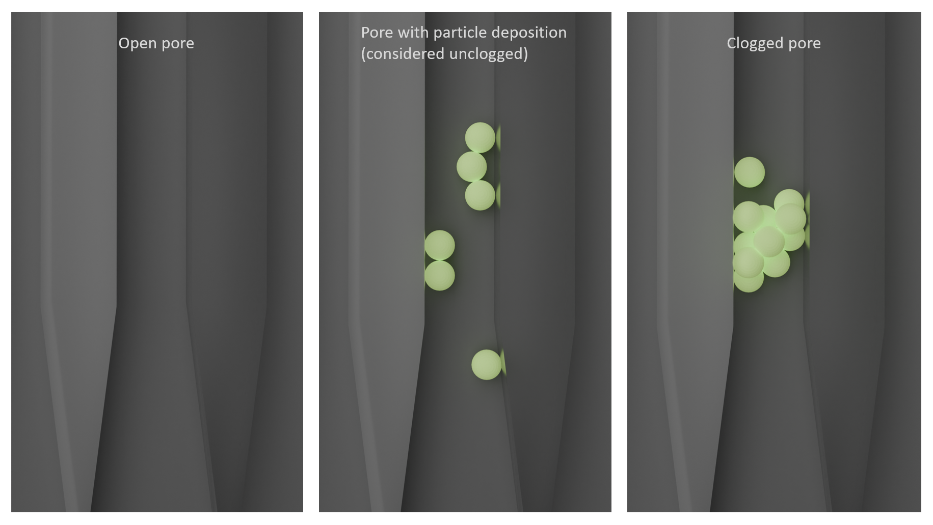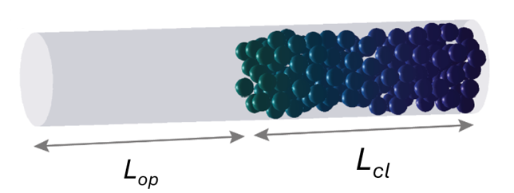
Figure A.1. The schematic of open and clogged pores and the underlying assumption that pores with deposited particles are considered unclogged as long as particles can still travel through.

Derivation of $K_{ij}$:
According to the definition of permeability:

$K_{ij}=\frac{Q_{ij}ηL_{tot}^{ij}}{A_{ij}ΔP_{tot}^{ij}}$ (A1)

Where $Q_{ij}$ is the volumetric flow rate through the throat and $η$ is the dynamic viscosity, both of which are considered constant here and $A_{ij}$ is the cross-sectional area of the Throat.

Substituting $ΔP_{tot}^{ij}$ with $ΔP_{op}^{ij}+ΔP_{cl}^{ij}$ gives:
$K_{ij}=\frac{Q_{ij}ηL_{tot}^{ij}}{A_{ij}(ΔP_{op}^{ij}+ΔP_{cl}^{ij})}$ (A2)

Given that $K_{op}=\frac{Q_{ij}ηL_{op}^{ij}}{A_{ij}ΔP_{op}^{ij}}$ and $K_{cl}=\frac{Q_{ij}ηL_{cl}^{ij}}{A_{ij}ΔP_{cl}^{ij}}$, we can express $ΔP_{op}^{ij}$ and $ΔP_{op}^{ij}$ as:

$ΔP_{op}^{ij}=\frac{Q_{ij}ηL_{op}^{ij}}{A_{ij}K_{op}}$ (A3)
$ΔP_{cl}^{ij}=\frac{Q_{ij}ηL_{cl}^{ij}}{A_{ij}K_{cl}}$ (A4)

Substituting $ΔP_{op}$ and $ΔP_{cl}$ back into the equation for $K_{ij}$ (A1) yields:

$K_{ij}={\left(\frac{L_{tot}^{ij}-L_{cl}^{ij}}{L_{tot}^{ij}K_{op}^{ij}}+\frac{L_{cl}^{ij}}{L_{tot}^{ij}K_{cl}^{ij}}\right)}^{-1}$ (A5)

This equation represents the total permeability of a throat clogged by particles, formulated as a harmonic average of the open and clogged sections, reflecting their series arrangement.

