Figure S1 Venn graph of the number of Unigene, A: Postoperative defecation time ≤5 days, B: Postoperative defecation time >5 days
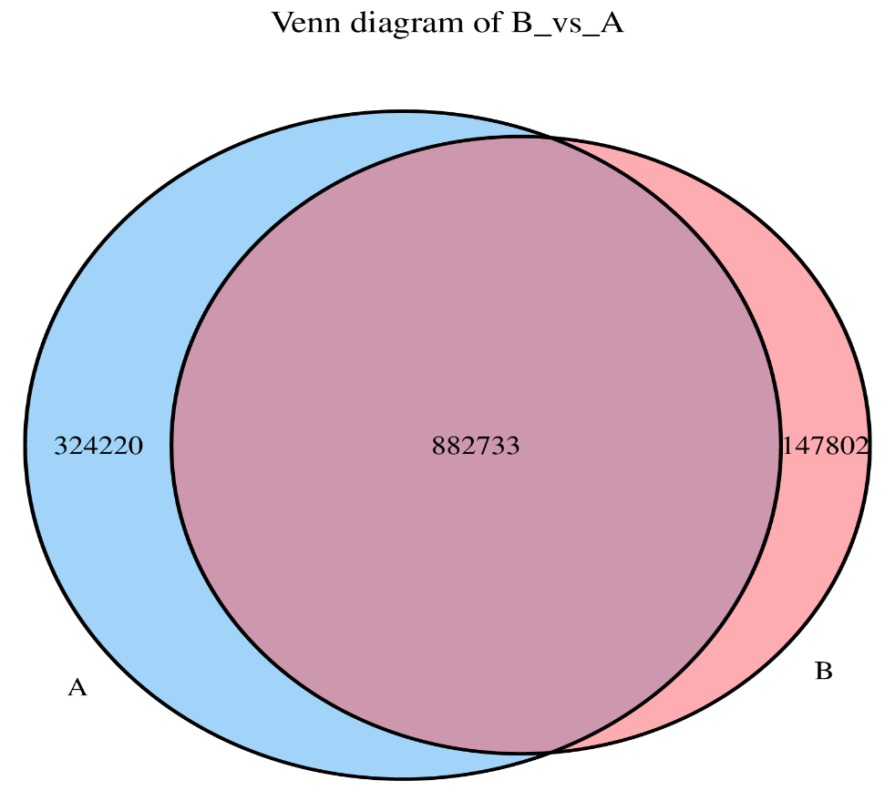

Figure S2 Postoperative microbiome species analysis (Phylum), the left figure is a bar stack chart, different colors represent different species, and the height of the bar color indicates the proportion in different groups. The right figure is a heat map. The gradient color from blue to red reflects the change in abundance from low to high. The closer it is to red, the higher the abundance. A: Postoperative defecation time ≤5 days, B: Postoperative defecation time >5 days
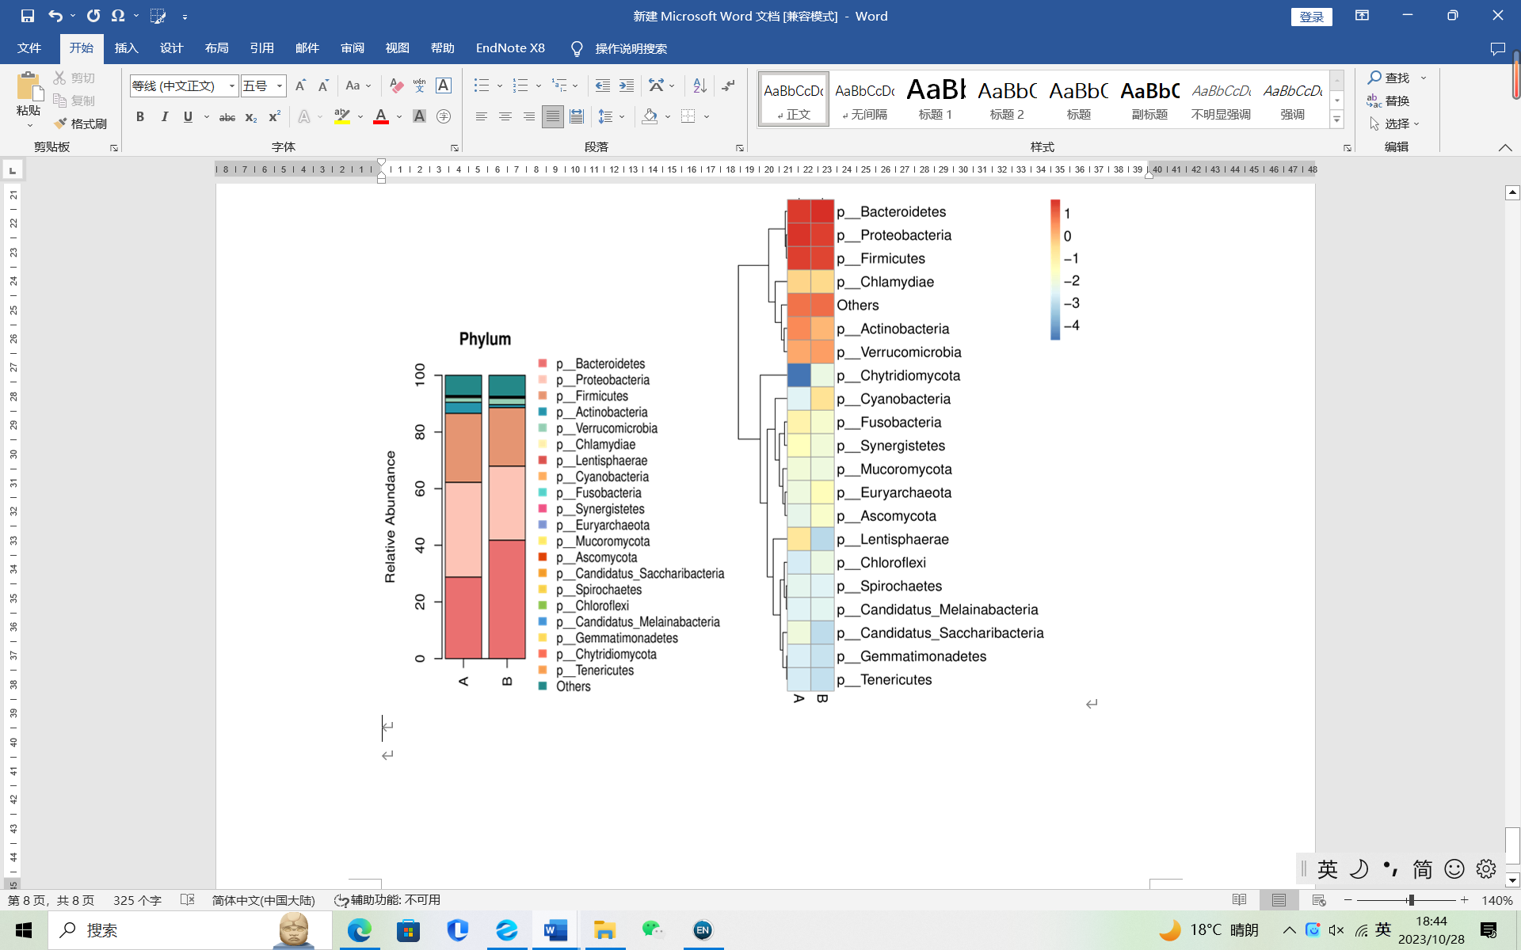
Figure S3 Postoperative microbiome species analysis (Class), A: Postoperative defecation time ≤5 days, B: Postoperative defecation time >5 days
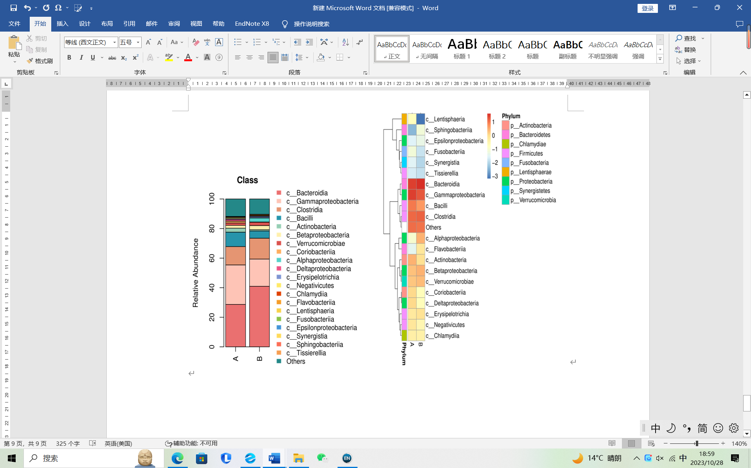

Figure S4 Postoperative microbiome species analysis (Order), A: Postoperative defecation time ≤5 days, B: Postoperative defecation time >5 days
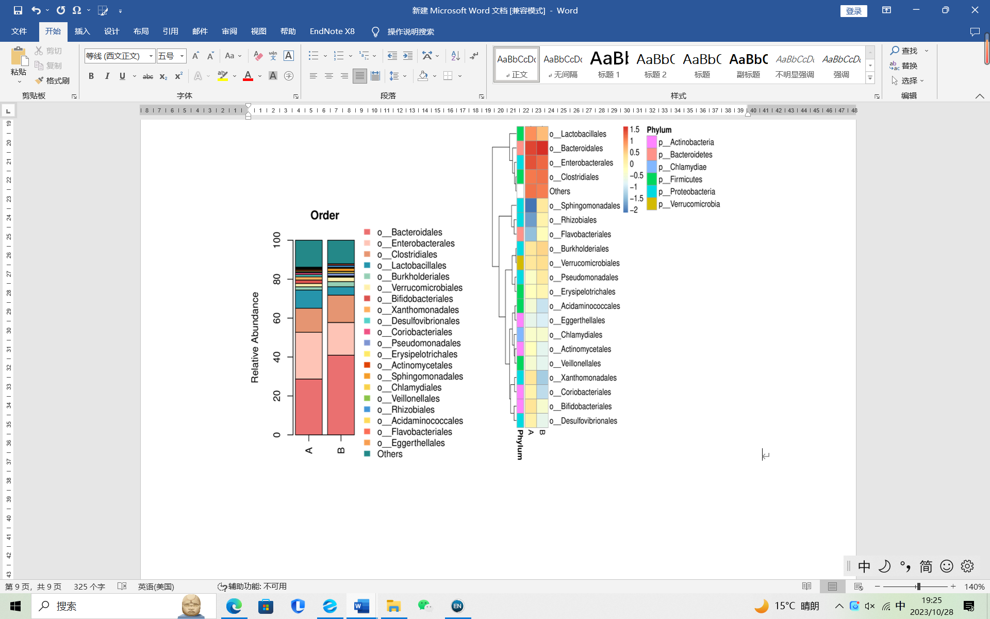

Figure S5 Postoperative microbiome species analysis (Family), A: Postoperative defecation time ≤5 days, B: Postoperative defecation time >5 days
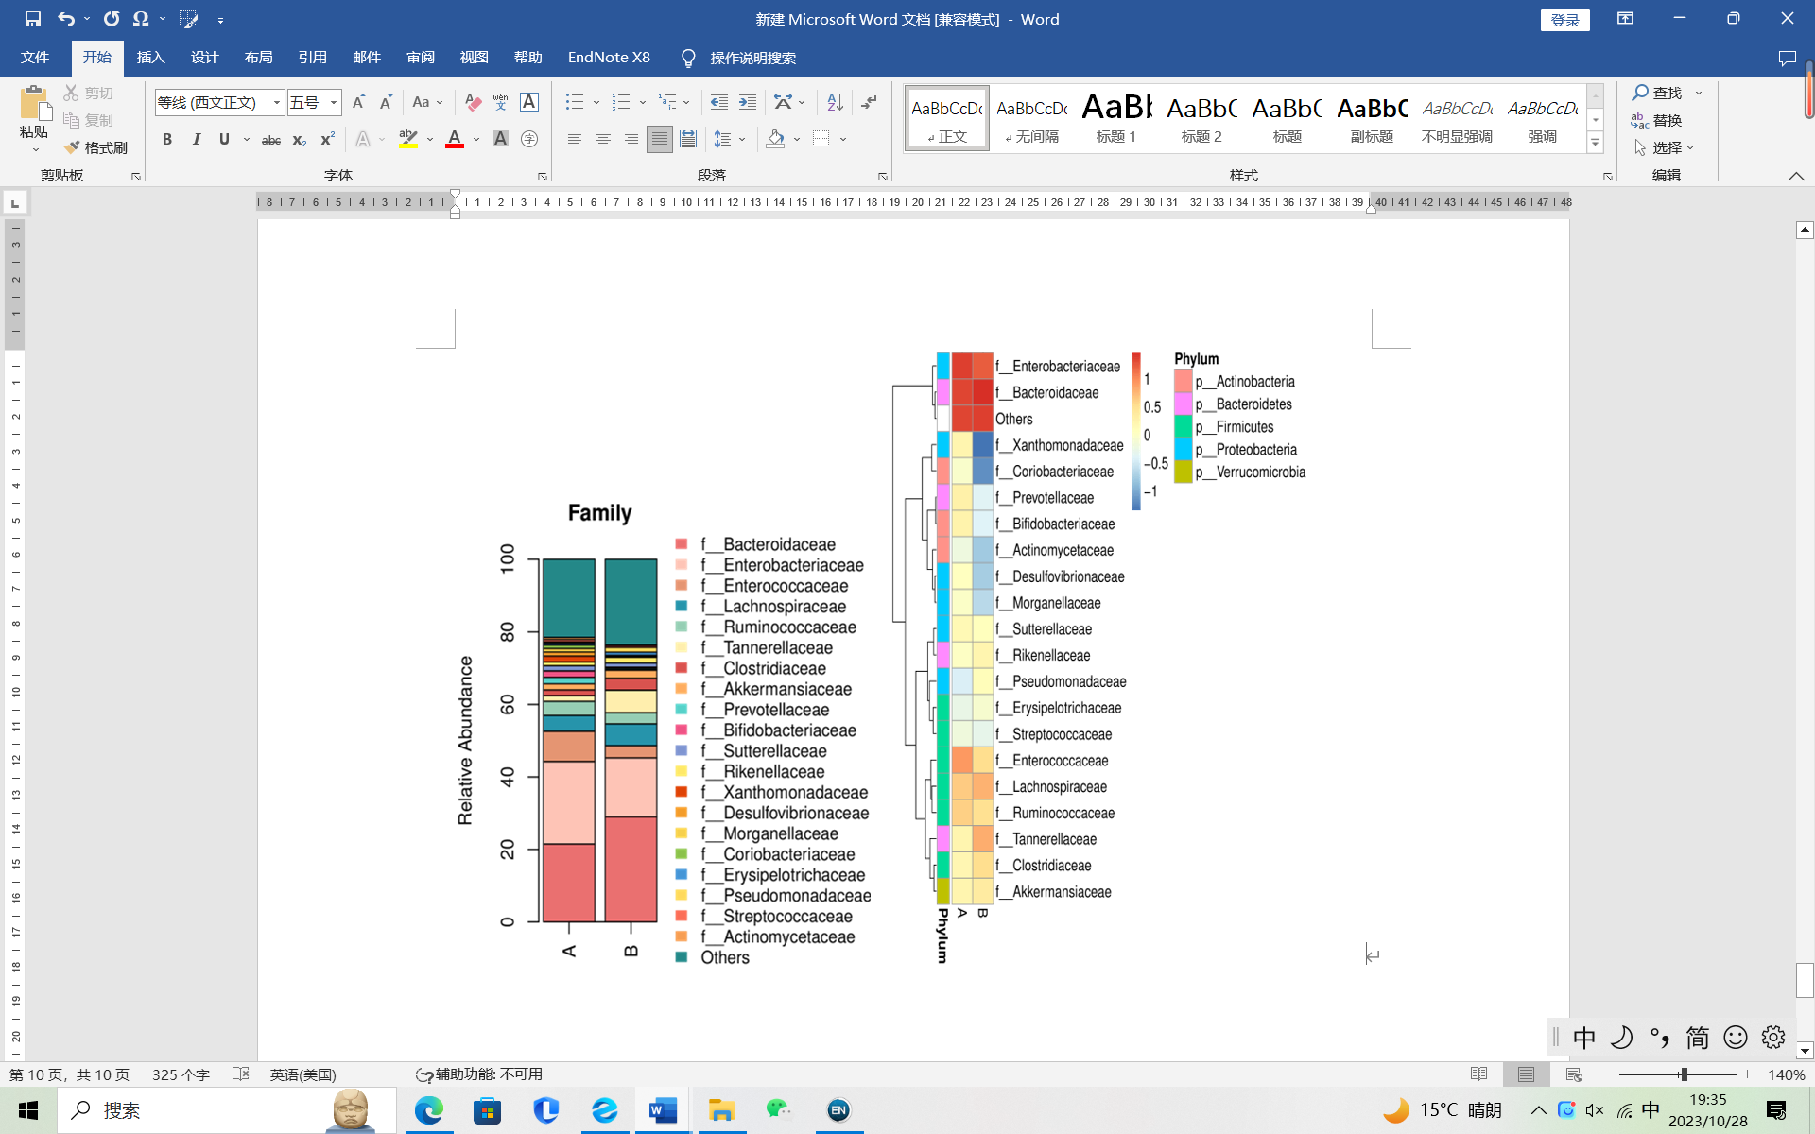

Figure S6 Postoperative microbiome species analysis (Genus), A: Postoperative defecation time ≤5 days, B: Postoperative defecation time >5 days
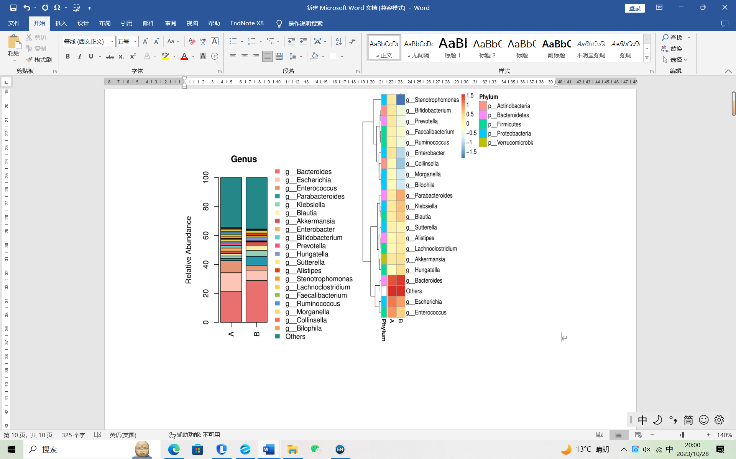

Figure S7 Postoperative microbiome species analysis (Species), A: Postoperative defecation time ≤5 days, B: Postoperative defecation time >5 days
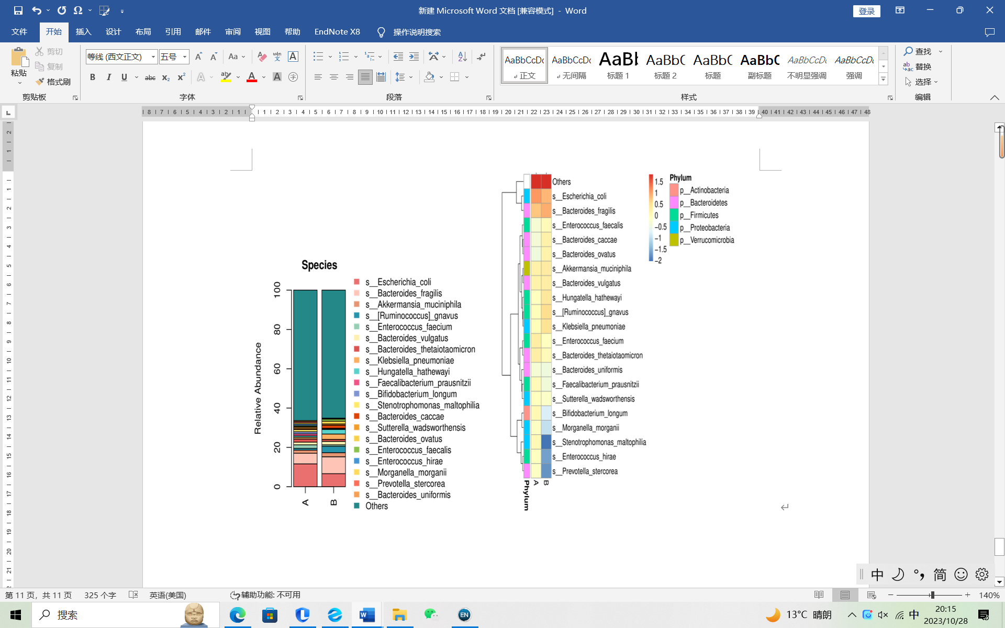
Figure S8 Manhattan plot for the analysis of intestinal species differences in patients after colon surgery. The vertical coordinate represents the P value, and the differences above the dotted line are statistically significant. Each dot or circle represents a hierarchical classification unit, and the size indicates its relative abundance. Points with significant differences are indicated by colored dots or rings, those with insignificant differences are indicated by gray rings, and those with significant differences within the group are indicated by colored solid dots. The upward triangular symbol indicates that the ratio of postoperative defecation time >5 days to postoperative defecation time ≤5 days is greater than 1. The inverted triangle symbol indicates a ratio <1. A: Postoperative defecation time ≤5 days, B: Postoperative defecation time >5 days
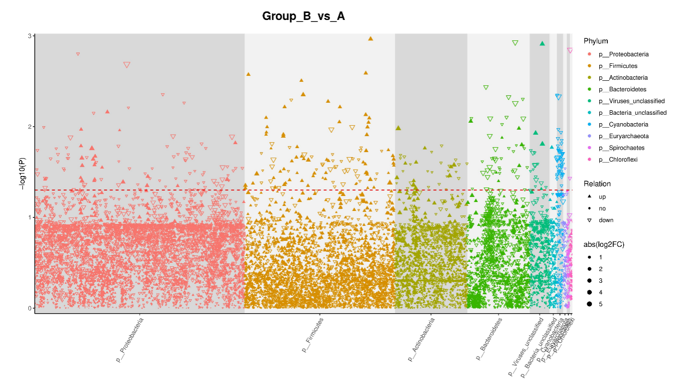
Figure S9 Differential functional annotation analysis of Unigene in GO. In the bar chart on the left, the vertical axis represents the top 30 functional items with the smallest p value, and the horizontal axis represents the proportion of each functional item in different groups. The higher the column, the higher the proportion. Columns of different colors represent different groups. In the scatter plot on the right, the vertical axis represents the difference P-values of each functional item (scientific notation), arranged from bottom to top in ascending order of P-values. The horizontal axis represents the abundance differences of each functional item between the two groups. The differences are marked as orange points on the right side of the dotted line, and the differences are marked as blue points on the left side of the dotted line. A: Postoperative defecation time ≤5 days, B: Postoperative defecation time >5 days
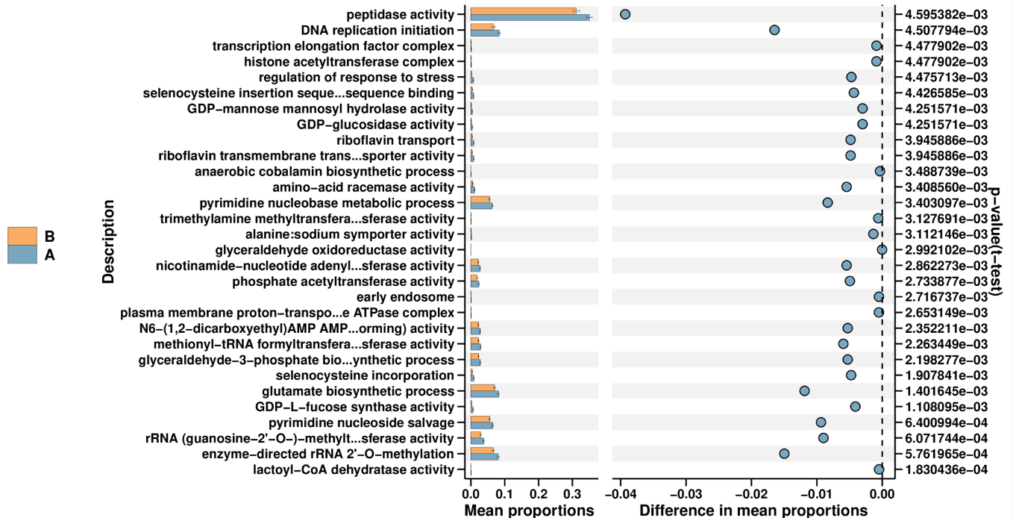
Figure S10 Postoperative Unigene in KEGG function annotation comparison chart (path definition). A: Postoperative defecation time ≤5 days, B: Postoperative defecation time >5 days
