Substrate | Biovar 1 | Biovar 2 | Biovar 3 | Biovar 4 | Biovar 5 | Biovar 6 | Biovar 3b
Maltose | - | + | + | - | + | + | +
Lactose | - | + | + | - | + | + | -
Cellobiose | - | + | + | - | + | + | +
Mannitol | - | - | + | + | + | + | +
Sorbitol | - | - | + | + | - | - | +
Dulcitol | - | - | + | + | - | - | -
Table S1. Biovar determination of Ralstonia solanacearum isolates based on the acid production through utilization of various carbohydrates.

Table S2. List of primers and amplicon size for Pmx-PCR used in phylotying of RSSC
Primers | Sequence (5’-3’) | Specific to phylotype | Amplicon
Nmult21:1F | CGTTGATGAGGCGCGCAATTT | Forward primer for phylotype I | 144bp
Nmult21:2F | AAGTTATGGACGGTGGAAGTC | Forward primer for phylotype II | 372 bp
Nmult23:AF | ATTACSAGAGCAATCGAAAGATT | Forward primer for phylotype III | 91bp
Nmult22: InF | ATTGCCAAGACGAGAGAAGTA | Forward primer for phylotype IV | 213bp
Numult22: RR | TCGCTTGACCCTATAACGAGTA | Reverse primer for all phylotypes
759 | GTCCCGTCAACTCACTTTCC | Species-Specific forward primer
760 | GTGCCGTCAGCAATGCGGAA | Species-Specific reverse primer | 288bp

Table S3. List of Ralstonia solanacearum reference species complex strains used in the phylogenetic analysis
Strain | GenBank accession no. | Host | Origin | Phylotype¹ | Sequevar²
Maff211497 | AB508649 | Ginger | Japan | I | 30
Maff107639 | AB620014 | Wild turmeric | Japan | I | 30
Maff211479 | AB508598 | Japanese ginger | Japan | I | 30
Z6 | FJ561141 | Ginger | China | I | 14
GMI1000 | KY605047 | Tomato | French Guyana | I | 18
PSS219 | FJ61167 | Tomato | Taiwan | I | 34
PSS81 | FJ561066 | Tomato | Taiwan | I | 14
Psi7 | EF371804 | Tomato | Indonesia | IV | 10
R230 | AF295280 | Banana | Indonesia | IV | 10
Tb3 | FJ561128.1 | Tobacco | China | I | 17
CIP365 | GQ907151.1 | Potato | Philippines | I | 45
RS121 | KT355485.1 | Pepper | Florida | I | UD³
PSS190 | EU407285.1 | Tomato | Taiwan | I | 15
SUPP1725 | AB508665.1 | Bellflower | Japan | I | UD³
Zo4 | FJ561156.1 | Ginger | Philippines | I | 14
ACH732 | EF371812.1 | Heliconia | USA | IV | 6
K60(CFBP2047) | DQ657614.1 | Tomato | USA | II | 7
J25 | AF295279.1 | Potato | Kenya | III | 20
Pn18 | MG999606.1 | Peanut | China | I | 14
Pn29 | MG999616.1 | Peanut | China | I | 14
Pn30 | MG999617.1 | Peanut | China | I | 14
Pn31 | MG999618.1 | Peanut | China | I | 14
RS-10-249 | HQ245037 | Eggplant | Andaman Island | I | 48
RS-10-253 | HQ245039 | Eggplant | Andaman Island | I | 47
RS-08-60 | HQ245002 | Eggplant | Goa | I | 17
RS-10-250 | HQ245038 | Eggplant | Andaman Island | I | 14
M3Pi9.107 | KX242313.1 | Chilli pepper | Mauritius: Rodrigues | I | 33
RS-08-04 | HQ244995.1 | Eggplant | Goa | I | UD³
RS-08-44 | KF920632.1 | Eggplant | Goa | I | 14
B1 | FJ561159.1 | Sweet potato | China | I | 15
R288 | GQ907153.1 | Mulberry | China | I | 12
RS-09-151 | HQ245019 | Eggplant | Goa | I | 44

¹Phylotype Characterization based on multiplex PCR according to the protocol described by Fegan & Prior (2005).
²Sequevar determined based on analyses of partial endoglucanase gene sequences. Sequences within a sequevar have <1% nucleotide difference among the strains (Poussier et al., 2000; Fegan & Prior, 2005)
³UD (undetermined); indicates that the strain did not align with a RSSC strain within any publishes sequevar.

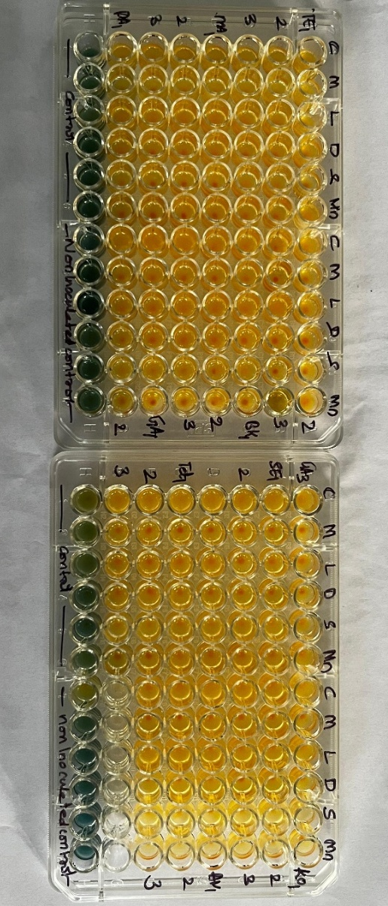
Fig S1. Improved biovar test showing complete color change on sugar and alcohol utilization

