Supporting information
NiCo alloys anchored on N-doped carbon nanotubes as efficient bifunctional electrocatalysts for overall water splitting

Experimental

Characterizations

The X-ray diffraction (XRD) patterns were collected using a Shimadzu XRD-6000 diffractometer with Cu-K_{α} radiation source. Scanning electron microscope (SEM) and transmission electron microscope (TEM) images were acquired with a Zeiss Merlin-Compact SEM and a JEOL JEM-2100F TEM, respectively. Raman spectra were recorded with a RENISHAW INVIA Raman spectrometer at an excitation wavelength of 532 nm. X-ray photoelectron spectroscopy (XPS) measurements were performed on a Thermo-Fisher Scientific ESCALAB 250Xi XPS instrument with Al-K_{α} source, and the binding energies were calibrated using the C 1s peak at 284.8 eV. N₂ adsorption-desorption isotherms were measured at 77 K using a Micromeritics ASAP 2020 apparatus. Prior to the measurements, the samples were degassed for 4 hours.

Electrocatalytic measurements

The OER and HER measurements of catalysts were conducted on a CHI-760E electrochemical workstation (Shanghai Chenhua) using a standard three-electrode system at room temperature. A catalyst-coated glassy carbon electrode was used as the working electrode, while a saturated Hg/HgO (1.0 M KCl) electrode and a graphite rod served as the reference and counter electrodes, respectively. The working electrode was prepared as follows: 5.0 mg of catalyst powder was ultrosonically dispersed in a mixture of water/ethanol (500 µL/470 µL) containing 30 µL of Nafion (5 wt%) to form a homogeneous ink. The catalyst ink was then drop-cast onto a freshly polished glassy carbon electrode (3 mm diameter, ~0.34 mg cm⁻²) and air-dried.

All potentials were calibrated against a reversible hydrogen electrode (RHE) using the Nernst equation: E_{(RHE)} = E_{(HgO)} + 0.059pH + 0.098. Linear sweep voltammetry (LSV) curves for OER and HER were independently recorded in O₂-saturated and N₂-saturated 1.0 M KOH solutions at 5 mV s⁻¹ with 95% iR compensation. Tafel slopes were derived from LSV data using the Tafel equation: η = a + b × log j, where j represents the current density, η denotes the overpotential, and b is the Tafel slope. The electrochemical double-layer capacitance (C_{dl}) was estimated from cyclic voltammetry (CV) scans at non-Faradaic potentials with sweep rates ranging from 20 to 120 mV s⁻¹ (20 mV intervals). Catalytic stability was evaluated by investigating LSV curves after 3000 CV cycles, and the chronoamperometric plots at constant potentials. A two-electrode electrolyzer was assembled using nickel foam (NF)-supported catalyst as both electrodes, with an asymmetrical configuration (Pt/C/NF‖RuO₂/NF) for comparison, all tested in 1.0 M KOH solution.
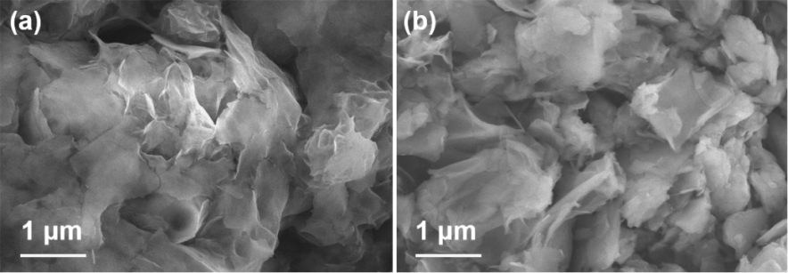
Fig. S1 SEM images of (a) Ni-LDH and (b) Co(OH)₂.
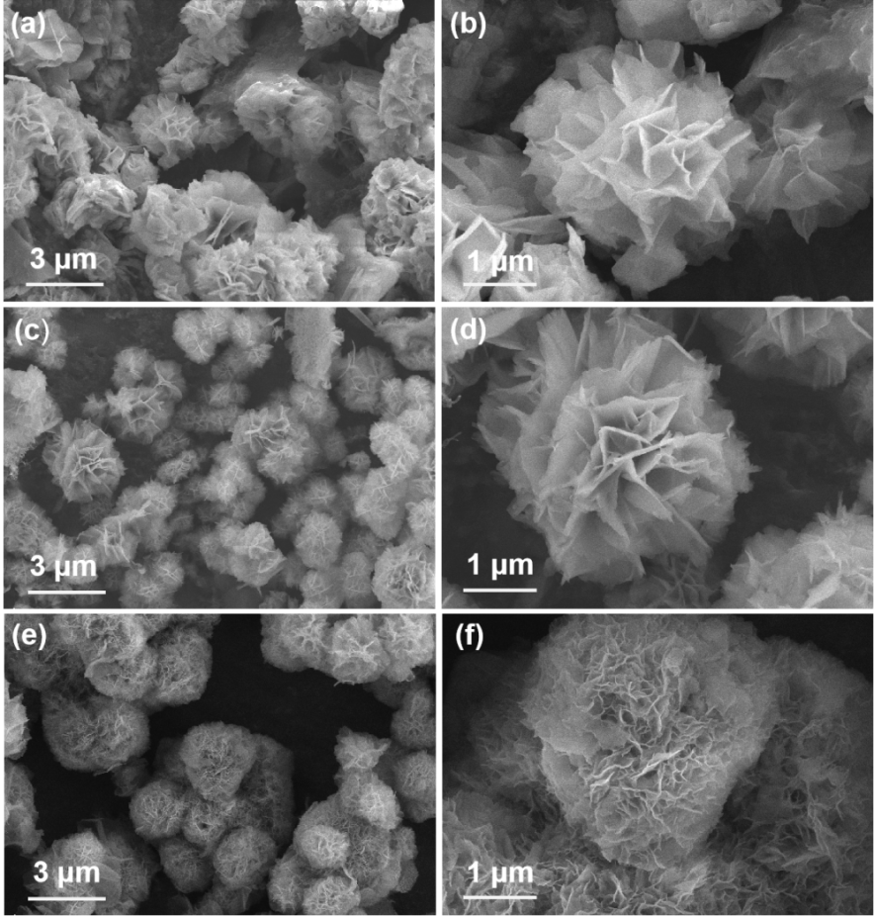
Fig. S2 SEM images of NiCo-LDH: (a, b) 1:1; (c, d) 2:1, and (e, f) 4:1.
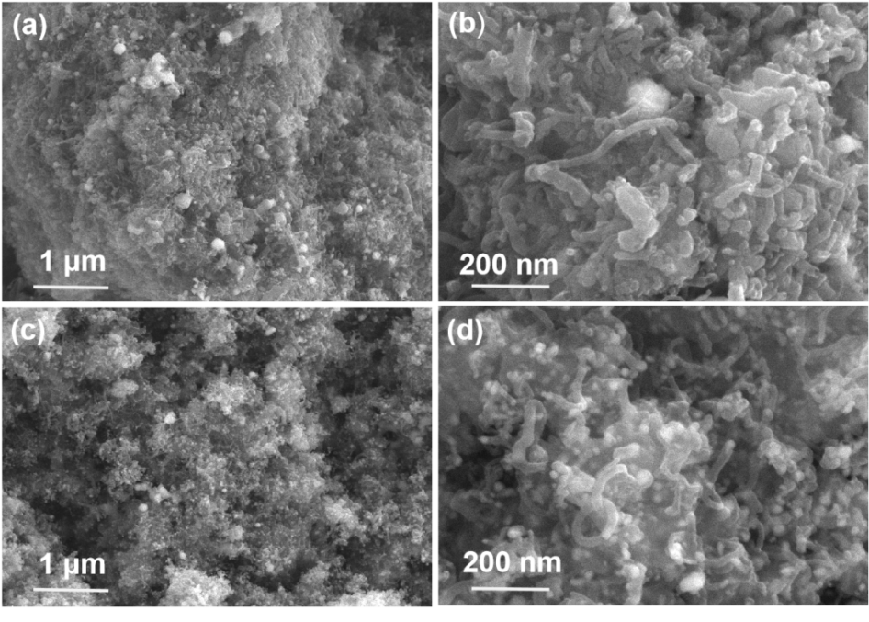
Fig. S3 SEM images of (a, b) Ni@NCNTs and (c, d) Co@NCNTs.
Fig. S4 XPS survey spectra of Ni₂Co₁@NCNTs, Ni@NCNTs, and Co@NCNTs.
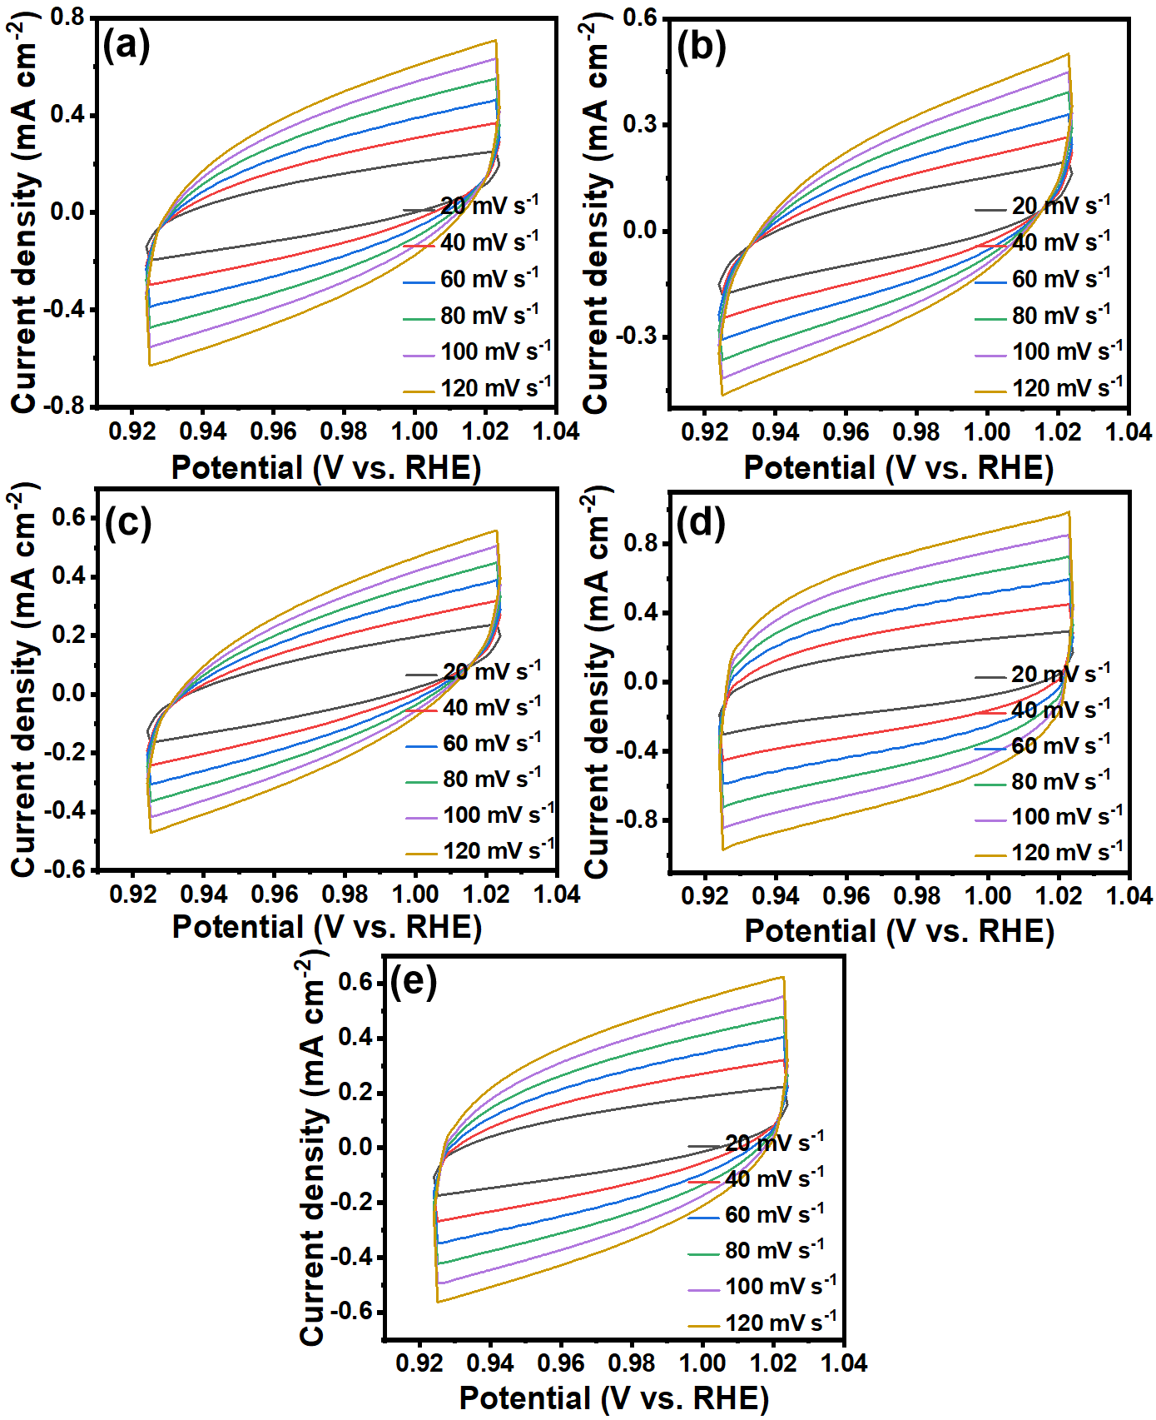
Fig. S5 OER CV curves at different scanning rates of (a) Ni@NCNTs, (b) Co@NCNTs, (c) Ni₁Co₁@NCNTs, (d) Ni₂Co₁@NCNTs, and (e) Ni₄Co₁@NCNTs in 1.0 M KOH solution.
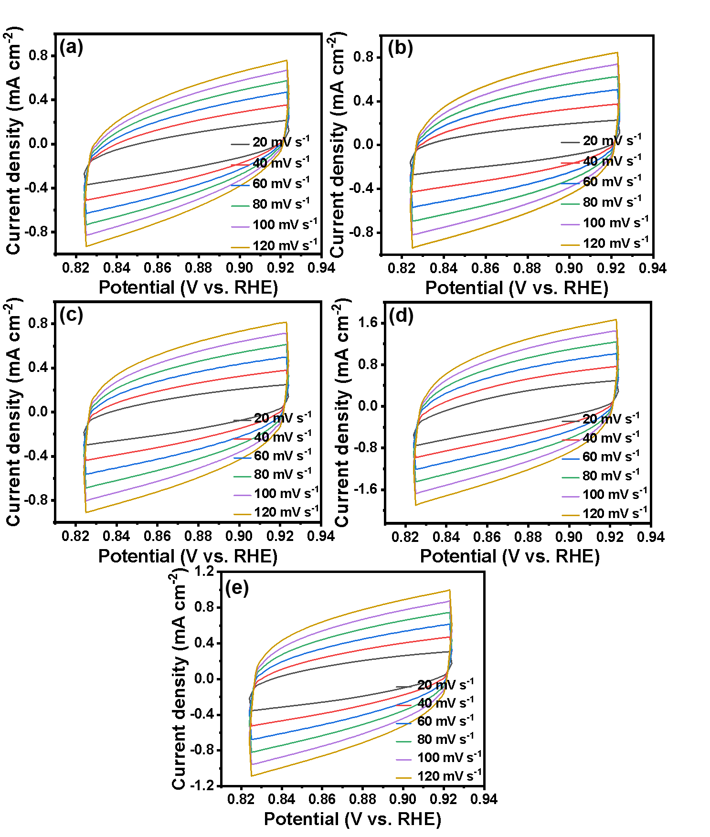
Fig. S6 HER CV curves at different scanning rates of (a) Ni@NCNTs, (b) Co@NCNTs, (c) Ni₁Co₁@NCNTs, (d) Ni₂Co₁@NCNTs, and (e) Ni₄Co₁@NCNTs in 1.0 M KOH solution.
Fig. S7 SEM images of Ni₂Co₁@NCNTs of (a) HER and (b) OER; (c) XRD patterns of Ni₂Co₁@NCNTs after LSV cycles of HER/OER.

