Supporting Information for
Two independent classes of allosteric transcription factors expand the regulatory landscape of bacterial guanidine metabolism
M. Sinn¹, I. Martin^{2,3}, A. Herman¹, A. Theisen¹, O. Mayans² and J. S. Hartig^{1,3}
¹ Department of Chemistry, University of Konstanz, Germany
²Department of Biology, University of Konstanz, Germany
³ Konstanz Research School Chemical Biology (KoRS-CB), University of Konstanz, Germany

Table of Content
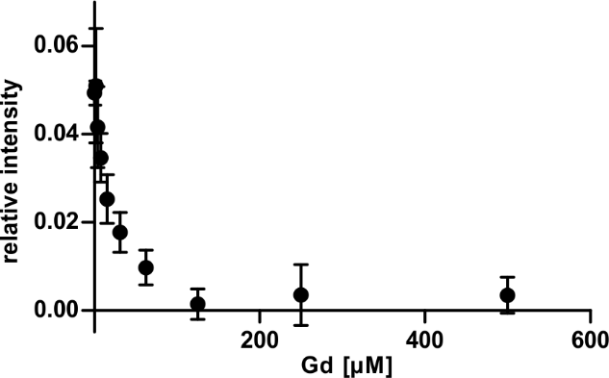
Supplementary Figure 1: Guanidine concentration-dependent filter binding assay for GdnR.
Supplementary Figure 2: GdnR filter binding assay.
Supplementary Figure 3: SPR analysis of C. cellasea GdnR.
Supplementary Figure 4: SPR analysis of C. cellasea GdnR binding to the S. griseus consensus motif.
Supplementary Figure 5: S. griseus GdnR- and guanidine-dependent eGFP expression
Supplementary Figure 6: Purification of S. boeckii GdcR.
Supplementary Figure 7: Radiograph of the NC and NY membranes from the GdcR filter binding assay.
Supplementary Table 1: Statistics for diffraction data processing and model building.
Supplementary Table 2: Sequences of DNA oligonucleotides used in this study.
Supplementary Figure 1: Guanidine concentration-dependent filter binding assay for GdnR. C. cellasea GdnR was incubated with radioactively labelled DNA containing its cognate binding site. The binding reactions were supplemented with increasing guanidine concentration (0 µM to 500 µM). Relative intensity was calculated as the ratio of intensity on the nitrocellulose membrane to the combined intensities of the nitrocellulose and nylon membrane. The relative intensity of the control reaction without GdnR was subtracted. Data represent mean of technical replicates with error bars (n=3, s.d.).
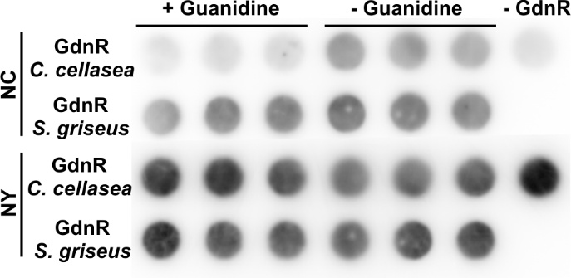
Supplementary Figure 2: GdnR filter binding assay. Radiograph of the nitrocellulose and nylon membrane of the GdnR filter binding assay. GdnR from S. griseus and C. cellasea was incubated with radioactively labelled DNA comprising the respective binding site. The binding reaction was supplemented with 1 mM guanidine (+ Gd). Control reactions were set up without guanidine (-Gd) and without GdnR (-GdnR).
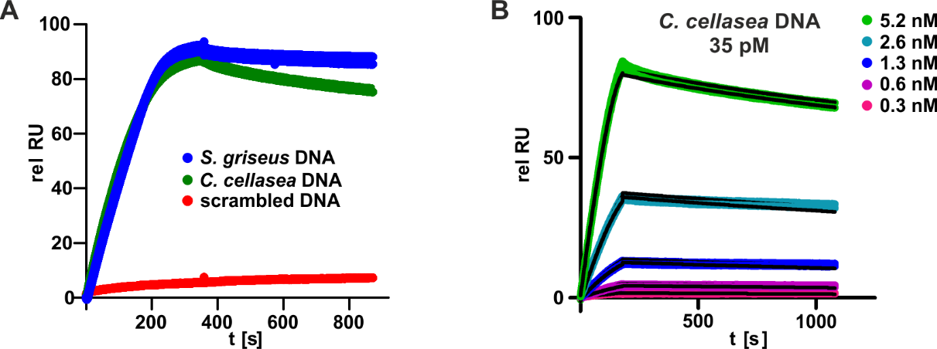
Supplementary Figure 3: SPR analysis of C. cellasea GdnR. A For the SPR analysis biotinylated DNA containing the binding motif of S. griseus or C. cellasea were immobilized on a SA-sensor chip. The scrambled C. cellasea DNA served as a control (Supplementary Table 2). GdnR (5 nM) of was injected and binding was monitored for all DNA. Experiment was performed in technical duplicates. B Replication of the SPR analysis of the C. cellasea interaction with its cognate DNA binding site (Figure 2E). GdnR was injected at different concentrations. Data were fitted by kinetic analysis assuming 1:1 binding (black lines). Experiment was performed in technical duplicates.
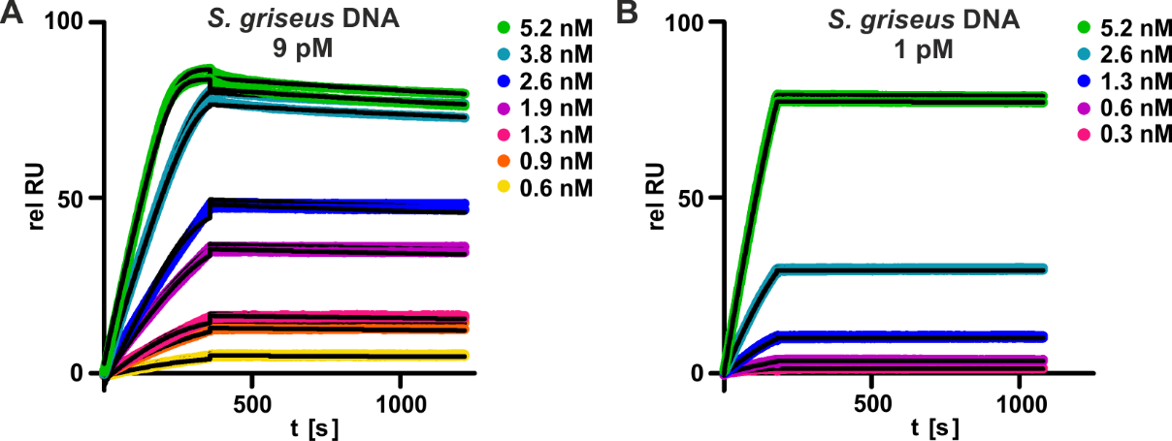
Supplementary Figure 4: SPR analysis of C. cellasea GdnR binding to the S. griseus consensus motif. C. cellasea GdnR was injected at different concentrations. Data were fitted by kinetic analysis assuming 1:1 binding (black lines). Experiment was performed in technical duplicates. A and B represent two independent experiments.
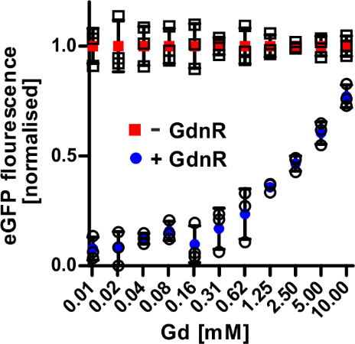
Supplementary Figure 5: S. griseus GdnR- and guanidine-dependent eGFP expression. eGFP expression was put under control of GdnR by cloning the S. griseus GdnR binding site close to the constitutive eGFP promoter. S. griseus GdnR expression was induced by 10 µM of IPTG (+ GdnR). Samples without IPTG were run as control (-GdnR). Medium was supplemented with guanidine (10 µM to 10 mM). eGFP fluorescence was corrected by cell density and normalized. Data represent the mean of biological triplicates with error bars (n=3, s.d.).
Supplementary Figure 6: Purification of S. boeckii GdcR. Coomassie-stained denaturing PA-gel analysing the steps of GdcR purification. Desalted protein was used for experiments.
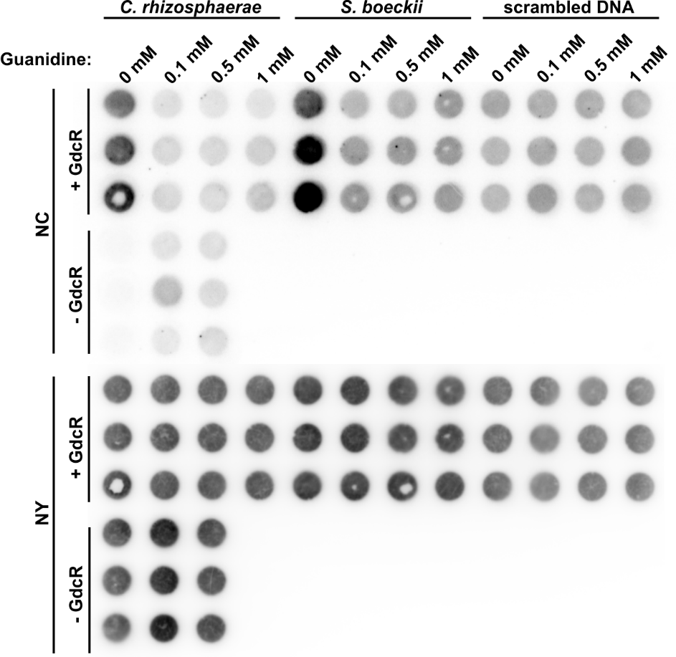
Supplementary Figure 7: Radiograph of the NC and NY membranes from the GdcR filter binding assay (Figure 4).

Supplementary Table 1: Statistics for diffraction data processing and model building.
GdnR/Gd

PDB code 30PE

Space group P3₁12
Cell dimensions: a,b,c (Å) 95.09, 95.20, 181.100
Copies in a.u. 1

Data Processing

Beamline P13, PETRA III, DESY
Detector Dectris EIGER1 Si 16M
Wavelength (Å) 0.9763
Resolution (Å) 25.0 - 1.22 (1.23 -1.22)ª
No. Reflections 68648 (1624)ª
R_{sym}(I) (%) 5.5 (293.2)ª
$<I/σ\left(I\right)>$ 23.76 (1.03)ª
CC1/2 (%) 100.0 (36.4)ª
Completeness (%) 100.0 (100.0)ª
Multiplicity 20.0 (20.4)ª

Model Refinement

No. working/free reflections 68586/2008
Rwork/Rfree (%) 13.68/15.24
No. Atoms Protein 3316
No. Atoms Solvent 296
No. of Ligands / Atoms 1 x Gd^{b} / 9
Average B factors (Å²)
Protein 31.66
Solvent 45.15
Ligands 18.37
R.m.s.d. bond length (Å) 0.007
R.m.s.d. angles (°) 0.932
Ramachandran plot
Favoured/Outliers (%) 98.07/0.0

ª Values in parentheses correspond to the highest resolution shell; ^{b} Gd: Guanidinium.

Supplementary Table 2: Sequences of DNA oligonucleotides used in this study.
Description | Sequence (5’ to 3’)
GdnR binding site, S. griseus, fwd | [Btn]AATCCATAGAGGTATACCTGTCGATCGACAGGTATTGCGATAGTGAGG
GdnR binding site, S. griseus, rev | CCTCACTATCGCAATACCTGTCGATCGACAGG  TATACCTCTATGGATT
GdnR binding site, C. cellasea, fwd | [Btn]GGCCCTCCCCGTGGTTCCTGTCGGCTGACAG  GAACACAGTGCGAGGCG
GdnR binding site, C. cellasea, rev | CGCCTCGCACTGTGTTCCTGTCAGCCGACAG  GAACCACGGGGAGGGCC
Scrambled GdnR binding site, C. cellasea, fwd | [BTn]CAGGAATGGAGCAGTAGCAACTGTTAGC  TAGTTAAATTTGCCTACGGG
Scrambled GdnR binding site, C. cellasea rev | CCCGTAGGCAAATTTAACTAGCTAACAGTTG  CTACTGCTCCATTCCTG
Backbone generation for reporter construct, fwd | GCTAGCATTATACCTAGGACTGAGC
Backbone generation for reporter construct, rev | AAGAAGGAGATATACCATGGGCC
Gibson assembly insert with GdnR binding site for reporter construct, S. griseus, fwd | CTAGGTATAATGCTAGCCATAGAGGTATACCTGTCGATCGACAGGTATTGCGATAGTAAGAAGGAGATATAC
Gibson assembly insert with GdnR binding site for reporter construct, S. griseus, rev | GTATATCTCCTTCTTACTATCGCAATACCTGTCGATCGACAGGTATACCTCTATGGCTAGCATTATACCTAG
GdcR binding site, S. boeckii, fwd | TTCAGTATTACATATTGCATCCTTCGTAATATCGC
GdcR binding site, S. boeckii, rev | GGCGATATTACGAAGGATGCAATATGTAATACT
GdcR binding site, C. rhizosphaerae, fwd | ATTGATATTACCAATTCCCGCAATAGTAATAATCG
GdcR binding site, C. rhizosphaerae, rev | CCGATTATTACTATTGCGGGAATTGGTAATATCA
Scrambled GdcR binding site, S. boeckii, fwd | ATTGAACTATATATATTACACATGCCTAGACATCG
Scrambled GdcR binding site, S. boeckii, rev | CCGATGTCTAGGCATGTGTAATATATATAGTTCA
Gibson assembly insert with GdnR binding site for reporter construct, S. boeckii, fwd | AGGTATAATGCTAGCTATTACCAATTCCCGCAATAGTAATAAGAAGGAGATATAC
Gibson assembly insert with GdnR binding site for reporter construct, S. boeckii, rev | GTATATCTCCTTCTTTATTACTATTGCGGGAATTGGTATAGCTAGCATTATACCT

