Appendices
Supplementary Table 1 Basic Diet Formula and Nutritional Components
Dietary composition | Percentage (%) | Nutritional ingredient | Percentage (%)
Fish meal | 38.0 | Crude protein | 42.67
Fish oil | 6.0 | Crude fat | 10.86
Shrimp meal | 6.4 | Crude ash | 12.93
Bean pulp | 28.0
Flour | 16.4
Choline chloride | 0.2
Soya bean lecithin | 1.0
Ca(H₂PO₄)₂ | 1.0
Premix | 3.0
Total | 100
Premix provided the following per kg of the diet: VA 2.5mg, VE (50%) 100mg, VD 3mg, VK 20mg, VB1 50mg, VB2 200mg, VB6 500mg, VB12 0.02mg, VC 480mg, folic acid 15mg, pantothenic acid 400mg, inositol 1000mg, biotin 5mg, nicotinic acid 750mg, Fe 75mg, Cu 3.5mg, Mn 16mg, I 0.65mg, Co 0.5mg, Se 0.3mg, Zn 65mg

Supplementary Table 2 The number of colonies
Dilution ratio | OD₆₀₀ value | Bacterial count (CFU/mL)
0 | 1.292 | 9.2×10⁷
2 | 0.734 | 4.6×10⁷
4 | 0.396 | 2.3×10⁷
8 | 0.213 | 1.15×10⁷
16 | 0.116 | 5.75×10⁶
32 | 0.059 | 2.88×10⁶

Supplementary Figure 1: The relationship between OD₆₀₀ absorbance value and the number of Pseudomonas aeruginosa colonies

Supplementary Table 3: Primer Sequences
Gene | Primer sequence 5’-3’ | Size | Serial number
β-actin | F:GTCAGGTCATCACCATCGGAA | 141 | JX027376.1
β-actin | R:CCTTACGGATGTCAACGTCAC | 141 | JX027376.1
IL-1β | F:CTCAGCACCACGTTACTGGA | 106 | MZ467298.1
IL-1β | R:ATGCAGCCAGTTAGGATCACA | 106 | MZ467298.1
IL-8 | F:GGCACTTTCACTGACCCTT | 118 | PQ558644.1
IL-8 | R:ATGGATAAAGTCTGAAACCGTCT | 118 | PQ558644.1
IL-10 | F:ACATGATCTCAAGCACACCCT | 104 | JAGXEW010000765.1
IL-10 | R:CCTGCATATTTCCAAACTGGTTC | 104 | JAGXEW010000765.1
TNF-α | F:TACAACATGCAAACGCAACCCC | 101 | XM_034056461.3
TNF-α | R:CCATAGCACAATTAAGCCAACAC | 101 | XM_034056461.3
TGF-β1 | F:GCCCCTTTACATTGACTTCCG | 122 | JAGXEW010000056.1
TGF-β1 | R:AGTATCTGTTGTCTGCGTTCCA | 122 | JAGXEW010000056.1
ZO-1 | F:CGCAACTCTGGCATTATTCGC | 108 | SCEB01215518.1
ZO-1 | R:CGCATAATTCAATCGGTCCACT | 108 | SCEB01215518.1
Occludin | F:CTGATCATCTTCTTCGCCCAC | 139 | JAGXEW010000046.1
Occludin | R:CGTCCTGCACATTGTTAACCC | 139 | JAGXEW010000046.1
Claudin | F:CCTAATCCTGGCAGCAGTCAGA | 112 | JAGXEW010000027.1
Claudin | R:CCCTGACGCTACTTGTATGGAC | 112 | JAGXEW010000027.1

Supplementary Table 4 Effect of MOE on growth performance of Hybrid Sturgeon
Item | HP0 | HP100 | HP300 | HP500 | SEM | p-value
IW（g） | 6.48ª | 6.44ª | 6.62ª | 6.47ª | 0.99 | P=0.933
FW（g） | 17.16^{c} | 18.75^{b} | 19.85^{b} | 22.33ª | 0.45 | p＜0.05
WGR（%） | 155.92^{c} | 159.82^{c} | 203.47^{b} | 280.98ª | 10.61 | p＜0.05
SGR(%) | 1.77^{c} | 1.82^{c} | 2.09^{b} | 2.56ª | 0.69 | p＜0.05
FCR(%) | 2.0ª | 1.92ª | 1.43^{b} | 1.41^{b} | 0.92 | p＜0.05
CF(%) | 0.54ª | 0.53ª | 0.56ª | 0.55ª | 0.01 | P=0.561
HSI(%) | 4.59ª | 3.30^{c} | 4.06^{b} | 3.83^{b} | 0.11 | p＜0.05
VSI(%) | 11.03ª | 9.99ª | 10.50ª | 10.46ª | 0.20 | P=0.373

Supplementary Table 5 The Impact of MOE on the Structure of the Duodenum
Item | HP0 | HP100 | HP300 | HP500 | SEM | p value
VH (um) | 227.88^{c} | 231.05^{c} | 259.39^{b} | 336.79ª | 9.34 | p＜0.05
VW (um) | 31.43^{c} | 30.17^{c} | 38.90^{b} | 45.90ª | 1.40 | p＜0.05
MT (um) | 25.01^{d} | 28.45^{c} | 33.48^{b} | 43.93ª | 1.55 | p＜0.05
Intestinal villus height (VH), intestinal villus width (VW), intestinal mucosal thickness (MT).

Supplementary Figure 2 MOE enhances intestinal antioxidant function
(A) MDA content. (B) SOD content. (C) T-AOC content. (D) GSH-Px content. (E) CAT content.

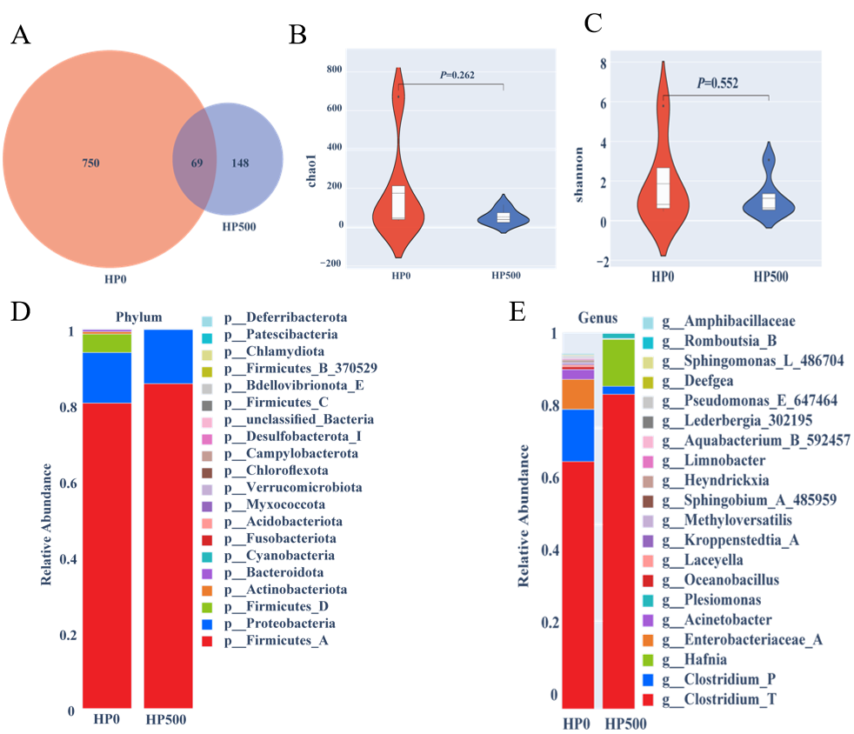
Supplementary Figure 3 Analysis of the effect of MOE on e intestinal microbiota of Hybrid Sturgeon
(A) Number of microbial taxa.(B) Chao1 analysis.(C) Shannon index.(D) Microbial composition at the phylum level.(E) Microbial composition at the genus level.

