SUPPLEMENTARY MATERIAL

Supplementary Figure 1. Trends over time of the number of new leprosy cases registered, where indicated whether or not GPS coordinates could be collected. The 2019 data include cases that were registered over a four-month timeframe (from 1 January 2019 to 30 April 2019) and were extrapolated (multiplied by three) to represent the estimated number of cases for the whole year of 2019 (light grey).
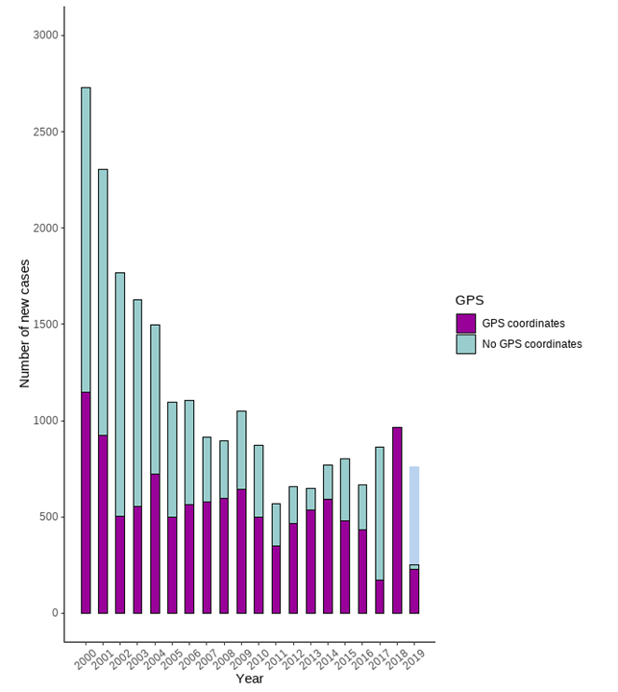
Supplementary Figure 2. Estimated annual population size per district. Annual population estimates per union were acquired by extrapolating the Census 2011 WorldPop 100 m² grid square raster data (www.worldpop.org). Annual population growth rates were calculated based on a weighted average of three available population data sources: UN 2001 to 2015 (https://population.un.org/wpp/, available at the national level); World Population Review 2000, 2005, 2010 and 2015 to 2019 (http://worldpopulationreview.com/countries/bangladesh-population/, available at the national level); and Bangladesh Bureau of Statistics 1991, 2001, 2011 and 2016 (http://www.citypopulation.de/Bangladesh-Mun.html, available at the district level). For the missing years, growth rates were calculated based on the available rates from other years from the same data source, where an exponentially growing population was assumed. For 2019, the population size of 2018 was used.

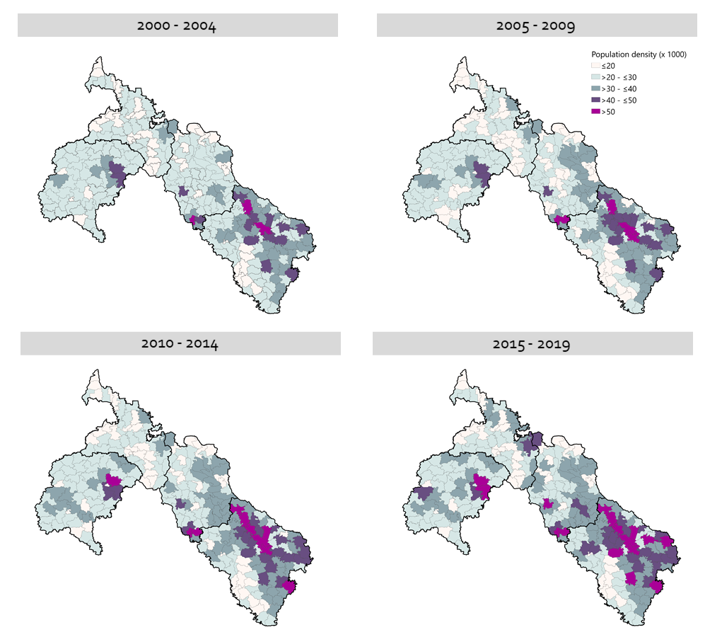
Supplementary Figure 3. Estimated population density per union per 5-year time frame.

Supplementary Table 2. Demographic, disease and location characteristics of leprosy cases overall, and cases for which GPS coordinate were collected retrospectively in northwest Bangladesh, detected between January 2000 and April 2019.
 | All registered cases | Cases with GPS coordinates available
Total | N = 20,623 (100%) | N = 11,044 (100%)
Sex
Male | 11,649 (56.5%) | 6,269 (56.8%)
Female | 8,974 (44.5%) | 4,775 (43.2%)
Age at diagnosis (years)
Below 15 | 2,589 (12.6%) | 1,229 (11.1%)
15 to 24 | 4,035 (19.6%) | 2,109 (19.1%)
25 to 34 | 4,027 (19.2%) | 2,200 (19.9%)
35 to 44 | 3,916 (19.0%) | 2,146 (19.4%)
45 to 54 | 3,334 (16.2%) | 1,868 (16.9%)
55 and older | 2,722 (13.2%) | 1,492 (13.5%)
Group
Paucibacillary (PB) | 15,319 (74.3%) | 8,393 (76.0%)
Multibacillary (MB) | 5,301 (25.7%) | 2,650 (24.0%)
Unknown | 3 | 1
Skin smear
Negative | 16,546 (89.1%) | 8,871 (89.7%)
Positive | 2,029 (9.9%) | 1,015 (10.3%)
Unknown | 2,048 | 1,158
Disability
Grade 0 | 17,809 (86.4%) | 9,545 (86.4%)
Grade 1 | 1,441 (7.0%) | 724 (6.6%)
Grade 2 | 1,367 (6.6%) | 770 (7.0%)
Unknown | 6 | 5
Mode of detection
Survey | 1,524 (7.4%) | 1,136 (10.3%)
Referred | 2,107 (10.2%) | 1,440 (13.1%)
Voluntary | 15,582 (75.6%) | 7,966 (72.2%)
Contact | 1,390 (6.7%) | 489 (4.4%)
Unknown | 20 | 13
District
Nilphamari | 7,928 (38.4%) | 3477 (31.5%)
Panchagarh | 2,001 (9.7%) | 906 (8.1%)
Rangpur | 7,825 (37.9%) | 5,247 (47.5%)
Thakurgaon | 2,869 (13.9%) | 1,414 (12.8%)

Supplementary Figure 4. Mean population size (panels A, B, C), cumulative case counts (panels D, E, F) and unsmoothed cumulative incidence levels (panels G, H, I) and hotspots detected with spatial scan statistics with identification numbers (panels J, K, L) in northwest Bangladesh between January 2000 and April 2019.
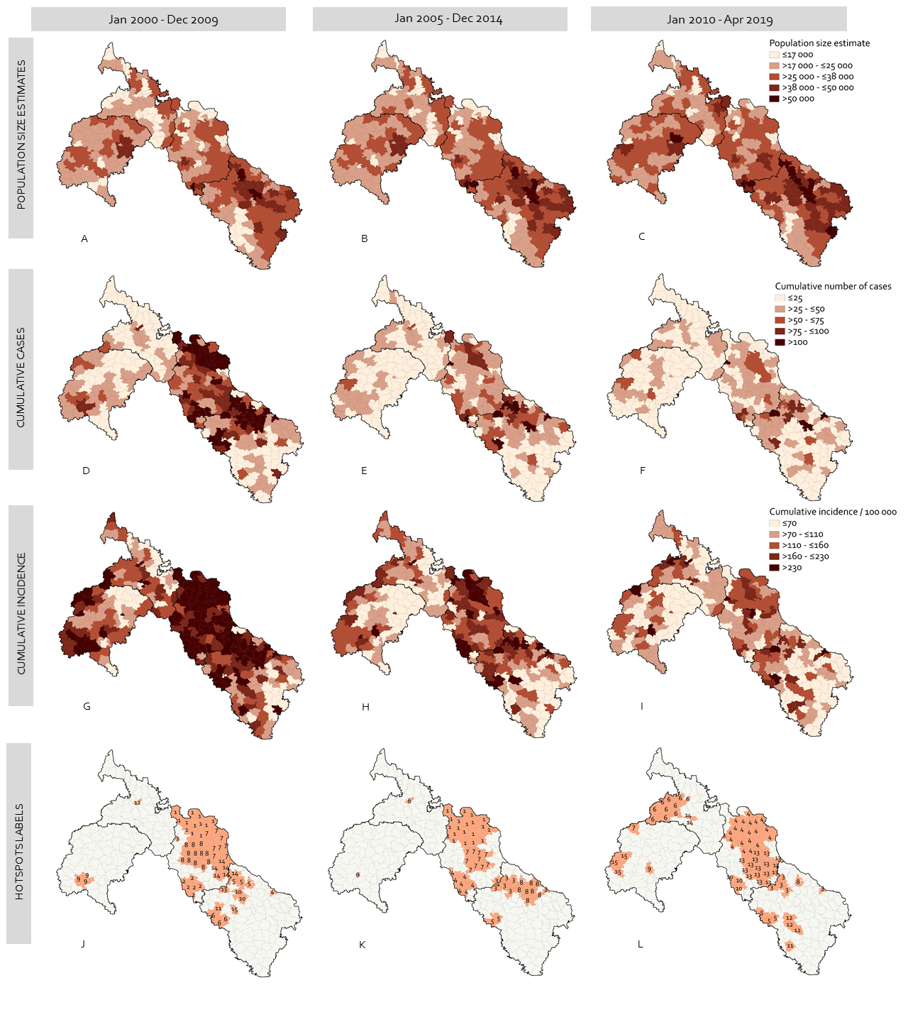

Supplementary Table 3. Leprosy hotspots in northwest Bangladesh between January 2000 and April 2019, detected with spatial scan statistics (https://www.satscan.org/). The location identification numbers of hotspots are shown in Supplementary Figure 3 (panels J to L). The area locations are shown in Figure 3.
Timeframe | Identification number | Location (as in Figure 3) | Number of unions | Hotspot surface (km²) | Population | Observed number of cases | Expected number of cases | Relative risk (RR) | Log likelihood | P-value
2000-2009
 | 1 | 1 | 12 | 296.04 | 233,938 | 1,215 | 489 | 2.63 | 400.80 | <0.001
 | 2 | 3 | 6 | 178.48 | 176,397 | 987 | 368 | 2.81 | 368.58 | <0.001
 | 3 | 1 | 1 | 30.86 | 6,777 | 172 | 14 | 12.29 | 272.53 | <0.001
 | 4 | 2 | 1 | 30.03 | 21,353 | 202 | 45 | 4.58 | 148.55 | <0.001
 | 5 | 2 | 3 | 58.54 | 120,169 | 557 | 251 | 2.27 | 141.37 | <0.001
 | 6 | 5 | 3 | 93.52 | 68,486 | 333 | 143 | 2.36 | 92.65 | <0.001
 | 7 | 1 | 8 | 245.68 | 194,698 | 697 | 407 | 1.75 | 88.27 | <0.001
 | 8 | 1 | 12 | 337.99 | 252,519 | 783 | 309 | 1.51 | 56.17 | <0.001
 | 9 | 4 | 3 | 96.24 | 53,361 | 194 | 112 | 1.75 | 25.17 | <0.001
 | 10 | 2 | 2 | 48.33 | 82,366 | 268 | 172 | 1.57 | 23.11 | <0.001
 | 11 | 5 | 1 | 28.63 | 33,933 | 135 | 71 | 1.91 | 22.97 | <0.001
 | 12 | 6 | 1 | 22.11 | 14,839 | 75 | 31 | 2.43 | 22.31 | <0.001
 | 13 | 2 | 1 | 20.63 | 25,617 | 107 | 54 | 2.01 | 20.73 | <0.001
 | 14 | 1 | 6 | 98.53 | 199,154 | 533 | 416 | 1.29 | 15.54 | <0.001
 | 15 | 5 | 1 | 22.53 | 21,369 | 82 | 45 | 1.84 | 12.53 | <0.001
Total | - | - | 61 | 1,608 | 1,504,976 | 6,340 | 2 927 | - | - | -
2005-2014
 | 1 | 1 | 20 | 447.39 | 45,1138 | 979 | 546 | 1.90 | 150.85 | <0.001
 | 2 | 2 | 1 | 14.26 | 23,043 | 158 | 28 | 5.75 | 144.93 | <0.001
 | 3 | 2 | 6 | 166.89 | 22,6151 | 562 | 273 | 2.13 | 121.22 | <0.001
 | 4 | 3 | 8 | 216.58 | 21,9677 | 518 | 266 | 2.01 | 97.31 | <0.001
 | 5 | 5 | 2 | 61.90 | 44,110 | 181 | 53 | 3.44 | 94.35 | <0.001
 | 6 | 6 | 1 | 28.17 | 16,194 | 63 | 20 | 3.23 | 30.27 | <0.001
 | 7 | 1 | 10 | 278.48 | 254,815 | 416 | 308 | 1.37 | 17.62 | <0.001
 | 8 | 2 | 8 | 207.69 | 466,036 | 690 | 564 | 1.24 | 14.13 | <0.001
 | 9 | 4 | 1 | 23.29 | 11,848 | 36 | 14 | 2.52 | 11.50 | 0.002
Total | - | - | 57 | 1,444.65 | 1,713,012 | 3,603 | 2 072 | - | - | -
2010-2019
 | 1 | 1 | 1 | 6.99 | 7,973 | 87 | 7 | 12.10 | 136.63 | <0.001
 | 2 | 2 | 1 | 11.79 | 24,824 | 120 | 23 | 5.37 | 103.42 | <0.001
 | 3 | 2 | 4 | 98.22 | 143,460 | 290 | 131 | 2.27 | 73.48 | <0.001
 | 4 | 1 | 20 | 570.47 | 514,023 | 741 | 469 | 1.65 | 72.83 | <0.001
 | 5 | 5 | 3 | 90.53 | 79,620 | 160 | 73 | 2.23 | 39.54 | <0.001
 | 6 | 7 | 10 | 301.22 | 212,354 | 309 | 194 | 1.62 | 29.98 | <0.001
 | 7 | 7 | 1 | 37.42 | 23,626 | 63 | 22 | 2.94 | 26.24 | <0.001
 | 8 | 2 | 1 | 25.80 | 42,355 | 89 | 39 | 2.32 | 24.07 | <0.001
 | 9 | 4 | 1 | 27.30 | 17,841 | 51 | 16 | 3.15 | 23.60 | <0.001
 | 10 | 3 | 3 | 71.42 | 85,537 | 140 | 78 | 1.81 | 20.13 | <0.001
 | 11 | 5 | 1 | 29.99 | 19,101 | 42 | 17 | 2.42 | 12.41 | 0.001
 | 12 | 5 | 1 | 96.24 | 59,263 | 94 | 54 | 1.75 | 12.17 | 0.001
 | 13 | 1 | 17 | 379.53 | 499,555 | 557 | 456 | 1.24 | 11.28 | 0.003
 | 14 | 6 | 1 | 19.65 | 15,203 | 32 | 14 | 2.31 | 8.64 | 0.028
 | 15 | 7 | 3 | 125.35 | 97,658 | 130 | 89 | 1.47 | 8.33 | 0.040
Total | - | - | 68 | 1,891.92 | 1,842,393 | 2,905 | 1 682 | - | - | -

Supplementary Table 4. Demographic, disease and location characteristics of leprosy cases in northwest Bangladesh, detected from January 2000 to April 2019.
 | Outside of hotspots | Weak hotspots  (relative risk 1-2) | Medium hotspots  (relative risk 2-3) | Strong hotspots  (relative risk >3)
Total | N = 9,734 (100%) | N = 5,045 (100%) | N = 3,394 (100%) | N = 1,930 (100%)
Sex
Male | 5,424 (56.3%) | 2,871 (57.5%) | 1,901 (56.0%) | 1,075 (55.7%)
Female | 4,216 (43.7%) | 2,118 (42.5%) | 1,493 (44.0%) | 855 (44.3%)
Age at diagnosis (years)
Below 15 | 1,119 (11.5%) | 609 (12.1%) | 450 (13.3%) | 339 (17.6%)
15 to 24 | 1,977 (20.3%) | 930 (18.4%) | 634 (18.7%) | 403 (20.9%)
25 to 34 | 1,945 (20.0%) | 980 (19.4%) | 681 (20.1%) | 332 (17.2%)
35 to 44 | 1,855 (19.1%) | 978 19.4%) | 643 (18.9%) | 342 (17.7%)
45 to 54 | 1,540 (15.8%) | 853 (16.9%) | 578 (17.0%) | 272 (14.1%)
55 and older | 1,298 (13.3%) | 695 (13.8%) | 408 (12.0%) | 232 (12.6%)
Group
Paucibacillary (PB) | 7,192 (73.9%) | 3,671 (72.8%) | 2,620 (77.2%) | 1,474 (76.4%)
Multibacillary (MB) | 2,539 (26.1%) | 1,374 (27.2%) | 774 (22.8%) | 456 (23.6%)
Unknown | 3 | 0 | 0 | 0
Skin smear
Negative | 7,629 (88.9%) | 4,107 (89.3%) | 2,917 (92.0%) | 1,581 (89.8%)
Positive | 948 (11.1%) | 492 (10.7%) | 252 (8.0%) | 179 (10.2%)
Unknown | 1,157 | 446 | 225 | 170
Disability
Grade 0 | 8,460 (86.9%) | 4,299 (85.2%) | 2,945 (86.8%) | 1,675 (86.8%)
Grade 1 | 655 (6.7%) | 373 (7.4%) | 237 (7.0%) | 137 (7.1%)
Grade 2 | 617 (6.3%) | 370 (7.4%) | 211 (6.2%) | 118 (6.1%)
Unknown | 2 | 3 | 1 | 0
Mode of detection
Survey | 715 (7.4%) | 439 (8.7%) | 196 (5.8%) | 138 (7.2%)
Referred | 1,090 (11.2%) | 539 (10.7%) | 268 (7.9%) | 138 (7.2%)
Voluntary | 7,301 (75.1) | 3,670 (72.8%) | 2,698 (79.6%) | 1,538 (79.8%)
Contact | 621 (6.4%) | 391 (7.8%) | 227 (6.7%) | 114 (5.9%)
Unknown | 7 | 6 | 5 | 2
District
Nilphamari | 1,532 (15.7%) | 2,917 (57.8%) | 2,218 (65.4%) | 1,023 (53.0%)
Panchagarh | 1,534 (15.8%) | 232 (4.6%) | 90 (2.7%) | 115 (6.0%)
Rangpur | 4,256 (43.7%) | 1,604 (31.8%) | 1,019 (30.0%) | 737 (38.2%)
Thakurgaon | 2,412 (24.8%) | 292 (5.8%) | 67 (2.0%) | 55 (2.8%)
Distance nearest clinic (mean [SD]) | 6.9 (3.4) | 6.2 (3.0) | 6.2 (3.6) | 6.0 (3.9)
Distance nearest city (mean [SD]) | 13.4 (7.3) | 12.8 6.9) | 13.6 (4.5) | 9.9 (5.8)
Population density per 100 m² (mean [SD]) | 11.7 (6.2) | 13.0 (7.1) | 10.1 (5.0) | 18.7 (9.8)

