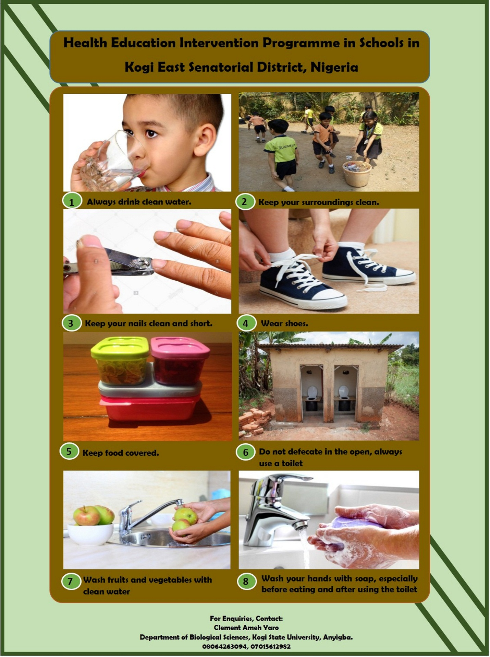

ETHICAL APPROVALS
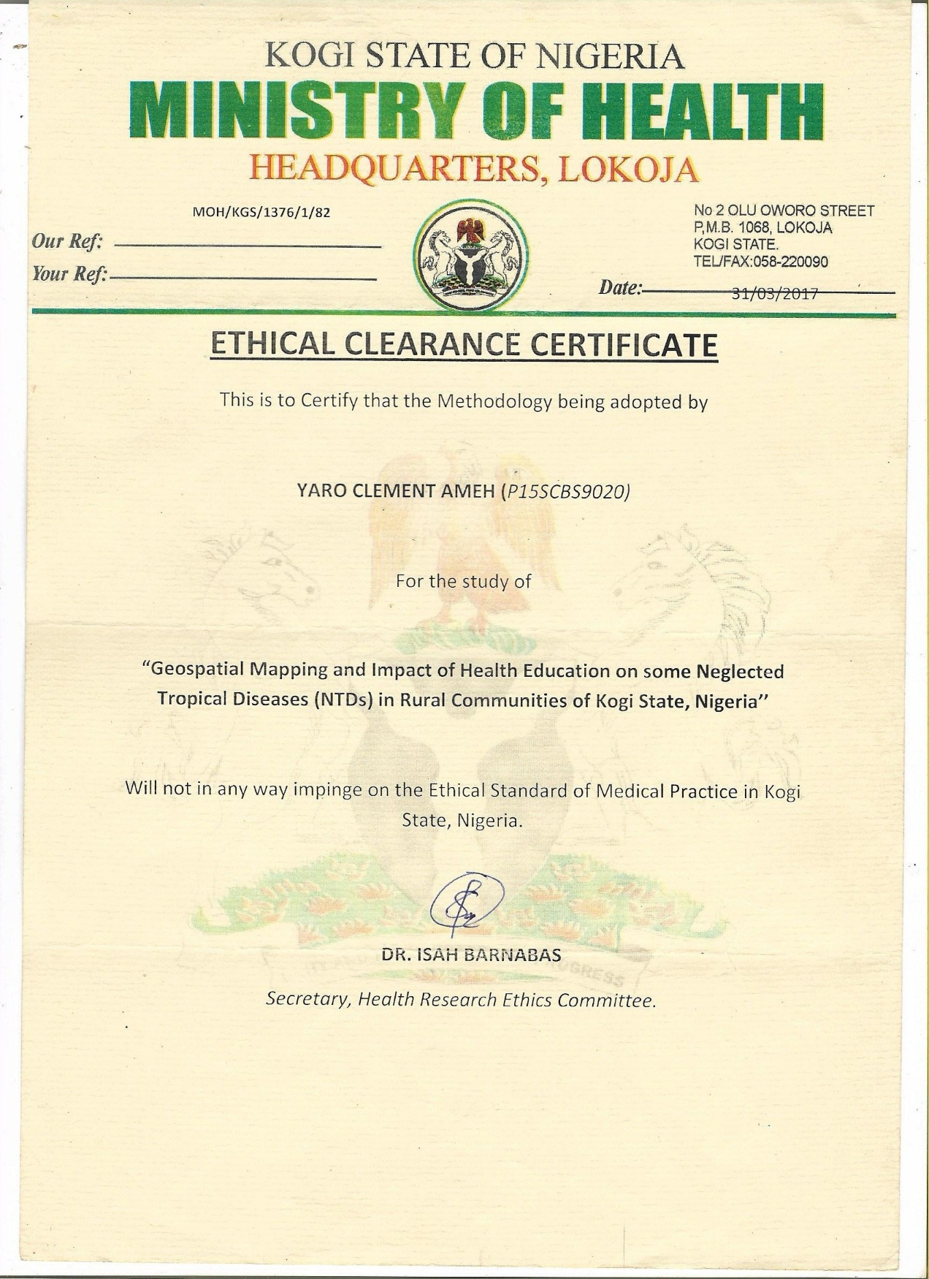

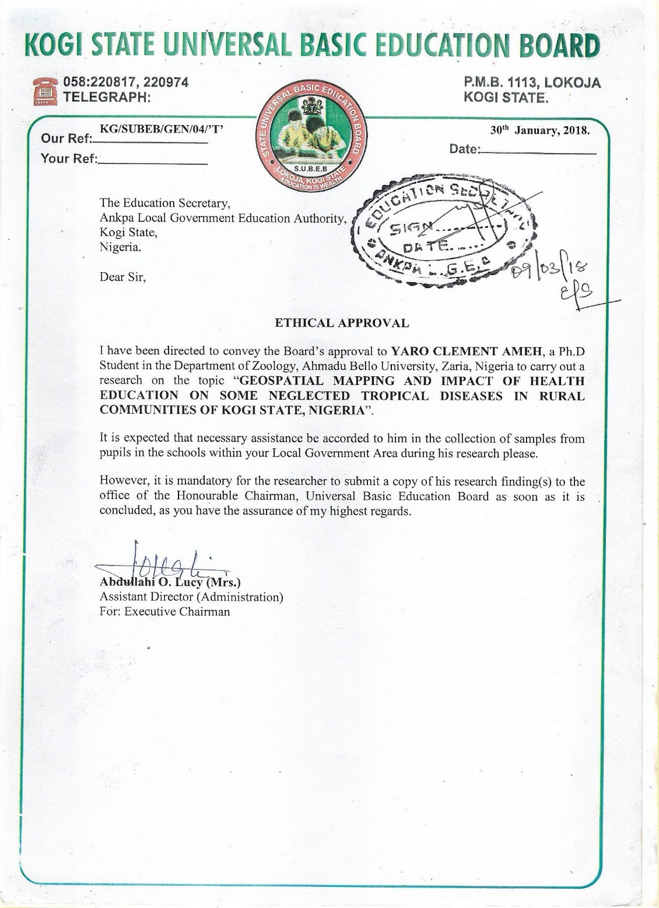

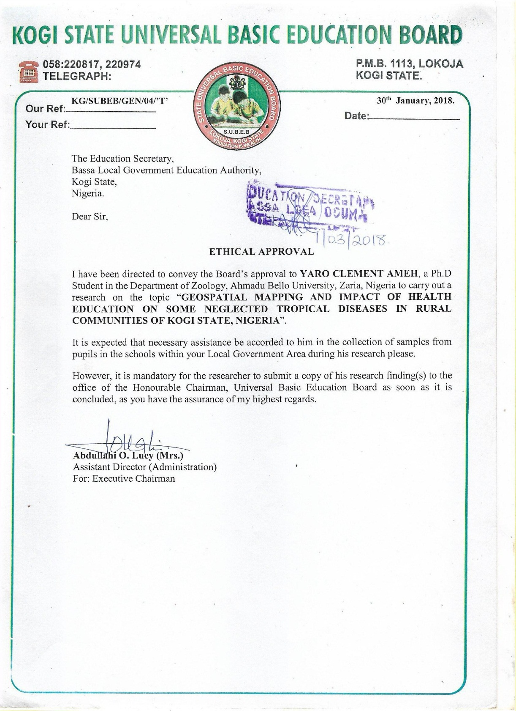

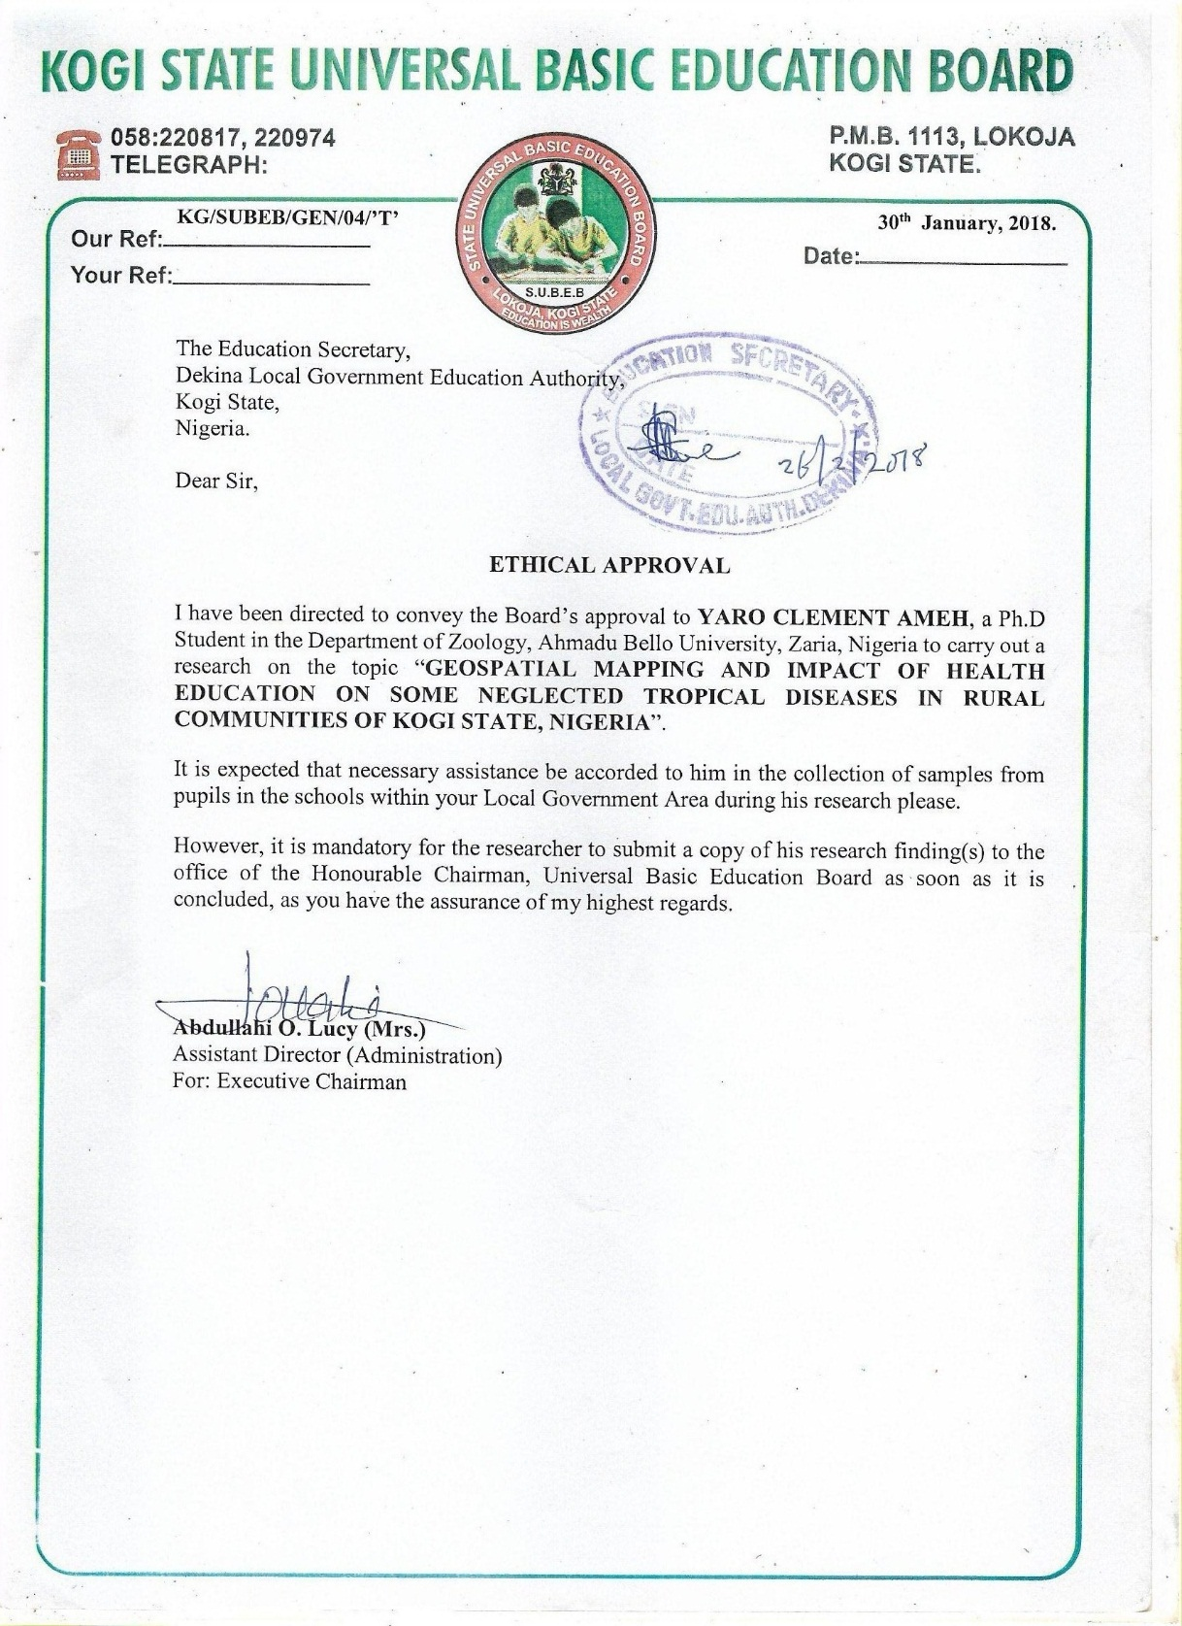



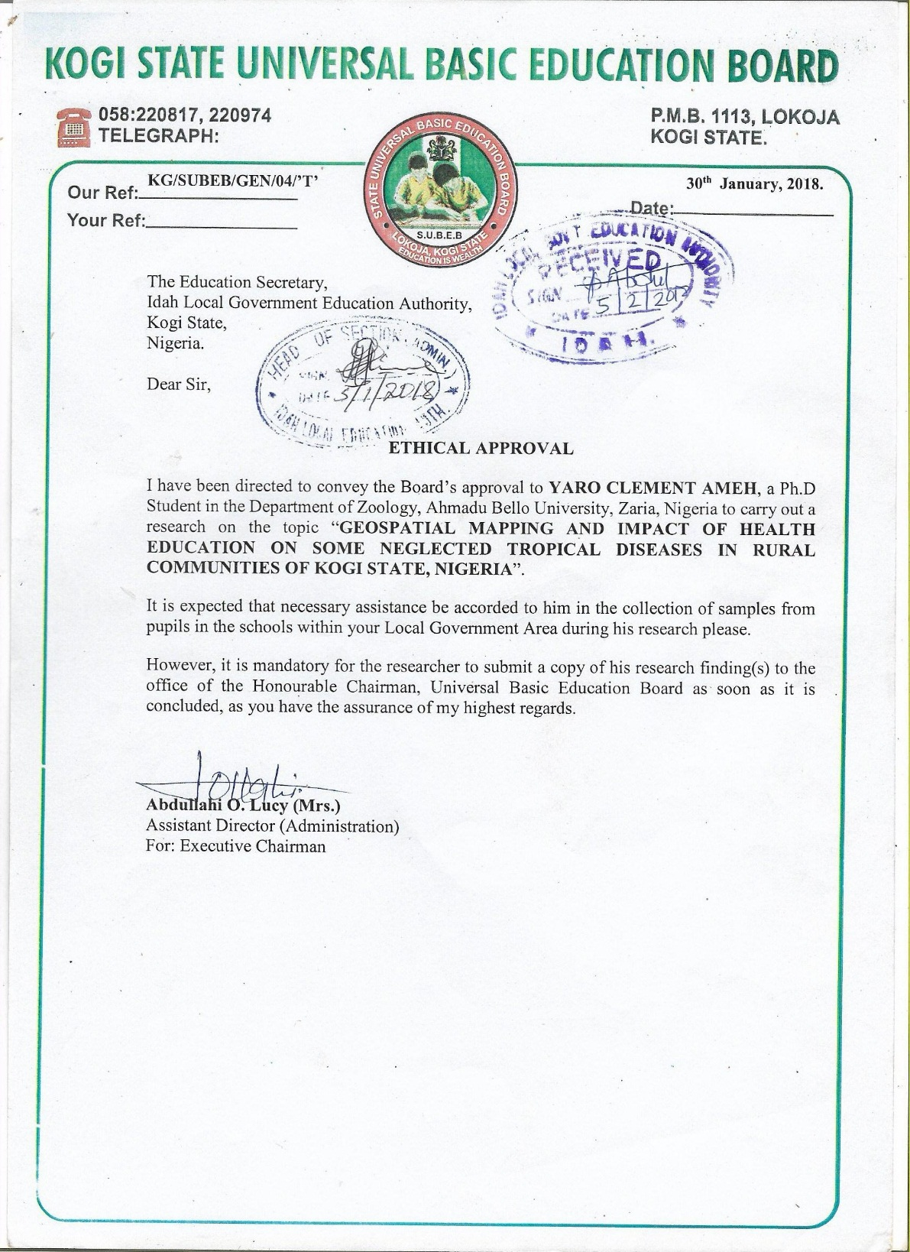

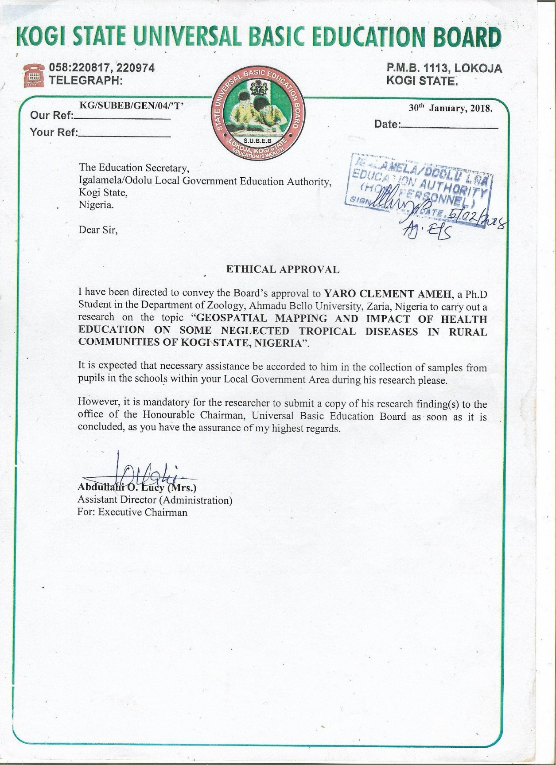

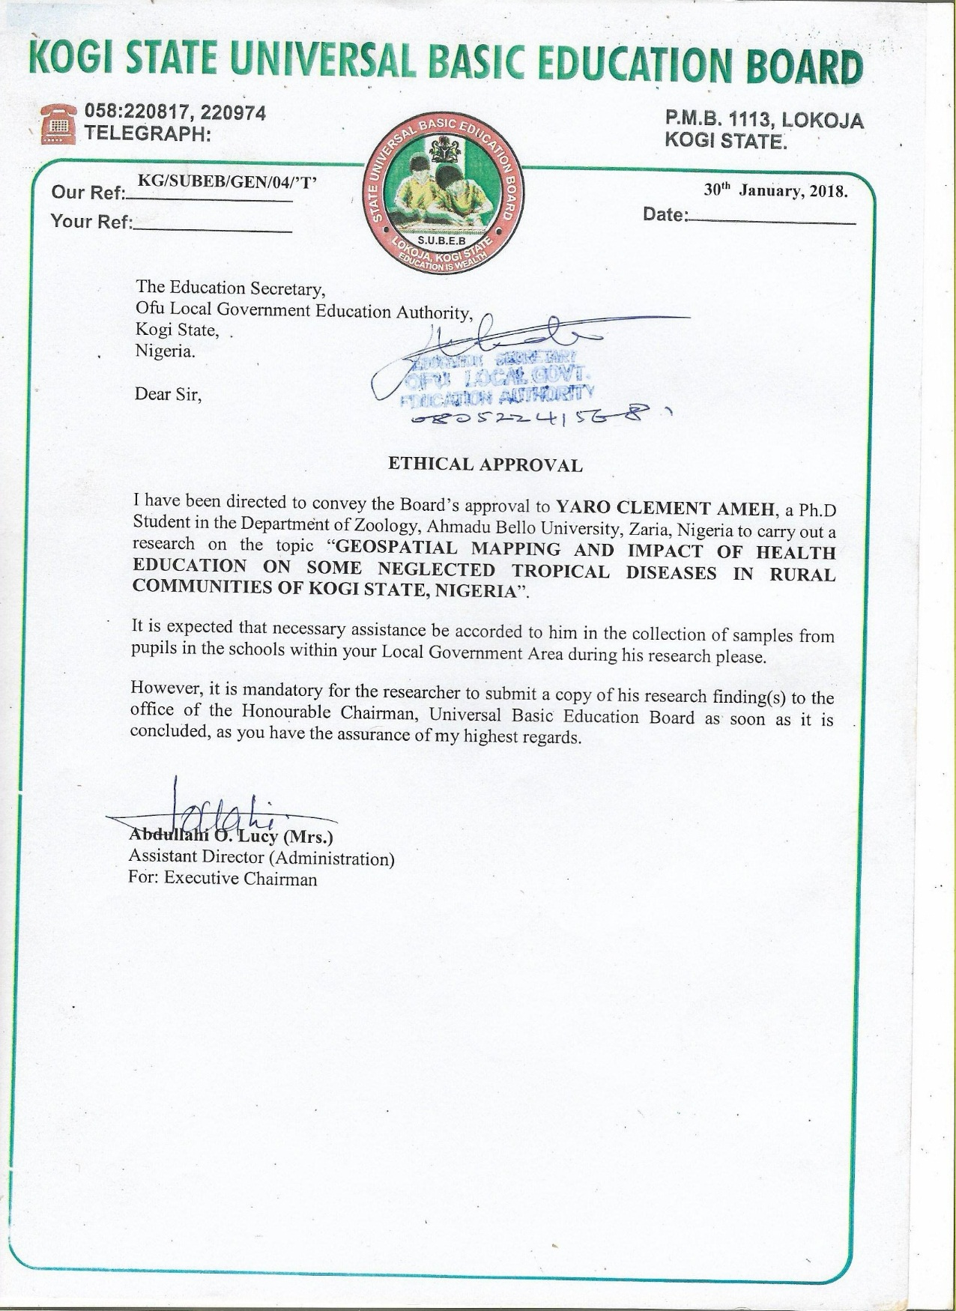

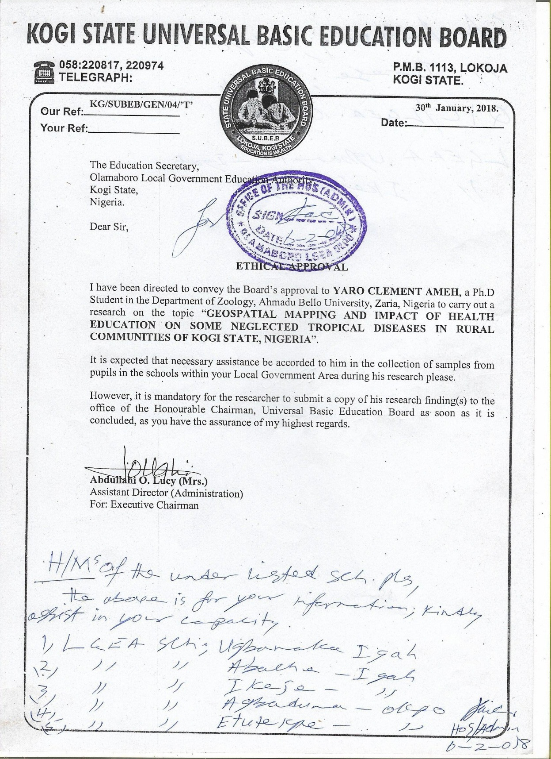



CONSENTS

Consent for Participation in Study
I volunteer to participate in a study by Clement Ameh Yaro in rural communities of Kogi East, Nigeria.
- My participation is voluntary and I understand that I will not be paid for it. I am aware that I have the right to withdraw and discontinue participation at any time.

- I understand that participation involves being interviewed by the researchers during data collection.

- I have been assured that my identity and the information obtained from this study will not be disclosed and that my confidentiality as a participant in this study will remain secure. Subsequent uses of records and data will be subject to standard data use policies which protect the anonymity of individuals and institutions.

- However, the access to the above mentioned information is strictly open to only the researcher.

- I understand that this research study has been reviewed and approved by the institutional ethical committee and for further queries I am allowed to contact the committee.

- I have read and understood the explanation provided to me. I have had all my questions answered to my satisfaction, and I voluntarily agree to participate in this study.

- I have been given a copy of this consent form.

______________________________ __________________________
Participant’s Signature with Date Signature of the Witness

Signature of the Investigator.

Consent of Parents/Guardian for Participation in Study
- I have read in my naïve language and understand the participant information sheet.

- I have been given sufficient time to consider whether or not to allow my ward to participate in this study.

- I have had the opportunity to use a translator, legal representative, family support or a friend to help me to ask questions and understand the research study.

- I am satisfied with the answers that have been given regarding the research and I have a copy of this consent form and information sheet.

- I understand that taking part in this study is voluntarily.

- I consent to the researcher collecting and processing my ward’s information, including information about his/her health.

- I understand that I may withdraw my ward from the research at any time.

- I am assured that confidentiality of the data will be maintained.

- I understand that I will be given a copy of my ward’s results.

- I understand that I neither have to bear any expenses nor receive any financial aid for participating.

- If I decide to withdraw from the study, I agree that the information collected about by ward up to the time of withdrawal may be utilized.

Name of Participant______________________________

Name of parent or Guardian________________________

Signature of Parent or Guardian____________________________

Date_________________________________________________________

APPENDIX IV:
GEOGRAPHIC POSITIONING SYSTEM (GPS) OF COMMUNITIES

LGA | Village | Latitude | Longitude
Ankpa | Enokpoli | 7.4508 | 7.6454
Ankpa | Enjema | 7.4746 | 7.6599
Ankpa | Ogodo | 7.3964 | 7.5786
Ankpa | Opulega | 7.4146 | 7.6137
Ankpa | Ikanekpo | 7.444 | 7.5398
Bassa | Oguma | 7.8864 | 7.0644
Bassa | Our Lady Sheria | 7.892 | 7.0764
Bassa | LGEA Sheria | 7.8914 | 7.0798
Bassa | Akakana | 7.9227 | 7.1777
Bassa | Londu | 7.8687 | 7.0664
Dekina | Ojofu | 7.5328 | 7.1806
Dekina | Olofu | 7.5358 | 7.1561
Dekina | Odu-Ogbaloto | 7.6138 | 7.095
Dekina | Olubojo | 7.6298 | 7.088
Dekina | Ajiyolo-Akabe | 7.5702 | 7.0976
Ibaji | Itoduma | 6.9232 | 6.6836
Ibaji | Odogwu | 6.9603 | 6.7288
Ibaji | Onyedega | 6.8902 | 6.6755
Ibaji | Unale | 6.9093 | 6.7167
Ibaji | Ejule-Ojebe | 7.0019 | 6.7278
Idah | Ukwaja | 7.1089 | 6.7454
Idah | Sabon Gari | 7.1091 | 6.7403
Idah | Edeh | 7.1014 | 6.7386
Idah | Igalogba | 7.1206 | 6.7476
Idah | Ubomu | 7.1252 | 6.7413
Ofu | LGEA, Ejule | 7.3604 | 7.094
Ofu | St. Martins de Porres, Ejule | 7.3609 | 7.0985
Ofu | Alome | 7.3385 | 7.057
Ofu | Ikpokejo-Umomi | 7.3435 | 7.0308
Ofu | Ofakaga | 7.4103 | 7.125
Olamaboro | QIC/LGEA, Ogugu | 7.1518 | 7.4823
Olamaboro | RCM/LGEA, Ogugu | 7.1553 | 7.475
Olamaboro | Okpo | 7.2153 | 7.557
Olamaboro | Igah-Ikeje | 7.1959 | 7.5296
Olamaboro | Ugbamaka-Igah | 7.2404 | 7.4688
Omala | Ajiyolo-Ife | 7.7637 | 7.4399
Omala | Agbenema-Ife | 7.807 | 7.4533
Omala | Opada | 7.8386 | 7.4853
Omala | Islamiya, Abejukolo | 7.8644 | 7.5074
Omala | Central, Abejukolo | 7.8688 | 7.5061

