Supplementary appendix
The basic characteristics of Mozambique—including its geographic distribution, population structure, and health system—have been comprehensively described in a previously published study (JMIR Public Health and Surveillance - Spatial Access to Continuous Maternal and Perinatal Health Care Services in Low-Resource Settings: Cross-Sectional Study) ^{[1]}. Therefore, they will not be elaborated on in detail in this study.

Theoretical framework
The “Countdown to 2030” initiative regularly monitors maternal and child mortality and uses a comprehensive indicator framework to assess global progress, inequalities, and key drivers in Reproductive, Maternal, Newborn, Child, and Adolescent Health (RMNCAH), providing critical support for evidence-based decision-making and the achievement of the Sustainable Development Goals (SDGs) ^{[2]}. Against this backdrop, the United States Agency for International Development (USAID) proposed a health systems framework for improving maternal and child health, focusing on two key indicators: RMNCAH service coverage and maternal and child health outcomes, which respectively reflect the accessibility of health services and the effectiveness of health improvements^{[3]}. (Figure S1).
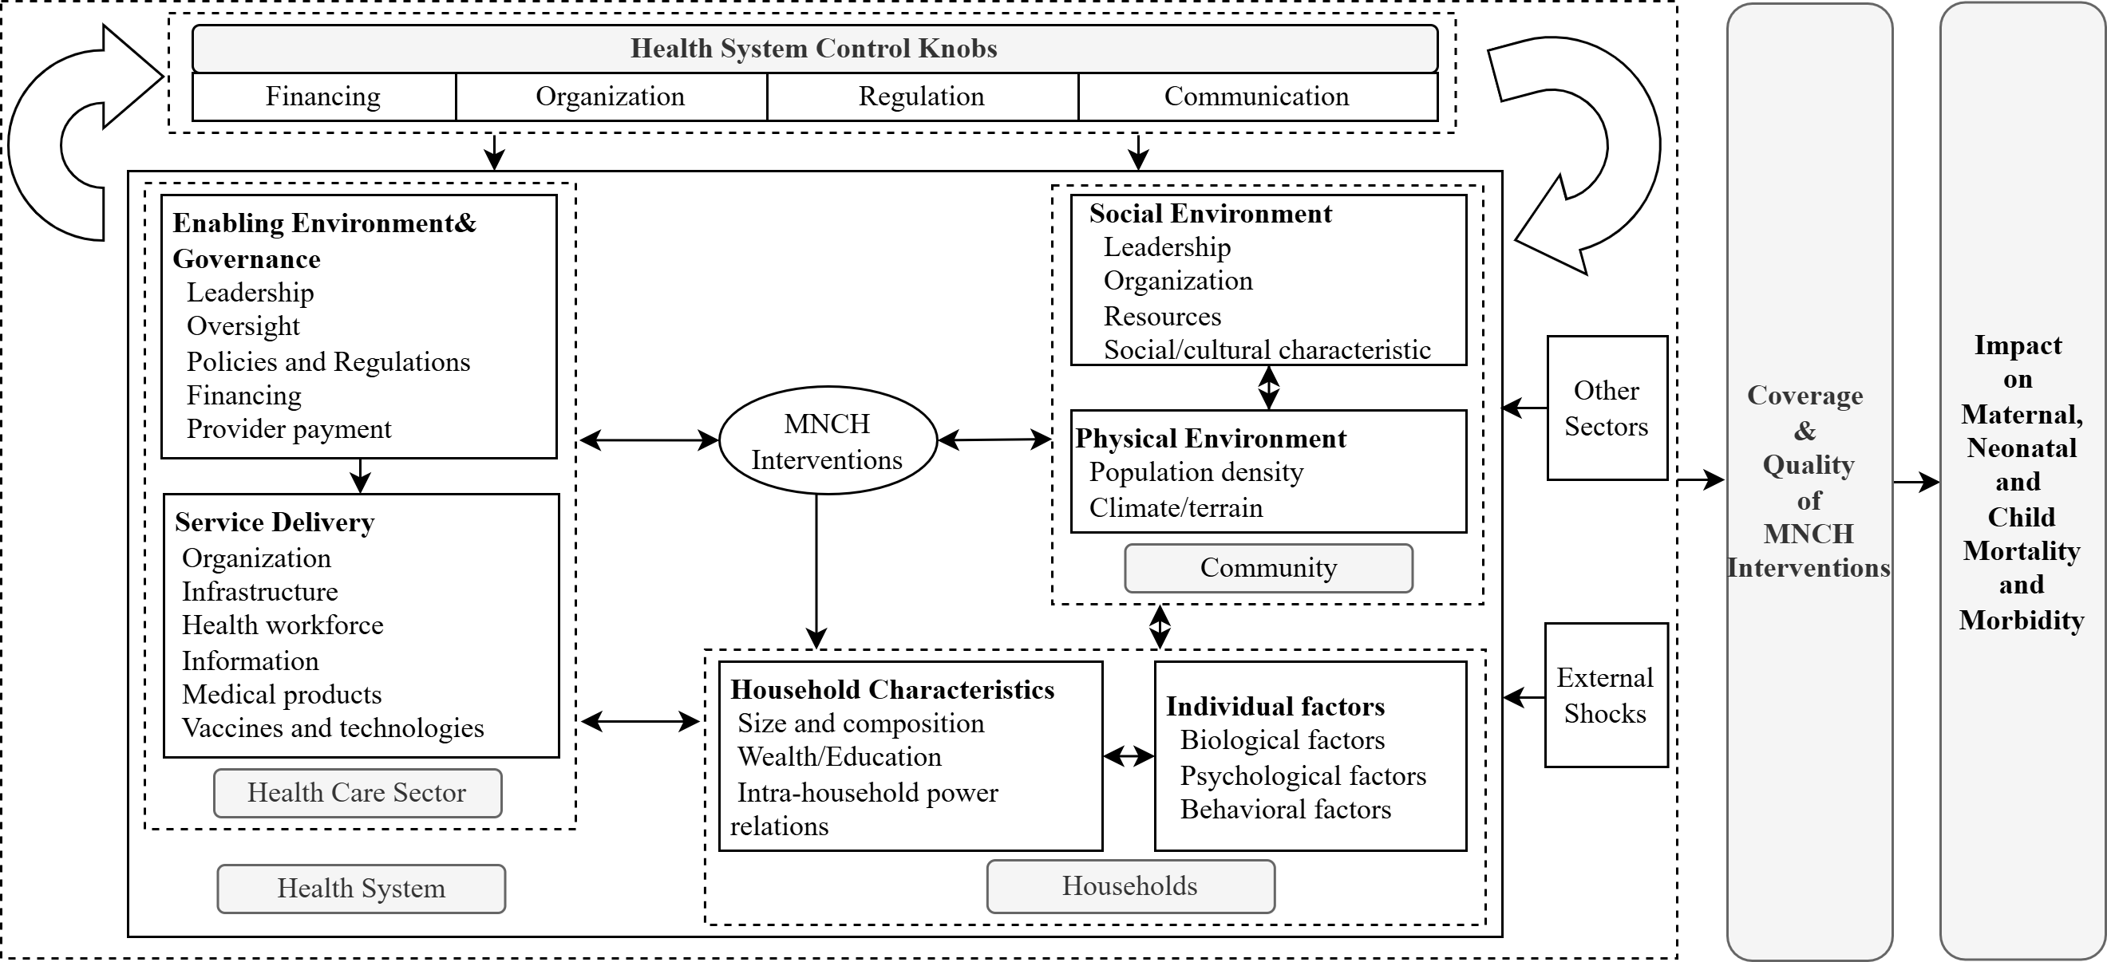
Figure S1 Strengthening Health Systems to Improve MNCH Outcomes - a Framework^{[4]}

Study design and data sources
The Mozambique Demographic and Health Survey (DHS) report provides a detailed description of the sampling methodology and survey instruments. All data used in this study are publicly available through the DHS database and do not require ethical approval^{[4]}. (Table S1)

Table S1 Mozambique Survey Databases
Data source | Survey year | Sampling design | Number of sampled households | Response  rate
Mozambique Demographic and Health Survey (MDHS) | 1997DHS | Two-stage stratified sampling | 27,048 | 99.0%
Mozambique Demographic and Health Survey (MDHS) | 2003DHS | Two-stage stratified sampling | 27,628 | 97.0%
Mozambique Demographic and Health Survey (MDHS) | 2011DHS | Two-stage stratified sampling | 31,614 | 98.%
Mozambique Demographic and Health Survey (MDHS) | 2015DHS | Two-stage stratified sampling | 39,979 | 99.0%
Mozambique Demographic and Health Survey (MDHS) | 2018DHS | Two-stage stratified sampling | 18,564 | 98.0%
Total | Five-year period | — | 14,4833 | 98.2%
Note: MDHS refers to the Mozambique Demographic and Health Survey. DHS was widely used international instruments for health and population surveys.

Measurement of Maternal and Child Health Service Coverage
Based on the theoretical framework of this study, this section adopts the essential maternal and child health (MCH) service-specific coverage indicators and the Composite Coverage Index (CCI), as proposed by the World Health Organization (WHO) in 2008, as outcome measures. The CCI encompasses eight key MCH interventions across four domains—reproductive health, pregnancy, childbirth, and childhood (Table S2). These services comprise a set of specific interventions that have been identified in the Disease Control Priorities, Third Edition (DCP3), as cost-effective in most countries worldwide.

By calculating a weighted average, the CCI provides a comprehensive measure of the continuity of MCH service coverage across the life course. Among these, several individual service coverage indicators have been incorporated into the monitoring framework of Sustainable Development Goal 3 (SDG 3), such as the coverage of family planning services (SDG 3.7.1, defined as the proportion of women aged 15–49 whose need for family planning is satisfied with modern methods), the proportion of births attended by skilled health personnel (SDG 3.1.2), and the coverage of vaccines included in national immunization programs (SDG 3.b.1).

As a composite indicator, the CCI is not only used to assess national progress toward achieving SDG 3 targets, but also to analyze inequalities in service coverage. For instance, it enables the identification of vulnerable populations requiring priority interventions based on wealth status, place of residence, and educational attainment. In addition, previous studies have provided comprehensive data and in-depth analyses of maternal and child health status and service coverage in Mozambique. Building on this evidence, and guided by the eight core MCH interventions proposed by WHO, this study further identifies priority MCH services that are aligned with the country’s local context and health needs.

Table S2 Components and definitions of the Composite Coverage Index (CCI)
Indicator | Numerator | Denominator
Demand for family planning satisfied by modern methods  (DFPSm) | Women using (or whose partner is using) modern contraceptive methods | Married or in-union women aged 15–49 years with a need for contraception
Antenatal care 4 or  more visits (ANC4+) | Women who had at least four antenatal care visits at any health facility | Women aged 15–49 years with a live birth in the 3 years preceding the survey
Skilled attendant at delivery (SBA) | Births attended by skilled health personnel (as defined nationally) | Women aged 15–49 years with a live birth in the 3 years preceding the survey
BCG vaccination  (BCG) | Children who received Bacillus Calmette–Guérin vaccine | Living children aged 12–23 months
DPT3 vaccination  (DPT3) | Children who received three doses of DPT vaccine | Living children aged 12–23 months
Measles vaccination  (MSL) | Children who received measles vaccine | Living children aged 12–23 months
Treatment for diarrhea  (ORS) | Children with diarrhoea who received oral rehydration salts | Living children aged 0–59 months with diarrhoea in the 2 weeks preceding the survey
Care-seeking for pneumonia  (CAREP) | Children for whom care was sought from an appropriate provider | Living children aged 0–59 months with suspected pneumonia in the 2 weeks preceding the survey
The Composite Coverage Index (CCI) is calculated as the weighted average of eight maternal and child health interventions, as shown in the following formula:
$$CCI=\frac{1}{4}(DFPSm+\left(\frac{ANC4+SBA}{2}+\frac{BCG+2×DPT3+MSL}{2}+\frac{ORS+CAREP}{2}\right) (S1.1)$$

LiST model parameterisation and intervention mapping
Provincial LiST inputs were parameterised by mapping each component of the LCCI intervention package to corresponding LiST interventions and their associated coverage indicators, with a detailed mapping provided in the Table S3. Specifically, intervention coverage was defined using nationally representative indicators derived primarily from Demographic and Health Surveys (DHS), WHO/UNICEF databases, and routine health information systems, depending on data availability.

For maternal health, coverage inputs included indicators such as demand for family planning satisfied by modern methods, antenatal care utilisation (including ≥4 and ≥8 visits and early initiation), intermittent preventive treatment in pregnancy, and skilled birth attendance. For newborn and child health, indicators included postnatal care within 48 hours, early initiation of breastfeeding, immunisation coverage (BCG, DPT3, polio, and measles), and treatment coverage for diarrhoea and pneumonia. Preventive interventions such as insecticide-treated net use during pregnancy and selected water, sanitation, and hygiene indicators were also incorporated where applicable.

Each indicator was mapped to its corresponding LiST intervention module, and provincial baseline values were used as inputs for the baseline scenario, while scale-up scenarios were modelled by increasing coverage to target levels (e.g., 80% LCCI) by 2030.

Table S3 Mapping of LCCI components to LiST interventions and coverage indicators
LCCI component | LiST intervention | Coverage indicator
Family planning | Contraceptive prevalence | Demand for family planning satisfied by modern methods (DFPSm)
Antenatal care | ≥4 antenatal care visits | % women with ≥4 ANC visits
Antenatal care | ≥8 antenatal care visits | % women with ≥8 ANC visits
Early ANC access | Timing of first ANC visit | % first ANC visit <16 weeks
Malaria in pregnancy | IPTp | % women receiving IPTp
HIV in pregnancy | PMTCT | % pregnant women receiving HIV treatment
Delivery care | Institutional delivery | % facility-based delivery
Delivery care | Skilled birth attendance | % births attended by skilled personnel
Postnatal care | PNC within 48h | % mothers receiving PNC within 48h
Newborn care | Immediate skin-to-skin | % newborns receiving skin-to-skin contact
Newborn care | Neonatal tetanus protection | % protected at birth
Breastfeeding | Early initiation | % breastfeeding within 1 hour
Child immunisation | BCG / Polio3 / DPT3 / Measles | % vaccinated (by antigen)
Diarrhoea treatment | ORS | % diarrhoea treated with ORS
Pneumonia treatment | Antibiotics for ARI | % care-seeking / treatment for pneumonia
Malaria prevention | ITN use in pregnancy | % pregnant women using ITNs
Water, sanitation | WASH interventions | % using improved water / sanitation

Health Policies in Mozambique
National-level policies
The General Peace Agreement signed in 1992 laid the foundation for the development of primary health care—particularly maternal and child health—and facilitated the implementation of the Health Sector Policy (1995–1999) and the “Health Sector Recovery Program,” underscoring maternal and child health as a government priority. The government subsequently formulated the Health Sector Strategic Plan (2014–2019), which clearly defined health priorities, implementation strategies, and resource commitments. Compared with the previous Health Sector Strategic Plan (2007–2012), the new plan placed greater emphasis on accelerating health improvements, enhancing the sustainability of the public health sector, and strengthening primary health care services, while aligning closely with the Sustainable Development Goals (SDGs) and broader health sector reforms. This plan proposed seven specific objectives: (1) increasing the accessibility and utilization of health services; (2) improving service quality; (3) reducing inequalities in service utilization; (4) enhancing the efficiency of resource use; (5) strengthening health partnerships; (6) improving transparency and accountability in resource use; and (7) reinforcing health system capacity. These objectives reflect the Mozambican government’s comprehensive efforts to improve equity, quality, and efficiency in health service delivery^{[5]}.

To mitigate the adverse impacts of natural disasters on the health system, the government developed the Health Sector Strategic Plan Extension (2020–2024), which proposed the following measures: (1) prioritizing the provision of essential health services to the most vulnerable populations through social mobilization, intersectoral collaboration, and resource mobilization; (2) addressing resource shortages and improving accessibility and quality of care through public–private partnerships; and (3) strengthening the training of local health personnel to enhance capacities in disease prevention, detection, and response, while improving the disaster resilience of health facilities^{[6]}.

Policies and strategies to improve service delivery
(1) Decentralization and service delivery. Decentralization has been a key strategy in Mozambique’s health system reform, aiming to transfer decision-making authority and service delivery responsibilities from the central to local levels. This approach is closely associated with improving access to primary health care, strengthening health infrastructure, and integrating maternal and child health services. It has enhanced both the accessibility and responsiveness of health services.
(2) Community mobilization. Since 1978, community health workers—known as Agentes Polivalentes Elementares (APEs)—have been an integral component of Mozambique’s health system. Community engagement has played a critical role in implementing the “Mother Initiative Model.” In maternal and child health service delivery, community resources, particularly community health workers, are widely utilized to improve service accessibility.
(3) Task shifting and human resource optimization. To address shortages in the health workforce, task-shifting strategies have been implemented, transferring certain medical responsibilities from physicians to trained non-physician health technicians. These personnel are deployed in remote areas to expand service coverage. Task shifting not only improves system efficiency and reduces costs but also alleviates the unequal distribution of health human resources.
(4) Intersectoral collaboration. Strengthening collaboration across sectors has contributed significantly to improvements in health services. For example, the abolition of school fees substantially increased girls’ school enrollment (from 37.3% in 1991 to 87.6% in 2011), and higher maternal education levels are negatively associated with under-five mortality. The implementation of education policies highlights the critical role of multisectoral coordination in achieving health goals^{[7]}.

Policy Development Status in Mozambique
Based on the 2018–2019 policy survey on sexual and reproductive health, as well as maternal, newborn, child, and adolescent health, Mozambique has currently developed and implemented a series of policies and legal regulations in the field of maternal and
child health^{[8]}. (Table S4)
Table S4 Policy Development Status in Mozambique
Policies / Laws / Guidelines (Maternal and Newborn Health)
National antenatal care policies/guidelines recommend at least 8 visits | No
National policies/guidelines ensuring every woman’s right to skilled care at delivery | Yes
National policies/guidelines on postnatal care for mothers and newborns | Yes
National policies/guidelines on the management of low birthweight and preterm newborns | Yes
National policies/guidelines/laws requiring review of neonatal deaths | Yes
National standards for neonatal intensive care management | Yes
National policies/guidelines/laws requiring review of all maternal deaths | Yes
National policies/guidelines/laws requiring review of stillbirths | No
Policies / Laws / Guidelines (Child Health)
National policies/guidelines on child pneumonia management | Yes
National policies/guidelines on child diarrhea management recommending treatment with oral rehydration salts (ORS), zinc, and fluids | Yes
National policies/guidelines on the management of acute malnutrition in children | Yes
National policies/guidelines on early childhood development | Yes
National policies/guidelines on integrated management of childhood illnesses | Yes
National standards for clinical management of critically ill children in hospitals | Yes
Policies / Laws / Guidelines (Adolescent Health)
National policies/guidelines specifically addressing adolescent health | No
National adolescent health programs | Yes
National standards for health-promoting schools | Yes
National standards for providing health services to adolescents | Yes
Provision of services to unmarried adolescents with consent, without parental/legal guardian approval | No
Provision of services to married adolescents with consent, without spousal approval | No
Note: “Yes” indicates that a policy/law/guideline has been established; “No” indicates that no policy/law/guideline has been established.

Supplementary Tables and Figures
Table S5 Projected coverage of localized maternal and child health services in 11 provinces of Mozambique, 2030
Localized maternal and child health service | MCH service coverage (%) (95% CrI)
Localized maternal and child health service | Niassa | Cabo Delgado | Nampula | Zambézia | Tete | Manica | Sofala | Inhambane | Gaza | Maputo | Maputo  City
Demand for family planning satisfied by modern methods (DFPSm)  (15-49 years) | 44.42  (27.47, 61.51) | 62.93  (46.05,  78.38) | 82.89  (71.67,  91.83) | 87.66  (78.70,  94.22) | 81.24  (70.33, 89.82) | 76.78  (64.69,  87.28) | 68.10  (54.06,  81.34) | 80.02  (68.53,  81.34) | 77.17  (65.40,  87.43) | 88.20  (80.68, 94.08) | 91.74  (86.32, 96.09)
Demand for family planning satisfied by modern methods (DFPSm)  (15-19years) | 48.24  (25.29,  (71.80) | 61.40  (37.64,  81.96) | 85.40  (70.67,  (95.57) | 87.56  (74.44,  (96.29) | 70.05  (52.98,  (85.09) | 64.53  (46.68,  (81.13) | 58.11  (38.60,  (75.50) | 63.95  (45.26,  80.31) | 56.96  (37.76,  (74.72) | 77.16  (62.07,  89.13) | 84.43  (72.55,  93.13)
Timing of first antenatal care visit  (<16 weeks’ gestation) | 10.83  (5.31, 17.89) | 14.03  (7.14,  22.79) | 29.27  (16.91,  43.03) | 46.23  (31.27,  62.66) | 12.76  (8.24, 18.31) | 21.37  (14.20, 29.24) | 14.62  (9.57,  20.86) | 18.96  (12.69,  26.57) | 19.89  (13.25,  27.66) | 21.27  (14.34,  29.48) | 31.14  (21.69,  40.96)
At least four antenatal care visits | 73.25  (66.80,  79.45) | 86.02  (82.02,  89.75) | 88.24 (84.75,  91.42) | 92.75  (90.40,  94.74) | 60.14  (47.25,  72.51) | 71.05  (59.54,  81.33) | 61.21  (48.78,  73.51) | 71.01  (59.49,  81.27) | 74.35  (63.49,  83.68) | 78.11  (68.09,  86.49) | 79.54  (70.21,  87.57)
At least eight antenatal care visits | 6.17  (3.75, 9.25) | 11.81  (7.44,  17.22) | 28.6  (19.67,38.66) | 42.71 (31.38,54.22) | 29.65  (11.05,  54.18) | 57.95  (32.16,  81.45) | 63.71  (38.63,  85.94) | 55.58  (30.01,  80.24) | 40.92  (17.57,  66.92) | 75.75  (53.70,  92.36) | 75.79  (53.83,  92.20)
Intermittent preventive treatment in pregnancy (IPTp) | 98.25  (96.04, 99.56) | 99.17  (98.07,  99.79) | 98.86  (97.40,  99.72) | 98.27  (96.01,  99.54) | 98.29  (96.05,  99.53) | 98.28  (96.08,  99.58) | 98.70  (96.98,  99.66) | 98.31  (96.12,  99.56) | 95.62  (90.22,  98.70) | 97.95  (95.28,  99.46) | 96.97  (93.12,  99.18)
Institutional delivery | 46.71  (23.53,  (70.67) | 70.00  (47.67,  88.28) | 96.54  (92.16,  99.18) | 98.98  (97.80,  99.73) | 75.26  (68.71,  81.40) | 86.79  (82.64,  90.51) | 84.58  (79.91,  88.89) | 79.91  (74.31,  85.29) | 87.41  (83.44,  91.00) | 94.94  (93.17,  96.47) | 96.76  (95.58,  97.73)
Skilled birth attendance | 60.94  (54.86, 66.91) | 72.22  (67.08,  77.07) | 82.66  (78.99,  86.21) | 91.44 (89.43,  93.4) | 69.75  (58.88,  79.20 | 77.66  (68.73,  85.63) | 73.45  (63.40,  82.33) | 75.38  (65.69,  83.62) | 81.47  (73.57,  88.22) | 87.82  (82.15,  92.16) | 92.31  (88.46,  95.47)
BCG immunization | 87.79  (68.58,  97.99) | 93.03  (80.5,  99.01) | 99.23  (97.53,  (99.91) | 95.78  (87.59,  (99.46) | 98.77  (96.90,  99.73) | 99.31  (98.24,  99.85) | 98.63  (96.58,  99.72) | 99.69  (99.20,  99.94) | 99.90  (99.75,  99.98) | 99.11  (99.87,  99.93) | 99.98  (99.96,  100.00)
DPT3 immunisation | 69.84  (49.19,  86.82) | 83.27  (68.28,  93.94) | 96.49 (92.37,  99.01) | 90.39 (80.32,  96.81) | 91.87 (85.28,  96.48) | 94.58  (89.93,  97.70) | 94.72  (90.29,  97.80) | 97.31  (94.92,  98.90) | 97.69  (95.61,  99.04) | 98.39  (96.94,  99.15) | 99.01  (98.11,  99.61)
Measles immunisation | 76.99  (59.2,  90.78) | 87.02  (74.95,  95.53) | 97.89  (95.43,  99.39) | 94.78  (89.14,  98.42) | 95.51  (92.05,  97.95) | 97.15  (94.91,  98.74) | 96.53  (93.77,  98.40) | 98.76  (97.77,  99.49) | 98.36  (97.07,  99.30) | 99.42  (98.95,  99.75) | 99.57  (99.22,  99.81)
Polio3 immunisation | 58.2  (36.54,  79.09) | 73.02  (53.84,  88.79) | 91.21  (82.03,  96.99) | 91.93 (83.56,  97.42) | 84.80 (74.02,  93.34) | 86.64 (76.71,  94.05) | 90.81  (83.54,  96.14) | 94.49  (89.83,  97.75) | 95.28  (91.11,  98.07) | 95.95  (92.39,  98.37) | 95.80  (92.12,  98.34)
Oral Rehydration Therapy | 48.80  (39.36,  58.1) | 76.00  (69.08,  82.69) | 78.62  (72.13,  84.66) | 89.83  (86.22,  93.06) | 66.80  (50.65,  81.95) | 67.66  (50.85,  82.06) | 67.79  (50.86,  81.82) | 72.69  (57.12,  85.40) | 74.72  (60.16,87.23) | 82.13  (70.10,  91.26) | 76.79  (62.90,  88.53)
Care seeking for pneumonia | 70.73  (53.09,  86.14) | 79.4  (64.88,  91.29) | 88.74  (79.34,  (95.75) | 73.6  (50.83,  87.33) | 89.12  (83.34,  93.61) | 89.48  (83.93,  93.93) | 90.48  (85.44,  94.54) | 90.96  (86.01,  94.79) | 90.29  (85.15,  94.44) | 90.99  (86.25,  94.94) | 92.74  (88.71,  95.80)
Note: Values outside parentheses indicate projected coverage in 2030, while values in parentheses represent the 95% credible intervals (CrIs) of the projections.
Table S6 Projected coverage of localized maternal and child health services
by place of residence in Mozambique, 2030
Localized maternal and child  health service | MCH service coverage (%) (95% CrI)
Localized maternal and child  health service | Rural | Urban
Demand for family planning satisfied by modern methods (DFPSm)  (15-49 years) | 61.92(40.84, 82.02) | 83.26 (69.13, 94.27)
Demand for family planning satisfied by modern methods (DFPSm)  (15-19years) | 83.47 (67.16, 94.90) | 92.94 (84.50, 98.17)
Timing of first antenatal care visit  (<16 weeks’ gestation) | 13.23(6.74, 21.09) | 20.61 (11.28, 31.61)
At least four antenatal care visits | 64.53(59.97, 68.75) | 74.82 (71.42, 78.42)
At least eight antenatal care visits | 4.40 (2.57, 6.75) | 17.67 (11.02, 25.28)
Intermittent preventive treatment in pregnancy (IPTp) | 98.29 (96.05, 99.53) | 17.67 (11.02, 25.28)
BCG immunization | 89.92 (77.61, 97.44) | 97.76 (94.47, 99.51)
Polio3 immunisation | 23.75 (3.87, 54.03) | 27.08 (5.21, 59.20)
DPT3 immunisation | 76.79 (56.37 91.60) | 93.19 (85.13, 98.33)
Measles immunisation | 85.01 (71.30, 92.84) | 96.62 (92.74, 98.99)
Population using basic drinking  water services | 56.30 (42.33, 69.66) | 93.52 (89.61, 96.50)
Improved sanitation facilities | 78.43 (58.82, 92.84) | 93.52 (89.61, 96.50)
Institutional delivery | 54.96 (31.52, 77.16) | 90.04 (79.62, 97.30)
Skilled birth attendance | 88.06 (81.89, 93.14) | 95.81 (93.41, 97.75)
Oral Rehydration Therapy | 61.57 (53.18, 70.24) | 74.84 (67.91,81.39)
Care seeking for pneumonia | 72.43 (51.64, 89.74) | 82.98 (66.87, 94.57)
Note: Values outside parentheses indicate projected coverage in 2030, while values in parentheses represent the 95% credible intervals (CrIs) of the projections.

Table S7 Projected coverage of localized maternal and child health services
by wealth quintile in Mozambique, 2030
Localized maternal and child health service | MCH service coverage (%) (95% CrI)
Localized maternal and child health service | Poorst | Poorer | Middle | Richer | Richest
Demand for family planning satisfied by modern methods (DFPSm) (15-49 years) | 64.91  (51.75, 77.15) | 74.75  (63.66,  84.79) | 80.66  (71.24 88.91) | 84.66  (76.69, 91.34) | 93.31  (89.27, 96.44)
Demand for family planning satisfied by modern methods (DFPSm)  (15-19years) | 71.42  (54.82, 85.69) | 79.41  (65.52,  90.71) | 82.70  (70.07, 92.15) | 87.69  (77.92, 94.82) | 93.11  (87.01, 97.23)
Timing of first antenatal care visit  (<16 weeks’ gestation) | 12.26  (7.42, 18.16) | 13.35  (8.16,  19.73) | 14.93  (9.09, 21.81) | 16.57  (10.17, 23.97) | 27.49  (18.05, 37.97)
At least four antenatal care visits | 52.66  (45.98, 59.27) | 60.32  (53.63, 66.46) | 65.83  (59.56, 71.60) | 74.94  (69.79, 79.91) | 81.08  (76.68, 84.90)
At least eight antenatal care visits | 2.70  (1.30,  4.57) | 6.22  (3.01,  10.21) | 9.67  (4.99, 15.69) | 16.32  (8.78, 25.48) | 34.45  (21.23, 48.31)
BCG immunization | 90.71  (80.85, 97.28) | 94.33  (87.88, 98.50) | 95.78  (90.75, 98.81) | 98.34  (96.25, 99.57) | 99.47  (98.80 99.87)
Polio3 immunisation | 71.19  (55.87, 84.59) | 79.47  (66.84, 89.87) | 82.33  (70.95, 91.58) | 91.12  (84.49, 96.20) | 94.69  (90.41 97.76)
DPT3 immunisation | 81.09  (69.03, 90.55) | 86.28  (77.11, 93.84) | 90.31  (83.28, 95.74) | 95.36  (91.52, 97.93) | 97.97  (96.27 99.16)
Measles immunisation | 89.01  (81.22, 94.91) | 90.70  (84.03, 95.87) | 93.44  (88.50, 97.12) | 97.80  (96.02, 99.08) | 99.03  (98.23 99.61)
Population using basic drinking  water services | 35.31  (11.10, 64.47) | 95.56  (87.51, 99.33) | 97.72  (93.41, 99.65) | 99.10  (97.33, 99.88) | 99.91  (99.72, 99.99)
Improved sanitation facilities | 98.81  (96.28, 99.86) | 99.61  (98.78, 99.96) | 99.78  (99.32, 99.97) | 99.96  (99.93, 100.00) | 99.99  (99.98, 100.00)
Institutional delivery | 58.90  (44.05, 72.61) | 70.60  (58.11, 82.56) | 73.87  (61.70, 84.64) | 91.09  (85.74, 95.50) | 97.26  (95.44, 98.68)
Skilled birth attendance | 57.38  (51.40, 63.43) | 67.02  (61.32, 72.22) | 72.35  (67.27, 77.07) | 88.26  (85.59, 90.69) | 90.82  (88.70, 92.81)
Oral Rehydration Therapy | 42.54  (34.98, 50.10) | 59.97  (52.28, 67.20) | 71.37  (64.88, 77.54) | 78.46  (73.20, 83.75) | 84.06  (79.73, 88.04)
Care seeking for pneumonia | 75.38  (62.93, 87.23) | 77.87  (65.84, 88.49) | 82.84  (72.73, 91.53) | 88.05  (80.35, 94.23) | 88.52  (80.71, 94.29)
Note: Values outside parentheses indicate projected coverage in 2030, while values in parentheses represent the 95% credible intervals (CrIs) of the projections.

Table S8 Projected coverage of localized maternal and child health services
by educational level in Mozambique, 2030
Localized maternal and child health service | MCH service coverage (%) (95% CrI)
Localized maternal and child health service | Illiterate | Primary education | Lower secondary education | High school and above
Demand for family planning satisfied by modern methods (DFPSm)  (15-49 years) | 44.42  (27.47, 61.51) | 62.93  (46.05, 78.38) | 82.89  (71.67, 91.83) | 87.66  (78.7, 94.22)
Demand for family planning satisfied by modern methods (DFPSm)  (15-19years) | 48.24  (25.29, 71.8) | 61.4  (37.64, 81.96) | 85.4  (70.67, 95.57) | 87.56  (74.44, 96.29)
Timing of first antenatal care visit  (<16 weeks’ gestation) | 10.83  (5.31, 17.89) | 14.03  (7.14, 22.79) | 29.27  (16.91, 43.03) | 46.23  (31.27, 62.66)
At least four antenatal care visits | 73.25  (66.8, 79.45) | 86.02  (82.02, 89.75) | 88.24  (84.75, 91.42) | 92.75  (90.4, 94.74)
At least eight antenatal care visits | 6.17  (3.75, 9.25) | 11.81  (7.44, 17.22) | 28.6  (19.67, 38.66) | 42.71  (31.38, 54.22)
Institutional delivery | 46.71  (23.53, 70.67) | 70.00  (47.67, 88.28) | 96.54  (92.16, 99.18) | 98.98  (97.8, 99.73)
Skilled birth attendance | 60.94  (54.86, 66.91) | 72.22  (67.08, 77.07) | 82.66  (78.99, 86.21) | 91.44  (89.43, 93.4)
BCG immunization | 87.79  (68.58, 97.99) | 93.03  (80.5, 99) | 99.23  (97.53, 99.91) | 95.78  (87.59, 99.46)
Polio3 immunisation | 69.84  (49.19, 86.82) | 83.27  (68.28, 93.94) | 96.49  (92.37, 99.01) | 90.39  (80.32, 96.81)
DPT3 immunisation | 76.99  (59.2, 90.78) | 87.02  (74.95, 95.53) | 97.89  (95.43, 99.39) | 94.78  (89.14, 98.42)
Measles immunisation | 58.2  (36.54, 79.09) | 73.02  (53.84, 88.79) | 91.21  (82.03, 96.99) | 91.93  (83.56, 97.42)
Oral Rehydration Therapy | 48.8  (39.36, 58.1) | 76  (69.08, 82.69) | 78.62  (72.1, 84.66) | 89.83  (86.22, 93.06)
Care seeking for pneumonia | 70.73  (53.09, 86.14) | 79.4  (64.88, 91.29) | 88.74  (79.34, 95.75) | 73.6  (34.56, 82.30)
Median breastfeeding duration | 12.84  (3.19, 28.64) | 11.7  (2.52, 25.96) | 9.76  (2.22, 22.55) | 6.24  (1.24, 15.03)
Note: Values outside parentheses indicate projected coverage in 2030, while values in parentheses represent the 95% credible intervals (CrIs) of the projections.
Table S9 Projected coverage of localized maternal and child health services in Mozambique, 2030, by province, place of residence, wealth quintile, and educational level
Stratification variables | Comprehensive coverage index of preventive services | Comprehensive coverage index of curative services
National levles | 67.27(55.96, 77.50) | 53.38(43.51, 62.88)
Provincial levels
Niassa | 61.32(56.42, 65.96) | 52.58(48.73, 57.91)
Cabo Delgado | 61.42(56.74, 66.22) | 43.11(37.51, 48.52)
Nampula | 62.76(57.94, 67.41) | 49.26(43.61, 54.80)
Zambézia | 53.90(48.89, 58.90) | 42.23(36.88, 47.73)
Tete | 61.49(56.57, 66.12) | 52.64(46.97, 58.21)
Manica | 63.65(58.87,68.18) | 57.55(52.18, 63.07)
Sofala | 63.11(58.39, 67.69) | 55.87(50.30, 61.24)
Inhambane | 64.71(59.99, 69.26) | 57.27(51.90, 62.83)
Gaza | 65.80(61.30, 70.38) | 61.33(55.78, 66.47)
Maputo Provincia | 73.10(69.02,76.91) | 67.04(62.02, 71.89)
Maputo Cidade | 77.68(74.14, 81.17) | 69.32(64.32, 73.88)
Place of residence
Rural | 53.74 (44.40, 62.90) | 46.41(40.35, 52.47)
Urban | 72.03(64.17, 79.17) | 63.94(58.25, 69.42)
Wealth quintile
Poorest | 52.80 (48.80, 57.00) | 37.14(33.97, 40.26)
Poorer | 60.10(56.13, 64.03) | 45.22(41.92, 48.55)
Middle | 64.97(61.26, 68.77) | 50.99(47.64, 54.37)
Richer | 73.58 (70.33, 76.76) | 63.25 (60.18, 66.44)
Richest | 82.96 (80.54, 85.19) | 68.88 (65.97, 71.79)
Educational level
Illiterate | 53.55 (46.58, 60.36) | 36.60 (34.65, 38.49)
Primary education | 62.74 (56.14, 69.11) | 51.29 (49.25, 53.41)
Lower secondary education | 75.68 (70.38, 80.67) | 63.06 (61.12, 65.00)
High school and above | 78.50 (73.70, 83.06) | 69.74 (67.96, 71.49)
Note: Values outside parentheses indicate projected coverage in 2030, while values in parentheses represent the 95% credible intervals (CrIs) of the projections.

Supplementary Figure 2 (A–D) presents the projected coverage of preventive services in 11 provinces of Mozambique in 2030. Figure 2A shows that the coverage of family planning services among women aged 15–49 is projected to be 91.74% in Maputo City, 88.20% in Maputo Province, 80.02% in Inhambane Province, and 81.24% in Tete Province, whereas other provinces are not expected to reach the 80% coverage target by 2030. Figure 2B indicates that family planning coverage among adolescents aged 15–19 is projected at 84.43% in Maputo City, with all other provinces failing to meet the 80% target. Figure 2C shows that coverage of at least four antenatal care visits is projected to fall below 80% in all regions by 2030, although Maputo City (79.54%) and Maputo Province (78.11%) approach the 80% target. Figure 2D indicates that coverage of at least eight antenatal care visits will not reach 80% in any region by 2030.

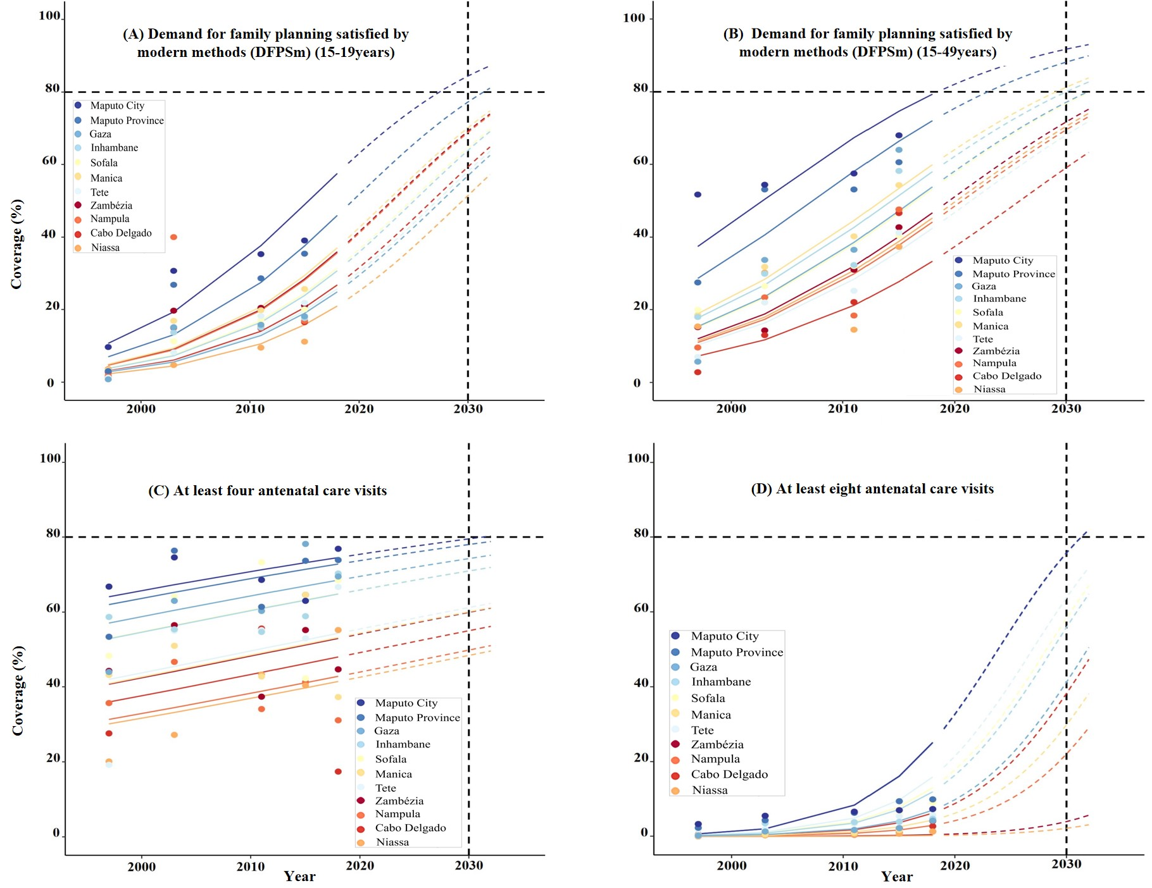
Figure S2 Trends in the coverage of preventive services by provinces (A–D), 1997–2030.
Note: Solid lines represent observed values from 1997, 2003, 2010, 2015, and 2018, while dashed lines indicate projected values, with 2030 representing the final projection.

Supplementary Figure 2 (E–H) presents the projected coverage of curative services in 11 provinces of Mozambique in 2030. Figure 2E shows that hospital-based delivery coverage is projected to be 94.94% in Maputo City and 96.76% in Maputo Province. Coverage is also projected at 87.14% in Gaza Province, 84.58% in Sofala Province, and 86.79% in Manica Province, all exceeding the 80% target. Other provinces are projected to fall below 80%. Figure 2F indicates that delivery coverage by skilled birth attendants is projected at 87.82% in Maputo City, 92.31% in Maputo Province, and 81.47% in Gaza Province, while all other provinces remain below the 80% target. Figure 2G shows that oral rehydration therapy for diarrhea is projected to reach 82.13% coverage in Maputo Province, whereas all other provinces are projected below 80%. Figure 2H indicates that treatment coverage for suspected pneumonia
exceeds 80% in all provinces.

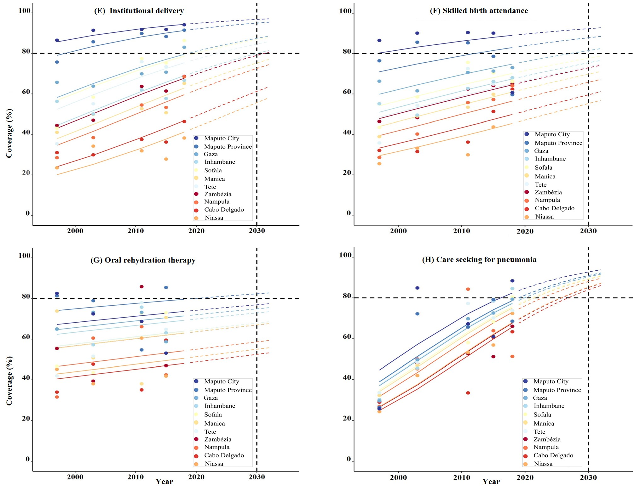

Figure S2 Trends in curative service coverage by province (E–H), 1997–2030.
Note: Solid lines represent observed values from 1997, 2003, 2010, 2015, and 2018, while dashed lines indicate projected values, with 2030 representing the final projection.
Figure S3 (A–D) presents the projected coverage of preventive services by place of residence in Mozambique in 2030. Figure 3A shows that coverage of family planning services among women aged 15–49 is projected at 61.92% in rural areas and 83.26% in urban areas. Figure 3B indicates that coverage of family planning services among adolescents aged 15–19 is projected at 83.47% in rural areas and 92.94% in urban areas. Figure 3C shows that coverage of at least four antenatal care visits is projected at 64.53% in rural areas and 74.82% in urban areas. Figure 3D indicates that coverage of at least eight antenatal care visits is projected to remain below 20% in both rural and urban population.

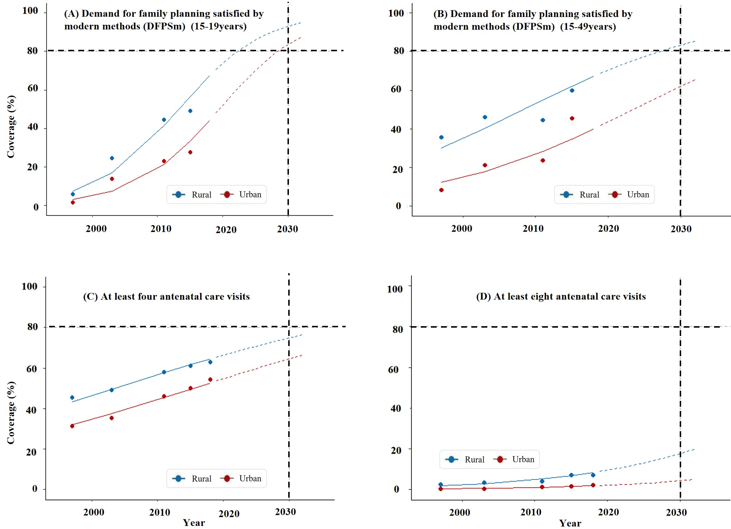
Figure S3 Trends in preventive service coverage by place of residence(A–D), 1997–2030.
Note: Solid lines represent observed values from 1997, 2003, 2010, 2015, and 2018, while dashed lines indicate projected values, with 2030 representing the final projection.

Supplementary Figure 3 (E–H) presents the projected coverage of curative services in 2030 across 11 provinces (municipalities). Figure 3E shows that the coverage of facility-based delivery is 72.43% among rural populations and 82.98% among urban populations. Figure 3F indicates that the coverage of deliveries attended by skilled birth attendants is 88.06% in rural areas and 95.81% in urban areas. Figure 3G shows that the coverage of oral rehydration salts (ORS) treatment for diarrhea is 61.57% in rural populations and 74.84% in urban populations. Figure 3H indicates that the coverage of treatment for suspected pneumonia is 72.43% in rural areas and 82.98% in urban areas.

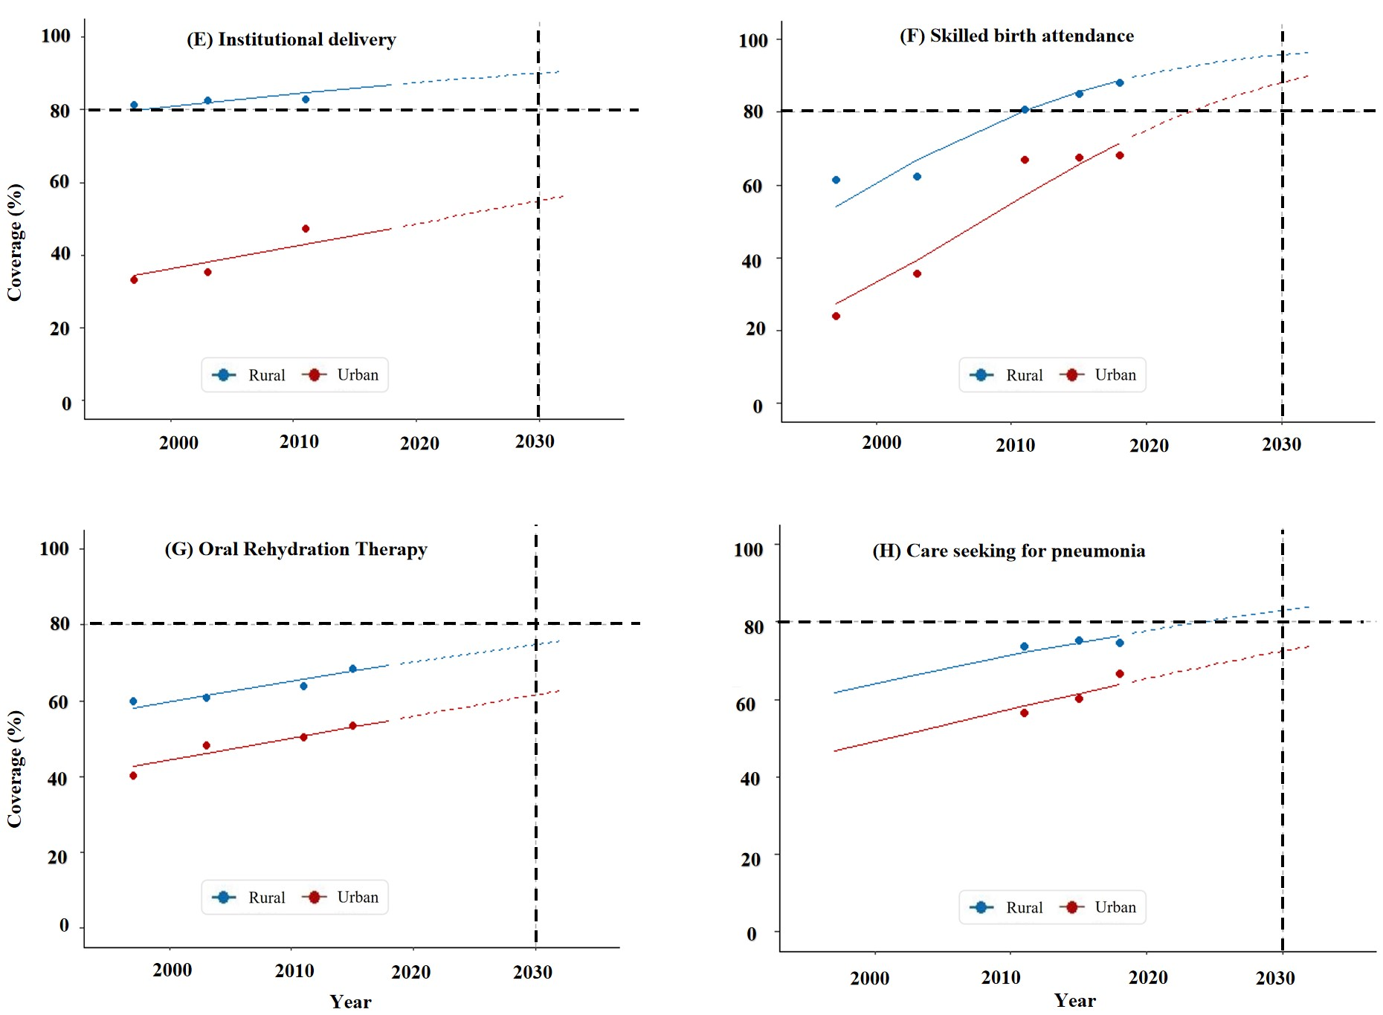

Figure S3 Trends in curative service coverage by place of residence (E–H), 1997–2030
Note: Solid lines represent observed values derived from data collected in 1997, 2003, 2010, 2015, and 2018. Dashed lines represent projected values, with 2030 as the final projection point.

Supplementary Figure 4 (A–D) presents the projected coverage of preventive services in 2030 by wealth quintile. Figure 4A shows that the coverage of family planning services among women aged 15–49 is 80.66% for the middle-wealth group, 84.66% for the richer group, and 93.31% for the wealthiest group. Figure 4B indicates that the coverage of family planning services among adolescents aged 15–19 is 82.7% in the middle-wealth group, 87.69% in the richer group, and 93.11% in the wealthiest group. Figure 4C shows that the coverage of at least four antenatal care visits reaches 81.08% in the wealthiest group, while other wealth groups fail to meet the 80% target. Figure 4D indicates that the coverage of at least eight antenatal care visits does not reach the 80% target in any wealth group.

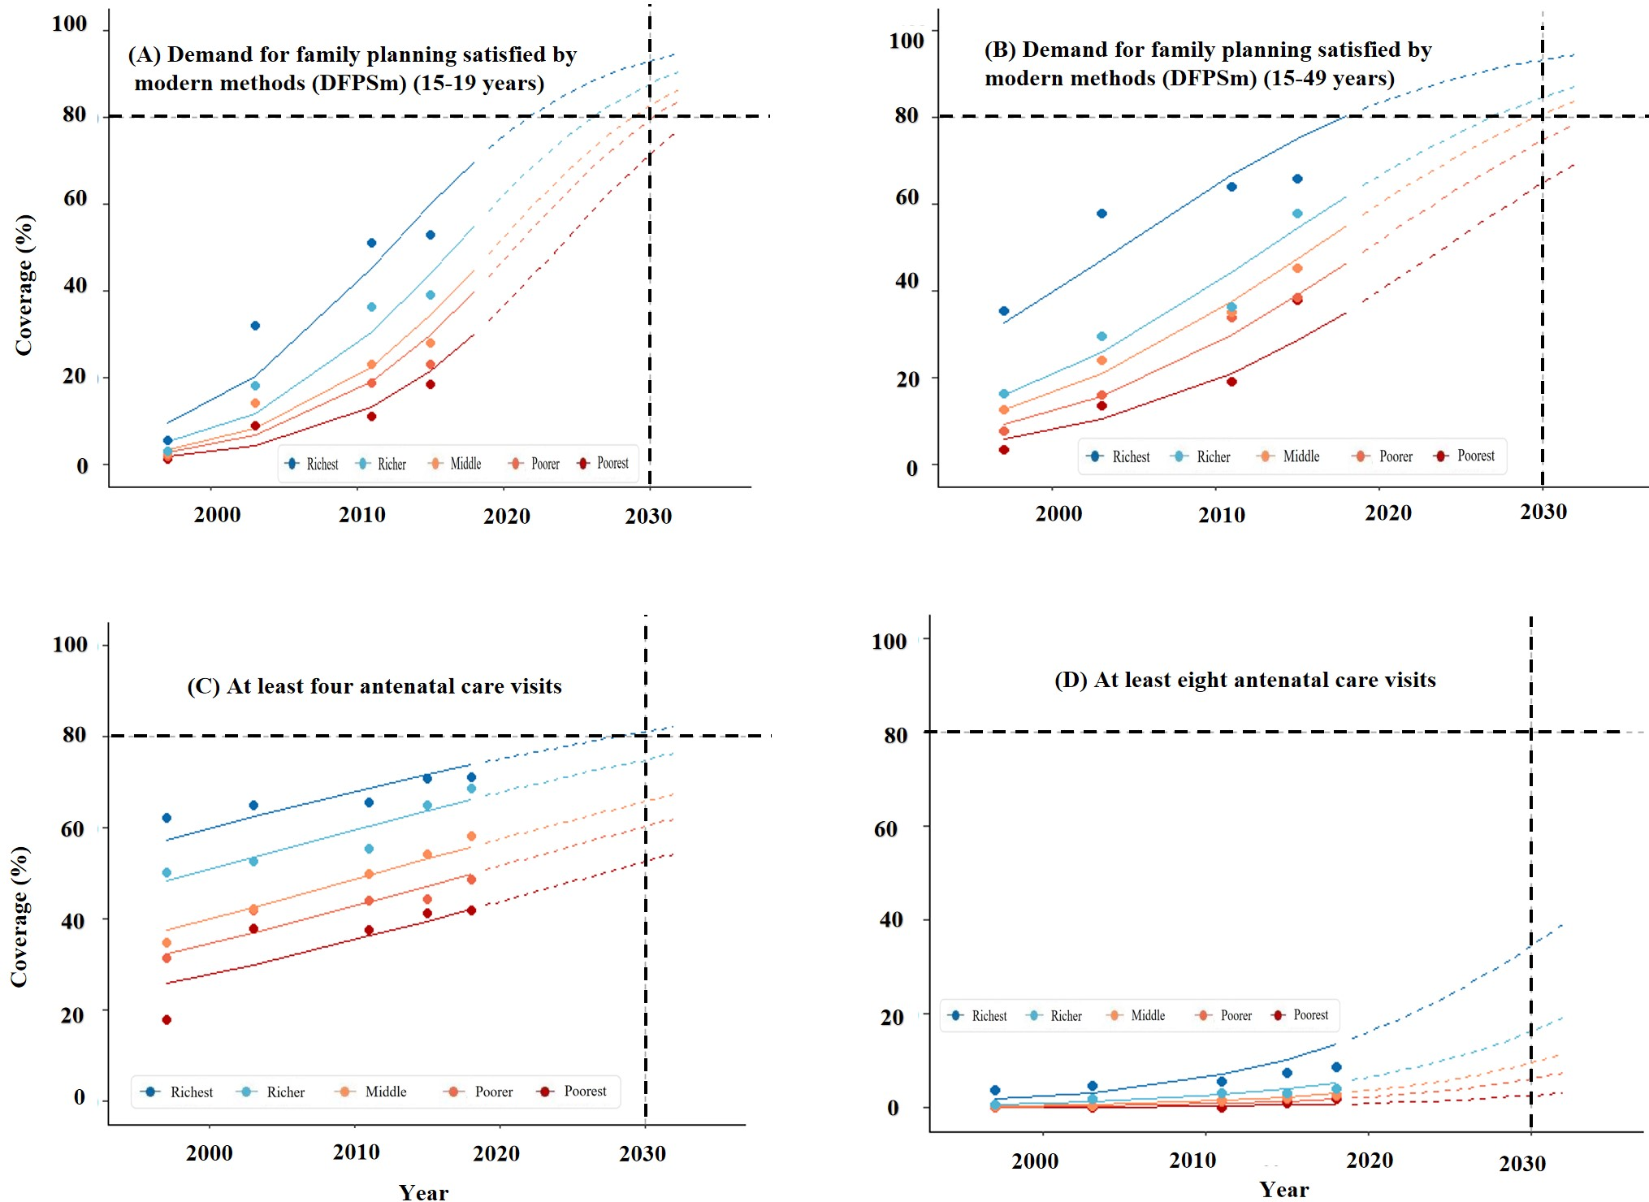
Figure S4 Trends in preventive service coverage by wealth quintile (A–D), 1997–2030
Note: Solid lines represent observed values based on data from 1997, 2003, 2010, 2015, and 2018. Dashed lines represent projected values, with 2030 as the final projection point.

Supplementary Figure 4 (E–H) presents the projected coverage of curative services in 2030 by wealth quintile. Figure 4E shows that the coverage of facility-based delivery is 91.09% in the richer group and 97.26% in the wealthiest group. Figure 4F indicates that the coverage of deliveries attended by skilled birth attendants is 88.26% in the richer group and 90.82% in the wealthiest group. Figure 4G shows that the coverage of oral rehydration salts (ORS) treatment for diarrhea reaches 84.06% in the wealthiest group, while other wealth groups fail to achieve the 80% target. Figure 4H indicates that the coverage of treatment for suspected pneumonia is 82.84% in the
middle-wealth group, 88.05% in the richer group, and 88.52% in the wealthiest group.

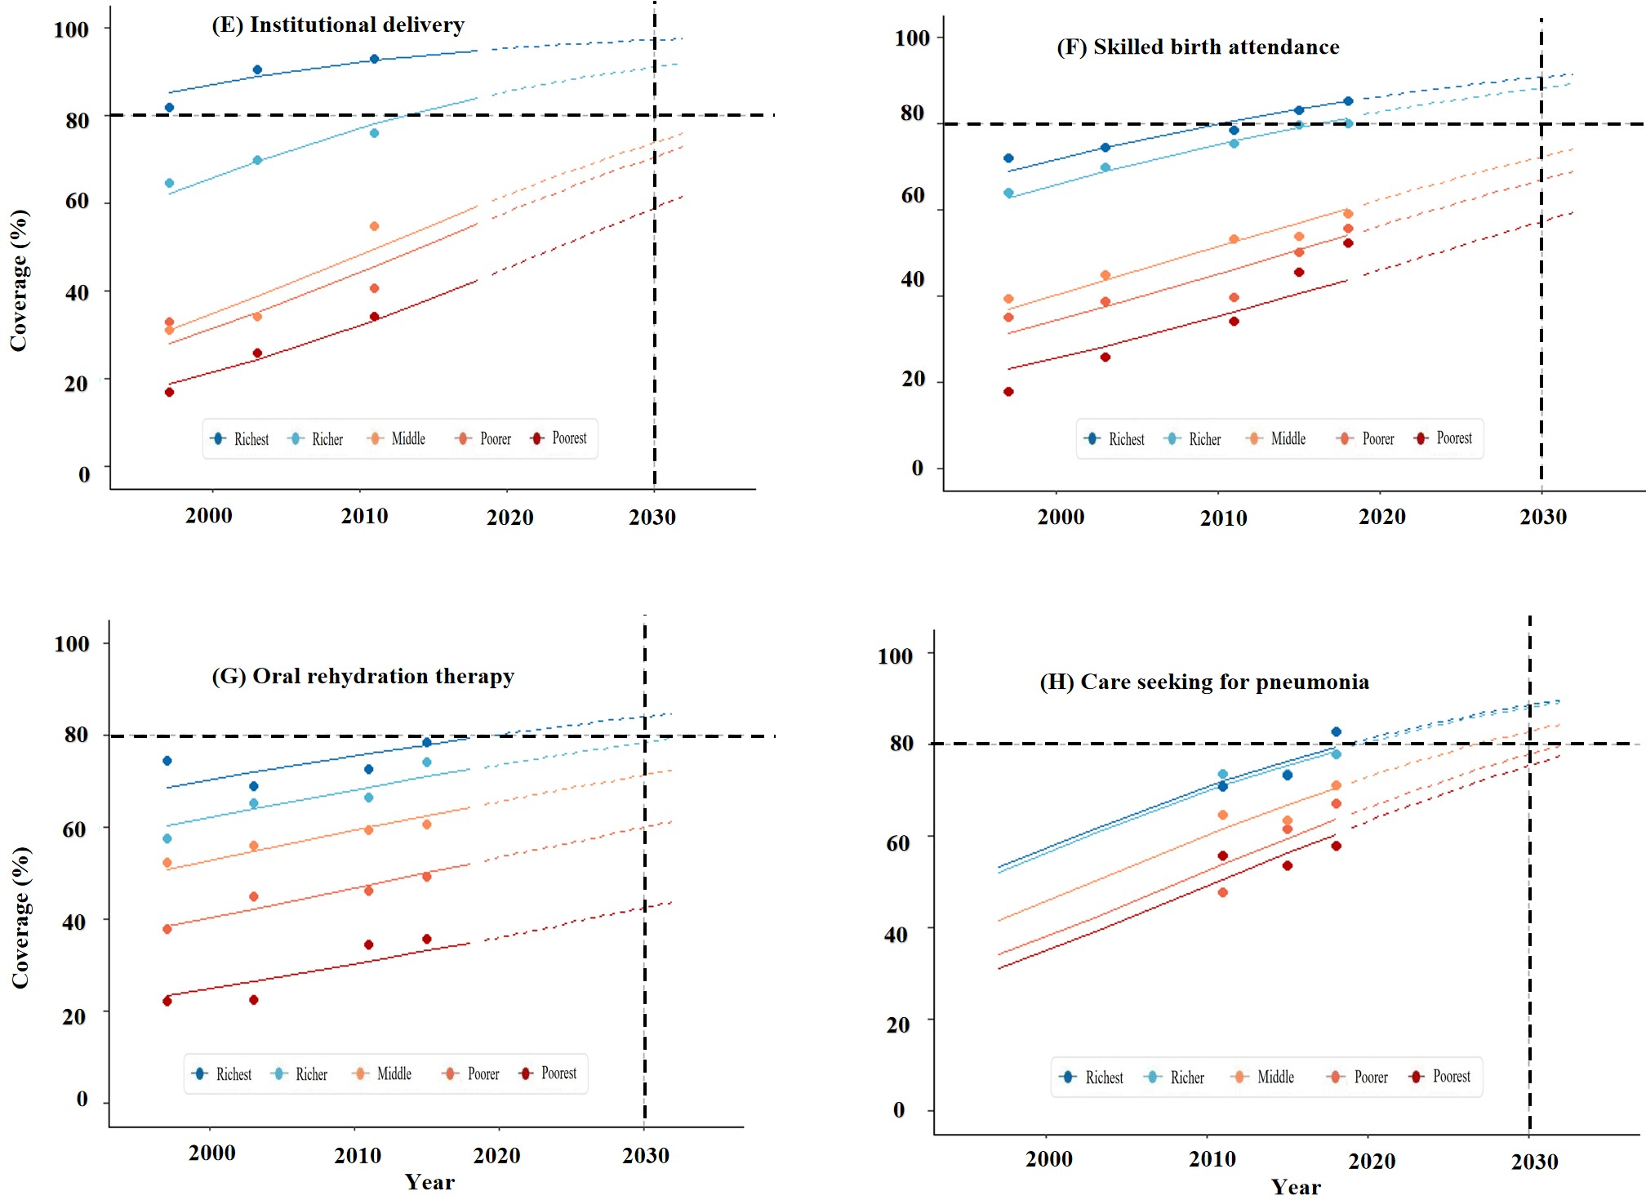

Figure S4 Trends in curative service coverage by wealth quintile (E–H), 1997–2030
Note: Solid lines represent observed values based on data from 1997, 2003, 2010, 2015, and 2018. Dashed lines represent projected values, with 2030 as the final projection point.

Supplementary Figure 5 (A–D) presents the projected coverage of preventive services in 2030 by education level. Figure 5A shows that the coverage of family planning services among women aged 15–49 is 82.89% for those with a junior high education and 87.66% for those with a high school education or above. Figure 5B indicates that the coverage of family planning services among adolescents aged 15–19 is 85.4% for those with a junior high education and 87.56% for those with a high school education or above. Figure 5C shows that the coverage of at least four antenatal care visits is 86.02% among women with a primary school education, 88.24% among those with a junior high education, and 92.75% among those with a high school education or above. Figure 5D indicates that the coverage of at least eight antenatal care visits fails to reach the 80% target across all education levels.

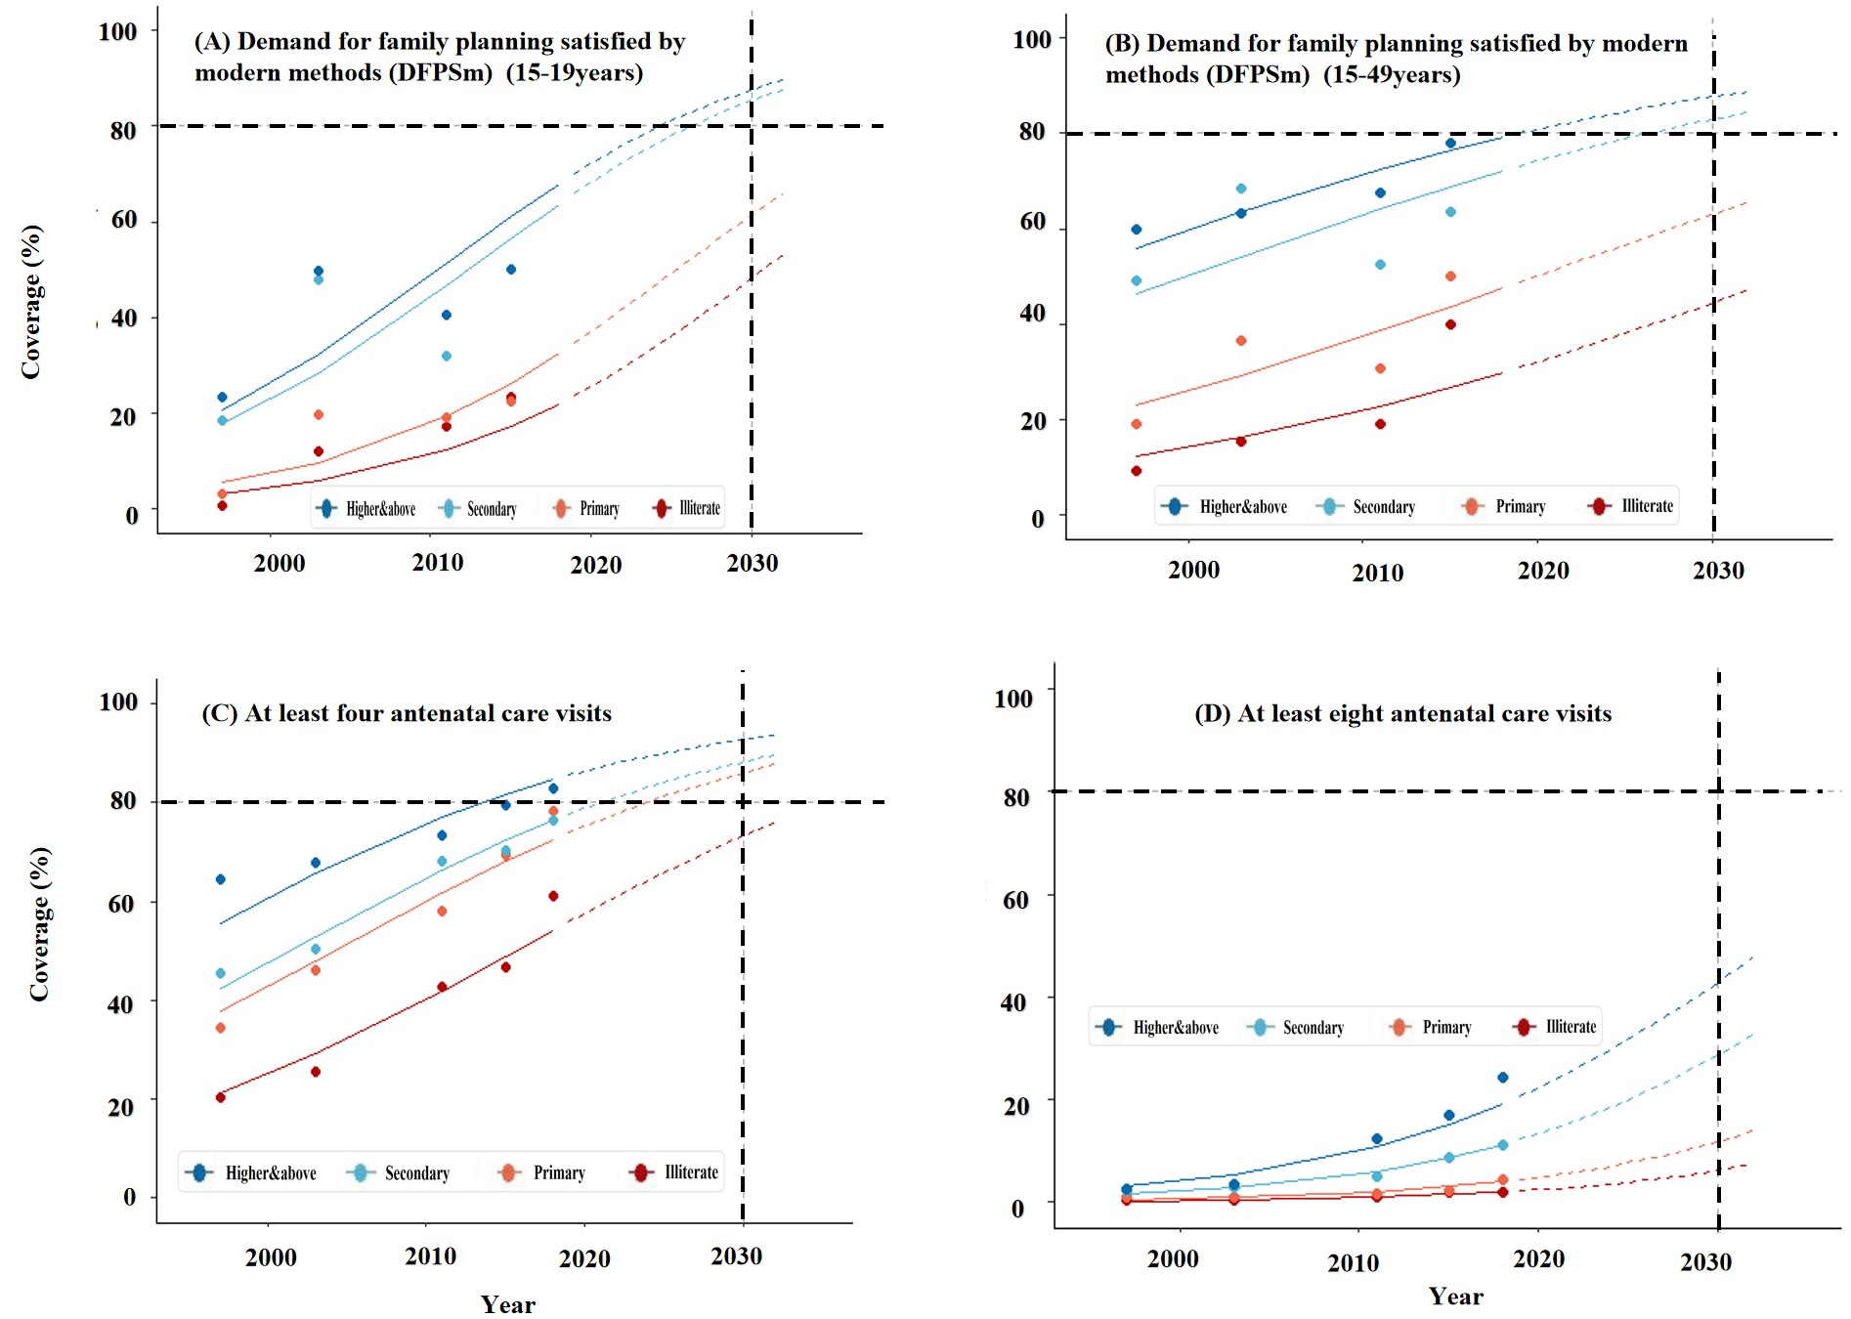
Figure S5 Trends in preventive service coverage by education level (A–D), 1997–2030
Note: Solid lines represent observed values based on data from 1997, 2003, 2010, 2015, and 2018. Dashed lines represent projected values, with 2030 as the final projection point.

Supplementary Figure 5 (E–H) presents the projected coverage of curative services in 2030 by education level. Figure 5E shows that the coverage of facility-based delivery is 96.54% among women with a junior high education and 98.98% among those with a high school education or above. Figure 5F indicates that the coverage of deliveries attended by skilled birth attendants is 82.66% in the junior high education group and 91.44% in the high school or above group. Figure 5G shows that the coverage of oral rehydration salts (ORS) treatment for diarrhea reaches 89.83% among women with a high school education, while other education groups fail to achieve the 80% target. Figure 5H indicates that the coverage of treatment for suspected pneumonia is 88.74% among women with a junior high education, while
other education groups fail to reach the 80% target.

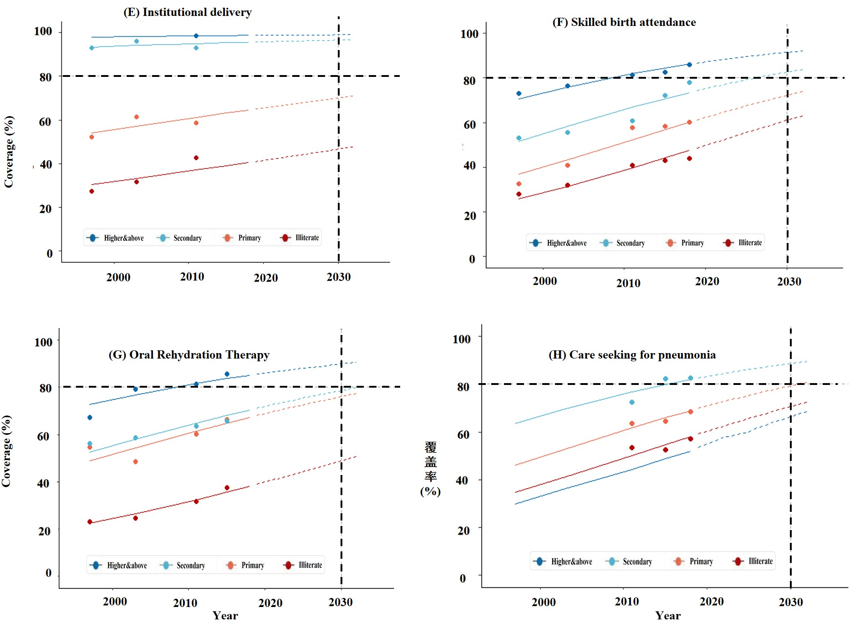
Figure S5 Trends in curative service coverage by education level (E–H), 1997–2030
Note: Solid lines represent observed values based on data from 1997, 2003, 2010, 2015, and 2018. Dashed lines represent projected values, with 2030 as the final projection point.

Supplementary Figure 6 (A–D) presents the projected coverage of environmental sanitation preventive services in 2030, stratified by wealth quintile and place of residence. Figure 6A shows that the coverage of basic drinking water services among the poorest group fails to reach the 80% target. Figure 6B indicates that the coverage of improved sanitation facilities exceeds the 80% target across all wealth groups. Figure 6C shows that the coverage of basic drinking water services among rural populations fails to reach the 80% target. Figure 6D indicates that the coverage of improved sanitation facilities is well above the 80% target in urban populations, while rural populations approach the 80% target.

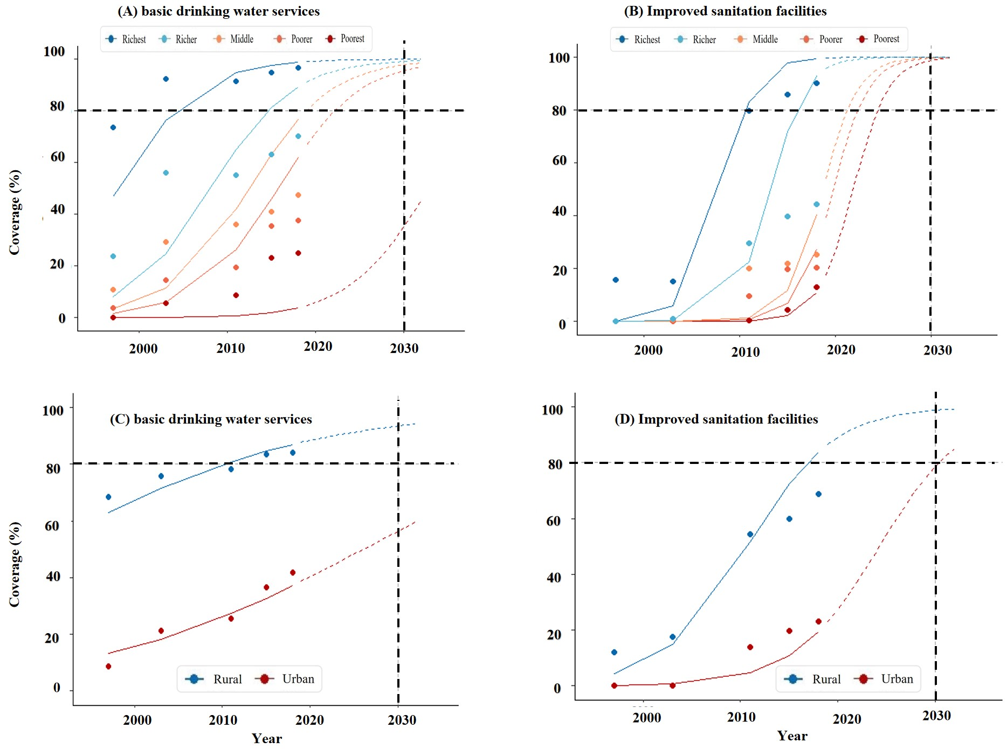
Figure S6 Trends in environmental sanitation preventive service coverage by wealth quintile and place of residence (A–D), 1997–2030
Note: Solid lines represent observed values based on data from 1997, 2003, 2010, 2015, and 2018. Dashed lines represent projected values, with 2030 as the final projection point.

Table S10 Projected mortality outcomes under baseline and scale-up scenarios
across 11 provinces/cities, 2030
Province/City | Scenario | Maternal deaths | Neonatal deaths | Under-5 deaths | Total deaths* | Reduction (%)
Niassa | Scale-up | 84 | 585 | 961 | 1045 | 50.24
Niassa | Baseline | 138 | 1419 | 1962 | 2100 | 50.24
Cabo  Delgado | Scale-up | 51 | 537 | 1565 | 1616 | 58.79
Cabo  Delgado | Baseline | 79 | 1963 | 3842 | 3921 | 58.79
Nampula | Scale-up | 21 | 440 | 1635 | 1656 | 59.33
Nampula | Baseline | 97 | 1621 | 3975 | 4072 | 59.33
Zambézia | Scale-up | 132 | 501 | 2548 | 2680 | 54.27
Zambézia | Baseline | 181 | 1954 | 5679 | 5860 | 54.27
Tete | Scale-up | 58 | 716 | 1802 | 1860 | 61.34
Tete | Baseline | 88 | 2157 | 4723 | 4811 | 61.34
Manica | Scale-up | 31 | 790 | 1261 | 1292 | 63.86
Manica | Baseline | 55 | 2486 | 3520 | 3575 | 63.86
Sofala | Scale-up | 56 | 1415 | 1789 | 1845 | 44.63
Sofala | Baseline | 117 | 2089 | 4215 | 3332 | 44.63
Inhambane | Scale-up | 53 | 246 | 361 | 414 | 62.47
Inhambane | Baseline | 89 | 737 | 1014 | 1103 | 62.47
Gaza | Scale-up | 23 | 307 | 1039 | 1062 | 46.71
Gaza | Baseline | 52 | 974 | 1941 | 1993 | 46.71
Maputo Provincia | Scale-up | 53 | 2038 | 3693 | 3746 | 52.28
Maputo Provincia | Baseline | 124 | 4789 | 7726 | 7850 | 52.28
Maputo  Cidade | Scale-up | 387 | 2939 | 3589 | 3976 | 59.58
Maputo  Cidade | Baseline | 490 | 6526 | 9347 | 9837 | 59.58
National | Scale-up | 949 | 10514 | 15543 | 16492 | 63.15
National | Baseline | 1510 | 26715 | 43244 | 44754 | 63.15
*Total deaths include maternal deaths and under-5 deaths (neonatal deaths are included in under-5 deaths).

Data are modelled projections for 2030 under baseline and scale-up scenarios. The baseline scenario assumes continuation of historical trends in intervention coverage, while the scale-up scenario assumes linear expansion of key interventions to 80% coverage of the composite intervention package (LCCI) by 2030. Deaths averted are calculated as the difference between baseline and scale-up scenario estimates. Percentage reduction is calculated relative to baseline mortality. All estimates are derived from LiST-based modelling incorporating province-specific baseline mortality and intervention coverage profiles. Maternal, neonatal, and under-five deaths are reported separately, with total deaths representing the aggregate of all age groups.

Table S11 Additional maternal, neonatal, and under-5 deaths averted by 2030 under CCI and LCCI scale-up scenarios compared with baseline in Mozambique, by region
Regions | Additional maternal deaths averted  by 2030  (CCI) | Additional maternal deaths averted  by 2030  (LCCI) | Additional maternal deaths averted  by 2030  (CCI) | Additional neonatal deaths averted  by 2030  (LCCI) | Additional maternal deaths averted  by 2030  (CCI) | Additional under-5 deaths averted  by 2030  (LCCI)
Niassa | 38 | 54 | 129 | 834 | 234 | 1001
Tete | 23 | 30 | 392 | 1441 | 760 | 2921
Inhambane | 31 | 36 | 109 | 491 | 236 | 653
Gaza | 24 | 29 | 211 | 667 | 320 | 902
Cabo Delgado | 18 | 28 | 287 | 1426 | 526 | 2277
Nampula | 61 | 76 | 326 | 1181 | 641 | 2340
Zambézia | 32 | 49 | 410 | 1453 | 1373 | 3131
Manica | 18 | 24 | 685 | 1696 | 654 | 2259
Sofala | 42 | 61 | 168 | 674 | 926 | 2426
Maputo Province | 62 | 71 | 1440 | 2751 | 1585 | 4033
Maputo Cidade | 94 | 103 | 1928 | 3587 | 3051 | 5758
National | 443 | 561 | 6085 | 16201 | 10306 | 27701
CCI (Composite Coverage Index) represents the WHO standard composite coverage index, while LCCI (Localised Composite Coverage Index) represents the localised version adapted to specific contexts.

Note: Detailed data on localized maternal and child health service coverage in Mozambique for the years 1997, 2003, 2010, 2015, and 2018 are not presented here. For access to the full dataset, please contact the author.

References
1 Li Q, Kanduma E, Ramiro I, Xu DR, Cuco RMM, Chaquisse E, Yang Y, Wang X, Pan J. Spatial Access to Continuous Maternal and Perinatal Health Care Services in Low-Resource Settings: Cross-Sectional Study. JMIR Public Health Surveill. 2024 Jul 18;10:e49367.
2 Countdown to 2030 Collaboration. Countdown to 2030. Countdown to 2030: tracking progress towards universal coverage for reproductive, maternal, newborn, and child health. Lancet, 2018, 391(10129): 1538-1548.
3 Ergo AB, Eichler R, Koblinsky M, et al. Strengthening Health Systems to Improve Maternal, Neonatal and Child Health Outcomes: A Framework[C], 2011.
4 The Demographic and Health Surveys (DHS). Available Datasets [EB/OL]. https://www.dhsprogram.com/data/available-datasets.cfm?ctryid=12, 2023-03-12
5 Sambo J, Bauhofer AFL, Boene SS, et al. Readiness of Mozambique Health Facilities to Address Undernutrition and Diarrhea in Children under Five: Indicators from 2018 and 2021 Survey Data. Healthcare (Basel), 2022, 10(7): 1200-1212.
6 Júnior JM, Cane RM, Gonçalves MP, et al. Projecting the lives saved by continuing the historical scale-up of child and maternal health interventions in Mozambique until 2030. J Glob Health, 2019, 9(1): 011102-011114.
7 Samuels F, Amaya AB, Balabanova D. Drivers of health system strengthening: learning from implementation of maternal and child health programmes in Mozambique, Nepal and Rwanda. Health Policy Plan, 2017, 32(7): 1015-1031.
8 Gausman J, Saggurti N, Adanu R, et al. Revising the definition of "demand satisfied for modern methods of family planning:" A cross-sectional study to explore incorporating person-centered constructs of demand, choice, and satisfaction. PLoS One, 2025, 20(1): e0316725-e0316732.

