Supporting Information
Phytocarbon Dots as an Oral Nano-Degrader of ENO1 for Alleviating Hepatic Fibrosis
Lin Gao^{1#}, Teng Liu^{1#}, Yi-Kun Li^{2#}, Ping Huang¹, Jing Li³, Hong-Li Gao¹, Jing-Xin Li²*, Jun-Xia Zheng⁴*, Zhi-Yuan Lu¹*
¹School of Pharmaceutical Sciences & Institute of Materia Medica, State Key Laboratory of Advanced Drug Delivery and Release Systems, Medical Science and Technology Innovation Center, Shandong First Medical University & Shandong Academy of Medical Sciences, Jinan, 250117,
²Department of Physiology, School of Basic Medical Sciences, Cheeloo College of Medicine, Shandong University, Jinan,250012, China.
³Department of Pathology, Zibo Central Hospital, Zibo, 255036, China.
⁴School of Biomedical and Phamaceutical Sciences, Guangdong University of Technology, Guangzhou, 510006, China.
#These authors contributed equally to this work.
*Corresponding authors.
ljingxin@sdu.edu.cn (Jing-Xin Li); junxiazheng@gdut.edu.cn (Jun-Xia Zheng); luzhiyuan@sdfmu.edu.cn (Zhi-Yuan Lu).

1. Experimental Section
Characterization of D-CDs
The morphological and structural properties of D-CDs were examined using a Talos F200S transmission electron microscope (TEM) (FEI, OR, USA) operating at an accelerating voltage of 200 kV. Additionally, X-ray diffraction (XRD) patterns were acquired using a Rigaku D/MAX-2600 diffractometer (Japan) with a scanning rate of 2° per minute to investigate the crystallinity of the D-CDs. The chemical bonding states and elemental composition were further analyzed by X-ray photoelectron spectroscopy (XPS) using a Thermo Scientific K-Alpha XPS system (USA). Photoluminescence properties were evaluated with an F-7000 fluorescence spectrophotometer (Hitachi, Japan) at an excitation wavelength of 450 nm. Fourier-transform infrared (FTIR) spectroscopy was performed on a Thermo Scientific spectrophotometer (USA) over the range of 400–4000 cm⁻¹ to identify the functional groups present on the D-CDs.
Stability of D-CDs
The colloidal stability of the synthesized carbon dots (CDs) was evaluated using a multi-parametric approach. First, the fluorescence spectra of the D-CDs were recorded immediately after mixing with NaCl solutions at varying concentrations (0 to 1.0 M) to evaluate the effects of ionic strength. Concurrently, the pH-dependent stability was analyzed by measuring the fluorescence spectra in buffer solutions across a pH range of 3 to 12. Furthermore, long-term stability was assessed by monitoring changes in fluorescence intensity over 16 days under accelerated storage conditions.
Analysis of Total Antioxidant Capacity of D-CDs
The total antioxidant capacity (T-AOC) of D-CDs was evaluated using a commercial T-AOC assay kit (Beyotime, China). Kinetic measurements were performed by monitoring the characteristic absorption peak of the ABTS•+ radical at 414 nm over a period of 60 seconds in response to varying concentrations of D-CDs. The decay of ABTS•+ concentration was quantified by continuous spectral scanning, which provided visible absorption spectra for each concentration group. This method allows the remaining ABTS•+ to be accurately determined, thereby enabling the calculation of the antioxidant capacity based on the radical scavenging activity of D-CDs.
Cell Culture
NCM460, AML-12, and HUVEC cell lines were obtained from the Shanghai Institute of Biological Sciences. All cells were maintained in their respective ATCC-recommended media, supplemented with 10% fetal bovine serum (APExBIO Technology LLC, Houston, USA) and 1% penicillin – streptomycin (Beyotime, Shanghai, China). Cultures were incubated at 37 °C in a humidified atmosphere containing 5% CO₂.
CCK-8 Assay
Cells were seeded in 96-well plates at a density of 1×10⁵ cells per well and cultured overnight. After 24-hour treatment according to the experimental grouping, cell viability was assessed using the Cell Counting Kit-8 (CCK-8; TargetMol, Shanghai, China). The kit solution was added to each well followed by incubation for 1 hours at 37°C. Absorbance was measured at 450 nm using a microplate reader, with cell viability calculated relative to untreated control cells.
Intracellular ROS Analysis
Intracellular reactive oxygen species (ROS) levels in LX2 cells were quantified using the fluorescent probe 2′,7′-dichlorodihydrofluorescein diacetate (DCFH-DA) (AmBeed, China), following the manufacturer’s protocol. Briefly, the cells were loaded with 10 μM DCFH-DA dissolved in serum-free medium and incubated at 37 °C for 30 minutes. After incubation, the cells were thoroughly washed three times with phosphate-buffered saline (PBS) to remove any residual, non-internalized probe. Subsequently, the cells were stained with Hoechst nuclear dye for 10 minutes to visualize cell nuclei, followed by another three PBS washes. The intracellular ROS levels, reflected by the oxidation of DCFH-DA to the fluorescent product DCF, were assessed based on fluorescence intensity using fluorescence microscopy.
Synthesis of D-CDs@CY5
D-CDs@CY5 was synthesized by dissolving D-CDs (15 mg) in methanol (15 mL), followed by the addition of 4-(4,6-dimethoxy-1,3,5-triazin-2-yl)-4-methylmorpholinium chloride (DMT-MM, 6.8 mg). The mixture was stirred at room temperature for 1 hour. CY5 amine (15 mg) was then introduced, and the reaction was continued at room temperature for 24 hours under light-protected conditions. The product was purified by dialysis against ultrapure water for 24 hours and lyophilized to obtain D-CDs@CY5.
Biosafety Evaluation of D-CDs
To systematically assess the biosafety profile of D-CDs, 8-week-old wild-type C57BL/6 mice were randomly allocated into three experimental groups. The treatment groups received intraperitoneal injections of D-CDs at doses of 100 or 500 mg/kg body weight, while the control group received an equivalent volume of physiological saline. Body weight was monitored regularly throughout the study period as an indicator of overall health status. At the endpoint of the experiment, peripheral blood samples were collected and analyzed using an automated hematology analyzer to assess hematological parameters. Serum levels of aspartate aminotransferase (AST), alanine aminotransferase (ALT), blood urea nitrogen (BUN), and creatinine (CREA) were quantified with a fully automated biochemistry analyzer to evaluate hepatic and renal functions. Furthermore, major organs including the heart, lungs, kidneys, spleen, and liver were harvested and processed for histopathological examination via hematoxylin and eosin (H&E) staining, allowing for microscopic evaluation of potential tissue damage or morphological alterations.
Western blot analysis
Protein extraction and immunoblotting analysis were carried out as follows. Total proteins were extracted from hepatic tissues or cultured cells using RIPA lysis buffer (Topscience, Shanghai, China) supplemented with protease inhibitors, phosphatase inhibitors, and phenylmethylsulfonyl fluoride (PMSF). Protein lysates were run through SDS-PAGE and transferred onto polyvinylidene difluoride (PVDF) membranes by electrophoresis. After blocking with 5% bovine serum albumin (BSA) for 2 hours at room temperature, membranes were incubated overnight at 4°C with primary antibodies targeting specific proteins. Following three 10-minute washes with Tris-buffered saline containing 0.1% Tween-20 (TBST), membranes were incubated with horseradish peroxidase (HRP)-conjugated secondary antibodies for 2 hours at room temperature. Immunoreactive bands were visualized using an enhanced chemiluminescence (ECL) kit (Beyotime, Shanghai, China). Glyceraldehyde-3-phosphate dehydrogenase (GAPDH) was used as the loading control.
Real-time quantitative PCR
Real-time quantitative PCR was performed as previously described36. Briefly, total RNA was extracted from liver tissues using Trizol reagent (Vazyme, Nanjing, China) following the manufacturer’s instructions. RT-qPCR was initially conducted using a cDNA kit (Vazyme, Nanjing, China) with 1 μg of total RNA as the template to synthesize cDNA under the following conditions: 42 °C for 2 minutes, 50 °C for 15 minutes, and 85 °C for 5 seconds. Quantitative real-time PCR was performed using ChamQ Universal SYBR qPCR Master Mix (Vazyme, Nanjing, China) on an ABI StepOne Plus real-time PCR system. All primer sequences are listed in Table S2.
2. Supplemental Tables
Table S1. Antibodies and commercial reagents used in this study.
Antibodies/Regents | Source | Catalog Number
GAPDH | Proteintech | 1E6D9
α-SMA | Proteintech | 14395-1-AP
Collagen 1 | Proteintech | 14695-1-AP
Vimentin | Proteintech | 10366-1-AP
Smad3 | Aladdin | Ab156560
P-Smad3 | MCE | HY-P80325
ENO1 | Proteintech | 11204-1-AP
AKT | Proteintech | 10176-2-AP
p-AKT | Proteintech | 66444-1-Ig
PI3K | CST | 4292S
p-PI3K | Affinity | AF3242
T-AOC Assay Kit | Beyotime | S0119
EDU | Beyotime | C0071S
CCK8 | TargetMo | C0005
DCFH-DA | Ambeed | A439906
HiScript III RT SuperMix | Vazyme | R323-01
ChamQ Universal SYBR qPCR Master Mix | Vazyme | Q711-02
TGF-β | PeproTech | 100-21
NBT | Rhawn | R031684
Riboflavin | Rhawn | R055090
L-Methionine | Rhawn | R130487
TMB | Rhawn | R002584
FeSO₄•7H₂O | Rhawn | R010224
CCL₄ | Rhawn | R015578
Silibinin | TargetMo | 22888-70-6
Table S2. Primer sequences were used in this study.
Genes | Oligonucleotides
m-Gapdh-F | AGGTCGGTGTGAACGGATTTG
m-Gapdh-R | TGTAGACCATGTAGTTGAGGTCA
m-Acta2-F | GTCCCAGACATCAGGGAGTAA
m-Acta2-R | TCGGATACTTCAGCGTCAGGA
m-Col1a1-F | GCTCCTCTTAGGGGCCACT
m-Col1a1-R | CCACGTCTCACCATTGGGG
m-Desmin-F | GTGGATGCAGCCACTCTAGC
m-Desmin-R | TTAGCCGCGATGGTCTCATAC
m-Vimentin-F | CGTCCACACGCACCTACAG
m-Vimentin-R | GGGGGATGAGGAATAGAGGCT
h-ACTA2-F | GCCATGTTCTATCGGGTACTTC
h-ACTA2-R  h-COL1A1-F  h-COL1A1-R  h-GAPDH-F  h-GAPDH-R | AAAAGACAGCTACGTGGGTGA  GTGCGATGACGTGATCTGTGA  CGGTGGTTTCTTGGTCGGT  CATACCAGGAAATGAGCTTGACA  CCACCTTTGACGCTGGG
h-PDGFB-F | CTCGATCCGCTCCTTTGATGA
h-PDGFB-R | CGTTGGTGCGGTCTATGAG
h-EGR1- F | CTGACCGCAGAGTCTTTTCCTG
h-EGR1- R | TGGGTGCCGCTGAGTAAATG
h-FN1- F | CGGTGGCTGTCAGTCAAAG
h-FN1- R | AAACCTCGGCTTCCTCCATAA
h-CCND1-F | GATGCCAACCTCC-TCAACGA
h-CCND1-R | CTTCTGTTCCTCGCAGACC

3. Supplementary Figures
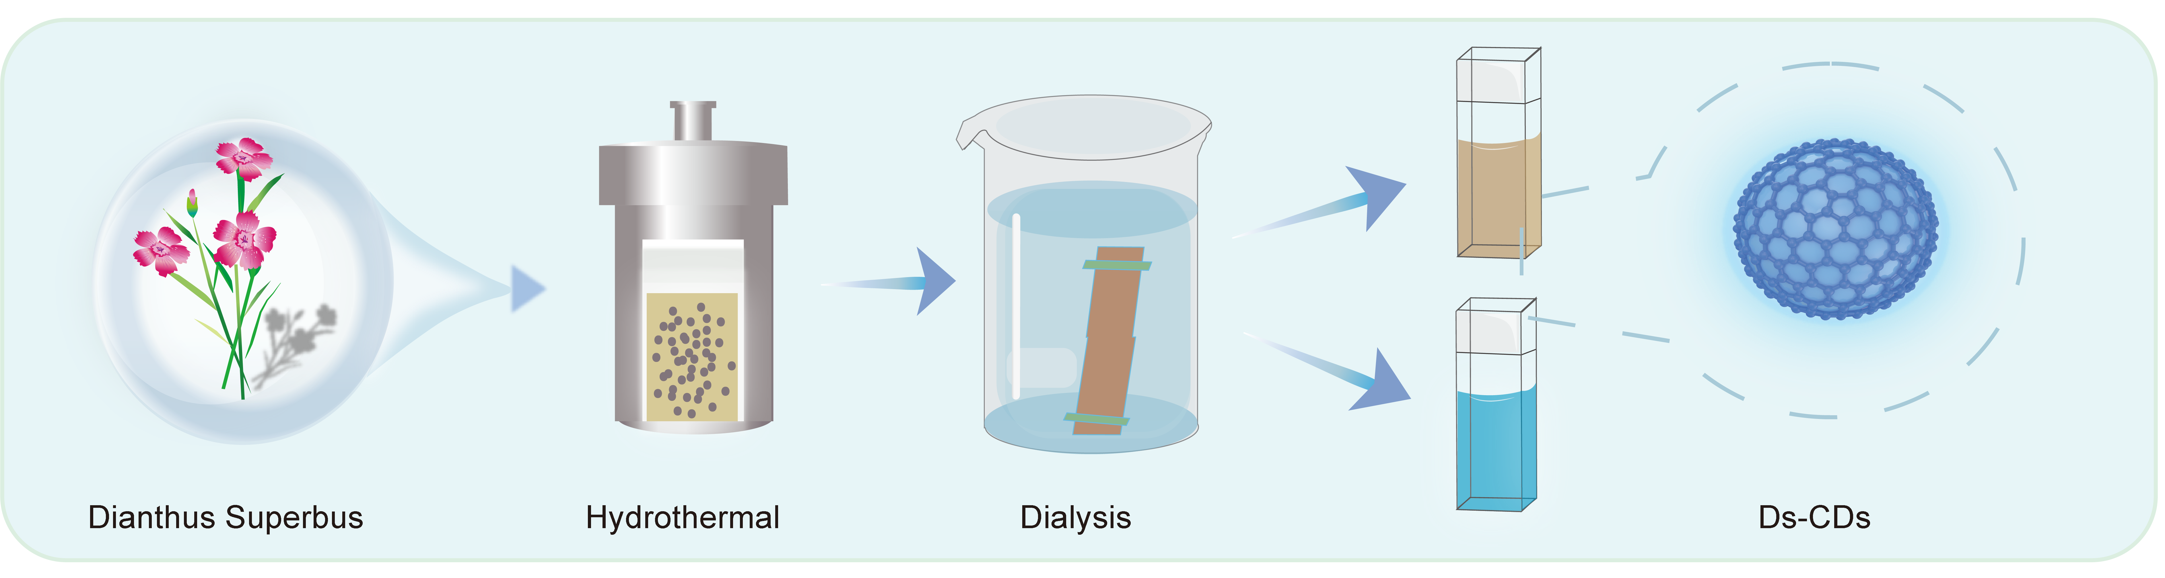
Figure S1. Simple schematic diagram of D-CD synthesis.
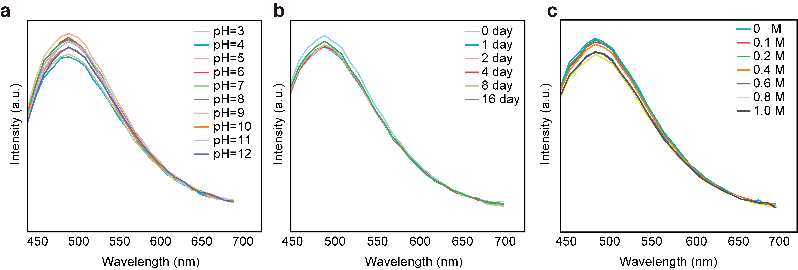
Figure S2. Stability characterization of D-CDs. (a) The fluorescence intensity at different pH values of D-CDs. (b) Changes in fluorescence intensity of D-CDs placed for different days. (c) Photoluminescence intensity profiles of D-CDs under varying ionic strengths (NaCl: 0-1.0 M).
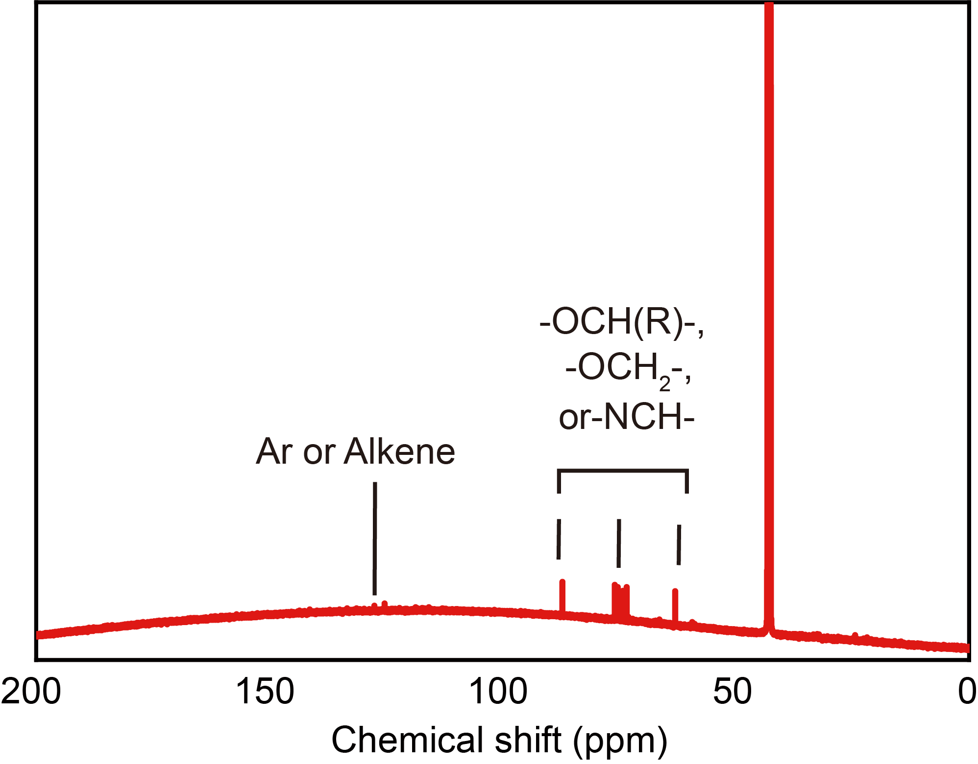
Figure S3. ¹³C NMR spectrum of D-CDs.
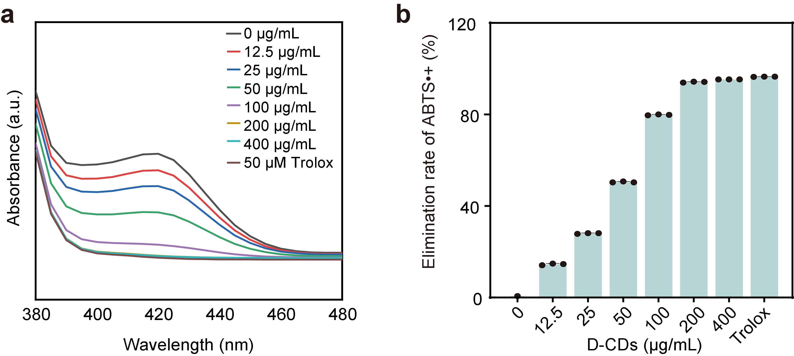
Figure S4. Total antioxidant capacity assays of D-CDs. (a) UV-Vis absorption spectra of ABTS•+ solution mixed with D-CDs at concentrations ranging from 0 to 400 μg/mL. (b) Scavenging rate of total antioxidant capacity of D-CDs at concentrations ranging from 0 to 400 μg/mL. Data represent mean ± SD.(n=3).
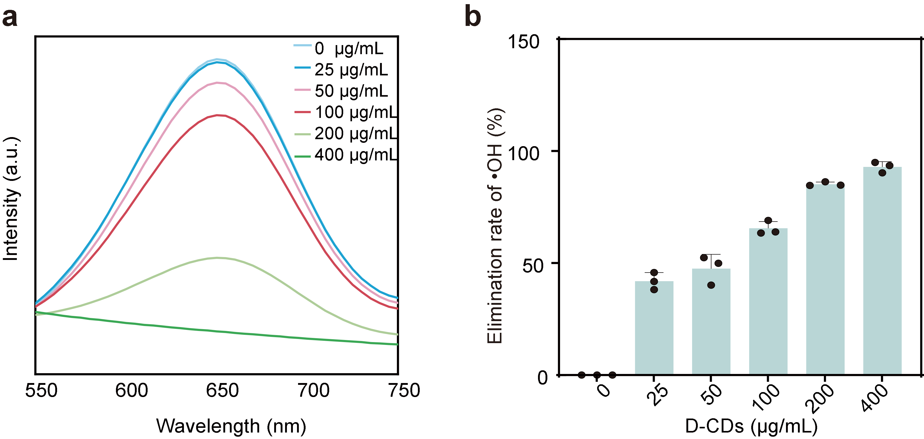
Figure S5. Scavenging activity against hydroxyl radicals (•OH) of D-CDs. (a) UV-Vis absorption spectra of hydroxyl radical (•OH) solution mixed with D-CDs at concentrations ranging from 0 to 400 μg/mL. (b) •OH radical scavenging rate of D-CDs at concentrations ranging from 0 to 400 μg/mL. Data represent mean ± SD.(n=3).
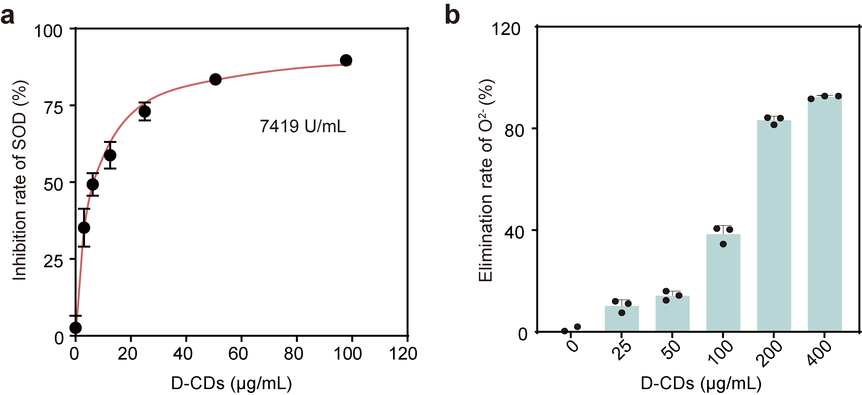
Figure S6. D-CDs Modulate SOD Activity and Scavenge Superoxide Anions. (a) Effects of CDs on superoxide dismutase (SOD) enzymatic activity across different concentrations. (b) Kinetics of superoxide anion (O₂•⁻) elimination by CDs with concentration-dependent profiling. Data represent mean ± SD.(n=3).

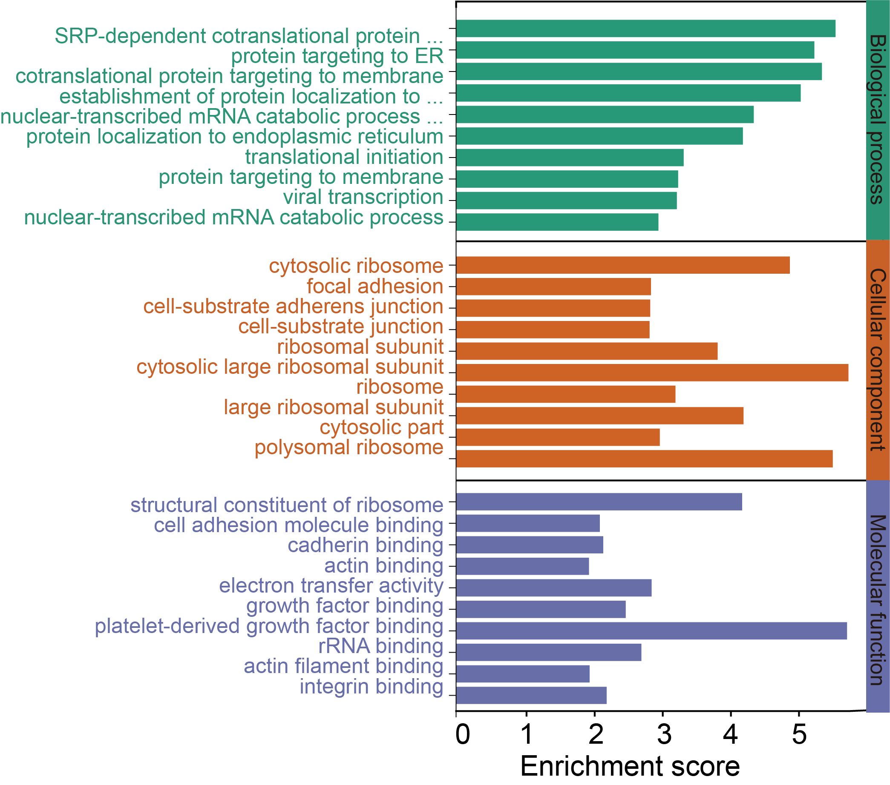
Figure S7. Analysis of Gene Ontology (GO) enrichment for Biological Process, Cellular Component, and Molecular Function categories.
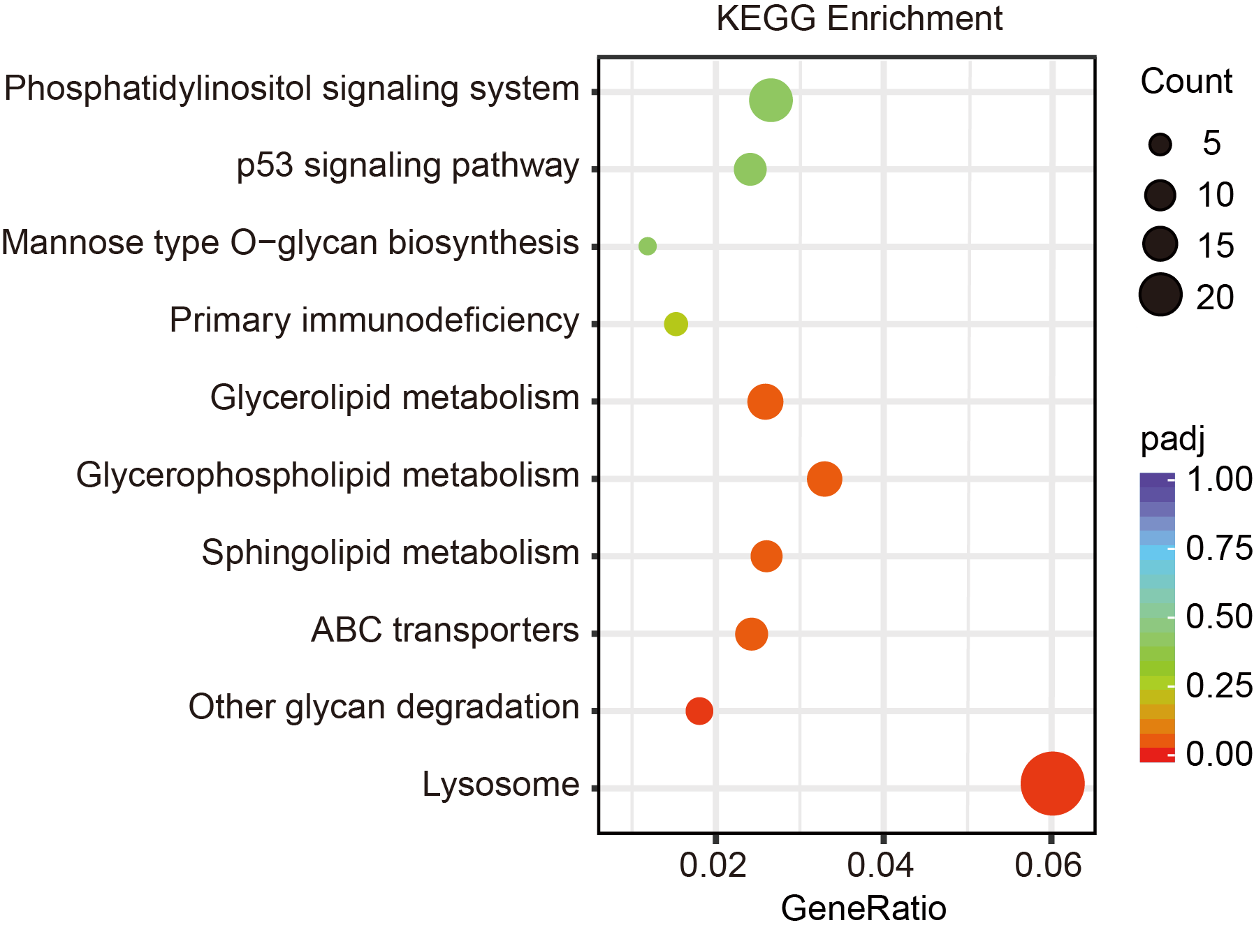
Figure S8. Enrichment plot showing the significantly enriched KEGG pathways for the down-regulated genes.
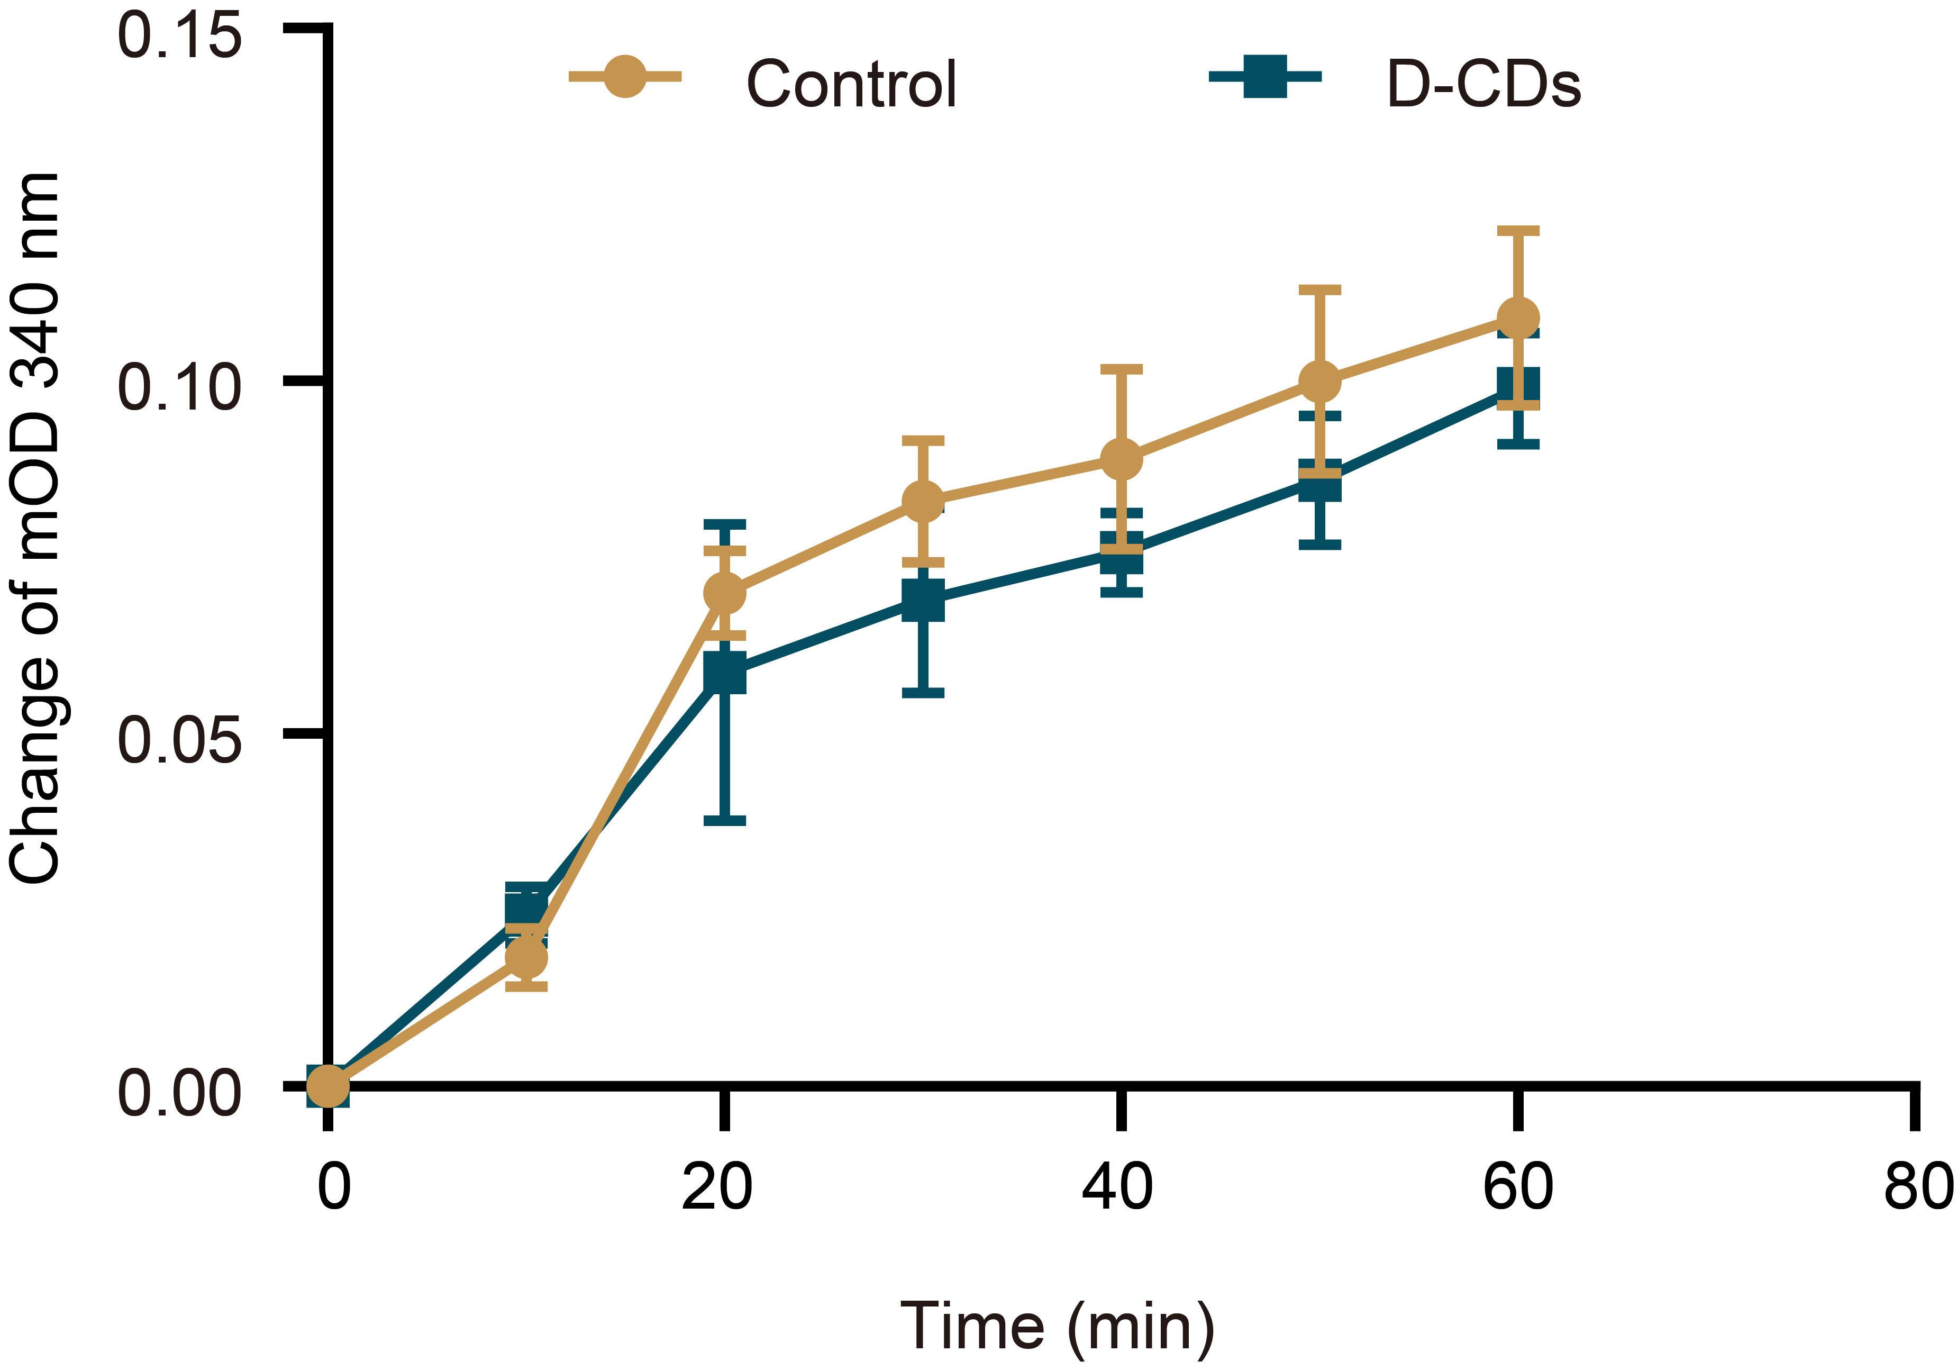
Figure S9.D-CDs inhibit the enzymatic activity of ENO1. In vitro enzymatic activity of purified ENO1 following incubation with the indicated concentrations of D-CDs, activity was determined by monitoring NADH consumption at 340 nm. Data represent mean ± SD.(n=3).
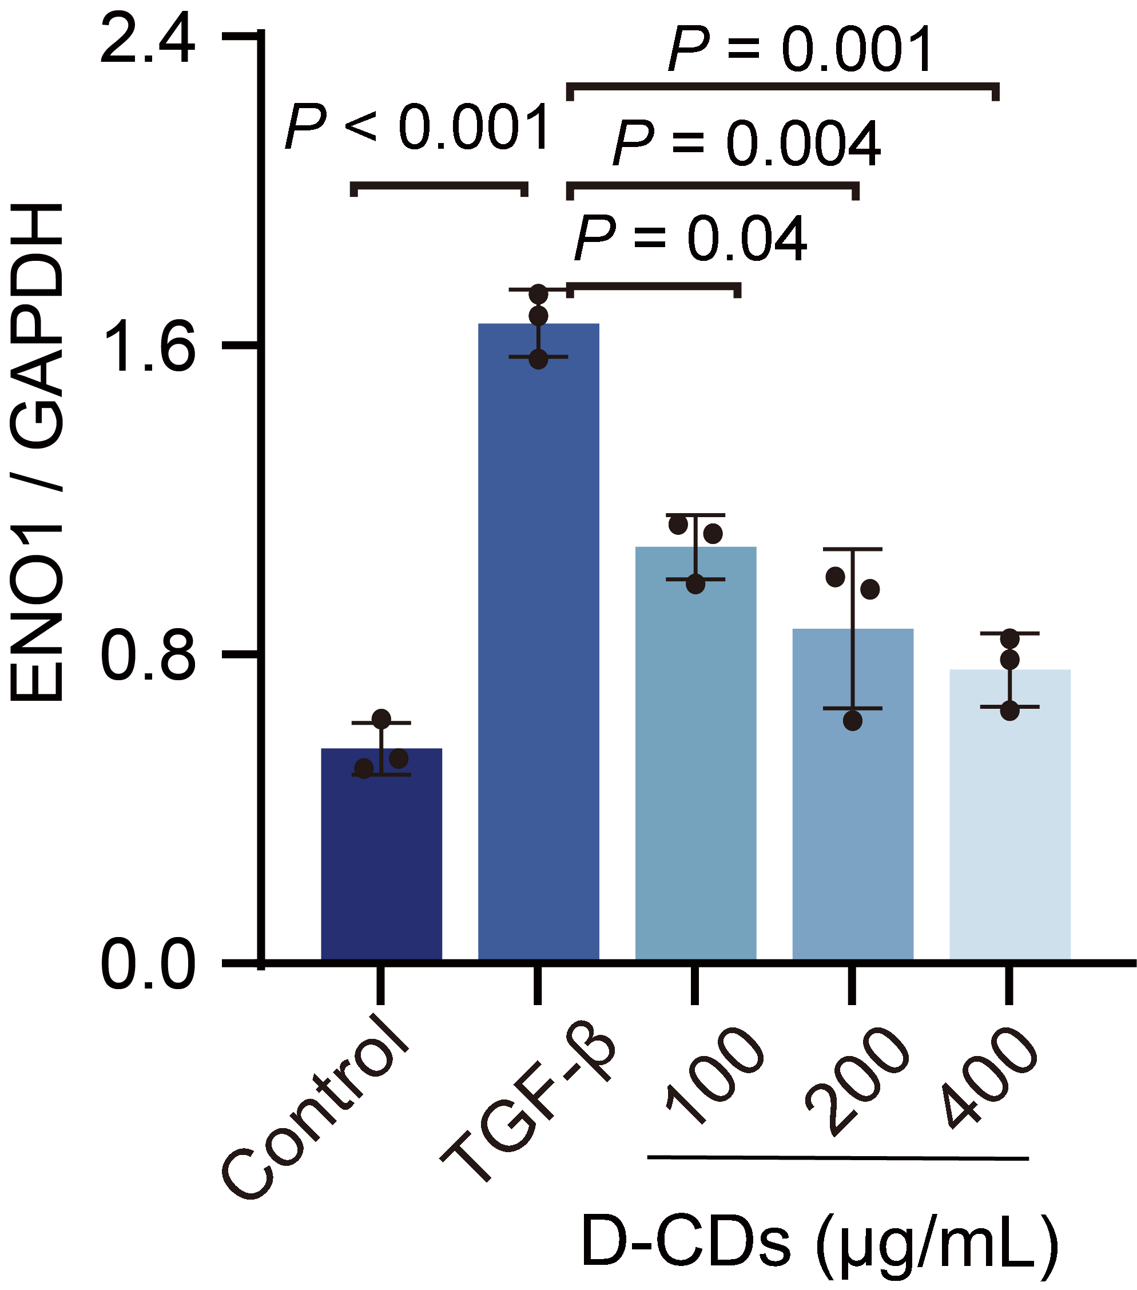
Figure S10. ENO1 protein levels in LX-2 cells, treated with or without D-CDs at various concentrations, were detected by Western blot and statistically quantified . P values were determined by an unpaired Student's t-test. Data represent mean ± SD.(n=3).
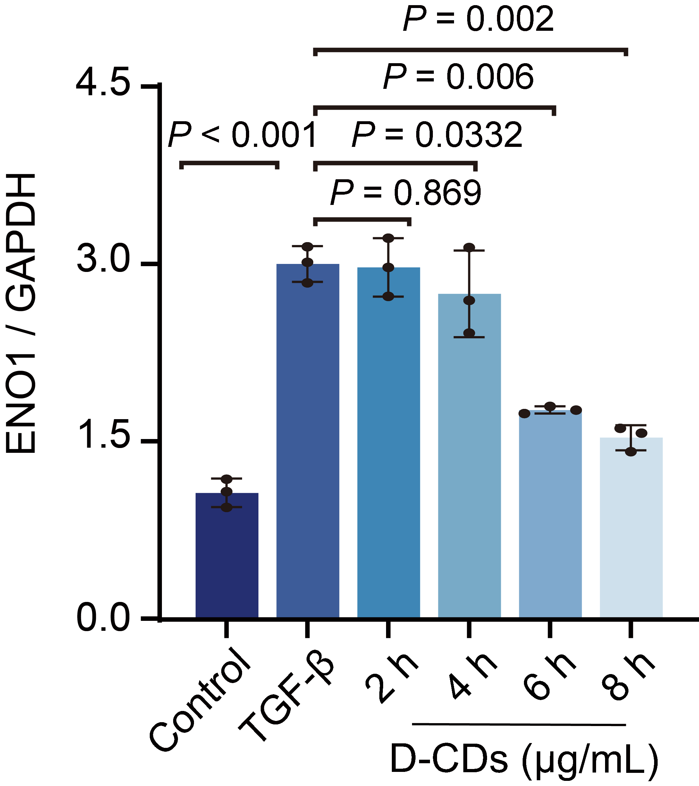
Figure S11. Quantitative analysis of ENO1 protein levels at different time points in TGF-β-induced LX-2 cells treated with 400 μg/mL D-CDs. P values were determined by unpaired Student's t-test. Data represent mean ± SD (n=3).
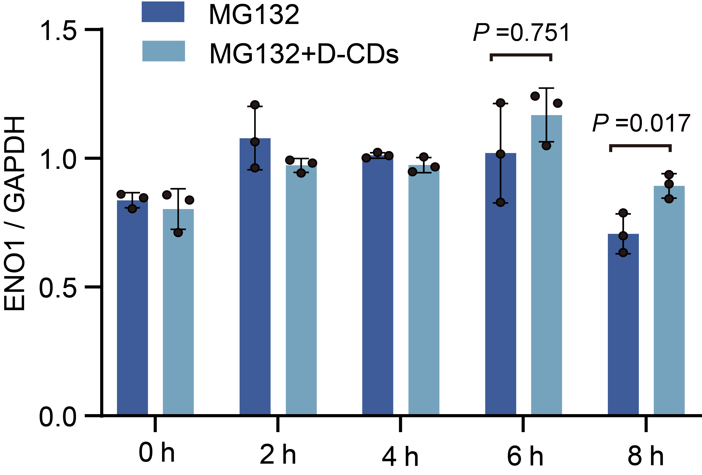
Figure S12. Quantitative analysis of ENO1 expression in LX-2 cells under proteasomal inhibition (MG132) was assessed by Western blot over a time course, with or without D-CDs. P values were determined by unpaired Student's t-test. Data represent mean ± SD (n=3).
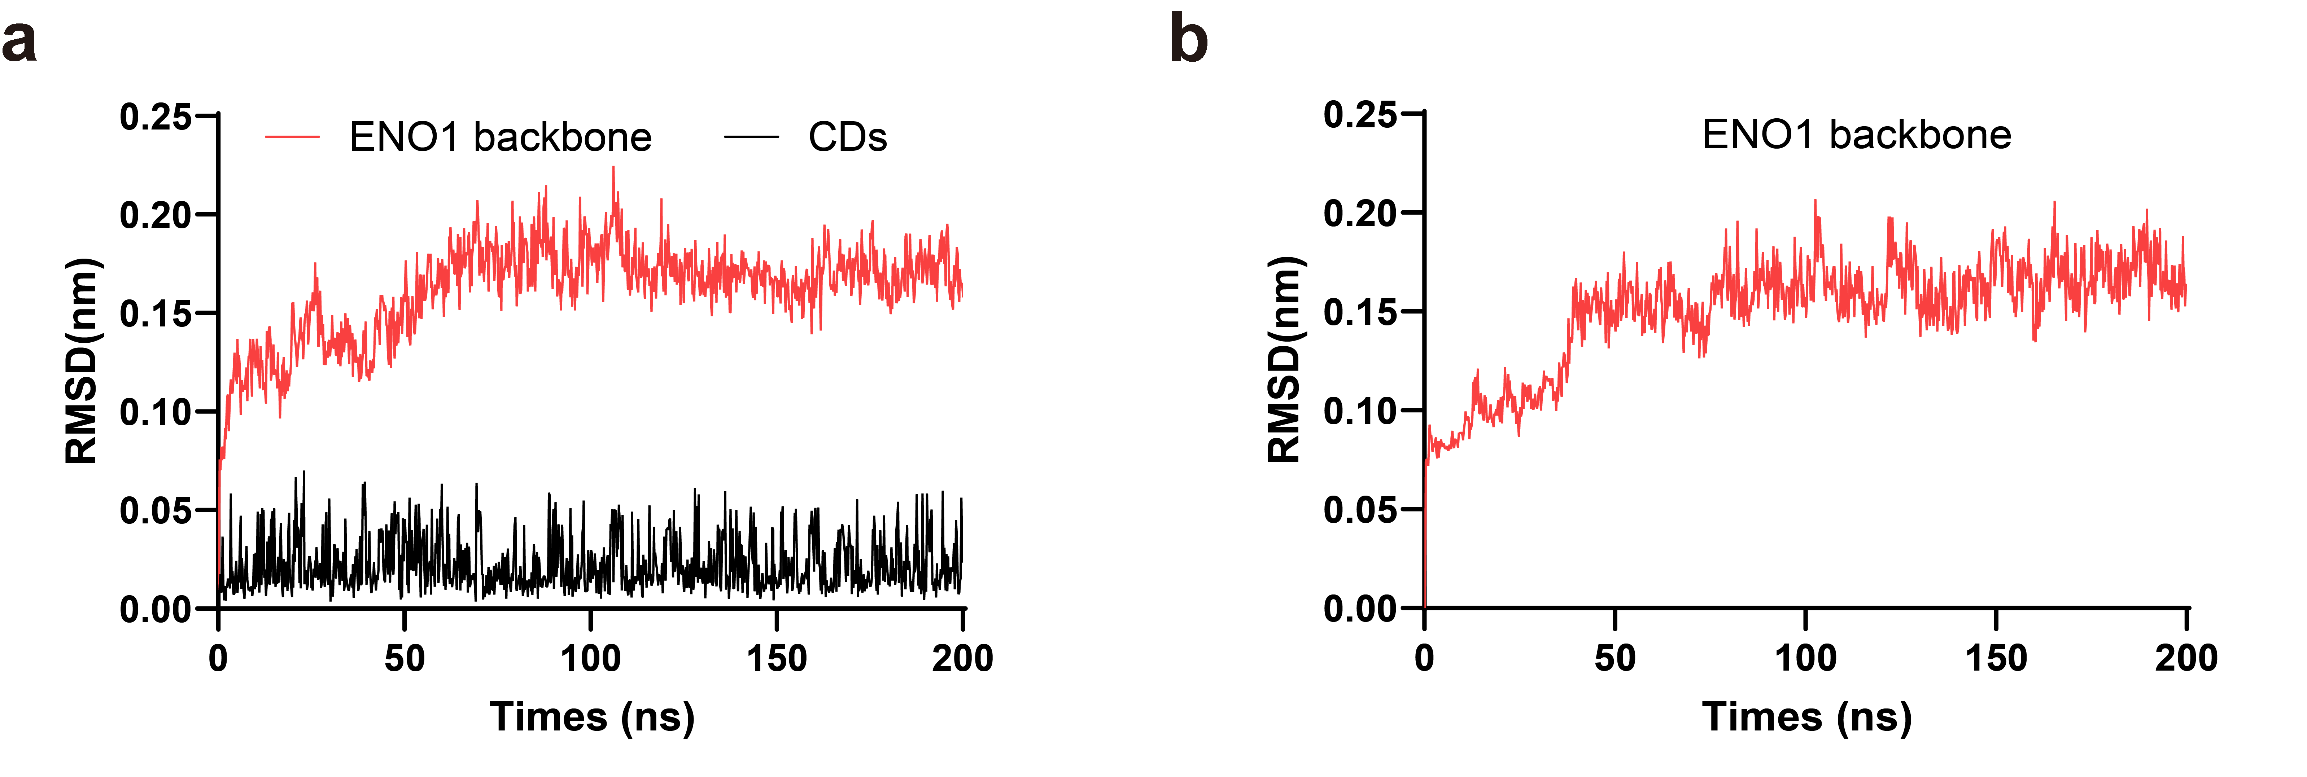
Figure S13. Molecular dynamics simulation stability analysis of the ENO1 and ENO1–CDs complex systems. (a) Simulation results of carbon dot ENO1 protein complex system. (b) Simulation results of ENO1 protein system alone.
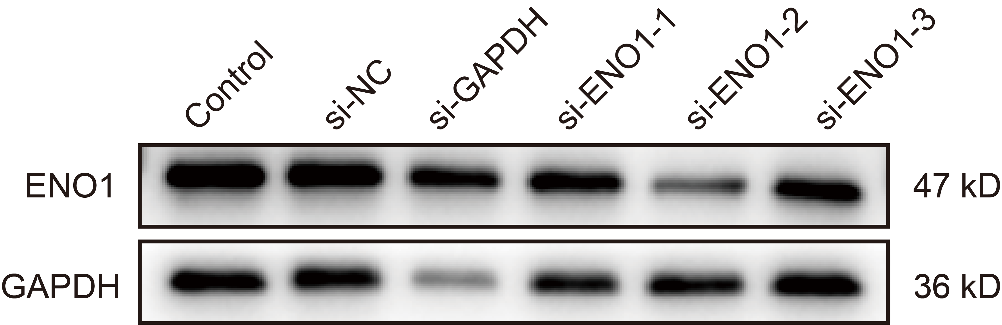
Figure S14. Screening of siRNAs targeting ENO1 and selection of the efficient sequence (si-ENO1-2) for subsequent experiments.

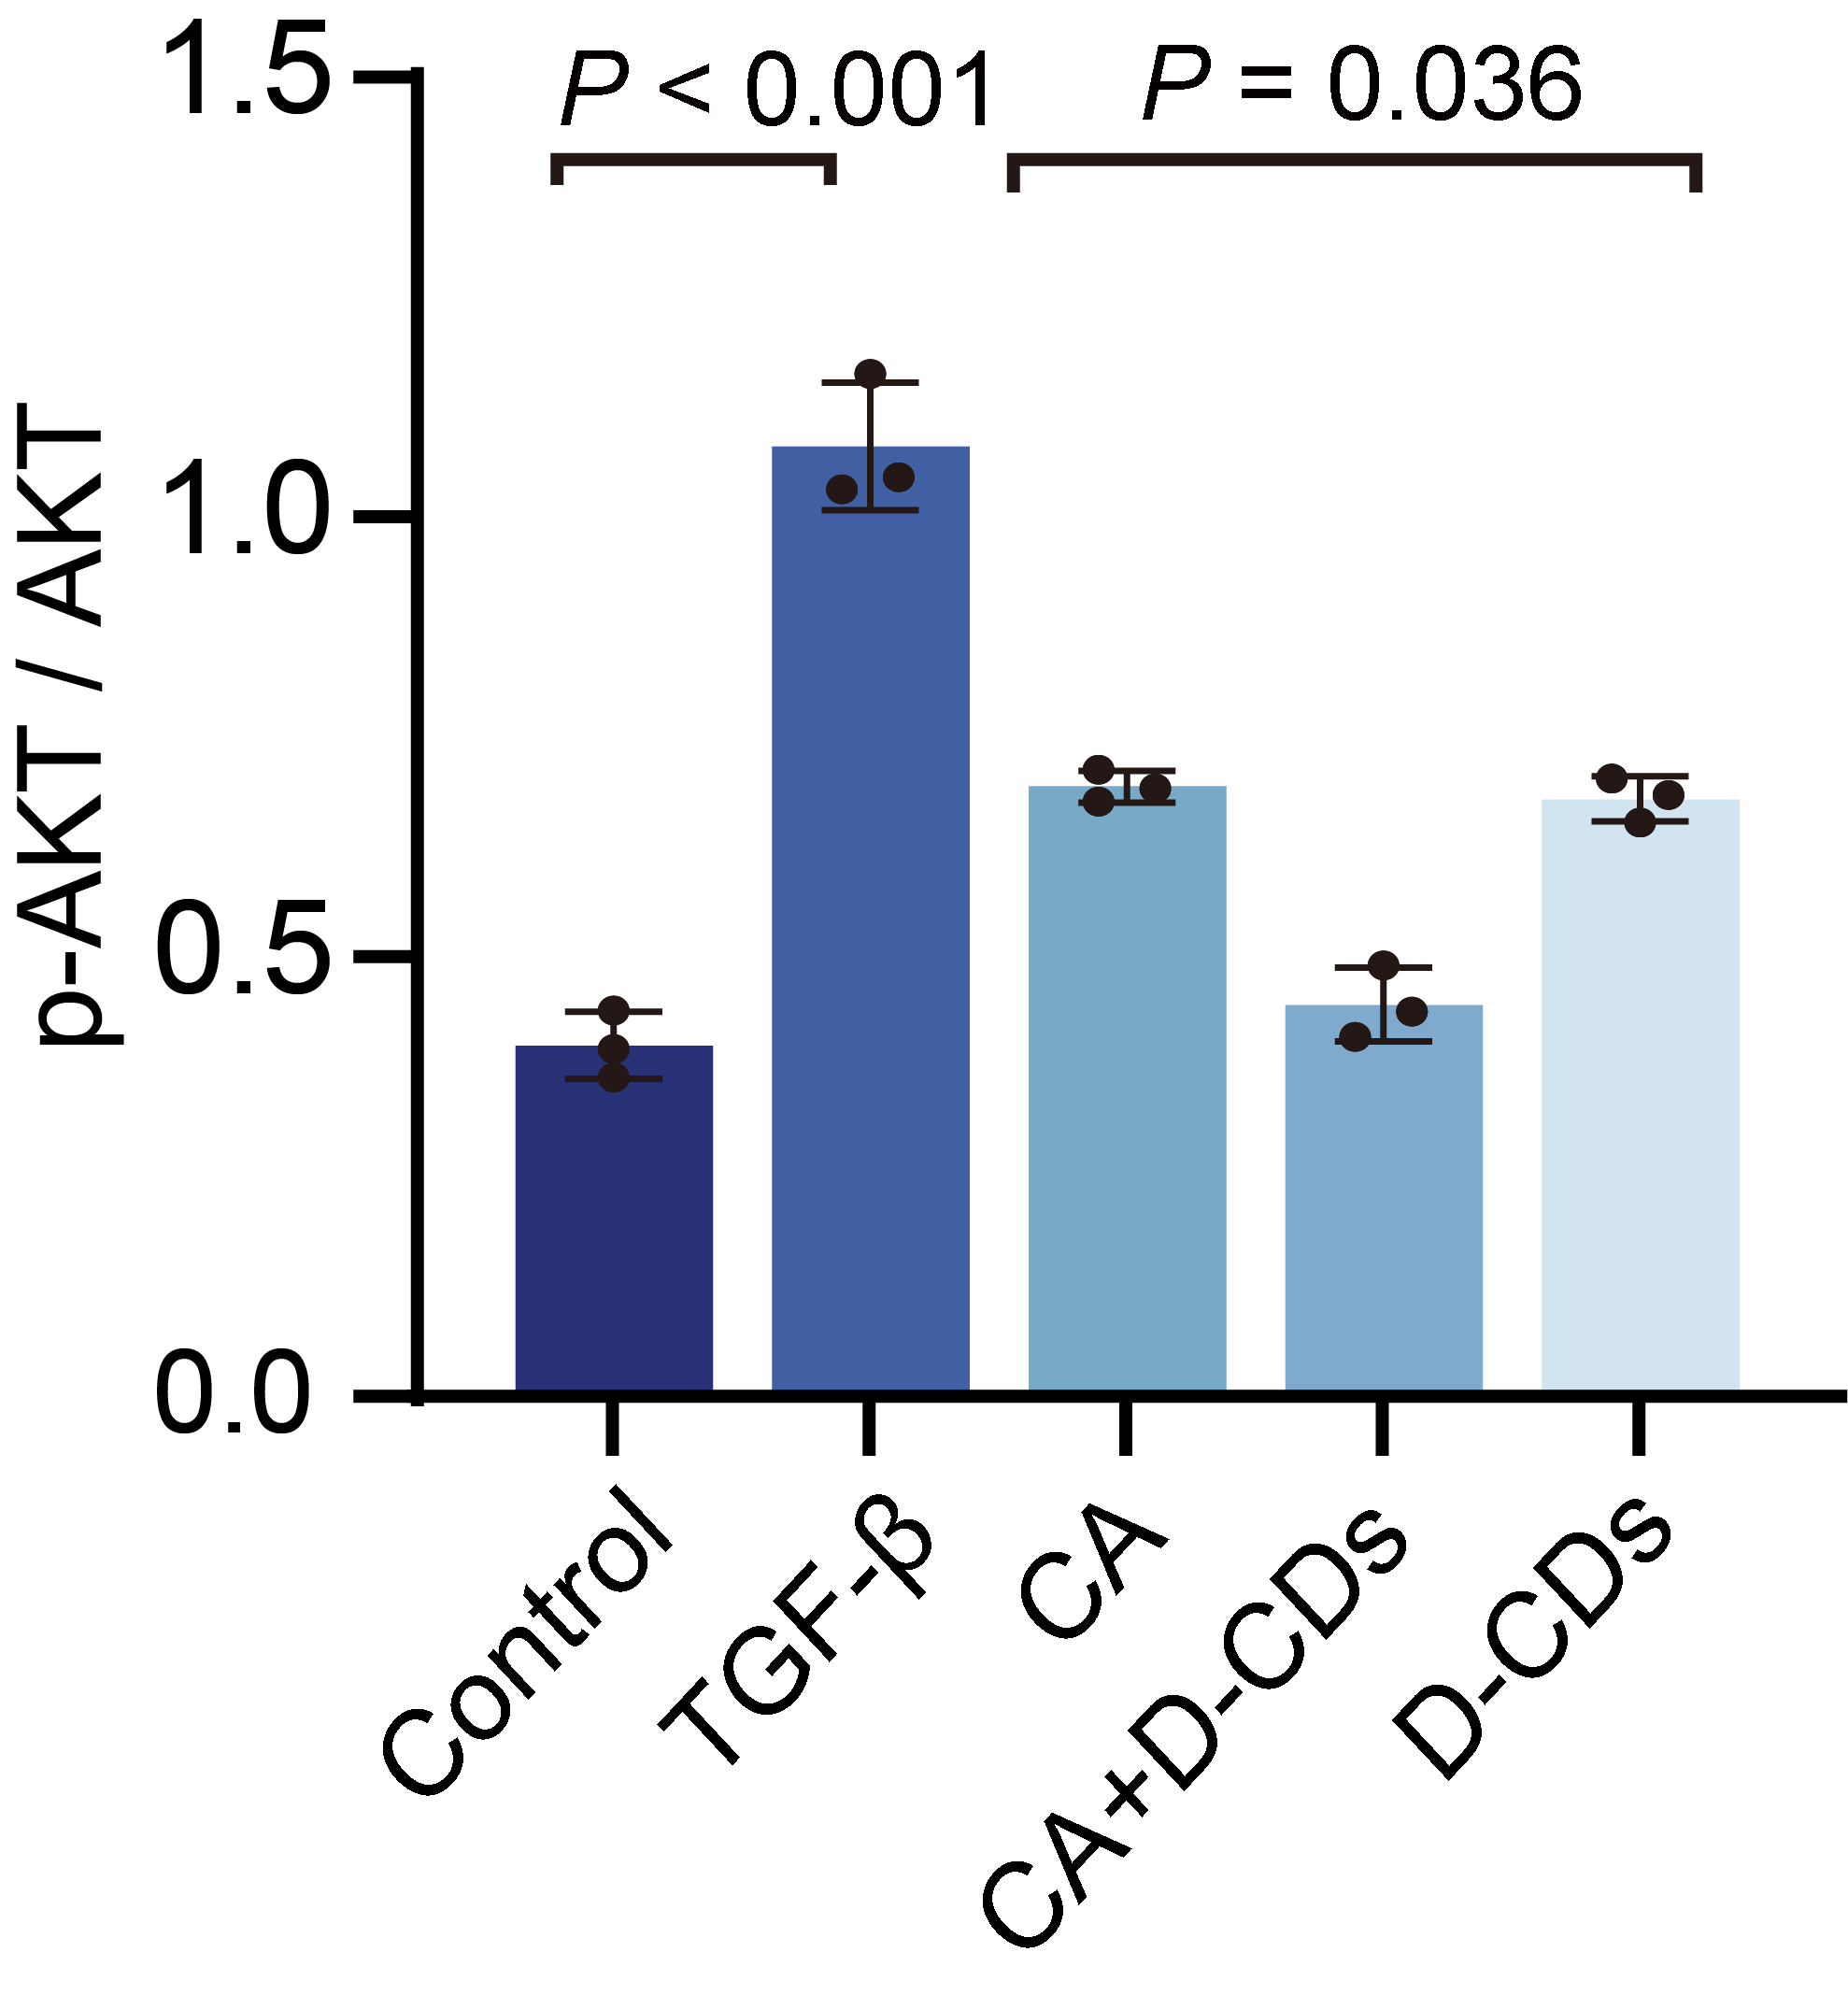
Figure S15. Quantitative analysis of p-AKT/AKT protein expression in LX-2 cells treated with CA, D-CDs, or their combination, assessed by immunoblotting. P values were determined by unpaired Student's t-test. Data represent mean ± SD (n=3).
Figure S16. Cell type annotation, condition distribution, and cell proportion analysis of integrated liver single-cell RNA-seq data. (a) Dot plot showing the expression of canonical marker genes used for the annotation of major liver cell types. (b) UMAP visualization of integrated single-cell data colored by condition (fibrosis and healthy). (c) Comparison of cell-type proportions between fibrotic and healthy liver tissues.
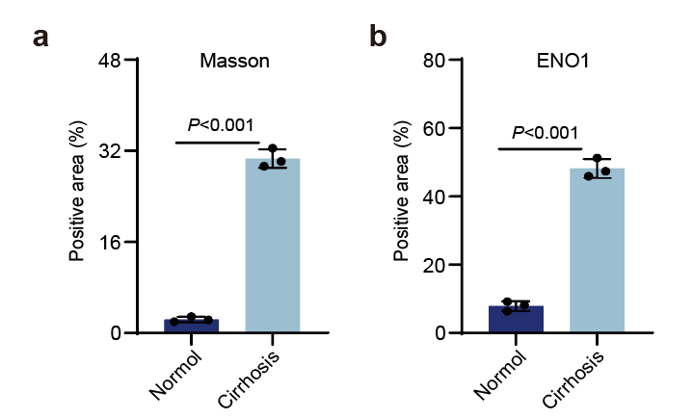
Figure S17. Quantitative histopathological analysis. (a) Quantification of collagen deposition via Masson’s trichrome staining. (b) Semiquantitative scoring of ENO1 immunohistochemistry. P values were determined by unpaired Student's t-test. Data represent mean ± SD (n=3).
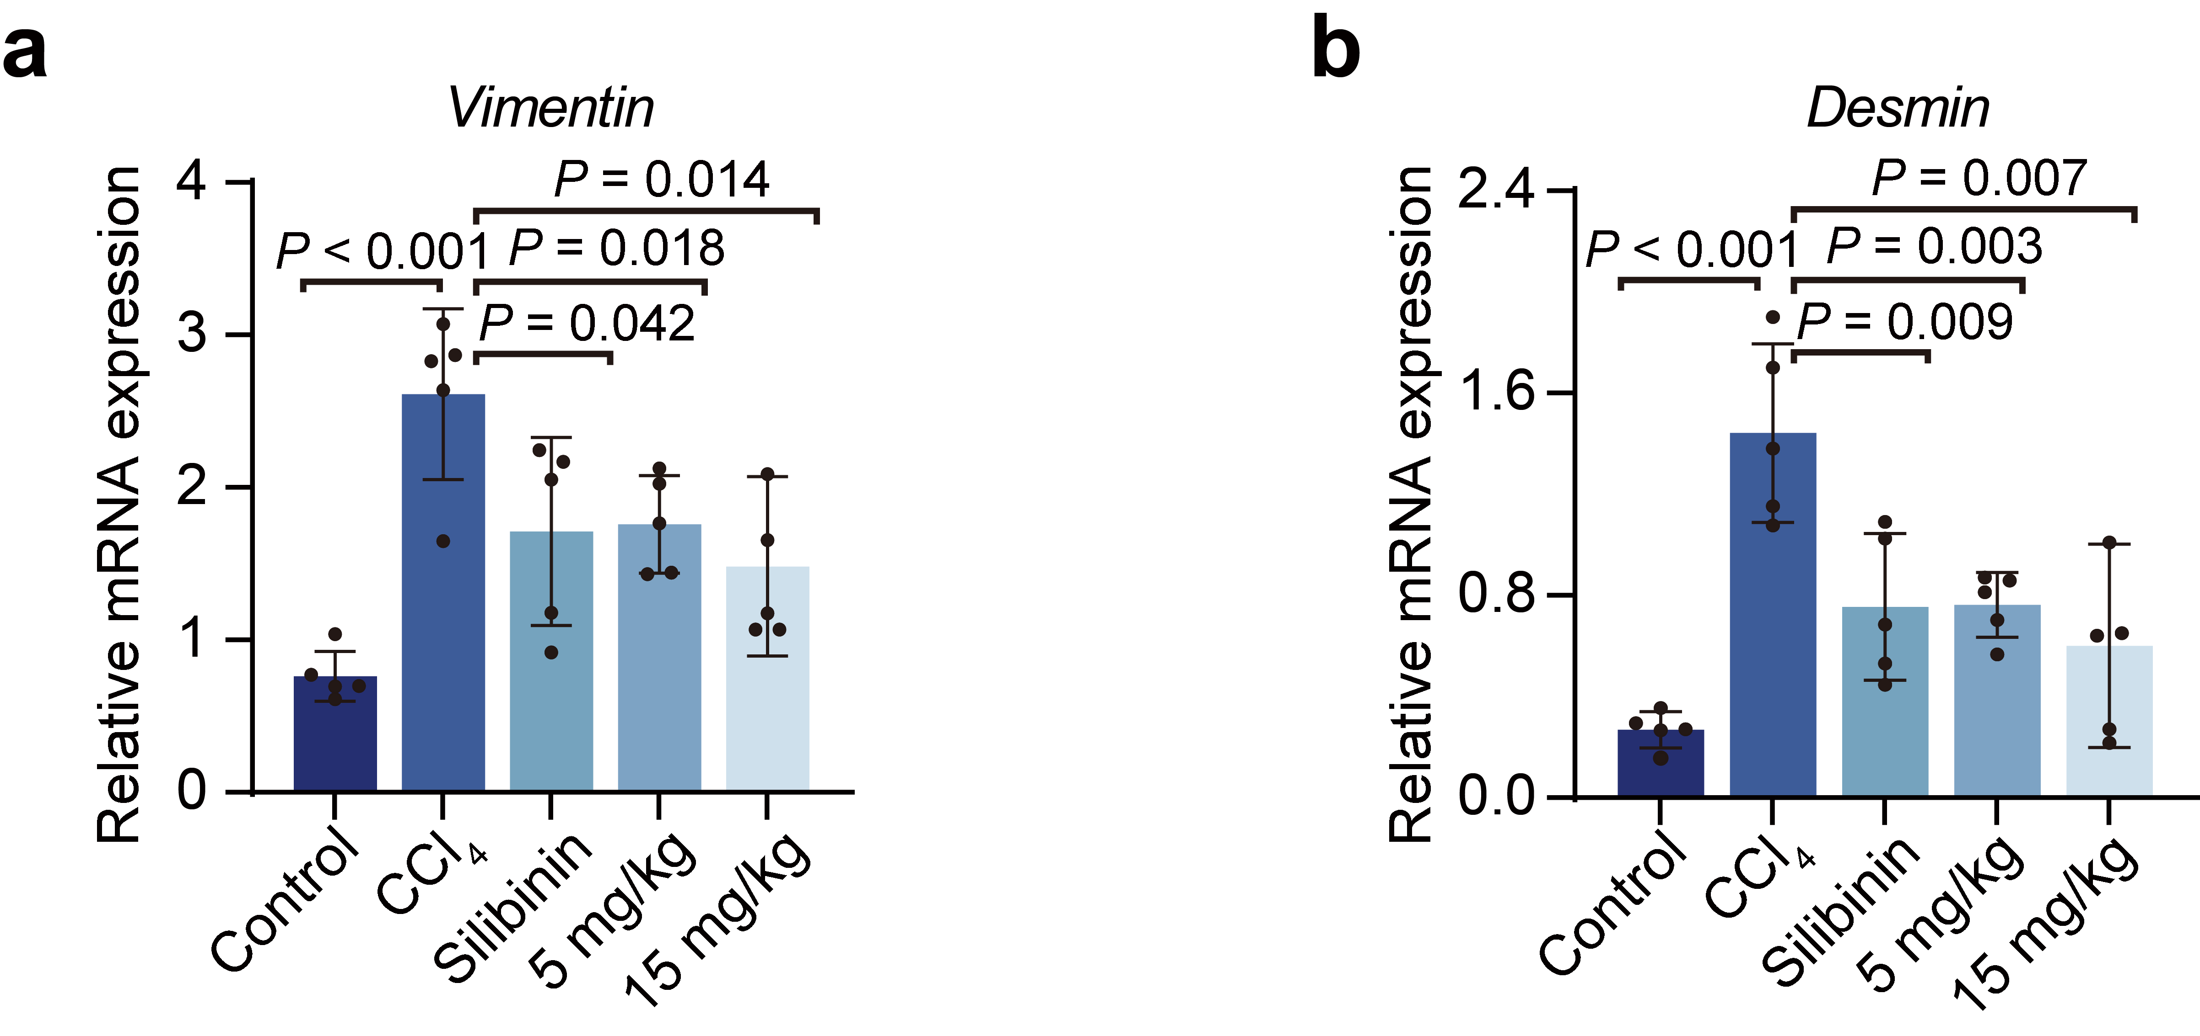
Figure S18. The effect of D-CDs on the mRNA expression of liver fibrotic markers in CCl₄-induced mice. (a-b) Expression of Vimentin and Desmin mRNAs. P values were determined by unpaired Student's t-test. Data represent mean ± SD (n=5).
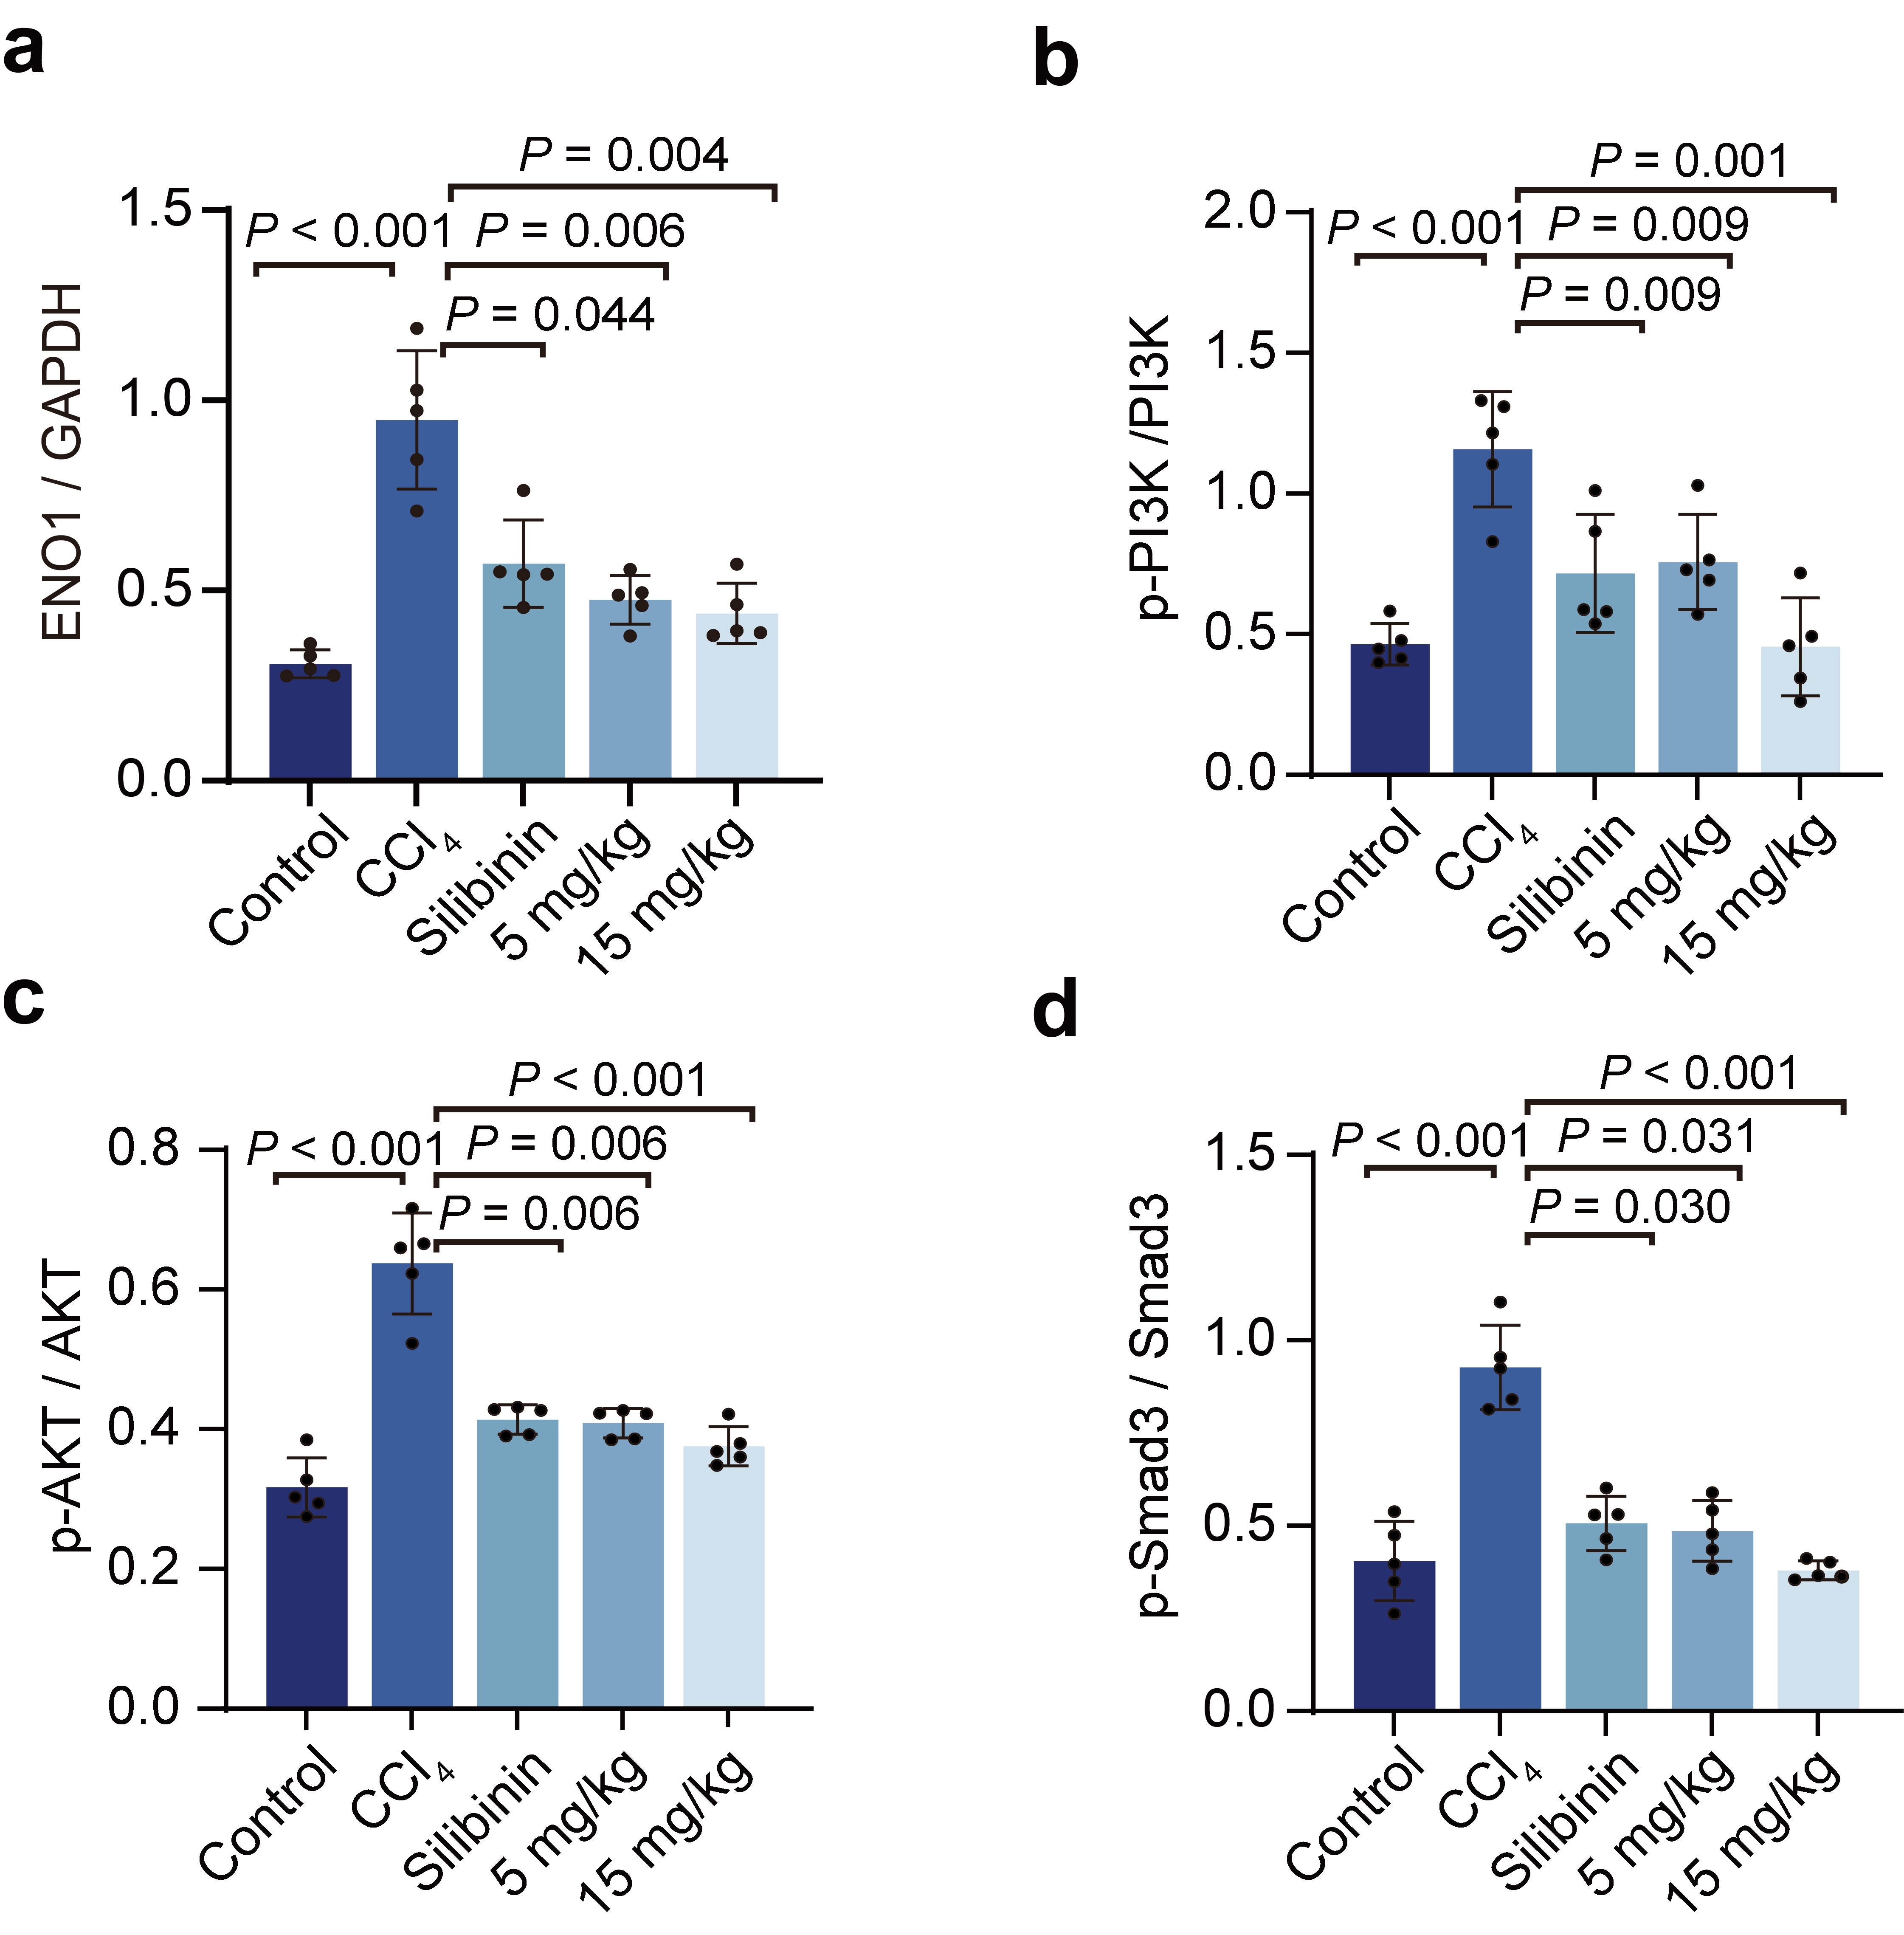
Figure S19. Effects of D-CDs on the expression of liver fibrosis-related proteins in CCl₄-induced mice. (a-d) Quantitative analysis of ENO1, PI3K, AKT, and Smad3 protein expression. P values were determined by unpaired Student's t-test. Data represent mean ± SD (n=5).
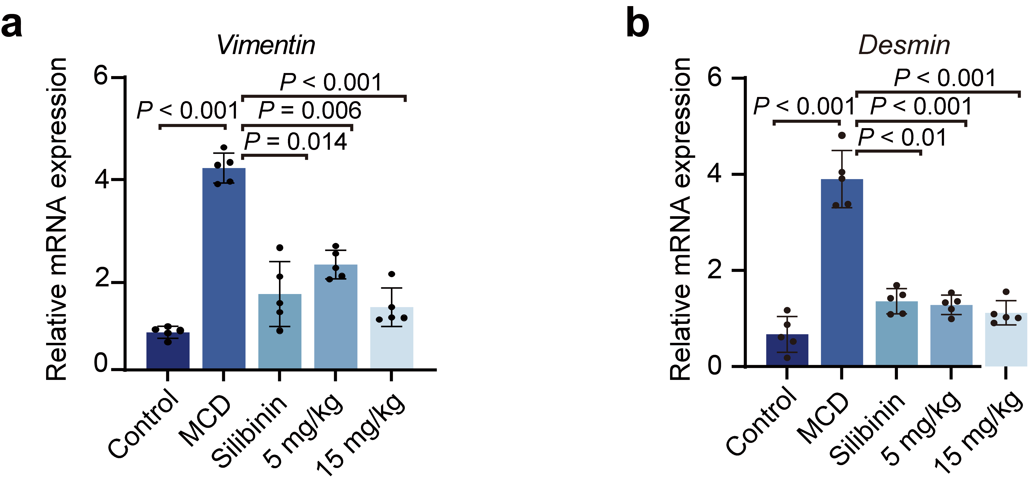
Figure S20. Impact of D-CDs on liver fibrotic gene expression in the MCD diet-induced model of hepatic fibrosis. (a-b) Expression of Vimentin and Desmin mRNAs. P values were determined by unpaired Student's t-test. Data represent mean ± SD (n=5).
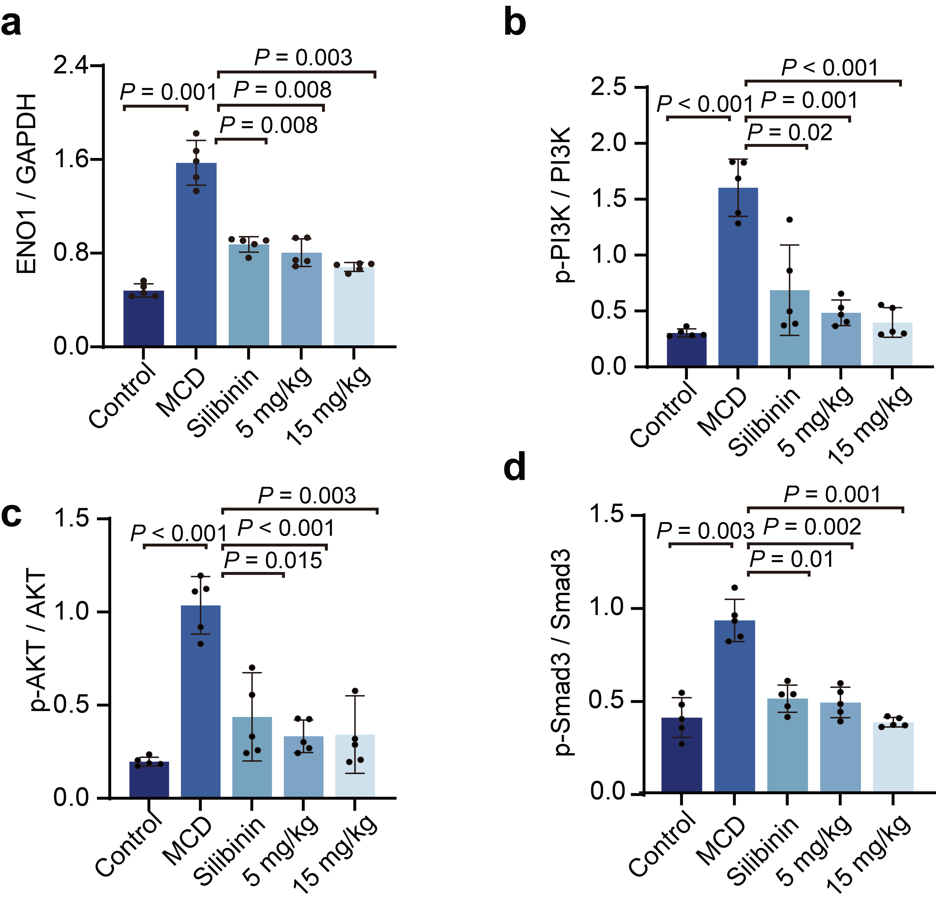
Figure S21. Effects of D-CDs on the expression of liver fibrosis-related proteins in MCD diet-induced mice. (a-d) Quantitative analysis of ENO1, PI3K, AKT, and Smad3 protein expression. P values were determined by unpaired Student's t-test. Data represent mean ± SD (n=5).
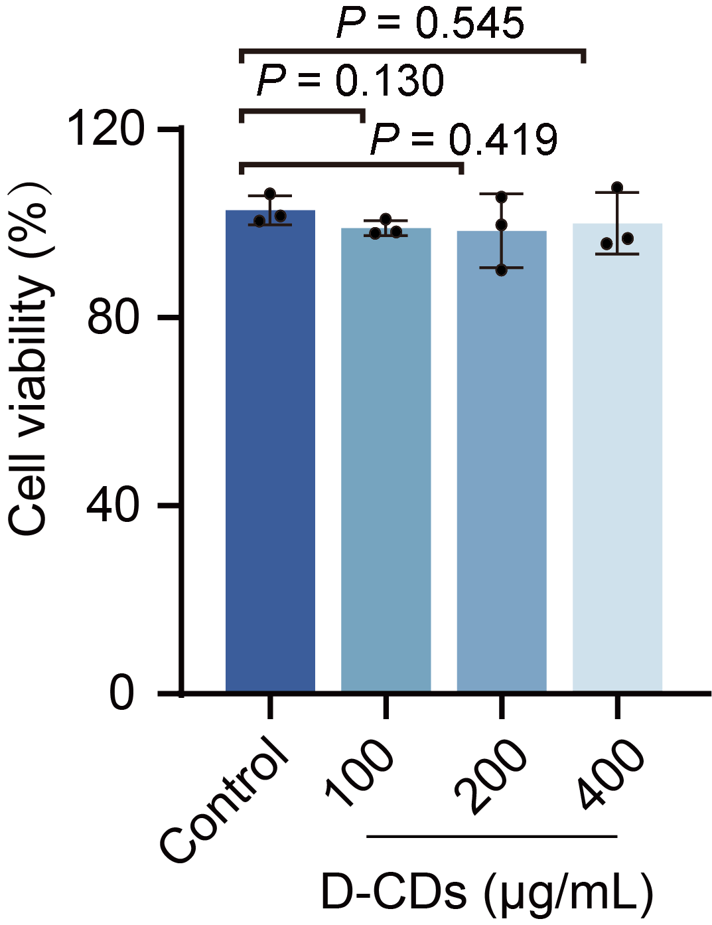
Figure S22. Cytotoxicity evaluation. Cell viability of NCM460 cells after treatment with D-CDs was determined by CCK-8 assay. P values were determined by an unpaired Student's t-test. Data represent mean ± SD (n=3).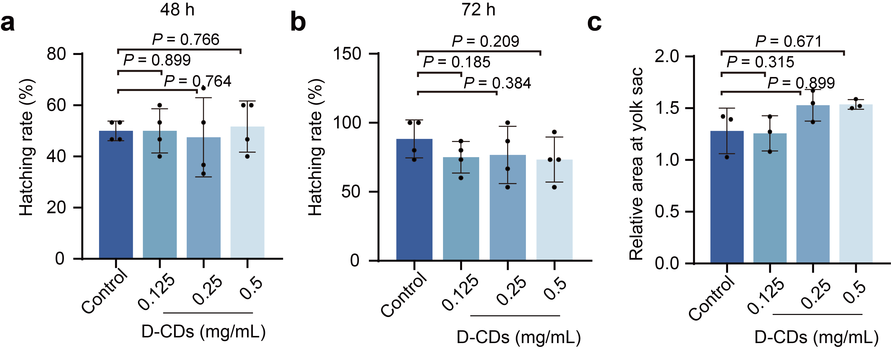
Figure S23. Embryotoxicity assessment of D-CDs in zebrafish. (a) Zebrafish embryonic hatching rate at 48 hours post-fertilization. (b) Hatching rate of zebrafish embryos at 72 hours post-fertilization (hpf). (c) Quantification of yolk sac resorption impairment in zebrafish embryos. P values were determined by an unpaired Student's t-test. Data represent mean ± SD (n=4).
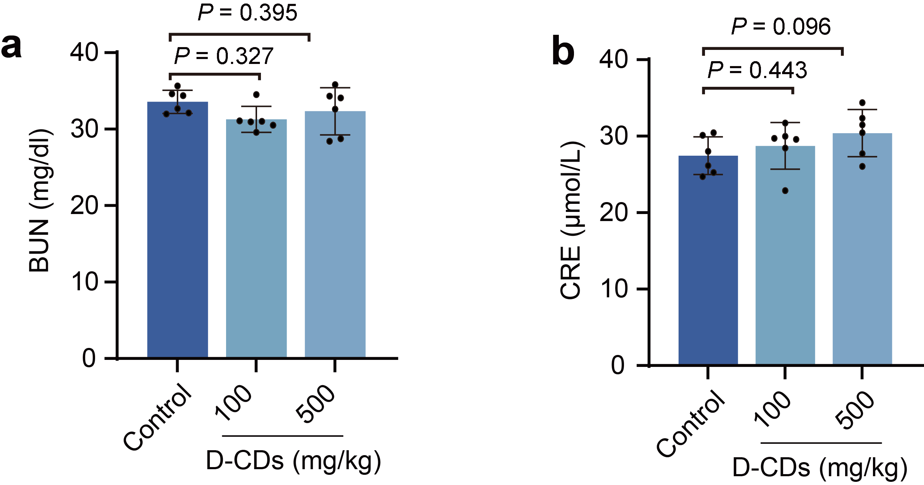
Figure S24. Serum parameters in mice after administration of D-CDs for 7 days. (a) Blood urea nitrogen levels. (b) Serum creatinine level. P values were determined by unpaired Student's t-test. Data represent mean ± SD (n=6).
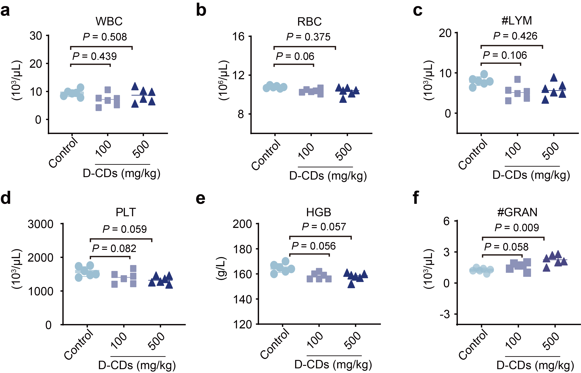
Figure S25. Hematological parameters in mice after administration of D-CDs for 7 days. (a) White blood cells (WBC). (b) Red blood cells (RBC). (c) Lymphocytes (LYM). (d) Platelets (PLT). (e) Hemoglobin (HGB). (f) Granulocytes (GRAN). P values were determined by unpaired Student's t-test. Data represent mean ± SD (n=6).
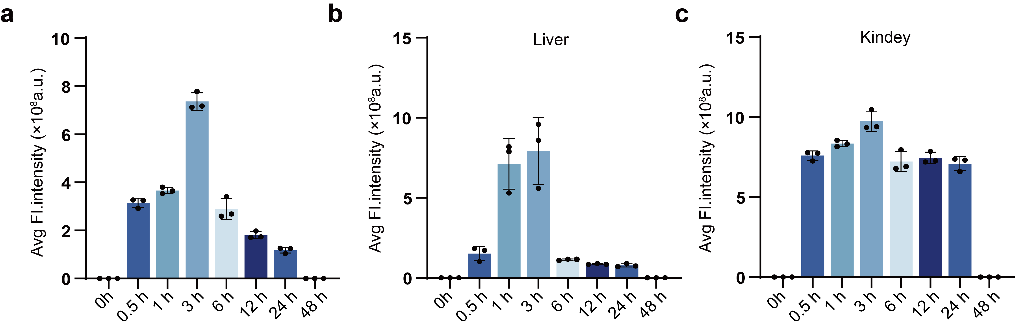
Figure S26. Statistical quantification of the mean fluorescence intensity of D-CDs@Cy5 over a 48-hour time course post intravenous administration. (a-c) Quantitative fluorescence intensity of major regions, including the whole body, liver, and kidneys. P values were determined by unpaired Student's t-test. Data represent mean ± SD (n=3).

