Table 3. Resistance against the wood-destroying fungus Coniophora puteana
in pictures and in terms of weight loss
Sample | Picture of the sample before test | Picture of the sample after test | Weight loss [%]
Forest residue | 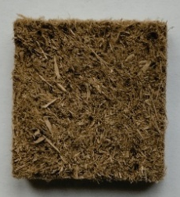 | 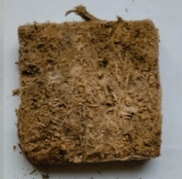 | 48±1
Bark | 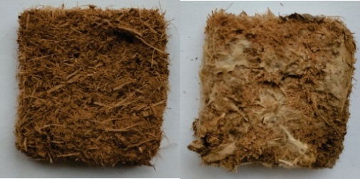 |  | 15±0.9
Saw dust | 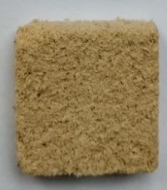 | 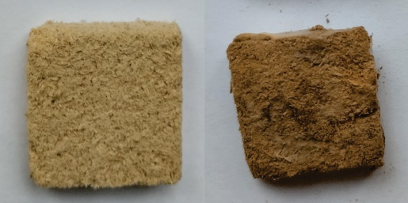 | 53±0.8
Control | 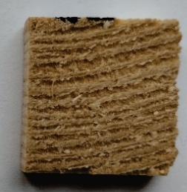 | 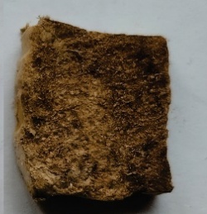 | 57±1.3

