Supplemental Information
Topology-Driven Photoenhanced Gold Recovery in Three-Dimensional Covalent Organic Frameworks
Yunyu Guo^{1,4}, Yuan-Zhe Cheng^{2,4}, Jiaqi Guo^{1,4}, Jiahuan Wang¹, Aowei Lv¹, Jingyang Lin¹, Jiaqi Ma¹, Shuai Fu^{3,*}, Mischa Bonn³, Xuesong Ding^{2,*} & Enquan Jin^{1,*}
¹State Key Laboratory of Inorganic Synthesis and Preparative Chemistry, College of Chemistry and International Center of Future Science, Jilin University, Changchun 130012, China.
²National Center for Nanoscience and Technology, Beijing 100190, China.
³Max Planck Institute for Polymer Research, Mainz 55128, Germany.
⁴These authors contributed equally to this work.
*E-mail: fu01@mpip-mainz.mpg.de; dingxs@nanoctr.cn; cenquanjin@jlu.edu.cn

Contents
1. Supplementary Methods S3
2. Supplementary Figures S4
3. Supplementary Tables S24
4. Supplementary References S32

1. Supplementary Methods
Theoretical calculation methods
All molecular structures were built and optimized using Discovery Studio 2024. The GAFF2 force field parameters for each molecule were generated using the Sobtop program. Molecular dynamics (MD) simulations were performed with GROMACS 2021 package, employing the GAFF2 force field throughout. Each system was solvated in a cubic box with TIP3P water molecules, and Na⁺/Cl⁻ counterions were added to neutralize the total charge of the system.
The initial conformations were first subjected to energy minimization for eliminating unfavorable steric contacts prior to production runs. Subsequently, a 100 ps NVT (constant number of particles, volume, and temperature) equilibration was performed for gradually heating the system towards the target temperature. The system was further equilibrated for 100 ps under NPT conditions (constant number of particles, pressure, and temperature) to allow the density to reach the equilibrium value at the target pressure. After the system was fully relaxed through the equilibration procedures, production molecular dynamics simulations were carried out. The equations of motion were integrated using the leap-frog algorithm with a time step of 1.0 fs (0.001 ps). A total of 100,000,000 integration steps were executed, corresponding to an overall simulation time of 100.0 ns.
Long-range electrostatic interactions were treated with the particle mesh Ewald (PME) method, while long-range van der Waals interactions were corrected using dispersion correction, owing to the use of a cut-off distance. Periodic boundary conditions were applied in all three dimensions. All trajectory analyses were processed with GROMACS built-in tools. Molecular conformations were visualized with PyMOL (http://www.pymol.org/), and all plots were generated using the Matplotlib library in Python.

2. Supplementary Figures
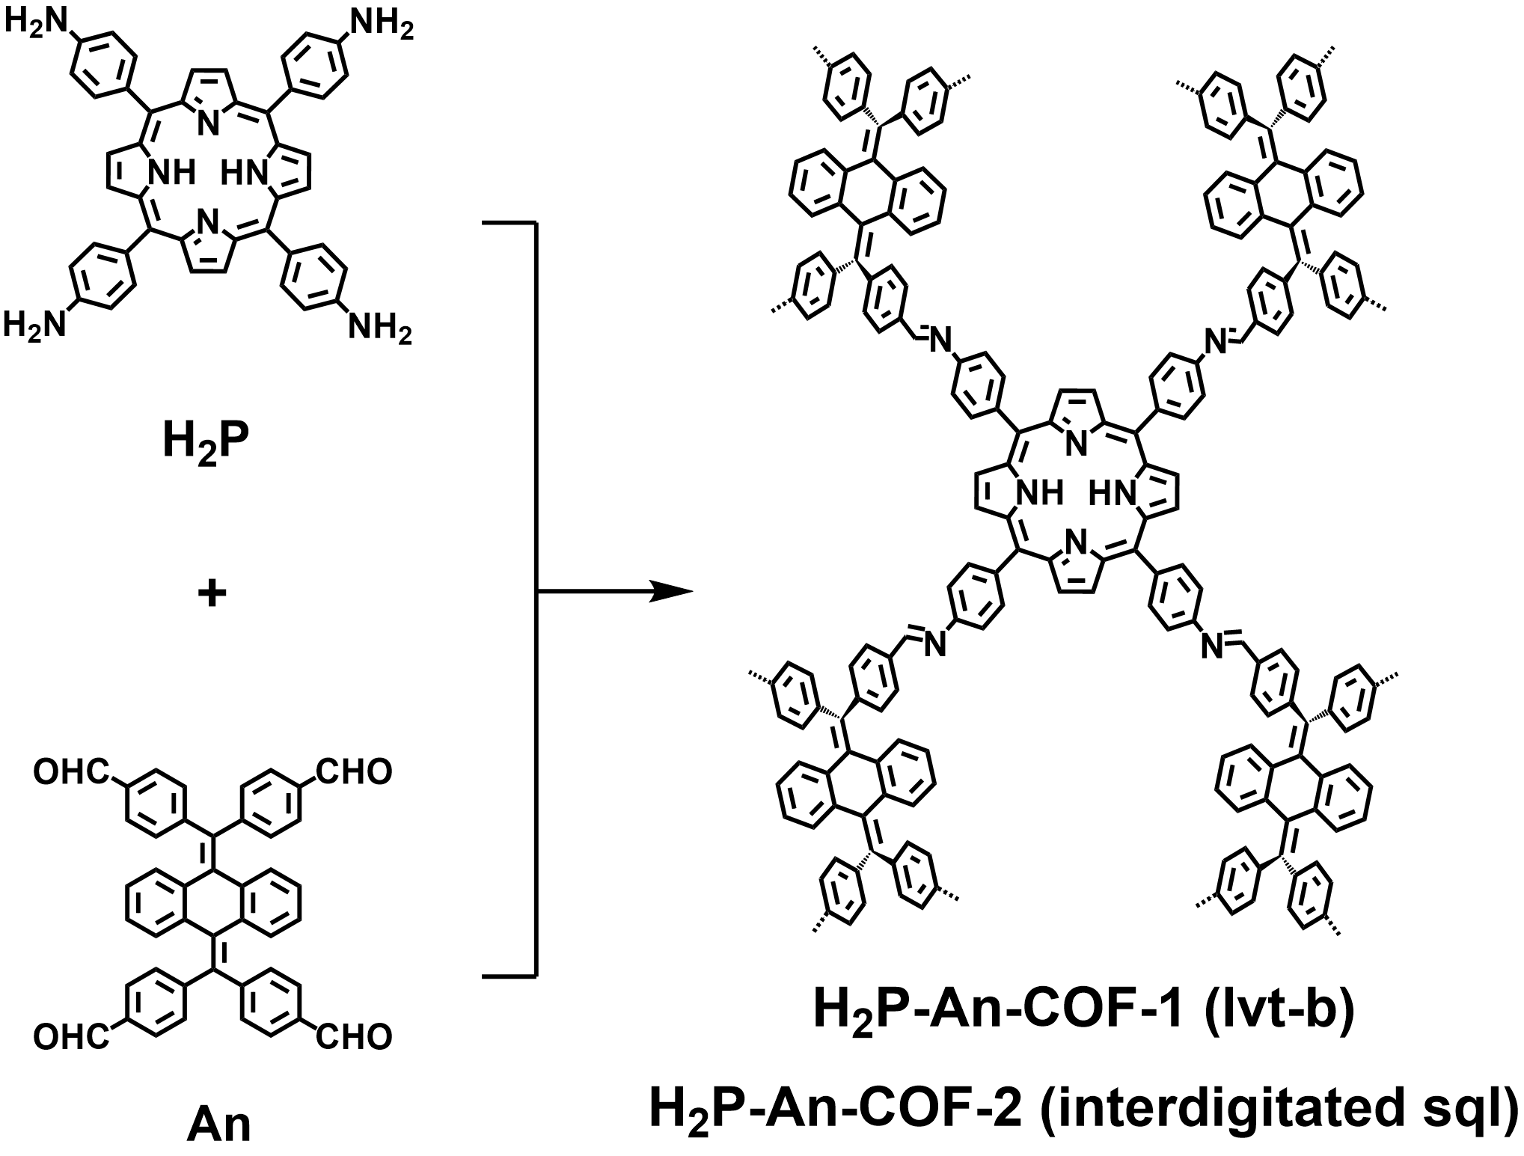
Supplementary Fig. 1 Synthetic route towards H₂P-An-COF-1 and H₂P-An-COF-2.
Supplementary Fig. 2 PXRD pattern of H₂P-An-COF-1.
Supplementary Fig. 3 Simulated PXRD of possible H₂P-An-COF-2 structures.
Supplementary Fig. 4 (a) Nitrogen sorption isotherm curve of H₂P-An-COF-1 (solid dots for adsorption and open circles for desorption) and (b) pore size distribution profiles of H₂P-An-COF-1.
Supplementary Fig. 5 Theoretical nitrogen sorption isotherms of H₂P-An-COF-2.
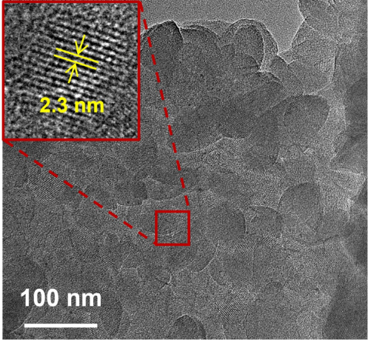
Supplementary Fig. 6 HR-TEM image of H₂P-An-COF-1 with a pore size of 2.3 nm.
Supplementary Fig. 7 FT-IR spectra of H₂P-An-COF-1, An, and H₂P.
Supplementary Fig. 8 Solid-state ¹³C NMR spectrum of H₂P-An-COF-1.
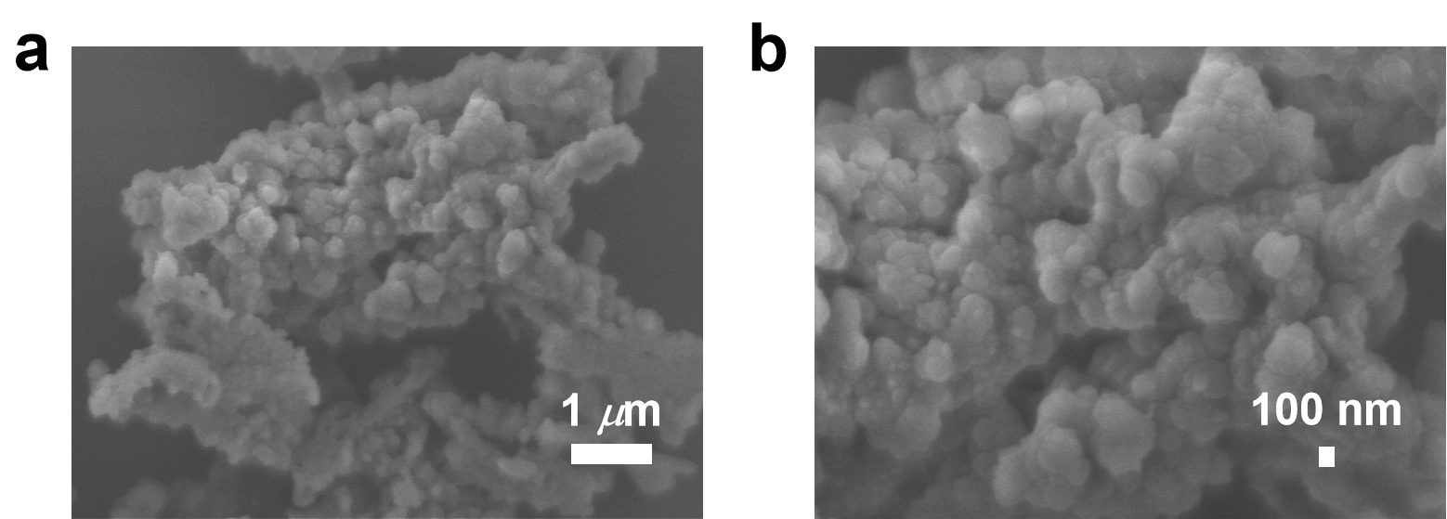
Supplementary Fig. 9 FE-SEM images of H₂P-An-COF-1.
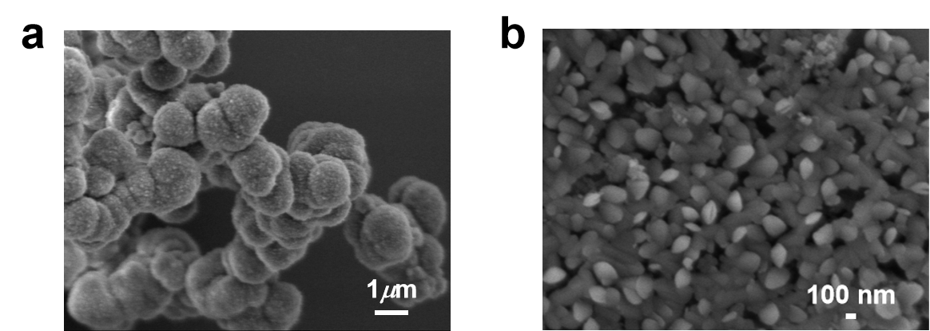
Supplementary Fig. 10 FE-SEM images of H₂P-An-COF-2.
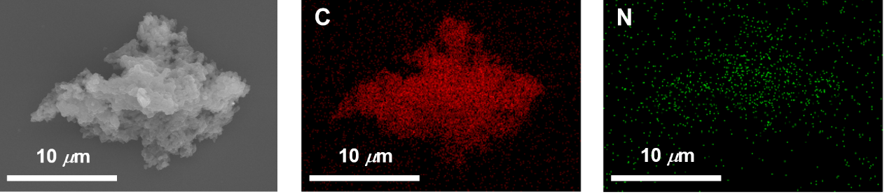
Supplementary Fig. 11 EDS images of H₂P-An-COF-1.
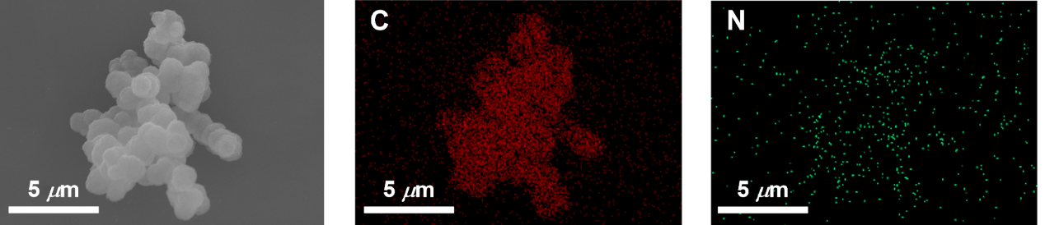
Supplementary Fig. 12 EDS images of H₂P-An-COF-2.
Supplementary Fig. 13 TGA curve of H₂P-An-COF-1.
Supplementary Fig. 14 TGA curve of H₂P-An-COF-2.
Supplementary Fig. 15 PXRD patterns of the transformation from H₂P-An-COF-1 to H₂P-An-COF-2 (a) within five days using varying amounts of aniline and (b) within different time using 100 μL of aniline.
Supplementary Fig. 16 PXRD patterns of the failed transformation from H₂P-An-COF-2 to H₂P-An-COF-1 (a) within five days using varying amounts of aniline and (b) within different time using 100 μL of aniline.
Supplementary Fig. 17 (a) PXRD patterns, (b) nitrogen sorption isotherm curve, (c) FT-IR spectra and (d) residual weights of H₂P-An-COF-1 after soaking in 1,4-dioxane, DCM, toluene, DMF, THF, H₂O, and an aqueous NaOH solution (12 M) for 24 h.
Supplementary Fig. 18 (a) PXRD patterns, (b) nitrogen sorption isotherm curve, (c) FT-IR spectra and (d) residual weights of H₂P-An-COF-2 after soaking in 1,4-dioxane, DCM, toluene, DMF, THF, H₂O, and an aqueous NaOH solution (12 M) for 24 h.

Supplementary Fig. 19 (a) UV-Vis spectra of H₂P (blue curve), An (purple curve), and H₂P-An-COF-1 (red curve). (b) Tauc plot of H₂P-An-COF-1.
Supplementary Fig. 20 Tauc plot of H₂P-An-COF-2.
Supplementary Fig. 21 Mott-Schottky plots of (a) H₂P-An-COF-1 and (b) H₂P-An-COF-2. The flat band potential derived from the intersection with the X-axis was −0.62 V for H₂P-An-COF-1 and −0.69 V for H₂P-An-COF-2 vs Ag/AgCl.
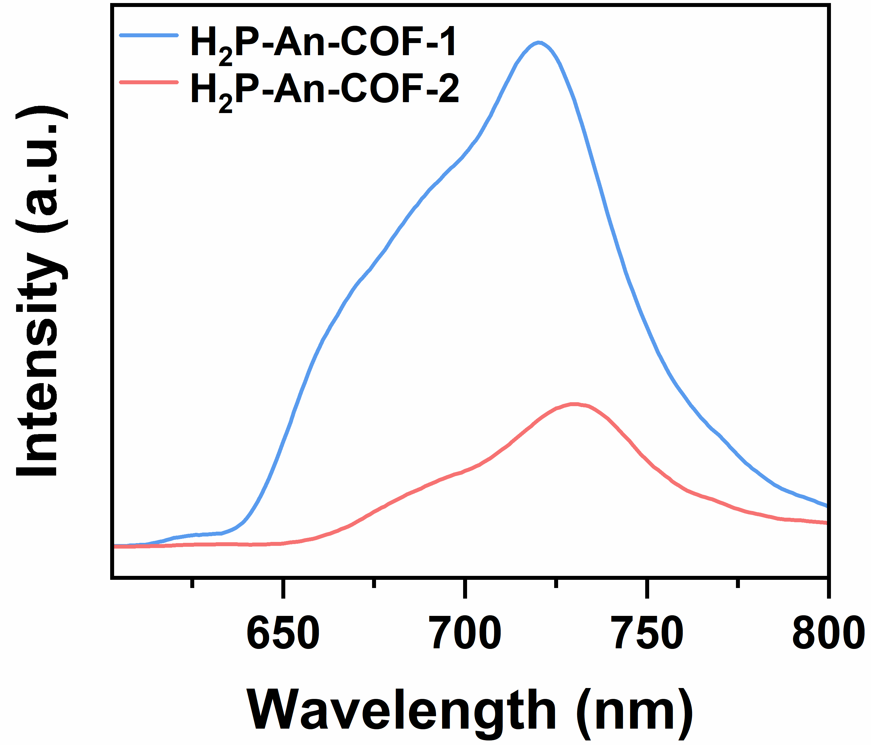
Supplementary Fig. 22 PL spectra of H₂P-An-COF-1 and H₂P-An-COF-2.
Supplementary Fig. 23 Fluorescence decay proﬁle of H₂P-An-COF-1 and H₂P-An-COF-2.
Supplementary Fig. 24 EPR conduction band electron spectra of H₂P-An-COF-1 and H₂P-An-COF-2 under light condition.
Supplementary Fig. 25 Frequency-resolved photoconductivity (Δσ (ω)) of (a) H₂P-An-COF-1 and (b) H₂P-An-COF-2 measured at 0.5 ps after the maximum photoconductivity.
Supplementary Fig. 26 EIS spectra of H₂P-An-COF-1 (blue dots) and of H₂P-An-COF-2 (red dots).
Supplementary Fig. 27 Transient photocurrents of H₂P-An-COF-1 (blue curve) and of H₂P-An-COF-2 (red curve).
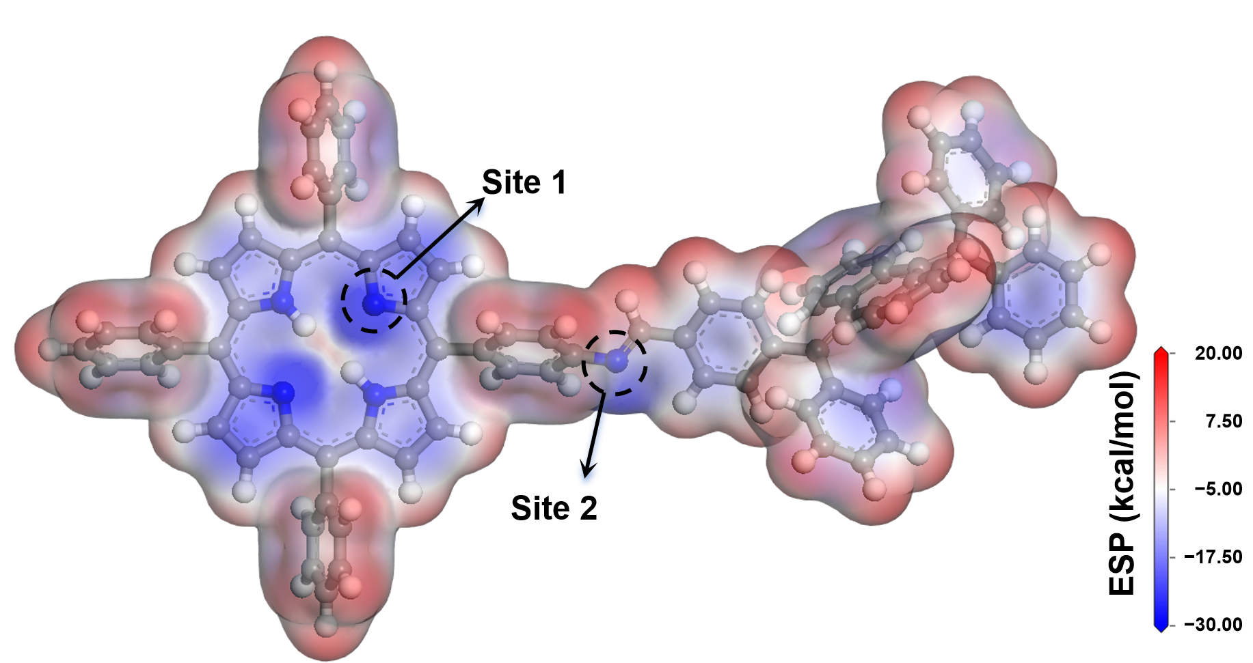
Supplementary Fig. 28 The electrostatic potential (ESP) for H₂P-An-COF-1 and H₂P-An-COF-2.
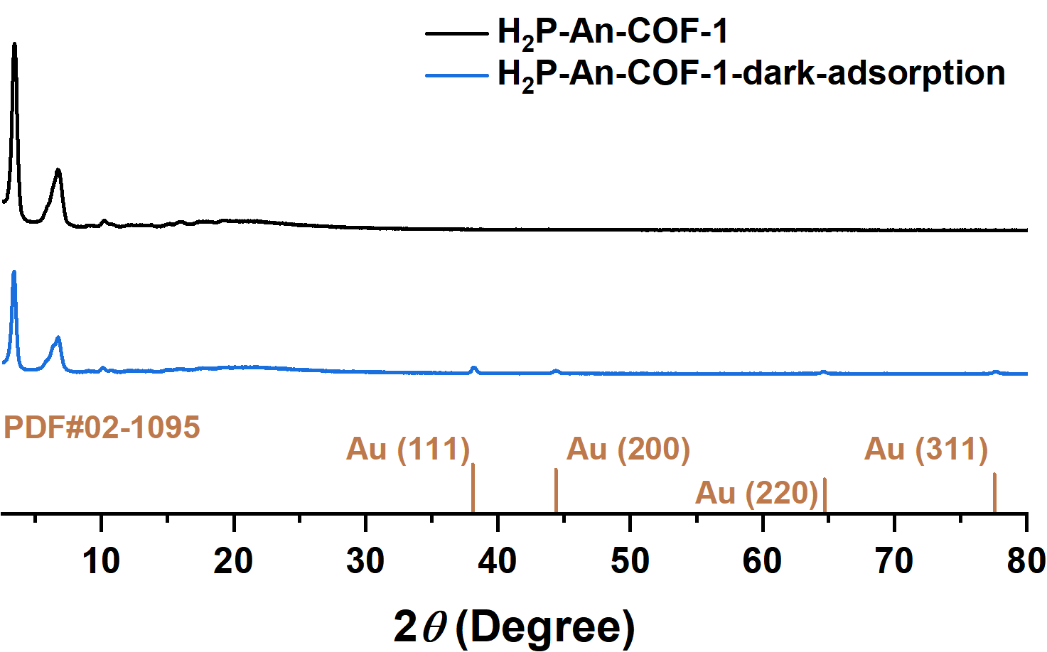
Supplementary Fig. 29 PXRD patterns of H₂P-An-COF-1 after gold desorption under dark conditions compared with the pristine samples.
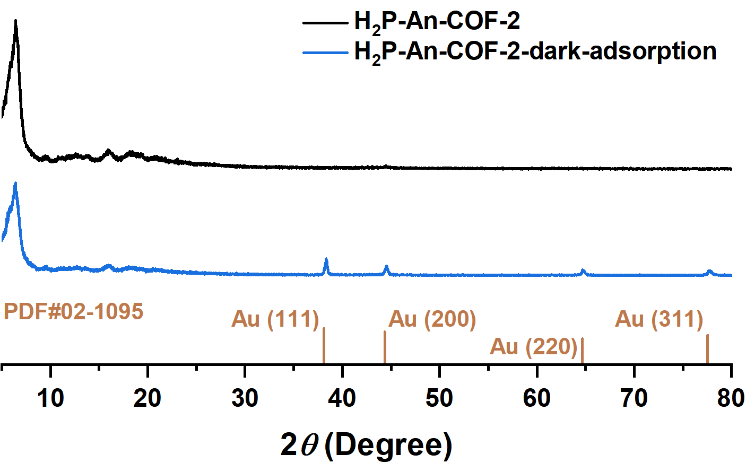
Supplementary Fig. 30 PXRD patterns of H₂P-An-COF-2 after gold desorption under dark conditions compared with the pristine samples.
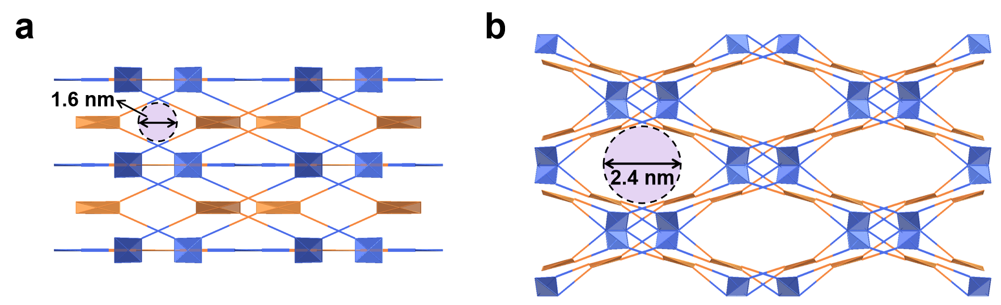
Supplementary Fig. 31 Topological models of (a) H₂P-An-COF-2 and (b) H₂P-An-COF-1.
Supplementary Fig. 32 EPR experiments of •O₂⁻ by DMPO under dark (black curve for on H₂P-An-COF-1 and purple curve for H₂P-An-COF-2) and illumination for 5 min (blue curve for H₂P-An-COF-1 and red curve for H₂P-An-COF-2).
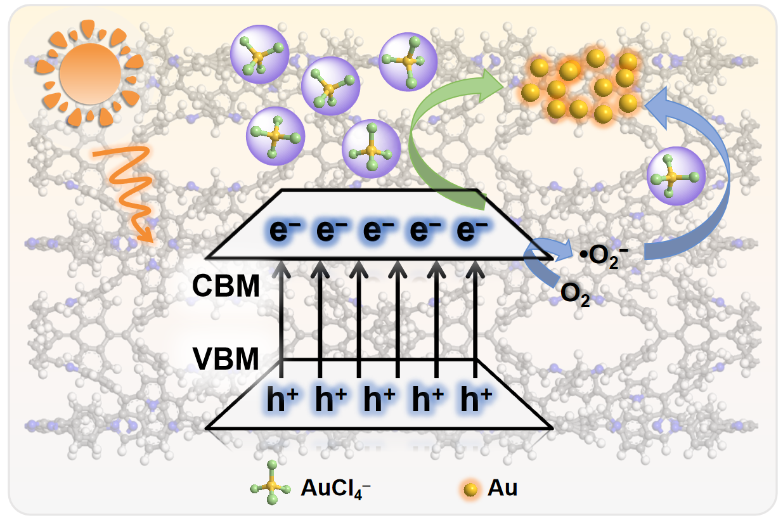
Supplementary Fig. 33 Proposed mechanism diagram of H₂P-An-COFs for gold recovery performance.
Supplementary Fig. 34 Comparison of gold adsorption performance of COF-366, H₂P-An-COF-1, and H₂P-An-COF-2 under dark and light conditions.
Supplementary Fig. 35 Langmuir adsorption models of (a) H₂P-An-COF-1 and (b) H₂P-An-COF-2 under dark and light; Freundlich adsorption models of (c) H₂P-An-COF-1 and (d) H₂P-An-COF-2 under dark and light.
Supplementary Fig. 36 (a) Pseudo-first-order and (b) pseudo-second-order adsorption kinetic plots of AuCl₄⁻ with H₂P-An-COF-2 under dark and light conditions.
Supplementary Fig. 37 (a) Pseudo-first-order and (b) pseudo-second-order adsorption kinetic plots of AuCl₄⁻ with H₂P-An-COF-1 under dark and light conditions.
Supplementary Fig. 38 (a) Calculated MSD of AuCl₄⁻ as a function of the simulation time. (b) Interaction energy between AuCl₄⁻ and protonated porphyrin nitrogen atoms.
Supplementary Fig. 39 Zeta potentials of H₂P-An-COF-1 (blue curve) and H₂P-An-COF-2 (red curve) with different pH values.
Supplementary Fig. 40 Comparison of the removal efficiencies of (a) H₂P-An-COF-1 and (b) H₂P-An-COF-2 under dark.
Supplementary Fig. 41 The adsorption selectivity of (a) H₂P-An-COF-1 and (b) H₂P-An-COF-2 for different metal ions in electronic waste leachate under dark.
Supplementary Fig. 42 The cyclic adsorption performance of (a) H₂P-An-COF-1 and (b) H₂P-An-COF-2 under dark.
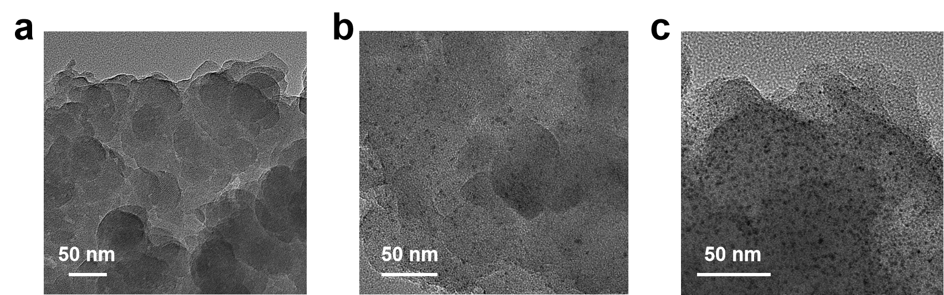
Supplementary Fig. 43 TEM images of H₂P-An-COF-1 (a) before adsorption, (b) after adsorption in the dark, and (c) after adsorption under light.
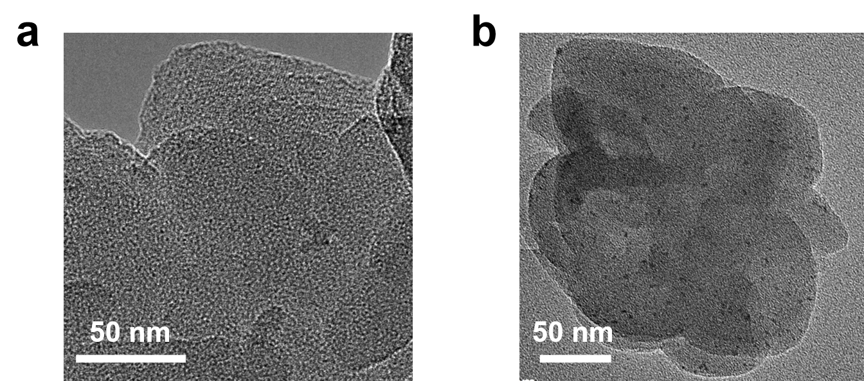
Supplementary Fig. 44 TEM images of H₂P-An-COF-2 (a) before adsorption and (b) after adsorption under dark.
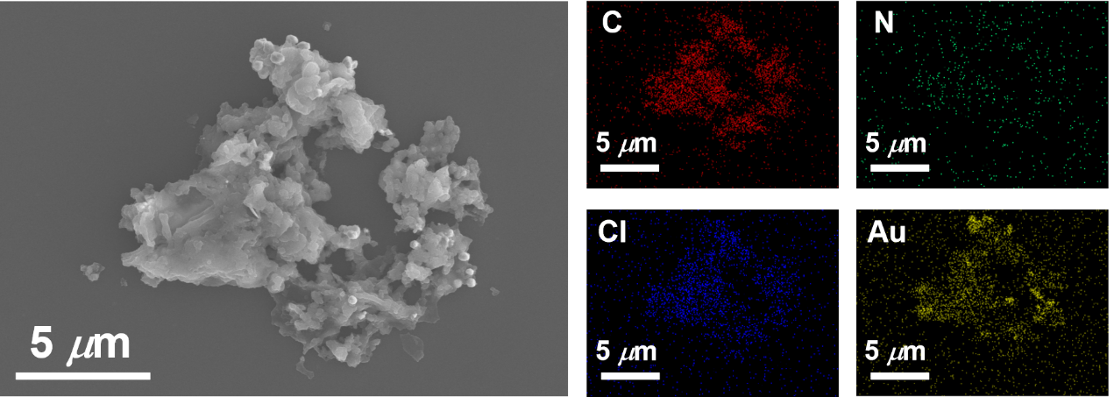
Supplementary Fig. 45 EDS images of H₂P-An-COF-1 after adsorption under dark.
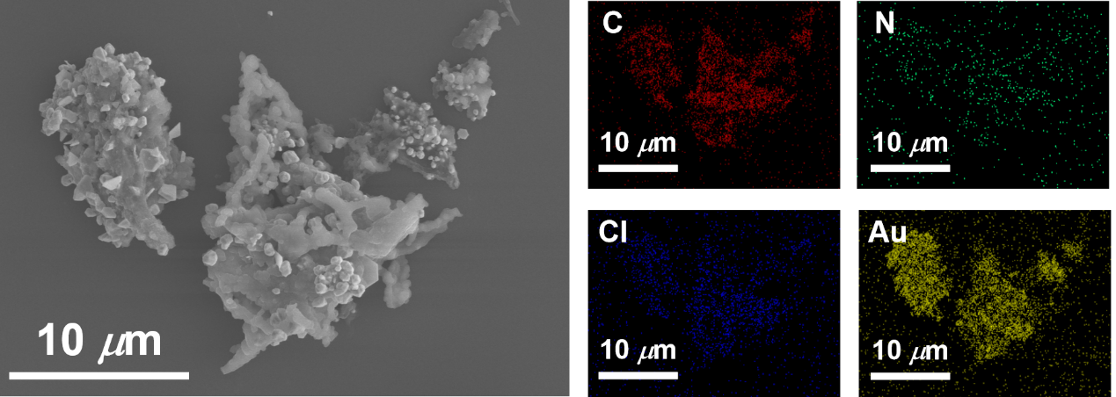
Supplementary Fig. 46 EDS images of H₂P-An-COF-1 after adsorption under light.
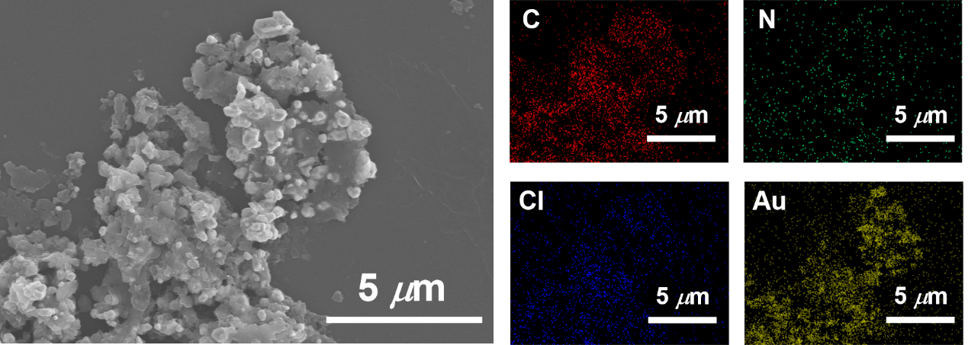
Supplementary Fig. 47 EDS images of H₂P-An-COF-2 after adsorption under dark.
Supplementary Fig. 48 XPS spectra of H₂P-An-COF-1 after adsorption under dark.
Supplementary Fig. 49 XPS spectra of H₂P-An-COF-2 after adsorption under dark.
Supplementary Fig. 50 XPS spectra of H₂P-An-COF-1 after adsorption under light.
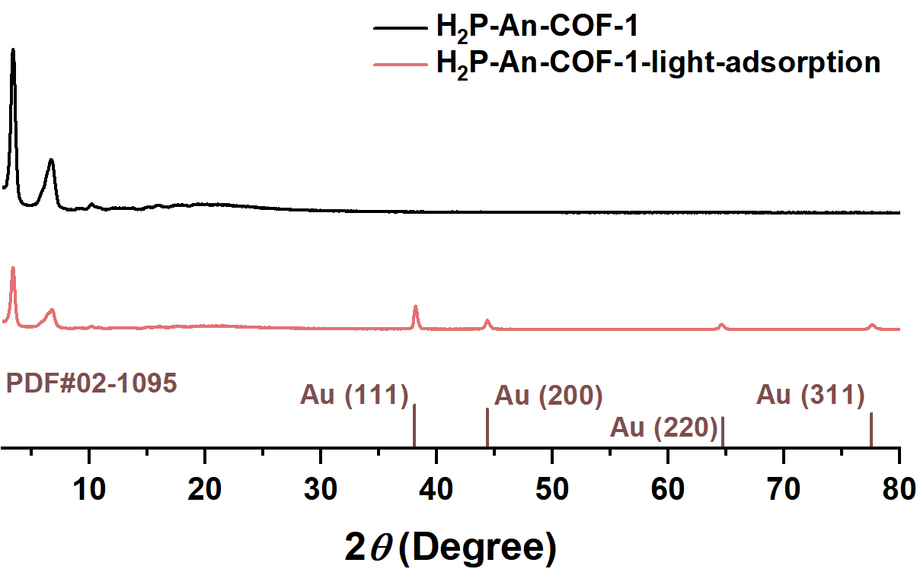
Supplementary Fig. 51 PXRD patterns of H₂P-An-COF-1 before and after gold adsorption under light conditions.
Supplementary Fig. 52 PXRD patterns of H₂P-An-COF-1 before adsorption and after gold desorption under dark and light conditions.
Supplementary Fig. 53 FT-IR spectra before and after gold adsorption, and after desorption of H₂P-An-COF-1.

3. Supplementary Tables
Supplementary Table 1. Absorption comparison of H₂P-An-COF-1 and H₂P-An-COF-2 with other reported materials towards gold.
COFs | Q_{e} (dark)  mg g⁻¹ | Q_{e} (light)  mg g⁻¹ | Fold Increase | Selectivity | Reference
COF-Py-BTP-NS | 2059 | 4374 | 2.1 | >99.9% | 1
COF-Py-BTP | 1893 | 2845 | 1.5 | / | 1
ECUT-COF-29 | 1759 | 3714 | 2.1 | 99% | 2
H₂P-An-COF-2 | 1164 | 3920 | 3.4 | >99% | this work
H₂P-An-COF-1 | 1189 | 2133 | 1.8 | >99% | this work
TAPP-TB-COF | 853 | 2766 | 3.2 | ~75% | 3
TAPP-TZ-COF | 1100 | 3548 | 3.2 | ~86% | 3
TAPP-TZ-OMe-COF | 1301 | 4109 | 3.2 | >99% | 3
v-2D-COF-Dz | / | 2465 | / | 99.5% | 4
v-2D-COF-Pz | / | 1854 | / | 98.4% | 4
DABI-COF | 3906.5 | 2142.7 | 1.8 | >90% | 5
Tp-BTD-AA | 1706.5 | 3094.6 | 1.8 | ~100% | 6
Pc–POSS–POPs | 862.07 | 1026.87 | 1.2 | 98.88% | 7
TpPa-1/CS aerogel | 1470 (25℃)  1575 (35℃) | 2152 | ~1.5 | 96% | 8

Supplementary Table 2. Fractional atomic coordinates for H₂P-An-COF-2.
Space group | P2 (No.3)
Calculated unit cell | a = 16.9974 Å, b = 31.6956 Å, c = 17.3573 Å,  α = γ = 90°, β = 123°
Pawley refinement | R_{p} = 2.44% and R_{wp} = 4.02%
Atoms | x | y | z
C1 | 0.0191 | 0.0342 | 0.1784
C2 | 0.0212 | 0.0213 | 0.2557
C3 | 0.0246 | 0.0755 | 0.1550
C4 | 0.0081 | 0.1250 | 0.0446
C5 | 0.0128 | 0.0847 | 0.0691
C6 | 0.0950 | 0.1457 | 0.2329
C7 | 0.0878 | 0.1844 | 0.2675
C8 | 0.0196 | 0.1903 | 0.2877
C9 | -0.0378 | 0.1560 | 0.2770
C10 | -0.0316 | 0.1174 | 0.2406
C11 | 0.0336 | 0.1120 | 0.2159
C12 | 0.0594 | 0.2635 | 0.3359
N13 | 0.0048 | 0.2307 | 0.3160
C14 | 0.1112 | 0.3341 | 0.4125
C15 | 0.0961 | 0.3704 | 0.4493
C16 | 0.0072 | 0.3784 | 0.4344
C17 | -0.0659 | 0.3492 | 0.3809
C18 | -0.0505 | 0.3127 | 0.3456
C19 | 0.0387 | 0.3043 | 0.3629
C20 | 0.0025 | 0.5226 | 0.5712
C21 | 0.0062 | 0.5432 | 0.6449
C22 | 0.0085 | 0.5216 | 0.7156
C23 | 0.1731 | 0.3671 | 0.0042
C24 | 0.2529 | 0.3545 | 0.0075
C25 | 0.1440 | 0.4082 | -0.0008
C26 | 0.0393 | 0.4586 | -0.0011
C27 | 0.0626 | 0.4180 | -0.0014
C28 | 0.1652 | 0.4674 | -0.0830
C29 | 0.2048 | 0.5066 | -0.0804
C30 | 0.2808 | 0.5225 | 0.0037
C31 | 0.3200 | 0.4976 | 0.0835
C32 | 0.2802 | 0.4585 | 0.0808
C33 | 0.2011 | 0.4435 | -0.0022
C34 | 0.2854 | 0.5903 | -0.0579
N35 | 0.3165 | 0.5645 | 0.0114
C36 | 0.3104 | 0.6555 | -0.1208
C37 | 0.3572 | 0.6938 | -0.1084
C38 | 0.4193 | 0.7103 | -0.0189
C39 | 0.4292 | 0.6887 | 0.0567
C40 | 0.3821 | 0.6506 | 0.0441
C41 | 0.3253 | 0.6330 | -0.0445
C42 | 0.5660 | 0.8527 | -0.0091
C43 | 0.6324 | 0.8731 | -0.0207
C44 | 0.6962 | 0.8515 | -0.0321
C45 | 0.8297 | 0.7015 | 0.8131
C46 | 0.7537 | 0.6887 | 0.7273
C47 | 0.8501 | 0.7424 | 0.8462
C48 | 0.9583 | 0.7919 | 0.9586
C49 | 0.9332 | 0.7516 | 0.9336
C50 | 0.7623 | 0.8099 | 0.8250
C51 | 0.7295 | 0.8492 | 0.7823
C52 | 0.7220 | 0.8581 | 0.6993
C53 | 0.7427 | 0.8260 | 0.6572
C54 | 0.7773 | 0.7868 | 0.7010
C55 | 0.7895 | 0.7787 | 0.7866
C56 | 0.6998 | 0.9330 | 0.7033
N57 | 0.6982 | 0.8996 | 0.6589
C58 | 0.6519 | 1.0074 | 0.7008
C59 | 0.6081 | 0.0450 | 0.6533
C60 | 0.5845 | 0.0521 | 0.5628
C61 | 0.6090 | 0.0213 | 0.5216
C62 | 0.6538 | 0.9816 | 0.5710
C63 | 0.6714 | 0.9749 | 0.6587
C64 | 0.4223 | 0.1928 | 0.4879
C65 | 0.3457 | 0.2133 | 0.4816
C66 | 0.2710 | 0.1912 | 0.4739
C67 | 0.1773 | 0.2983 | 0.0116
C68 | 0.2556 | 0.3110 | 0.0123
C69 | 0.1527 | 0.2572 | 0.0146
C70 | 0.0448 | 0.2068 | 0.0058
C71 | 0.0682 | 0.2474 | 0.0083
C72 | 0.2523 | 0.1927 | 0.0905
C73 | 0.2858 | 0.1536 | 0.0827
C74 | 0.2780 | 0.1426 | 0.0001
C75 | 0.2402 | 0.1720 | -0.0724
C76 | 0.2064 | 0.2110 | -0.0648
C77 | 0.2113 | 0.2216 | 0.0164
C78 | 0.3387 | 0.0718 | 0.0481
N79 | 0.3027 | 0.1014 | -0.0142
C80 | 0.4187 | 0.0018 | 0.0941
C81 | 0.4486 | -0.0326 | 0.0828
C82 | 0.4298 | -0.0502 | 0.0025
C83 | 0.3667 | -0.0235 | -0.0753
C84 | 0.3312 | 0.0159 | -0.0632
C85 | 0.3601 | 0.0299 | 0.0275
C86 | 0.5663 | 0.8074 | -0.0085
C87 | 0.6315 | 0.7864 | -0.0210
C88 | 0.6958 | 0.8078 | -0.0323
C89 | 0.0025 | -0.0347 | 0.1696
C90 | 0.0104 | -0.0221 | 0.2500
C91 | -0.0084 | -0.0758 | 0.1376
C92 | -0.0040 | -0.1253 | 0.0367
C93 | -0.0062 | -0.0850 | 0.0588
C94 | -0.0855 | -0.1426 | 0.1444
C95 | -0.0802 | -0.1813 | 0.1862
C96 | -0.0026 | -0.1903 | 0.2762
C97 | 0.0664 | -0.1590 | 0.3248
C98 | 0.0615 | -0.1204 | 0.2826
C99 | -0.0137 | -0.1120 | 0.1910
C100 | -0.0490 | -0.2624 | 0.2794
N101 | 0.0105 | -0.2313 | 0.3180
C102 | -0.1086 | -0.3304 | 0.2998
C103 | -0.0971 | -0.3672 | 0.3502
C104 | -0.0074 | -0.3788 | 0.4265
C105 | 0.0705 | -0.3531 | 0.4494
C106 | 0.0586 | -0.3162 | 0.3994
C107 | -0.0318 | -0.3039 | 0.3258
C108 | 0.0014 | 0.4770 | 0.5706
C109 | 0.0031 | 0.4563 | 0.6432
C110 | 0.0060 | 0.4779 | 0.7143
C111 | 0.8385 | 0.6327 | 0.8079
C112 | 0.7593 | 0.6452 | 0.7240
C113 | 0.8660 | 0.5915 | 0.8364
C114 | 0.9640 | 0.5415 | 0.9545
C115 | 0.9422 | 0.5820 | 0.9278
C116 | 0.8280 | 0.5388 | 0.7107
C117 | 0.7919 | 0.4991 | 0.6699
C118 | 0.7377 | 0.4758 | 0.6932
C119 | 0.7154 | 0.4939 | 0.7522
C120 | 0.7509 | 0.5333 | 0.7924
C121 | 0.8089 | 0.5558 | 0.7737
C122 | 0.7149 | 0.4122 | 0.6030
N123 | 0.7073 | 0.4332 | 0.6630
C124 | 0.6324 | 0.3539 | 0.4893
C125 | 0.5831 | 0.3155 | 0.4646
C126 | 0.5831 | 0.2903 | 0.5314
C127 | 0.6362 | 0.3037 | 0.6242
C128 | 0.6843 | 0.3423 | 0.6487
C129 | 0.6801 | 0.3683 | 0.5809
C130 | 0.4217 | 0.1475 | 0.4860
C131 | 0.3451 | 0.1261 | 0.4784
C132 | 0.2705 | 0.1475 | 0.4720
N133 | -0.0079 | -0.0002 | 0.8784
N134 | 0.8775 | 0.3327 | -0.0068
N135 | 0.1140 | 0.6672 | 0.1333
H136 | 0.0305 | 0.0455 | 0.3088
H137 | 0.0169 | 0.1512 | 0.0938
H138 | 0.1517 | 0.1409 | 0.2178
H139 | 0.1378 | 0.2113 | 0.2793
H140 | -0.0904 | 0.1592 | 0.2977
H141 | -0.0800 | 0.0901 | 0.2309
H142 | 0.1239 | 0.2603 | 0.3321
H143 | 0.1826 | 0.3286 | 0.4228
H144 | 0.1562 | 0.3938 | 0.4917
H145 | -0.1394 | 0.3551 | 0.3656
H146 | -0.1108 | 0.2896 | 0.3025
H147 | 0.0075 | 0.5791 | 0.6482
H148 | 0.0123 | 0.5397 | 0.7744
H149 | 0.3009 | 0.3791 | 0.0059
H150 | 0.0840 | 0.4850 | -0.0026
H151 | 0.1028 | 0.4547 | -0.1513
H152 | 0.1753 | 0.5255 | -0.1469
H153 | 0.3850 | 0.5091 | 0.1515
H154 | 0.3122 | 0.4386 | 0.1464
H155 | 0.2262 | 0.5795 | -0.1300
H156 | 0.2596 | 0.6424 | -0.1935
H157 | 0.3451 | 0.7118 | -0.1711
H158 | 0.4761 | 0.7023 | 0.1296
H159 | 0.3898 | 0.6338 | 0.1061
H160 | 0.6352 | 0.9091 | -0.0211
H161 | 0.7484 | 0.8697 | -0.0413
H162 | 0.7018 | 0.7130 | 0.6758
H163 | 0.9108 | 0.8184 | 0.9114
H164 | 0.7672 | 0.8028 | 0.8920
H165 | 0.7088 | 0.8743 | 0.8150
H166 | 0.7315 | 0.8316 | 0.5868
H167 | 0.7957 | 0.7613 | 0.6670
H168 | 0.7242 | 0.9293 | 0.7788
H169 | 0.6717 | 1.0035 | 0.7748
H170 | 0.5918 | 0.0700 | 0.6897
H171 | 0.5942 | 0.0269 | 0.4498
H172 | 0.6741 | 0.9564 | 0.5380
H173 | 0.3433 | 0.2492 | 0.4828
H174 | 0.2102 | 0.2091 | 0.4691
H175 | 0.3156 | 0.2931 | 0.0158
H176 | 0.0946 | 0.1809 | 0.0124
H177 | 0.2582 | 0.2014 | 0.1573
H178 | 0.3194 | 0.1306 | 0.1434
H179 | 0.2367 | 0.1643 | -0.1385
H180 | 0.1747 | 0.2344 | -0.1247
H181 | 0.3538 | 0.0787 | 0.1197
H182 | 0.3435 | -0.0333 | -0.1482
H183 | 0.2801 | 0.0357 | -0.1265
H184 | 0.6329 | 0.7505 | -0.0222
H185 | 0.7479 | 0.7897 | -0.0415
H186 | 0.0073 | -0.0466 | 0.2966
H187 | -0.0085 | -0.1519 | 0.0784
H188 | -0.1486 | -0.1354 | 0.0715
H189 | -0.1390 | -0.2056 | 0.1472
H190 | 0.1273 | -0.1647 | 0.3995
H191 | 0.1187 | -0.0956 | 0.3226
H192 | -0.1160 | -0.2570 | 0.2079
H193 | -0.1812 | -0.3217 | 0.2369
H194 | -0.1607 | -0.3879 | 0.3293
H195 | 0.1445 | -0.3622 | 0.5094
H196 | 0.1225 | -0.2960 | 0.4186
H197 | 0.0021 | 0.4204 | 0.6452
H198 | 0.0064 | 0.4599 | 0.7714
H199 | 0.7038 | 0.6273 | 0.6593
H200 | 0.9234 | 0.5150 | 0.9028
H201 | 0.8731 | 0.5575 | 0.6927
H202 | 0.8067 | 0.4858 | 0.6181
H203 | 0.6675 | 0.4764 | 0.7682
H204 | 0.7326 | 0.5473 | 0.8411
H205 | 0.7478 | 0.4273 | 0.5675
H206 | 0.6335 | 0.3735 | 0.4348
H207 | 0.5425 | 0.3043 | 0.3896
H208 | 0.6405 | 0.2830 | 0.6802
H209 | 0.7273 | 0.3528 | 0.7242
H210 | 0.3433 | 0.0902 | 0.4775
H211 | 0.2090 | 0.1294 | 0.4651
H212 | -0.0056 | 0.0052 | 0.9428
H213 | 0.9431 | 0.3382 | -0.0047
H214 | 0.0500 | 0.6726 | 0.0629
H215 | 0.4463 | 0.0083 | 0.1697
H216 | 0.4972 | -0.0495 | 0.1516
C217 | 0.0000 | 0.4063 | 0.5000
C218 | 0.0000 | 0.4529 | 0.5000
C219 | 0.0000 | -0.4068 | 0.5000
C220 | 0.0000 | 0.5467 | 0.5000
C221 | 0.5000 | 0.7377 | 0.0000
C222 | 0.5000 | 0.7836 | 0.0000
C223 | 0.5000 | -0.0771 | 0.0000
C224 | 0.5000 | 0.8767 | 0.0000
C225 | 0.5000 | 0.0787 | 0.5000
C226 | 0.5000 | 0.1242 | 0.5000
C227 | 0.5000 | 0.2626 | 0.5000
C228 | 0.5000 | 0.2166 | 0.5000
N229 | 0.0000 | -0.0586 | 0.0000
N230 | 0.0000 | 0.2736 | 0.0000
N231 | 0.0000 | 0.6084 | 0.0000
N232 | 0.0000 | 0.3916 | 0.0000
N233 | 0.0000 | 0.0585 | 0.0000
N234 | 0.0000 | 0.7251 | 0.0000

4. Supplementary References
1. Chen, Y. et al. Irreversible sulfur cyclization to construct a D–A type covalent organic framework with ultrastability for photoenhanced gold recovery. Nano Lett. 25, 14115–14123 (2025).
2. Huang, Z. et al. Efficient gold recovery by a thiazolyl covalent organic framework. Chem. Commun. 60, 4950 (2024).
3. Zhang, J. et al. Electronic structure tailored covalent organic frameworks for synergistic adsorptive-photocatalytic gold recovery from complex electronic waste. Research 8, 1012 (2025).
4. Yang, Q. et al. Isomeric conjugated covalent organic frameworks with tunable nitrogen topologies for integrated gold adsorption and photoreduction. Angew. Chem. Int. Ed. 64, e202516067 (2025).
5. Chen, S.-M. et al. A one-dimensional covalent organic framework for dual-mode sensing and photocatalytic recovery of gold ions from electronic waste. Sens. Actuators B 455, 139649 (2026).
6. Yang, S. et al. Covalent organic framework isomers for photoenhanced gold recovery from e-waste with high efficiency and selectivity. ACS Sustainable Chem. Eng. 10, 9719–9731 (2022).
7. Ding, R. et al. Highly efficient and selective gold recovery based on hypercross linking and polyamine-functionalized porous organic polymers. ACS Appl. Mater. Interfaces 14, 11803–11812 (2022).
8. Guo, W. et al. Self-floating COF/chitosan aerogel for light-induced enhanced gold recovery. Chem. Eng. J. 525, 169554 (2025).

