Supplement Material for:
An InSAR-GNSS displacement timeseries and velocity field for Aotearoa/New Zealand following the 2016 Kaikōura Earthquake
Ian J Hamling, Sigrun Hreinsdóttir, Tim J Wright, Andy Hooper, Chris Rollins, Karsten Spaans
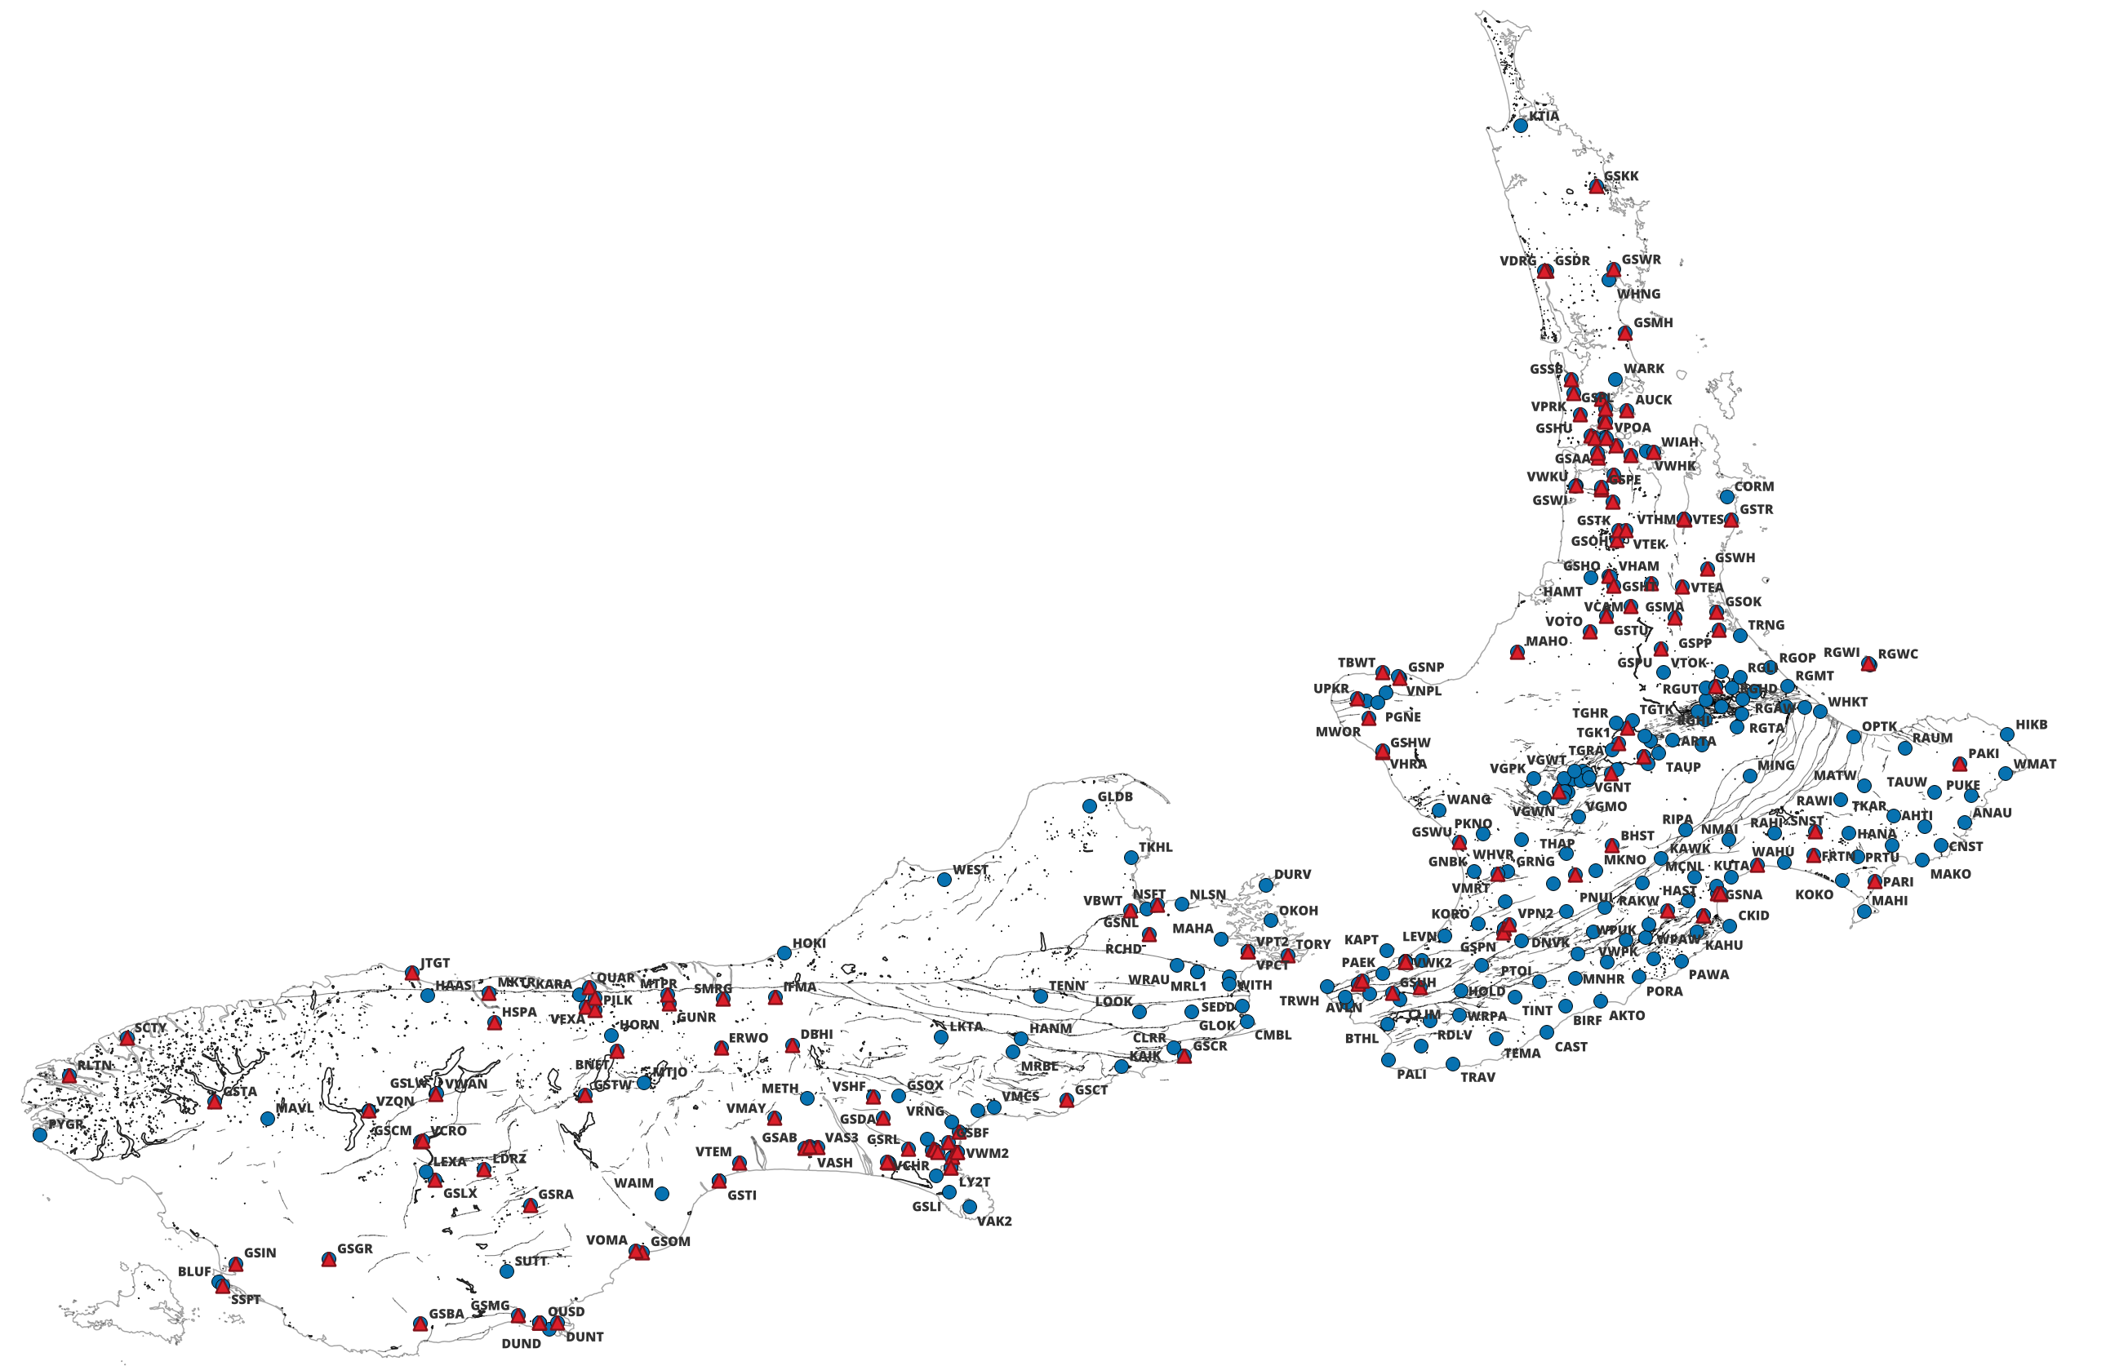
Figure SM1. All GNSS sites used in the study. Blue circles show the locations of all the available sites and red triangles show the sites which were not used in the long-wavelength tie.
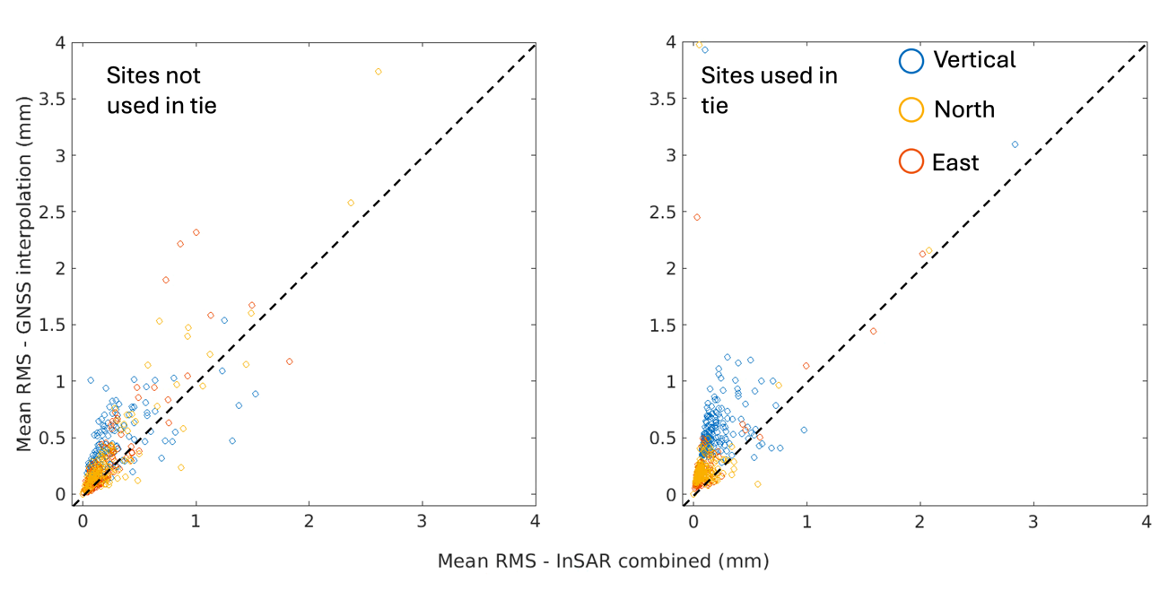Figure SM2. Comparison of the mean RMS misfit between the InSAR combined and GNSS interpolated timeseries at GNSS sites. The panel on the left shows the RMS for sites not used in the reference frame tie. Points plotted above the dashed line show where the InSAR combined timeseries out performs the GNSS interpolation. The different colours are for the east (red), north (orange) and vertical (blue) components.
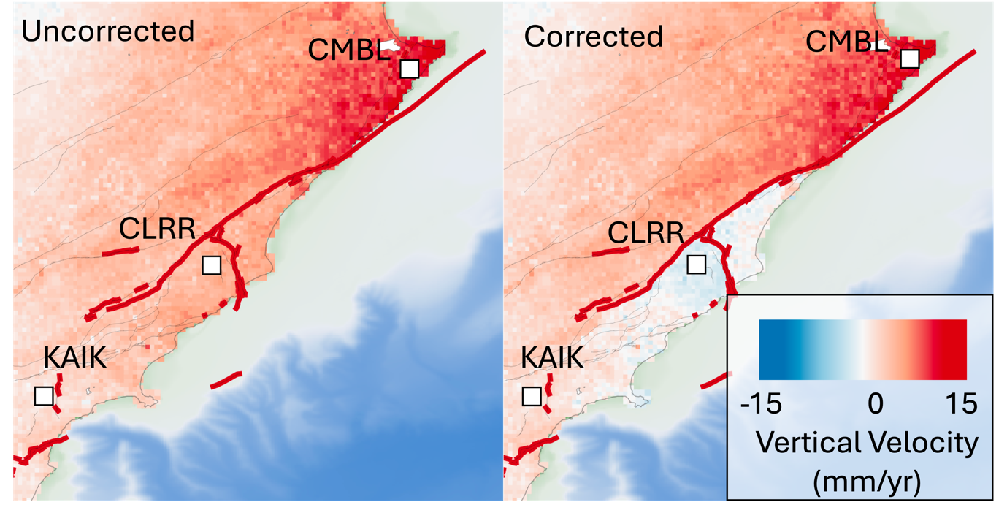Figure SM3. Local correction applied to fault bounded blocks associated with the Kaikōura earthquake using the continuous sites at CLRR and KAIK.

Cauchy Weighting
When down sampling the InSAR and GNSS onto the 1-km grid, we use a we use a Cauchy (Lorentzian) weighting function which gives higher weights to InSAR points similar to the expected GNSS but does not overly penalise the InSAR helping to preserve localized deformation while still anchoring the broader regional field to the GNSS
The weight w_{i} assigned to an InSAR observation based on its difference from the GNSS model (Δ_{i} = abs(obs_{InSAR} – obs_{GNSS}) is calculated as:
$$w_{i}=\frac{1}{1+{\left(\frac{Δ_{i}}{γ}\right)}^{2}}$$
where γ is a scale parameter that represents the expected noise floor or the acceptable deviation threshold (e.g., the standard deviation of the InSAR data, typically 10-15 mm per epoch).
Unlike a Gaussian penalty, which rapidly approaches zero beyond 2γ, the Cauchy function maintains a meaningful fractional weight (e.g., ~ 0.1) even when the difference is several times larger than γ. This heavy-tailed behaviour ensures that regional long-wavelength signals are strongly constrained by the GNSS network where agreement is high, while localized, high-magnitude deformation features observed by InSAR are retained in the final inversion rather than being statistically rejected as noise.

Weighted Least Squares (WLS) Inversion
To resolve the three-dimensional (3D) surface velocity field (East, North, Up) from 1D Line-of-Sight (LOS) InSAR measurements and sparse GNSS data, we formulate the problem as an overdetermined linear system. For a given point, the linear system is expressed as Gm = d, where d is the observation vector, m is the unknown 3D velocity vector [E, N, U], and G is the design matrix containing the unit projection vectors.
$$\begin{matrix}losxA & losyA & loszA \\ losxD & losyD & loszD \\ 1 & 0 & 0 \\ 0 & 1 & 0 \\ 0 & 0 & 1\end{matrix}= \left\lceil \begin{matrix}E \\ N \\ U\end{matrix}\right\rceil$$
where losxA/D, losyA/D and loszA/D are the unit look-vectors for the respective ascending (A) and descending (D) satellite tracks. To account for the uncertainties of the different data sources, we apply a Weighted Least Squares (WLS) approach. We define a diagonal weight matrix W, where each diagonal element is inversely proportional to the variance of the observation. The final solution is then obtained by minimizing the weighted sum of squared residuals:
$$m = {\left(G^{T} W G\right)}^{-1} G^{T} W d$$
The formal 1-sigma uncertainties for the inverted East, North, and Up velocities are derived from the square roots of the diagonal elements of the model covariance matrix:
$$C_{m} = {\left(G^{T} W G\right)}^{-1}$$

