Supplemental Figures and Tables

Supplemental Figure 1. Background of the Karenni Nurses Association.
The Karenni Nurses Association (KNA) was founded in 2022 by more than 160 Civil Disobedience Movement (CDM) nurses and midwives who left government service following the military coup and returned to Karenni State. Initially, many worked informally within their communities alongside other CDM health workers, but escalating conflict and successive waves of COVID-19 increased demand for health services. Early activities focused on providing care along the border and in displacement settings. With support from the Civil Health and Development Network, these efforts were later formalized into KNA to support internally displaced and conflict-affected populations.
One of the earliest identified needs was restoration of childhood vaccination services. KNA obtained vaccines and supplies through cross-border procurement from Thailand with support from international partners and transported them to displacement areas despite insecurity and access constraints. Drawing on prior experience in immunisation service delivery, KNA nurses and midwives established vaccination activities in multiple locations across Karenni State.
Over time, KNA expanded its activities alongside the broader disruption of Myanmar’s formal health system. Using the World Health Organization’s health system building blocks as an organizing framework, KNA developed teams for finance, procurement, logistics, service delivery, and workforce development. Activities included management of clinics, cold chain expansion, mobile outreach, emergency referral coordination, rehabilitation support, and delivery of primary care services to displaced populations.
To address workforce shortages, KNA also established Karenni Nursing University in 2022, offering a three-year Bachelor of Nursing Science programme through blended learning and cross-border partnerships. These activities were undertaken in collaboration with ethnic health organizations, civil society groups, and the National Unity Government, reflecting broader efforts to maintain essential health services in conflict-affected areas.

Supplementary Figure 2. Geographic setting and vaccine transport routes.
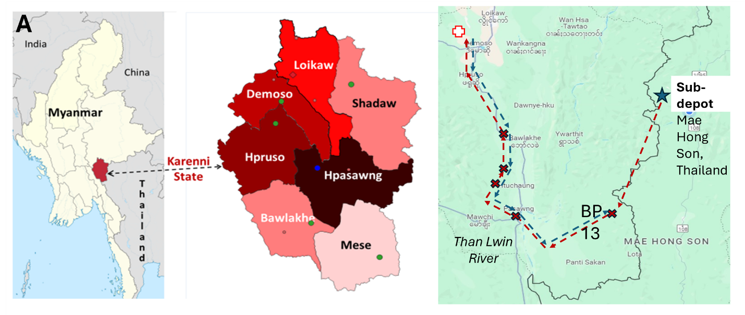
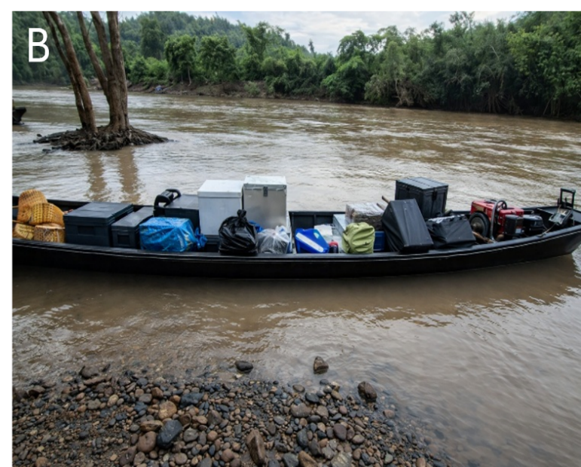 | 
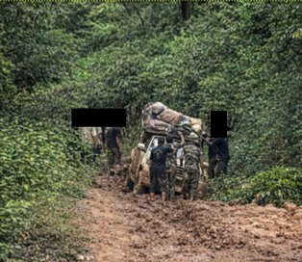 | 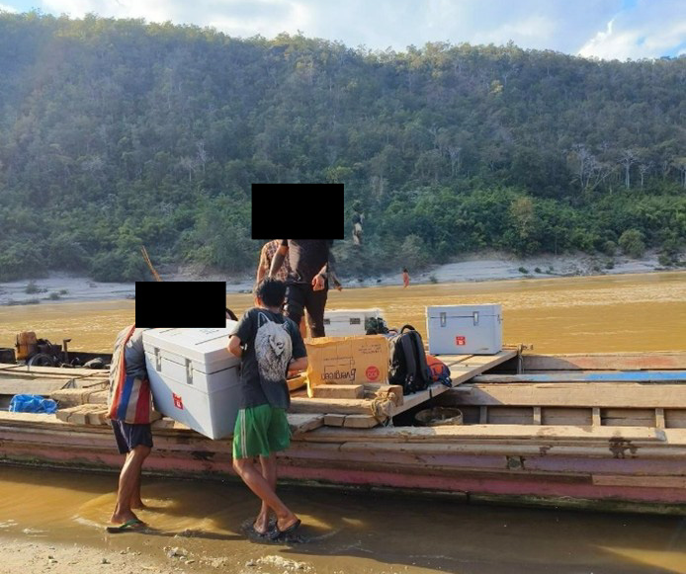
Map showing Karenni State, township boundaries, immunisation sites, and the cross-border transport route from Thailand to the central cold chain facility. The figure illustrates geographic dispersion and access constraints in the study area.
Photographs illustrating the transport methods and logistical approaches required to maintain the vaccine cold chain and avoid areas of military control. Images show transport of vaccines in white cold boxes across rivers by boat and elephant, and a truck carrying vaccines being freed from a mud-filled jungle road. Identifying facial features were obscured to protect confidentiality and safety
Supplementary Figure 3. Vaccination sites, dates of sessions, total sessions, and the reason sessions were not conducted.
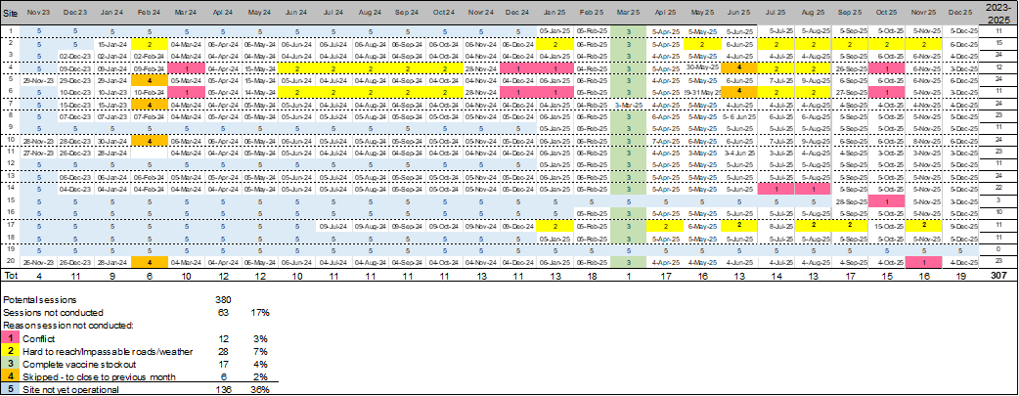

Supplementary Table 1. Number of Visits Required for Full Immunization by Age at Enrolment

Age at Enrolment | Accelerated Schedule | Routine Schedule
<1.5 months | 6 | 6
1.5 to <7 months | 5 | 5
7 to <8 months | 4 | 5
>= 8 to <9 months | 3 | 4
>=9 months to <16 months | 3 | 4
>=16 months | 3 | 3

Supplementary Table 2. Indicators required by United Nations and reported at the end each quarter
Indicator | Barrier to use
At least 1 dose of any vaccine on/before 5th birthday | No census available for denominators - Equivalent to total number of enrollees
Penta 1 before/on 5th birthday | No denominators available - Equivalent to total number of enrollees unless only BCG given
Penta 3 before/on 1st birthday | Insensitive to vaccination of older children enrolling
Penta 3 before/on 5th birthday* | No census available for denominators
MCV1 before/on 1st birthday | Insensitive to vaccination of older children enrolling
MCV1 before/on 5th birthday* | No census available for denominators
Penta 3, polio 3, MCV 2 before/on 5th birthday | JE encephalitis vaccine not included
Penta 1 to 3 dropout | Useful, but children may be vaccinated elsewhere
*Proportion of population

Supplementary Table 3. Baseline characteristics of children by eligibility for the analytic cohort
Characteristic | ≥18 months since  enrolment (analytic cohort) | <18 months since  enrolment | p value
N | 6563 | 6700
Age at enrolment, median (IQR) | 10.5 (3.9–21.7) | 3.1 (2.2–10.8) | <0.001
Age ≥1 year | 3052 (46.5%) | 1594 (23.8%) | <0.001
Male | 3388 (51.6%) | 3475 (51.9%) | 0.773
IDP | 3106 (47.3%) | 3276 (48.9%) | 0.070
Zero-dose | 2684 (40.9%) | 4912 (73.3%) | <0.001

P values are from Fisher's exact test for categorical variables and the Wilcoxon rank-sum test for continuous variables.

Supplementary Table 4. Baseline characteristics of children by immunisation status at enrolment and eligibility for the analytic cohort
 | Zero-dose at enrolment |  |  | Incompletely immunised at enrolment
Characteristic | Enrolled for ≥18 months* | Enrolled for <18 months | p | Enrolled for ≥18 months* | Enrolled for <18 months | p
N | 2684 | 4912 |  | 3879 | 1788
Age at enrolment, months
Median (IQR) | 3.0 (2.1–8.4) | 2.6 (2.0–3.5) | <0.001 | 17.8 (9.5–26.2) | 18.9 (11.0–26.1) | <0.001
≥1 year — n (%) | 546 (20.3%) | 294 (6.0%) | <0.001 | 2506 (64.6%) | 1300 (72.7%) | <0.001
Sex
Female — n (%) | 1276 (47.5%) | 2385 (48.6%) | 0.401 | 1899 (49.0%) | 839 (46.9%) | 0.161
Male — n (%) | 1408 (52.5%) | 2527 (51.4%) |  | 1980 (51.0%) | 948 (53.0%)
Residence
IDP — n (%) | 1165 (43.4%) | 2347 (47.8%) | <0.001 | 1941 (50.0%) | 929 (52.0%) | 0.189
Village — n (%) | 1519 (56.6%) | 2565 (52.2%) |  | 1938 (50.0%) | 859 (48.0%)
IDP=Internally displaced person
P values are from Fisher's exact test for categorical variables and the Wilcoxon rank-sum test for continuous variables.
* Analytic cohort
Supplementary Table 5. Return visit by time after enrolment as a predictor of immunisation status at 18 months among zero-dose children

Time after enrolment | No return visit, n | Incompletely immunized, n | PPV, % | Return visits, n | Fully immunized, n | NPV, % | Specificity, % | Sensitivity, %
3 months | 542 | 444 | 81.9 | 2,104 | 1,231 | 58.5 | 92.6 | 33.7
6 months | 357 | 336 | 94.1 | 2,289 | 1,308 | 57.1 | 98.4 | 25.5
9 months | 315 | 307 | 97.5 | 2,331 | 1,321 | 56.7 | 99.4 | 23.3
12 months | 299 | 296 | 99.0 | 2,347 | 1,326 | 56.5 | 99.8 | 22.5
Legend. PPV = positive predictive value; NPV = negative predictive value. No return visit indicates children who had not attended any follow-up vaccination visit after programme initiation by the specified time point. Incompletely immunised at 18 months refers to children who had not achieved full immunisation by 18 months after enrolment. PPV is the proportion of children with no return visit who had not achieved full immunisation by 18 months. NPV is the proportion of children with at least one return visit who achieved full immunisation by 18 months. Specificity is the proportion of children who achieved full immunisation by 18 months who were correctly classified as having returned. Sensitivity is the proportion of children who were incompletely immunised at 18 months who were correctly classified as having no return visit.

Supplementary Table 6. Model C. Multivariable models of factors associated with full immunisation among zero-dose children at 18 months after enrolment

Variable | 18 months OR (95% CI)
Age at enrolment (months) | 0.99 (0.97–1.01)
Male sex | 1.12 (0.94–1.33)
Village residence | 0.93 (0.78–1.11)
Accelerated schedule | 1.48 (0.77–2.84)
Vaccination opportunities (per 0.5 increase) | 1.14 (1.03–1.27)
Retained at 12 months | 168.88 (53.64–531.65)
Full immunisation was defined as receipt of all vaccines in the programme schedule.
The model included baseline demographic characteristics, programme delivery variables, and retention at 12 months, with study site included as a random intercept. Odds ratios (ORs) and 95% confidence intervals (CIs) are shown. Retention at 12 months was defined as at least one return vaccination visit within 12 months of enrolment. Vaccination opportunity was measured using the vaccination opportunity index, defined as the ratio of vaccination sessions available to the number of visits required to complete the vaccination schedule; ORs are presented per 0.5-unit increase in the index. Retention was treated as a descriptive marker of sustained programme engagement rather than an independent causal predictor of full immunisation. The large estimate for retention should be interpreted cautiously because of quasi-complete separation.

