Table S1. Periodontitis prevalence by case definition

Definition | Category | n (%)
2012 CDC/AAP | None | 66 (74.2%)
 | Mild | 0 (0.0%)
 | Moderate | 22 (24.7%)
 | Severe | 1 (1.1%)
2018 EFP/AAP | Stage I | 13 (14.6%)
 | Stage II | 62 (69.7%)
 | Stage III/IV | 14 (15.7%)

Table S2. Cross-tabulation of two case definitions and concordance metrics

CDC/AAP 2012 \ EFP/AAP 2018 | Stage I/II | Stage III/IV | Total
None + Mild | 63 | 3 | 66
Moderate + Severe | 12 | 11 | 23
Total | 75 | 14 | 89
Cross-tabulation of 2012 CDC/AAP moderate-to-severe periodontitis and 2018 EFP/AAP Stage III/IV in the analytic cohort. Exact agreement = 83.1% (74/89); Cohen's κ = 0.496, indicating moderate agreement between the two case definitions. The associations between the two binary classifications were statistically significant (χ² = 24.10, df = 1, p < 0.001; Fisher's exact p < 0.001). The two case definitions concurrently identified 11 cases (12.4%) and concurrently classified 63 individuals (70.8%) as non-cases. Discordant classifications occurred in 15 individuals (16.9%): 12 met 2012 CDC mod + sev criteria but not 2018 EFP/AAP Stage III/IV, while 3 met 2018 EFP/AAP Stage III/IV but not 2012 CDC/AAP mod + sev.
Table S3. Extended covariate sensitivity analysis (+ income, education). Mutually adjusted model (all three self-reported measures entered together) for 2012 CDC/AAP moderate + severe periodontitis, with income and education added to the five core covariates.

Predictor | aOR (95% CI), p-value
Self-reported measures
Self-reported oral health | 1.81 (0.86–3.82), 0.12
Perceived gingival abnormality | 0.40 (0.10–1.60), 0.19
OHIP-14 | 0.82 (0.44–1.54), 0.54
Covariates
Age | 2.77 (1.31–5.85), 0.01**
Female | 3.59 (0.64-20.11), 0.15
BMI | 1.30 (0.70-2.43), 0.41
Current smoker | 2.44 (0.27-22.37), 0.43
Current drinker | 1.46 (0.43-4.95), 0.54
High Income | 0.50 (0.94-2.62), 0.41
High Education | 6.42 (1.22-33.87), 0.03*
Model AUC | 0.80
* p < 0.05, ** p < 0.01.

Table S4. Mutually adjusted model (all three self-reported measures entered together) for 2018 EFP/AAP Stage III/IV

Predictor | aOR (95% CI), p-value
Self-reported measures
Self-reported oral health | 1.90 (0.87–4.15), 0.11
Perceived gingival abnormality | 1.03 (0.24–4.43), 0.97
OHIP-14 | 0.67 (0.33–1.34), 0.25
Covariates
Age | 3.62 (1.39–9.45), 0.01*
Female | 1.55 (0.66-2.84), 0.63
BMI | 1.37 (0.66-2.84), 0.40
Current smoker | 2.05 (0.13-32.1), 0.61
Current drinker | 0.91 (0.22-3.76), 0.90
Model AUC | 0.80
All three self-reported measures were entered together in a single regression and adjusted for age, sex, BMI, smoking, and drinking.
Figure S1. ROC curves for self-reported measures discriminating 2018 EFP/AAP Stage III/IV (n = 87, events = 14). All subjective AUCs near chance.

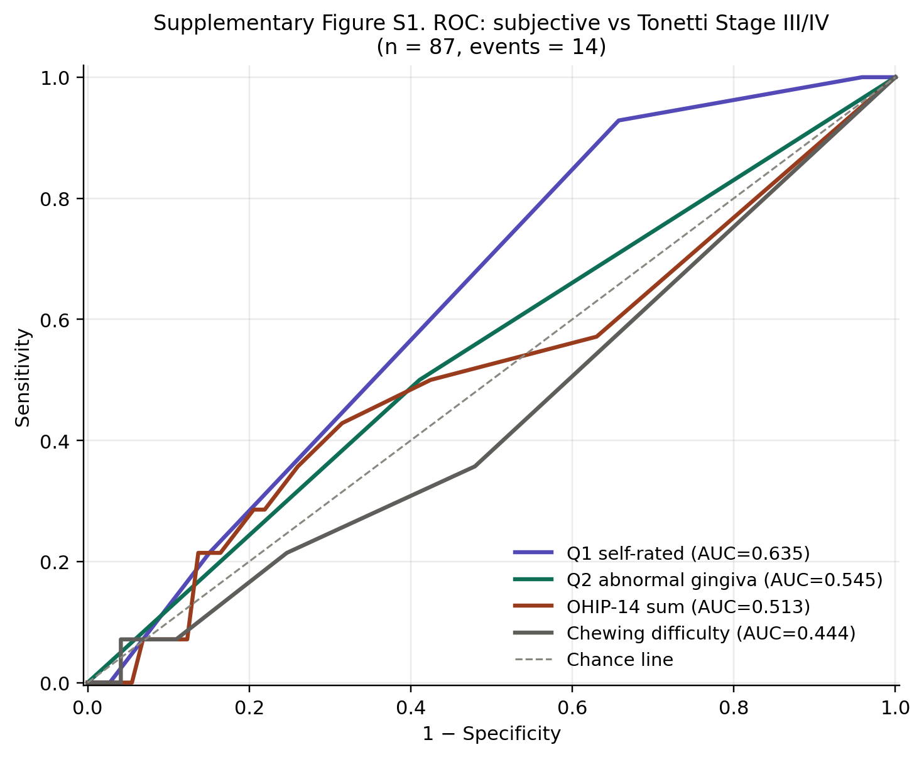

Figure S2. Forest plot of adjusted ORs in the mutually adjusted model for 2018 EFP/AAP Stage III/IV (n = 87, AUC = 0.80). Only age was statistically significant.

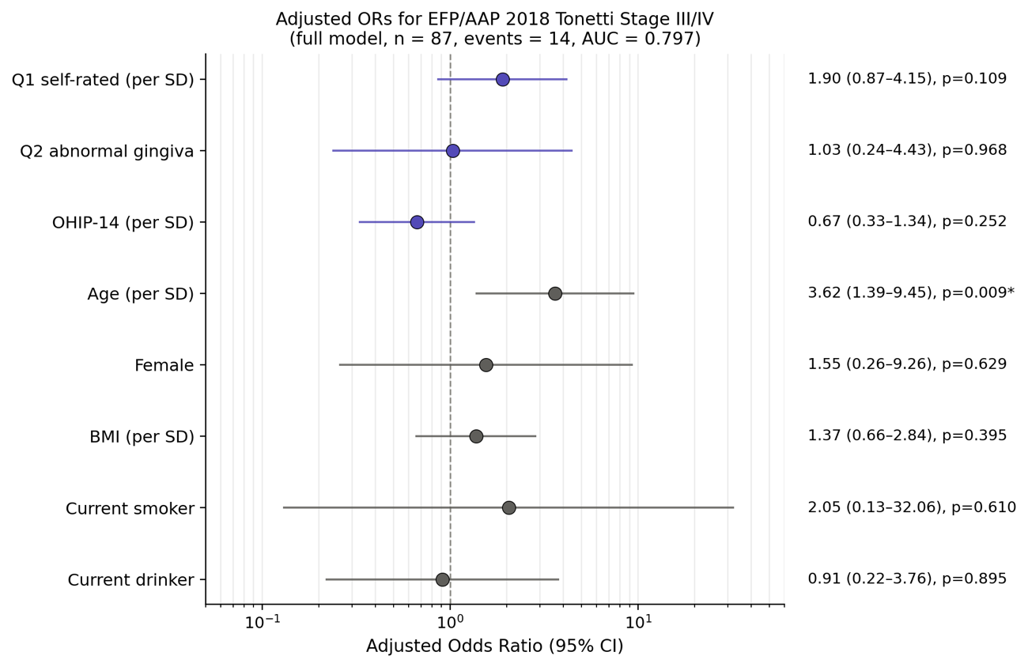

Figure S3. Side-by-side comparison of aORs from mutually adjusted models for two outcomes (2012 CDC/AAP moderate + severe vs 2018 EFP/AAP Stage III/IV). Self-reported oral health is significant only for 2012 CDC/AAP; age is significant for both.

