Supplementary Table 1: Search strategy for each database

Database | Search strategy | Fields | Records
PubMed | (("Hyperthermic Intraperitoneal Chemotherapy" OR "HIPEC" OR "Intraperitoneal Hyperthermic Chemotherapy")) AND (("Ovarian Neoplasms" OR "Ovarian Neoplasm" OR "Ovary Neoplasms" OR "Ovary Neoplasm" OR "Ovary Cancer" OR "Ovary Cancers" OR "Ovarian Cancer" OR "Ovarian Cancers " OR "Cancer of Ovary ")) | ALL fields | 827
Embase | ('ovarian neoplasms':ab,ti OR 'ovarian neoplasm':ab,ti OR 'ovary neoplasms':ab,ti OR 'ovary neoplasm':ab,ti OR 'ovary cancer':ab,ti OR 'ovary cancers':ab,ti OR 'ovarian cancer':ab,ti OR 'ovarian cancers':ab,ti OR 'cancer of ovary':ab,ti) AND ('hyperthermic intraperitoneal chemotherapy':ab,ti OR 'hipec':ab,ti OR 'intraperitoneal hyperthermic chemotherapy':ab,ti) | Title or abstract | 1229
Cochrane | (("Hyperthermic Intraperitoneal Chemotherapy" OR "HIPEC" OR "Intraperitoneal Hyperthermic Chemotherapy")) AND (("Ovarian Neoplasms" OR "Ovarian Neoplasm" OR "Ovary Neoplasms" OR "Ovary Neoplasm" OR "Ovary Cancer" OR "Ovary Cancers" OR "Ovarian Cancer" OR "Ovarian Cancers " OR "Cancer of Ovary ")) | ALL Text | 216
WOS | (("Hyperthermic Intraperitoneal Chemotherapy" OR "HIPEC" OR "Intraperitoneal Hyperthermic Chemotherapy")) AND (("Ovarian Neoplasms" OR "Ovarian Neoplasm" OR "Ovary Neoplasms" OR "Ovary Neoplasm" OR "Ovary Cancer" OR "Ovary Cancers" OR "Ovarian Cancer" OR "Ovarian Cancers " OR "Cancer of Ovary ")) | ALL fields | 1340

Supplementary Table 2: GRADE Assessment of analyzed outcomes.

Certainty assessment |  |  |  |  |  |  | № of patients |  | Effect |  | Certainty | Importance
№ of studies | Study design | Risk of bias | Inconsistency | Indirectness | Imprecision | Other considerations | HIPEC+CRS | CRS alone | Relative  (95% CI) | Absolute  (95% CI) | Certainty | Importance
Overall Survival (OS)
10 | randomised trials | not serious | not serious | not serious | not serious | none | 685 participants | 679 participants | HR 0.82  (0.65 to 1.01)  [Mortality] | 65 more per 1,000  (from 3 fewer to 148 more) | ⨁⨁⨁⨁  High
 |  |  |  |  |  |  | - | 18.0% | HR 0.82  (0.65 to 1.01)  [Mortality] | 65 more per 1,000  (from 3 fewer to 148 more) | ⨁⨁⨁⨁  High
Progression/Disease-free survival (PFS/DFS)
7 | randomised trials | not serious | not serious | not serious | not serious | none | 537 participants | 531 participants | HR 0.80  (0.66 to 1.02)  [progression] | 78 more per 1,000  (from 7 fewer to 148 more) | ⨁⨁⨁⨁  High
 |  |  |  |  |  |  | - | 22.0% | HR 0.80  (0.66 to 1.02)  [progression] | 78 more per 1,000  (from 7 fewer to 148 more) | ⨁⨁⨁⨁  High
CI: confidence interval; HR: hazard ratio

Supplementary Figure 1: The sensitivity analysis for Overall Survival (follow-up through 10 years).

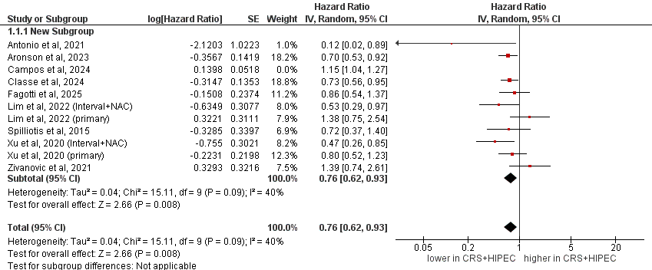

Supplementary Figure 2: The sensitivity analysis for progression/disease-free survival (PFS/DFS) (follow-up through 10 years).

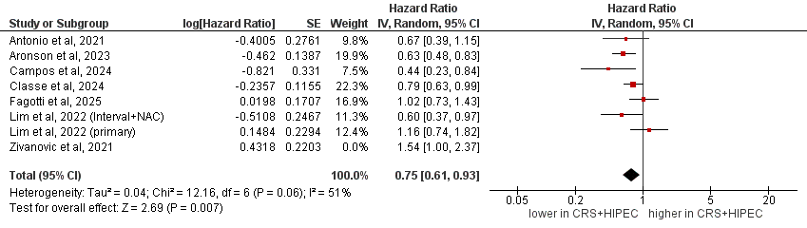

Supplementary Figure 3: Forest Plot meta-analysis for overall survival for subgroup analysis based on the tumor type or type of surgery.

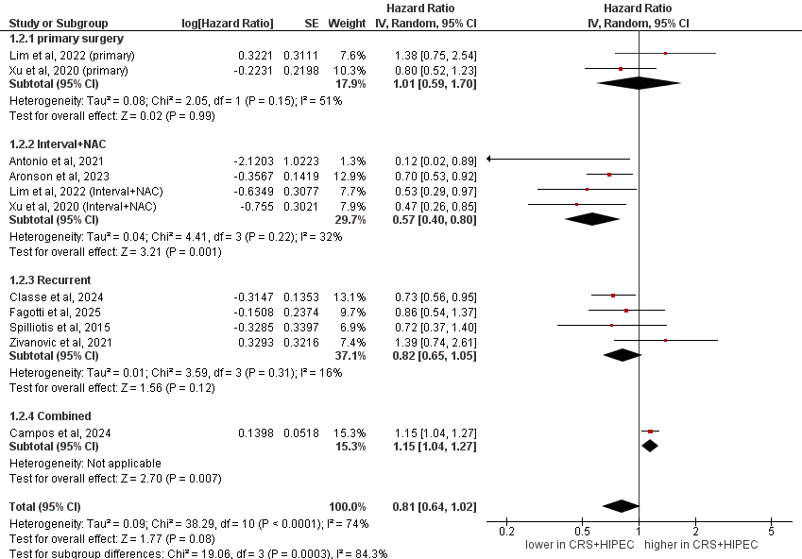

Supplementary Figure 4: Forest Plot meta-analysis for progression/disease-free survival for subgroup analysis based on the tumor type or type of surgery
