Supplemental

Effects of Tablet Crushing Methods on Solid-State Properties, Dissolution Behavior, and Dispensability of Acetaminophen Tablets

Yayoi Kawano^{a,b}, Tomohiro Tsuchidaª, Na Rongª, Kaoru Hiroseª, Nobuyuki Natori^{c}, Narumi Maidaª, Satoru Gotoª, Takehisa Hanawa^{a,*}

ª Faculty of Pharmaceutical Sciences, Tokyo University of Science, 6-3-1 Niijuku, Katsushika-ku, Tokyo 125-8585, Japan
^{b} Graduate School of Pharmaceutical Sciences, Nagoya City University, 3-1 Tanabe-dori, Mizuho-ku, Nagoya 467-8603, Japan
^{c} Formulation Department, CMC Center, Kaken Pharmaceutical Co., Ltd. 301, Gensuke, Fujieda-shi, Shizuoka 426-8646, Japan

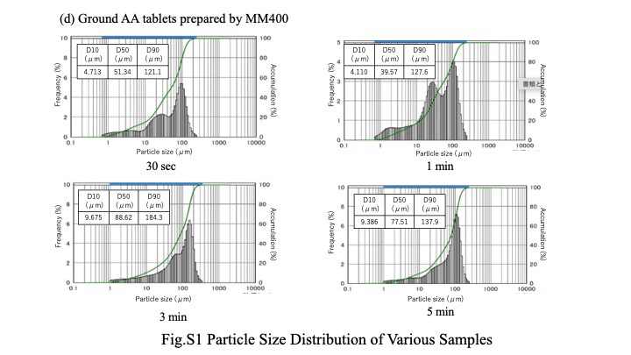
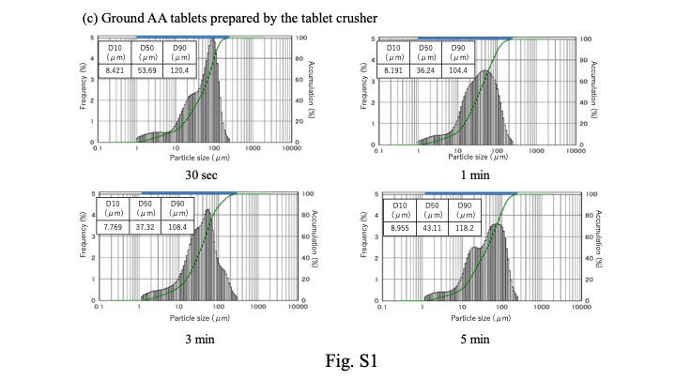
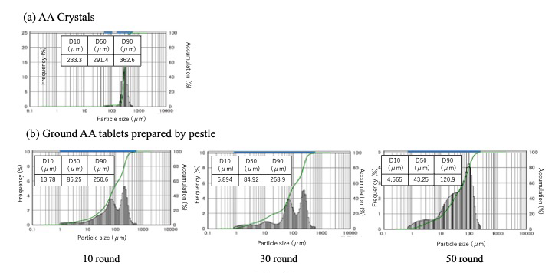
OBM
Fig.S1 Particle Size Distribution of Various Samples
Fig. S2. PXRD Patterns of Lactose Hydrate Crystals and Ground Samples Prepared Using Various Methods.

Fig.3. FTIR Spectra of Various Samples

