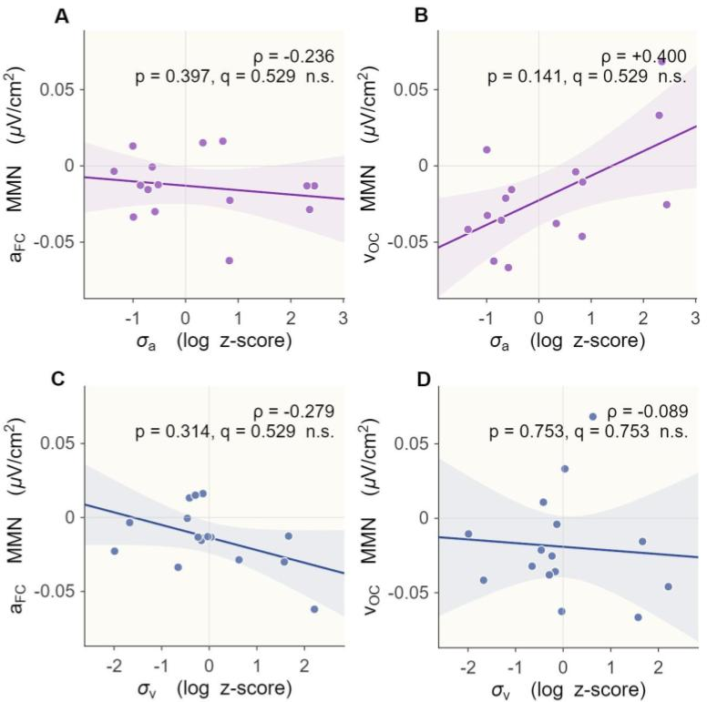
Supplementary Figure S1. No association between BCI noise parameters and unimodal MMN responses
Scatter plots showing relationships between BCI-derived sensory noise parameters and unimodal MMN amplitudes in predefined regions of interest. (A) Auditory sensory noise (σₐ, log z-scored) and frontocentral auditory MMN (A_{FC}). (B) Auditory sensory noise and occipital visual MMN (V_{OC}). (C) Visual sensory noise (σᵥ, log z-scored) and frontocentral auditory MMN (A_{FC}). (D) Visual sensory noise and occipital visual MMN (V_{OC}). No significant correlations were observed in any condition (all p > 0.1). Solid lines indicate linear fits, and shaded regions represent 95% confidence intervals. These results indicate that the relationship between auditory sensory noise and MMN amplitude is not present at the unimodal level, supporting the specificity of the main effect to multisensory (audiovisual) processing.

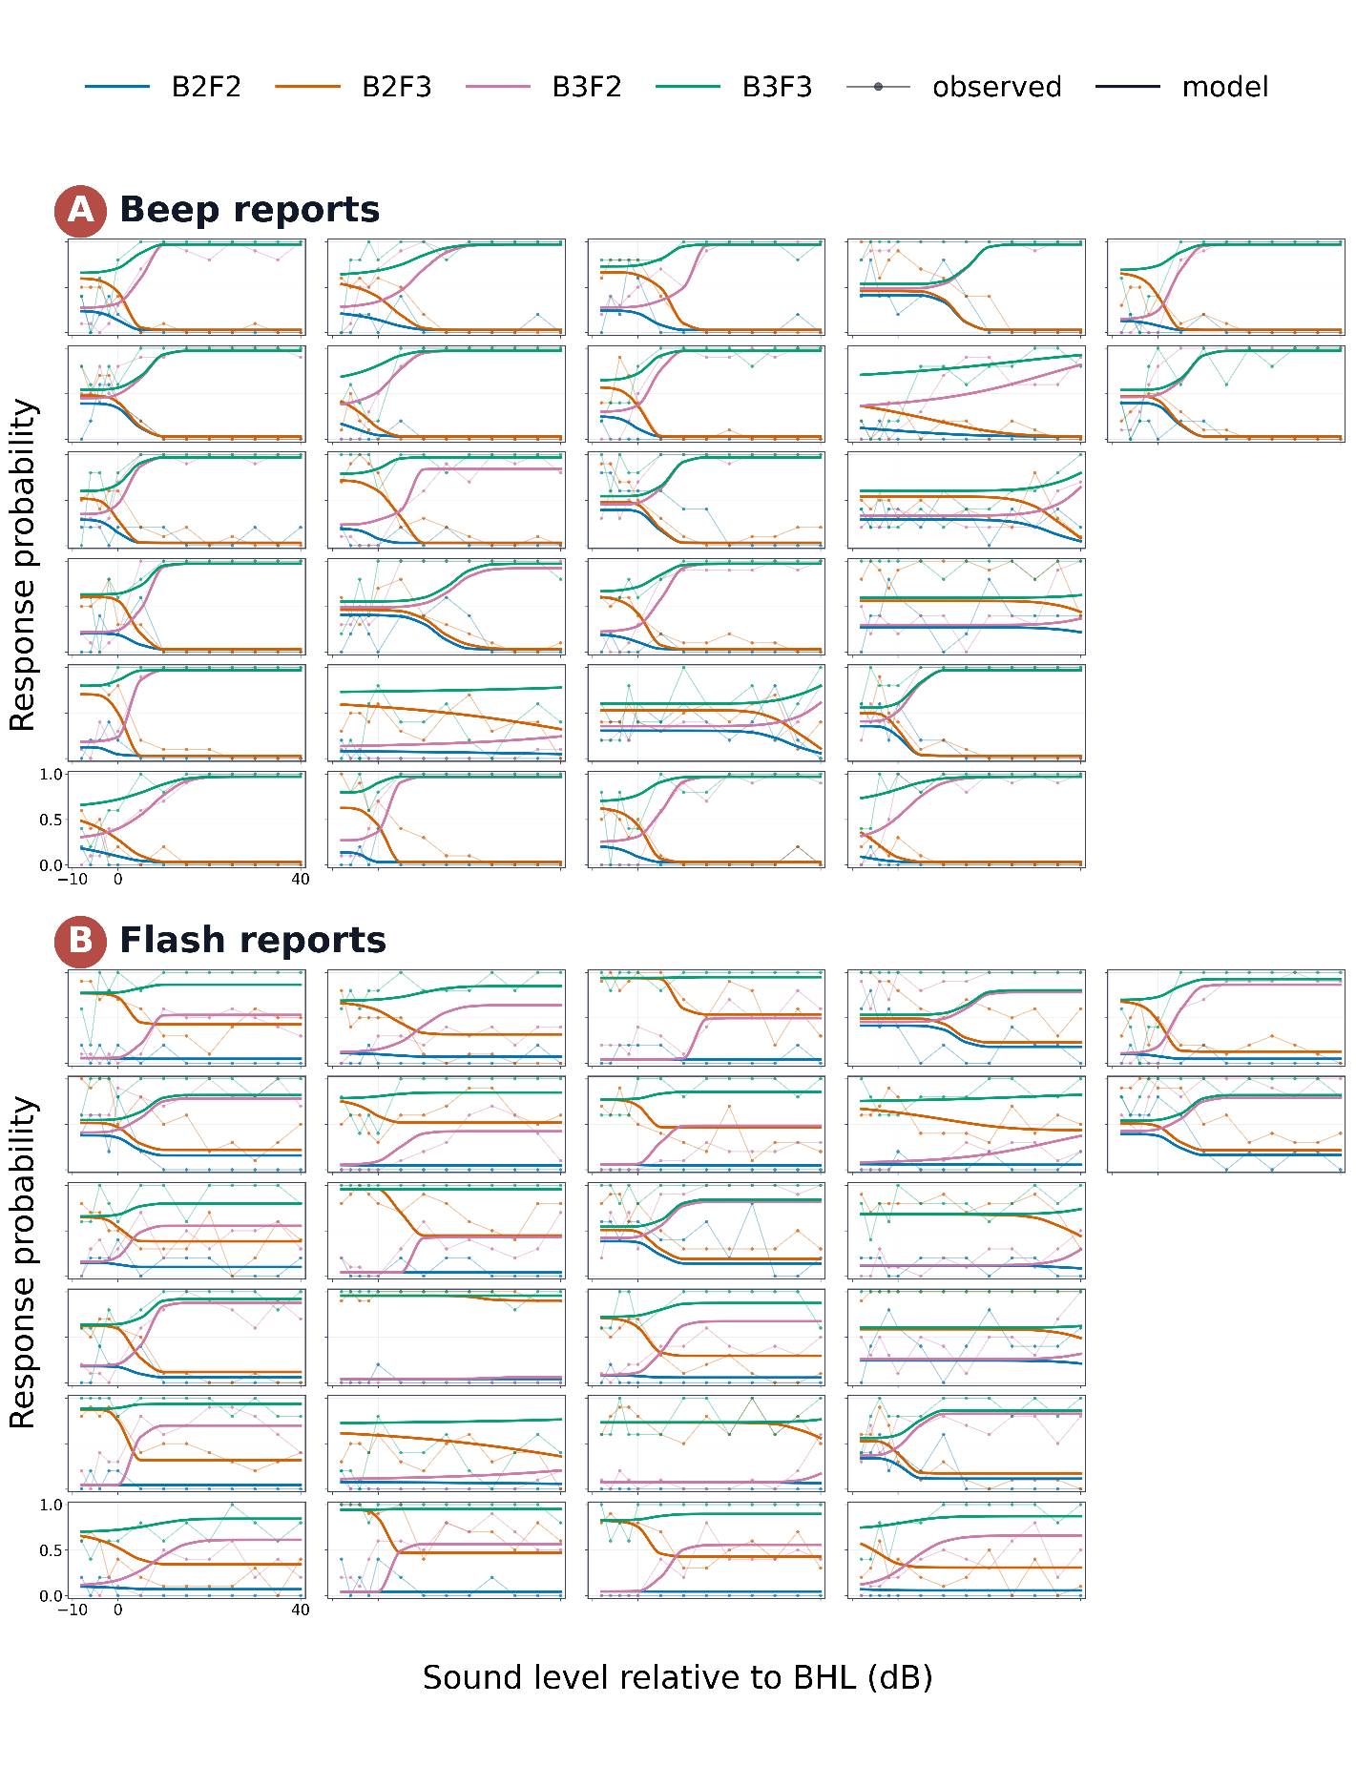
Supplementary Figure S2. Extended posterior predictive checks for the selected postdictive BCI model.
Observed and model-predicted report probabilities are shown for beep reports (A) and flash reports (B). Each tile shows one participant from the behavioural BCI cohort (N = 26), arranged in column order. Colors indicate physical stimulus condition: B2F2, B2F3, B3F2, and B3F3. Faint lines with points show observed report probabilities, and thicker smooth lines show posterior predictive means from the selected model. Tick marks are shown on all tiles; numeric scale labels are shown on the bottom-left reference tile in each panel. The x-axis shows sound level relative to behavioural hearing level (BHL), and the y-axis shows response probability.

Supplementary Results: Cross-reference robustness of the σ_{a} – AV_{OC} association
To assess whether the primary σ_{a}–AV_{OC} association depended on the EEG reference scheme, the same correlation analysis was repeated using the original FCz reference, average reference, and mastoid reference, in addition to the CSD-transformed data. The positive association between σ_{a} and AV_{OC} MMN amplitude was observed across all reference schemes: original reference, ρ = +0.664, p = 0.0086; average reference, ρ = +0.739, p = 0.0024; mastoid reference, ρ = +0.839, p = 0.0001; CSD, ρ = +0.707, p = 0.0043 (Supplementary Fig. S3). These results indicate that the primary finding was robust to the choice of EEG reference.

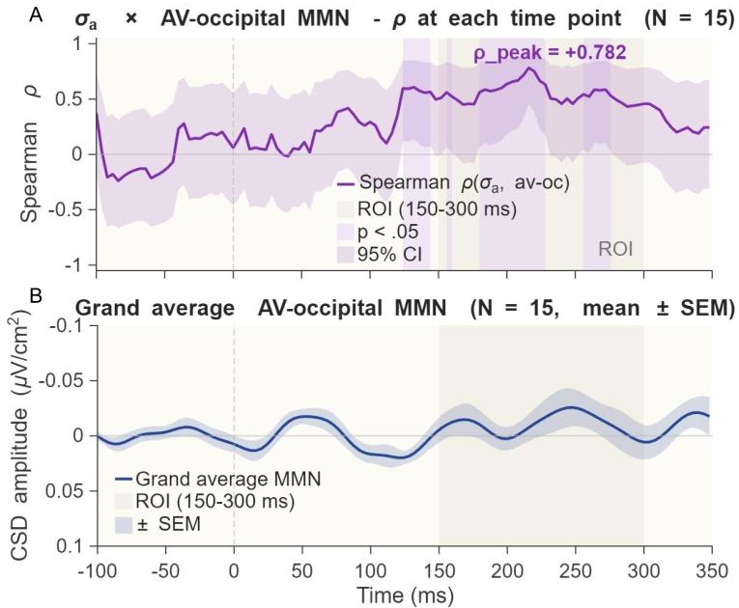
Supplementary Figure S3. Temporal specificity of the σ_{a} × AV_{OC} MMN correlation.
(A) Spearman ρ(t) between σ_{a} and individual AV_{OC} MMN amplitude at each time point (N = 15). The shaded purple region indicates the 95% confidence interval (Fisher z-transform). The light lavender patches indicate time points reaching p < 0.05 (uncorrected). The grey shaded region marks the predefined ROI window (150–300 ms). (B) Grand-average AV-occipital MMN waveform (mean ± SEM, N = 15). The peak correlation (ρ = +0.782) falls within the ROI window, confirming the temporal specificity of the primary finding.

Supplementary Results: High- and low-σ_{a} waveform visualization
To provide an intuitive visualization of the primary brain–behaviour association, participants in the EEG sample were divided into high- and low-σ_{a} groups using a median split on the participant-level σ_{a} estimate. Grand-average standard, deviant, and difference waveforms were then plotted separately for the AV_{OC} and AV_{FC} ROIs (Supplementary Fig. S4). Consistent with the main continuous-trait analysis, the high-σ_{a} group showed a weaker occipital avMMN difference wave than the low-σ_{a} group. By contrast, the corresponding AV_{FC} waveforms showed less clear separation between groups, in line with the absence of a significant σ_{a}–AV_{FC} correlation in the main analysis. Because σ_{a} is inherently continuous and the EEG subsample was modest (N = 15), these grouped waveforms are presented for descriptive visualization only.

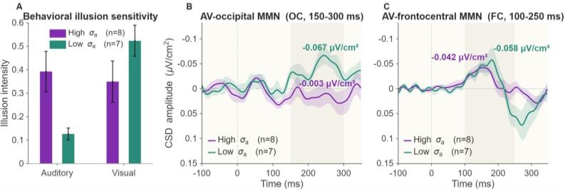
Supplementary Figure S4. Median-split visualization of auditory-noise effects on behaviour and audiovisual MMN.
Participants in the EEG subsample were divided into high- and low-σₐ groups using a median split for descriptive visualization only.
(A) Behavioural illusion intensity in the high-σₐ and low-σₐ groups. High-σₐ participants showed greater auditory illusion intensity, whereas low-σₐ participants showed greater visual illusion intensity. Bars indicate group means and error bars indicate SEM.
(B) Grand-average audiovisual occipital MMN difference waves at the occipital ROI (AV_{OC}, 150–300 ms). Low-σₐ participants showed a more negative AV_{OC} response than high-σₐ participants, consistent with the continuous σₐ– AV_{OC} correlation.
(C) Grand-average audiovisual frontocentral MMN difference waves at the frontocentral ROI (AVFC, 100–250 ms). In contrast to AV_{OC}, the two σₐ groups showed little separation in the predefined AVFC analysis window.
Shaded grey regions indicate predefined analysis windows, and coloured bands indicate ±SEM. This grouped analysis was used only to visualize the direction of the primary continuous-trait association and was not treated as an independent inferential test.

Supplementary Results: Model comparison across candidate BCI families
To determine which computational family best accounted for the behavioural reports, we compared segregation, forced fusion, classical BCI, and postdictive BCI using PSIS-LOO and stacking weights (Supplementary Table S1). Consistent with the main-text summary, the postdictive BCI model showed the strongest out-of-sample predictive performance, exceeding the classical BCI model and substantially outperforming segregation and forced fusion. These results supported the use of the postdictive BCI model as the computational basis for the subsequent behavioural and EEG analyses.

Supplementary Table S1. Comparison of 4 BCI models
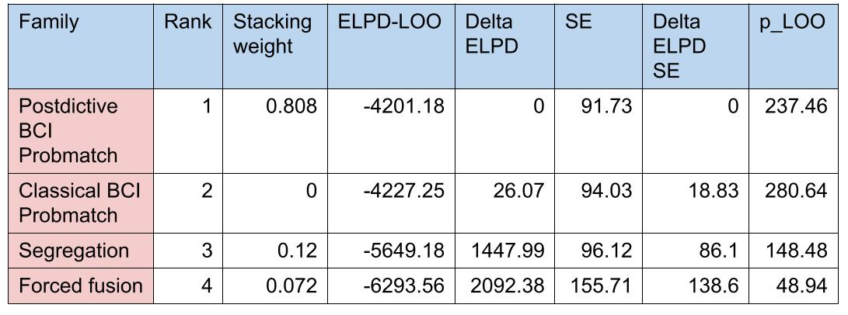

Supplementary Results: Sampling and fit diagnostics of the candidate BCI models
Sampling diagnostics were examined for all candidate model families to evaluate convergence and the stability of the model-comparison results. The winning postdictive BCI model showed acceptable overall sampling behaviour, supporting the reliability of the posterior summaries used in the main analyses. By contrast, some alternative models, particularly the classical BCI model, showed weaker convergence or less stable fit behaviour, and were therefore interpreted more cautiously (Supplementary Table S2). These diagnostics reinforce the conclusion that the postdictive BCI model provided the most suitable account of the behavioural data among the tested model families.

Supplementary Table S2. Sampling diagnostics for the tested BCI model families.
