Figure S1. List of all reviewed entries with Roco proteins. Showing the Q61-equivalent positions (fourth column), highlighting the diversity of amino acids at this position. Only LRRK2 has arginine at the Q61-equivalent position.

Figure S2. Nucleotide-binding affinity of R1398A. Fluorescence polarization assays showing that the R1398A variant exhibits GDP affinity similar to WT ROC, whereas GTP𝛾S affinity is modestly reduced compared to WT. The measured Kd values for R1398A were 1.18 ± 0.12 µM for GDP and 6.42 ± 0.49 µM for GTP𝛾S.
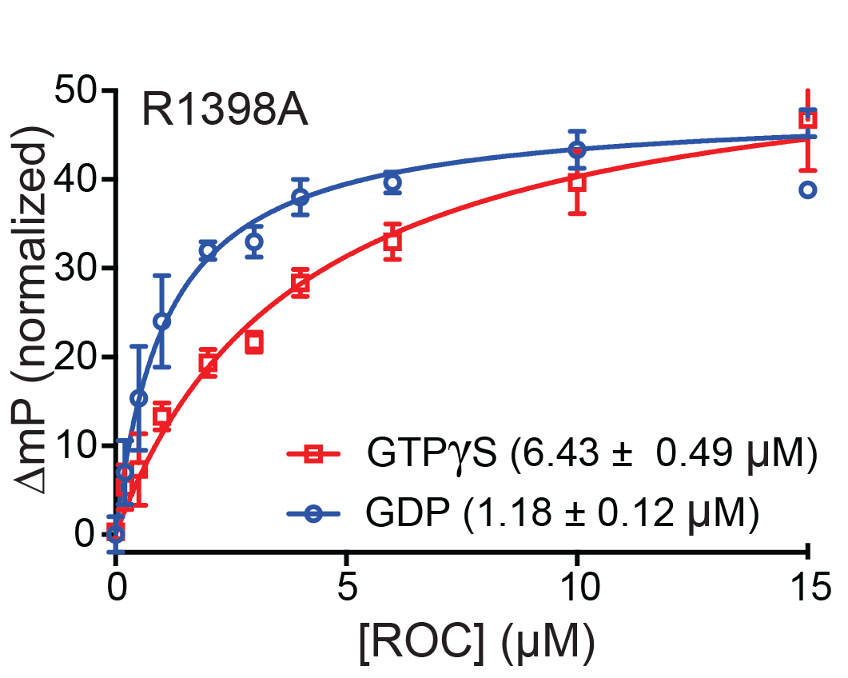

Table S1. Data collection and refinement statistics

 | ROC R1398H
Data collection
Space group | P21
Unit cell | a=44.497, b=101.785, c=44.527 Å
 | α=90°, β=101.38°, γ=90°
Wavelength (Å) | 1.0331
Resolution (Å)¹ | 20.1–1.97 (2.04–1.97)
Completeness (%) | 99.30 (96.49)
Rmerge¹² | N/A⁴
I/σ(I) | 13.64 (3.51)
Refinement
Unique reflections | 27,409 (2,666)
Protein atoms | 2,709
Solvent atoms | 134
Ligands | 58
R-factor (Rfree) (%)³ | 18.04 (22.14)
Average B-factor (Å²) | 43.60
R.M.S. deviations
Bonds (Å) | 0.007
Angles (°) | 1.21
Ramachandran plot
Most favored regions (%) | 96.75
Additionally allowed regions (%) | 2.37
Outlier regions (%) | 0.89

¹ Values for the highest resolution shell are indicated in parentheses.
² Rmerge = Σhi |Ihi – <Ih>| / Σh<Ih>, where Ihi is the intensity of the ith observation of reflection h and <Ih> is the average intensity over redundant measurements.
³ R-factor = Σ||Fo|–|Fc|| / Σ|Fo|, where Fo and Fc are the observed and calculated structure-factor amplitudes. Rfree is monitored with 5% of reflections excluded from refinement.
⁴ Rmerge is not applicable (multiplicity = 1.0; data collected without redundancy).

