Supplementary Information
Single-cell viral capture identifies injury-remodeling programs and host-response candidates in RSV-infected airway organoids
This supplementary file accompanies the RSV host-response submission-ready manuscript. Legends are placed directly below each figure to preserve manuscript reading order.
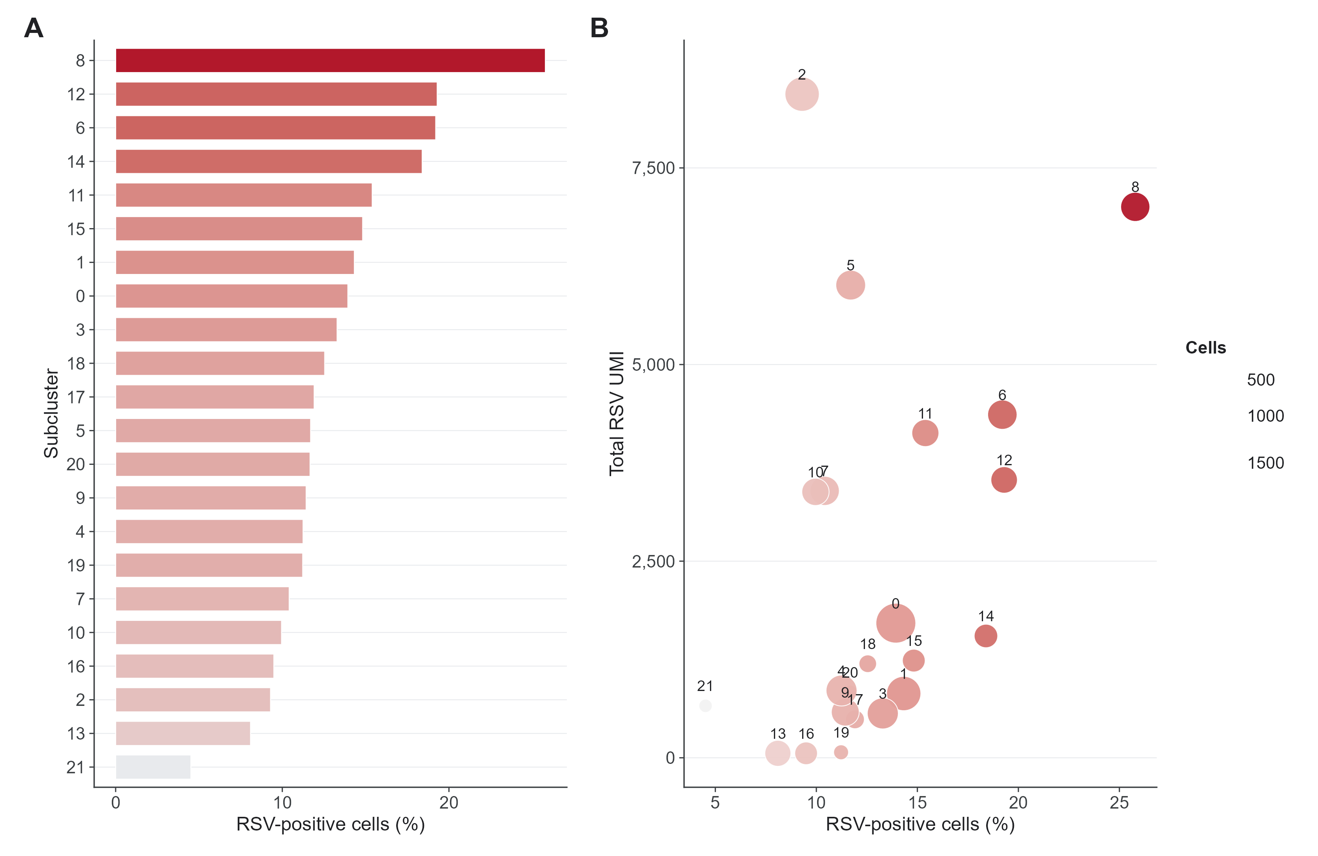
Figure S1. Focused epithelial-cell reclustering and annotation. (A) RSV-positive fraction across epithelial subclusters after focused reclustering. (B) Total RSV UMI burden by epithelial subcluster. The highest RSV-positive epithelial subclusters were 8, 12 and 6, mapping mainly to IFN-high/stress-injury, AT2-like/cycling epithelial and pan-epithelial/IFN-high/stress-injury mixed states, respectively. Refined-state marker gene sets are provided in Supplementary Data 2.
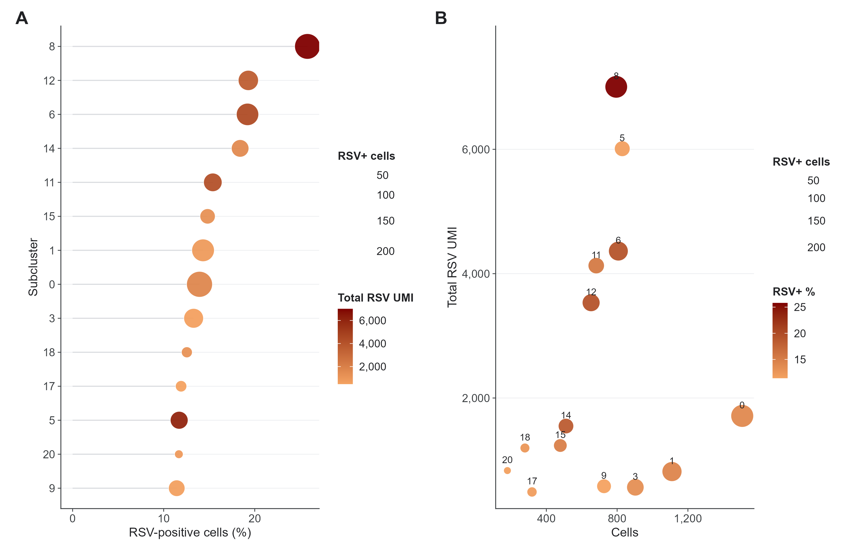
Figure S2. RSV burden distribution among epithelial cells. (A) RSV-positive fraction across epithelial states. (B) Total RSV UMI distribution across the same states. (C) Marker-score composition of RSV-enriched epithelial contexts. RSV transcript signal is concentrated in selected epithelial states rather than uniformly distributed across the atlas.
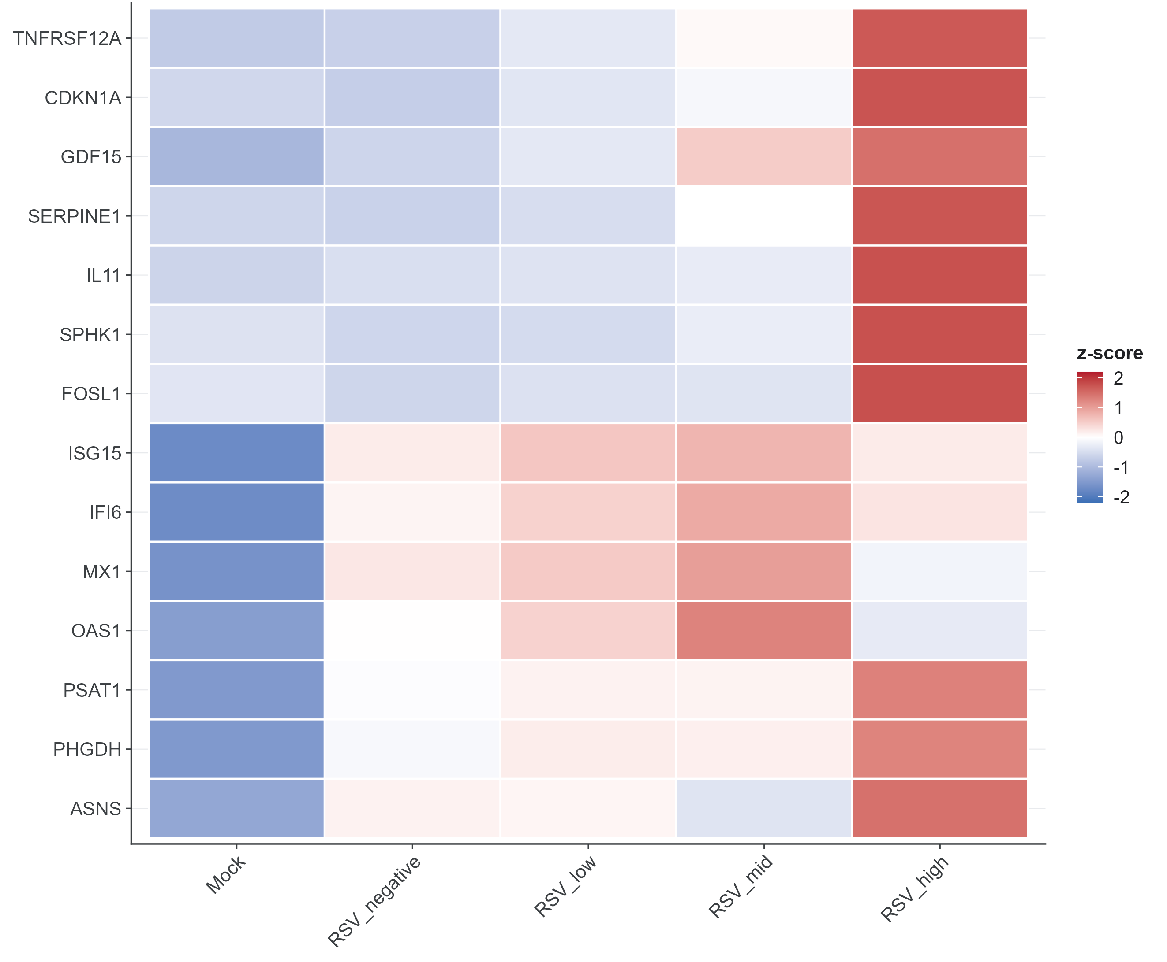
Figure S3. RSV dose-response genes. (A) Genes ranked according to association with viral-load strata among RSV-positive cells. (B) Top positive dose-response genes enriched in stress-remodeling and injury-response programs. (C) Lower-ranking or negative associations provide contrast for the viral-load-linked host response.
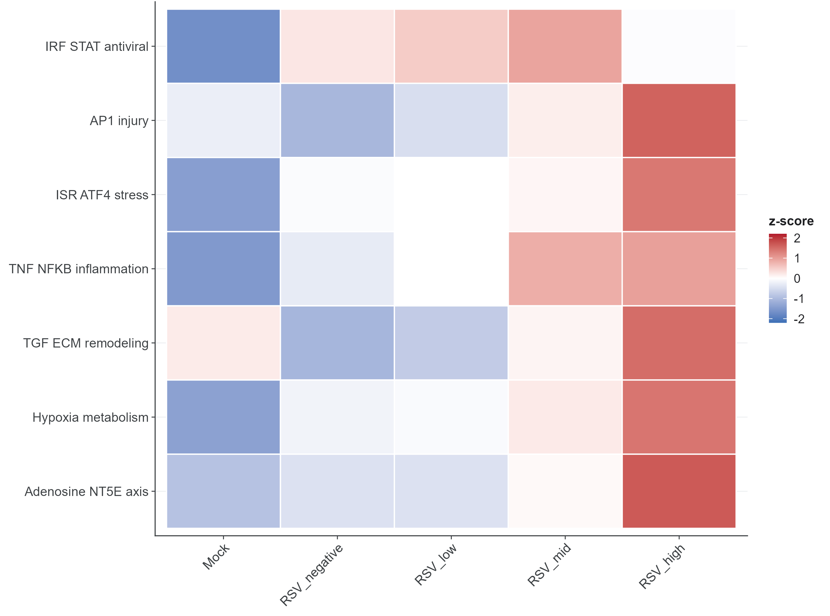
Figure S4. Transcription-factor and pathway axes. (A) Transcription-factor summary of ranked RSV-associated programs. (B) Pathway-level enrichment highlights stress, interferon and NF-kappaB-related axes. (C) Remodeling and metabolic summaries nominate TGF-beta, EGFR, TWEAK and metabolic-response biology.
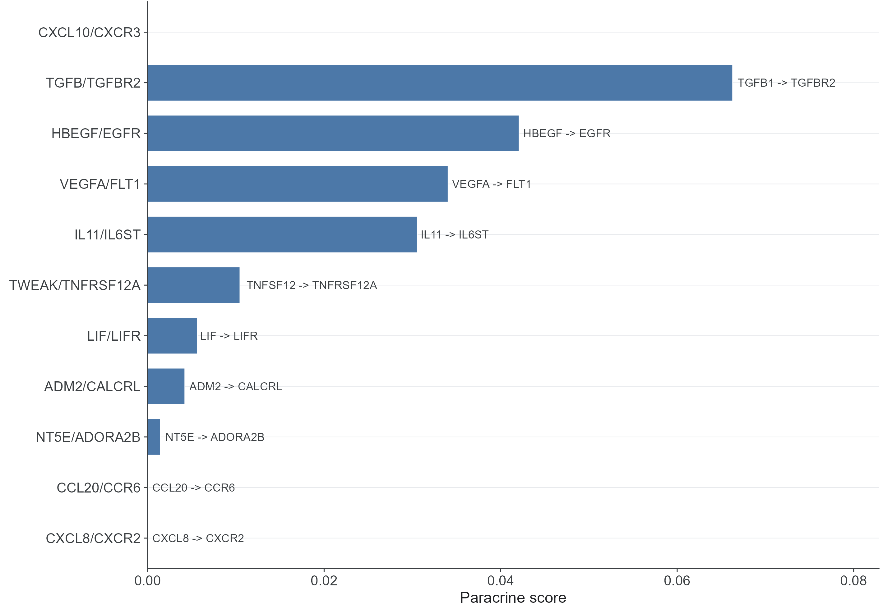
Figure S5. Ligand-receptor remodeling axes. (A) Curated sender-receiver expression scores prioritize candidate paracrine interactions. (B) Top remodeling axes include TGFB/TGFBR2, HBEGF/EGFR, VEGFA/FLT1, IL11/IL6ST and TWEAK/TNFRSF12A. (C) Scores represent expression-based ligand and receptor abundance across sender and receiver states, not permutation-tested interaction probabilities.
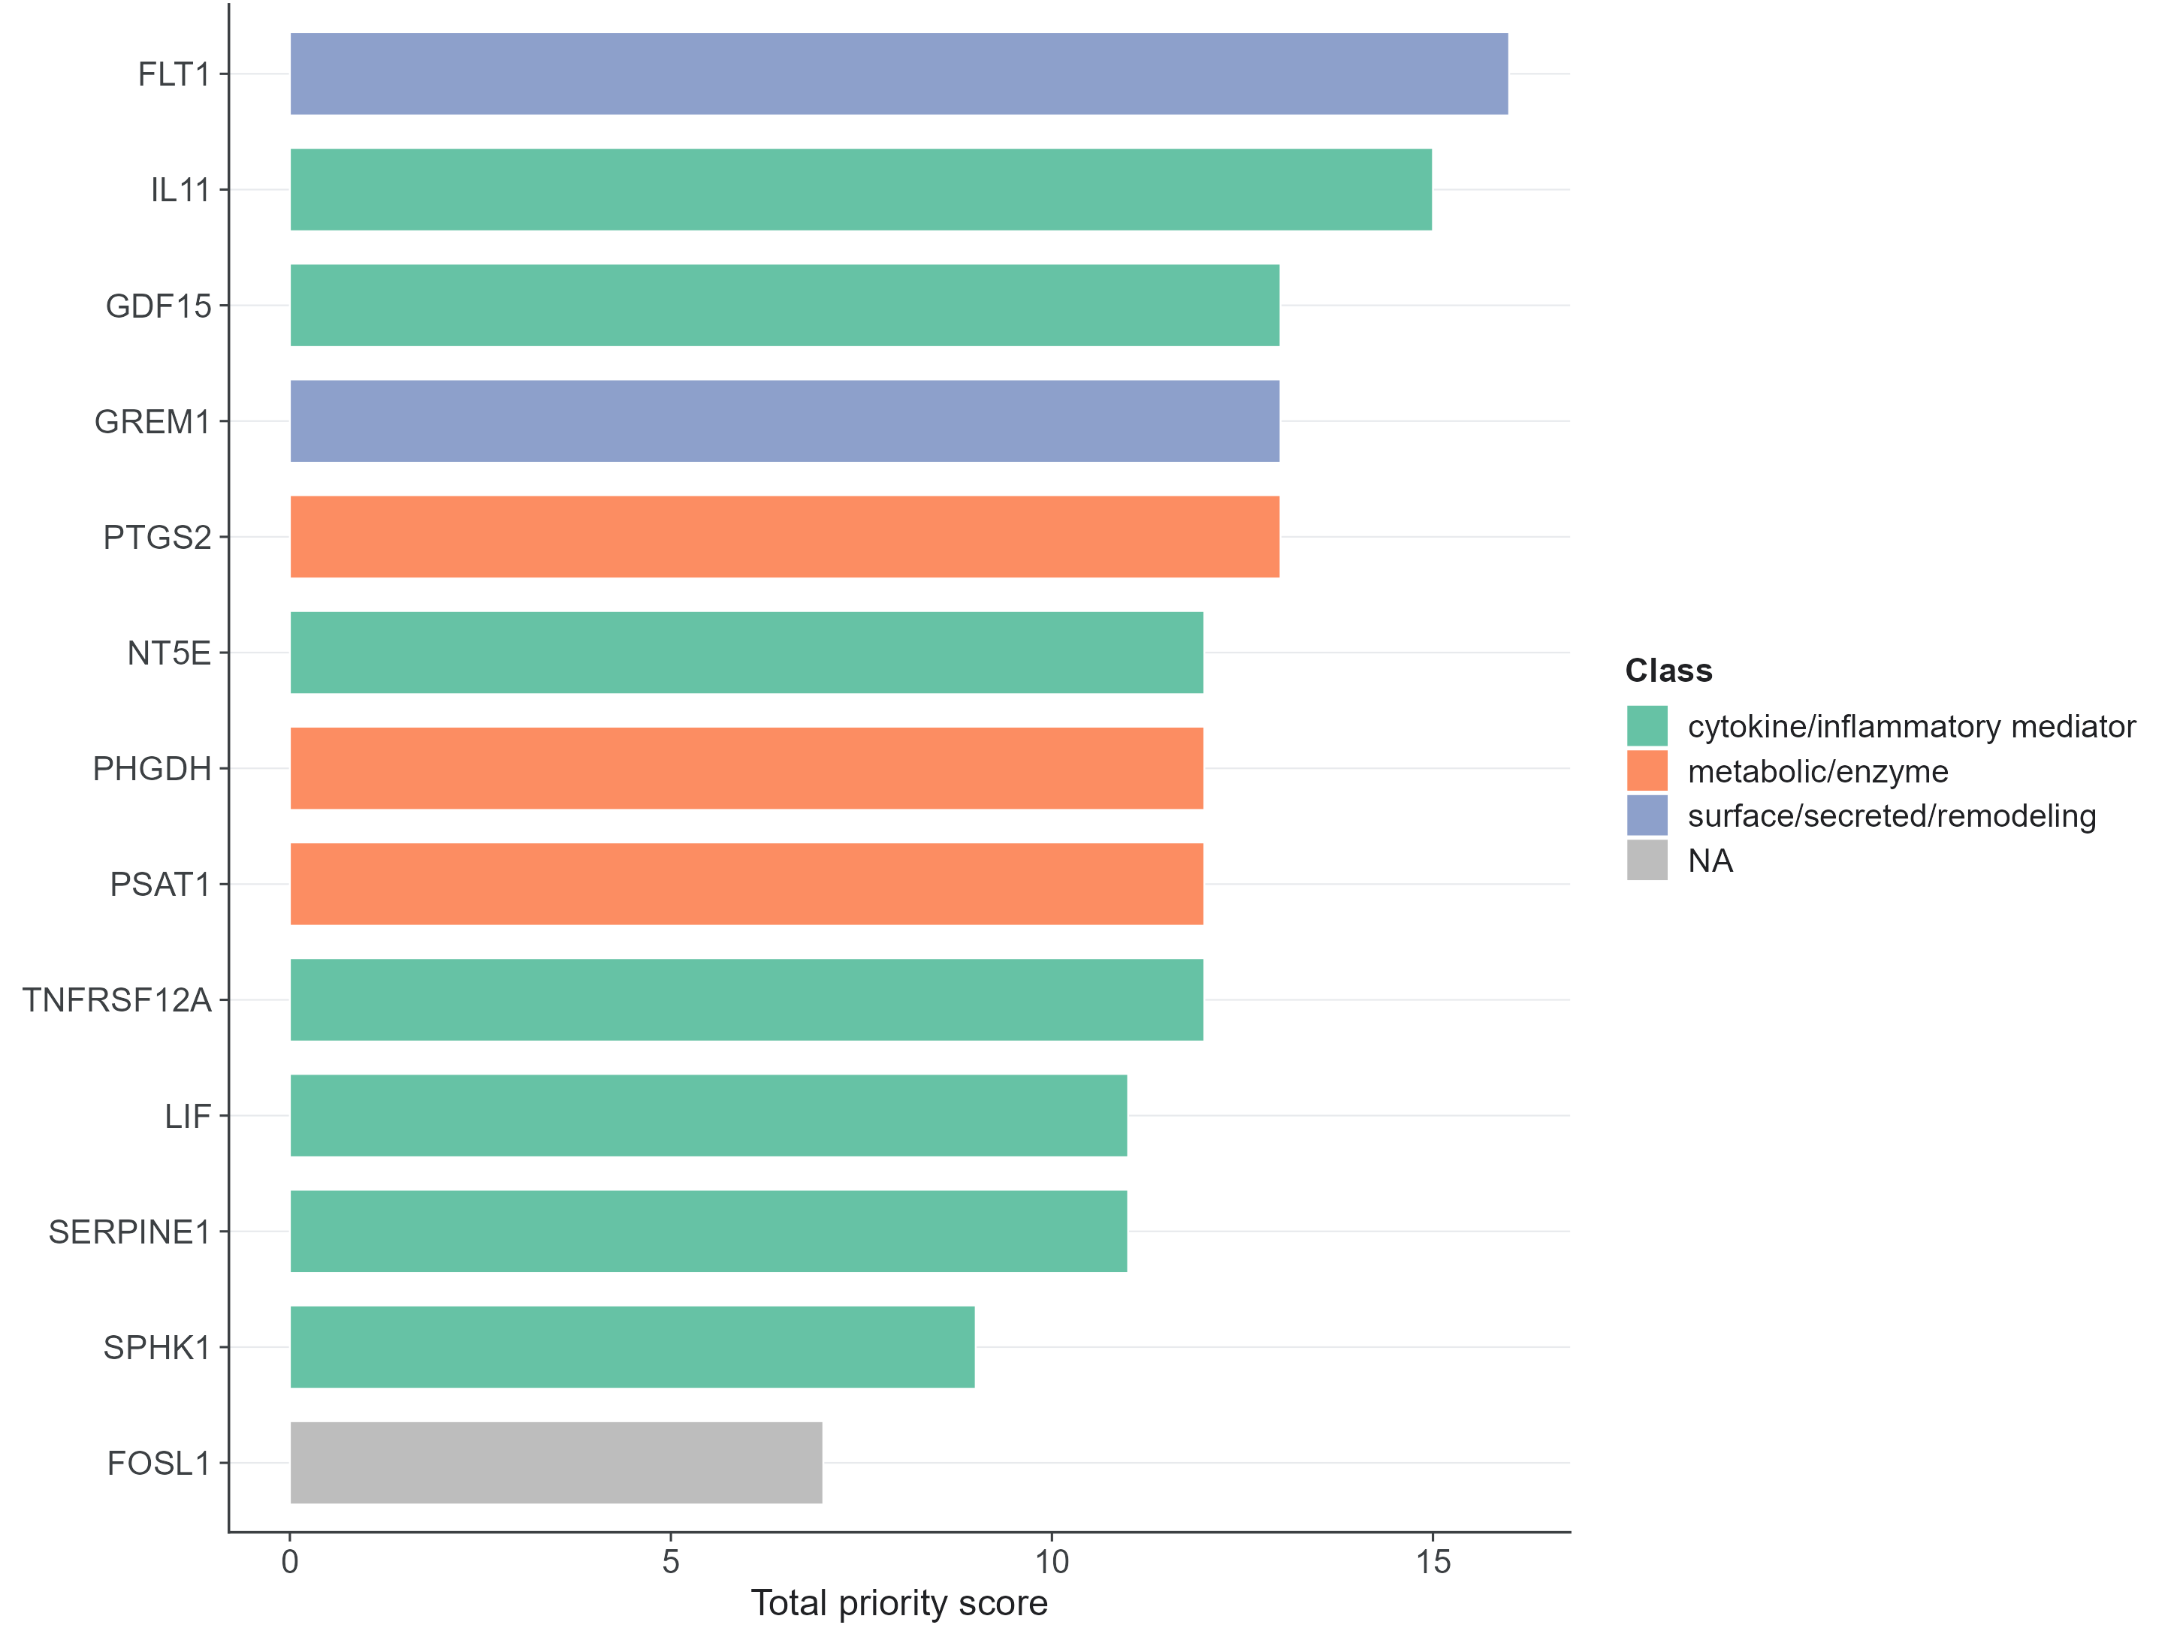
Figure S6. Integrated target panel. (A) Candidate genes summarized by differential-expression evidence. (B) Viral-load association and pathway membership prioritize injury-remodeling genes. (C) Cross-dataset support highlights candidates that remain coherent beyond the discovery single-cell atlas.
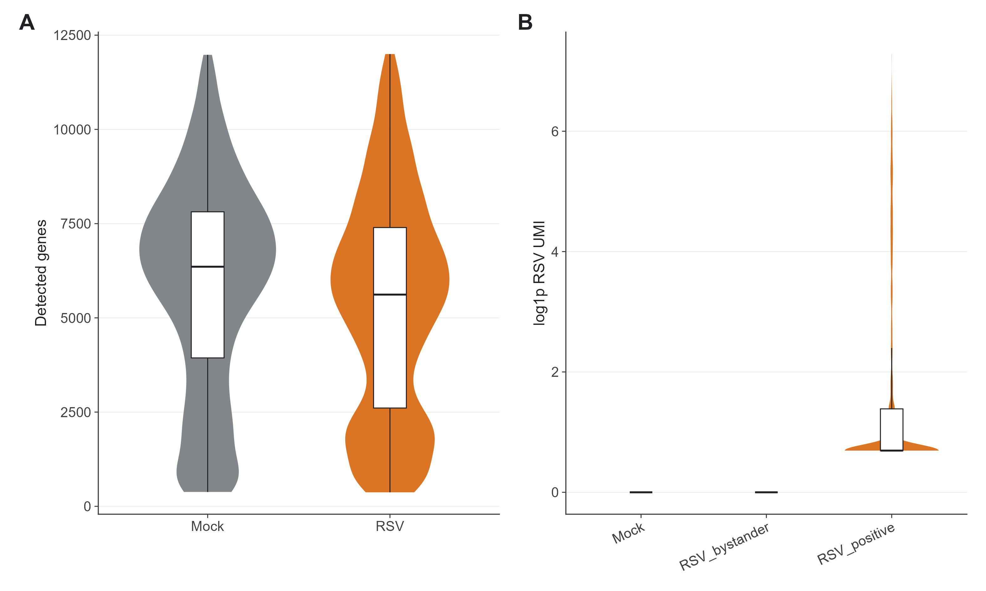
Figure S7. Quality control and RSV feature capture. (A) Single-cell quality-control metrics for the discovery atlas. (B) RSV feature capture across exposed cells. (C) Infection-state definition based on detectable RSV UMI signal. (D) Threshold sensitivity analyses for RSV UMI >=2, >=3, >=5 and >=10 are provided in Supplementary Data 2.
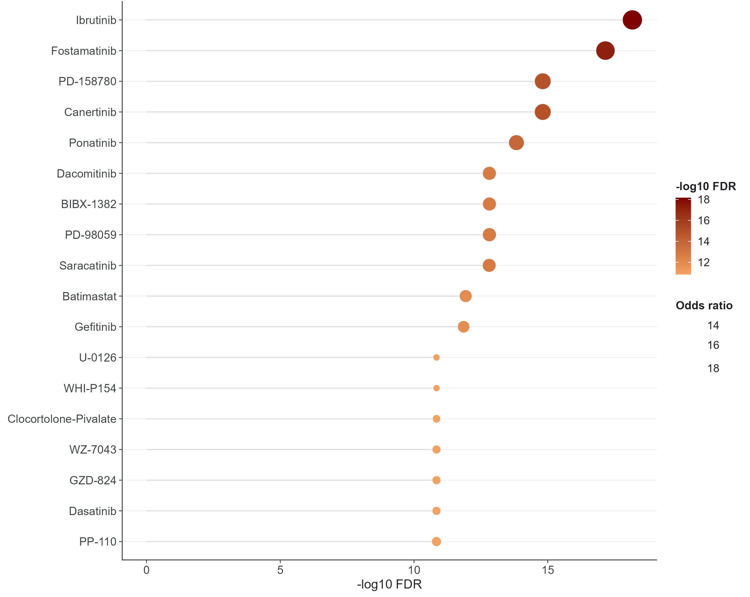
Figure S8. Perturbagen and virtual-screening details. (A) Drug-signature reversal ranks candidate perturbagens against RSV-associated host signatures. (B) Virtual perturbation summaries rank candidate host nodes. (C) These outputs are prioritization evidence for follow-up validation rather than direct drug-efficacy evidence.
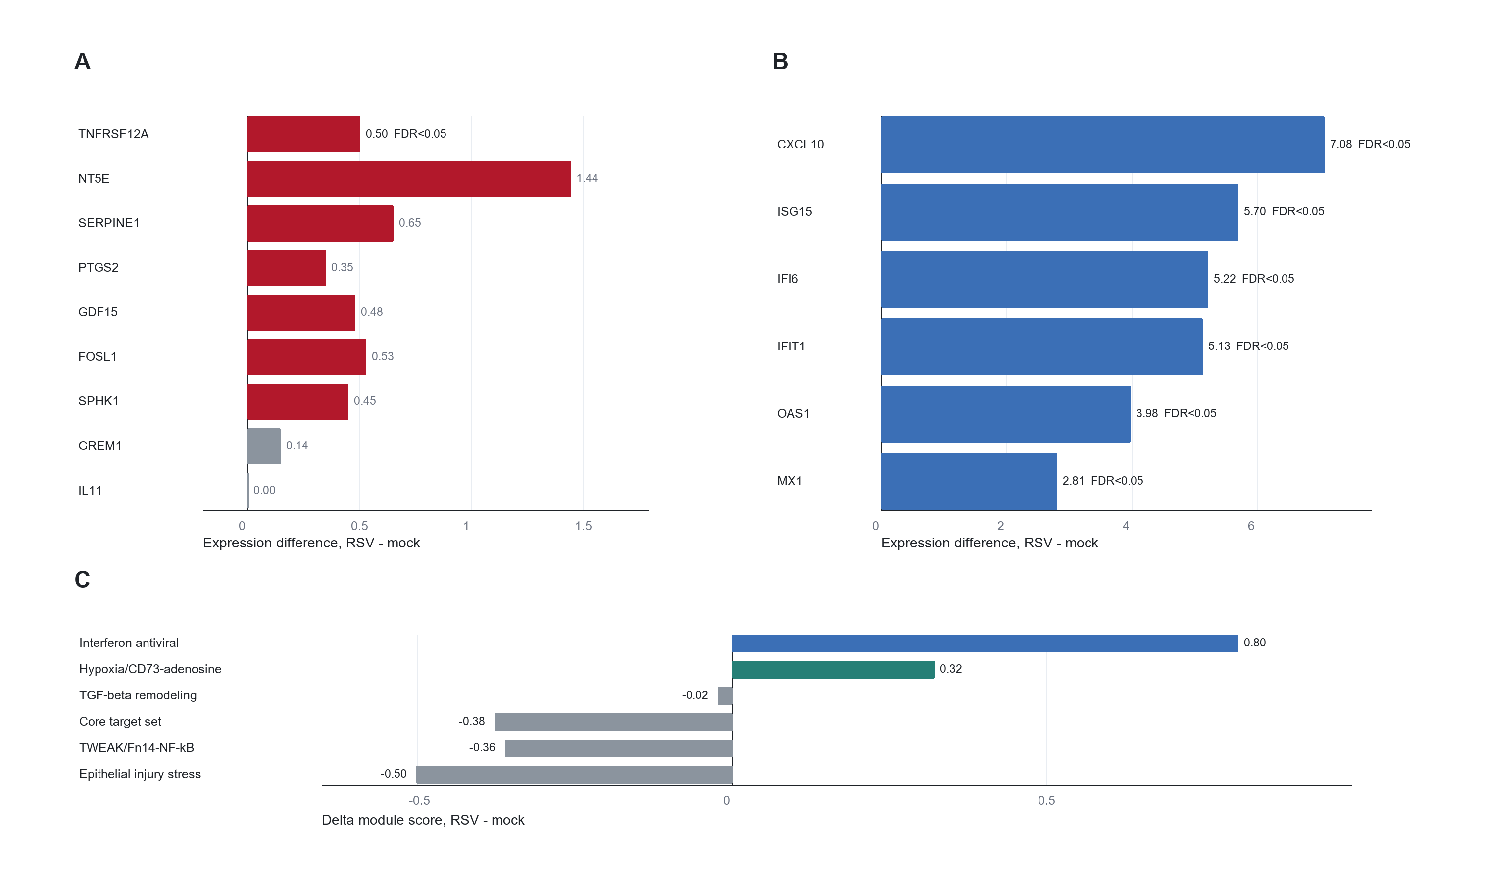
Figure S9. External support in GSE32139 primary airway epithelium. (A) Time-matched RSV 48 h and mock 48 h primary polarized airway epithelial samples were compared. (B) Antiviral controls show expected induction. (C) TNFRSF12A, NT5E, SERPINE1 and PTGS2 show supportive epithelial responses. (D) IL11 shows context dependence in this primary-cell dataset.
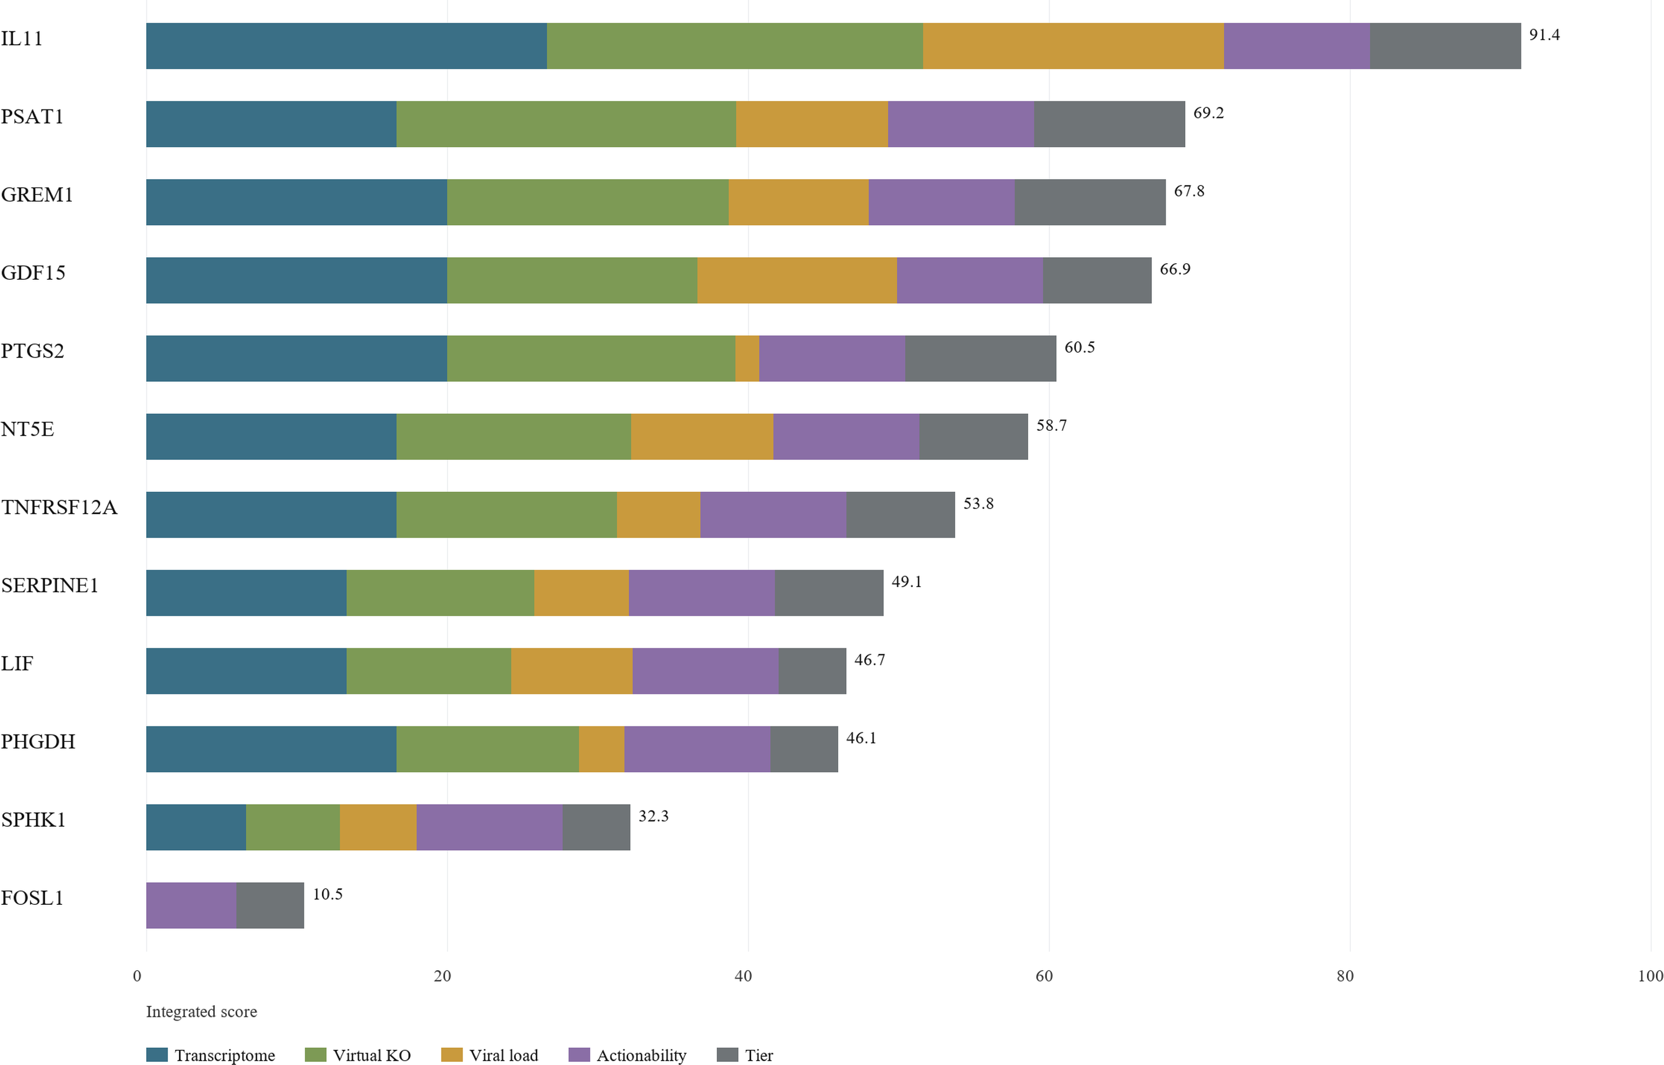
Figure S10. Multi-layer host-target reprioritization. (A) Differential expression, viral-load association, virtual perturbation summaries, tier labels and actionability features were integrated using transparent post hoc weights. (B) IL11, PSAT1, GREM1 and PTGS2 remain the most stable Tier 1 candidates. (C) GDF15, NT5E/CD73, TNFRSF12A/Fn14 and SERPINE1 form a biologically coherent second tier. Full weights and component scores are provided in Supplementary Data 2.
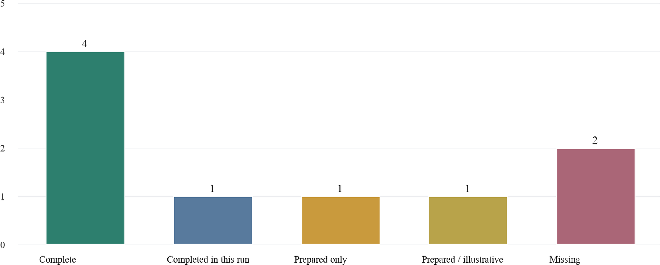
Figure S11. Evidence-boundary audit for the optional direct-antiviral add-on. (A) Completed evidence layers include the host-response atlas and prioritization workflow. (B) Prepared-only layers include the direct-antiviral scaffold explored during project development. (C) Missing evidence layers include final docking, molecular-dynamics and resistance-hotspot tables. This audit explains why direct RSV F-protein inhibitor combinations are retained as future validation context rather than presented as a main result.

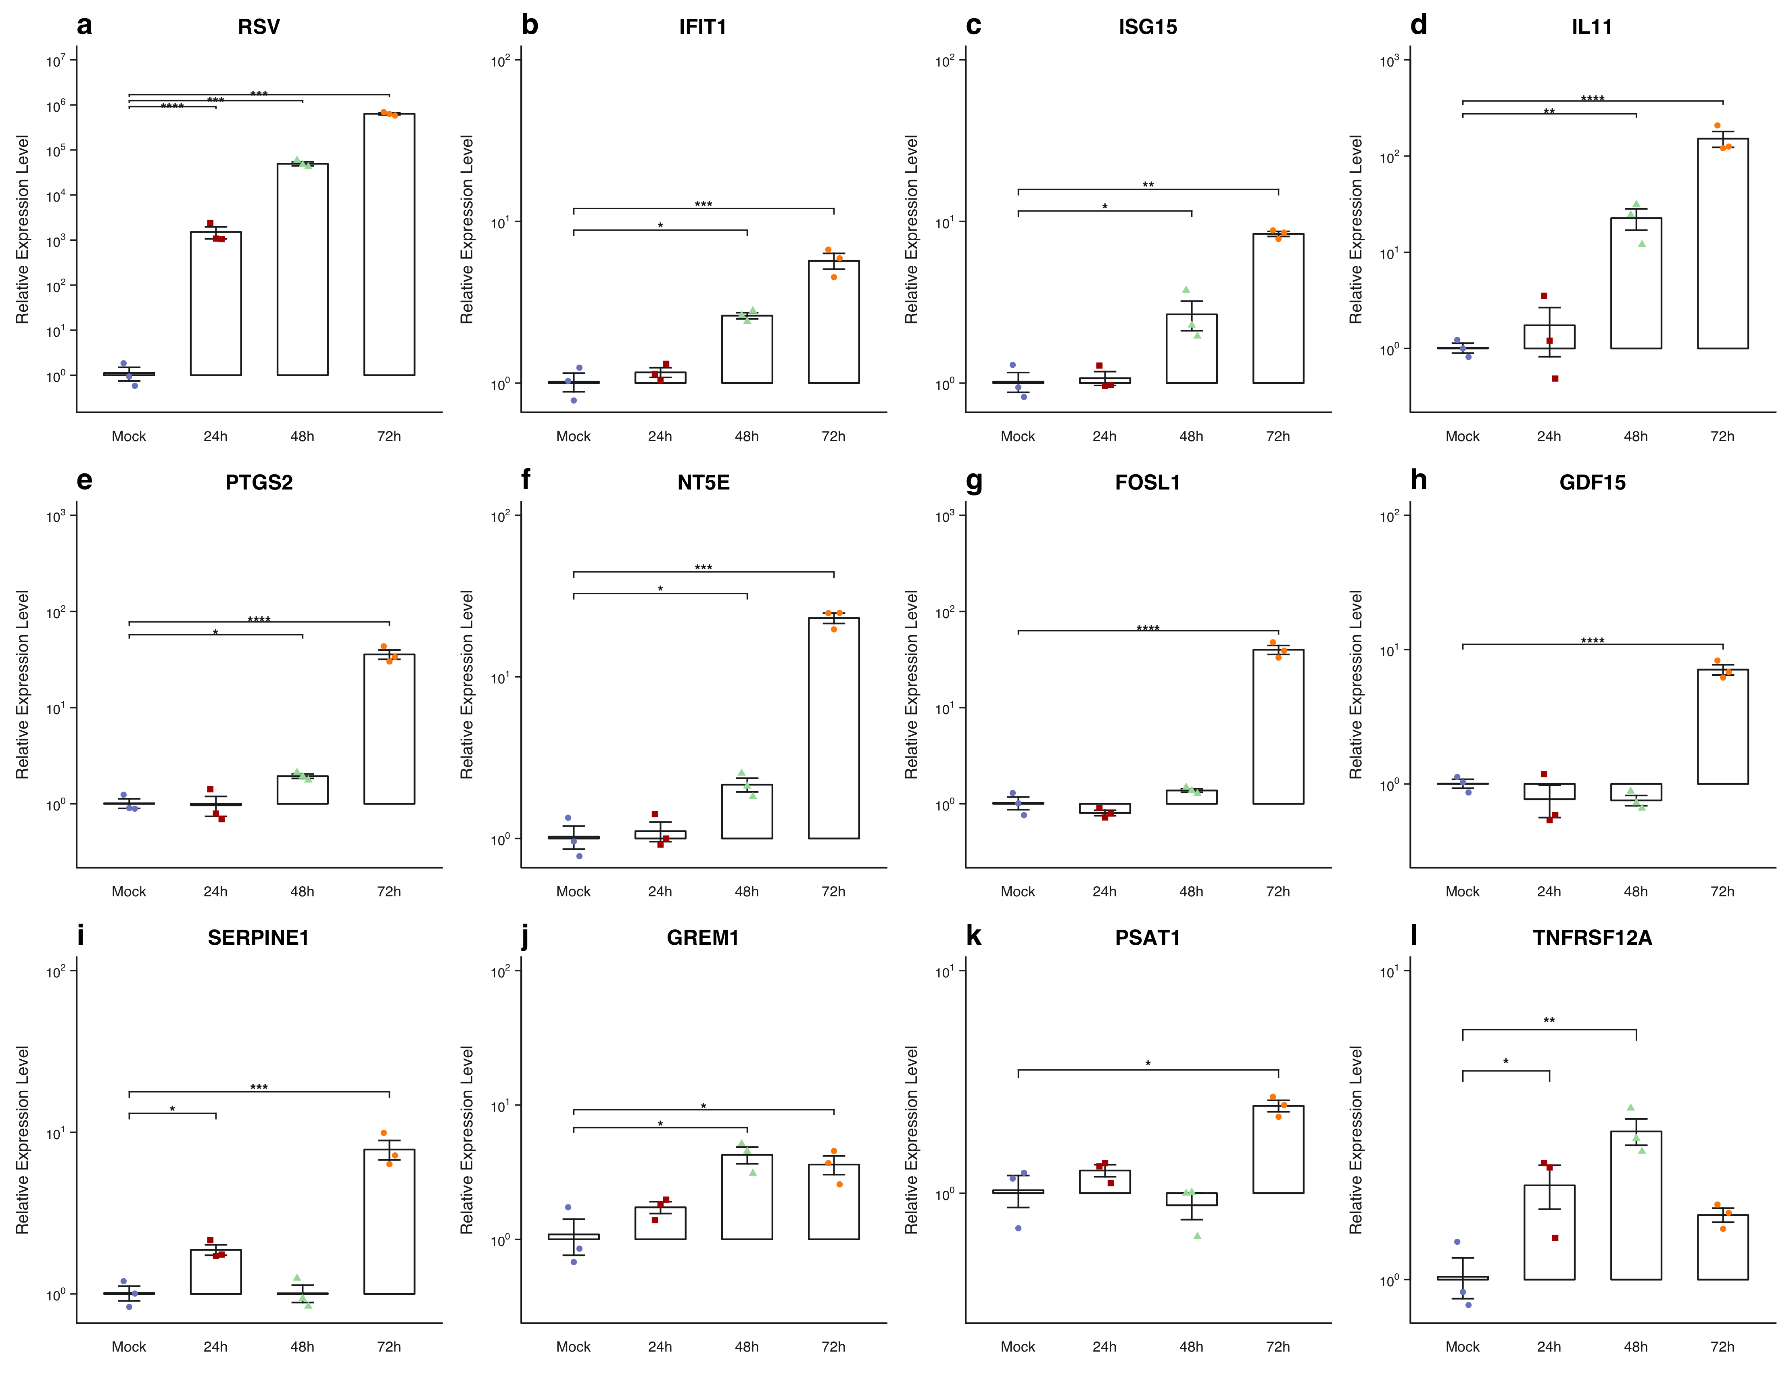
Figure S12. In-house RSV qPCR time-course support screen. (A) RSV signal increases from 24 to 72 h. (B) Antiviral controls IFIT1 and ISG15 are induced. (C) Selected injury-remodeling candidates including IL11, PTGS2, NT5E, FOSL1 and GDF15 show supportive time-course induction. (D) SERPINE1 and TNFRSF12A are weaker or more variable in the current assay. Raw Ct values, normalized calculations, replicate-level summaries, primer sequences and qPCR processing metadata are provided in Supplementary Data 1.

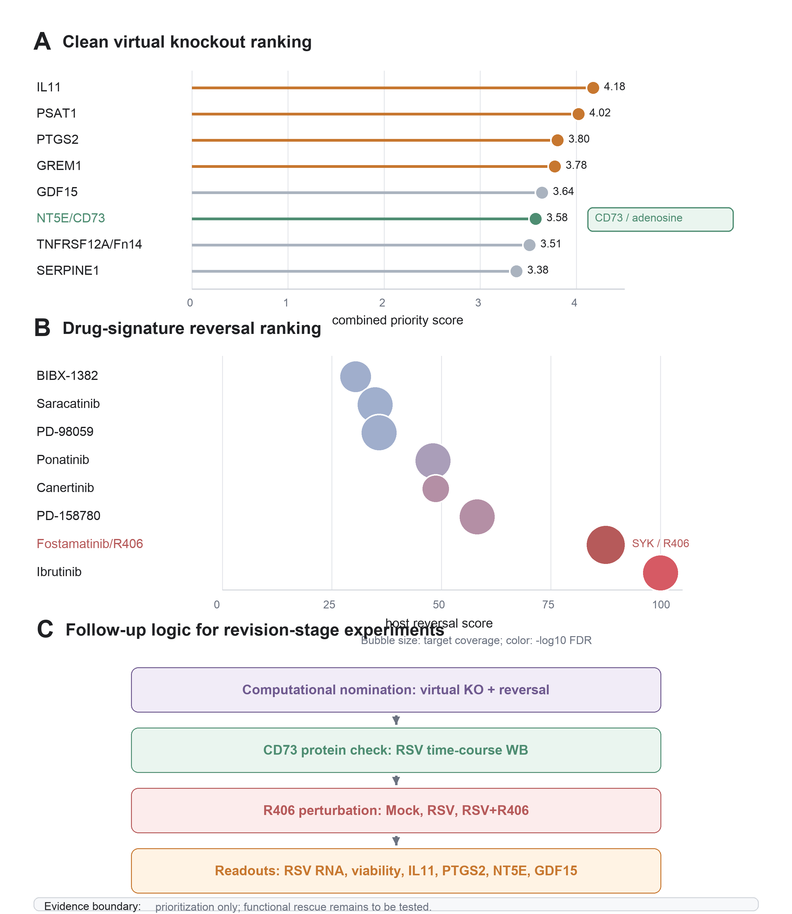
Figure S13. In silico perturbation prioritizes CD73/adenosine and SYK/R406 candidate axes. (A) Clean virtual knockout ranking highlights NT5E/CD73 as a secondary-tier network-relevant candidate. (B) Drug-signature reversal ranks host-response perturbagens and highlights Fostamatinib/R406 as a high-priority SYK-axis follow-up candidate. (C) Compact follow-up roadmap summarizes CD73 protein induction testing, R406 perturbation and readouts for RSV RNA, viability and remodeling markers. The figure supports experimental prioritization only and does not establish functional rescue.

