Supplementary materials:

Temperature effect on Re-entrant condensation of globular protein in presence of tri-valent ions

Subhankar Pandit, Sarathi Kundu*

Soft Nano Laboratory, Physical Sciences Division, Institute of Advanced Study in Science and Technology, Vigyan Path, Paschim Boragaon, Garchuk, Guwahati, Assam 781035, India

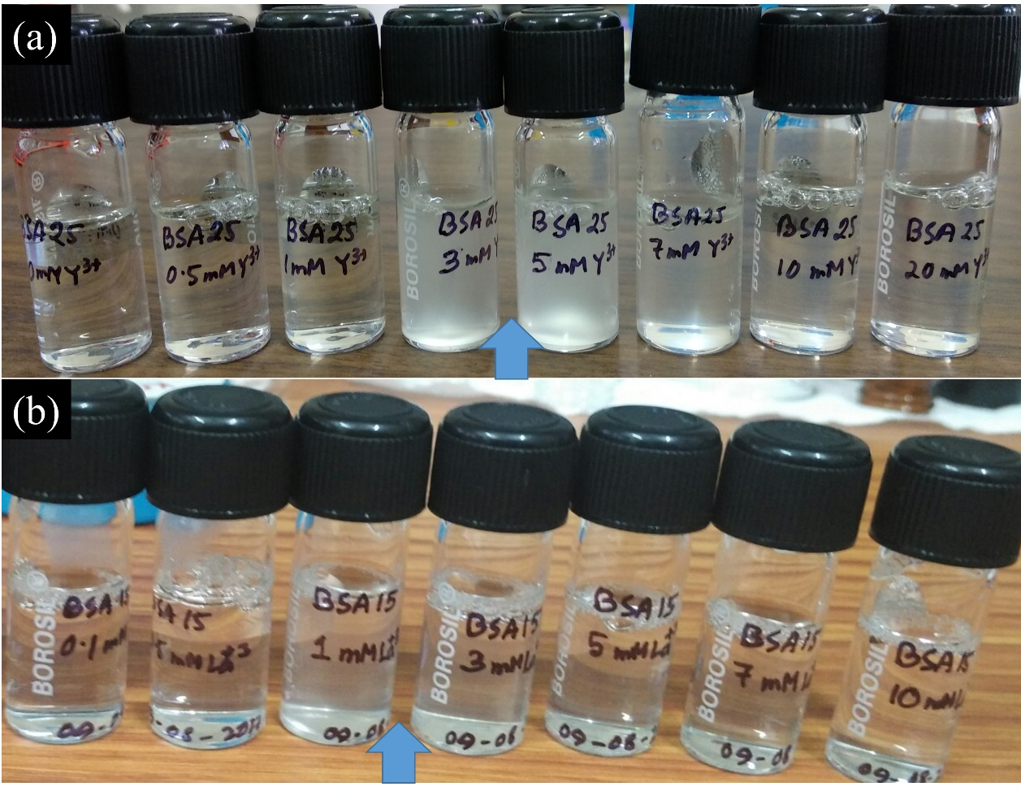
Fig. S1: Photograph of re-entrant phase of BSA protein in the presence of tri-valent ions (a)Yttrium (Y³⁺), and (b) Lanthanum (La³⁺).
Fig. S2: UV-Visible absorption (black line) and fluorescence emission (red line) of pure BSA at 25 mg/ml concentration at room temperature (25ºC).

