Supporting Information (SI)
Defect Geometry and Concentration Controlled Excitonic Landscape in Monolayer MX₂-family: A Systematic G₀W₀-BSE Study of Chalcogen Vacancies
Shishir Timilsenaª, Sanju Gupta^{b,c,*}, Muhammad Idrees Bhattiª, and Nicholas Dimakis^{a,*}
ªDepartment of Physics and Astronomy, University of Texas-Rio Grande Valley, Edinburg, TX 78539, USA
^{b}Department of Physics, The Pennsylvania State University, University Park, PA 16802, USA
^{c}Department of Physics and Astronomy, University of Georgia, Athens, GA 30602, USA

Table T1. Supercell sizes and corresponding lattice constants used for the DFT calculations of MoS₂, MoSe₂, and WSe₂.
 | Supercell | Lattice Constant Å
MoS₂ | 4×4×1 | 12.77
MoS₂ | 2×2×1 | 6.38
MoS₂ | 1×1×1 | 3.19 (Ref [1])
MoSe₂ | 4×4×1 | 13.29
MoSe₂ | 2×2×1 | 6.64
MoSe₂ | 1×1×1 | 3.32 (Ref [2])
WSe₂ | 4×4×1 | 13.28
WSe₂ | 2×2×1 | 6.64
WSe₂ | 1×1×1 | 3.32 (Ref [3] )

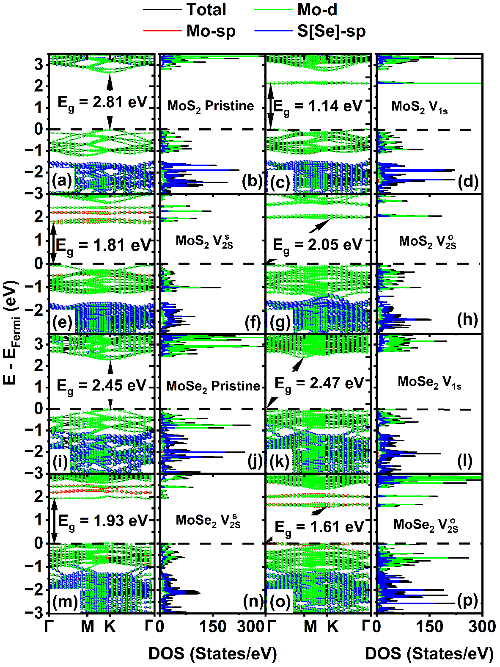

Fig. S1. Wannier-interpolated G₀W₀ band structures and corresponding G₀W₀ density of states (DOS), including both total and orbital-projected contributions, for pristine and defective 4×4 MoS₂ and MoSe₂ monolayers without spin–orbit coupling. Panels show (a, b) pristine MoS₂, (c, d) MoS₂ $V_{1S}$, (e, f) MoS₂ $V_{2S}^{s}$, (g, h) MoS₂ $V_{2S}^{o}$, (i, j) pristine MoSe₂, (k, l) MoSe₂ $V_{1Se}$, (m, n) MoSe₂ $V_{2Se}^{s}$, and (o, p) MoSe₂ $V_{2Se}^{o}$. Black, red, green, and blue denote the total, metal-sp, metal-d, and S/Se-sp contributions, respectively. The arrows indicate the G₀W₀ band gaps, and the Fermi energy is set to zero. Here, $V_{1X}$, $V_{2X}^{s}$, and $V_{2X}^{o}$, denote a single chalcogen vacancy, two chalcogen vacancies in the same layer, and two chalcogen vacancies in opposite layers, respectively, where X = S or Se.

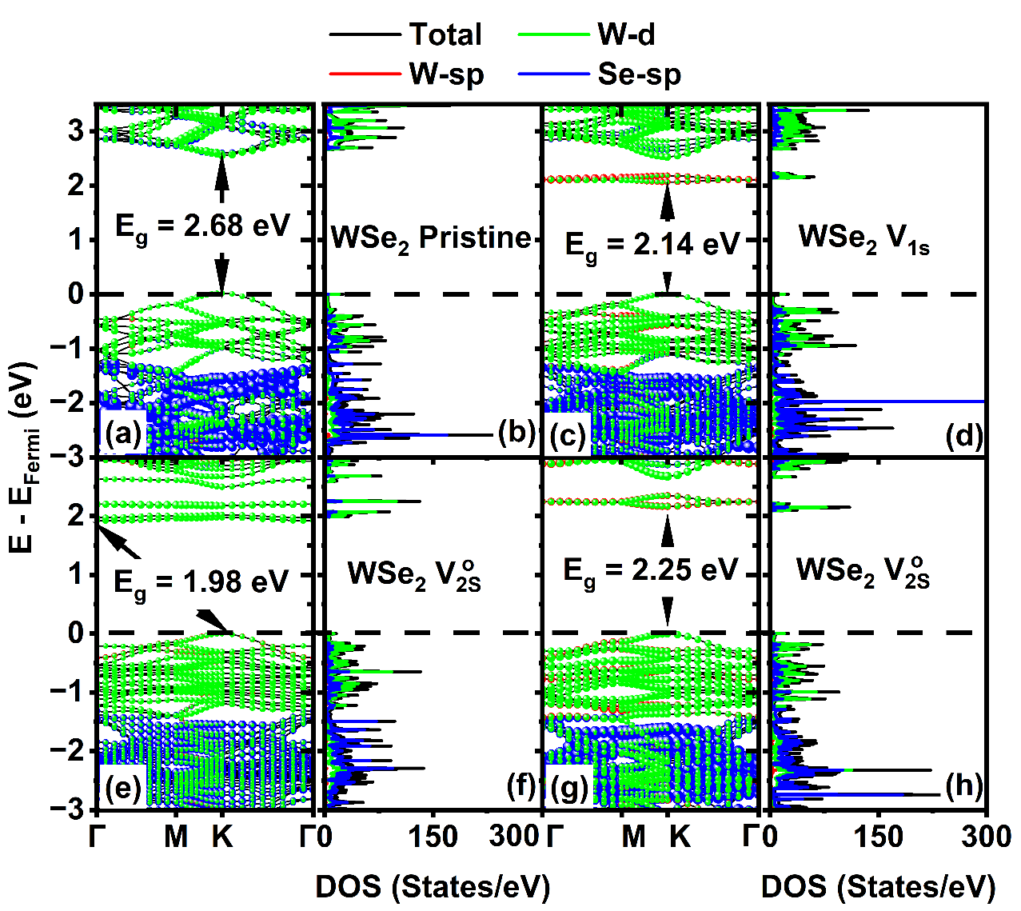

Fig. S2. Wannier-interpolated G₀W₀ band structures and corresponding G₀W₀ density of states (DOS), including both total and orbital-projected contributions, for pristine and defective 4×4 WSe₂ monolayers without spin-orbit coupling. Panels show (a, b) pristine WSe₂, (c, d) single Se vacancy $V_{1Se}$, (e, f) same-layer Se divacancy $V_{2Se}^{s}$, and (g, h) opposite-layer Se divacancy $V_{2Se}^{o}$. Black, red, green, and blue denote total, W-sp, W-d, and Se-sp contributions, respectively. The arrows indicate the G₀W₀ band gaps, and the Fermi energy is set to zero.

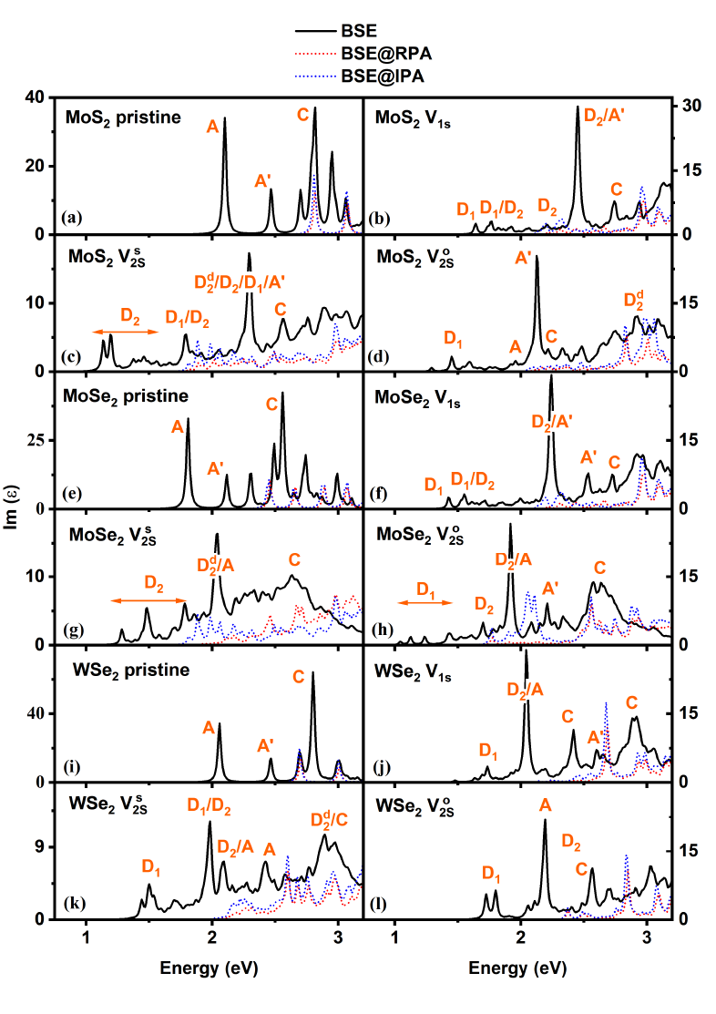
Fig. S3. In-plane component of the imaginary part of the dielectric function calculated for the 4×4 supercells of (a)-(d) MoS₂, (e)-(h) MoSe_{2,} and (i)-(l) WSe₂ monolayers. Panels show (a, e, i) pristine monolayers, (b, f, j) single chalcogen vacancy $V_{1X}$, double chalcogen vacancies on the same layer (c, g, k) $V_{2X}^{s}$ and (d,h,l) on opposite layers $V_{2X}^{o}$, where X = S or Se. Black, red, and blue curves correspond to the full BSE, BSE@RPA, and BSE@IPA spectra, respectively. RPA denotes the random-phase approximation, and IPA the independent-particle approximation. The labels A, B, A′, B′, and C denote bright, pristine-like excitonic features, whereas in defective spectra, these labels refer to perturbed, host-like excitons when they remain resolved. Orange arrows in the defective spectra indicate the classified optical regions: $D_{2}^{d}$ or Deep D₂ corresponding to deep in-gap defect-to-defect transitions, D₂ corresponding to shallower defect-to-defect transitions, and D₁ corresponding to transitions from perturbed valence-band states to defect-derived states in the conduction band.

Table S2. Direct G₀W₀ band gap ($E_{g}^{GW})$, exciton binding energy ($E_{b}$), and approximate energy ranges and prominent peaks based on oscillator strength for the D₁, Deep D₂, D₂, and the perturbed host-like excitons of defective 2×2 supercells of MoS_{2,} MoSe_{2,} and WSe₂ monolayers with spin–orbit coupling. The Brillouin zone was sampled using a Γ-centered 8×8×1 grid. D₁ denotes perturbed valence-to-defect band transitions, D₂ denotes defect-to-defect band transitions involving shallow defect states, and Deep D₂ denotes defect-to-defect transitions involving deeper vacancy-derived states. $V_{1X}$, $V_{2X}^{s}$, and, $V_{2X}^{o}$ denote a single chalcogen vacancy, same-layer chalcogen divacancy, and opposite-layer chalcogen divacancy, respectively, where X = S or Se.
Defect | $$E_{g}^{GW}$$ | $$E_{b}$$ | Optical Transition Energies (eV)
 |  |  | D₁ | Deep D₂ | D₂ | A-like / A′-like / upper perturbed
MoS₂
$$V_{1S}$$ | 1.56 | 0.57 | 1.13–1.50; 2.00 | 2.00; 2.15; 2.31; 2.44; 2.61 | 1.59–1.63; 2.00; 2.09 | 2.21–2.25ª; 2.36^{b}; 2.44^{c}; 2.65^{d}; 3.14e
$$V_{2S}^{s}$$ | 0.62 | 0.36 | 0.54–1.56; 1.81; 2.34; 2.41 | 1.53; 1.57; 1.68; 1.87–2.01; 2.05–2.20; 2.38; 2.42–2.54; 2.62–2.68 | 0.27–0.42; 0.79–0.86; 0.92–0.99; 1.12–1.14; 1.21–1.25; 1.26–1.31; 1.49; 1.51; 1.54; 1.57; 2.01 | 2.41ª; 2.62 ^{c}; 2.72^{f}; 2.79e
$$V_{2S}^{o}$$ | 1.27 | 0.51 | 1.38–1.53; 1.66–1.71; 1.74–1.79; 1.86–1.95; 2.11 | 1.57; 1.70–2.24; 2.56; 2.63; 2.77; 3.09 | 0.83–1.35; 1.39; 1.52; 1.67; 1.80 | 2.02ª; 2.13^{b}; 2.17^{c}; 2.24^{d}; 2.98e
MoSe₂
$$V_{1Se}$$ | 1.23 | 0.34 | 0.98–1.48; 1.78; 1.87 | 1.48–1.68; 1.80; 1.87; 1.91; 1.95; 2.02; 2.72 | 1.83–1.87; 1.88; 1.95; 2.14 | 1.79 ª, 2.00^{c}; 2.08^{f}; 2.13^{b}; 2.15 ^{f}; 2.60e
$$V_{2Se}^{s}$$ | 0.61 | 0.33 | 0.43–0.83; 1.02–1.13; 1.19–1.30; 1.73; 1.86; 2.03; 2.21 | 1.00–1.48; 1.60–2.16; 2.28–2.36; 2.74–2.76 | 0.30; 0.85–0.90; 1.10; 1.14–1.17; 1.22; 1.26–1.27; 1.34; 1.41–1.49; 1.91; 2.12 | 2.34^{c,e}
$$V_{2Se}^{o}$$ | 1.13 | 0.49 | 1.44–1.60; 1.70–1.72; 1.77–1.81; 1.90–1.97 | 1.95; 2.01–2.07; 2.40; 2.66–2.67 | 0.71–0.81; 1.17–1.20 | 1.46–1.47 ª; 1.54–1.55^{b}; 1.64–1.66^{c}; 1.76–1.78^{c}; 1.81–1.86 ^{c}; 2.05^{f}; 2.42e
WSe₂
$$V_{1Se}$$ | 1.27 | 0.32 | 0.95–1.64; 1.65–1.75; 1.78–1.82; 1.84–1.85; 1.88; 1.92; 2.07 | 1.87; 1.99; 2.03–2.06; 2.30–2.36; 2.38; 2.42; 2.47–2.48; 2.55–2.60; 2.81; | 1.63;1.65; 1.76; 1.80–1.83; 1.88; 1.94–1.96; 2.02–2.05; 2.09–2.14; 2.21–2.22; 2.28–2.36; 2.48 | 1.77–1.79ª; 1.81^{b}; 1.84^{c}; 2.13^{f}; 2.25e
$$V_{2Se}^{s}$$ | 1.30 | 0.43 | 0.87–1.11; 1.18; 1.23; 1.34–1.39; 1.90; 2.04; 2.33 | 1.22; 1.29; 1.41; 1.52; 1.66; 1.84–1.96; 2.07; 2.16; 2.31–2.35; 2.51–2.64; 2.90 | 1.02–1.06; 1.10; 1.16–1.22; 1.25–1.46; 1.54–1.84; 2.36; 2.55 | 2.56e
$$V_{2Se}^{o}$$ | 1.25 | 0.53 | 0.72–1.43; 1.68–1.70; 1.78; 2.08–2.11 | 1.83; 1.88; 2.10–2.16; 2.24; 2.30; 2.36; 2.41; 2.46–2.50 | 1.83–1.84; 1.87; 1.90; 2.00–2.06; 2.12–2.20; 2.32 | 1.62ª; 1.79–1.84^{b}; 1.87–1.91^{c}; 1.96^{d}; 2.00^{f}; 2.31e
Perturbed excitons are labeled as follows: ª A-like; ^{b} B-like; ^{c} A′-like; ^{d} B′-like; ^{e} higher-lying mixed/C-like; ^{f} 3s/3p Rydberg state.

Table S3. Direct G₀W₀ band gap ($E_{g}^{GW})$, exciton binding energy ($E_{b}$), and approximate energy ranges and prominent peaks based on oscillator strength for the D₁, Deep D₂, D₂, and the perturbed host-like excitons of defective 4×4 supercells of MoS_{2,} MoSe_{2,} and WSe₂ monolayers without spin–orbit coupling. The Brillouin zone was sampled using a Γ-centered 4×4×1 grid. D₁ denotes perturbed valence-to-defect band transitions, D₂ denotes defect-to-defect band transitions involving shallow defect states, and Deep D₂ denotes defect-to-defect transitions involving deeper vacancy-derived states. $V_{1X}$, $V_{2X}^{s}$, and, $V_{2X}^{o}$ denote a single chalcogen vacancy, same-layer chalcogen divacancy, and opposite-layer chalcogen divacancy, respectively, where X = S or Se.

Defect | $$E_{g}^{GW}$$ | $$E_{b}$$ | Optical Transition Energies (eV)
 |  |  | D₁ | Deep D₂ | D₂ | A-like / A′-like / upper perturbed
MoS₂
$$V_{1S}$$ | 2.14 | 0.72 | 1.64–1.86 |  | 1.76; 1.90; 1.93–2.46 | 2.46^{i}; 2.54ª; 2.68^{b}; $≥$2.73^{c}
$$V_{2S}^{s}$$ | 1.81 | 0.68 | 1.78–1.80; 1.91; 2.28 | 2.24; 2.29; 2.30–2.31; 2.36; 2.54; 2.81; 2.88; 2.96 | 1.14–1.56; 1.84; 1.92–2.05; 2.27 | 2.29–2.31^{vi}; $≥$2.54^{c}
$$V_{2S}^{o}$$ | 2.06 | 0.77 | 1.45; 1.59 | 2.92–3.02 | 1.29; 1.57; 1.96–2.12 | 1.95^{v}; 2.13^{b}; $≥$2.21^{c}
MoSe₂
$$V_{1Se}$$ | 2.14 | 0.71 | 1.43–1.52; 1.55^{ii}; 1.56–1.65; 1.69^{ii} |  | 1.55^{ii};1.69^{ii}; 1.72–2.25 | 2.25^{i}; 2.33ª; 2.53^{b}; $≥$2.51^{c}
$$V_{2Se}^{s}$$ | 1.93 | 0.65 | 1.94; 2.04 | 2.05; 2.41–2.42 | 1.28–1.91; 1.97–2.03; 2.06; 2.19; 2.23–2.24; 2.31 | 2.05 ª; 2.19^{iii}; 2.26–2.66^{c}; 2.53^{iv}; 2.67^{b}
$$V_{2Se}^{o}$$ | 1.66 | 0.62 | 1.04–1.44 | 2.09; 2.23–2.33; 2.63–2.78 | 1.52–1.93 | 1.92ª;2.32^{b}; 2.64^{b}; 2.54–2.78^{c}
WSe₂
$$V_{1Se}$$ | 2.14 | 0.51 | 1.63–1.96 | 2.81–2.84; 2.87–2.94 | 2.04; 2.20; 2.39; 2.61; 2.69 | 2.04ª; 2.16^{i}; 2.33–2.65^{c}; 2.66^{b}; 2.78^{i}; 2.81–2.87^{c}; 2.88^{d}; $≥$2.90^{c}
$$V_{2Se}^{s}$$ | 2.09 | 0.65 | 1.44–1.75; 1.96–1.99; 2.07; 2.11; 2.30 | 2.43–2.46; 2.52^{iv}; 2.58; 2.76; 2.77^{iv}; 2.83^{iv}; 2.89^{iv}; 2.94–2.96 | 1.88–1.95; 1.97; 2.00; 2.06; 2.08–2.10; 2.16–2.24; 2.31; 2.34; 2.49; 2.58; | 2.09ª; 2.13^{v}; 2.16^{v}; 2.18; 2.24^{b}; 2.27ª; 2.42ª; 2.46ª; ≥2.41^{c}
$$V_{2Se}^{o}$$ | 2.09 | 0.54 | 1.72–1.80 | 2.77; 2.88–2.91; 2.96 | 2.06–2.17; 2.27; 2.34; 2.40; 2.48–2.49; 2.55; 2.57; 2.59; 2.69^{i}; 2.71^{iii}; 2.75 | 2.19ª; 2.35^{b}; 2.54ª; 2.56–2.68^{c}; ≥2.71^{c}
Perturbed excitons are labeled as follows: ª A-like; ^{b} A′-like; ^{c} higher-lying mixed/C-like; ^{d} 3s/3p Rydberg state. Mixed excitons as follows: ^{i} D₂+A'; ^{ii} D₁+D₂; ^{iii} Deep D₂+ higher-lying mixed/C-like; ^{iv} Deep D₂+A-like; ^{v} D₁+A-like.

References
[1] S. Ahmad, S. Mukherjee, A comparative study of electronic properties of bulk MoS2 and its monolayer using DFT technique: application of mechanical strain on MoS2 monolayer, Graphene, 3 (2014) 52–59.
[2] Y. Feng, H. Bai, M. An, Y. Wu, X. Wang, Density functional theory study of the electronic and optical properties of SnSe2/MoSe2 heterostructures under strain and electric field: implications for optoelectronic devices, ACS Applied Nano Materials, 6 (2023) 15795–15806.
[3] Y. Wang, X. Zhang, On the role of crystal defects on the lattice thermal conductivity of monolayer WSe2 (P63/mmc) thermoelectric materials by DFT calculation, Superlattices and Microstructures, 160 (2021) 107057.

