Supplemental Information for: Arctic-boreal carbon flux representation greatly improved despite remaining gaps

SI Text:
This file contains supplemental tables and figures which help to understand certain analyses. It contains information on the sensitivity analysis on spatial resolution size impact on the analysis and more detailed tables and figures on Principle Components Analysis. There is also detailed maps of the clustering analysis results and how tower sites vary over various clusters and finally more information on potential next best sites across the four scenarios.
The following file contains the following:
Tables S1 & S2
Figures S1-S9

SI Tables and Figures
Table S 1: Summary statistics of the different spatial scales tested for the Euclidean distance analysis.
Euclidean Distance Statistic | 1 km | 2 km | 5 km | 10 km
Minimum | 0.13 | 0.15 | 0.16 | 0.16
1st Quartile | 1.14 | 1.14 | 1.14 | 1.13
Median | 1.45 | 1.48 | 1.47 | 1.47
Mean | 1.57 | 1.57 | 1.57 | 1.56
3rd Quartile | 1.91 | 1.91 | 1.91 | 1.91
Max | 5.77 | 5.74 | 7.46 | 8.08

Table S 2: Loadings of Principal Components (PC) in the Principal Components Analysis (PCA) showing the weighting and relationships of the input variables to the final PCA. Next to each PC in parentheses is the percent variability represented by each PC totaling 74% of variability.
Variables | PC1 (33%) | PC2 (20%) | PC3 (12%) | PC4 (8%)
Mean Annual Temperature | -0.35 | -0.06 | 0.02 | 0.19
Mean Annual Precipitation | -0.28 | -0.19 | -0.03 | -0.07
Precipitation Seasonality | 0.15 | 0.28 | -0.21 | -0.07
Mean Diurnal Range | -0.10 | 0.38 | -0.15 | -0.19
Isothermality | -0.27 | 0.02 | -0.15 | 0.13
Temperature Seasonality | 0.21 | 0.35 | -0.02 | -0.31
Temperature Annual Range | 0.14 | 0.39 | -0.03 | -0.32
Maximum Annual NDVI | 0.29 | -0.18 | -0.12 | 0.16
Annual NDVI Sum | -0.26 | 0.04 | 0.23 | -0.26
Maximum EVI | -0.33 | 0.18 | 0.00 | 0.03
Minimum NDWI | -0.30 | 0.25 | 0.12 | -0.07
August Band 7 (SWIR) | -0.27 | 0.21 | 0.15 | 0.08
Bulk Density | -0.09 | 0.10 | -0.49 | 0.06
pH | 0.23 | 0.09 | -0.16 | 0.41
Carbon Stock | 0.06 | -0.01 | 0.44 | -0.08
Carbon Density | 0.15 | -0.08 | 0.48 | -0.04
Sand | -0.06 | -0.35 | -0.21 | -0.43
Silt | 0.05 | 0.23 | 0.26 | 0.28
Clay | 0.04 | 0.29 | 0.05 | 0.36
Permafrost Probability | 0.34 | 0.06 | 0.01 | -0.15

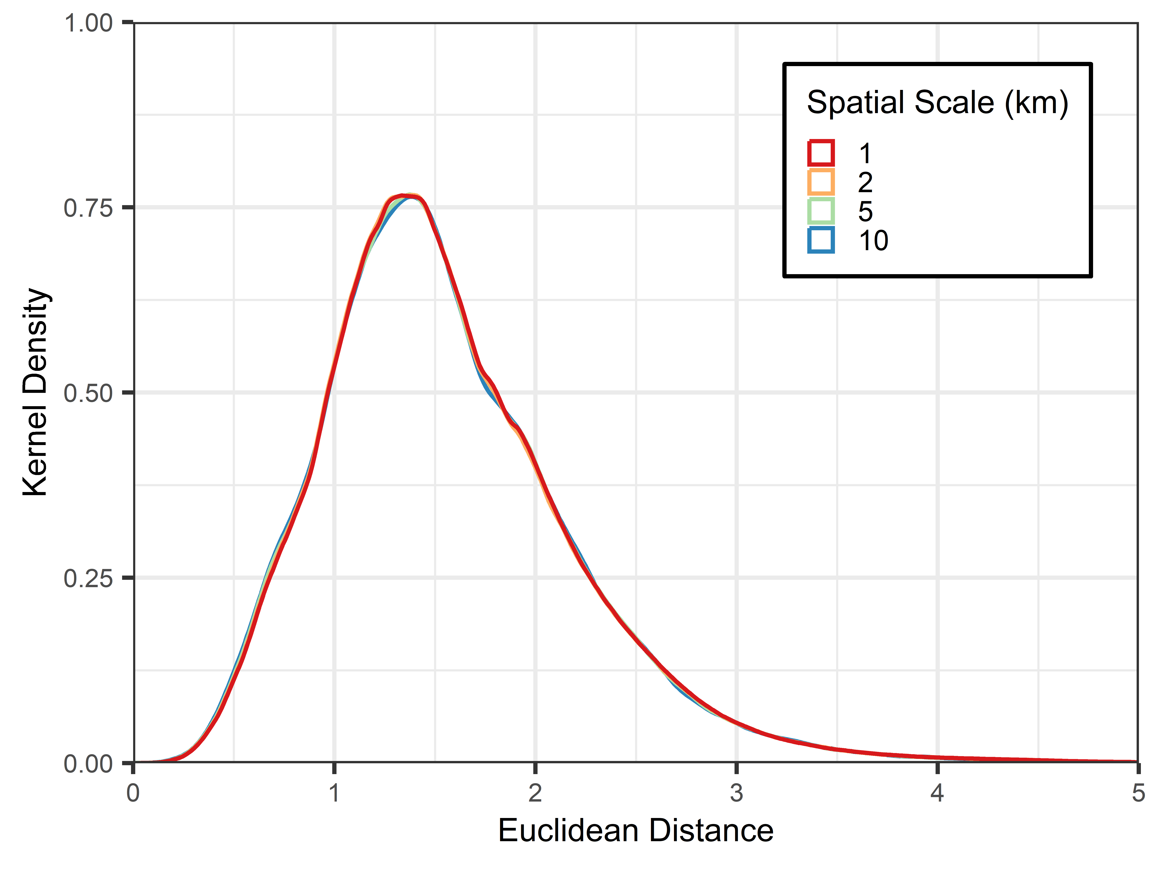
Figure S 1: Kernal density plot of the Euclidean distance measures over the different spatial resolutions tested showing almost identical distributions based on the spatial scale.

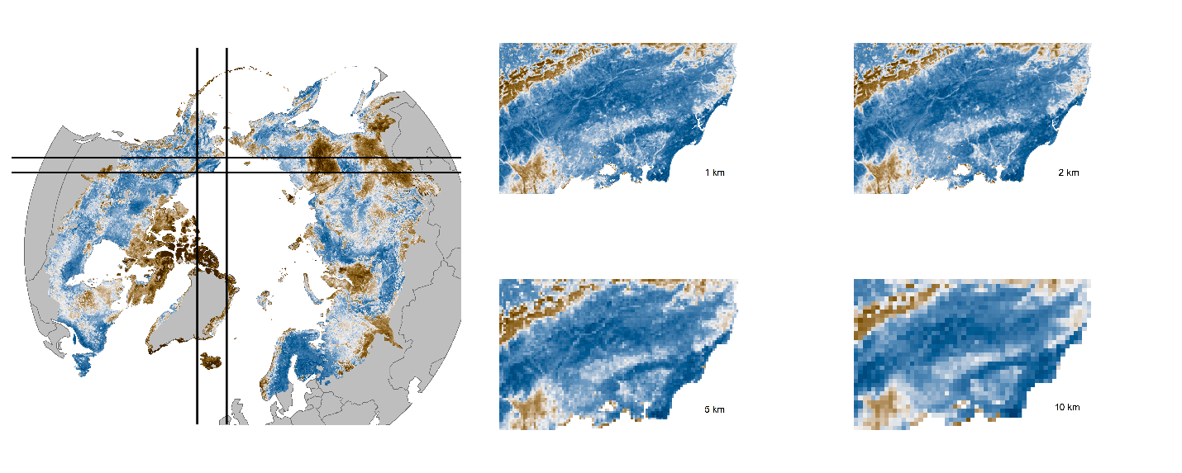
Figure S 2: The whole domain to the left with a rectangle highlight the inset zoomed in images to the right at the four spatial resolutions tested for the spatial sensitivity analysis. At 2km, flux towers will measure within the grid cell, and fine scale heterogeneity is not lost. At greater coarseness, some fine scale heterogeneity is lost albeit large scale trends remain.

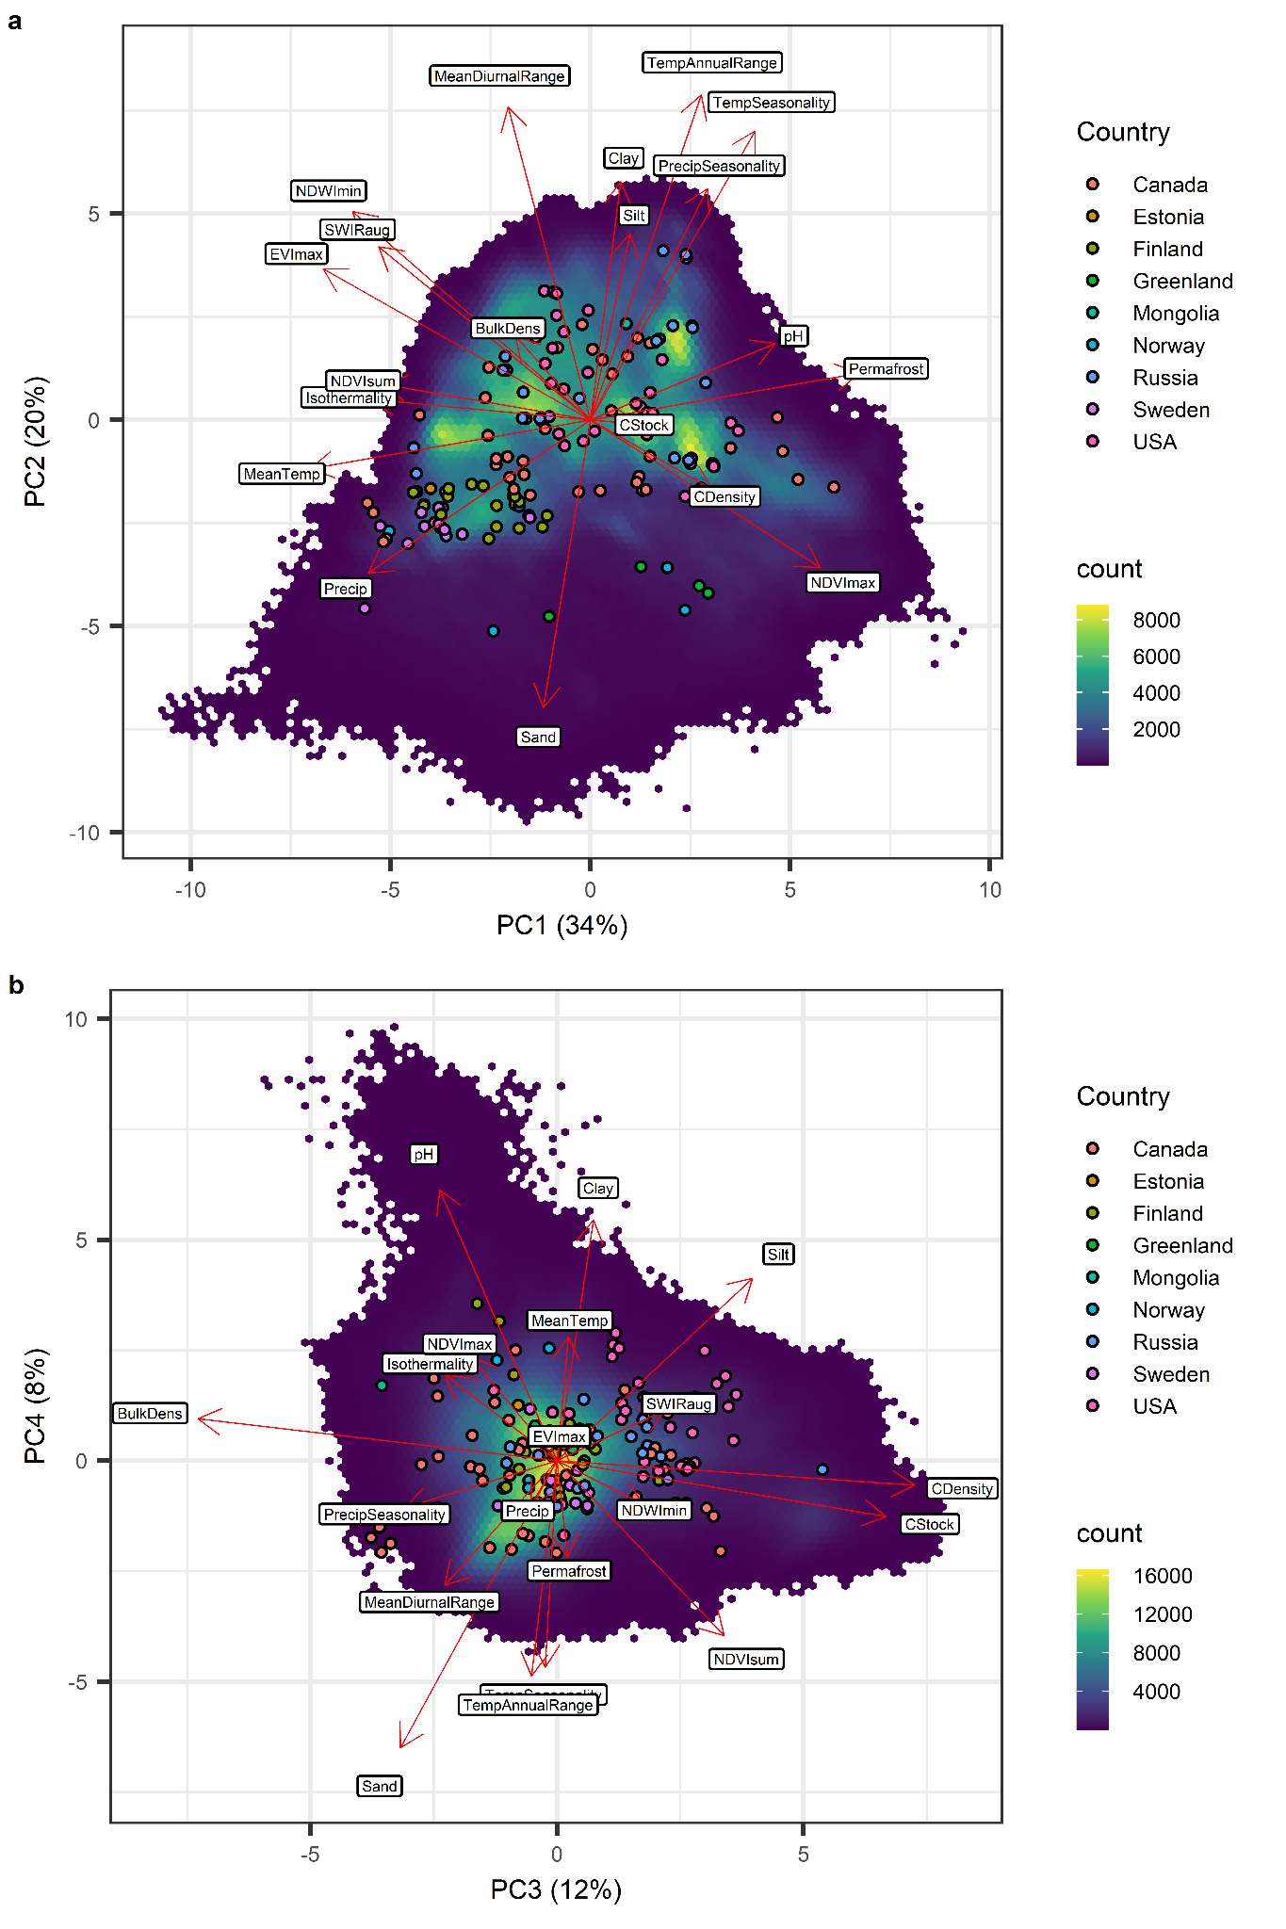
Figure S 3: Principal Components Analysis (PCA) with loadings shown on biplot. Number of eddy covariance tower sites of the base 2022 network are shown as points with their color denoting the country they are in. Lighter areas indicate high density of grid cells in this data space and dark purple areas show where data is less dense.
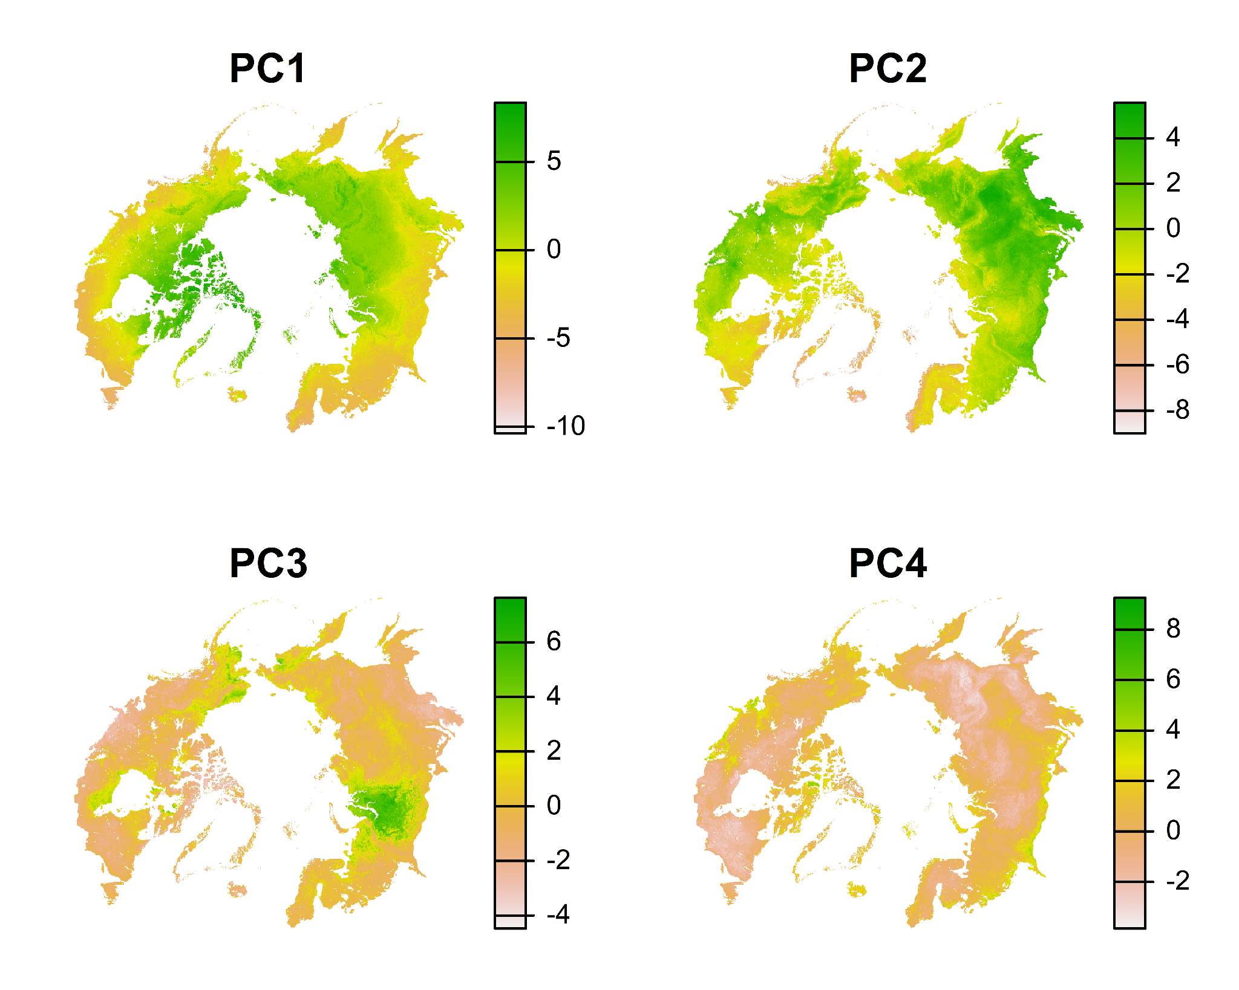
Figure S 4: Results of the Principal Components Analysis and final layers used as data input in the Euclidean Distance Calculations.
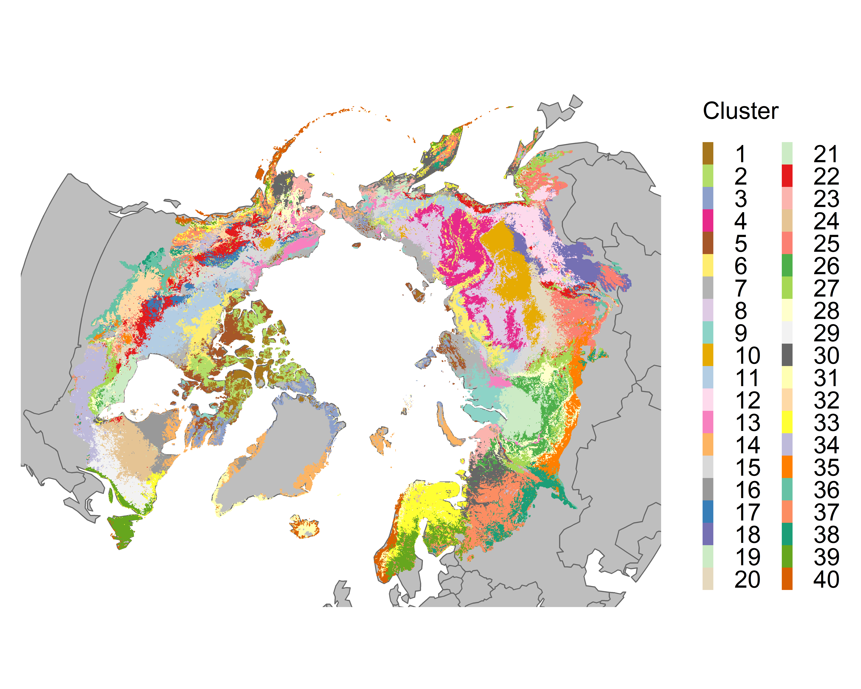
Figure S 5: The 40 clusters from the k-means clustering using the top four principal components from the principal components analysis.
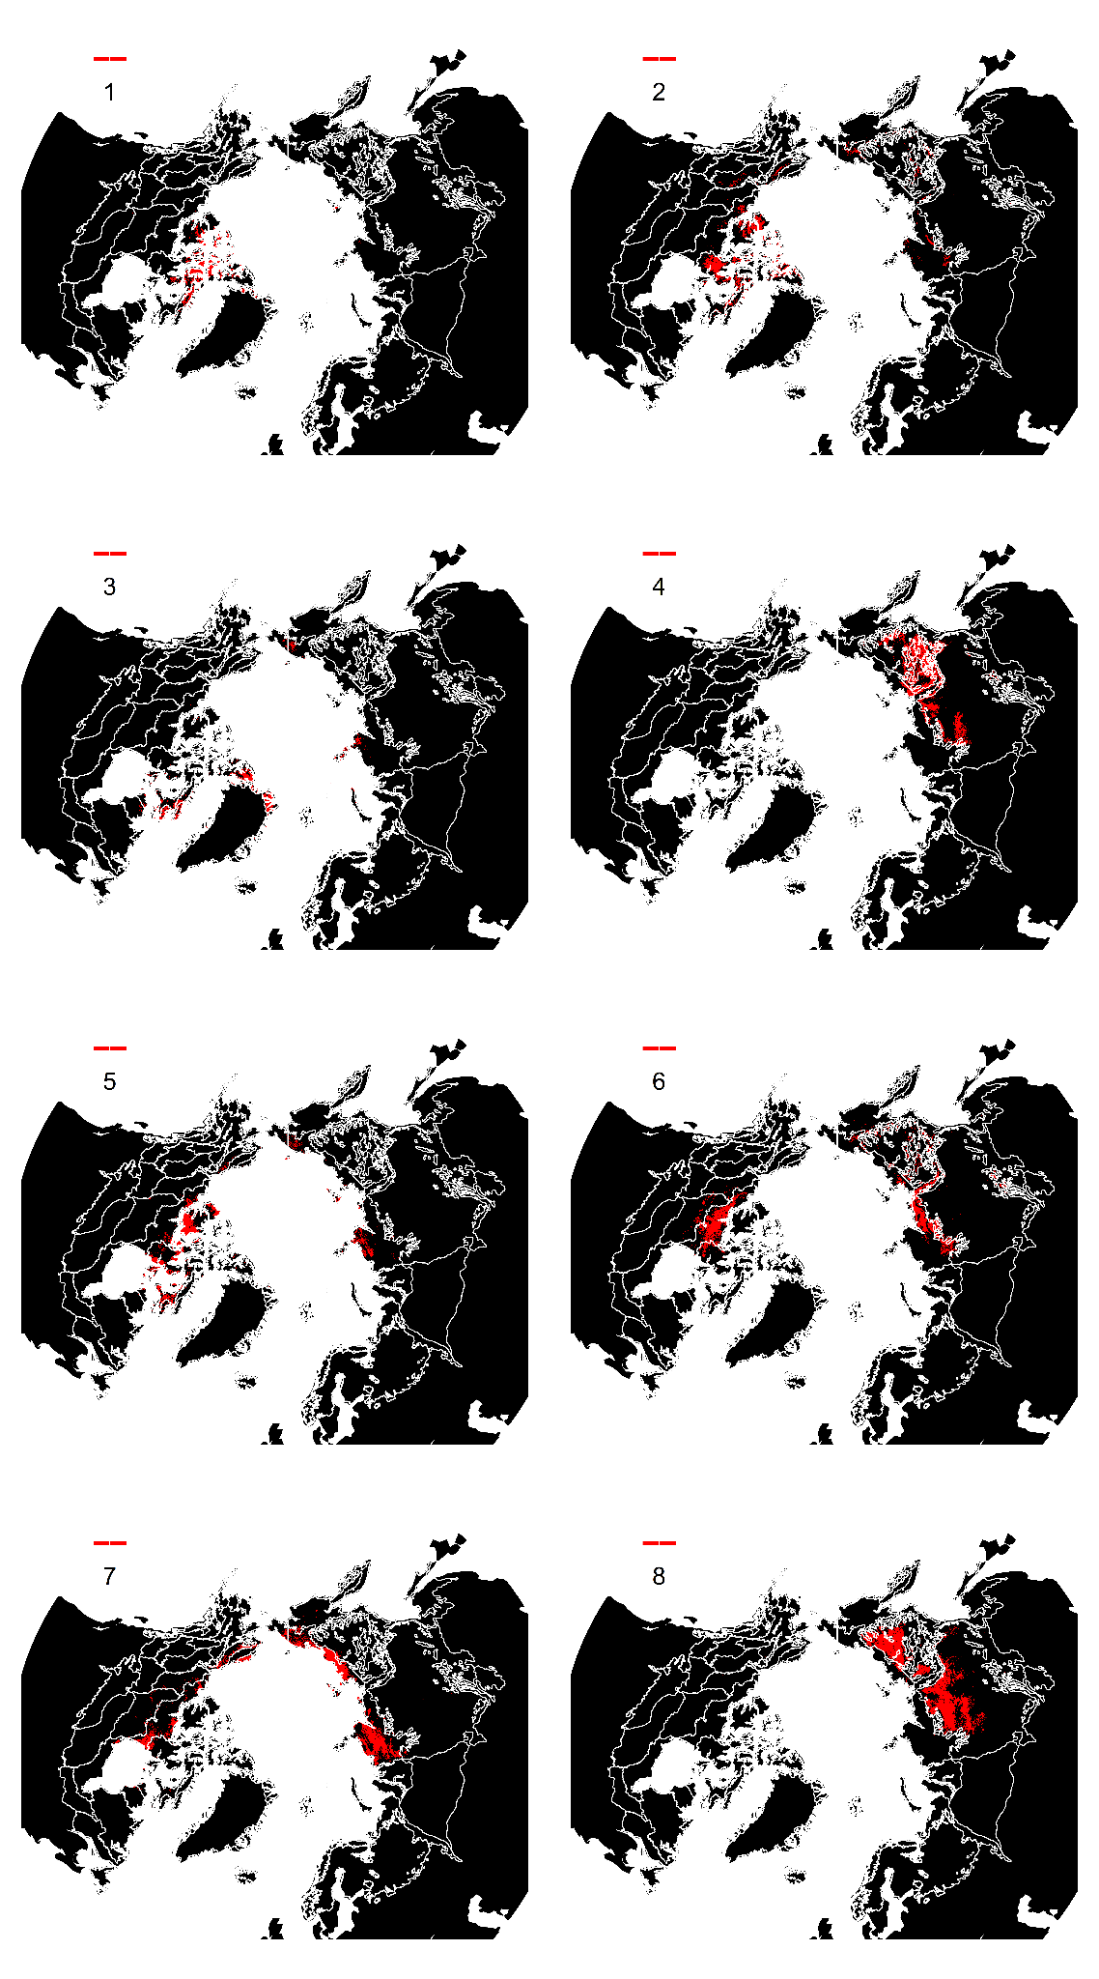
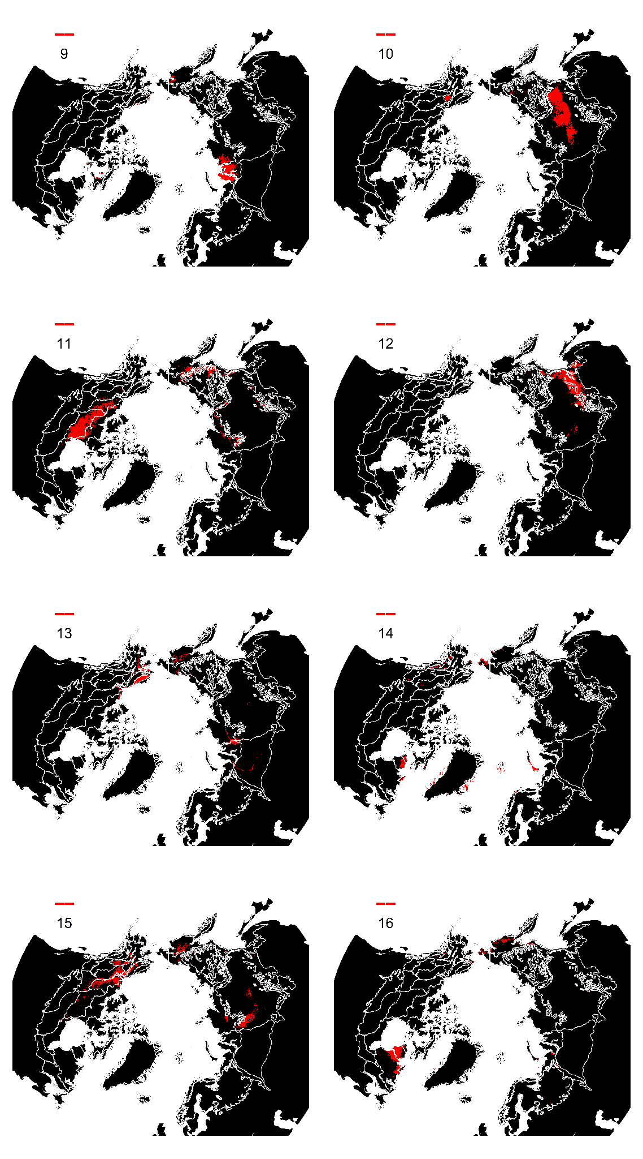
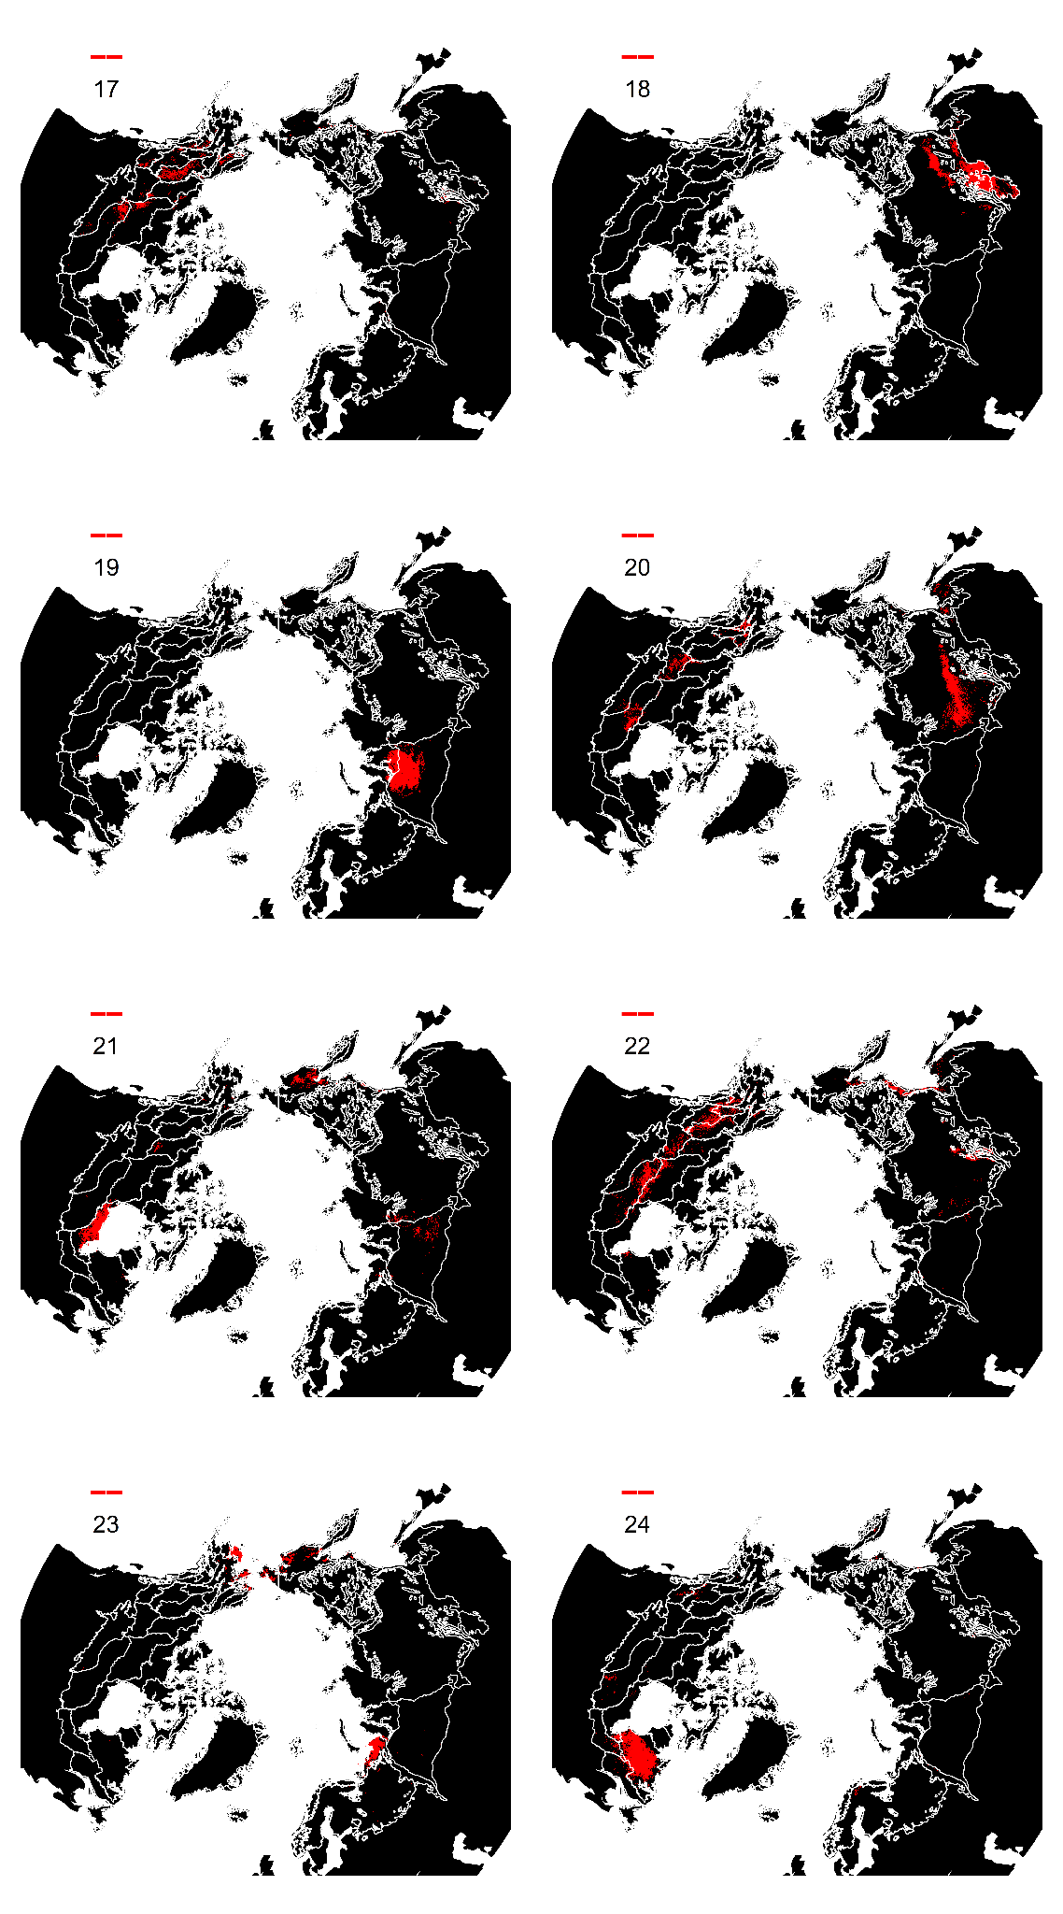
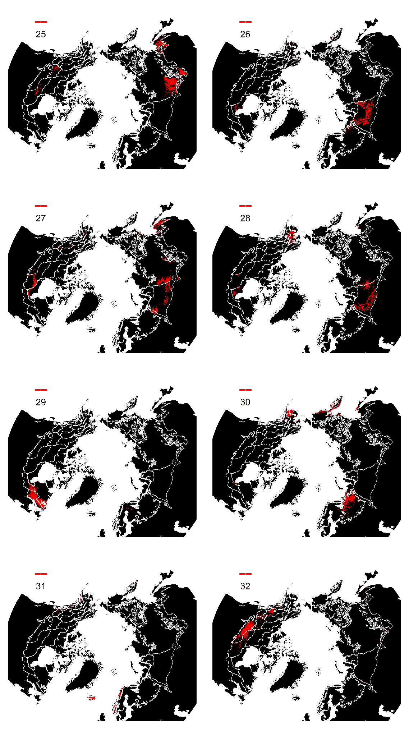
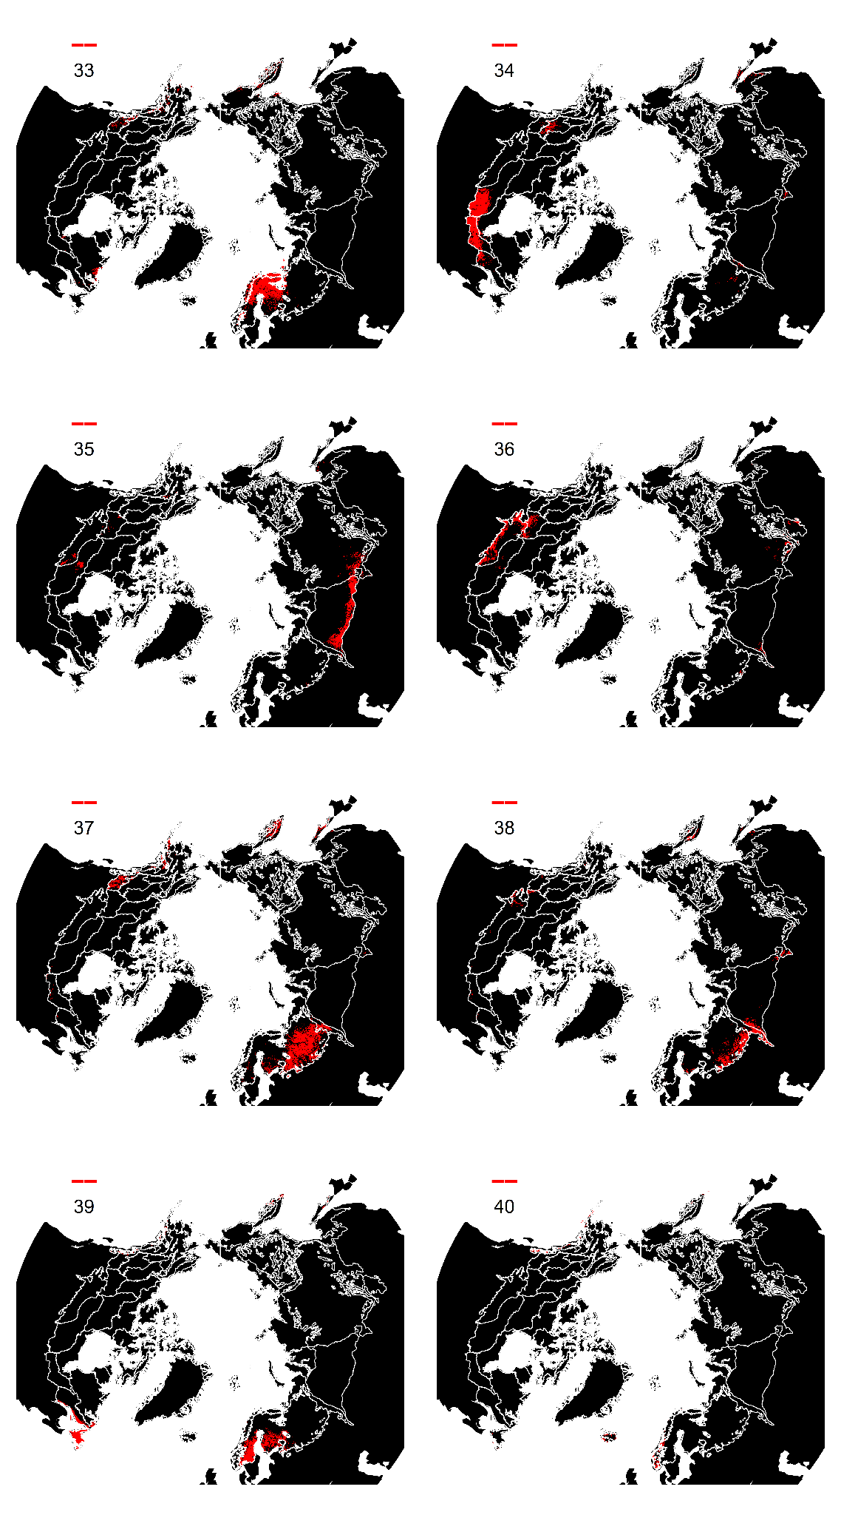
Figure S 6: Maps of clusters to highlight locations of individual clusters (red) within the Arctic-boreal region.

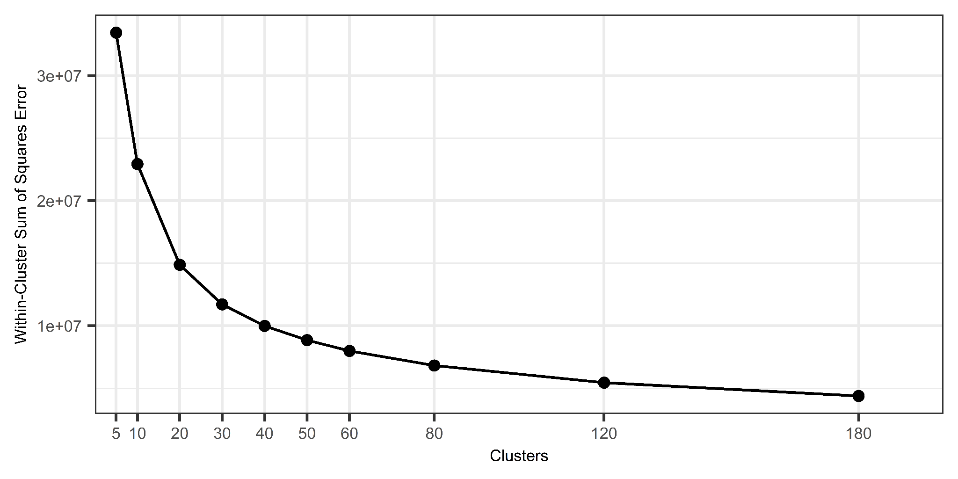
Figure S 7: Within cluster error for various k-means clusters across the Arctic-boreal region for clusters ranging from five to 180. Forty clusters were chosen where the within cluster error was not meaningfully reduced with additional clusters. This also aligned well with the ecoregions from Dinerstein et al., (2017).
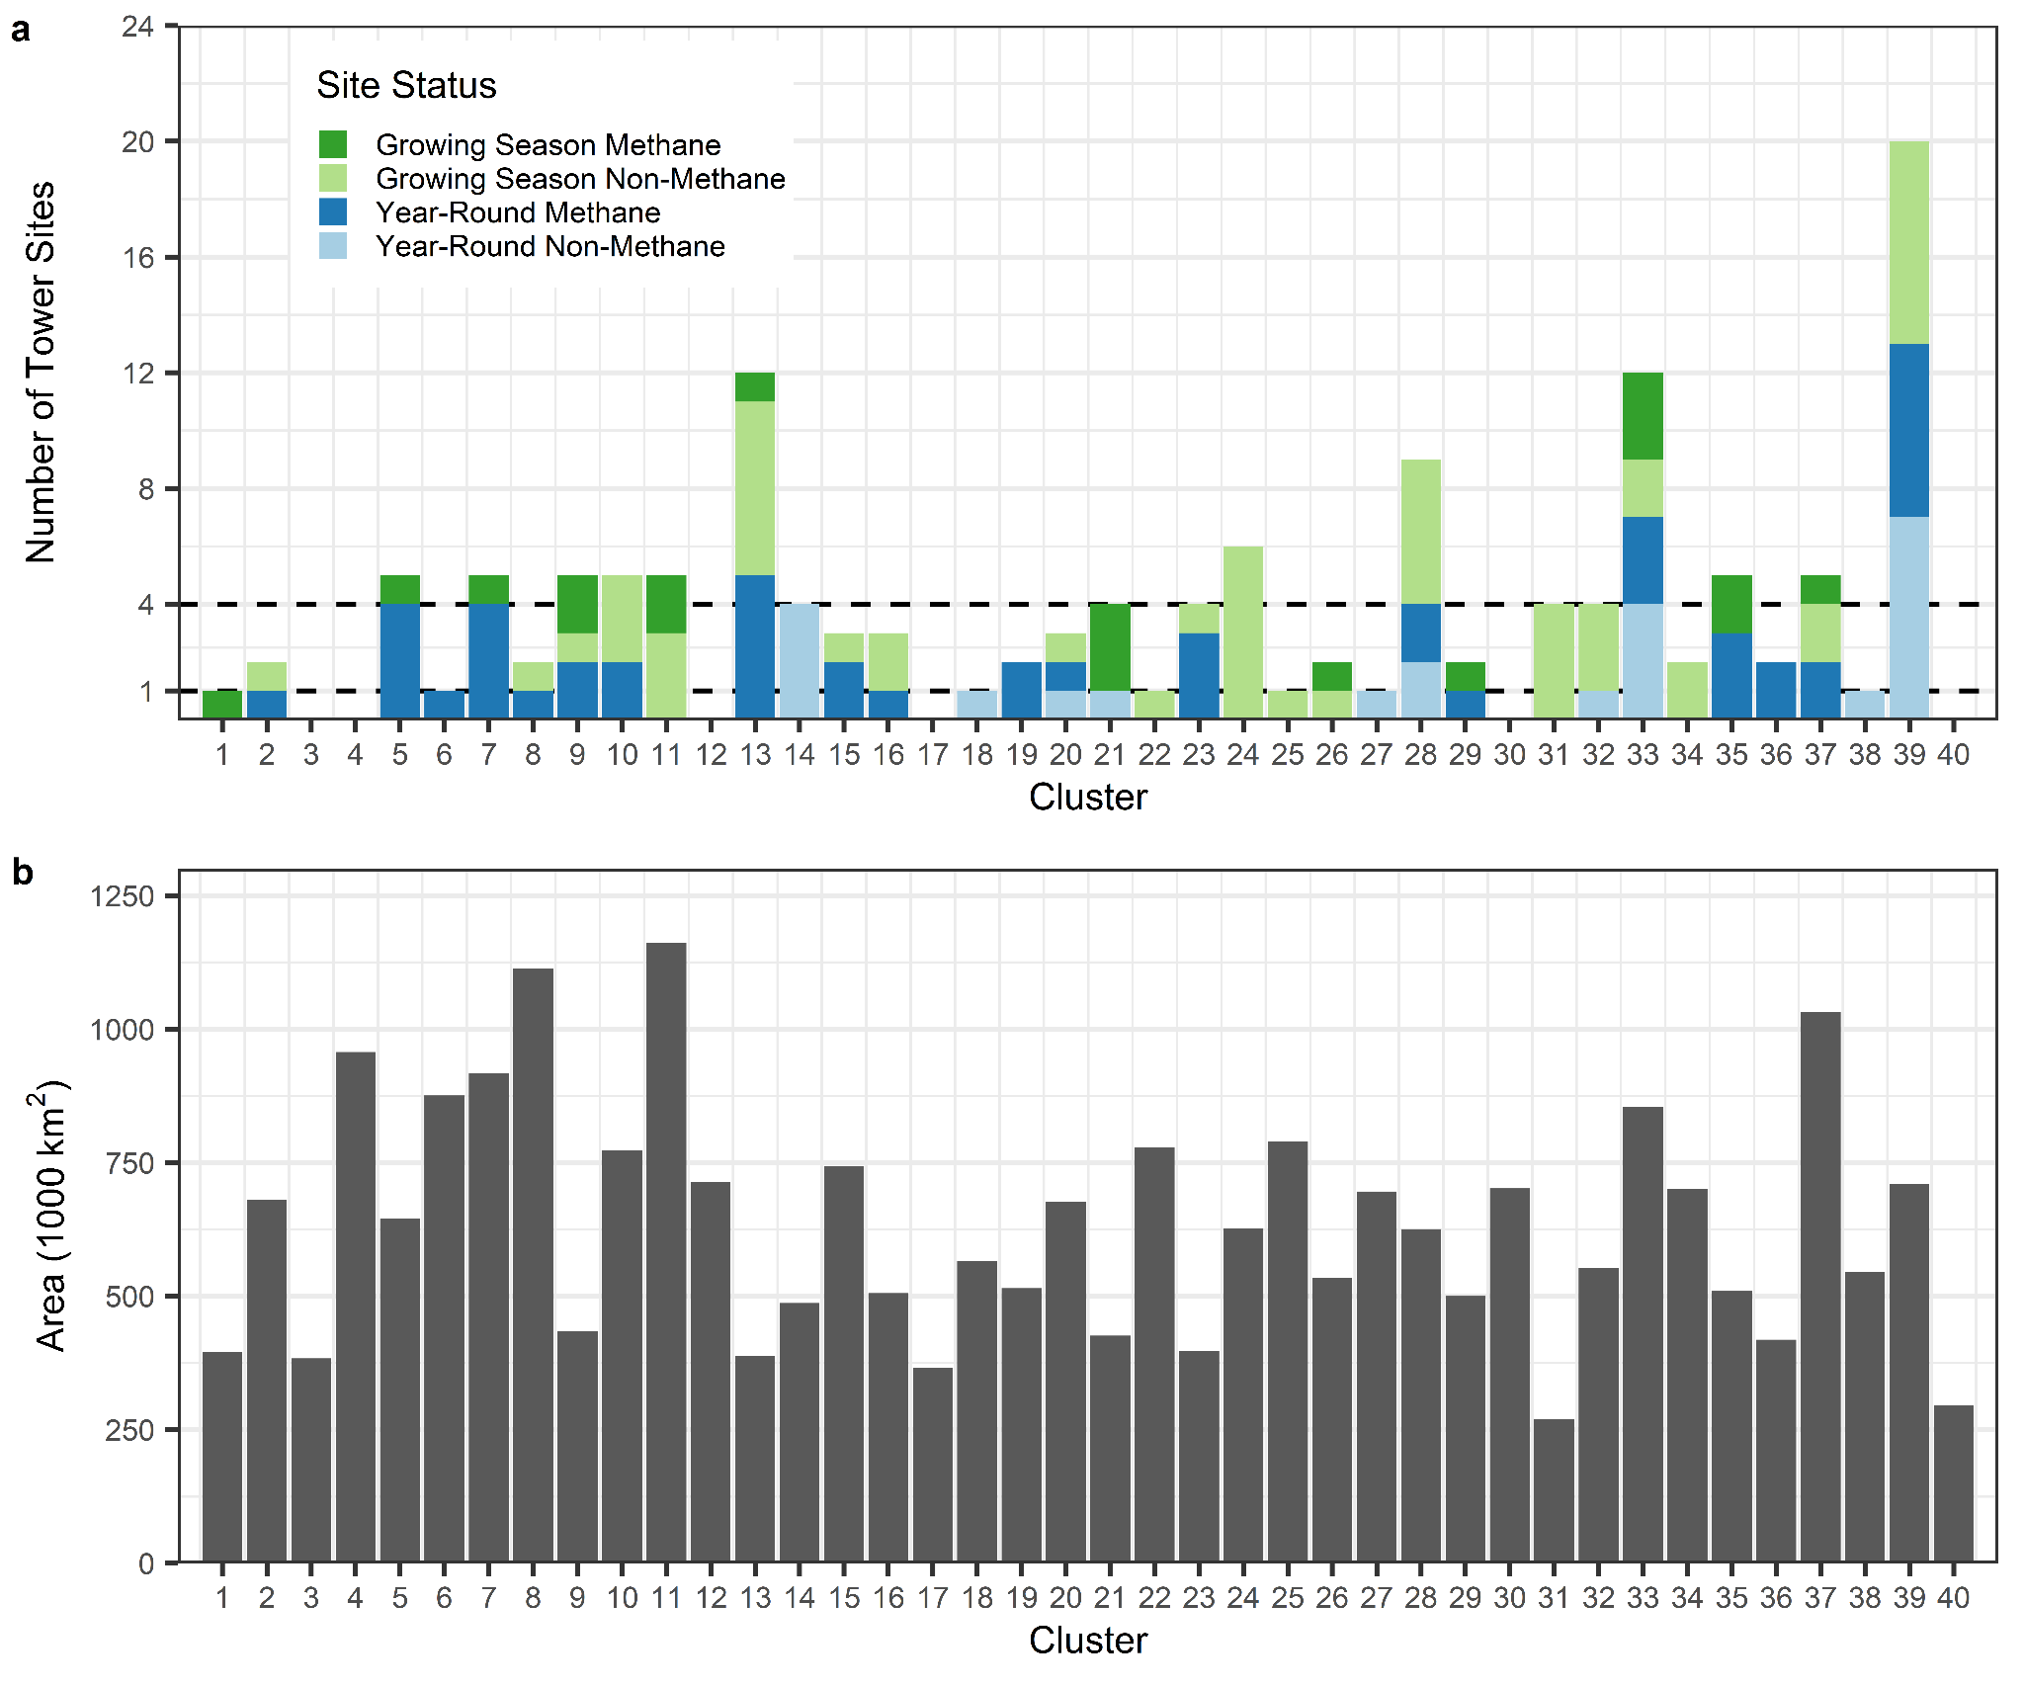
Figure S 8: (a) Counts of number of active tower sites within each cluster in the base network. Dotted lines marking the number of tower sites to be included in the ER1 and ER4 thresholds. (b) Spatial area of the clusters in hectares.
Figure S 9: Bar plots of the mean improvement (i.e., reduction) in Euclidean distance and the next top 25 potential sites in each of the four scenarios. Black bars indicate an existing site where the rest are potential

