Supplementary Materials
Table S1 Definitions of CKM syndrome stage 0-4
Table S2 Missingness of baseline variables
Table S3 Variance Inflation Factor (VIF) for independent variables in the fully adjusted model (Model 3) with CTI as the exposure
Table S4 Variance Inflation Factor (VIF) for independent variables in the fully adjusted model (Model 3) with CHG as the exposure
Table S5 Sensitivity analysis using the complete-case dataset
Table S6 Sensitivity analysis excluding outliers
Table S7 Sensitivity analysis excluding events within the first 2 years of follow-up
Table S8 E-value analysis for the associations of CTI and CHG with new-onset heart disease in participants with CKM syndrome stages 0-3
Table S9 Analysis using logistic regression at 9 years follow-up.
Figure S1. The distributions of key continuous variables before and after outlier treatment.

Table S1 Definitions of CKM syndrome stage 0-4[1]
CKM syndrome stages | Definition
Stage 0: No CKM risk factors | Individuals with normal BMI and waist circumference, normoglycemia, normotension, a normal lipid profile, and no evidence of CKD or subclinical or clinical CVD
Stage 1: Excess or dysfunctional adiposity | Individuals with overweight/obesity, abdominal obesity, or dysfunctional adipose tissue, without the presence of other metabolic risk factors or CKD  BMI ≥25 kg/m2 (or ≥23 kg/m2 if Asian ancestry),  Waist circumference ≥88/102 cm in women/men (or if Asian ancestry ≥80/90 cm in women/men), or Fasting blood glucose ≥100–124 mg/dL or HbA1c between 5.7% and 6.4%
Stage 2: Metabolic risk factors and CKD | Individuals with metabolic risk factors (hypertriglyceridemia [≥135 mg/dL], hypertension, MetS, diabetes), or CKD
Stage 3: Subclinical CVD in CKM | Subclinical ASCVD or subclinical HF among individuals with excess/dysfunctional adiposity, other metabolic risk factors, or CKD  Subclinical ASCVD to be principally diagnosed by coronary artery calcification (subclinical atherosclerosis by coronary catheterization/CT angiography also meets criteria)  Subclinical HF diagnosed by elevated cardiac biomarkers (NT-proBNP ≥125 pg/mL, hs-troponin T ≥14 ng/L for women and ≥22 ng/L for men, hs-troponin I ≥10 ng/L for women and ≥12 ng/L for men) or by echocardiographic parameters, with a combination of the 2 indicating highest HF risk.  Risk equivalents of subclinical CVD  Very high-risk CKD (stage G4 or G5 CKD or very high risk per KDIGO classification)  High predicted 10-y CVD risk
Stage 4: Clinical CVD in CKM | Clinical CVD (coronary heart disease, HF, stroke, peripheral artery disease, atrial fibrillation) among individuals with excess/dysfunctional adiposity, other CKM risk factors, or CKD  Stage 4a: no kidney failure  Stage 4b: kidney failure present
Reference of Table S1
1. Ndumele CE, Rangaswami J, Chow SL, Neeland IJ, Tuttle KR, Khan SS, Coresh J, Mathew RO, Baker-Smith CM, Carnethon MR et al: Cardiovascular-Kidney-Metabolic Health: A Presidential Advisory From the American Heart Association. Circulation 2023, 148(20):1606-1635.

Table S2 Distribution of missing values for variables
Variables | The number of missing data | Percent (%)
Location | 4 | 0.001
Drinking | 365 | 0.054
Smoking | 21 | 0.003
Dyslipidemia | 77 | 0.011
SBP | 22 | 0.003
DBP | 21 | 0.003
LDL-C | 10 | 0.001
BUN | 1 | 0.000
SBP, systolic blood pressure; DBP, diastolic blood pressure; LDL-C, low-density lipoprotein cholesterol; BUN, blood urea nitrogen

Table S3 Variance Inflation Factor (VIF) for independent variables in the fully adjusted model (Model 3) with CTI as the exposure
Variable | GVIF | DF | GVIF^(1/(2*Df))
CTI | 1.097 | 1 | 1.048
Age | 2.184 | 1 | 1.478
sex | 3.312 | 1 | 1.82
Location | 1.187 | 1 | 1.09
Marital | 1.12 | 1 | 1.058
Education | 1.584 | 3 | 1.08
Smoking | 2.132 | 2 | 1.208
Drinking | 1.495 | 2 | 1.106
BMI | 1.021 | 1 | 1.011
LDL-C | 1.033 | 1 | 1.016
eGFR | 3.159 | 1 | 1.777
Cr | 3.399 | 1 | 1.844
BUN | 1.15 | 1 | 1.072
UA | 1.547 | 1 | 1.244
Model 3: adjusted for age, gender, location, smoking status and BMI，LDL_C, eGFR, Cr, BUN, UA.
CTI: C-reactive protein-triglyceride-glucose; BMI: body mass index; LDL-C, low-density lipoprotein cholesterol; eGFR, estimated glomerular filtration rate; Cr, creatinine; BUN, blood urea nitrogen; UA, uric acid

Table S4 Variance Inflation Factor (VIF) for independent variables in the fully adjusted model (Model 3) with CHG as the exposure
Variable | GVIF | DF | GVIF^(1/(2*Df))
CHG | 1.133 | 1 | 1.064
Age | 2.179 | 1 | 1.476
sex | 3.282 | 1 | 1.812
Location | 1.19 | 1 | 1.091
Marital | 1.12 | 1 | 1.058
Education | 1.584 | 3 | 1.08
Smoking | 2.134 | 2 | 1.209
Drinking | 1.498 | 2 | 1.106
BMI | 1.021 | 1 | 1.01
LDL-C | 1.105 | 1 | 1.051
eGFR | 3.159 | 1 | 1.777
Cr | 3.399 | 1 | 1.844
BUN | 1.142 | 1 | 1.069
UA | 1.502 | 1 | 1.226
Model 3: adjusted for age, gender, location, smoking status and BMI，LDL_C, eGFR, Cr, BUN, UA.
CHG: Cholesterol–high-density lipoprotein–glucose; BMI: body mass index; LDL-C, low-density lipoprotein cholesterol; eGFR, estimated glomerular filtration rate; Cr, creatinine; BUN, blood urea nitrogen; UA, uric acid

Table.S5 Sensitivity analysis using complete-case analysis
 | Model 1 |  |  | Model 2 |  |  | Model 3
 | HR (95%CI) | P value |  | HR (95%CI) | P value |  | HR (95%CI) | P value
CTI | 1.12 (1.06, 1.18) | <0.001 |  | 1.09 (1.03, 1.15) | 0.003 |  | 1.10 (1.04, 1.16) | 0.001
(per 1 SD)
CTI
quartile
Q1 | Reference |  |  | Reference |  |  | Reference
Q2 | 1.20 (1.02, 1.42) | 0.032 |  | 1.16 (0.98, 1.37) | 0.087 |  | 1.15 (0.97, 1.36) | 0.104
Q3 | 1.25 (1.06, 1.48) | 0.008 |  | 1.18 (1.00, 1.39) | 0.055 |  | 1.18 (0.99, 1.39) | 0.058
Q4 | 1.47 (1.25, 1.72) | <0.001 |  | 1.35 (1.15, 1.59) | <0.001 |  | 1.37 (1.15, 1.61) | <0.001
P for trend |  | <0.001 |  |  | <0.001 |  |  | <0.001
CHG | 1.11 (1.05, 1.17) | <0.001 |  | 1.09 (1.03, 1.15) | 0.003 |  | 1.09 (1.03, 1.15) | 0.004
(per 1 SD)
CHG
quartile
Q1 | Reference |  |  | Reference |  |  | Reference
Q2 | 1.06 (0.90, 1.25) | 0.501 |  | 1.03 (0.87, 1.21) | 0.751 |  | 1.02 (0.86, 1.21) | 0.816
Q3 | 1.18 (1.00, 1.38) | 0.050 |  | 1.14 (0.97, 1.34) | 0.121 |  | 1.13 (0.95, 1.34) | 0.157
Q4 | 1.29(1.10, 1.51) | 0.002 |  | 1.21 (1.03, 1.42) | 0.018 |  | 1.22 (1.02, 1.45) | 0.028
P for trend |  | <0.001 |  |  | 0.008 |  |  | 0.013
Model 1: non-adjusted;
Model 2: adjusted for age, gender, location, smoking status and BMI;
Model 3: adjusted for age, gender, location, smoking status and BMI，LDL_C, eGFR, Cr, BUN, UA.
CTI: C-reactive protein-triglyceride-glucose, CHG: Cholesterol–high-density lipoprotein–glucose, HR: hazard ratio, CI: confidence interval.
Table.S6 Sensitivity analysis using raw metrics without Winsorization
 | Model 1 |  |  | Model 2 |  |  | Model 3
 | HR (95%CI) | P value |  | HR (95%CI) | P value |  | HR (95%CI) | P value
CTI | 1.12(1.06, 1.18) | <0.001 |  | 1.09 (1.03, 1.15) | 0.003 |  | 1.10 (1.04, 1.16) | 0.002
(per 1 SD)
CTI
quartile
Q1 | Reference |  |  | Reference |  |  | Reference
Q2 | 1.20 (1.02, 1.42) | 0.033 |  | 1.16 (0.98, 1.37) | 0.087 |  | 1.15 (0.97, 1.36) | 0.104
Q3 | 1.25 (1.06, 1.47) | 0.009 |  | 1.18 (1.00, 1.39) | 0.057 |  | 1.18 (0.99, 1.39) | 0.060
Q4 | 1.46 (1.24, 1.72) | <0.001 |  | 1.35 (1.14, 1.58) | <0.001 |  | 1.36 (1.15, 1.61) | <0.001
P for trend |  | <0.001 |  |  | <0.001 |  |  | <0.001
CHG | 1.10 (1.05, 1.16) | <0.001 |  | 1.08 (1.03, 1.15) | 0.004 |  | 1.09 (1.03, 1.15) | 0.005
(per 1 SD)
CHG
quartile
Q1 | Reference |  |  | Reference |  |  | Reference
Q2 | 1.05 (0.90, 1.24) | 0.567 |  | 1.02 (0.87, 1.21) | 0.785 |  | 1.02 (0.86, 1.20) | 0.850
Q3 | 1.16 (1.00, 1.37) | 0.068 |  | 1.13 (0.96, 1.33) | 0.139 |  | 1.12 (0.95, 1.33) | 0.179
Q4 | 1.27(1.08, 1.49) | 0.003 |  | 1.21 (1.03, 1.41) | 0.023 |  | 1.21 (1.01, 1.43) | 0.034
P for trend |  | 0.001 |  |  | 0.010 |  |  | 0.016
Model 1: non-adjusted;
Model 2: adjusted for age, gender, location, smoking status and BMI;
Model 3: adjusted for age, gender, location, smoking status and BMI，LDL_C, eGFR, Cr, BUN, UA.
CTI: C-reactive protein-triglyceride-glucose, CHG: Cholesterol–high-density lipoprotein–glucose, HR: hazard ratio, CI: confidence interval.
Table.S7 Sensitivity analysis excluding events within the first 2 years of follow-up
 | Model 1 |  |  | Model 2 |  |  | Model 3
 | HR (95%CI) | P value |  | HR (95%CI) | P value |  | HR (95%CI) | P value
CTI | 1.10 (1.04, 1.17) | 0.002 |  | 1.07 (1.01, 1.14) | 0.026 |  | 1.08 (1.01, 1.15) | 0.025
(per 1 SD)
CTI
quartile
Q1 | Reference |  |  | Reference |  |  | Reference
Q2 | 1.19 (0.99, 1.43) | 0.069 |  | 1.15 (0.95, 1.38) | 0.145 |  | 1.13 (0.94, 1.36) | 0.195
Q3 | 1.20 (0.99, 1.44) | 0.058 |  | 1.13 (0.94, 1.36) | 0.201 |  | 1.11 (0.92, 1.34) | 0.259
Q4 | 1.44 (1.21, 1.72) | <0.001 |  | 1.33 (1.11, 1.60) | 0.002 |  | 1.33 (1.10, 1.60) | 0.003
P for trend |  | <0.001 |  |  | 0.003 |  |  | 0.005
CHG | 1.11 (1.05, 1.18) | <0.001 |  | 1.09 (1.03, 1.16) | 0.004 |  | 1.09 (1.02, 1.16) | 0.008
(per 1 SD)
CHG
quartile
Q1 | Reference |  |  | Reference |  |  | Reference
Q2 | 1.05 (0.87, 1.26) | 0.617 |  | 1.02 (0.85, 1.23) | 0.827 |  | 1.01 (0.84, 1.22) | 0.917
Q3 | 1.21 (1.01, 1.45) | 0.038 |  | 1.18 (0.99, 1.41) | 0.072 |  | 1.17 (0.96, 1.41) | 0.115
Q4 | 1.31(1.09, 1.56) | 0.003 |  | 1.24 (1.04, 1.48) | 0.018 |  | 1.23 (1.02, 1.49) | 0.035
P for trend |  | <0.001 |  |  | 0.006 |  |  | 0.013
Model 1: non-adjusted;
Model 2: adjusted for age, gender, location, smoking status and BMI;
Model 3: adjusted for age, gender, location, smoking status and BMI，LDL_C, eGFR, Cr, BUN, UA.
CTI: C-reactive protein-triglyceride-glucose, CHG: Cholesterol–high-density lipoprotein–glucose, HR: hazard ratio, CI: confidence interval.

Table S8 E-value analysis for the associations of CTI and CHG with new-onset heart disease in participants with CKM syndrome stages 0-3
 | E-Value | E-Value for Lower limit of 95%CI
CTI | 1.764 | 1.418
CHG | 1.508 | 1.090
- values were calculated based on hazard ratios from the fully adjusted model (Model 3).
Model 3: adjusted for age, gender, location, smoking status and BMI，LDL_C, eGFR, Cr, BUN, UA.
CKM: Cardiovascular-Kidney-Metabolic syndrome,CTI: C-reactive protein-triglyceride-glucose, CHG: Cholesterol–high-density lipoprotein–glucose.

Table.S9 Analysis using logistic regression at 9 years follow-up
 | Model 1 |  |  | Model 2 |  |  | Model 3
 | OR (95%CI) | P value |  | OR (95%CI) | P value |  | OR (95%CI) | P value
CTI | 1.13 (1.07, 1.21) | <0.001 |  | 1.11 (1.04, 1.18) | <0.001 |  | 1.12 (1.05, 1.19) | <0.001
(per 1 SD)
CTI
quartile
Q1 | Reference |  |  | Reference |  |  | Reference
Q2 | 1.21 (1.01, 1.46) | 0.038 |  | 1.18 (0.98, 1.41) | 0.083 |  | 1.16 (0.96, 1.4) | 0.117
Q3 | 1.29 (1.07, 1.54) | 0.007 |  | 1.22 (1.02, 1.47) | 0.031 |  | 1.21 (1, 1.46) | 0.046
Q4 | 1.5 (1.26, 1.79) | <0.001 |  | 1.41 (1.18, 1.69) | <0.001 |  | 1.41 (1.17, 1.7) | <0.001
P for trend |  | <0.001 |  |  | <0.001 |  |  | <0.001
CHG | 1.11 (1.05, 1.18) | <0.001 |  | 1.1 (1.03, 1.17) | 0.004 |  | 1.1 (1.03, 1.17) | 0.006
(per 1 SD)
CHG
quartile
Q1 | Reference |  |  | Reference |  |  | Reference
Q2 | 1.03 (0.86, 1.24) | 0.723 |  | 1.01 (0.84, 1.22) | 0.889 |  | 0.99 (0.82, 1.2) | 0.934
Q3 | 1.17 (0.98, 1.39) | 0.09 |  | 1.13 (0.95, 1.35) | 0.177 |  | 1.12 (0.92, 1.35) | 0.251
Q4 | 1.3 (1.09, 1.55) | 0.004 |  | 1.23 (1.03, 1.47) | 0.021 |  | 1.22 (1.01, 1.48) | 0.039
P for trend |  | 0.001 |  |  | 0.009 |  |  | 0.017
Model 1: non-adjusted;
Model 2: adjusted for age, gender, location, smoking status and BMI;
Model 3: adjusted for age, gender, location, smoking status and BMI，LDL_C, eGFR, Cr, BUN, UA.
CTI: C-reactive protein-triglyceride-glucose, CHG: Cholesterol–high-density lipoprotein–glucose, HR: hazard ratio, CI: confidence interval.
Figure S1. The distributions of key continuous variables before and after outlier treatment.

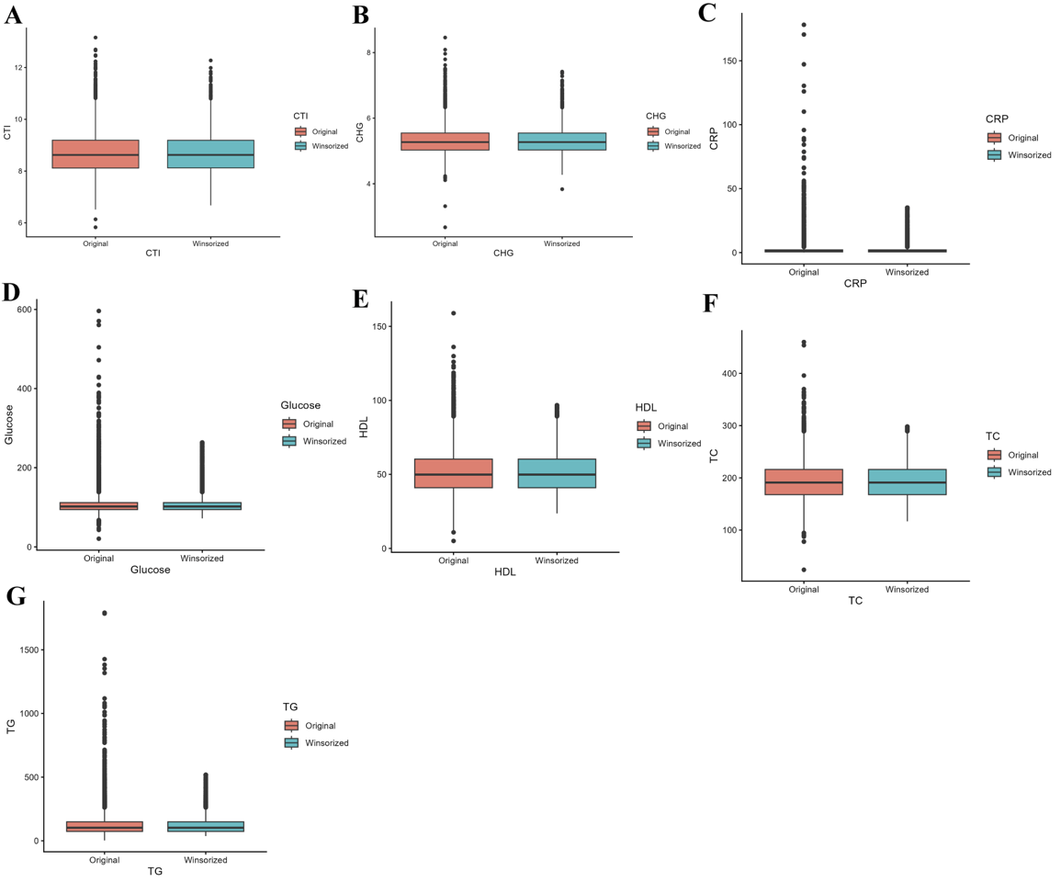
(A) CTI: C-reactive protein-triglyceride-glucose, (B) CHG: Cholesterol–high-density lipoprotein–glucose, (C) CRP: C-reactive protein, (D) FPG: fasting plasma glucose, (E) HDL: High-density lipoprotein; (F) TC: Total cholesterol; (G)TG: Triglycerides;

