Supplementary Materials for

Parkinson’s disease: Individual placebo responses are predicted by baseline expression of a striato-limbic network

János Barbero¹, An Vo^{1,2}, Joshua J. Strohl¹, Sebastiano Vacca^{1,3}, Chris C. Tang¹, Nha Nguyen¹, Prashin Unadkat^{1,4}, Yilong Ma^{1,2}, Shichun Peng¹, Martin Niethammer^{1,2}, Brage Brakedal^{5,6,7}, Johan Wallin^{8,9}, Ioanna Markaki^{8,9}, Per Svenningsson^{8,9}, Michael G. Kaplitt¹⁰,
Charalampos Tzoulis^{5,6,7}, and David Eidelberg^{1,2}*

¹ Center for Neurosciences, The Feinstein Institutes for Medical Research; Manhasset, NY, USA.
² Department of Molecular Medicine, Donald and Barbara Zucker School of Medicine at Hofstra/Northwell; Hempstead, NY, USA.
³ Elmezzi Graduate School of Molecular Medicine; Manhasset, NY, USA.
⁴ Department of Neurosurgery, Donald and Barbara Zucker School of Medicine at Hofstra/Northwell; Hempstead, NY, USA.
⁵ Neuro-SysMed, Department of Neurology, Haukeland University Hospital; Bergen, Norway.
⁶ Department of Clinical Medicine, University of Bergen; Bergen, Norway.
⁷ K.G. Jebsen Center for Translational Research in Parkinson’s disease, University of Bergen; Bergen, Norway.
⁸ Department of Clinical Neuroscience, Karolinska Institutet; Stockholm, Sweden.
⁹ Center of Neurology, Academic Specialist Center, Torsplan; Stockholm, Sweden.
¹⁰ Department of Neurological Surgery, Weill Cornell Medical College; New York, NY, USA.

* Corresponding Author: David Eidelberg, MD
Center for Neurosciences, The Feinstein Institutes for Medical Research
350 Community Drive, Manhasset, NY 11030.
Phone: 516-562-2498; Fax: 516-562-1008; E-mail: deidelberg@northwell.edu

Supplementary Figures: Figs. S1 and S2; Supplementary Tables: Tables S1A-D and S2A-C

Supplementary Figures
Fig. S1. Sham surgery-related pattern (SSRP). The SSRP was identified in Parkinson’s disease (PD) subjects who received sham surgery as part of a randomized double-blind trial of subthalamic AAV2-Gad gene therapy as described elsewhere (9, 10). The network was characterized by sham-induced metabolic increases in the anterior cingulate cortex (BA 32/24), subcallosal gyrus (BA 25), hippocampus, amygdala, and posterior cerebellar vermis, as well as in the precommisural ventral striatum.

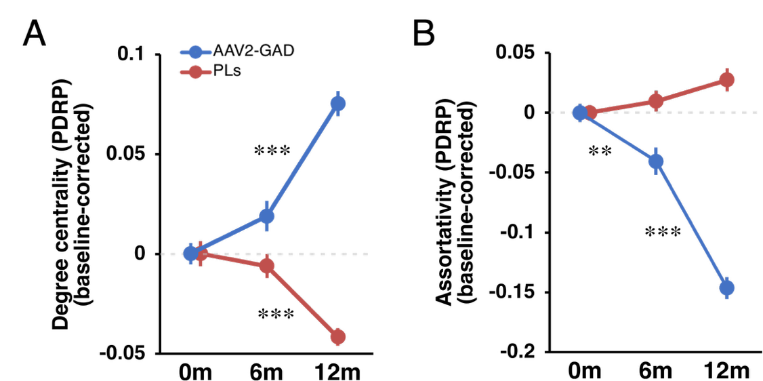
Figure S2. Gene therapy induces reorganization in PDRP. (A) PDRP degree centrality rose steadily in the year following subthalmic AAV2-GAD gene therapy (blue), with significant increases between baseline and 12 m (+19.6%) and between 6m and 12m (+14.0%, p<0.0001 for both intervals; Tukey-Kramer HSD). Following sham surgery (red), by contrast, this graph metric declined over the same time period, with significant reductions between baseline and 12m (-9.6%) and between 6m and 12m (-8.3%, p<0.0001 for both intervals). (B) Meanwhile, PDRP assortativity declined after gene therapy (blue), with significant reductions between baseline and 6m (-12.2%, p=0.007) and between 6m and 12m (-36.2%, p<0.0001). By contrast, in PLs (red) an increasing trend was seen for this metric (p=0.06; one-way ANOVA), consistent with disease progression (21).

Supplementary Tables
Table S1. Baseline Characteristics and Clinical Changes Under the Blind
- Demographics
 | n | Age¹ | M/F
PLs | 19 | 61.6 ± 1.8 | 14/5
PLi | 28 | 60.4 ± 1.9 | 18/10
PLo | 15 | 62.2 ± 2.8 | 14/1
¹ mean ± standard error (SE)

- UPDRS motor ratingsª
PLs | OFF^{b}  (n=19) | ON^{c}  (n = 18) | OFF^{d}  (n = 13) | ON^{e}  (n = 12)
Baseline | 38.3 ± 2.0¹ | 20.3 ± 2.2 | 37.8 ± 2.3 | 18.6 ± 2.3
6 months | 35.1 ± 2.7 | 17.4 ± 1.8 | 34.0 ± 3.1 | 16.6 ± 2.1
∆₀₋₆  (p value) | -3.2 ± 1.2 (p=0.015)² | -3.0 ± 1.3  (p=0.037) | -3.7 ± 1.3  (p=0.011) | -2.0 ± 1.3  (p=0.15)
12 months | 32.9 ± 2.6 | 17.4 ± 2.1 | 33.1 ± 2.8 | 17.2 ± 2.4
∆₀₋₁₂  (p value) | -5.4 ± 1.6  (p=0.003) | -2.8 ± 1.1  (p=0.015) | -4.6 ± 1.2  (p=0.004) | -1.3 ± 1.1  (p=0.26)
OFF = off-medication state
ON = on-medication state
ª UPDRS Part III (Fahn and Elton 1984)
^{b} Sham surgery subjects scanned under the blind at 6 months: off-state (OFF) UPDRS motor ratings at 6 and 12 months (see Methods)
^{c} Sham surgery subjects: on-state (ON) UPDRS motor ratings at 6 and 12 months
^{d} Subset of sham surgery subjects scanned under the blind at 6 months in whom th e12 month scans were obtained after unblinding: off-state (OFF) UPDRS motor ratings at both time points
^{e} Members of the blind/unblind subset with on-state UPDRS motor ratings at both time points
¹ mean ± standard error (SE)
² Paired Student’s t-test

- UPDRS motor ratingsª
PLi | OFF | ON
Baseline | 28.4 ± 1.7¹ | 16.5 ± 1.5
9 months | 25.5 ± 2.0 | 15.7 ± 1.6
∆₀₋₉  (p value) | -2.9 ± 1.3  (p=0.033)² | -0.8 ± 0.9  (p=0.35)
21 months | 25.4 ± 2.0 | 15.5 ± 1.4
∆₀₋₂₁  (p value) | -3.0 ± 1.2  (p=0.018) | -1.0 ± 0.8  (p=0.21)
OFF = off-medication state
ON = on-medication state
ª MDS-UPDRS Part III (59)
¹ mean ± standard error (SE)
² Paired Student’s t-test

- UPDRS motor ratingsª
PLo
Baseline | 27.0 ± 2.2
1 month | 26.3 ± 2.8
∆₀₋₁  (p value) | -0.7 ± 1.3  (p=0.61)
ª MDS-UPDRS Part III (59)
¹ mean ± standard error (SE)
² Paired Student’s t-test

Table S2. Correlations of Baseline Network Expression with Clinical Change Under the Blind
A. SSRP
 |  | OFF | Baseline network score vs.  ∆UPDRS (OFF) |  | Baseline network score vs. ∆UPDRS (OFF): baseline adjusted |  | ON | Baseline network score vs.  ∆UPDRS (ON) |  | Baseline network score vs. ∆UPDRS (ON): baseline adjusted
 |  | n | r | p | r | p | n | r | p | r | p
Sham surgery (PLs)
6m | All | 19 | 0.63 | 0.004 | 0.64 | 0.004 | 19 | 0.51 | 0.03 | 0.64 | 0.005
6m | Unblinded subset¹ | 13 | 0.77 | 0.002 | 0.74 | 0.006 | 13 | 0.30 | 0.32 | 0.52 | 0.09
12m | All | 19 | -0.06 | 0.82 | -0.06 | 0.83 | 18 | 0.29 | 0.25 | 0.33 | 0.19
12m | Unblinded subset | 13 | -0.05 | 0.87 | -0.09 | 0.78 | 12 | 0.20 | 0.53 | 0.31 | 0.35
Injected placebo (PLi)
9m |  | 28 | 0.09 | 0.64 | 0.09 | 0.67 | 28 | 0.42 | 0.03 | 0.39 | 0.04
21m |  | 28 | 0.31 | 0.11 | 0.31 | 0.11 | 28 | 0.41 | 0.03 | 0.38 | 0.05
Oral Placebo (PLo) |  | 15 | 0.55 | 0.03 | 0.58 | 0.03
OFF: Off-state beginning at least 8 hours after last medication dose
ON: On-state beginning at least 1 hour after usual morning medication dose
¹ Subset of PLs subjects who were unblinded between 6 and 12 months (see Methods)

B. PDRP
 |  | OFF | Baseline network score vs.  ∆UPDRS (OFF) |  | ON | Baseline network score vs. ∆UPDRS (ON): baseline adjusted
 |  | n | r | p | n | r | p
Sham surgery (PLs)
6m | All | 19 | 0.30 | 0.21 | 19 | 0.40 | 0.092
6m | Unblinded subset¹ | 13 | 0.46 | 0.11 | 13 | 0.26 | 0.40
12m | All | 19 | 0.034 | 0.89 | 18 | 0.40 | 0.10
12m | Unblinded subset | 13 | 0.17 | 0.58 | 12 | 0.58 | 0.047
Injected placebo (PLi)
9m |  | 28 | 0.086 | 0.66 | 28 | 0.21 | 0.27
21m |  | 28 | 0.38 | 0.047 | 28 | 0.24 | 0.22
Oral Placebo (PLo) |  | 15 | 0.28 | 0.32
OFF: Off-state beginning at least 8 hours after last medication dose
ON: On-state beginning at least 1 hour after usual morning medication dose
¹ Subset of PLs subjects who were unblinded between 6 and 12 months (see Methods)

C. DMN
 |  | OFF | Baseline network score vs.  ∆UPDRS (OFF) |  | ON | Baseline network score vs. ∆UPDRS (ON): baseline adjusted
 |  | n | r | p | n | r | p
Sham surgery (PLs)
6m | All | 19 | -0.26 | 0.28 | 19 | -0.26 | 0.28
6m | Unblinded subset¹ | 13 | -0.1 | 0.74 | 13 | -0.083 | 0.79
12m | All | 19 | -0.14 | 0.58 | 18 | -0.42 | 0.08
12m | Unblinded subset | 13 | -0.19 | 0.54 | 12 | -0.38 | 0.22
Injected placebo (PLi)
9m |  | 28 | -0.16 | 0.14 | 28 | -0.21 | 0.29
21m |  | 28 | -0.28 | 0.15 | 28 | -0.22 | 0.27
Oral Placebo (PLo) |  | 15 | -0.095 | 0.74
OFF: Off-state beginning at least 8 hours after last medication dose
ON: On-state beginning at least 1 hour after usual morning medication dose
¹ Subset of PLs subjects who were unblinded between 6 and 12 months (see Methods)

