Supplemental Table 1 Demographics and neuropathology of included participants, stratified by cognitive status at initial visit (including MCI cases)
Variable | Initial visit Normal | Initial visit MCI | Initial visit Dementia | Overall | P-value: initial Normal vs initial Dementia
Sample size (n) | 1452 | 1084 | 4309 | 6845 | N/A
% Female | 59 | 39 | 43.5 | 46.1 | <0.0001
% White | 94.6 | 95.3 | 93.4 | 94.0 | 0.11
Age at initial visit (years) [SD] | 80.5 [9.0] | 77.1 [10.3] | 72.4 [11.1] | 74.8 [11.1] | <0.0001
Age at death (years) [SD] | 88.0 [9.1] | 83.2 [10.4] | 76.7 [11.3] | 80.1 [11.7] | <0.0001
# total visits (avg [SD]) | 6.2 [3.5] | 4.8 [2.7] | 3.2 [2.3] | 4.1 [2.9] | <0.0001
% with initial visit only | 8.3 | 10.5 | 28.8 | 21.5 | <0.0001
% dementia at last visit | 26.9 | 66.3 | 99.6 | 78.9 | <0.0001
Median # of participants per ADRC | 24 | 20 | 88.5 | 152 | <0.0001

Supplemental Table 2 Select Alzheimer's disease neuropathologic changes (ADNC), stratified by cognitive status at initial visit (including MCI cases)
Variable | Initial visit Normal | Initial visit MCI | Initial visit Dementia | Overall | P-value: initial Normal vs initial Dementia
Sample size (n) | 1452 | 1084 | 4309 | 6845 | N/A
% with high level ADNCª | 16.0 | 43.4 | 56.6 | 44.2 | <0.0001
% with Thal Aβ phase 5ª | 18.0 | 36.5 | 49.5 | 39.3 | <0.0001
% with frequent neuritic plaques | 19.8 | 37.0 | 54.4 | 44.3 | <0.0001
% with Braak NFT stage 0 | 3.3 | 4.7 | 8.0 | 6.5 | <0.0001
% with Braak NFT stage I | 11.4 | 7.5 | 6.8 | 7.9 | <0.0001
% with Braak NFT stage II | 19.9 | 11.4 | 6.7 | 10.2 | <0.0001
% with Braak NFT stage III | 19.8 | 13.5 | 6.4 | 10.3 | <0.0001
% with Braak NFT stage IV | 24.0 | 16.4 | 9.0 | 13.4 | <0.0001
% with Braak NFT stage V | 12.3 | 19.1 | 18.1 | 17.0 | <0.0001
% with Braak NFT stage VI | 7.6 | 24.4 | 42.4 | 32.2 | <0.0001
ªEffective sample sizes: normal = 939, MCI = 710, dementia = 2169

Supplemental Table 3 Frequencies of various tau pathologies (PSP, CBD, Pick's, argyrophilic grains, tangle-predominant disease, and FTLD-Tau in general), stratified by cognitive status at initial visit (including MCI cases)
Variable | Initial visit Normal | Initial visit MCI | Initial visit Dementia | Overall | P-value: initially Normal vs Dementia
Sample size (n) | 1452 | 1084 | 4309 | 6845 | N/A
Percentage with PSP | 3.3 | 5.3 | 4.5 | 4.3 | 0.058
Percentage with CBD | 0.7 | 1.5 | 3.3 | 2.5 | <0.0001
Percentage with Pick’s disease | 0.1 | 1.1 | 3.0 | 2.1 | <0.0001
Subsample size (n)ª | 929 | 695 | 2148 | 3772 | N/A
Percentage with argyrophilic grains (NPFTDT5)ª | 12.2 | 5.0 | 6.0 | 7.3 | <0.0001
Percentage with tangle dominant disease (NPFTDT9)ª | 6.4 | 1.7 | 1.1 | 2.5 | <0.0001
Percentage with FTLD-tau related pathologies or other tauopathies (NPFTDTAU)ª | 26.2 | 19.7 | 23.0 | 23.2 | 0.058
ªEffective sample sizes for analyses of NPFTDT5, NPFTDT9, and NPFTDTAU

Supplemental Table 4 Select Alzheimer's disease neuropathologic changes (ADNC), stratified by cognitive status at initial visit, among participants with eventual autopsy-confirmed PSP (including MCI cases)
Variable | Initial visit Normal | Initial visit MCI | Initial visit Dementia | Overall | P-value: initially Normal vs Dementia
Sample size (n) | 48 | 57 | 192 | 297 | N/A
% Female | 52.1 | 40.4 | 38 | 40.7 | 0.076
% White | 97.9 | 94.7 | 95.8 | 96 | 0.69
Age at initial visit (years) [SD] | 79.3 [8.7] | 73.2 [8.3] | 72.8 [8.1] | 73.9 [8.6] | <0.0001
Age at death (years) [SD] | 89.6 [7.9] | 77.9 [9.6] | 76.2 [8.6] | 78.7 [9.9] | <0.0001
# total visits (avg [SD]) | 8.0 [3.8] | 3.7 [2.0] | 2.8 [1.9] | 3.8 [3.0] | <0.0001
% with initial visit only | 2.1 | 12.3 | 33.9 | 24.6 | <0.0001
% dementia at last visit | 45.8 | 59.7 | 98.4 | 82.5 | <0.0001
% with high level ADNCª | 5.3 | 7.7 | 11.6 | 9.5 | 0.36
% with Thal Aβ phase 5ª | 12.2 | 7.3 | 11.3 | 10.7 | 0.88
% with frequent neuritic amyloid plaques | 20.8 | 10.5 | 14.6 | 14.8 | 0.31
% with Braak NFT stage 0 | 0.0 | 14.0 | 15.6 | 12.8 | <0.0001
% with Braak NFT stage I | 0.0 | 10.5 | 16.1 | 12.5 | <0.0001
% with Braak NFT stage II | 12.5 | 22.8 | 15.6 | 16.5 | <0.0001
% with Braak NFT stage III | 20.8 | 12.3 | 10.9 | 12.8 | <0.0001
% with Braak NFT stage IV | 31.3 | 7.0 | 9.9 | 12.8 | <0.0001
% with Braak NFT stage V | 4.2 | 10.5 | 7.8 | 7.7 | <0.0001
% with Braak NFT stage VI | 8.3 | 3.5 | 9.4 | 8.1 | <0.0001
ªeffective sample sizes: normal = 41, MCI = 41, dementia = 115

Supplemental Table 5 Select clinical features of participants with autopsy-confirmed PSP, stratified by cognitive status at initial visit (including MCI cases)
Variable | Initial visit Normal | Initial visit MCI | Initial visit Dementia | Overall | P-value: initially Normal vs Dementia
Persons with pathologic dx of PSP, n | 48 | 57 | 192 | 297 | N/A
Persons with pathologic dx of PSP, also with clinical dx of PSP, % (FINAL VISIT) | 8.3 | 40.4 | 48.4 | 40.4 | <0.0001
Persons with pathologic dx of PSP, also with clinical dx of Parkinson dis., % (FINAL VISIT) | 12.5 | 5.3 | 3.7 | 5.4 | 0.026

Supplemental Table 6 Clinical features among participants with clinical data available related to PSP-associated symptoms, stratified by cognitive status at initial visit (including MCI cases)
Variable | Initial visit Normal | Initial visit MCI | Initial visit Dementia | Overall | P-value: initially Normal vs Dementia
Persons with detailed clinical readouts of PSP, n | 435 | 244 | 481 | 1160 | N/A
Persons with detailed clinical readouts of PSP, also with pathologic dx of PSP, n | 22 | 17 | 34 | 73 | N/A
Persons with detailed clinical readouts of PSP, also with pathologic dx of PSP, % | 5.1 | 7 | 7.1 | 6.3 | 0.2
Persons with detailed clinical readouts of PSP, also with pathologic dx of PSP: % with eye movement changes consistent with PSP (FINAL VISIT) | 4.5 | 58.8 | 47.1 | 37 | 0.0007
Persons with detailed clinical readouts of PSP, also with pathologic dx of PSP:% with dysarthria consistent with PSP (FINAL VISIT) | 4.5 | 52.9 | 47.1 | 35.6 | 0.0007
Persons with detailed clinical readouts of PSP, also with pathologic dx of PSP:% with axial rigidity consistent with PSP (FINAL VISIT) | 4.5 | 35.3 | 47.1 | 31.5 | 0.0007
Persons with detailed clinical readouts of PSP, also with pathologic dx of PSP:% with gait disorder consistent with PSP (FINAL VISIT) | 4.5 | 35.3 | 47.1 | 31.5 | 0.0007
Persons with detailed clinical readouts of PSP, also with pathologic dx of PSP:% with apraxia of speech (FINAL VISIT) | 4.5 | 29.4 | 29.4 | 21.9 | 0.036

Supplemental Table 7 the 23 UK-ADRC PSP cases analyzed for digital pathology*

Case # | Status | Years followed on study | Age at death | Sex | APOE genotype | Final CDR-GLOB | Interval CDR to death (months) | ADNC: CERAD Neuritic amyloid plaque score
1 | Incident | 17.9 | 84 | Female | ε2/ε3 | 0.5 | 3 | No
2 | Incident | 17.3 | 98 | Female | ε2/ε3 | 1 | 96 | No
3 | Incident | 19.0 | 90 | Female | ε3/ε3 | 0 | 8 | No
4 | Incident | 5.6 | 84 | Male | ε3/ε3 | 0.5 | 14 | A = CERAD possible
5 | Incident | 11.1 | 76 | Female | ε2/ε3 | 2 | 2 | No
6 | Incident | 22.7 | 93 | Male | ε3/ε3 | 0.5 | 17 | No
7 | Incident | 7.7 | 69 | Female | ε3/ε4 | 0.5 | 3 | No
8 | Prevalent | 8.0 | 86 | Male | ε3/ε3 | 1 | 11 | A = CERAD possible
9 | Prevalent | 9.9 | 89 | Female | ε3/ε3 | 3 | 24 | No
10 | Prevalent | 1 visit | 85 | Female | Ν/Α | N/A | N/A | No
11 | Prevalent | 1 visit | 75 | Male | ε3/ε3 | 1 | 2 | No
12 | Prevalent | 3.2 | 65 | Female | ε3/ε3 | 0.5 | 36 | No
13 | Prevalent | 1 visit | 67 | Male | Ν/Α | N/A | N/A | B = CERAD probable
14 | Prevalent | 9.5 | 89 | Male | ε3/ε4 | 3 | 36 | B = CERAD probable
15 | Prevalent | 4.9 | 67 | Female | ε3/ε3 | 0.5 | 3 | No
16 | Prevalent | 1.2 | 61 | Female | ε3/ε3 | 0.5 | 36 | A = CERAD possible
17 | Prevalent | 1 visit | 81 | Male | ε3/ε3 | 1 | 20 | No
18 | Prevalent | 1 visit | 79 | Female | Ν/Α | N/A | N/A | C = Definite AD
19 | Prevalent | 8.4 | 79 | Female | ε3/ε3 | 3 | 48 | No
20 | Prevalent | 1.5 | 63 | Female | ε3/ε4 | 1 | 18 | A = CERAD possible
21 | Prevalent | 1 visit | 70 | Male | ε3/ε3 | 3 | 6 | No
22 | Prevalent | 1.1 | 74 | Male | Ν/Α | 3 | 6 | No
23 | Prevalent | 4.2 | 87 | Female | ε3/ε3 | 3 | 36 | No
*-ADNC: Alzheimer’s disease neuropathologic change; APOE: Apolipoprotein E; CDR: Clinical Dementia Rating; CERAD: Consortium to Establish a Registry for Alzheimer’s Disease; PSP: progressive supranuclear palsy; UK-ADRC: University of Kentucky Alzheimer’s Disease Research Center

Supplemental Fig. 1

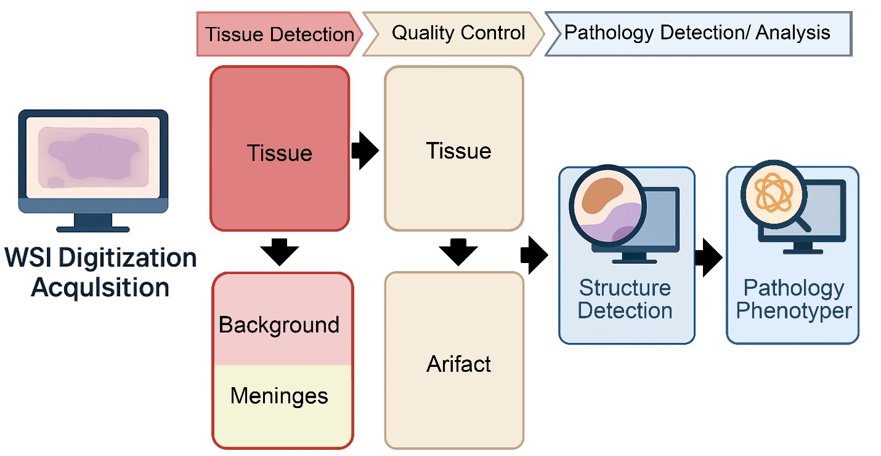
Supplemental Fig. 1 Digital pathology workflow for automated detection and phenotyping of PSP- associated pathology. This figure depicts the schematic overview of the automated pathology pipeline used to analyze digitized whole-slide images (WSIs). Following WSI acquisition, tissue-containing regions are identified and separated from background and meningeal tissue using a tissue detection DenseNet classifier. Tissue regions then undergo quality control to exclude artifacts such as tissue folds, staining artifacts and areas of poor focus, prior to downstream analysis. High-quality tissue areas are processed for structure detection and automated pathology phenotyping, enabling detection and quantification of disease-associated lesions across anatomically defined regions.

Supplemental Fig. 2
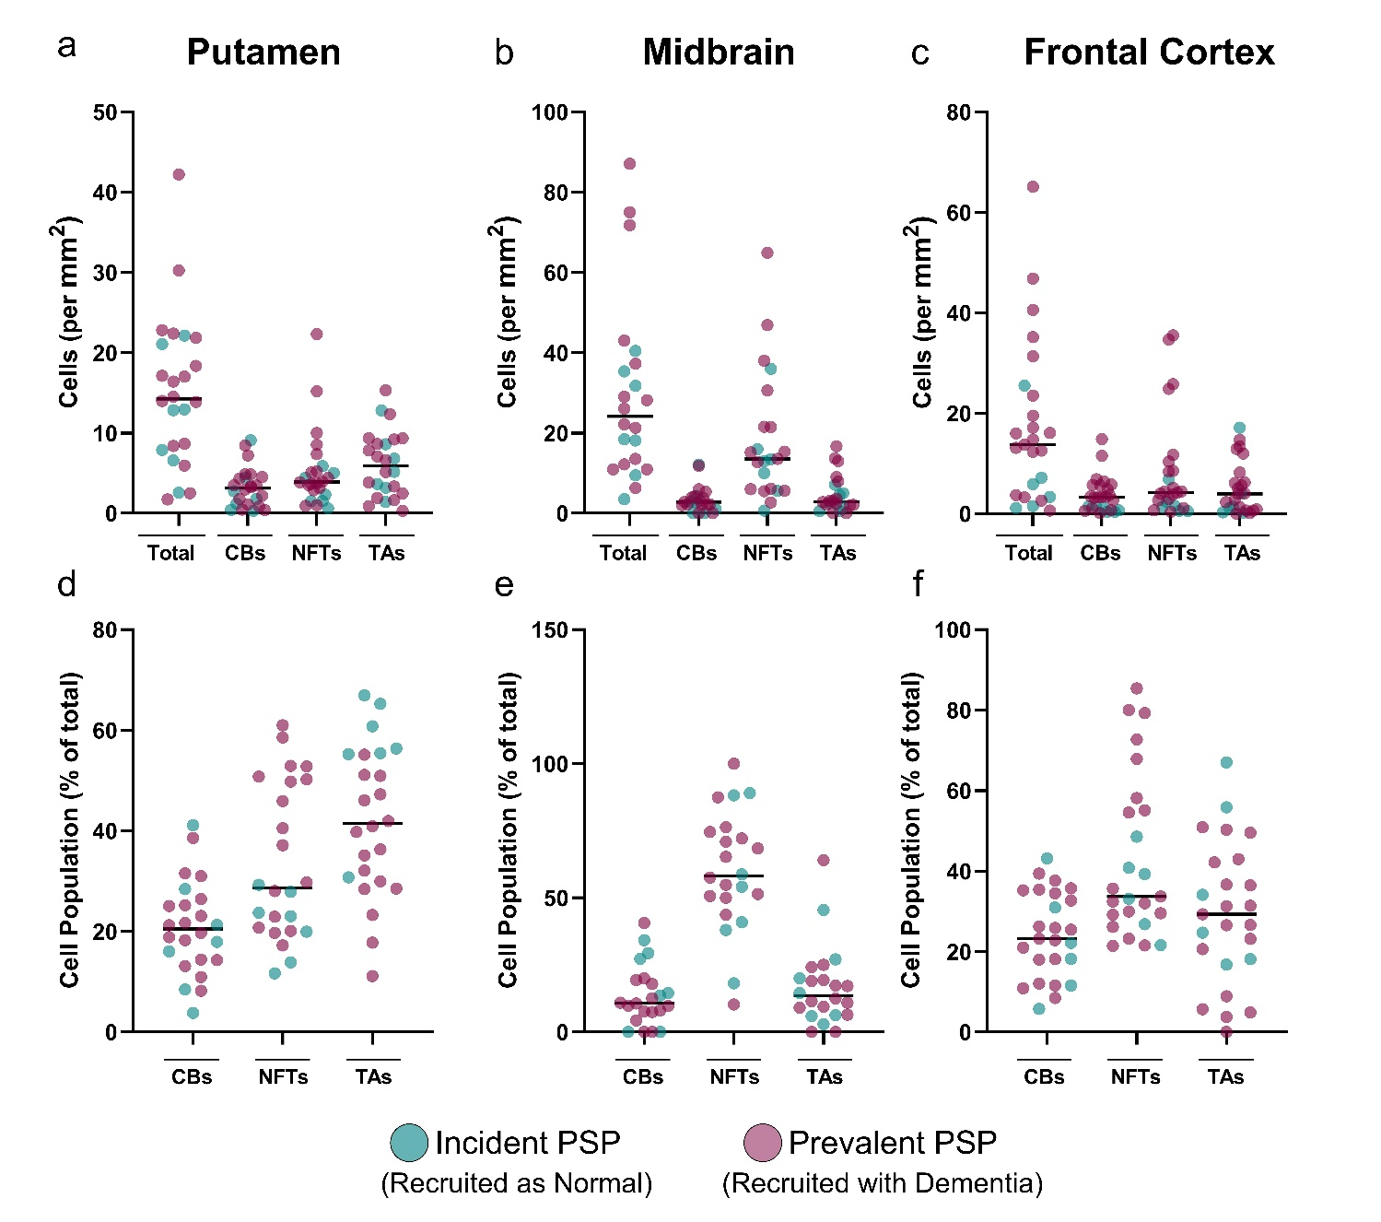
Supplemental Fig. 2 Regional burden and composition of PSP-related tau pathologies in incident and prevalent PSP cases. This figure shows the quantification of pTau pathology density across the putamen (a & d), midbrain (b & e), and frontal cortex (c & f) in incident and prevalent PSP cases. Turquoise points indicate incident PSP cases and maroon points indicate prevalent PSP cases. Panels a-c shows total lesion density and subtype-specific densities of coiled bodies (CBs), neurofibrillary tangles (NFTs), and tufted astrocytes (TAs), expressed as cells per mm², in the putamen, midbrain, and frontal cortex, respectively. Panels d-f show the proportional contribution of CBs, NFTs, and TAs to the total detected lesion population in each region. Horizontal bars indicate group means.

