Analysis

Prevalence of Fasciola infection
Out of 100 examined cattle, 39 animals were positive for Fasciola spp., giving an overall prevalence of 39.0%.
Regarding species distribution:
- Fasciola hepatica was detected in 20.0%
- Fasciola gigantica in 12.0%
- Fasciola magna in 7.0%
Some animals showed mixed infections involving more than one species.
- Positive cattle were older on average than negative cattle: 5.21 vs 4.29 years
- Age was significantly associated with positivity:
  - Mann–Whitney U: p = 0.035
  - Logistic regression: OR = 1.345, 95% CI 1.056–1.712, p = 0.016

Association between age and infection
The mean age of infected cattle (5.21 years) was higher than that of non-infected cattle (4.29 years), indicating a trend of increased infection with age.
Statistical analysis showed:
- Mann–Whitney U test: p = 0.035
- Logistic regression: OR = 1.345
- 95% CI: 1.056–1.712
- p = 0.016
This indicates that age is a significant risk factor, with older cattle having higher odds of infection.

Figure 7. Presents overall prevalence of Fasciola spp, distribution of Fasciola species, Age comparison between infected and non-infected cattle
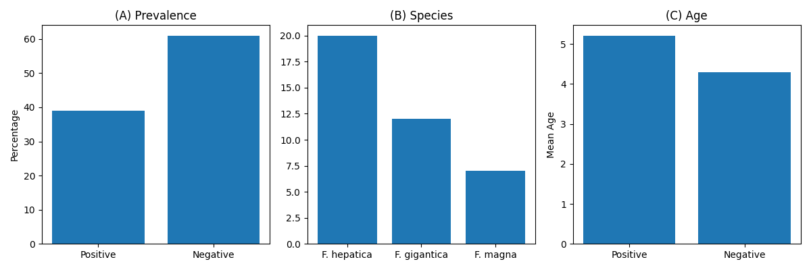

Figure 8. Statistical analysis of regression: age vs probability of infection
