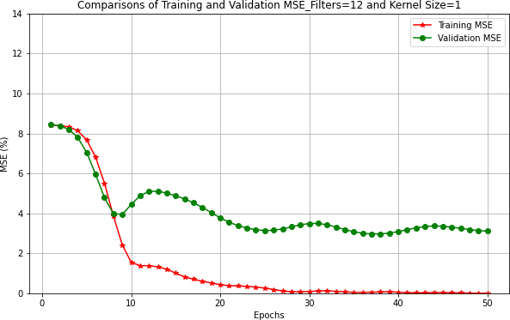
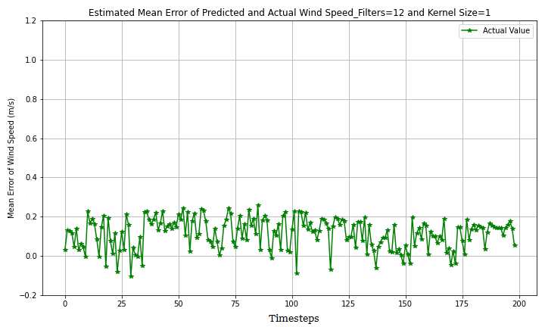
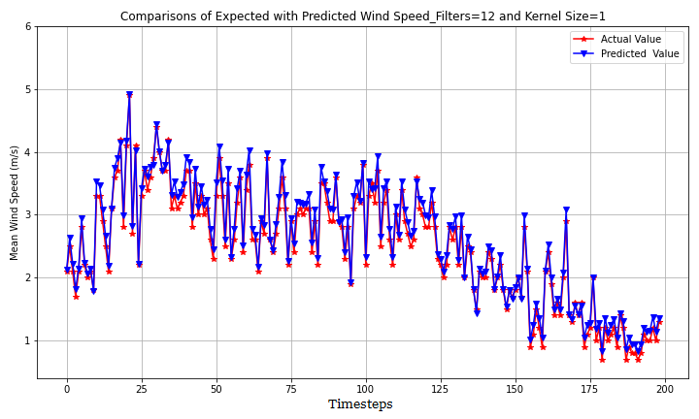
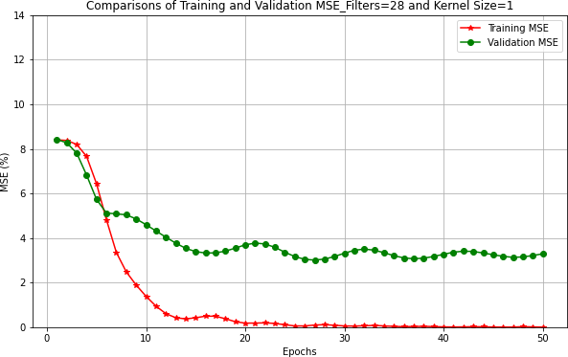
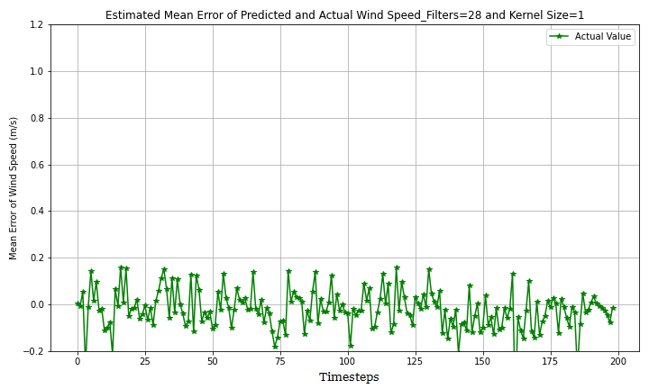
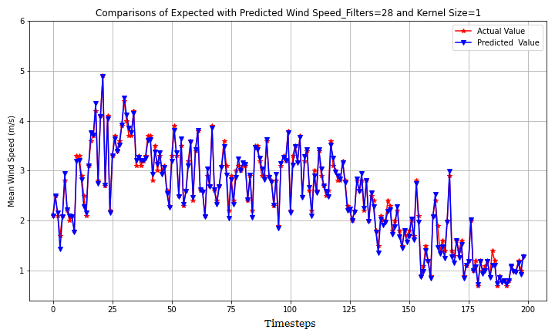
a) Conv2D Model losses (Filter map =12)
b) Conv2D Model Prediction (Filter map =12)
c) Conv2D Model Prediction error (Filter map =12)
d) Conv2D Model losses (Filter map =28)
e) Conv2D Model Prediction (Filter map =28)
f) Conv2D Model Prediction error (Filter map =28)

Fig S1 a-f: Conv2D model tuning based on varied parameters (number of filters and kernel sizes) and predictions with estimated ME

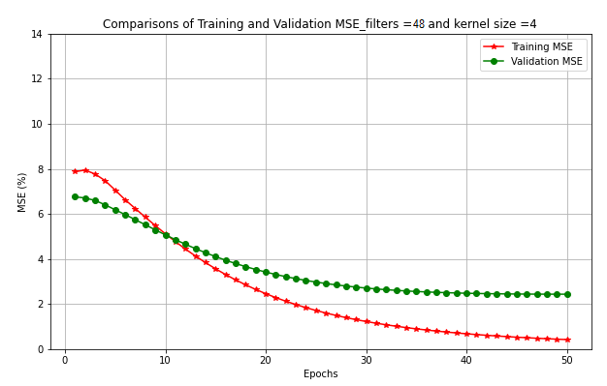
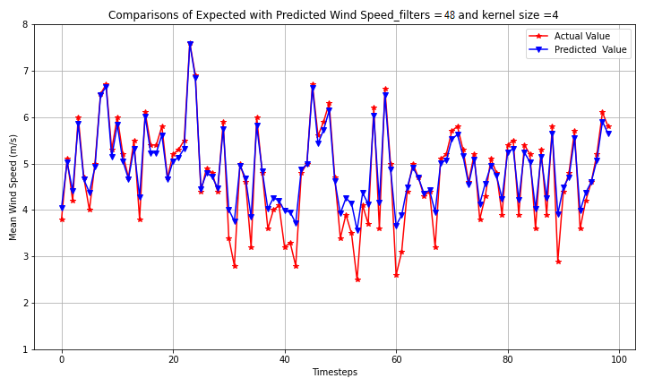
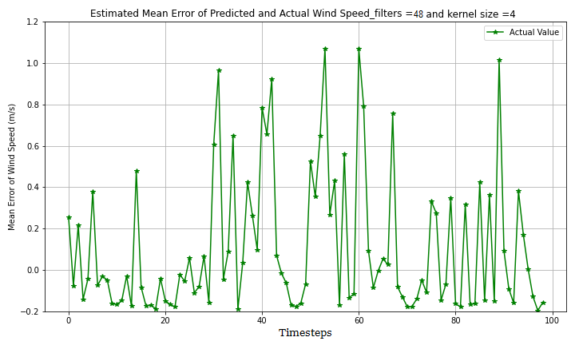
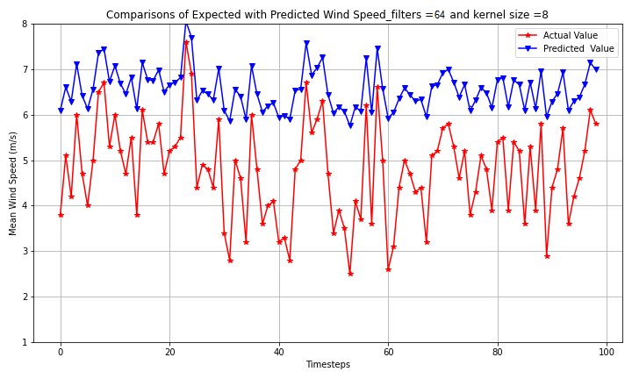
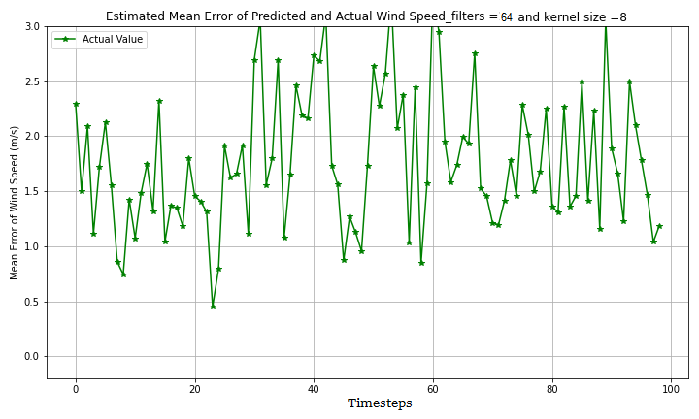
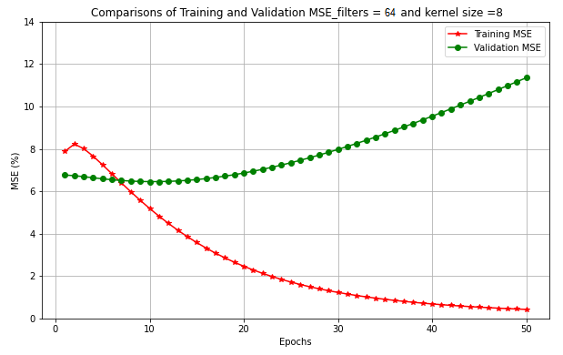
a) ConvLSTM2D Model losses (Filter map =48)
b) ConvLSTM2D Model Prediction (Filter map =48)
c) ConvLSTM2D Model Prediction error (Filter map =48)
d) ConvLSTM2D Model losses (Filter map =64)
e) ConvLSTM2D Model Prediction (Filter map =64)
f) ConvLSM2D Model Prediction error (Filter map =64)

Fig S2 a-f: ConvLSTM2D model tuning based on varied parameters (number of filters and kernel sizes) and predictions with estimated ME

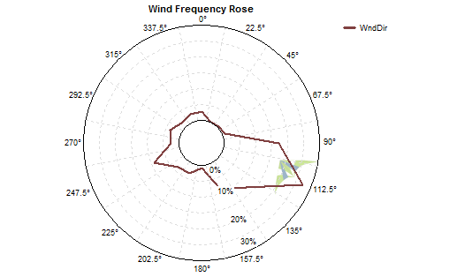
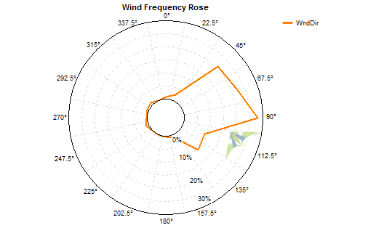
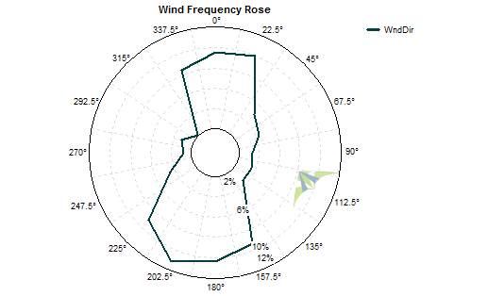
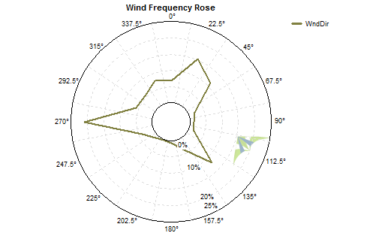
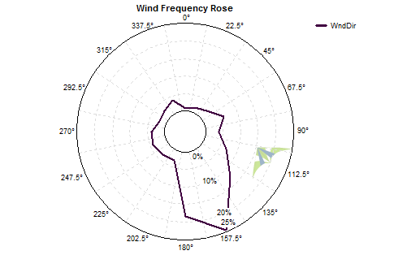
a) Wind Rose_SM2-Va
b) Wind Rose_SM3-Te
e) Wind Rose_SM-ST5
d) Wind Rose_SM-ST4
c) Wind Rose_SM-ST3

Fig S3 a-e: Prevailing sectorwise wind directional flow(s) at considered stations

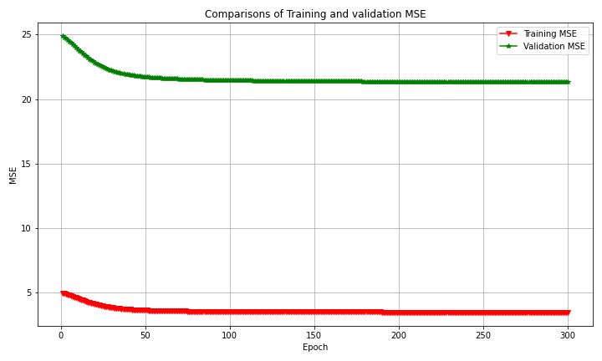
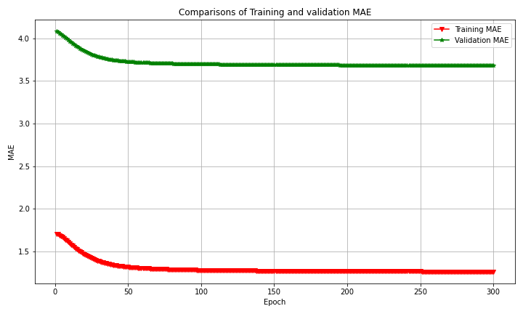
a) Conv1D Model Loss (un-normalized dataset)
b) Conv1D Model MAE (un-normalized dataset)

Fig S4 a-b: Plots of Conv1D model performances with un-normalized input arrays (300 Iterations).

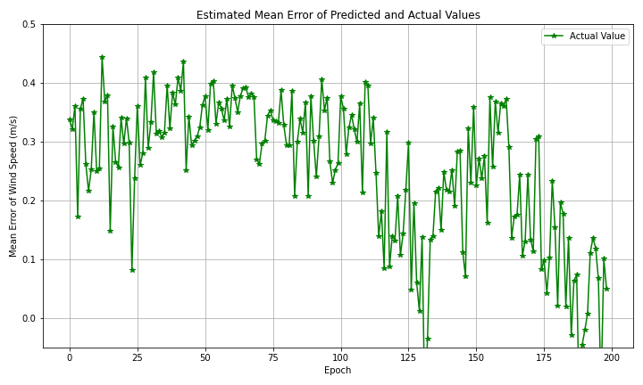
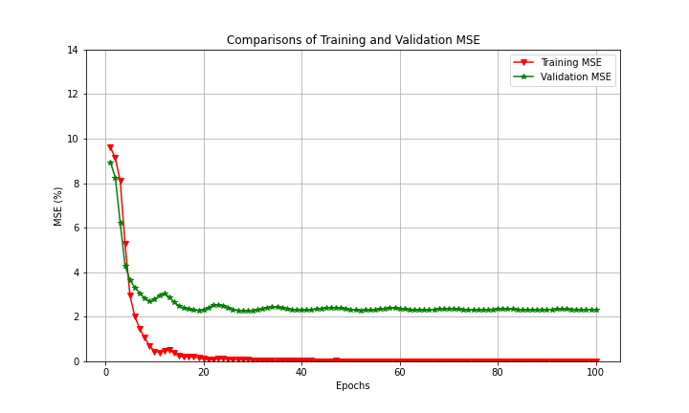
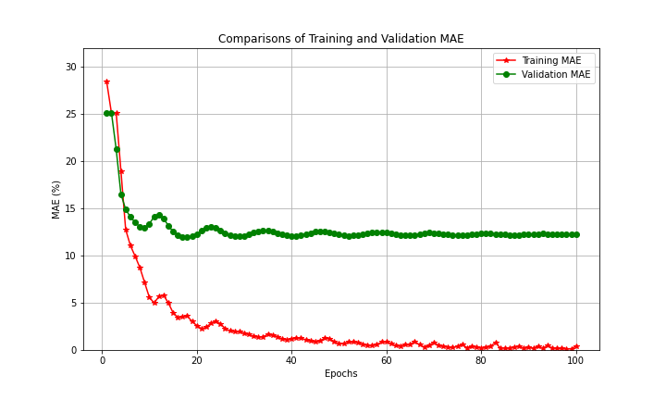
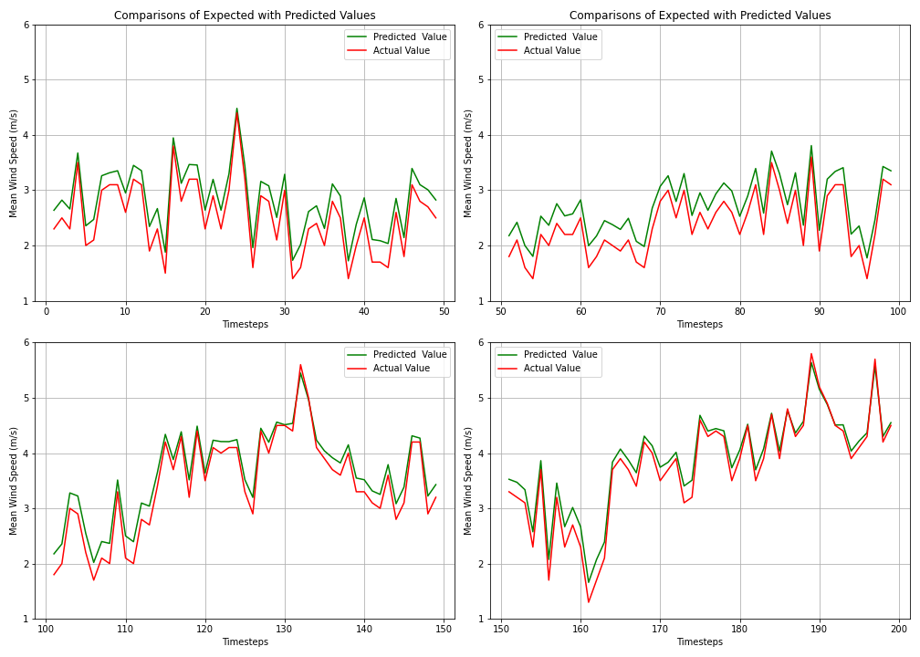
a) Conv1D Model losses (normalized dataset)
b) Conv1D Model MAE (normalized dataset)

c) Conv1D Model Prediction Error (ME)
d1) Conv1D Model Prediction (0-50 timestep)
d2) Conv1D Model Prediction (50-100 timestep)
d3) Conv1D Model Prediction (100-150 timestep)
d4) Conv1D Model Prediction (150-200 timestep)
d) Conv1D Model Wind Speed (m/s) Prediction (0-200 timesteps)

Fig S5 a-d: Plots of Conv1D model performances with normalized input arrays (300 Iterations), model prediction errors and corresponding wind speeds.

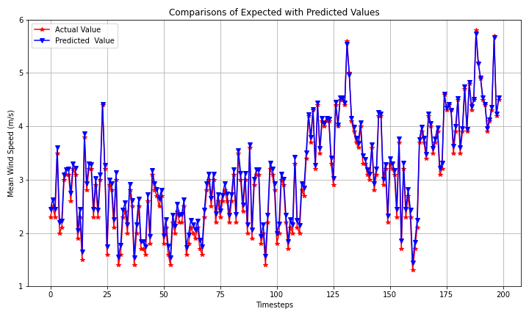
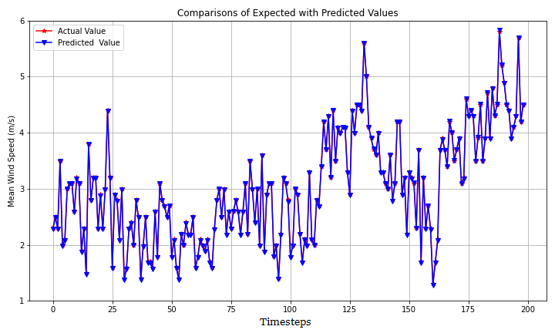
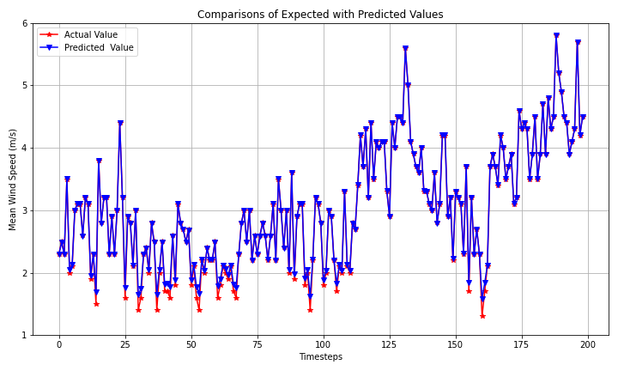
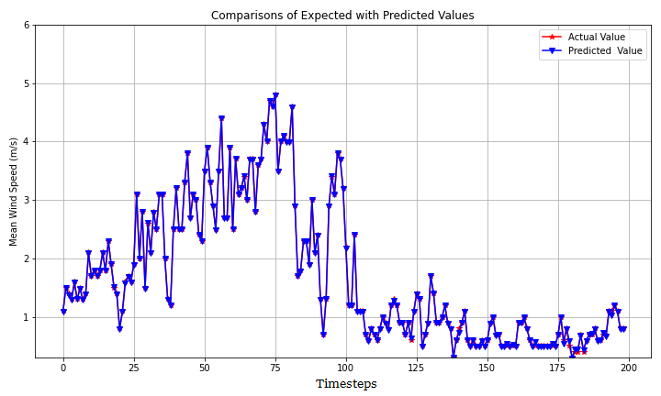
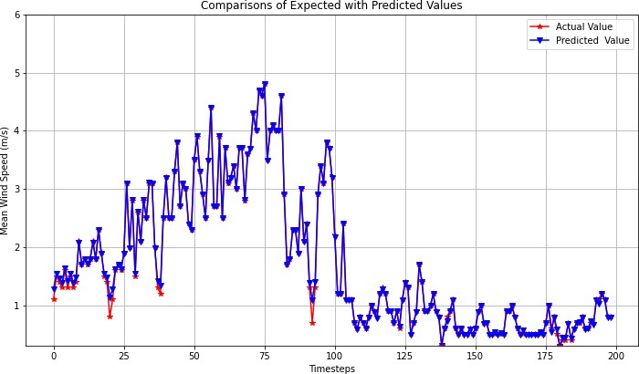
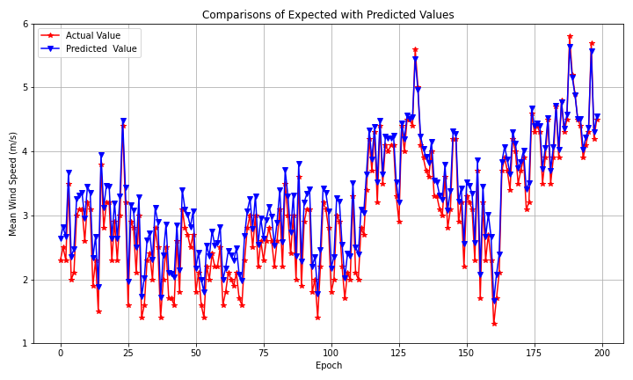
a) Conv2D prediction model from 1st batch training b) ConvLSTM2D prediction model from 1st batch training c) LSTM prediction model from 1st batch training
d) Conv2D prediction model from 2nd batch training e) ConvLSTM2D prediction model from 2nd batch training f) Conv1D prediction model from 1st batch training

Fig S6 a-f: Conv2D, ConvLSTM2D and LSTM prediction models of time series wind speeds (200 timesteps ahead), respectively.

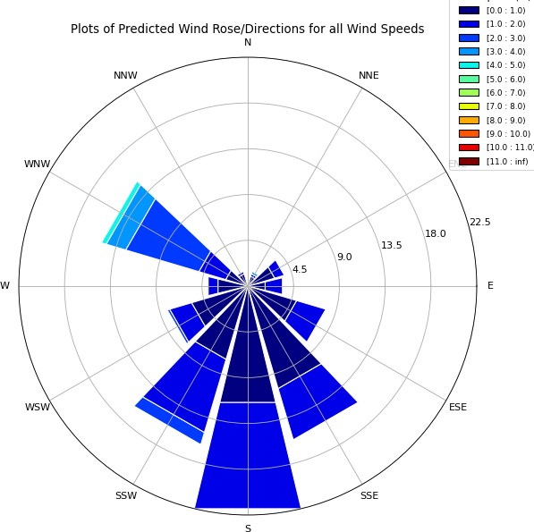
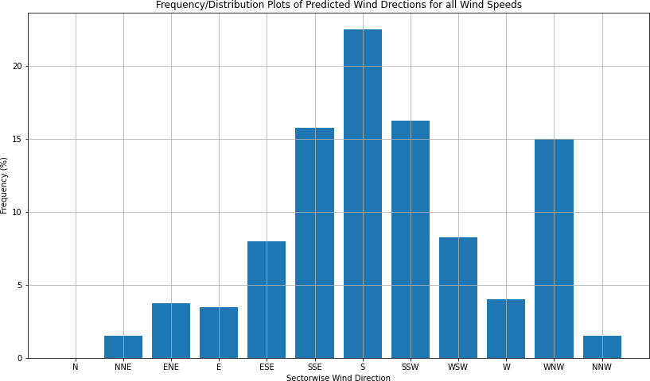
  - ConvLSTM2D Model Wind Rose b) ConvLSTM2D Model Wind Direction Frequency (%)

Fig S7 a-b: Plots of ConvLSTM2D model wind rose and its frequency distribution of all wind speeds, respectively.

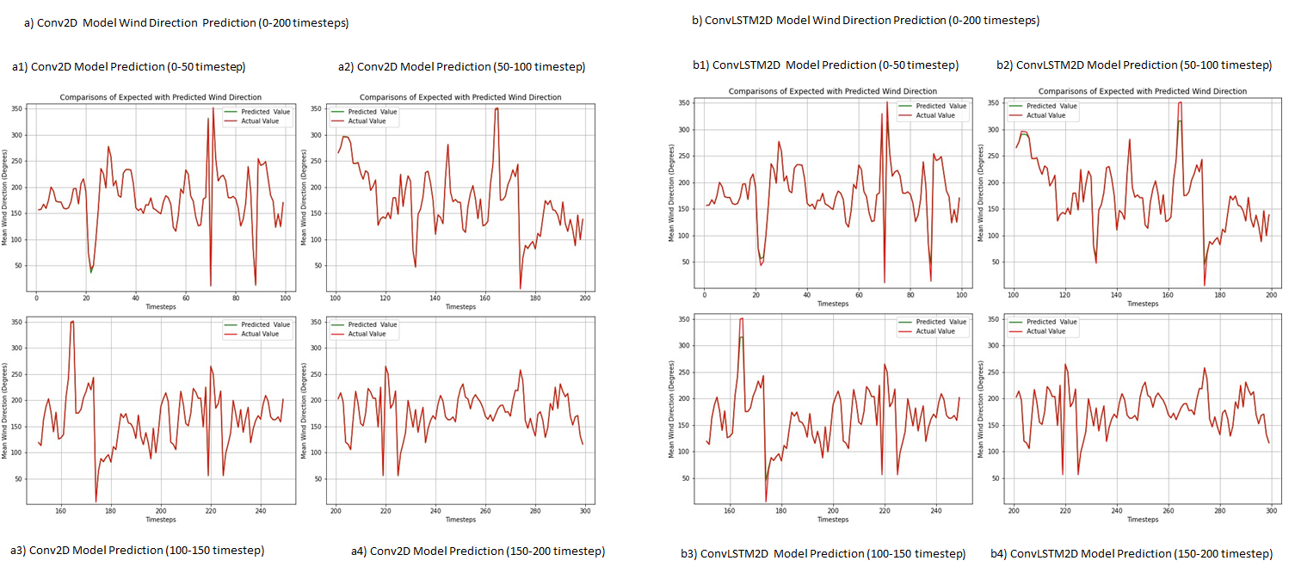

Fig S8 a-b: Plots of Conv2D and ConvLSTM2D model predictions of time series wind directions (0-200 timesteps), respectively.

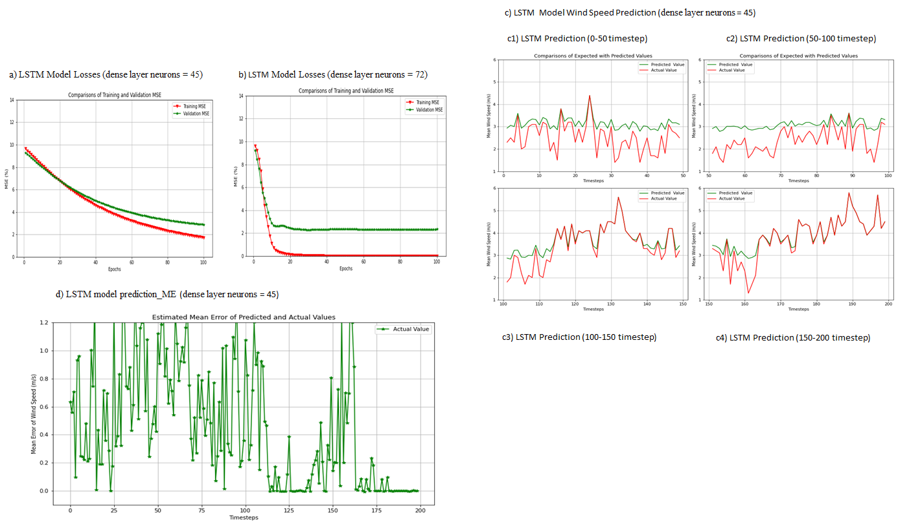

Fig S9 a-d: Performance comparisons of LSTM model (dense layer neurons =45 and 72), plots of LSTM model predictions of wind speed, and prediction errors (200 timesteps).

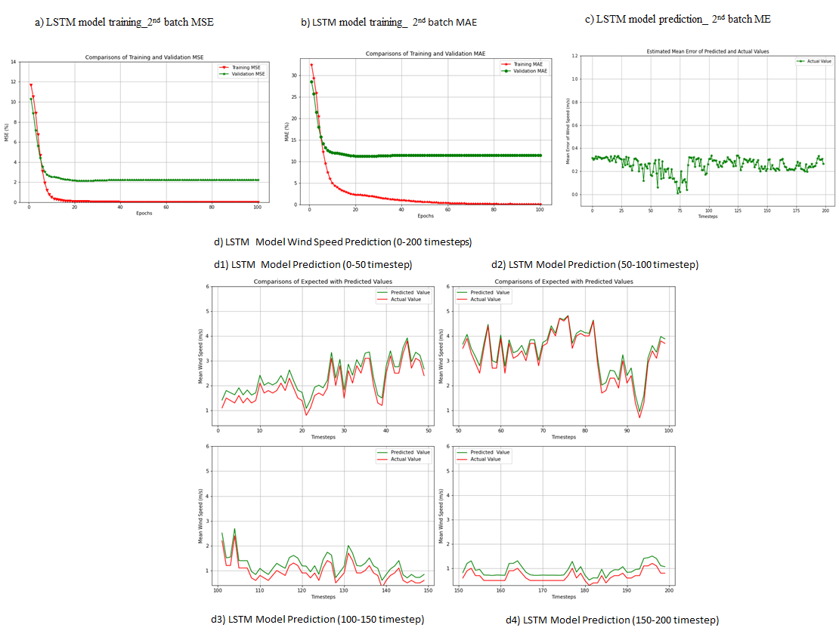

Fig S10 a-d: LSTM model performance comparisons for 2nd batch training, model prediction errors and corresponding wind speed forecasts (0-200 timesteps).

