Maternal Nutrient Intake and Gestational Weight Gain: Trimester-Specific Associations in a Taiwanese Prospective Cohort
Sang Thanh Huynh¹, Jane C.-J. Chao², Yi Chun Chen², Fan-Fen Wang³, Jung-Su Chang^{2,4} , Chyi-Huey Bai^{1,5,}*
¹ School of Public Health, College of Public Health, Taipei Medical University, Taipei, Taiwan
² School of Nutrition and Health Sciences, College of Nutrition, Taipei Medical University, Taipei, Taiwan
³ Department of Internal Medicine, Yangming Branch, Taipei City Hospital, Taipei, Taiwan
⁴ Graduate Institute of Metabolism and Obesity Sciences, College of Nutrition, Taipei Medical University, Taipei, Taiwan
⁵ Department of Public Health, School of Medicine, College of Medicine, Taipei Medical University, Taipei, Taiwan
* Correspondence: Chyi-Huey Bai, baich@tmu.edu.tw

Content:
Supplementary Figure S1: Flow diagram of participant recruitment, exclusions, and final analytic sample in the Nutrition and Health Survey in Taiwanese Pregnant Women (NAHSIT-P), a population-based longitudinal cohort study. The flowchart illustrates the progression of the present study population.
Supplementary Figure S2: Multicollinearity diagnostics based on adjusted variance inflation factors in multivariable models across the second and third trimesters.
Supplementary Figure S3. Prevalence of energy-adjusted (per 1000 kcal) macronutrient and micronutrient imbalance across pregnancy trimesters. Nutrient density distributions did not differ significantly across trimesters.
Supplementary Table S1. Daily macronutrient and micronutrient intakes across pregnancy trimesters.
Supplementary Table S2. Prevalence of nutrient imbalance according to Taiwan’s DRIs across pregnancy trimesters.
Supplementary Table S3. Energy-adjusted nutrient intake (per 1000 kcal) across pregnancy trimesters.
Supplementary Table S4. Associations between serum vitamin B12 concentrations and achieving gestational weight gain within the recommended range in the second trimester, including correlation with dietary intake and non-linear analyses.

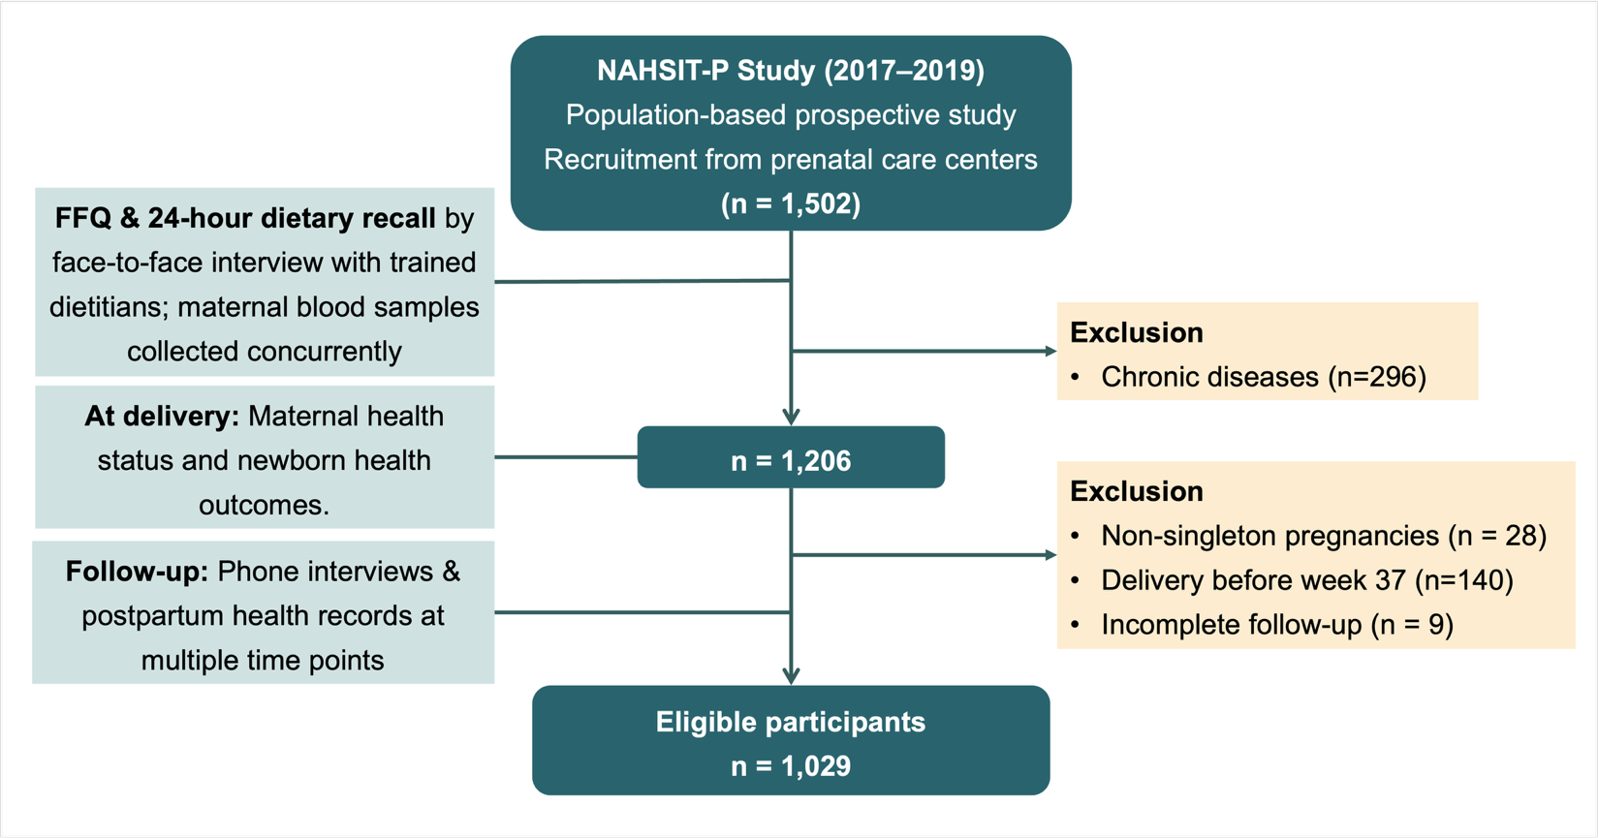
Supplementary Figure S1: Flow diagram of participant recruitment, exclusions, and final analytic sample in the Nutrition and Health Survey in Taiwanese Pregnant Women (NAHSIT-P), a population-based longitudinal cohort study. The flowchart illustrates the progression of the present study population.

Supplementary Table S1. Daily macronutrient and micronutrient intakes across pregnancy trimesters
Nutrient | Total  (n=1,029) | Trimester |  |  | P-value
Nutrient | Total  (n=1,029) | 1st | 2nd | 3rd | P-value
Nutrient | Total  (n=1,029) | (n=145) | (n=439) | (n=445) | P-value
Macronutrients (Median, IQR)
Calories (kcal) | 1803.5 (767.0) | 1733.6 (756.8) | 1752.0 (763.0) | 1876.3 (753.3) | 0.009*
Protein (g) | 66.8 (32.9) | 62.3 (32.7) | 65.9 (35.0) | 68.4 (31.6) | 0.017*
Carbohydrates (g) | 222.6 (104.2) | 216.7 (88.2) | 213.7 (109.1) | 232.5 (101.4) | 0.008*
Dietary fiber (g) | 13.2 (10.4) | 13.3 (10.4) | 12.5 (9.5) | 14.3 (11.3) | 0.031*
Fat (g) | 71.0 (40.7) | 63.1 (44.6) | 70.1 (43.3) | 73.1 (34.8) | 0.031*
Micronutrients (Median, IQR)
Iron (mg) | 9.2 (6.1) | 8.5 (7.2) | 8.9 (5.9) | 9.7 (6.0) | 0.051
Calcium (mg) | 419.8 (386.2) | 367.5 (283.6) | 404.6 (399.2) | 446.0 (393.7) | 0.013*
Vitamin D (mcg) | 2.8 (8.1) | 2.8 (6.2) | 2.8 (9.6) | 2.8 (8.2) | 0.306
Folate (mcg) | 191.2 (114.4) | 167.2 (122.4) | 191.0 (111.9) | 199.4 (111.7) | 0.004*
Other
Zinc (mg) | 8.5 (5.1) | 7.7 (4.2) | 8.4 (5.4) | 8.8 (4.9) | 0.007*
Vitamin B1 (mg) | 0.9 (0.6) | 0.8 (0.6) | 0.9 (0.6) | 0.9 (0.7) | 0.274
Vitamin B3 (mg) | 13.0 (9.4) | 11.6 (9.9) | 12.9 (9.5) | 13.6 (8.8) | 0.076
Vitamin B6 (mg) | 1.2 (0.8) | 1.1 (0.83) | 1.2 (0.8) | 1.3 (0.7) | 0.022*
Vitamin B12 (mcg) | 2.9 (3.3) | 2.7 (2.8) | 2.8 (3.6) | 3.0 (3.4) | 0.041*
RE (mcg) | 490.8 (593.6) | 432.6 (601.2) | 484.9 (553.6) | 516.6 (638.6) | 0.382
Vitamin C (mg) | 77.8 (105.8) | 78.5 (117.3) | 77.0 (98.2) | 78.4 (107.6) | 0.440
Vitamin E (mg) | 26.8 (20.3) | 27.1 (20.8) | 25.5 (21.2) | 27.5 (19.8) | 0.233
Nutrient in blood (median, SD)
Vitamin B12 (pg/mL) | 275.0 (168.0) | 388.0 (222.5) | 293.0 (162.0) | 242.0 (133.0) | <0.001*
IQR, Interquartile Range; RE, Retinol Equivalent; * p-value < 0.05

Supplementary Table S2. Prevalence of nutrient imbalance according to Taiwan’s DRIs across pregnancy trimesters.
Nutrient | Total | Trimester |  |  | P-value
Nutrient | (n=1029) | 1st | 2nd | 3rd | P-value
Nutrient |  | (n=145) | (n=439) | (n=445) | P-value
Macronutrients (n,%)
Calories (kcal)
Inadequate | 586 (56.9) | 63 (43.4) | 275 (62.6) | 248 (55.7) | <0.001
Excessive | 443 (43.1) | 82 (56.6) | 164 (37.4) | 197 (44.3)
Protein (g)
Inadequate | 574 (55.8) | 91 (62.8) | 246 (56.0) | 237 (53.3) | 0.134
Excessive | 455 (44.2) | 54 (37.2) | 193 (44.0) | 208 (46.7)
Carbohydrates (g)
Inadequate | 94 (9.1) | 6 (4.1) | 46 (10.5) | 42 (9.4) | 0.068
Excessive | 935 (90.9) | 139 (95.9) | 393 (89.5) | 403 (90.6)
Carbohydrates (g)$
Inadequate | 0 (0.0)
Excessive | 1029 (100) | 145 (100) | 439 (100) | 445 (100)
Dietary fiber (g)
Inadequate | 943 (91.6) | 126 (86.9) | 410 (93.4) | 407 (91.5) | 0.049
Excessive | 86 (8.4) | 19 (13.1) | 29 (6.6) | 38 (8.5)
Fat (g)
Inadequate | 98 (9.5) | 17 (11.7) | 44 (10.0) | 37 (8.3) | <0.001
Excessive | 734 (71.3) | 87 (60.0) | 302 (68.8) | 345 (77.5)
Adequate | 197 (19.1) | 41 (28.3) | 93 (21.2) | 63 (14.2)
Micronutrients (n,%)
Iron (mg)
Inadequate | 942 (91.5) | 123 (84.8) | 374 (85.2) | 445 (100.0) | <0.001
Excessive | 87 (8.5) | 22 (15.2) | 65 (14.8) | 0 (0.0)
Calcium (mg)
Inadequate | 965 (93.8) | 140 (96.6) | 409 (93.2) | 416 (93.5) | 0.323
Excessive | 64 (6.2) | 5 (3.4) | 30 (6.8) | 29 (6.5)
Vitamin D (mcg)
Inadequate | 775 (75.3) | 113 (77.9) | 327 (74.5) | 335 (75.3) | 0.706
Excessive | 254 (24.7) | 32 (22.1) | 112 (25.5) | 110 (24.7)
Folate (mcg)
Inadequate | 1029 (100) | 145 (100) | 439 (100) | 445 (100)
Excessive | 0 (0.0) | 0 (0) | 0 (0) | 0 (0)
Other
Zinc (mg)
Inadequate | 946 (91.9) | 134 (92.4) | 404 (92.0) | 408 (91.7) | 0.957
Excessive | 83 (8.1) | 11 (7.6) | 35 (8.0) | 37 (8.3)
Vitamin B1 (mg)
Inadequate | 641 (62.3) | 78 (53.8) | 282 (64.2) | 281 (63.1) | 0.071
Excessive | 388 (37.7) | 67 (46.2) | 157 (35.8) | 164 (36.9)
Vitamin B3 (mg)
Inadequate | 668 (64.9) | 84 (57.9) | 297 (67.7) | 287 (64.5) | 0.101
Excessive | 361 (35.1) | 61 (42.1) | 142 (32.3) | 158 (35.5)
Vitamin B6 (mg)
Inadequate | 883 (85.8) | 126 (86.9) | 372 (84.7) | 385 (86.5) | 0.692
Excessive | 146 (14.2) | 19 (13.1) | 67 (15.3) | 60 (13.5)
Vitamin B12 (mcg)
Inadequate | 456 (44.3) | 69 (47.6) | 203 (46.2) | 184 (41.3) | 0.237
Excessive | 573 (55.7) | 76 (52.4) | 236 (53.8) | 261 (58.7)
RE (mcg)
Inadequate | 568 (55.2) | 79 (54.5) | 230 (52.4) | 259 (58.2) | 0.217
Excessive | 461 (44.8) | 66 (45.5) | 209 (47.6) | 186 (41.8)
Vitamin C (mg)
Inadequate | 672 (65.3) | 97 (66.9) | 296 (67.4) | 279 (62.7) | 0.306
Excessive | 357 (34.7) | 48 (33.1) | 143 (32.6) | 166 (46.5)
Vitamin E (mg)
Inadequate | 167 (16.2) | 30 (20.7) | 74 (16.9) | 63 (14.2) | 0.161
Excessive | 862 (83.8) | 115 (79.3) | 365 (83.1) | 382 (85.8)

Supplementary Table S3. Energy-adjusted nutrient intake (per 1000 kcal) across pregnancy trimesters.
Energy-adjusted nutrient intake (per 1000 kcal) | Total  (n=1029) | Trimester
Energy-adjusted nutrient intake (per 1000 kcal) | Total  (n=1029) | 1st  (n=145) | 2nd  (n=439) | 3rd  (n=445) | p-value
Protein (g) | 35.98 (10.99) | 36.92 (10.69) | 37.16 (10.60) | 36.78 (10.61) | 0.766
Carbohydrate (g) | 123.77 (32.95) | 125.22 (31.78) | 123.85 (28.66) | 124.24 (30.01) | 0.805
Dietary fiber (g) | 7.23 (5.96) | 6.88 (4.66) | 7.55 (5.02) | 7.17 (5.04) | 0.288
Fat density (g) | 39.39 (13.96) | 39.60 (13.12) | 40.05 (11.75) | 39.67 (12.88) | 0.460
Iron (mg) | 5.02 (3.11) | 5.06 (2.87) | 5.16 (2.80) | 5.09 (2.90) | 0.695
Folate (mcg) | 97.78 (58.74) | 107.11 (59.50) | 107.24 (54.19) | 106.48 (56.98) | 0.348
Vitamin D (mcg) | 1.54 (2.93) | 1.51 (5.10) | 1.45 (4.77) | 1.50 (4.63) | 0.390
Vitamin B1 (mg) | 0.49 (0.28) | 0.51 (0.31) | 0.51 (0.27) | 0.51 (0.28) | 1.000
Vitamin B3 (mg) | 6.83 (4.34) | 7.00 (4.01) | 7.09 (4.21) | 7.00 (4.13) | 0.630
Vitamin B6 (mg) | 0.66 (0.29) | 0.68 (0.35) | 0.69 (0.32) | 0.68 (0.32) | 0.141
Vitamin B12 (mcg) | 0.64 (0.32) | 0.64 (0.32) | 0.63 (0.35) | 0.64 (0.33) | 0.280
Vitamin C (mg) | 40.77 (58.55) | 43.34 (53.42) | 42.78 (55.94) | 42.74 (55.67) | 0.704
Vitamin E (mg) | 14.69 (9.38) | 15.25 (9.74) | 15.21 (9.36) | 15.20 (9.43) | 0.906
Calcium (mg) | 204.57 (145.18) | 227.00 (203.08) | 233.02 (178.51) | 225.12 (185.21) | 0.153
Zinc (mg) | 4.57 (1.45) | 4.65 (1.66) | 4.69 (1.75) | 4.66 (1.69) | 0.475

Supplementary Figure S2: Multicollinearity diagnostics based on adjusted variance inflation factors in multivariable models across the second and third trimesters.
Supplementary Figure S3. Prevalence of energy-adjusted (per 1000 kcal) macronutrient and micronutrient imbalance across pregnancy trimesters. Nutrient density distributions did not differ significantly across trimesters.
Supplementary Table S4. Associations between serum vitamin B12 concentrations and achieving gestational weight gain within the recommended range in the second trimester, including correlation with dietary intake and non-linear analyses.
Spearman’s Correlation
Vitamin B12 biomarker vs density intake |  | ρ | p-value
Vitamin B12 biomarker vs density intake |  | 0.108 | 0.024
Association between Vitamin B12 biomarker and GWG within the recommended range
Continuous exposure | aOR | 95% CI | p-value
Vitamin B12 (per unit) | 0.999 | (0.998, 1.001) | 0.373
Quartile exposure (Q1 reference)
Q2 | 0.978 | (0.551, 1.737) | 0.94
Q3 | 1.37 | (0.773, 2.441) | 0.283
Q4 | 0.708 | (0.383, 1.296) | 0.264
Non-linear analysis (Cubic splines) |  | P (Overall) | P (Non-linear)
Vitamin B12 biomarker |  | 0.371 | 0.284

